Supplementary Materials

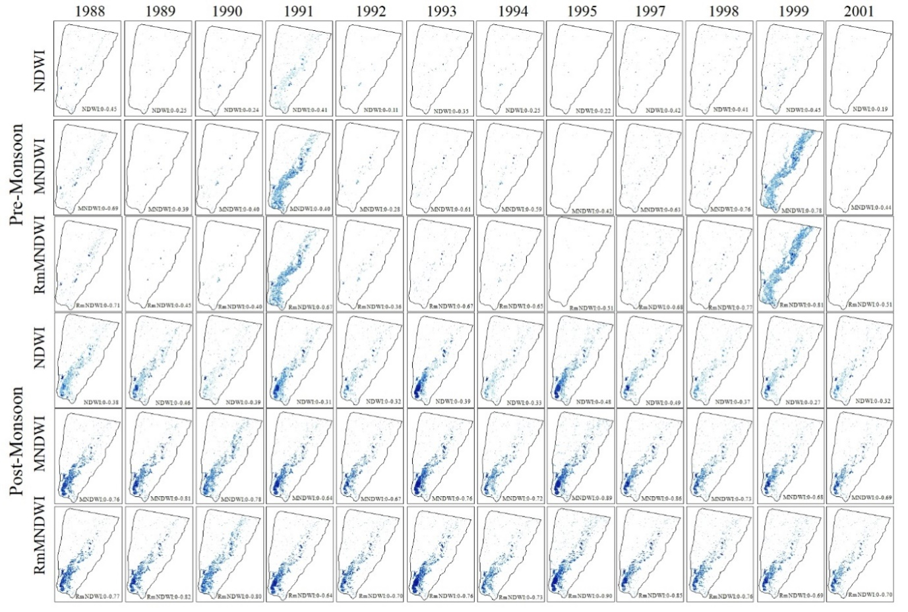
Figure. S1 Wetland mapping using NDWI, MNDWI, RmNDWI indices for both pre and post monsoon (1988-2001).
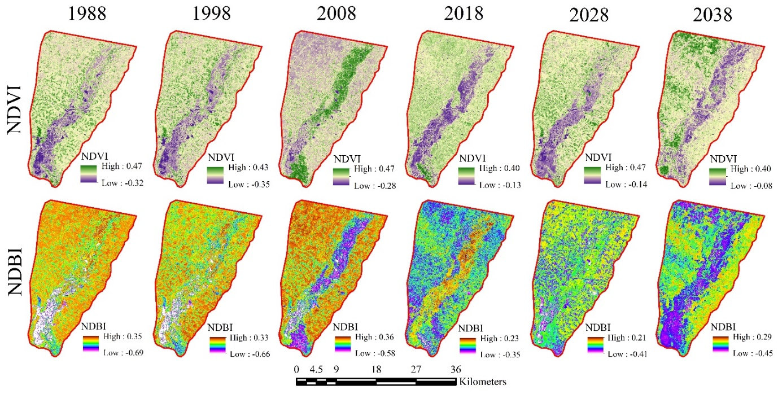
Figure. S2 Simulated NDVI and NDBI for future wetland area prediction.

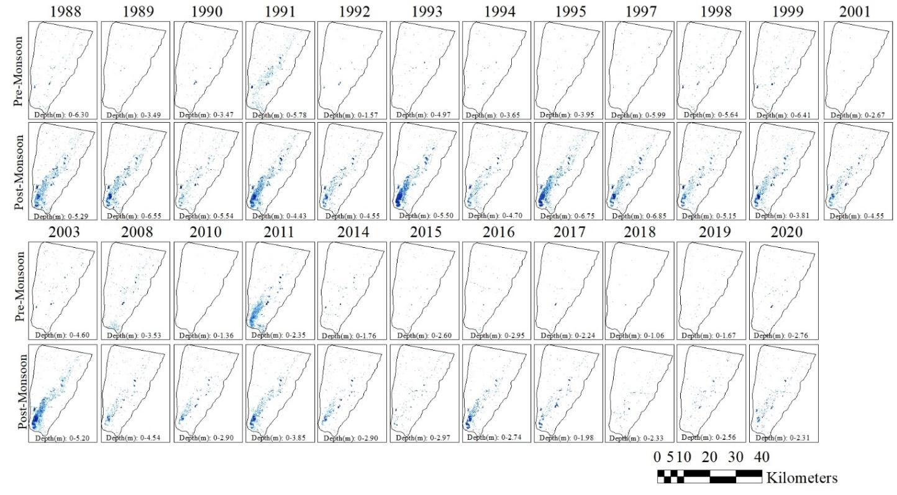
Figure. S3 Wetland depth mapping between 1988-2020 for pre-monsoon and post-monsoon seasons.
Table. S1 Overall accuracy, Kappa coefficient and AUC of ROC values of different water indices in pre- and post-monsoon seasons.
Year | Indices | Pre-monsoon |  |  | Post-monsoon
Year | Indices | Overall accuracy | Kappa Co-efficient | ROC AUC | Indices | Overall accuracy | Kappa Co-efficient | ROC AUC
1988 | NDWI | 92.5 | 0.830 | 0.691 | NDWI | 89 | 0.795 | 0.864
1988 | MNDWI | 94 | 0.845 | 0.762 | MNDWI | 92.5 | 0.830 | 0.865
1988 | RmNDWI | 96 | 0.865 | 0.790 | RmNDWI | 94 | 0.880 | 0.866
1990 | NDWI | 91.5 | 0.820 | 0.829 | NDWI | 90 | 0.775 | 0.860
1990 | MNDWI | 92.5 | 0.855 | 0.844 | MNDWI | 92 | 0.805 | 0.870
1990 | RmNDWI | 93 | 0.880 | 0.848 | RmNDWI | 92 | 0.825 | 0.874
1991 | NDWI | 92 | 0.825 | 0.690 | NDWI | 91 | 0.815 | 0.847
1991 | MNDWI | 93 | 0.860 | 0.777 | MNDWI | 91 | 0.835 | 0.864
1991 | RmNDWI | 92.5 | 0.870 | 0.811 | RmNDWI | 93 | 0.855 | 0.869
1992 | NDWI | 94 | 0.844 | 0.730 | NDWI | 89 | 0.815 | 0.808
1992 | MNDWI | 96 | 0.865 | 0.750 | MNDWI | 91.5 | 0.840 | 0.871
1992 | RmNDWI | 96 | 0.900 | 0.768 | RmNDWI | 93.5 | 0.860 | 0.880
1993 | NDWI | 92 | 0.860 | 0.790 | NDWI | 92.5 | 0.835 | 0.794
1993 | MNDWI | 93 | 0.870 | 0.812 | MNDWI | 94 | 0.880 | 0.851
1993 | RmNDWI | 93 | 0.890 | 0.840 | RmNDWI | 96 | 0.900 | 0.852
1994 | NDWI | 90 | 0.860 | 0.820 | NDWI | 93 | 0.880 | 0.840
1994 | MNDWI | 94 | 0.880 | 0.842 | MNDWI | 94 | 0.890 | 0.848
1994 | RmNDWI | 95.5 | 0.900 | 0.839 | RmNDWI | 96 | 0.910 | 0.850
1995 | NDWI | 94 | 0.880 | 0.860 | NDWI | 89.5 | 0.845 | 0.856
1995 | MNDWI | 95 | 0.890 | 0.950 | MNDWI | 92.5 | 0.874 | 0.897
1995 | RmNDWI | 96 | 0.910 | 0.955 | RmNDWI | 96.5 | 0.935 | 0.904
1997 | NDWI | 92 | 0.920 | 0.718 | NDWI | 94 | 0.840 | 0.879
1997 | MNDWI | 97 | 0.930 | 0.823 | MNDWI | 96 | 0.860 | 0.887
1997 | RmNDWI | 98 | 0.940 | 0.823 | RmNDWI | 97 | 0.895 | 0.890
1998 | NDWI | 91 | 0.870 | 0.829 | NDWI | 94 | 0.880 | 0.890
1998 | MNDWI | 92 | 0.872 | 0.870 | MNDWI | 95 | 0.890 | 0.913
1998 | RmNDWI | 94 | 0.890 | 0.889 | RmNDWI | 96.5 | 0.925 | 0.917
1999 | NDWI | 90 | 0.829 | 0.545 | NDWI | 93 | 0.870 | 0.905
1999 | MNDWI | 92 | 0.845 | 0.555 | MNDWI | 96.5 | 0.904 | 0.904
1999 | RmNDWI | 95.5 | 0.915 | 0.565 | RmNDWI | 96.5 | 0.925 | 0.906
2001 | NDWI | 91 | 0.840 | 0.767 | NDWI | 94.5 | 0.865 | 0.832
2001 | MNDWI | 92 | 0.860 | 0.837 | MNDWI | 94.5 | 0.885 | 0.861
2001 | RmNDWI | 94 | 0.890 | 0.851 | RmNDWI | 96 | 0.900 | 0.867
2003 | NDWI | 94 | 0.870 | 0.808 | NDWI | 95 | 0.890 | 0.593
2003 | MNDWI | 95 | 0.885 | 0.593 | MNDWI | 97.5 | 0.915 | 0.842
2003 | RmNDWI | 96 | 0.905 | 0.809 | RmNDWI | 97.5 | 0.925 | 0.864
2008 | NDWI | 95.5 | 0.900 | 0.510 | NDWI | 95 | 0.900 | 0.863
2008 | MNDWI | 93 | 0.875 | 0.545 | MNDWI | 95 | 0.920 | 0.897
2008 | RmNDWI | 93.5 | 0.880 | 0.555 | RmNDWI | 96 | 0.930 | 0.900
2010 | NDWI | 85 | 0.705 | 0.875 | NDWI | 90 | 0.870 | 0.845
2010 | MNDWI | 85.5 | 0.710 | 0.896 | MNDWI | 92.5 | 0.895 | 0.871
2010 | RmNDWI | 85.5 | 0.715 | 0.900 | RmNDWI | 95 | 0.920 | 0.880
2011 | NDWI | 92 | 0.830 | 0.900 | NDWI | 94 | 0.890 | 0.792
2011 | MNDWI | 85 | 0.760 | 0.838 | MNDWI | 95 | 0.900 | 0.881
2011 | RmNDWI | 86 | 0.770 | 0.838 | RmNDWI | 97.5 | 0.925 | 0.868
2014 | NDWI | 92 | 0.830 | 0.685 | NDWI | 94 | 0.865 | 0.861
2014 | MNDWI | 86 | 0.770 | 0.754 | MNDWI | 95 | 0.875 | 0.888
2014 | RmNDWI | 92 | 0.795 | 0.759 | RmNDWI | 96 | 0.910 | 0.900
2015 | NDWI | 92 | 0.820 | 0.695 | NDWI | 92.5 | 0.875 | 0.882
2015 | MNDWI | 85 | 0.750 | 0.757 | MNDWI | 95 | 0.900 | 0.914
2015 | RmNDWI | 91 | 0.810 | 0.840 | RmNDWI | 96.5 | 0.915 | 0.924
2016 | NDWI | 92 | 0.820 | 0.690 | NDWI | 93 | 0.880 | 0.928
2016 | MNDWI | 91 | 0.810 | 0.835 | MNDWI | 95 | 0.90 | 0.948
2016 | RmNDWI | 93 | 0.865 | 0.846 | RmNDWI | 97.5 | 0.925 | 0.952
2017 | NDWI | 92.5 | 0.860 | 0.520 | NDWI | 95 | 0.90 | 0.838
2017 | MNDWI | 90 | 0.835 | 0.783 | MNDWI | 97.5 | 0.925 | 0.925
2017 | RmNDWI | 94 | 0.875 | 0.864 | RmNDWI | 97.5 | 0.935 | 0.925
2018 | NDWI | 93 | 0.865 | 0.676 | NDWI | 95 | 0.910 | 0.858
2018 | MNDWI | 93 | 0.918 | 0.745 | MNDWI | 96 | 0.920 | 0.932
2018 | RmNDWI | 95 | 0.938 | 0.789 | RmNDWI | 97.5 | 0.935 | 0.951
2019 | NDWI | 96 | 0.948 | 0.806 | NDWI | 95 | 0.910 | 0.955
2019 | MNDWI | 86 | 0.720 | 0.797 | MNDWI | 97.5 | 0.935 | 0.970
2019 | RmNDWI | 87 | 0.745 | 0.845 | RmNDWI | 97.5 | 0.955 | 0.972
2020 | NDWI | 92 | 0.845 | 0.843 | NDWI | 95.5 | 0.915 | 0.861
2020 | MNDWI | 86 | 0.775 | 0.900 | MNDWI | 96.5 | 0.925 | 0.888
2020 | RmNDWI | 87.5 | 0.750 | 0.912 | RmNDWI | 96.5 | 0.945 | 0.914

Table. S2 Calculated overall accuracy, kappa co-efficient, and AUC of ROC values of simulated wetland area.
Predicted years | Overall accuracy (%) | Kappa co-efficient | AUC of ROC
2008 | 85.3 | 0.93 | 0.91
2018 | 86.4 | 0.96 | 0.93

