Supplementary Material
Article type: Original article
Title: Association between urinary heavy metals and non-melanoma skin cancer: Insights from a population-based study
Kexun Zhang, MD¹, Ke Zhang, MS², Hua Wang, MD¹, Yang Qin², Feng Hong, PhD^{3*}, Wei Zhang, MD, PhD^{2*3*}

¹ Department of Infectious Disease Control, Kunshan Center for Disease Control and Prevention, Kunshan, Jiangsu, China.
² Department of Dermatology, Affiliated Hospital of Guizhou Medical University, Guiyang, Guizhou, China.
³ School of Public Health, the Key Laboratory of Environmental Pollution Monitoring and Disease Control, Ministry of Education, Guizhou Medical University, Guizhou, China.

*Corresponding author:

Feng Hong, PhD
Wei Zhang, MD, PhD
No. 28 Guiyi Street,
Guiyang, Guizhou, 550001, China
Email: fhong@gmc.edu.cn, weizahn@gmc.edu.cn

Supplementary figures: 2 (Figure S1, Figure S2)

Supplementary tables: 3 (Table S1, Table S2)

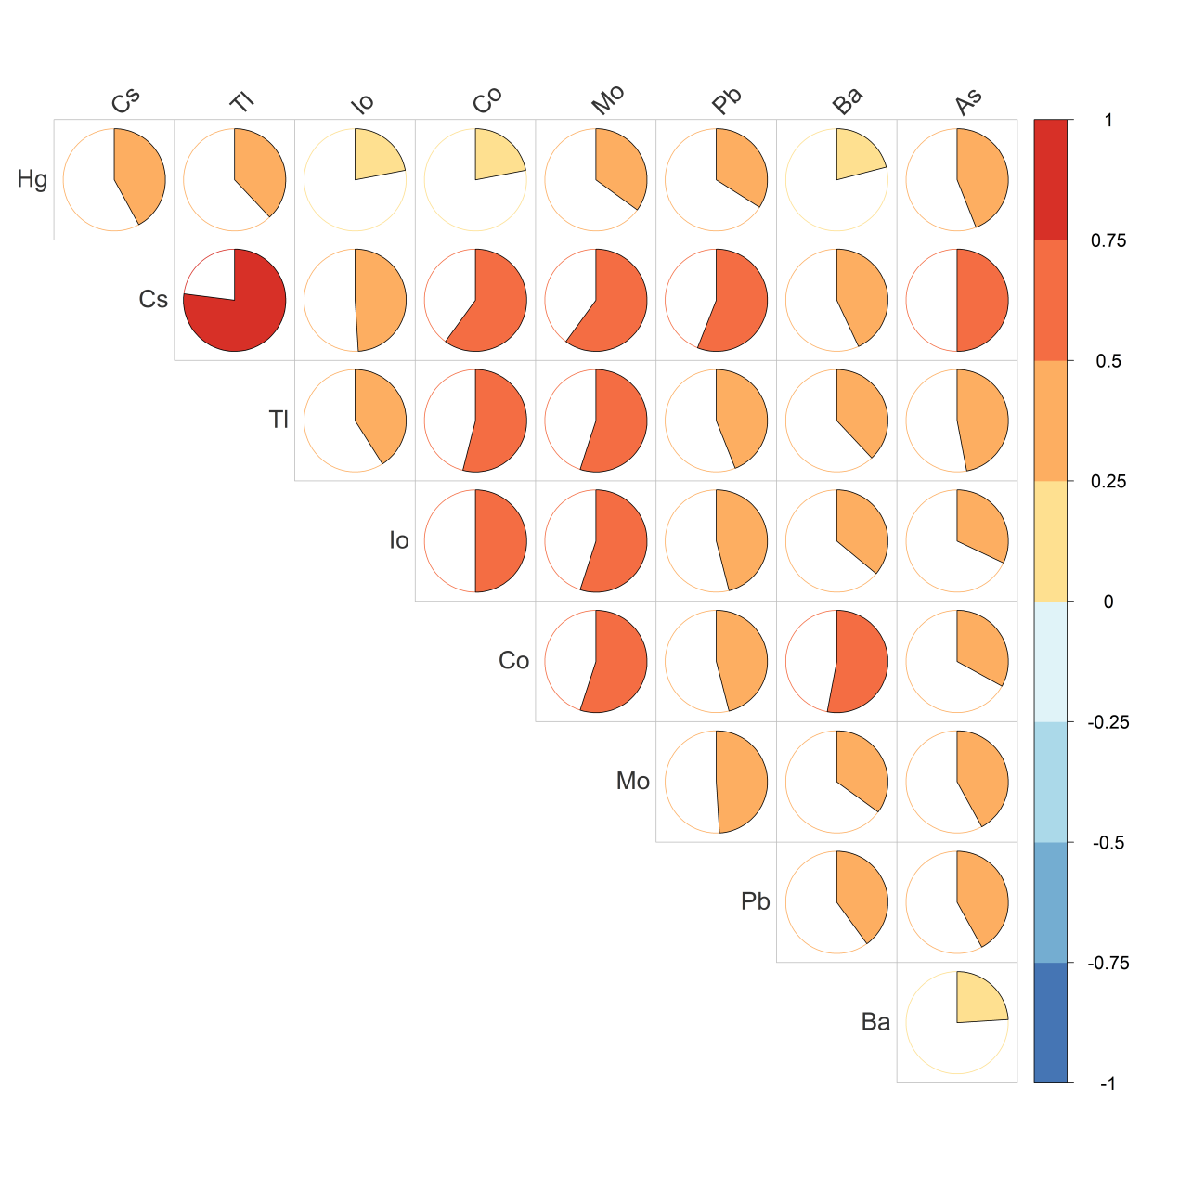
Figure S1. Spearman correlation of ln-transformed urinary metals in this study population.

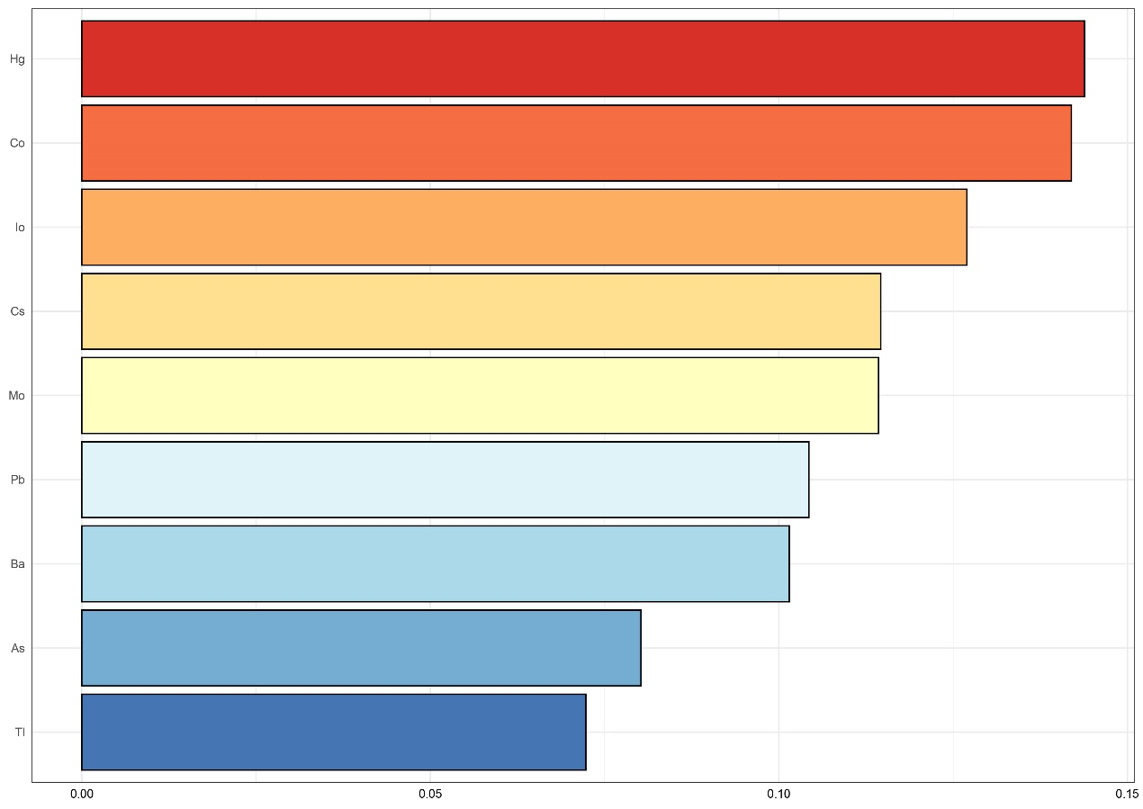
Figure S2. Weights of urinary metals associated with NMSC in WQS analyses, adjusting for age, sex, race/ethnicity, educational level, smoking, BMI, and urine creatinine. X-axis: The weights of each urinary metal in the positive WQS model regression index (total weight = 1). Y-axis: Nine urinary metals.

Table S1. Associations of single, combined metals with skin cancer with additional adjustment for family income-to-poverty ratio

Heavy metals | Continuous  OR (95% CI) | Quartiles of single, combined metals [OR (95% CI)] |  |  |  | P for trend
Heavy metals | Continuous  OR (95% CI) | Q1 | Q2 | Q3 | Q4 | P for trend
Hg | 1.34 (1.07, 1.69) | 1.00 (Ref.) | 1.40 (0.69, 2.83) | 1.70 (0.77, 3.75) | 2.72 (1.45, 5.12) | 0.003
Cs | 1.28 (0.90, 1.84) | 1.00 (Ref.) | 1.51 (0.71, 3.24) | 1.08 (0.52, 2.22) | 1.65 (0.72, 3.75) | 0.331
Tl | 1.20 (0.89, 1.61) | 1.00 (Ref.) | 1.06 (0.62, 1.83) | 1.62 (0.93, 2.82) | 1.34 (0.59, 3.03) | 0.246
Io | 1.32 (1.10, 1.59) | 1.00 (Ref.) | 1.73 (0.81, 3.69) | 2.19 (1.04, 4.64) | 2.79 (1.23, 6.31) | 0.016
Co | 1.29 (1.03, 1.62) | 1.00 (Ref.) | 1.97 (1.08, 3.58) | 2.17 (1.10, 4.25) | 2.33 (1.24, 4.39) | 0.012
Mo | 1.17 (0.93, 1.47) | 1.00 (Ref.) | 1.52 (0.85, 2.72) | 1.95 (1.08, 3.52) | 0.96 (0.45, 2.05) | 0.634
Pb | 1.26 (0.97, 1.63) | 1.00 (Ref.) | 1.85 (1.03, 3.33) | 2.01 (1.05, 3.85) | 1.78 (0.93, 3.41) | 0.106
Ba | 1.10 (0.87, 1.39) | 1.00 (Ref.) | 1.31 (0.67, 2.58) | 1.96 (0.91, 4.20) | 1.72 (0.88, 3.39) | 0.090
As | 1.20 (0.93, 1.56) | 1.00 (Ref.) | 1.74 (0.98, 3.11) | 1.90 (1.01, 3.56) | 1.62 (0.74, 3.53) | 0.190
Combined metals | 2.16 (1.42, 3.29) | 1.00 (Ref.) | 2.56 (1.25, 5.26) | 4.41 (2.04, 9.53) | 4.46 (1.74, 11.47) | 0.001
Note: Model was adjusted for age, sex, race/ethnicity, educational level, smoking, BMI, urine creatinine, and family income-to-poverty ratio. The number of missing data for family income-to-poverty ratio was 910

Table S2. Associations of single, combined metals with skin cancer with additional adjustment for marriage status

Heavy metals | Continuous  OR (95% CI) | Quartiles of single, combined metals [OR (95% CI)] |  |  |  | P for trend
Heavy metals | Continuous  OR (95% CI) | Q1 | Q2 | Q3 | Q4 | P for trend
Hg | 1.31 (1.05, 1.63) | 1.00 (Ref.) | 1.40 (0.71, 2.76) | 1.62 (0.75, 3.50) | 2.49 (1.39, 4.48) | 0.004
Cs | 1.25 (0.89, 1.74) | 1.00 (Ref.) | 1.44 (0.69, 2.99) | 1.05 (0.53, 2.10) | 1.56 (0.71, 3.40) | 0.366
Tl | 1.17 (0.88, 1.55) | 1.00 (Ref.) | 1.14 (0.68, 1.93) | 1.53 (0.87, 2.68) | 1.30 (0.59, 2.86) | 0.299
Io | 1.29 (1.09, 1.54) | 1.00 (Ref.) | 1.54 (0.74, 3.21) | 2.02 (0.98, 4.20) | 2.56 (1.16, 5.63) | 0.021
Co | 1.34 (1.07, 1.68) | 1.00 (Ref.) | 1.90 (1.05, 3.42) | 2.03 (1.05, 3.94) | 2.31 (1.26, 4.22) | 0.011
Mo | 1.12 (0.89, 1.41) | 1.00 (Ref.) | 1.38 (0.78, 2.43) | 1.67 (0.94, 2.97) | 0.86 (0.41, 1.80) | 0.930
Pb | 1.18 (0.93, 1.51) | 1.00 (Ref.) | 1.67 (0.95, 2.96) | 1.89 (0.99, 3.60) | 1.58 (0.85, 2.93) | 0.164
Ba | 1.11 (0.89, 1.39) | 1.00 (Ref.) | 1.33 (0.69, 2.57) | 1.95 (0.93, 4.09) | 1.73 (0.90, 3.31) | 0.083
As | 1.21 (0.94, 1.55) | 1.00 (Ref.) | 1.70 (0.95, 3.02) | 1.92 (1.04, 3.54) | 1.67 (0.78, 3.58) | 0.154
Combined metals | 2.03 (1.34, 3.08) | 1.00 (Ref.) | 2.43 (1.24, 4.77) | 4.15 (1.97, 8.72) | 3.88 (1.59, 9.48) | 0.001
Note: Model was adjusted for age, sex, race/ethnicity, educational level, smoking, BMI, urine creatinine, and marriage status. The number of missing data for marriage status was 4, and this covariate was divided into three factors, including married/ cohabiting, widowed/divorced/separated, or never married.

