Supplementary Information for
The dynamic chirality flips of Skyrmion bubbles characterized by electron tomography

Yuan Yao^{1,4*}, Bei Ding^{1,4}, Jinjing Liang^{1,3}, Hang Li¹, Xi Shen¹, Richeng Yu¹, Wenhong Wang^{1,2,3*}
¹Beijing National Laboratory for Condensed Matter Physics, Institute of Physics, Chinese Academy of Sciences, Beijing 100190, China
² Songshan Lake Materials Laboratory, Dongguan, Guangdong 523808, China
³University of Chinese Academy of Sciences, Beijing 100049, China
⁴These authors contributed equally: Yuan Yao and Bei Ding

Corresponding Author
*E-mail: yaoyuan@iphy.ac.cn
wenhong.wang@iphy.ac.cn

Supplementary Note 1. Raw images of tilting series
The raw images of x-tilt and y-tilt series have been acquired in JEOL 2100F and the defocus value was 300 μm for the over-focus and under-focus images. The exposure time was fixed to 1 s for all images to ensure the uniform beam intensity.
Supplementary Figure 1 Under focus, in focus and over focus images of x-tilt 0.4
Supplementary Figure 2 Under focus, in focus and over focus images of y-tilt 1.2

Supplementary Note 2. 3D magnetic structure of typical type-I and type-II bubbles
The micromagnetic simulations were carried out by using 3D object oriented micromagnetic framework (OOMMF) with the parameter used in previous report. ^{[1]} Magnetization matrix obtained from the OOMMF simulation was input into the home-made program to compute the exit wave of electron beam penetrating the simulated magnetic structures and the LTEM images were synthesized by the electron optical parameters, such as wavelength, defocus, energy dispersion envelope, etc.
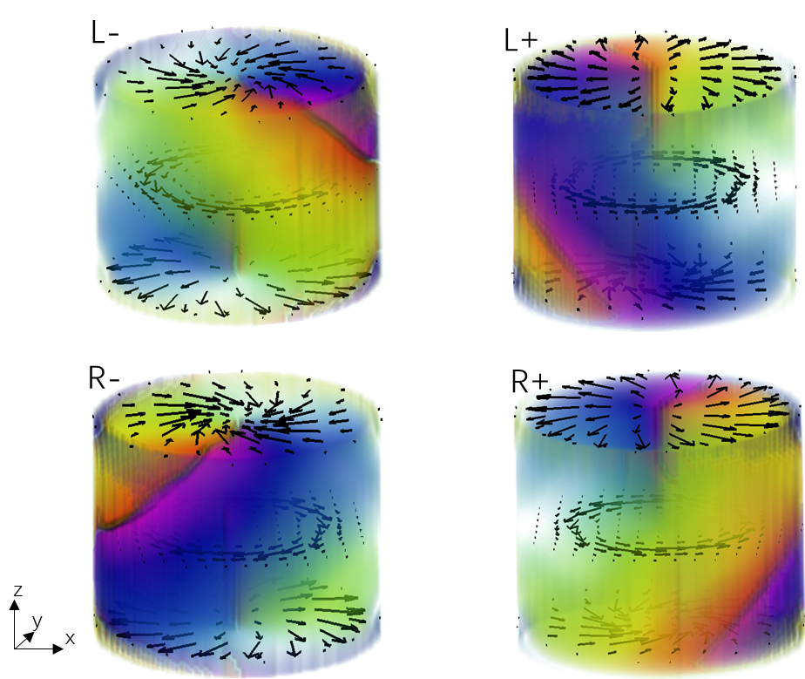
Supplementary Figure 3 The rendered 3D structure of in-plane components of various Type-I bubbles.
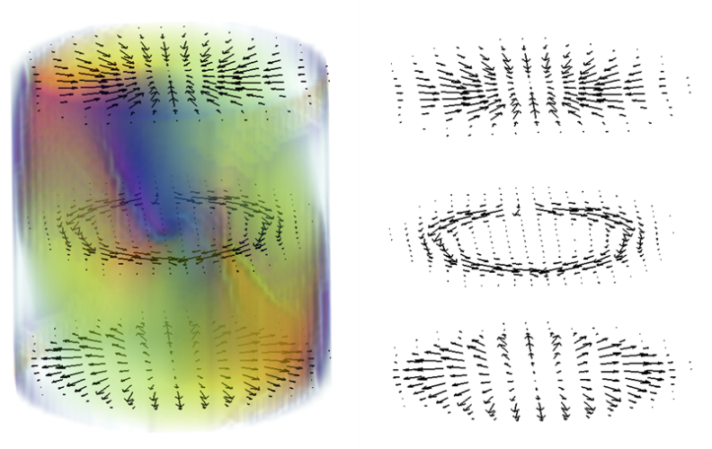
Supplementary Figure 4 The rendered 3D structure of in-plane components of Type II bubbles.

Supplementary Note 3. The type of bubbles recognized from the 3D B_{x} or B_{y} component
The spin configurations of bubbles marked in Fig.2 are shown in this section.
a 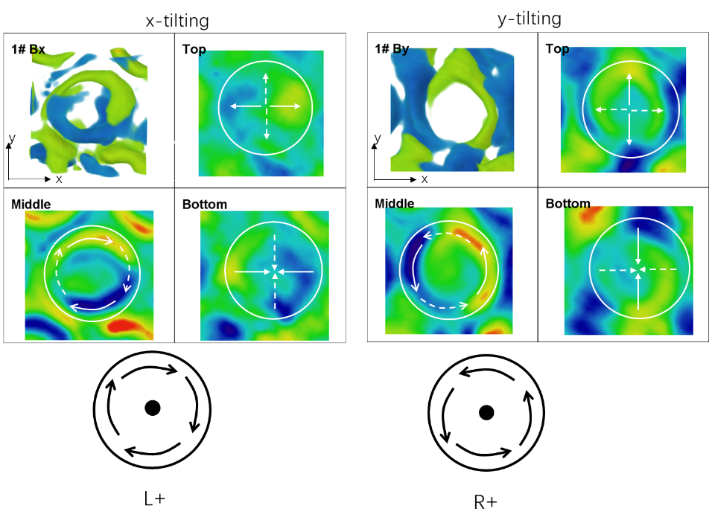
b 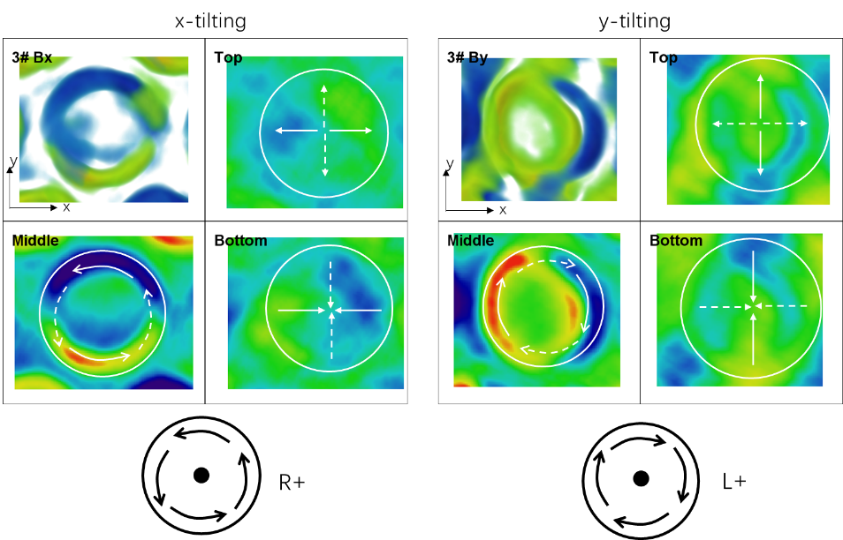
c 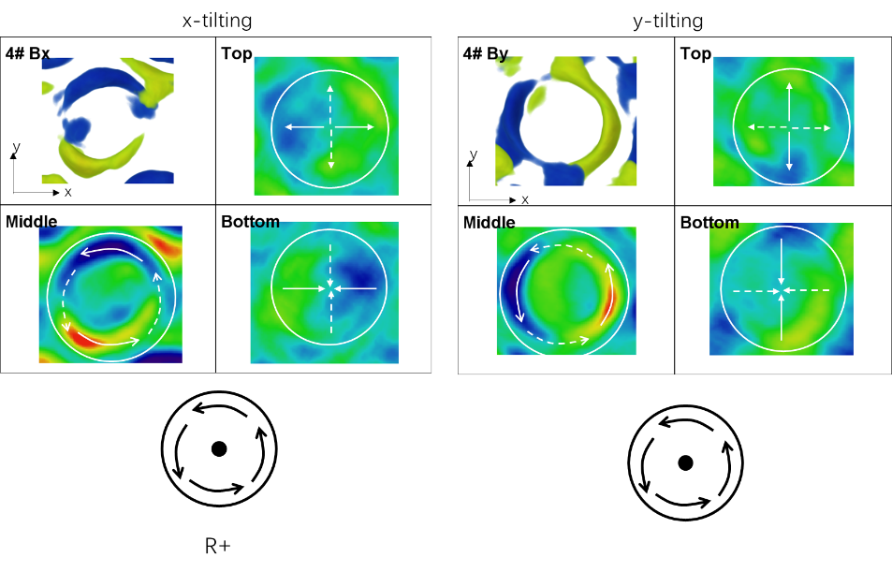
d 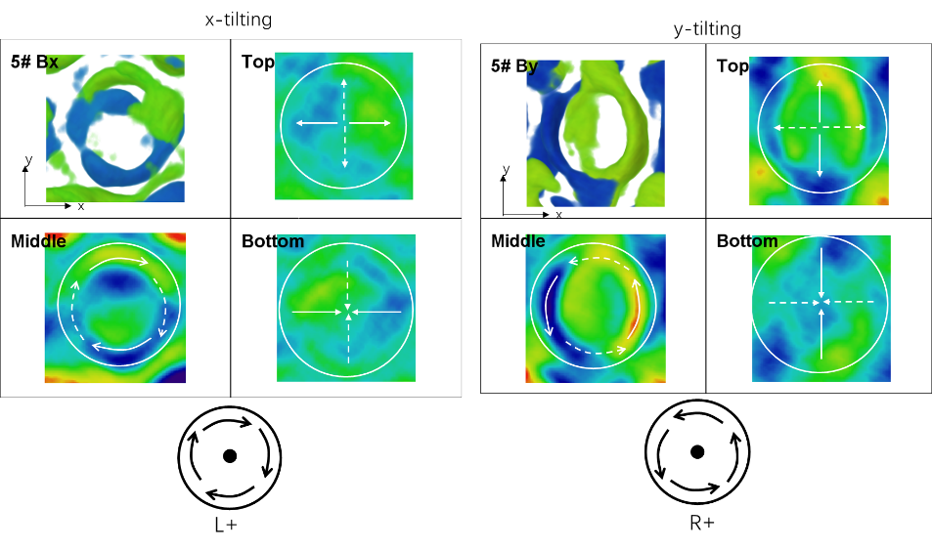
e 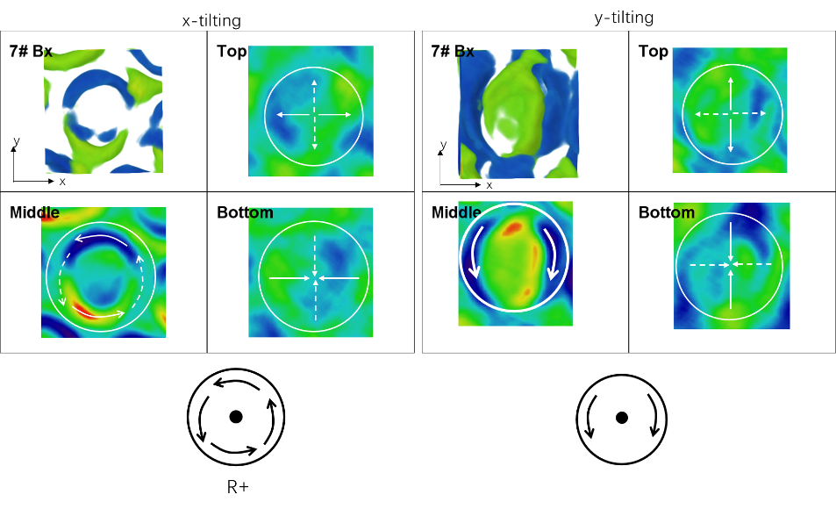
f 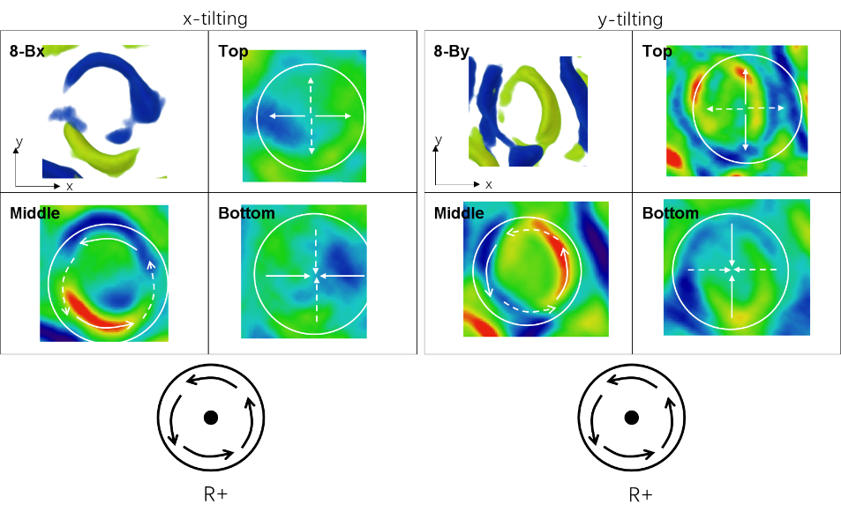
g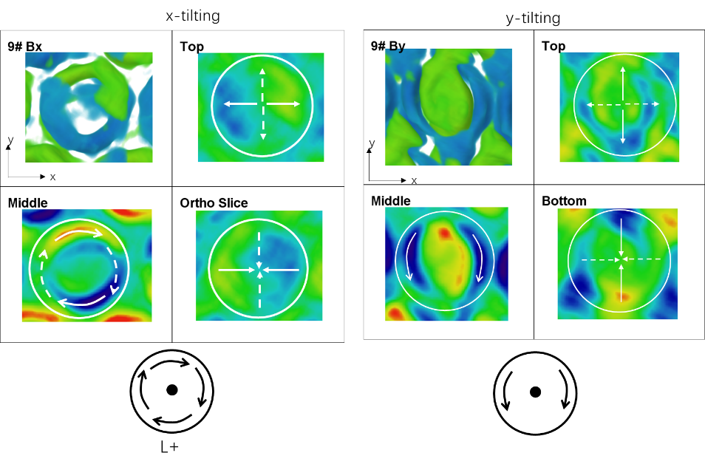
h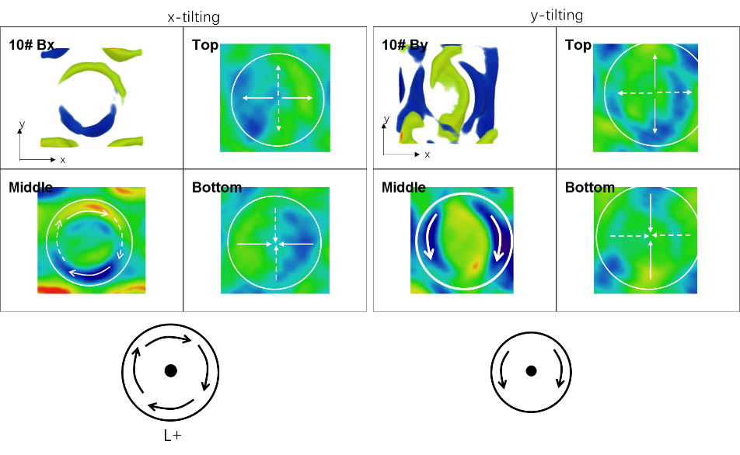
i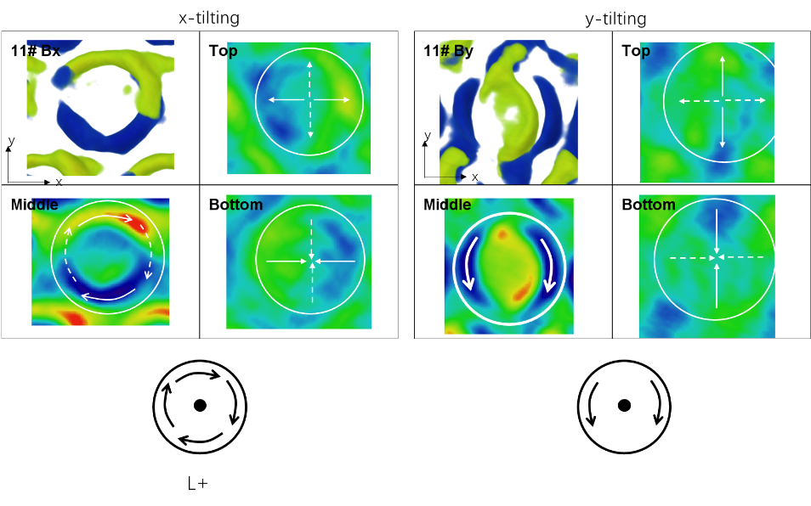
g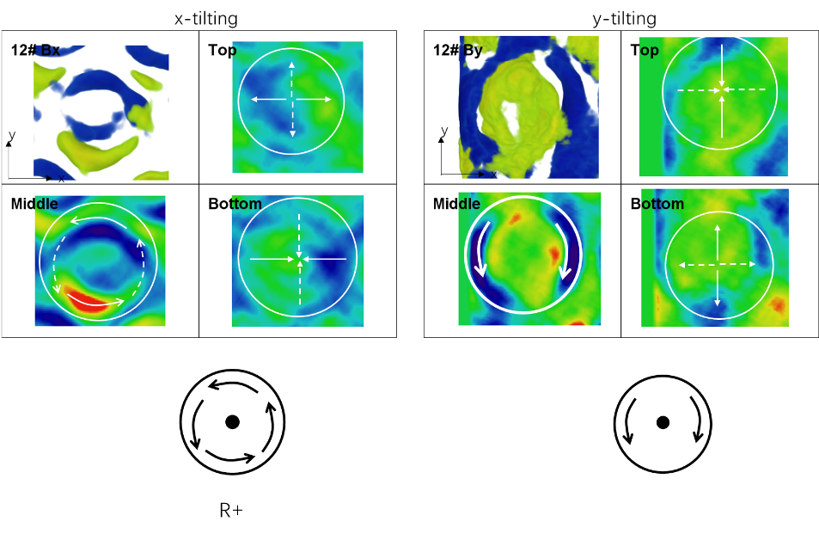
k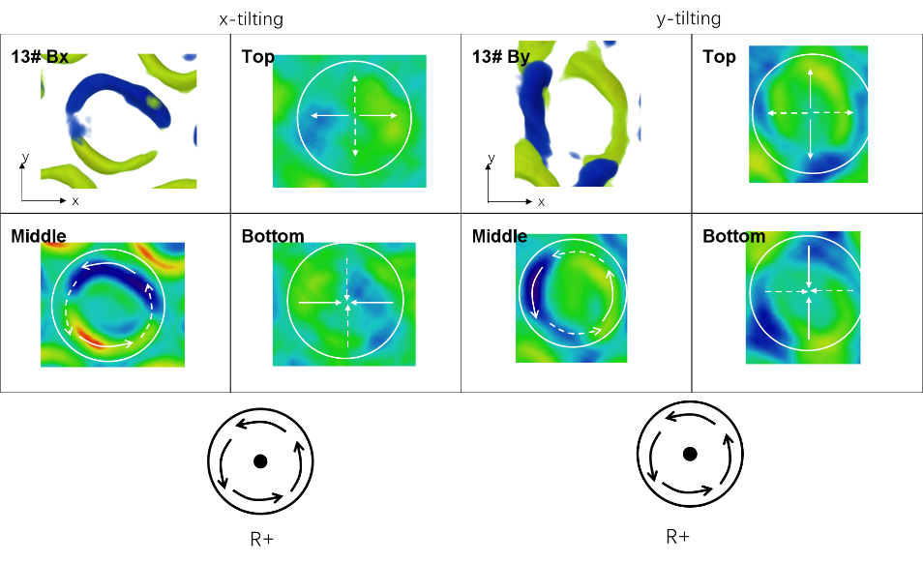
Supplementary Figure 5 The type of bubbles recognized from the 3D B_{x} or B_{y} component

Moview 1 Bx of the bubbles
Moview 2 By of the bubbles
Moview 3 Bx and By of 2# bubble
Moview 4 Orientation mapping of in-plane component of 2# bubble and R+ model
Moview 5 Bx and By of 4# bubble

Reference
1. Ding, B. et al. Manipulating Spin Chirality of Magnetic Skyrmion Bubbles by In-Plane Reversed Magnetic Fields in (Mn_{1−x}Ni_{x})₆₅Ga₃₅(x = 0.45) Magnet. Phys. Rev. Appl. 12, (2019)

