Supplementary
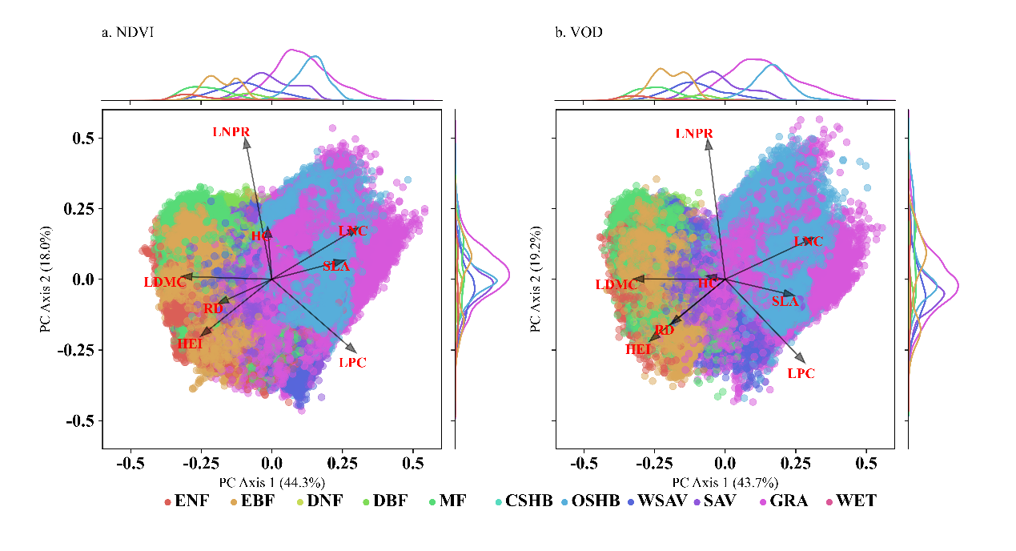
Fig S1 Distribution of global IGBP landcover types on principal component axes of functional traits. HEI: Canopy height, LNC: Leaf nitrogen content, LDMC: Leaf dry matter content, SLA: Specific leaf area, RD: Root depth, LPC: leaf phosphorus content, HC: Hydraulic conductivity, LNPR: Leaf N:P ratio. ENF: Evergreen Needleleaf Forests, EBF: Evergreen Broadleaf Forests, DNF: Deciduous Needleleaf Forests, DBF: Deciduous Broadleaf Forests, MF: Mixed Forests, CSHB: Closed Shrublands, OSHB: Open Shrublands, WSAV: Woody Savannas, SAV: Savannas, GRA: Grasslands, WET: Permanent Wetlands.

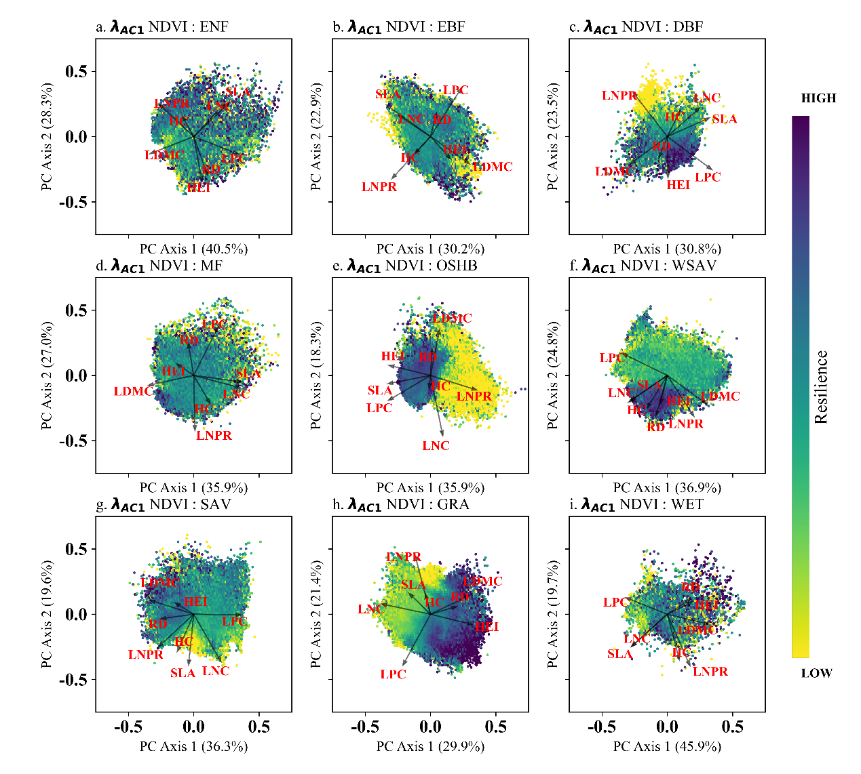
Fig S2 Distribution of vegetation resilience (𝜆_{𝐴𝐶1} NDVI) in principal component space of functional traits across IGBP landcover types. Arrows indicate the loadings of plant traits in PCA space. The percentage on each axis indicates the proportion of total variance explained by the respective principal component. HEI: Canopy height, LNC: Leaf nitrogen content, LDMC: Leaf dry matter content, SLA: Specific leaf area, RD: Root depth, LPC: leaf phosphorus content, HC: Hydraulic conductivity, LNPR: Leaf N:P ratio. ENF: Evergreen Needleleaf Forests, EBF: Evergreen Broadleaf Forests, DBF: Deciduous Broadleaf Forests, MF: Mixed Forests, OSHB: Open Shrublands, WSAV: Woody Savannas, SAV: Savannas, GRA: Grasslands, WET: Permanent Wetlands. The color bar indicates a gradient of vegetation resilience, increasing from yellow (low) to purple (high).

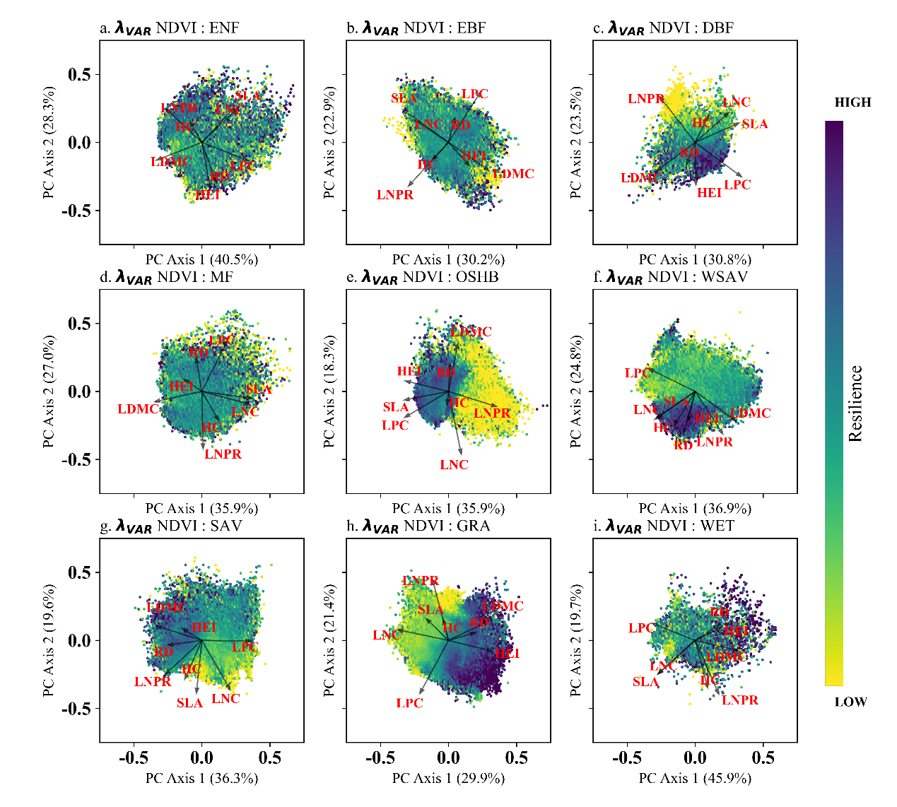
Fig S3 Distribution of vegetation resilience (𝜆_{𝑉𝑎𝑟} NDVI) in principal component space of functional traits across IGBP landcover types. Arrows indicate the loadings of plant traits in PCA space. The percentage on each axis indicates the proportion of total variance explained by the respective principal component. HEI: Canopy height, LNC: Leaf nitrogen content, LDMC: Leaf dry matter content, SLA: Specific leaf area, RD: Root depth, LPC: leaf phosphorus content, HC: Hydraulic conductivity, LNPR: Leaf N:P ratio. ENF: Evergreen Needleleaf Forests, EBF: Evergreen Broadleaf Forests, DBF: Deciduous Broadleaf Forests, MF: Mixed Forests, OSHB: Open Shrublands, WSAV: Woody Savannas, SAV: Savannas, GRA: Grasslands, WET: Permanent Wetlands. The color bar indicates a gradient of vegetation resilience, increasing from yellow (low) to purple (high).

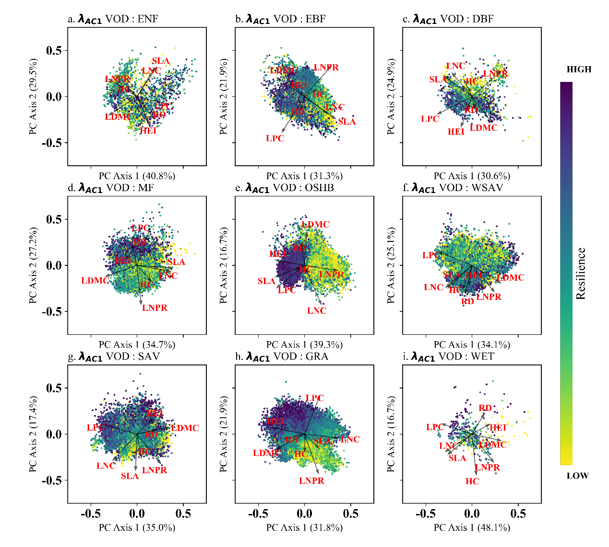
Fig S4 Distribution of vegetation resilience (𝜆_{𝐴𝐶1} VOD) in principal component space of functional traits across IGBP landcover types. Arrows indicate the loadings of plant traits in PCA space. The percentage on each axis indicates the proportion of total variance explained by the respective principal component. HEI: Canopy height, LNC: Leaf nitrogen content, LDMC: Leaf dry matter content, SLA: Specific leaf area, RD: Root depth, LPC: leaf phosphorus content, HC: Hydraulic conductivity, LNPR: Leaf N:P ratio. ENF: Evergreen Needleleaf Forests, EBF: Evergreen Broadleaf Forests, DBF: Deciduous Broadleaf Forests, MF: Mixed Forests, OSHB: Open Shrublands, WSAV: Woody Savannas, SAV: Savannas, GRA: Grasslands, WET: Permanent Wetlands. The color bar indicates a gradient of vegetation resilience, increasing from yellow (low) to purple (high).

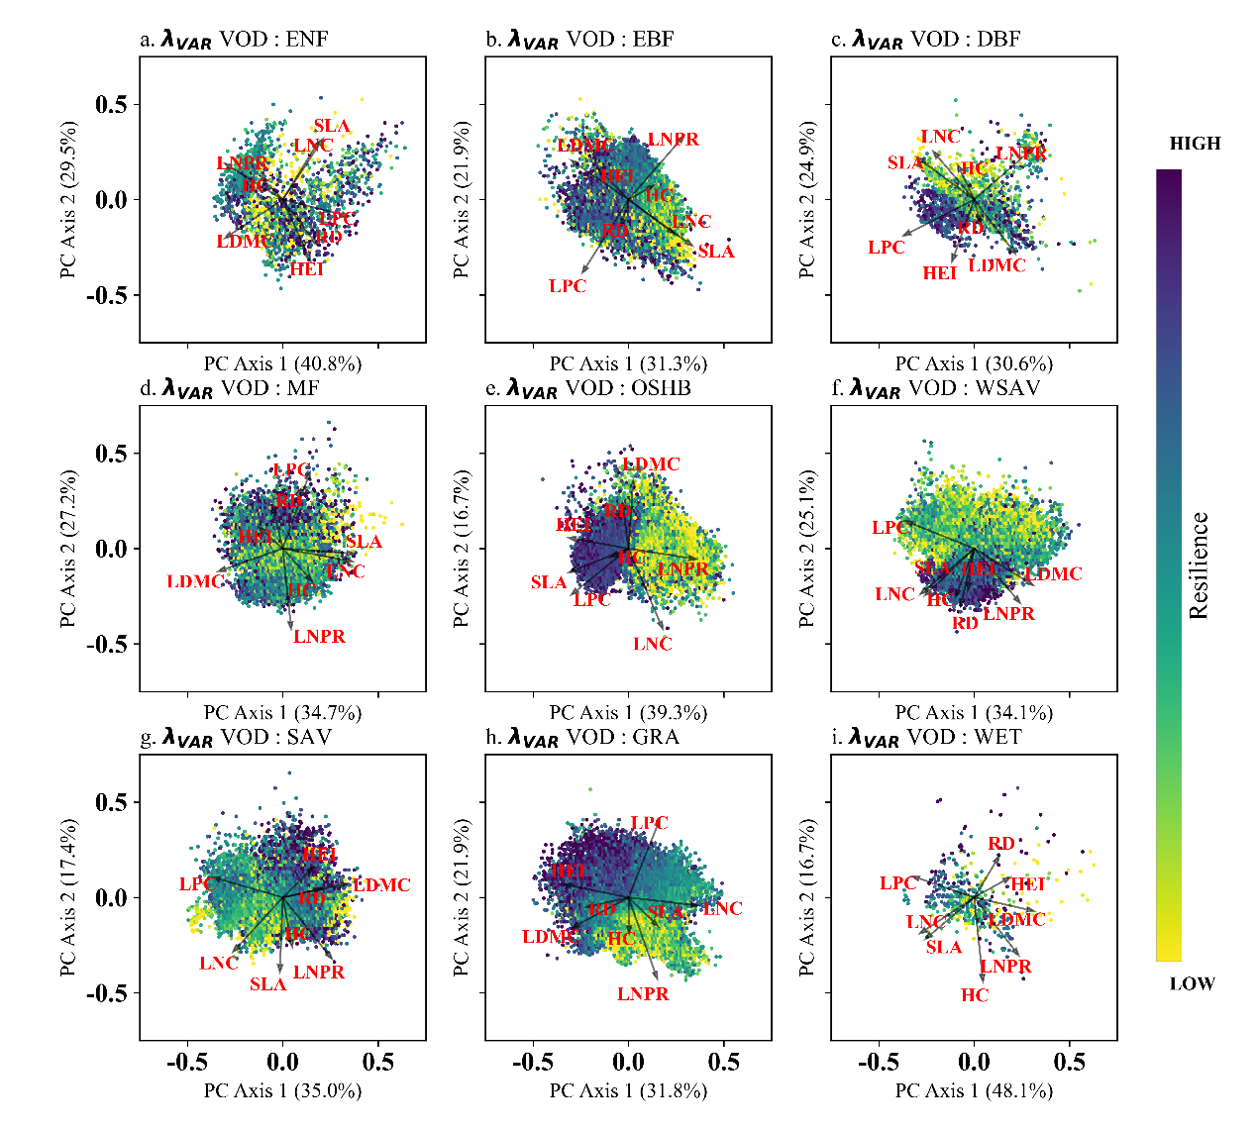
Fig S5 Distribution of vegetation resilience (𝜆_{𝑉𝑎𝑟} VOD) in principal component space of functional traits across IGBP landcover types. Arrows indicate the loadings of plant traits in PCA space. The percentage on each axis indicates the proportion of total variance explained by the respective principal component. HEI: Canopy height, LNC: Leaf nitrogen content, LDMC: Leaf dry matter content, SLA: Specific leaf area, RD: Root depth, LPC: leaf phosphorus content, HC: Hydraulic conductivity, LNPR: Leaf N:P ratio. ENF: Evergreen Needleleaf Forests, EBF: Evergreen Broadleaf Forests, DBF: Deciduous Broadleaf Forests, MF: Mixed Forests, OSHB: Open Shrublands, WSAV: Woody Savannas, SAV: Savannas, GRA: Grasslands, WET: Permanent Wetlands. The color bar indicates a gradient of vegetation resilience, increasing from yellow (low) to purple (high).

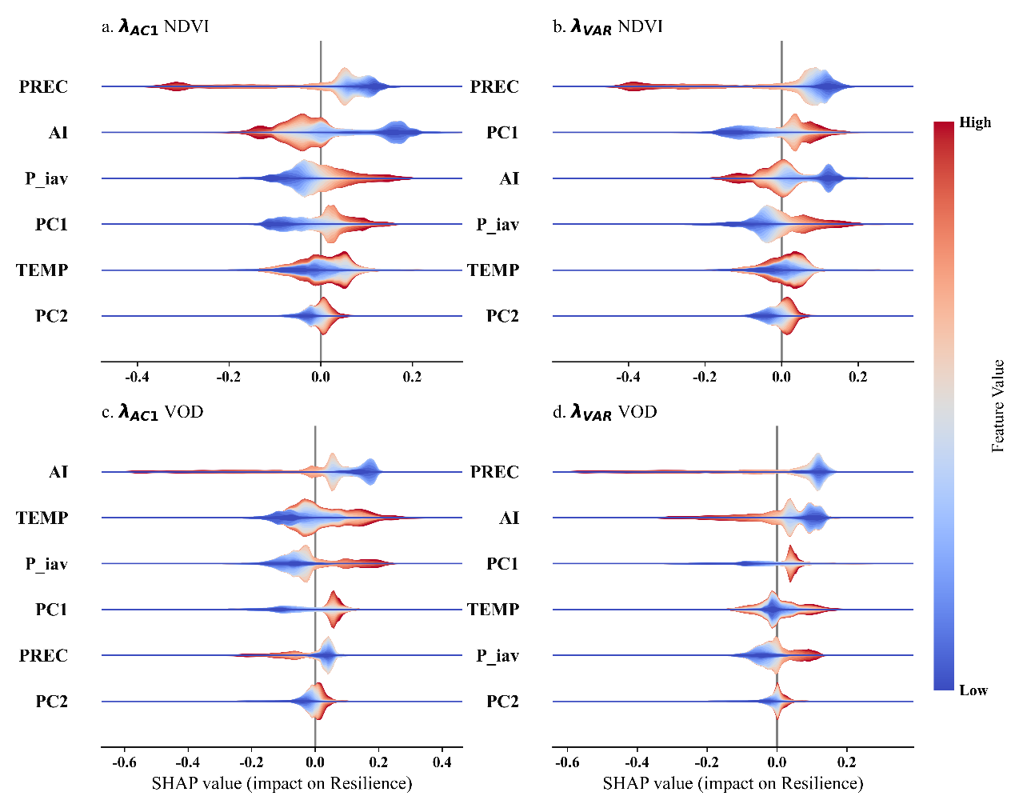
Fig S6 Relative importance and effects of functional traits and climatic drivers on vegetation resilience. SHAP (SHapley Additive exPlanations) values illustrate the relative importance and directional influence of functional traits and climatic factors on vegetation resilience, as measured by four indicators: (a) 𝜆_{𝐴𝐶1} NDVI, (b) 𝜆_{𝑉𝑎𝑟} NDVI, (c) 𝜆_{𝐴𝐶1} VOD, and (d) 𝜆_{𝑉𝑎𝑟} VOD. Higher SHAP values indicate lower vegetation resilience. Each violin plot represents the distribution of SHAP values for a given variable, where the color gradient indicates the feature value (blue = low, red = high). Results are based on machine learning models trained to explain vegetation resilience using functional traits and four climatic drivers: AI: Aridity index, PC1, PC2: The first two principal components of functional trait variation, PREC: Total precipitation, P_iav: Interannual precipitation variability, TEMP: Mean annual temperature. Drivers are ordered in descending order by their mean absolute SHAP values, reflecting their relative importance in the model. factors are ordered by their mean absolute SHAP values, reflecting their relative importance in the model.
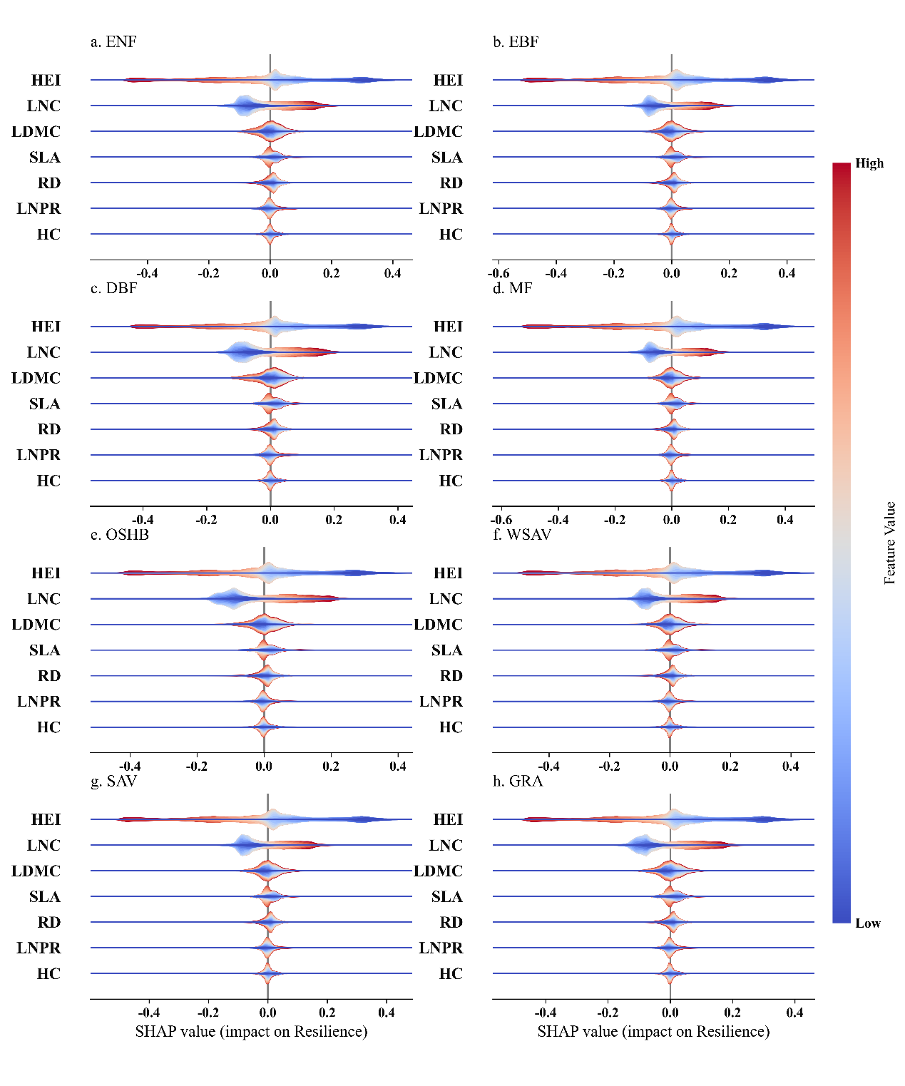
Fig S7 Relative importance and effects of plant functional traits on vegetation resilience (𝜆_{𝐴𝐶1} NDVI) across IGBP landcover types. SHAP (SHapley Additive exPlanations) values showing the relative importance and directional influence of plant functional traits on vegetation resilience. Higher SHAP value indicate lower vegetation resilience. Each violin plot represents the distribution of SHAP values for a given trait, where color indicates the trait value (blue = low, red = high). Results are based on machine learning models trained to predict vegetation resilience from seven functional traits. HEI: Canopy height, LNC: Leaf nitrogen content, LDMC: Leaf dry matter content, SLA: Specific leaf area, RD: Root depth, HC: Hydraulic conductivity, LNPR: Leaf N:P ratio. Traits are ordered by their mean absolute SHAP values, reflecting their relative importance in the model. ENF: Evergreen Needleleaf Forests, EBF: Evergreen Broadleaf Forests, DNF: Deciduous Needleleaf Forests, DBF: Deciduous Broadleaf Forests, MF: Mixed Forests, CSHB: Closed Shrublands, OSHB: Open Shrublands, WSAV: Woody Savannas.

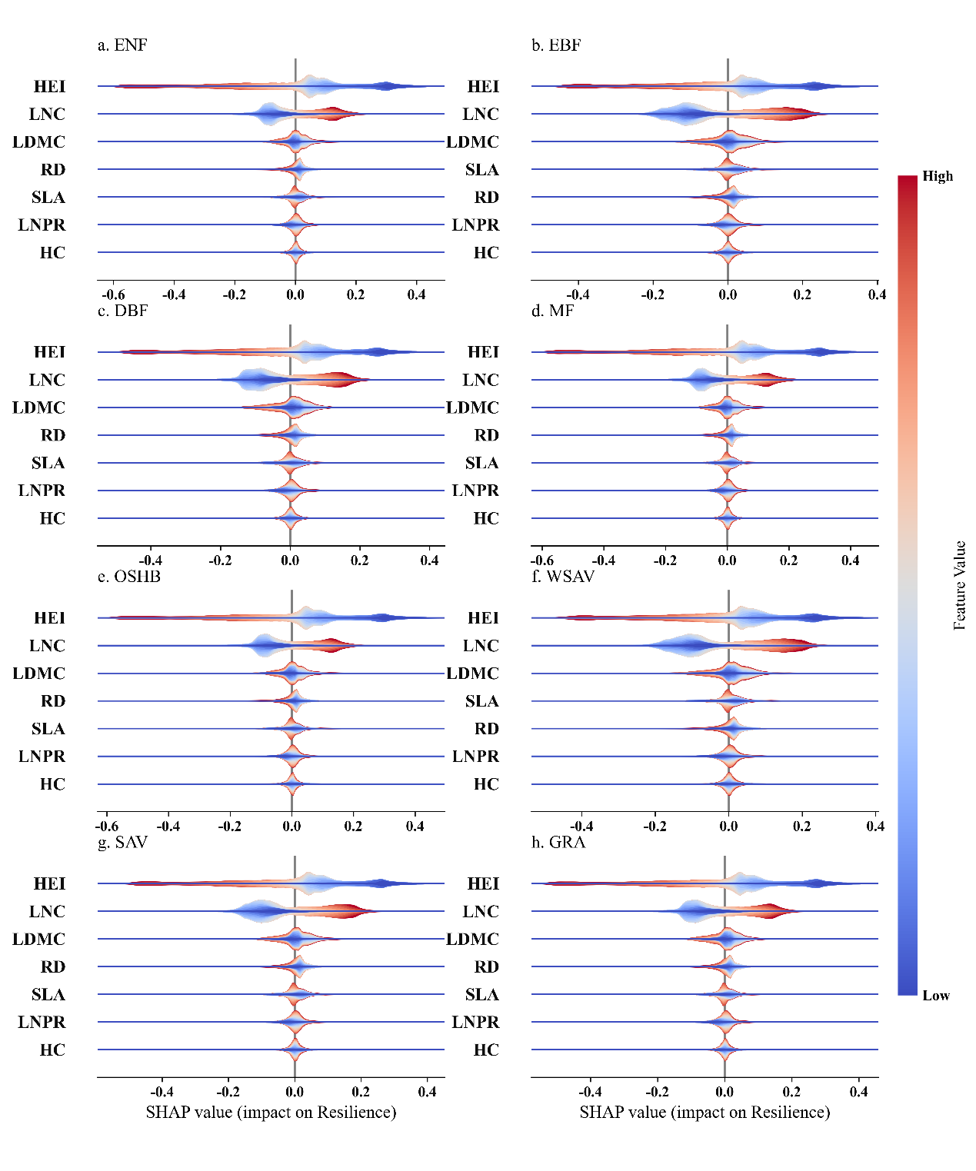
Fig S8 Relative importance and effects of plant functional traits on vegetation resilience (𝜆_{𝑉𝑎𝑟} NDVI) across IGBP landcover types. SHAP (SHapley Additive exPlanations) values showing the relative importance and directional influence of plant functional traits on vegetation resilience. Higher SHAP value indicate lower vegetation resilience. Each violin plot represents the distribution of SHAP values for a given trait, where color indicates the trait value (blue = low, red = high). Results are based on machine learning models trained to predict vegetation resilience from seven functional traits. HEI: Canopy height, LNC: Leaf nitrogen content, LDMC: Leaf dry matter content, SLA: Specific leaf area, RD: Root depth, HC: Hydraulic conductivity, LNPR: Leaf N:P ratio. Traits are ordered by their mean absolute SHAP values, reflecting their relative importance in the model. ENF: Evergreen Needleleaf Forests, EBF: Evergreen Broadleaf Forests, DNF: Deciduous Needleleaf Forests, DBF: Deciduous Broadleaf Forests, MF: Mixed Forests, CSHB: Closed Shrublands, OSHB: Open Shrublands, WSAV: Woody Savannas.
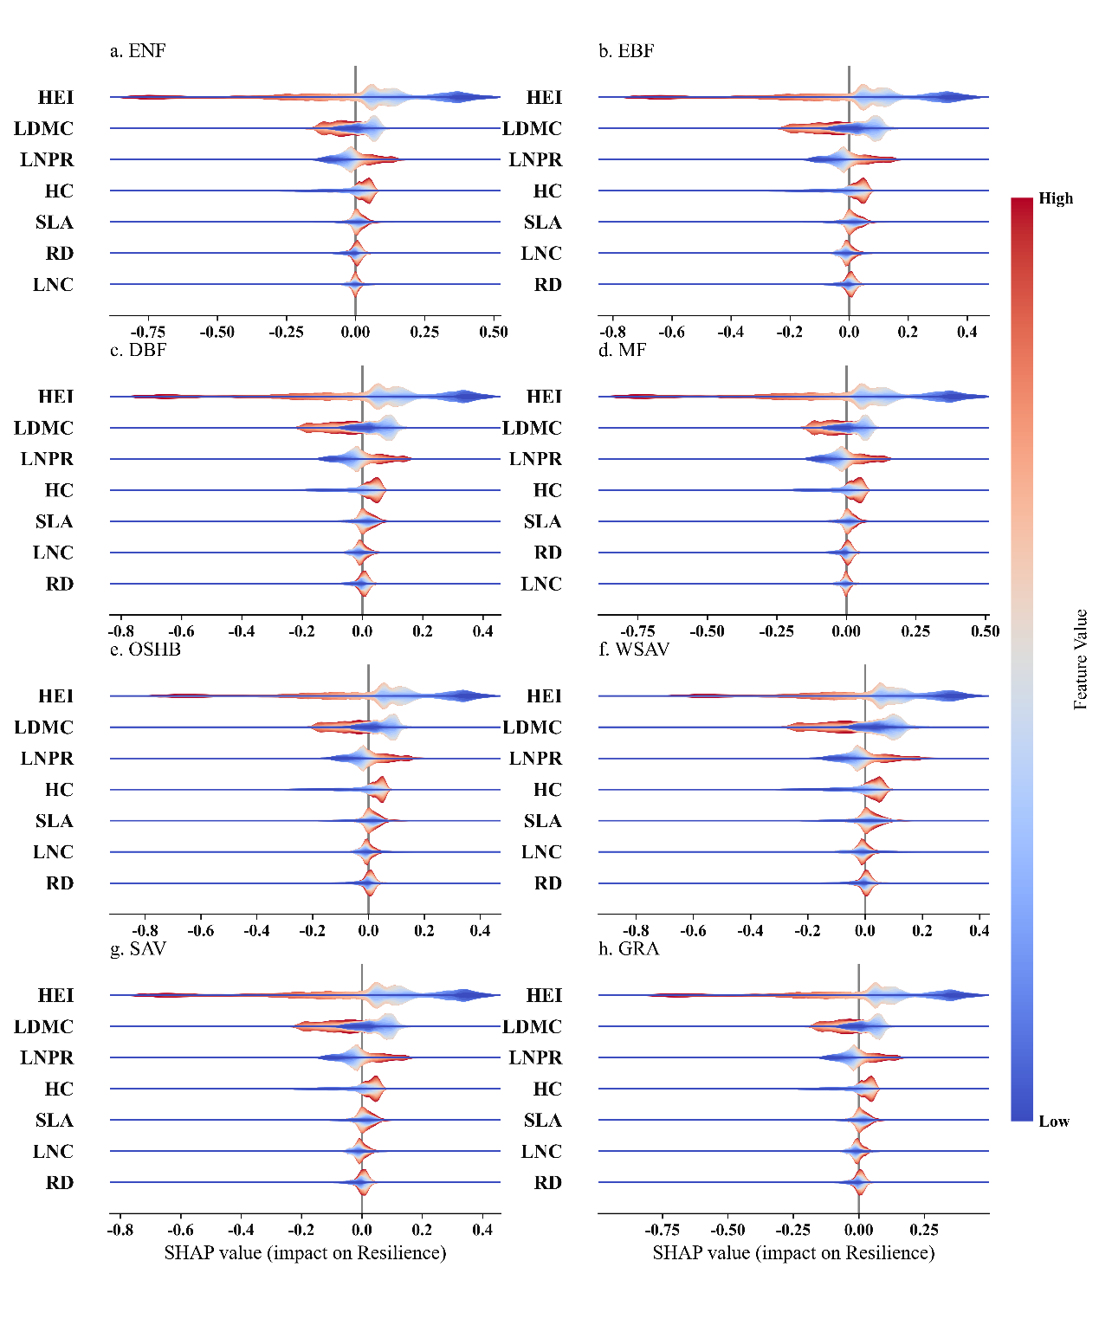
Fig S9 Relative importance and effects of plant functional traits on vegetation resilience (𝜆_{𝐴𝐶1} VOD) across IGBP landcover types. SHAP (SHapley Additive exPlanations) values showing the relative importance and directional influence of plant functional traits on vegetation resilience. Higher SHAP value indicate lower vegetation resilience. Each violin plot represents the distribution of SHAP values for a given trait, where color indicates the trait value (blue = low, red = high). Results are based on machine learning models trained to predict vegetation resilience from seven functional traits. HEI: Canopy height, LNC: Leaf nitrogen content, LDMC: Leaf dry matter content, SLA: Specific leaf area, RD: Root depth, HC: Hydraulic conductivity, LNPR: leaf N:P ratio. Traits are ordered by their mean absolute SHAP values, reflecting their relative importance in the model. ENF: Evergreen Needleleaf Forests, EBF: Evergreen Broadleaf Forests, DNF: Deciduous Needleleaf Forests, DBF: Deciduous Broadleaf Forests, MF: Mixed Forests, CSHB: Closed Shrublands, OSHB: Open Shrublands, WSAV: Woody Savannas.

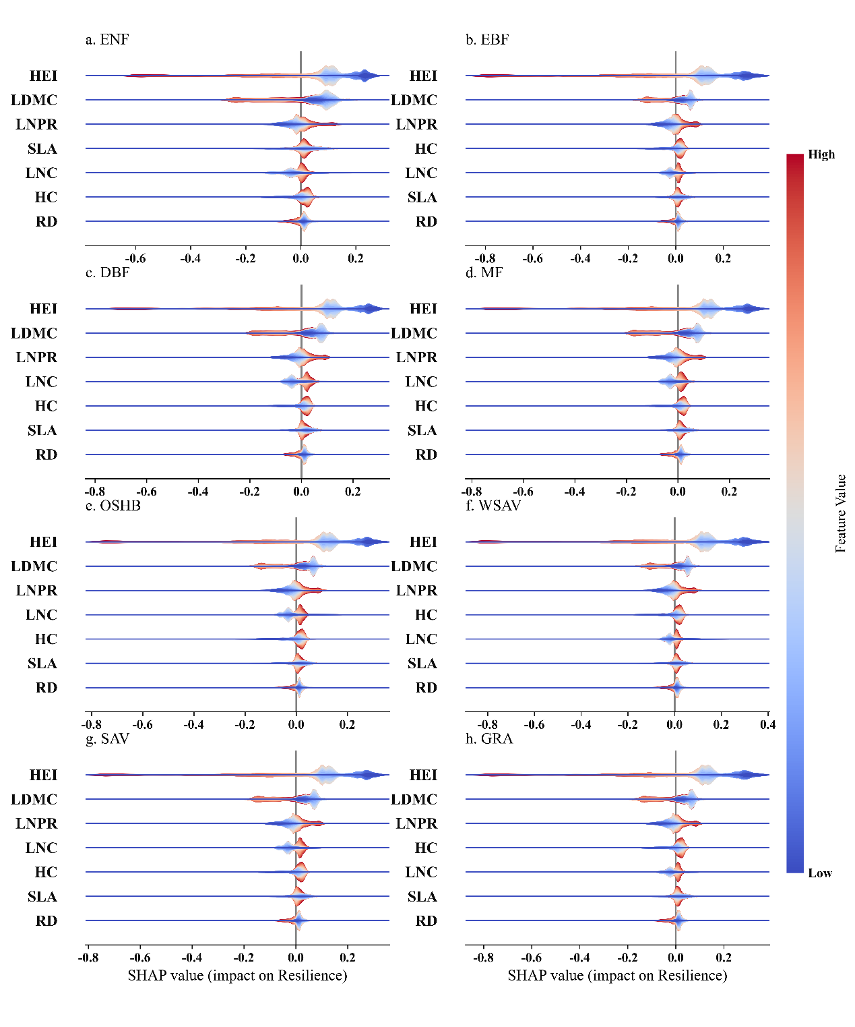
Fig S10 Relative importance and effects of plant functional traits on vegetation resilience (𝜆_{𝑉𝑎𝑟} VOD) across IGBP landcover types. SHAP (SHapley Additive exPlanations) values showing the relative importance and directional influence of plant functional traits on vegetation resilience. Higher SHAP value indicate lower vegetation resilience. Each violin plot represents the distribution of SHAP values for a given trait, where color indicates the trait value (blue = low, red = high). Results are based on machine learning models trained to predict vegetation resilience from seven functional traits. HEI: Canopy height, LNC: Leaf nitrogen content, LDMC: Leaf dry matter content, SLA: Specific leaf area, RD: Root depth, HC: Hydraulic conductivity, LNPR: Leaf N:P ratio. Traits are ordered by their mean absolute SHAP values, reflecting their relative importance in the model. ENF: Evergreen Needleleaf Forests, EBF: Evergreen Broadleaf Forests, DNF: Deciduous Needleleaf Forests, DBF: Deciduous Broadleaf Forests, MF: Mixed Forests, CSHB: Closed Shrublands, OSHB: Open Shrublands, WSAV: Woody Savannas.

