Supplementary Materials

Room-temperature sol–gel synthesis of metal–organic framework glasses with programmable microporosity

Shuke Zhao, Jie Yang, Fan Zhou, Wengang Huang, Meilin Yin, Marija Švegovec, Haijiao Lu, Xianwei Li, Tao Yan, Fengxia Wei, Chao Ji, Cong Wang, Zhonghua Zhu, Tian Tian, Andraž Krajnc, Yinghong Zhou, Zhihua Qiao, Vicki Chen, Anthony K. Cheetham, Rijia Lin and Jingwei Hou

*Corresponding author. Email: yinghong.zhou@uq.edu.au; qiaozhihua@tiangong.edu.cn; r.lin1@uq.edu.au; jingwei.hou@uq.edu.au

The PDF file includes:

Supplementary Text
Supplementary Fig. 1 to 70
Supplementary Table 1 to 8
Supplementary References

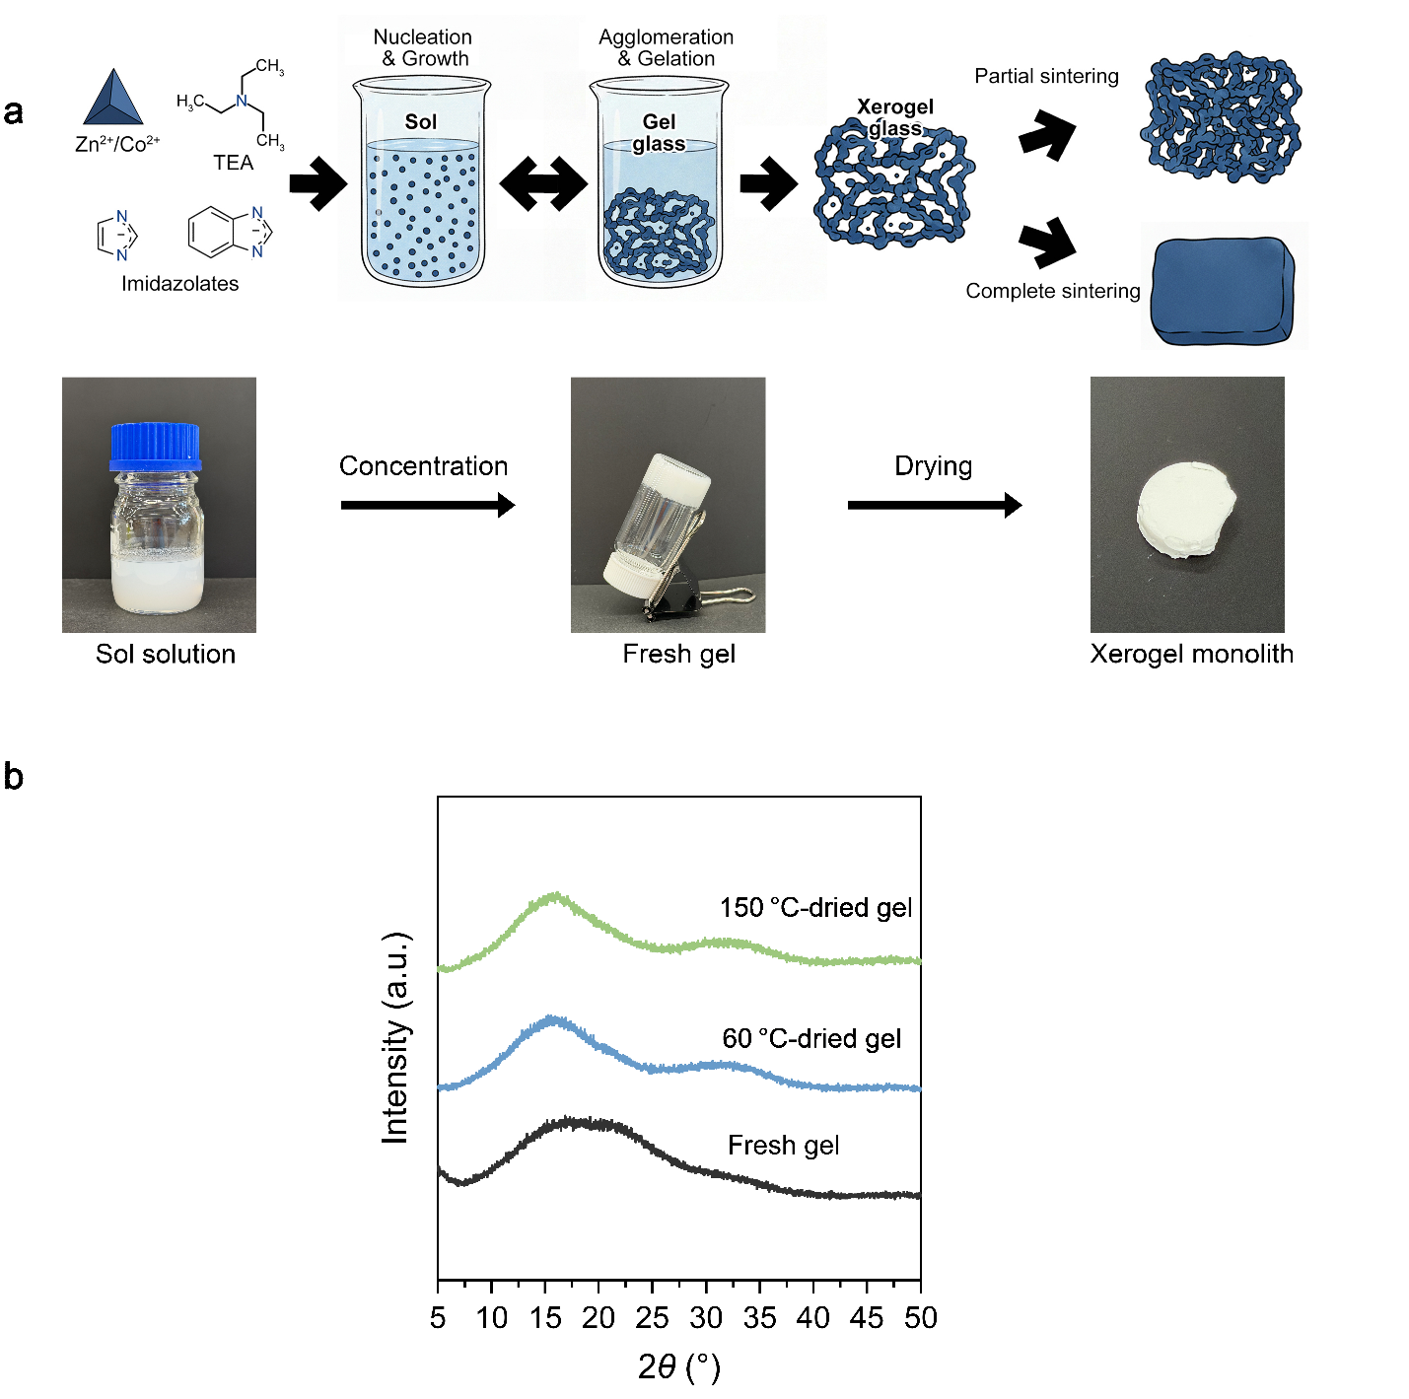

Supplementary Fig. 1 | Synthesis of the sol–gel ZIF glass. a, Schematic representation and optical images of the ZIF sol–gel glass formation process. b, Powder X-ray diffraction (PXRD) patterns of the fresh gel, xerogel monoliths after drying at 60 °C for 24 h and subsequent vacuum drying at 150 °C for 24 h.
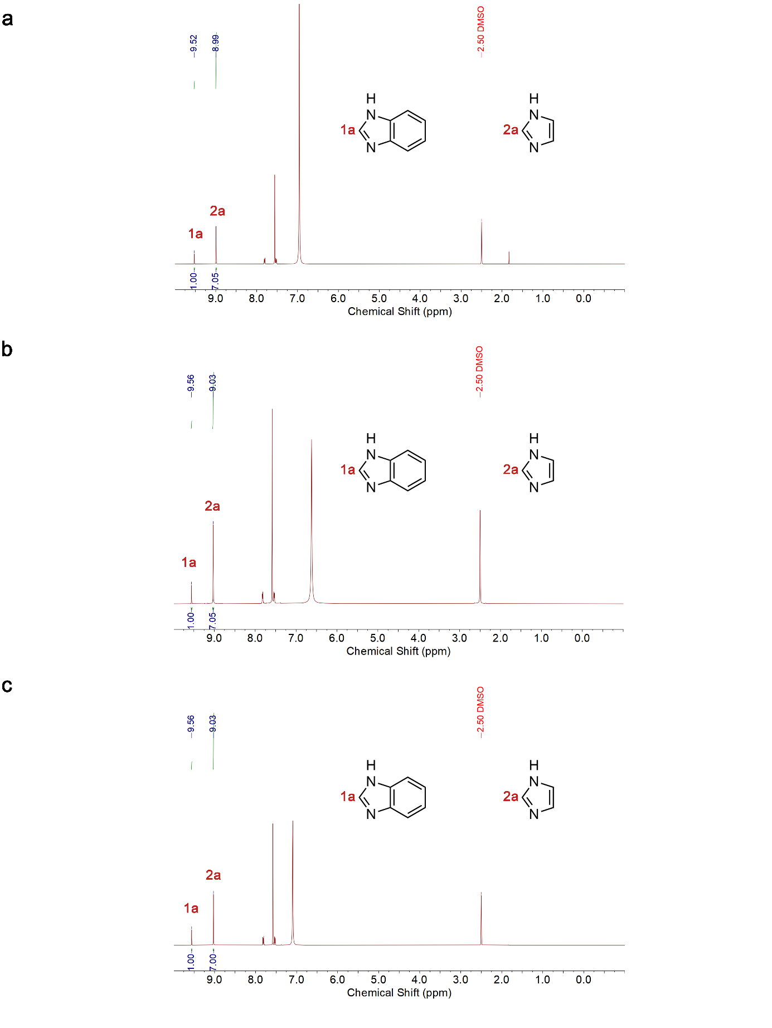

Supplementary Fig. 2 | ¹H NMR spectrum of the xerogels before and after thermal treatment. a, ¹H NMR spectrum of xerogel. b, ¹H NMR spectrum of xerogel after annealing at 350 °C. c, ¹H NMR spectrum of xerogel after annealing at 450 °C. Samples were digested in the mixture of DMSO-d₆ (0.50 mL) and DCl/D₂O (35 wt%, 0.05 mL) prior to measurements. No DMF resonance is detected for all of these samples.
Supplementary Fig. 3 | SEM images of amorphous ZIF-62 gel with different magnifications. For electron microscopy characterisation, freshly prepared gels were washed with methanol via solvent exchange to remove residual solvent and impurities. The resulting suspension was then diluted and drop-cast onto a silicon wafer, and vacuum-dried at 70 °C for imaging analysis.

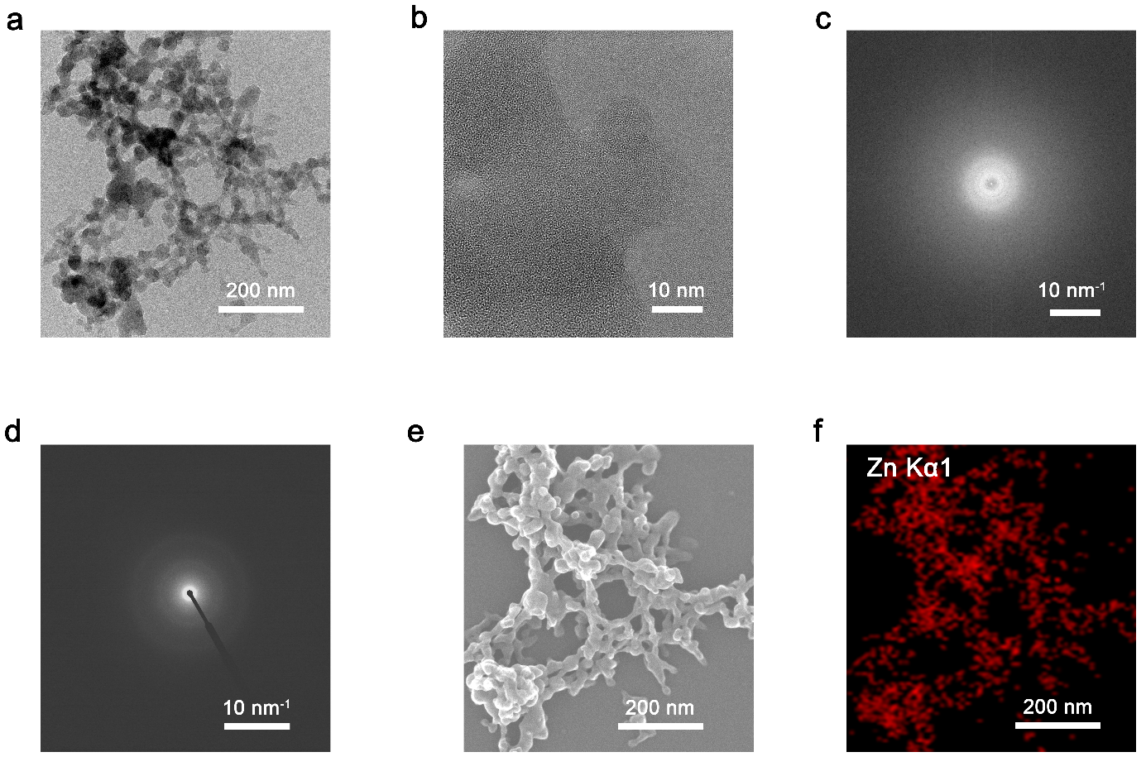

Supplementary Fig. 4 | High-resolution TEM images of amorphous ZIF-62 gel. a, Representative HRTEM image and b, corresponding magnified region. c, Fast Fourier transform (FFT) of the HRTEM image. d, Selected-area electron diffraction (SAED) pattern confirming the amorphous nature. e, STEM mode image and f, corresponding EDS elemental maps acquired from the same region. Gels were transferred from DMF to methanol via direct solvent exchange, followed by dilution, drop-casting onto carbon-coated copper grids, and drying at 70 °C prior to TEM analysis.

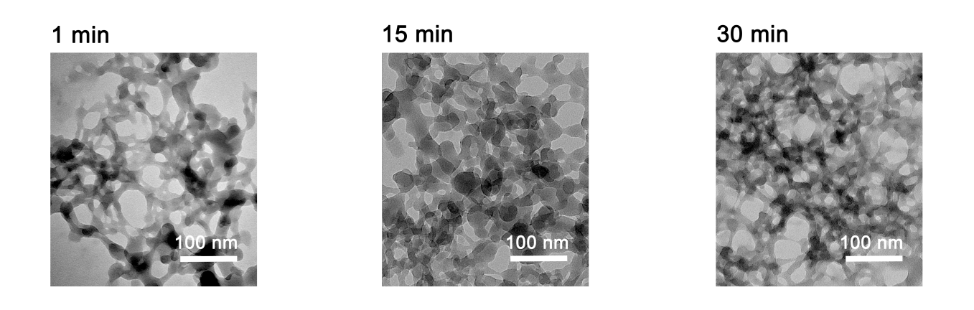

Supplementary Fig. 5 | Time series of ex situ TEM images displaying the formation of amorphous ZIF-62 gel. Samples were collected 1, 15 and 30 min after the addition of TEA. Each sample was immediately solvent exchanged with methanol to quench the reaction, followed by deposition onto copper grids and drying at 70 °C prior to TEM analysis.

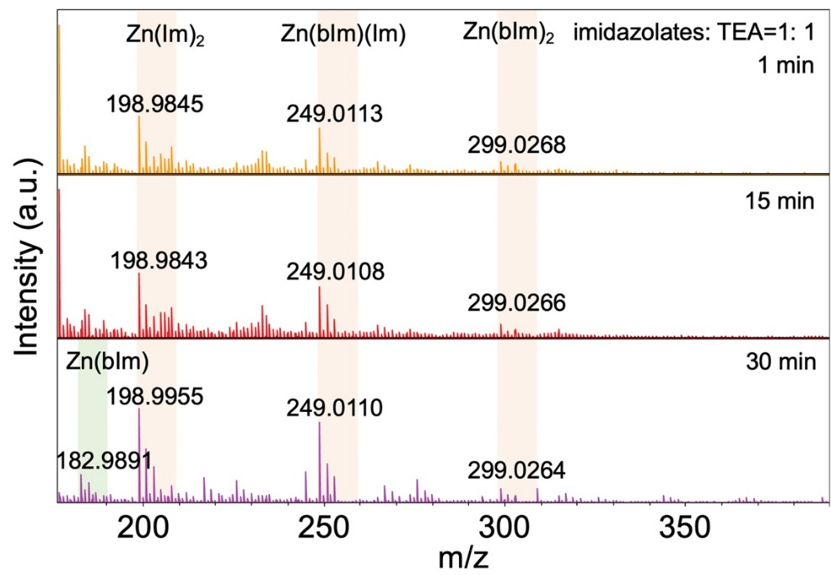
Supplementary Fig. 6 | MALDI-TOF MS spectra of the sol-gel reaction suspension collected at different reaction times, showing the evolution of Zn–imidazolate cluster species during sol formation.

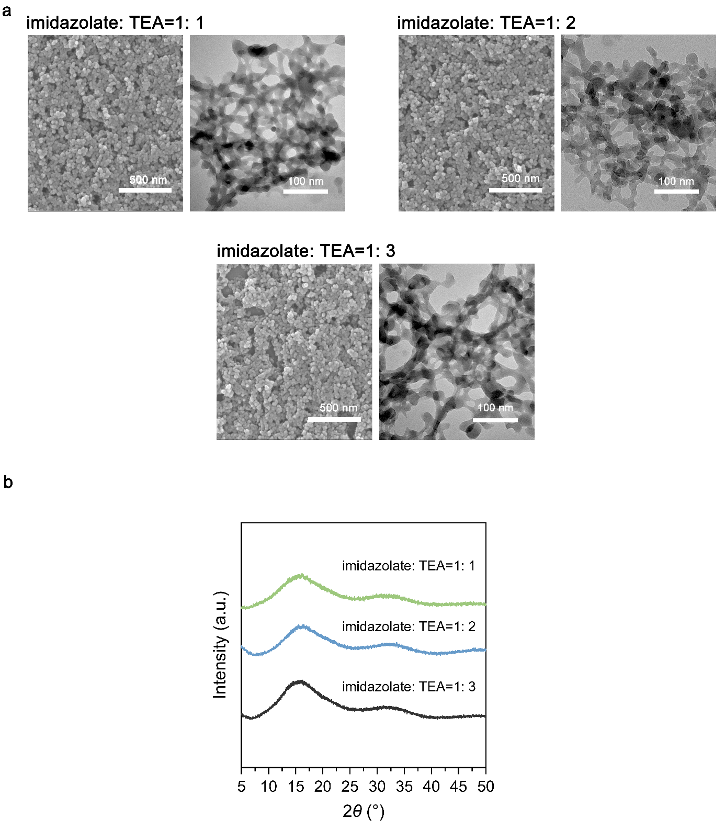
Supplementary Fig. 7 | Amorphous ZIF-62 gels synthesised with different imidazolate-to-TEA ratios. a, Ex situ TEM images collected after 30 min of reaction. b, Corresponding PXRD patterns.

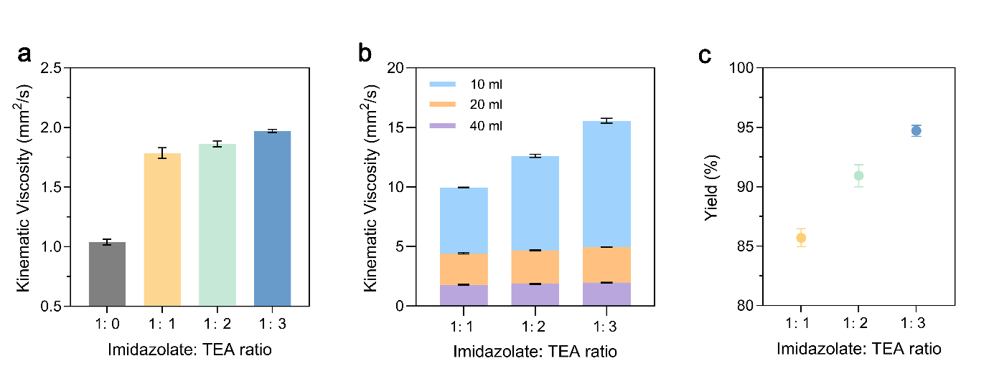

Supplementary Fig. 8 | Sol viscosity and yield of samples synthesised with different imidazolate-to-TEA ratios. a, Comparison of the kinematic viscosity of sols prepared with different imidazolates: TEA ratios. The precursor solution prior to TEA addition (grey) is shown as a control. The measurement was conducted after 30 min reaction. b, The viscosity of the as-synthesised sol can be tuned by post-synthetic concentration, achieved by further reducing the solvent volume to 20 and 10 mL of DMF. c, Reaction yields after 30 min of samples synthesised with different imidazolate: TEA ratios. As the ligands were used in excess, metal salt was considered the limiting reagent, and the yield was determined based on the Zinc precursor.

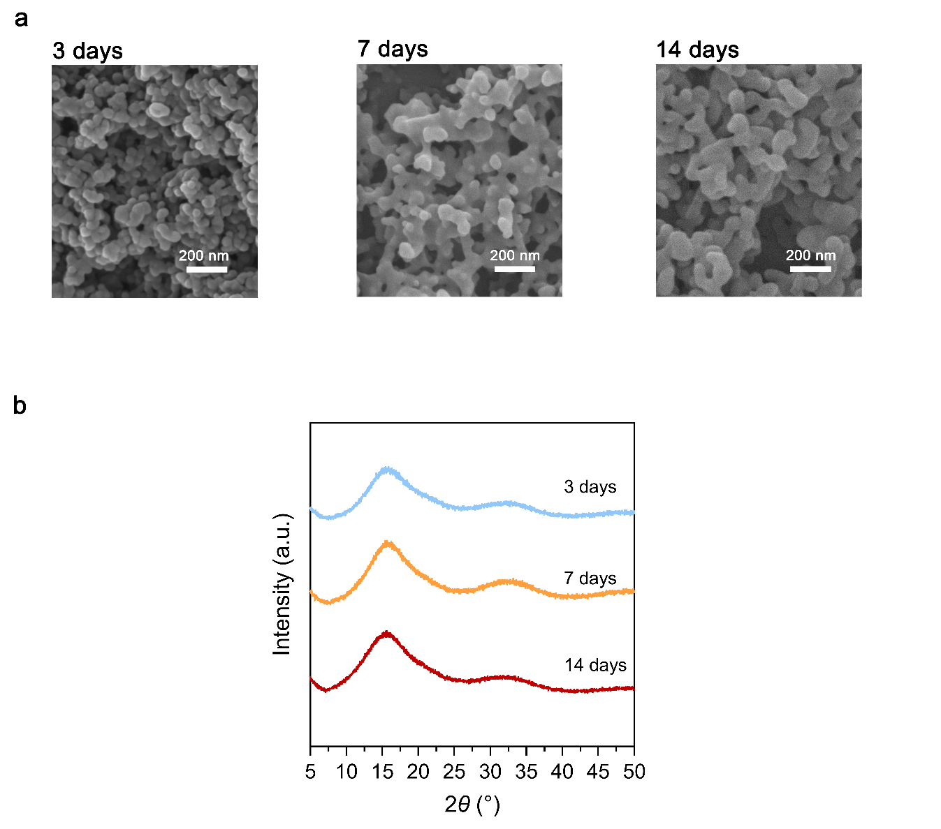

Supplementary Fig. 9 | Aging experiment of the sol–gel samples under ambient temperature. a, SEM images, and b, PXRD patterns of amorphous ZIF-62 gels aged at room temperature for different durations, with the sol-gel retained in the original reaction solution without washing.

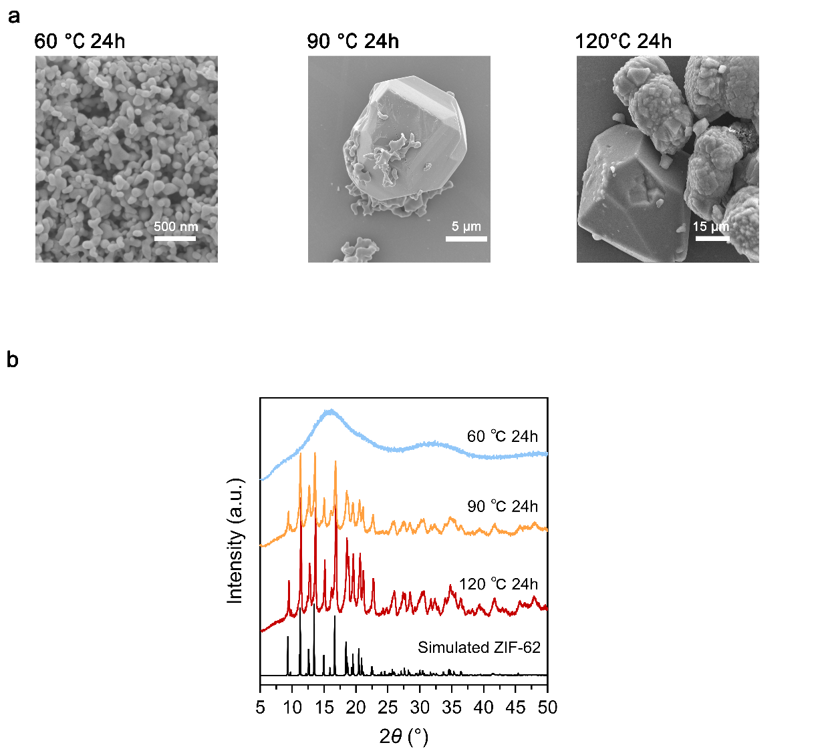

Supplementary Fig. 10 | Aging experiment of the sol–gel samples under elevated temperatures. a, SEM images, and b, PXRD patterns of amorphous ZIF-62 gels aged for 24 h at different temperatures, with samples retained in the original reaction solution without washing.
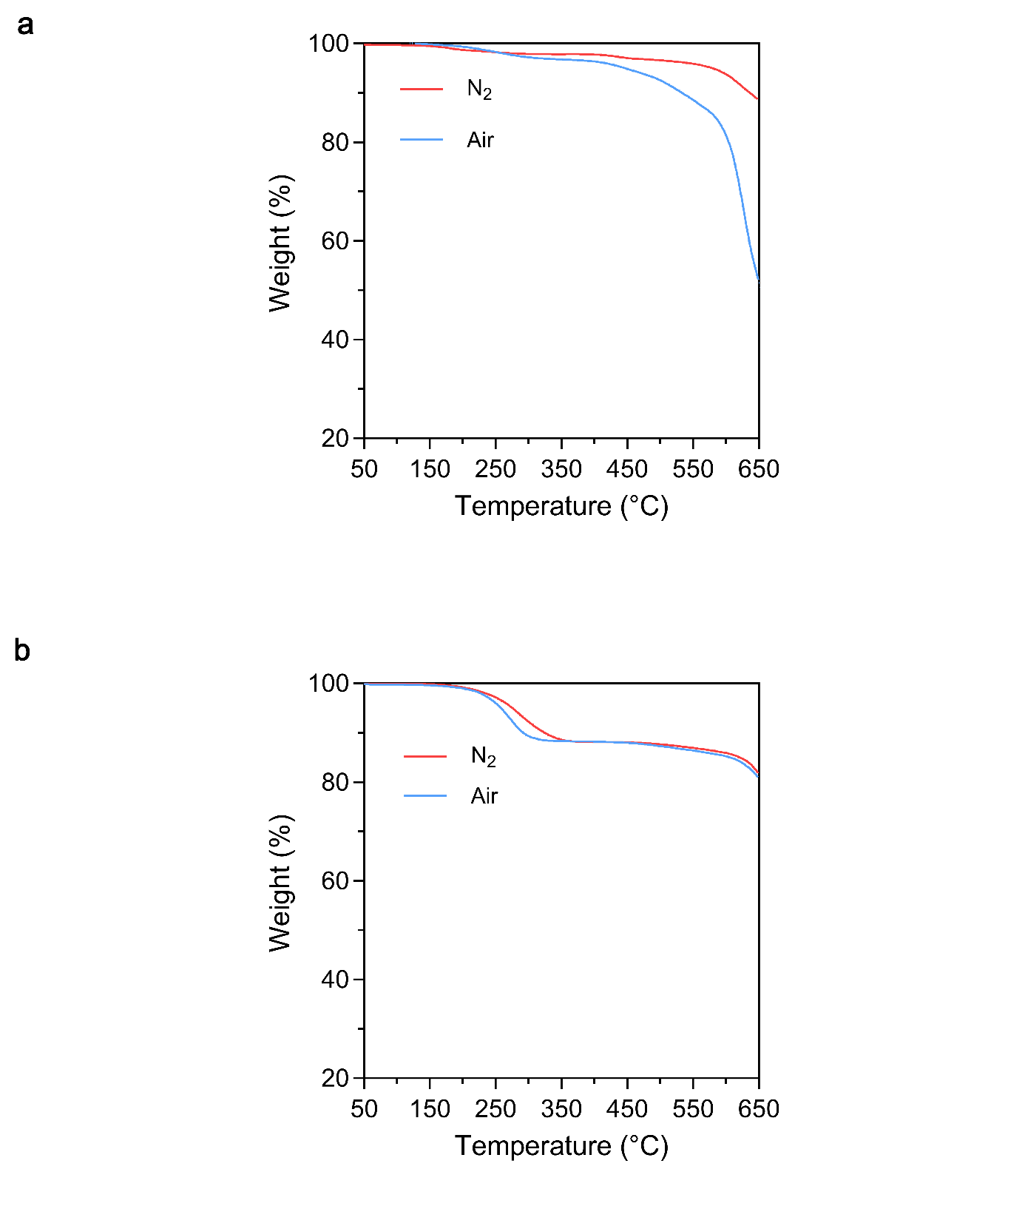
Supplementary Fig. 11 | TGA profiles of a, amorphous ZIF-62 xerogel monoliths and b, solvothermal-synthesised ZIF-62 crystals measured under air and N₂ atmospheres.

Supplementary Fig. 12 | DSC curves of solvothermal synthesised ZIF-62 crystal with heating ramp of 10 °C min⁻¹ in both upscans.

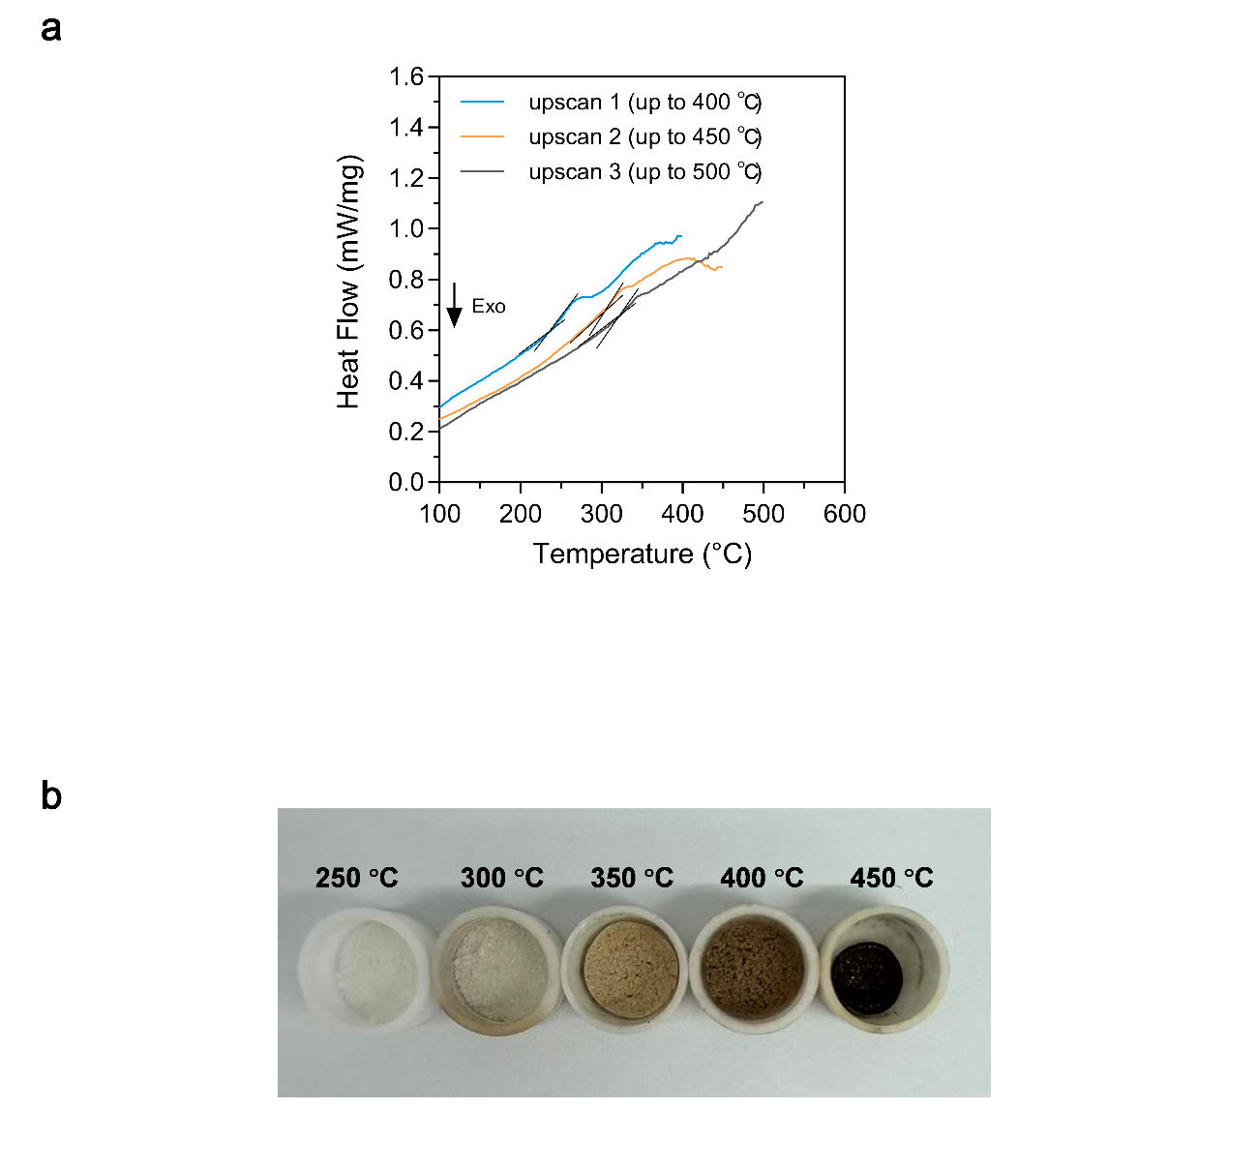
Supplementary Fig. 13 | Thermal behaviour of amorphous ZIF-62 xerogel. a, DSC curves of ZIF-62 xerogel. Multiple DSC upscans are indicated by different colours, with heating rate of 10 °C min⁻¹. b, Photographs of xerogels annealed at different temperatures. To ensure homogeneous heating, the monolithic samples were ground into powders prior to thermal treatment. With increasing annealing temperature, the initially loose particles progressively coalesce into a continuous mass, providing direct visual evidence of a solid-rubbery state transformation. Upon reaching 450 °C, pronounced volume shrinkage is observed, indicating substantial macroscopic densification at elevated temperatures.

Supplementary Fig. 14 | Determination of apparent fragility index (m). a, DSC upscans of a_{g}ZIF-62-gel measured at different heat ramping rate. T_{f} is determined as the onset temperature of the glass transition. The T_{f} measured with the heating rate of 10 °C min⁻¹ is defined as T_{g}. b, Apparent fragilities of a_{g}ZIF-62-gel, determined as the slope of log(1/q) vs T_{g}/T_{f} near T_{g}. c, DSC upscans of 300 °C treated a_{g}ZIF-62-gel, and d, apparent fragilities of the relaxed gel glass.
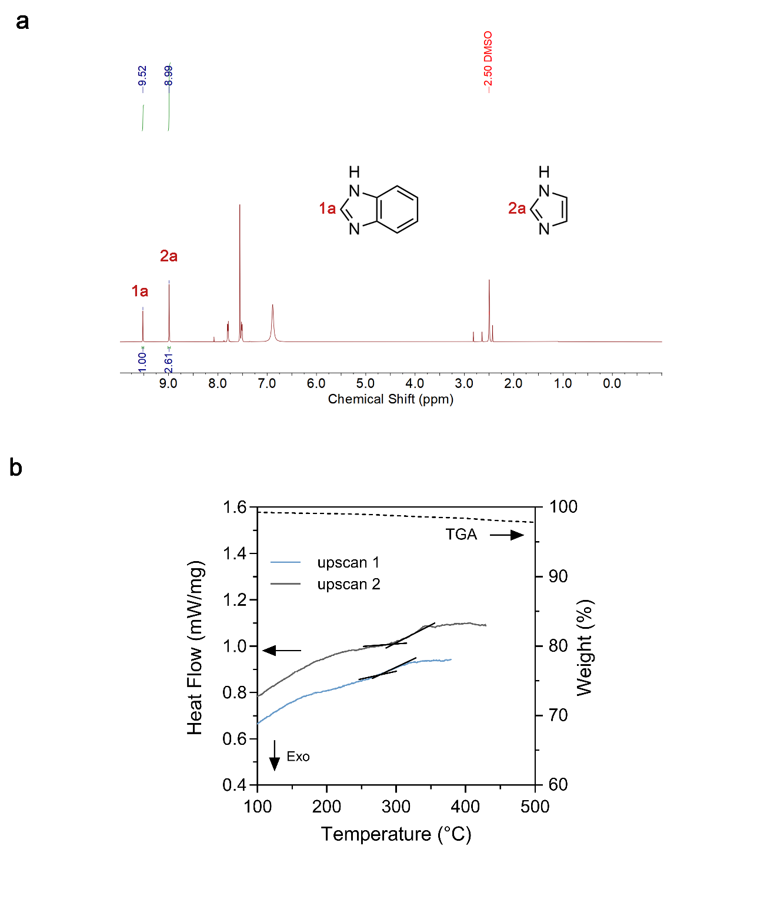

Supplementary Fig. 15 | a, ¹H NMR spectrum, and b, TGA and DSC curves of a_{g}ZIF-62-gel with a high bIm content: [Zn(Im)_{1.44}(bIm)_{0.56})].

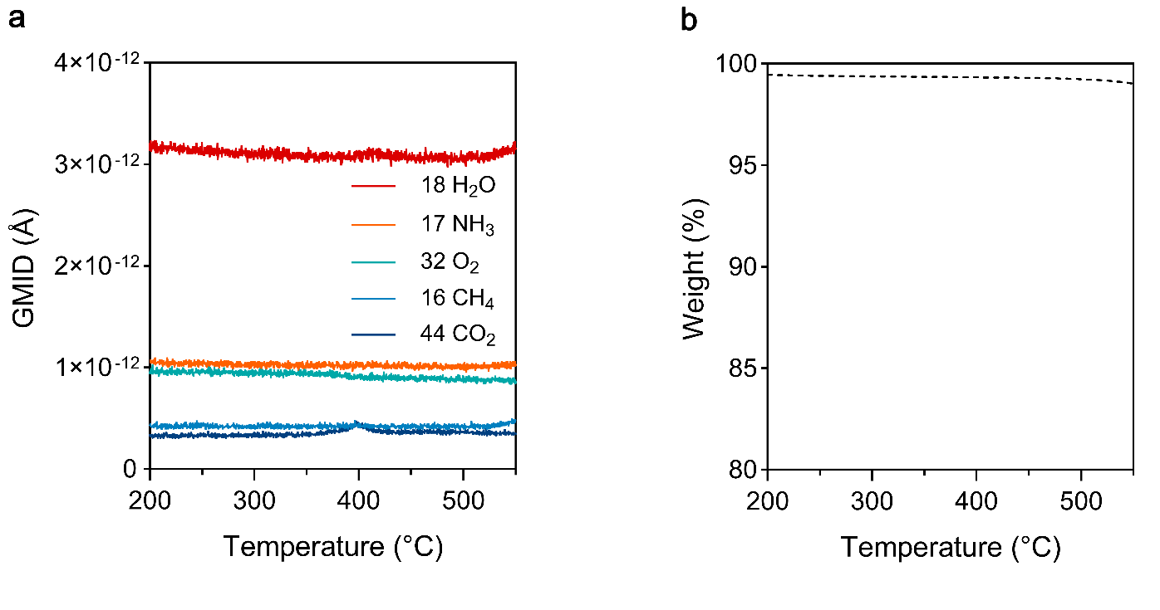
Supplementary Fig. 16 | a, TPD-MS analysis, and b, TGA test of a_{g}ZIF-62-gel monolith pre-annealed at 450 °C.

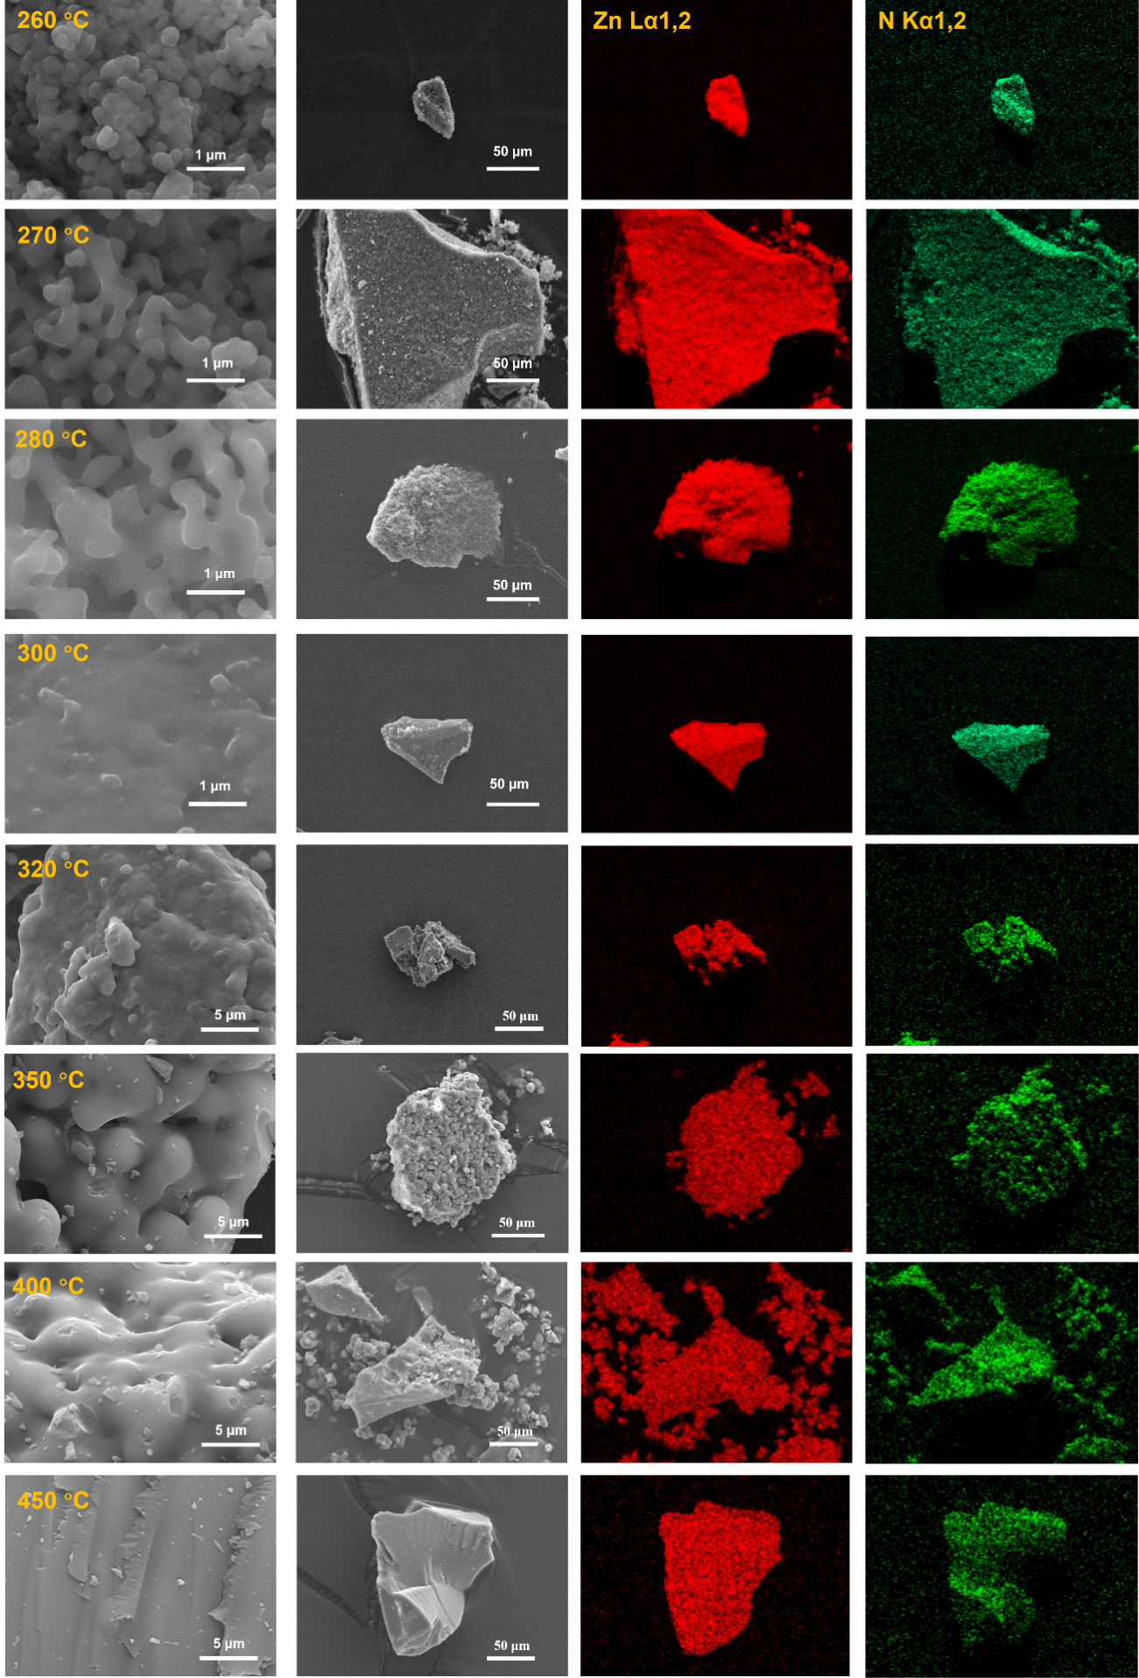

Supplementary Fig. 17 | SEM images and corresponding EDS elemental maps of a_{g}ZIF-62-gel monoliths after thermal treatment at different temperatures.

Supplementary Fig. 18 | In situ synchrotron SAXS profiles of a_{g}ZIF-62-gel monolith.

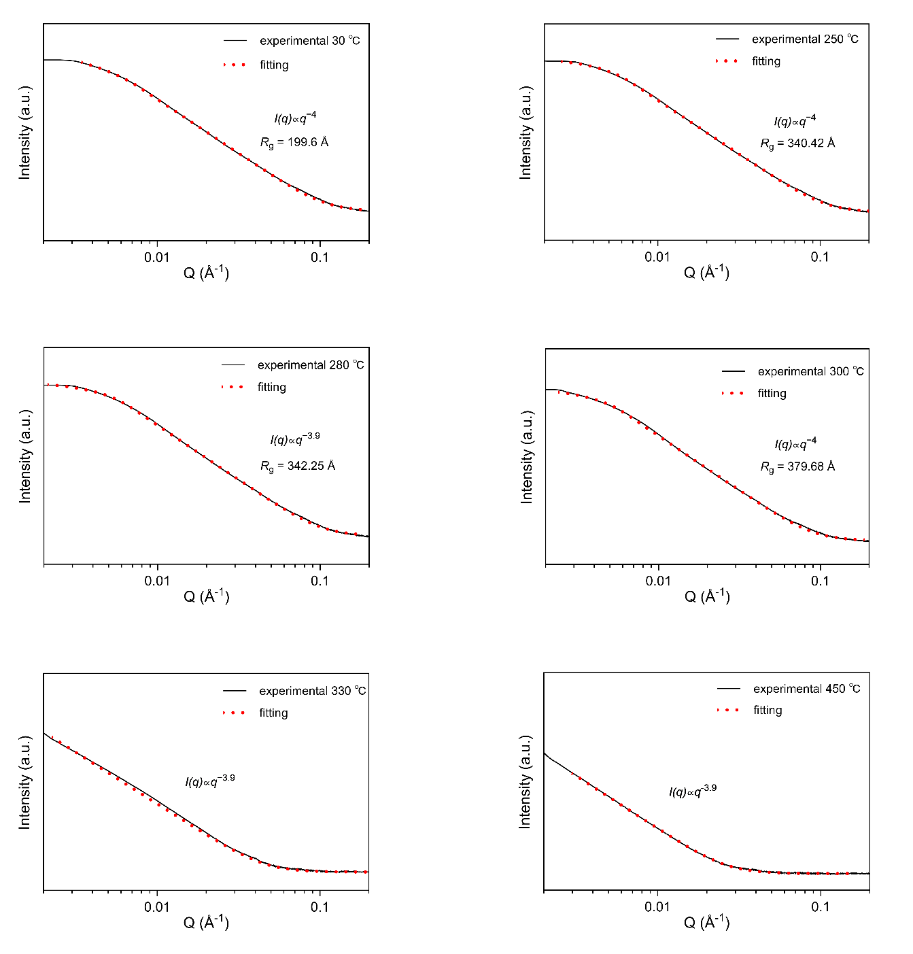
Supplementary Fig. 19 | SAXS fitting results of in situ measurements on a_{g}ZIF-62-gel monolith. With increasing temperature, the shoulder feature in the low-q region progressively diminishes, indicating a continuous increase in the characteristic structural scale. Correspondingly, the radius of gyration (R_{g}) extracted from Guinier Porod analysis increases with temperature. At temperatures above ~330 °C, the absence of a distinct low-q Guinier knee precludes reliable determination of R_{g}; instead, the extension of the power-law regime towards lower q, together with the reduced low-q scattering intensity, further supports the growth of characteristic structural dimensions. These observations provide direct evidence for thermally induced fusion of the gel monolith, occurring in the same temperature range as the glass transitions identified by DSC.

Supplementary Fig. 20 | Ex situ THz-FarIR spectra of a_{g}ZIF-62-gel, solvothermal-synthesised ZIF-62 and corresponding melt-quenched a_{g}ZIF-62.

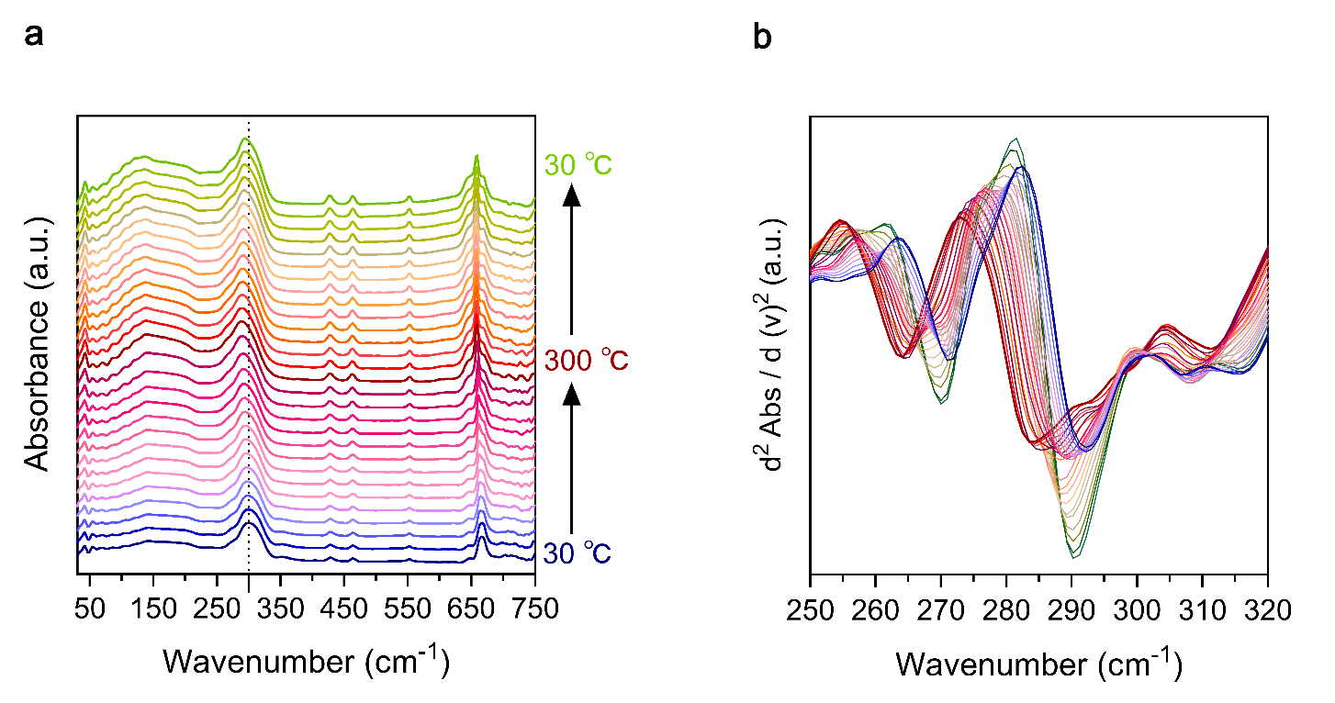

Supplementary Fig. 21 | a, In situ THz-FarIR spectra of a_{g}ZIF-62-gel. b, Corresponding second derivative of the spectra.
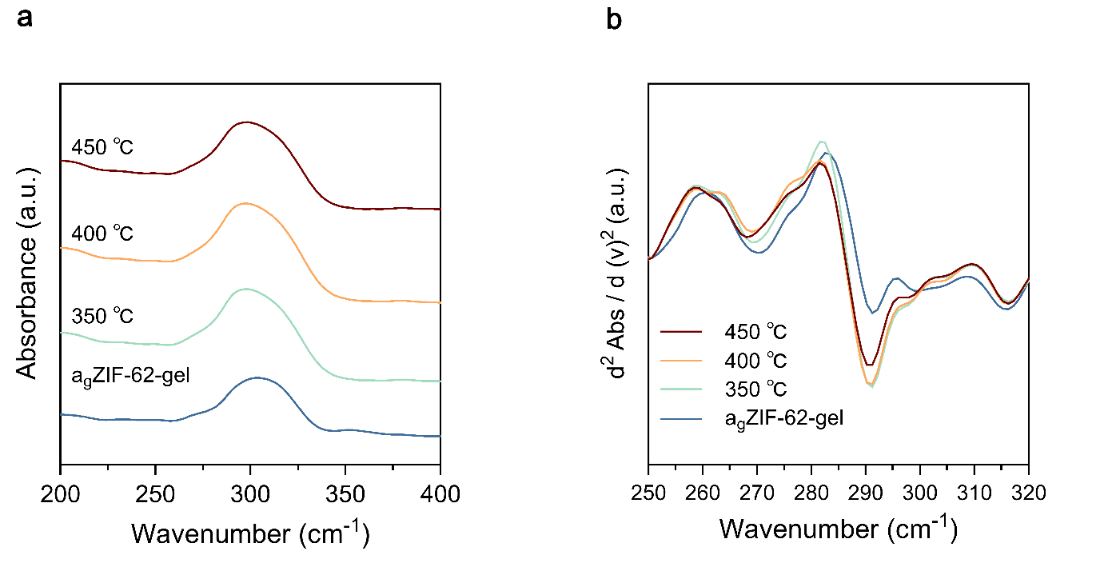

Supplementary Fig. 22 | a, Ex situ THz-FarIR spectra of a_{g}ZIF-62-gel and a_{g}ZIF-62-gel samples thermally treated at 350, 400 and 450 °C. b, Corresponding second derivative of THz-FarIR spectra.

Supplementary Fig. 23 | FTIR spectra of a_{g}ZIF-62-gel samples treated at different temperatures.

Supplementary Fig. 24 | Zn K-edge XANES spectra of the a_{g}ZIF-62-gel, and a_{g}ZIF-62-gel samples thermally treated at 300 and 450 °C.

Supplementary Fig. 25 | EXAFS signals of the a_{g}ZIF-62-gel, and a_{g}ZIF-62-gel samples thermally treated at 300 and 450 °C.

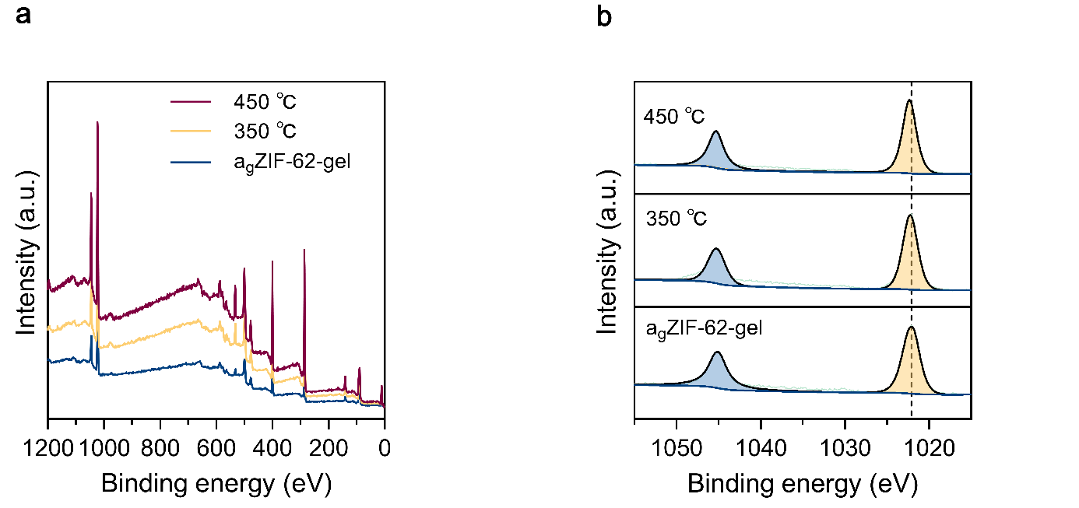

Supplementary Fig. 26 | a, XPS full spectra, and b, Zn 2p spectra of a_{g}ZIF-62-gel samples annealing at different temperatures. All samples display two Zn 2p peaks, implying that the Zn²⁺ ions remain unreduced during the heating process.

Supplementary Fig. 27 | X-ray scattering factors for a_{g}ZIF-62-gel and a_{g}ZIF-62-gel samples annealed at 300 and 450 °C. The panel on the right shows locally enlarged region, indicating the reduction of full width at half maximum of the first sharp diffraction peak.

Supplementary Fig. 28 | Simulated total pair distribution function (PDF) and corresponding partial PDFs of the system using a crystalline ZIF-62 structure¹. The top curve represents the total PDF, while the lower curves show the partial contributions from specific atomic pairs. Distinct peaks in each partial PDF indicate preferred interatomic separations and local structural correlations, whose superposition gives rise to the features observed in the total PDF.

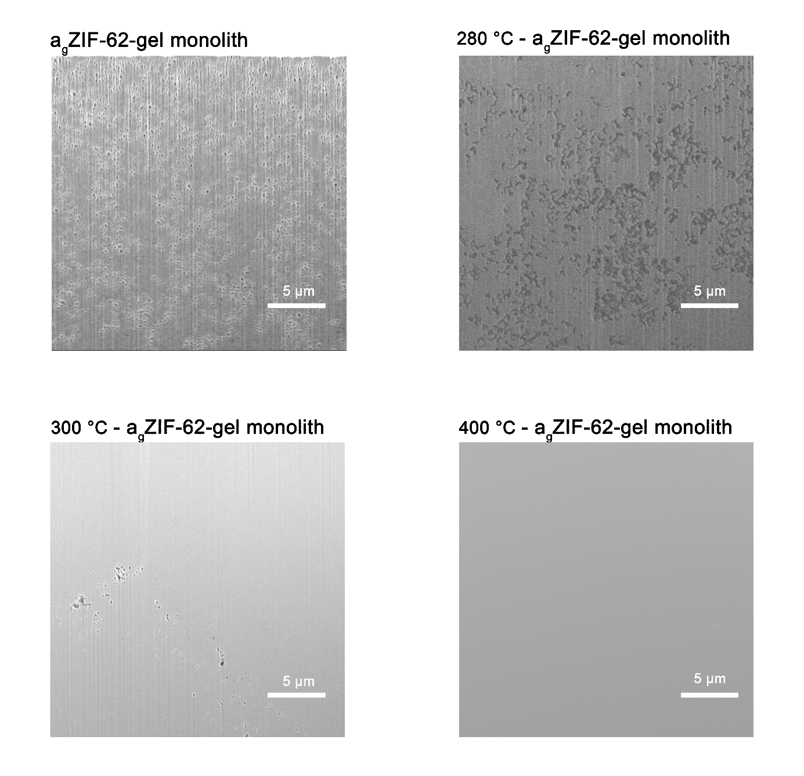

Supplementary Fig. 29 | FIB SEM of a_{g}ZIF-62-gel monoliths treated at different temperatures.

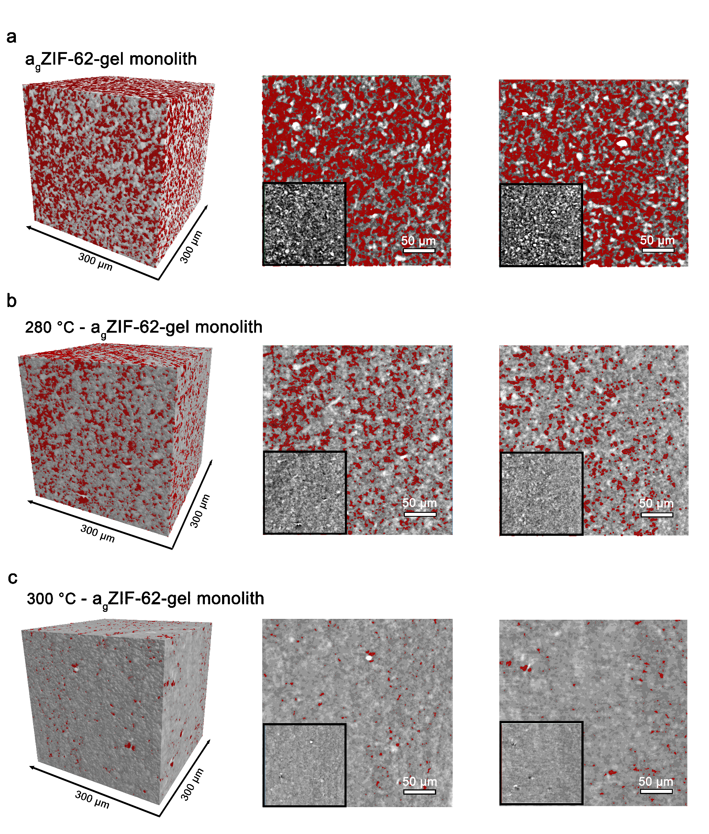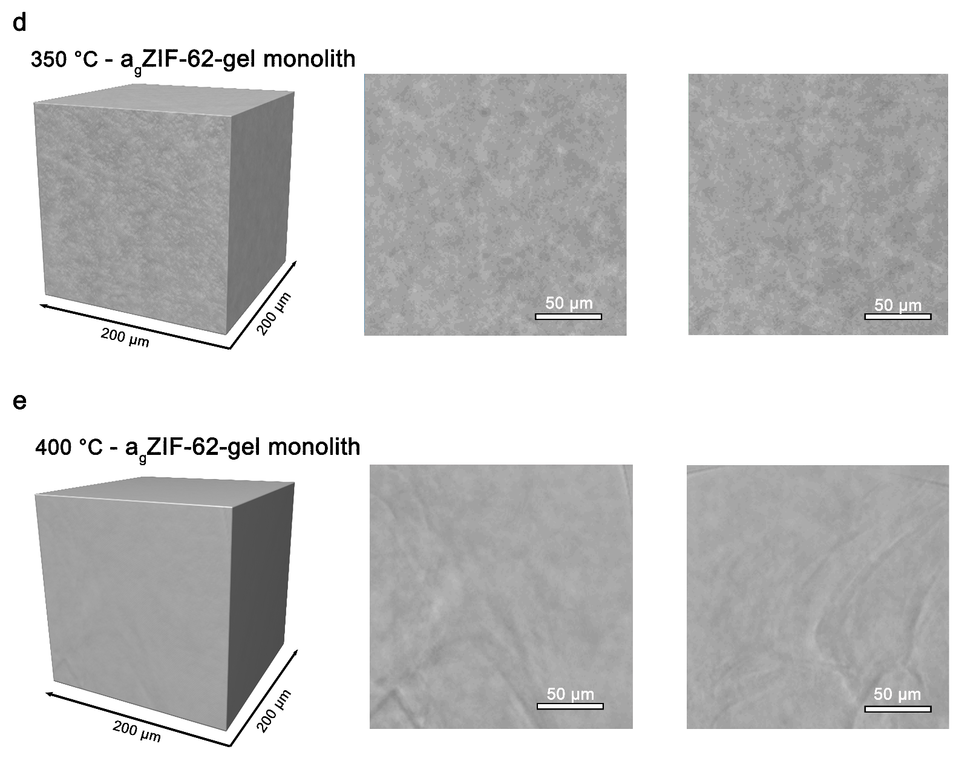

Supplementary Fig. 30 | Synchrotron MCT showing the evolution of the three-dimensional porous architecture of the agZIF-62-gel monoliths upon thermal treatment. Corresponding front and side cross-sectional views are shown alongside the 3D renderings. Pore structures were identified in Dragonfly through greyscale-based segmentation of the reconstructed micro-CT volumes and highlighted in red. Insets in the planar views of a–c show the original reconstructed slices prior to pore segmentation.

Supplementary Fig. 31 | Pore size distribution of a_{g}ZIF-62-gel monoliths with different annealing temperatures calculated from N₂ adsorption isotherms at 77 K using DFT method.

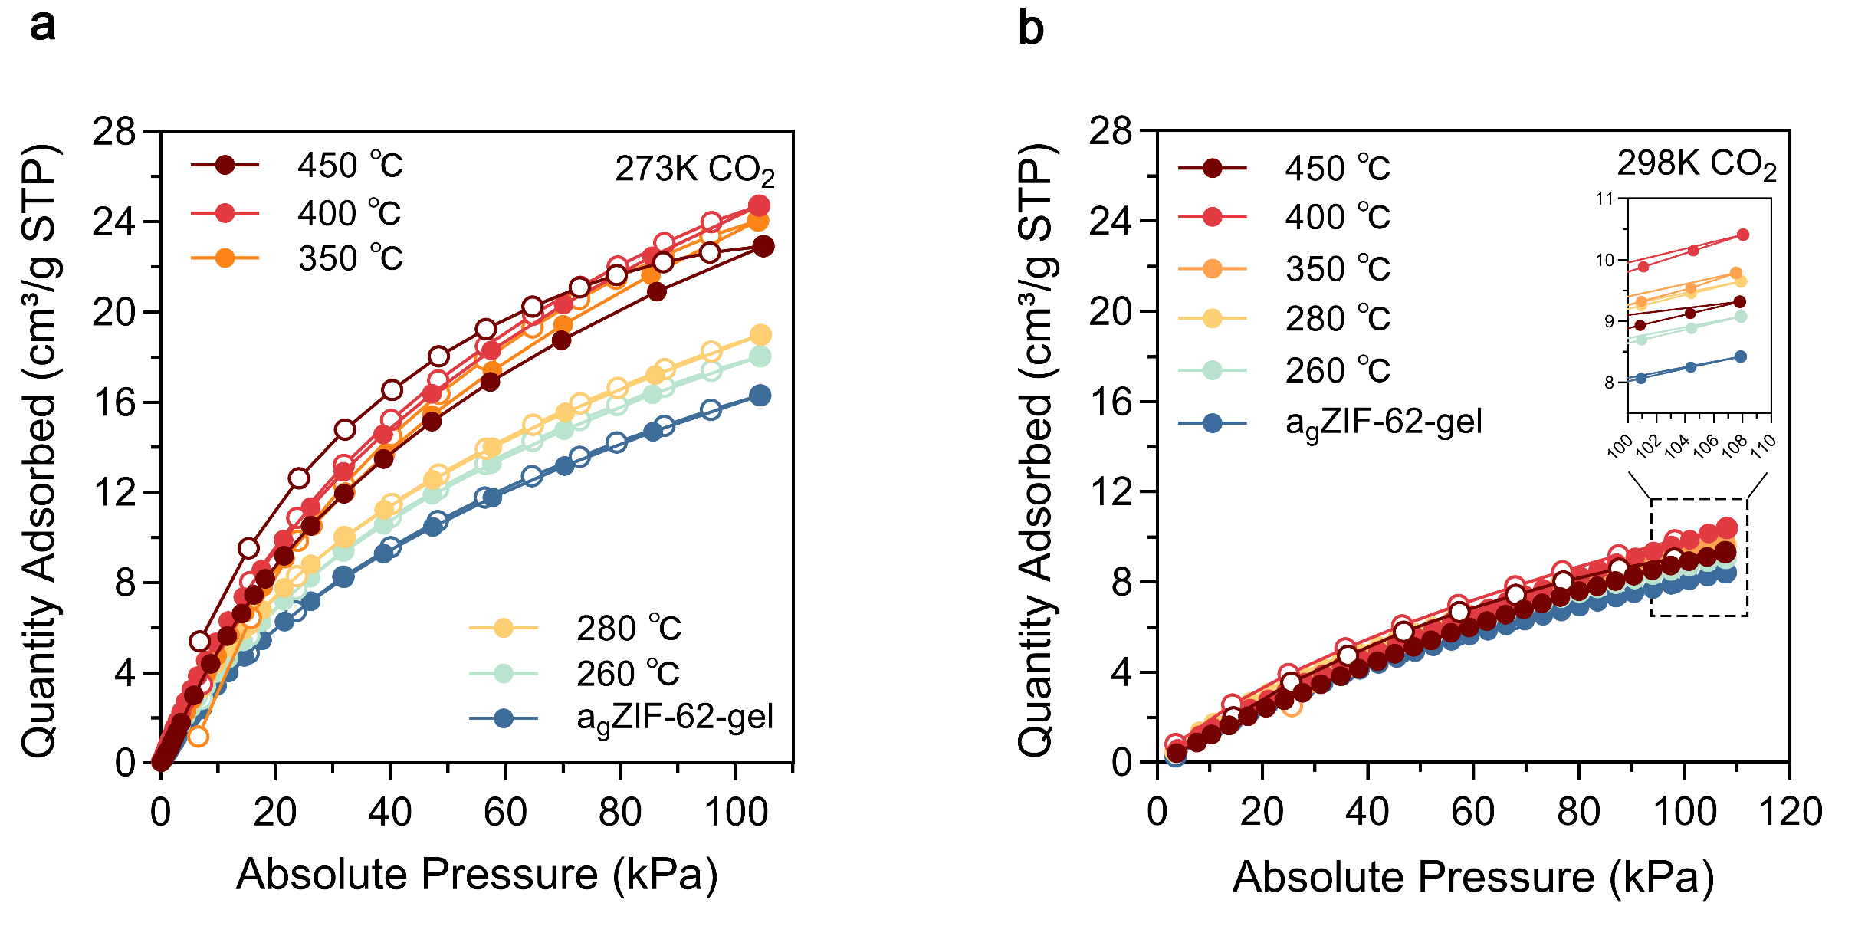

Supplementary Fig. 32 | CO₂ sorption isotherms measured at a, 273 K and b, 298 K for a_{g}ZIF-62-gel monoliths annealed at different temperatures.

Supplementary Fig. 33 | PALS pore size distributions of a_{g}ZIF-62-gel samples annealed at different temperatures revealing progressive pore narrowing and enhanced microporosity.

Supplementary Fig. 34 | Evolution of density and accessible porosity upon thermal relaxation. a, Skeleton density (blue) measured by He pycnometry and apparent (envelope) density (grey) derived from CO₂ adsorption analysis for samples subjected to different thermal treatments. b, Porosity calculated from CO₂ adsorption isotherms, representing the fraction of CO₂-accessible pore volume within the material.

Supplementary Fig. 35 | Isosteric heat of CO₂ adsorption of a_{g}ZIF-62-gel samples annealed at different temperatures.

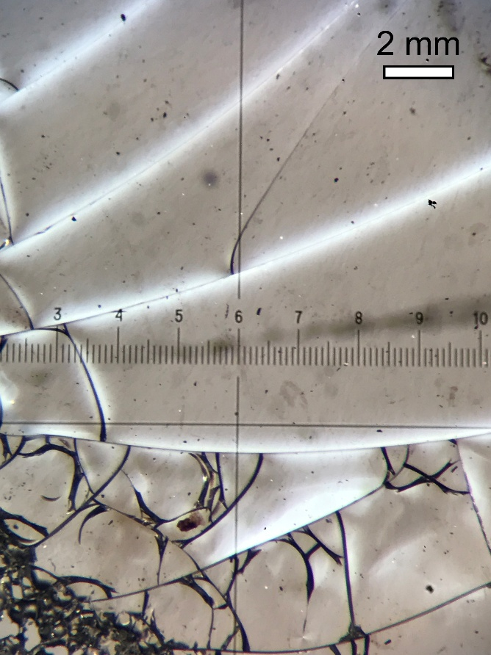
Supplementary Fig. 36 | Stress-induced fracturing within bulk MOF glass during thermal treatment.
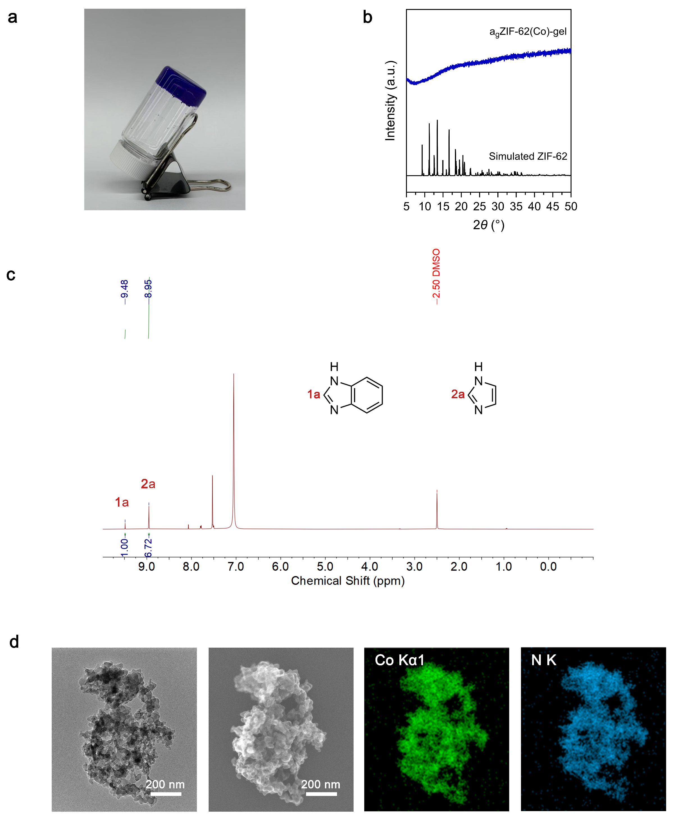

Supplementary Fig. 37 | Synthesis of the a_{g}ZIF-62(Co)-gel. a, Optical image of a_{g}ZIF-62(Co)-gel demonstrating its self-supporting nature upon vial inversion. b, PXRD pattern of a_{g}ZIF-62(Co)-gel (xerogel) showing the absence of sharp Bragg peaks, which confirms the amorphous nature of the sample. c, ¹H NMR spectrum of the digested xerogel. d, HRTEM and STEM images of the fresh gel with element mapping.

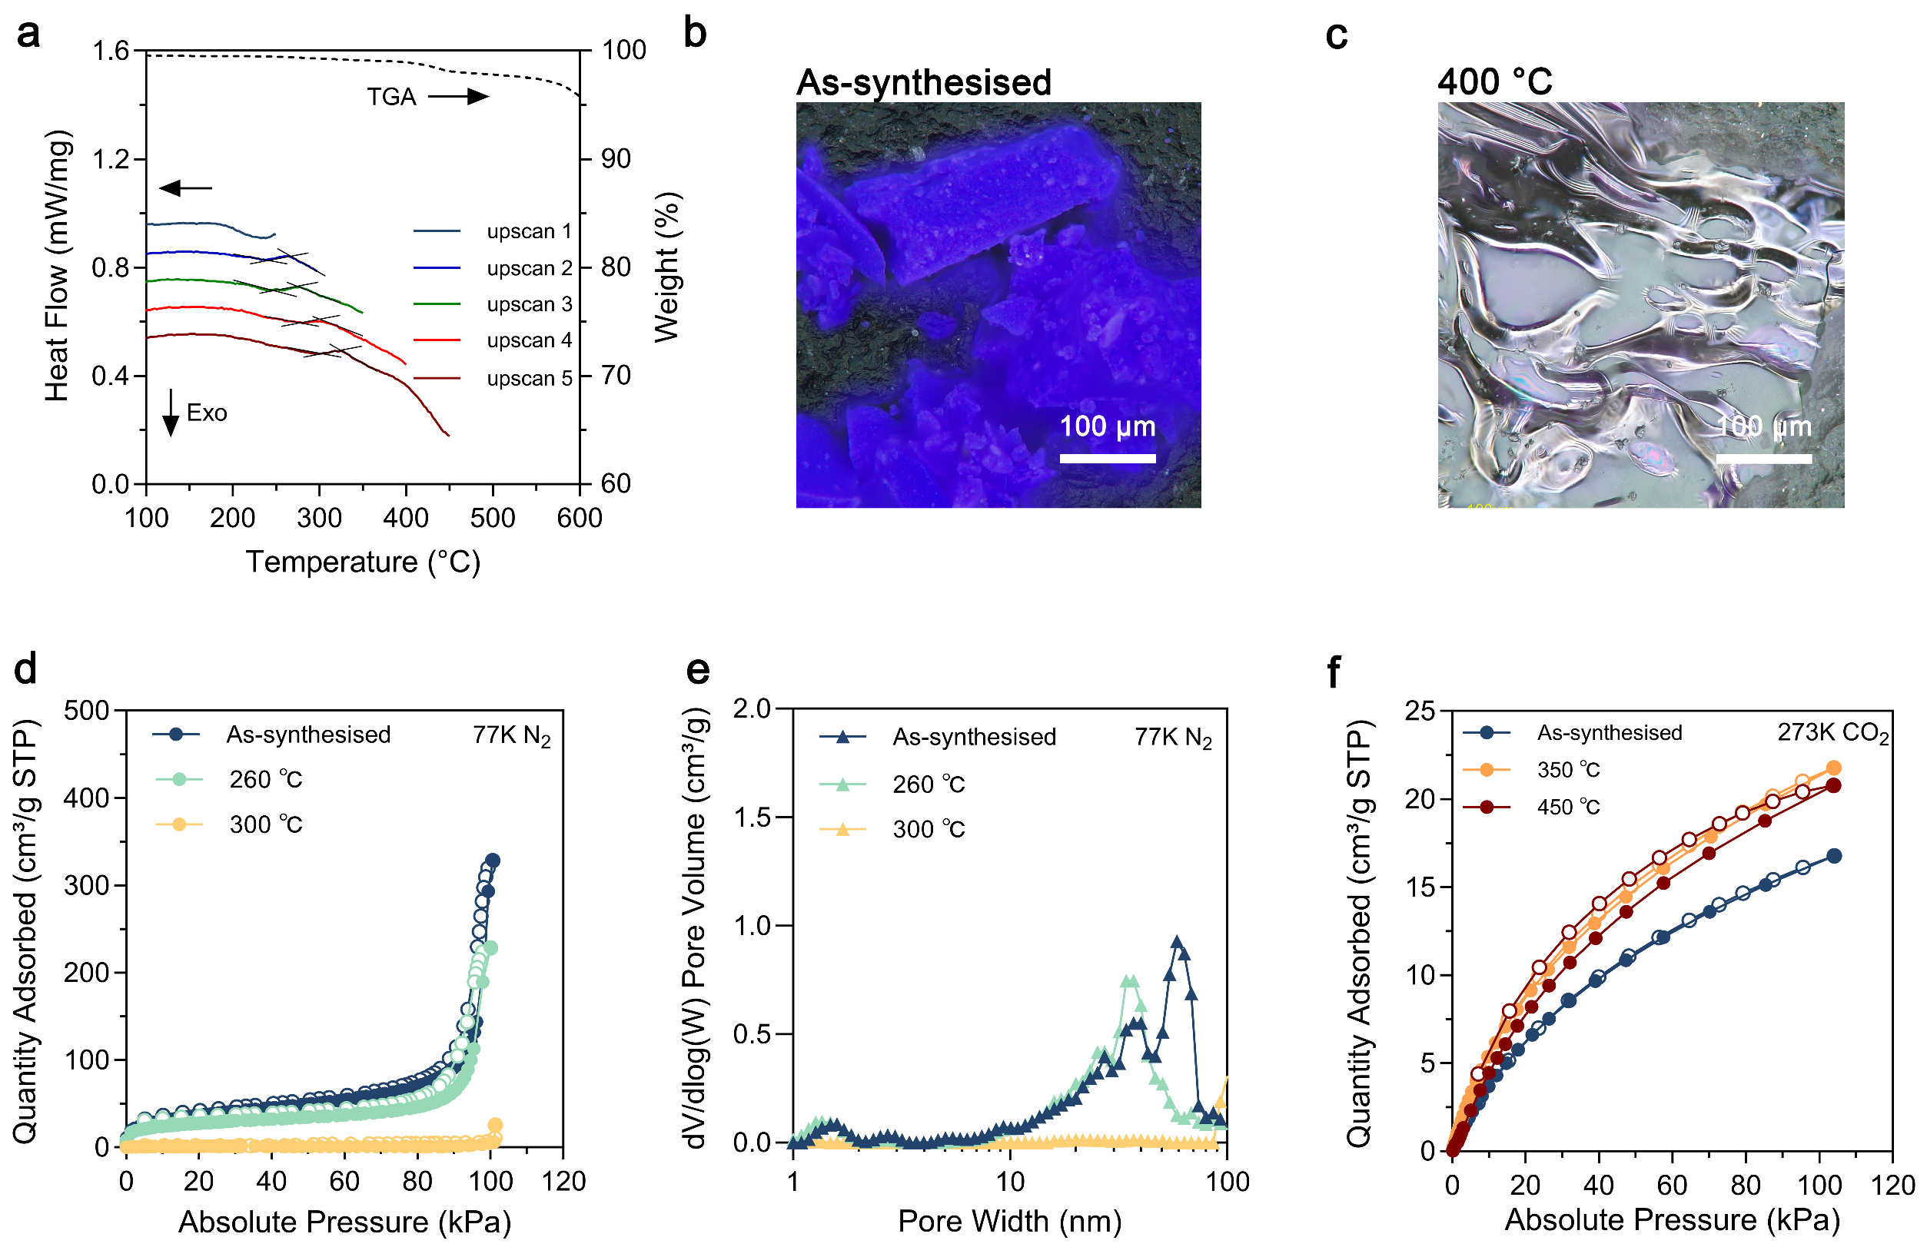

Supplementary Fig. 38 | Glass formation and porosity evolution of the a_{g}ZIF-62(Co)-gel. a, TGA and DSC curves of a_{g}ZIF-62(Co)-gel. A clear glass transition signal is observed during the first heating scan, while the slight increase of T_{g} to higher temperatures in subsequent heating scans is consistent with structural relaxation. b–c, Optical microscopy images of the as-synthesised gel and 400 °C-treated gel, showing the macroscopic evolution of the glassy samples. d–e, N₂ adsorption (solid circles)-desorption (hollow circles) profiles collected at 77 K and corresponding pore size distributions (calculated by the DFT method). f, CO₂ sorption isotherms measured at 273 K, showing the microporosity augmentation upon annealing.
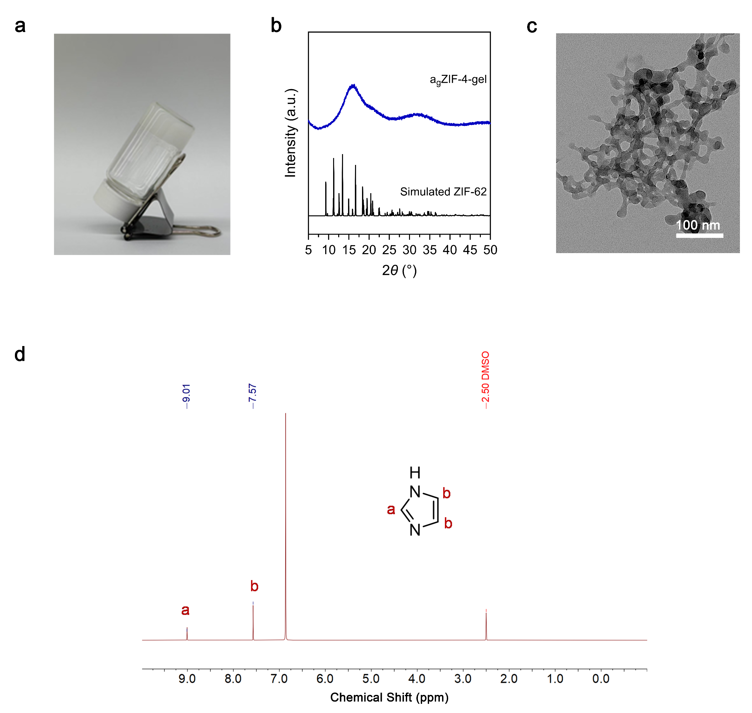

Supplementary Fig. 39 | Synthesis of the a_{g}ZIF-4-gel. a, Optical image of a_{g}ZIF-4-gel showing its self-supporting nature. b, PXRD pattern of xerogel, demonstrating the amorphous nature of the sample. c, TEM image of the fresh gel. d, ¹H NMR spectrum of the digested xerogel.

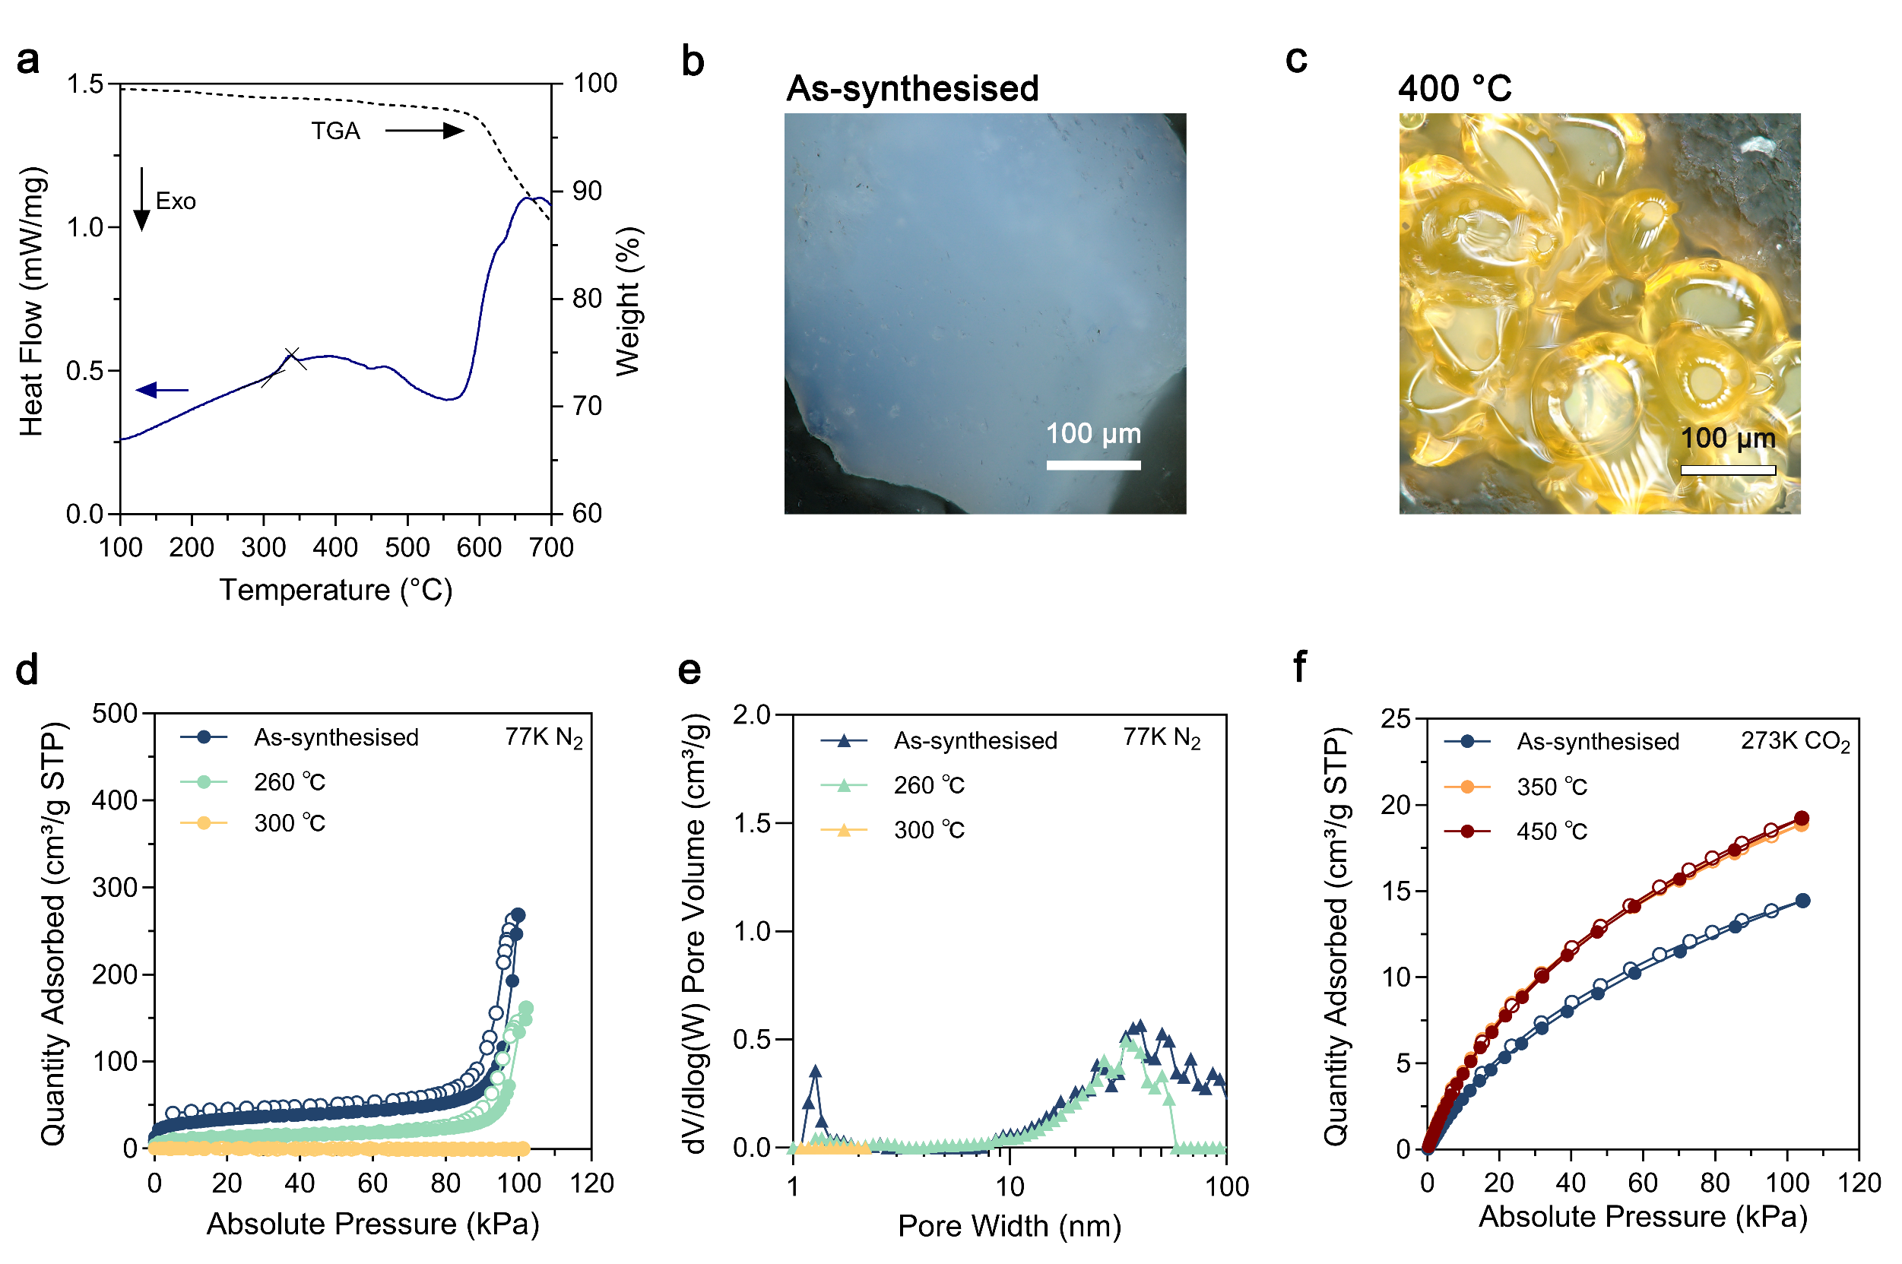

Supplementary Fig. 40 | Glass formation and porosity evolution of the a_{g}ZIF-4-gel. a, Simultaneous TGA–DSC measurement of a_{g}ZIF-4-gel. A clear glass transition is observed during the heating process, and no melting signal or recrystallisation is detected prior to decomposition. b–c, Optical microscopy images showing the macroscopic evolution of the sample upon heating to 400 °C, consistent with glassy behaviour. d–e, N₂ adsorption (solid circles)-desorption (hollow circles) profiles collected at 77 K and corresponding pore size distributions (calculated by the DFT method). f, CO₂ sorption isotherms measured at 273 K, showing the enhanced microporosity.
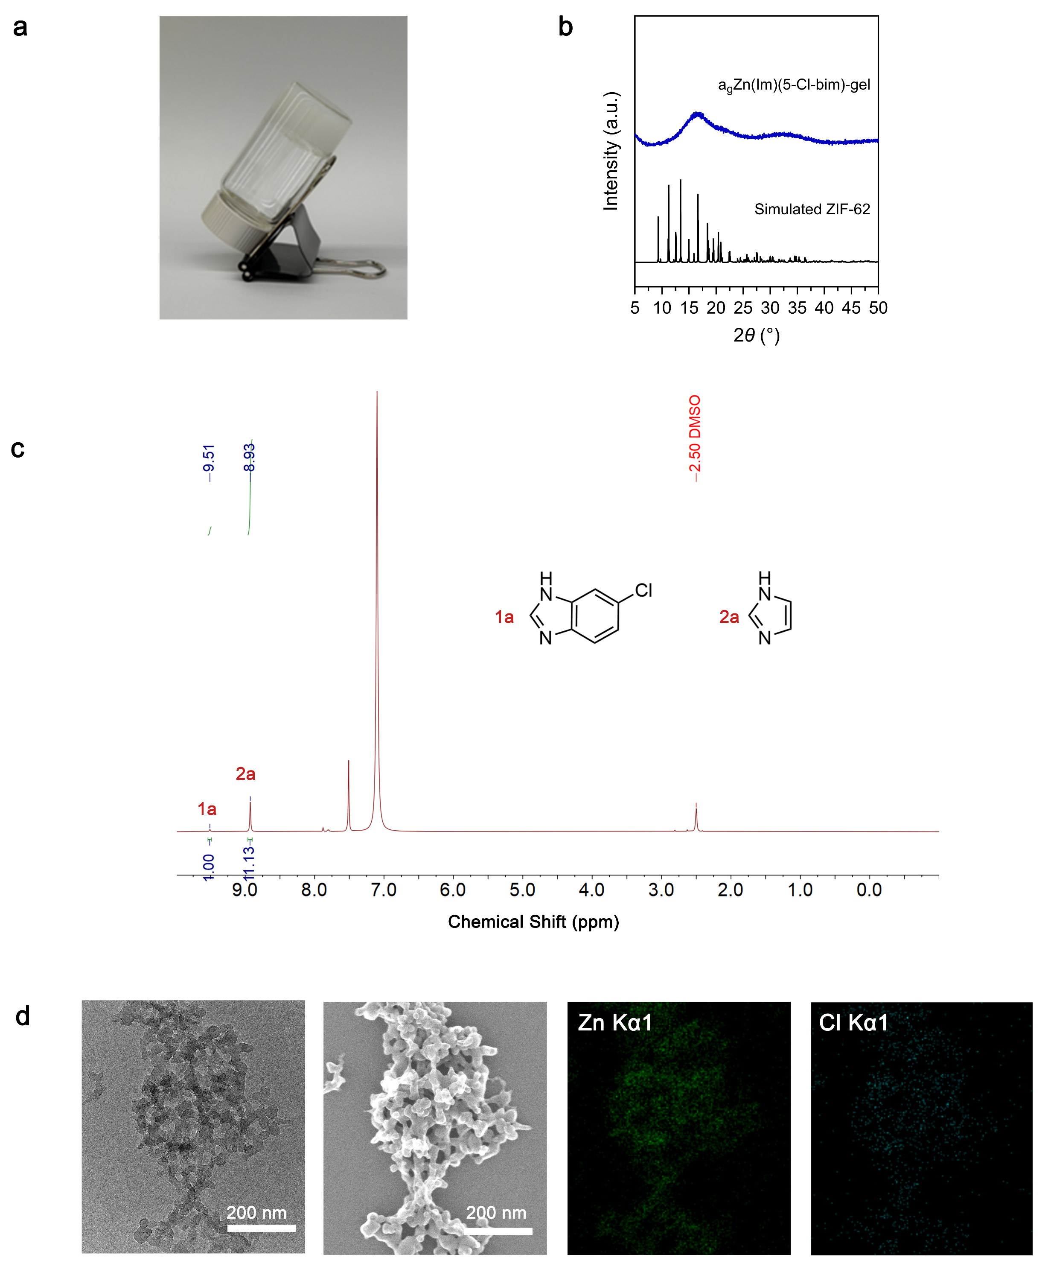

Supplementary Fig. 41 | Synthesis of the a_{g}Zn(Im)(5-Cl-bIm)-gel. a, Optical photograph of a_{g}Zn(Im)(5-Cl-bIm)-gel. b, PXRD pattern showing the amorphous nature of the xerogel. c, ¹H NMR spectrum of the digested xerogel. d, HRTEM and STEM images with elemental mapping. The uniform spatial distribution of Zn and Cl confirms the successful incorporation of the Cl-substituted ligand into the synthesised framework.
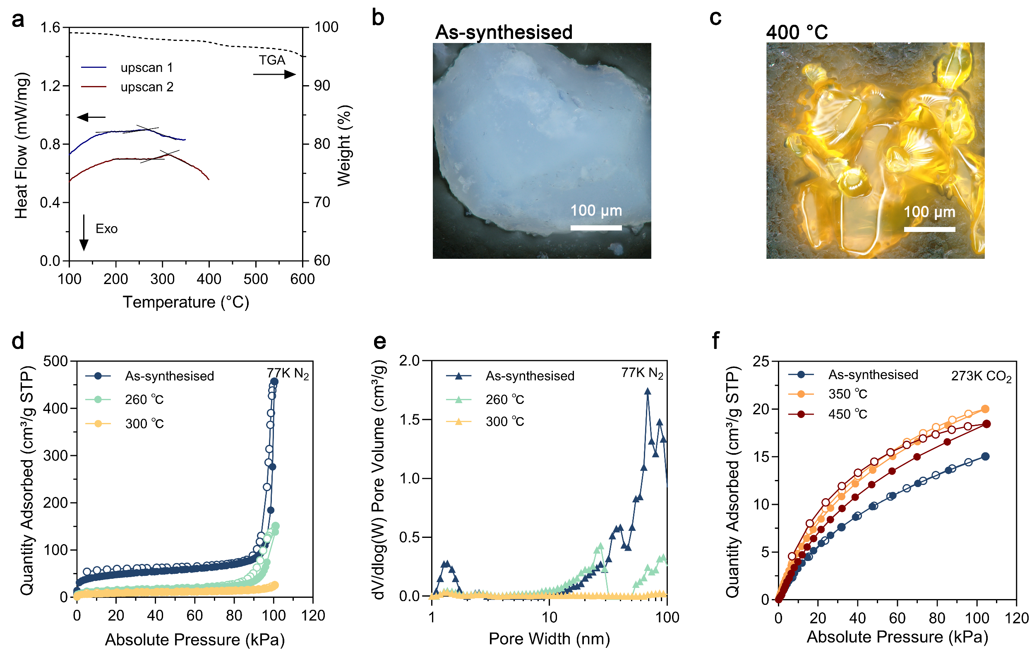

Supplementary Fig. 42 | Glass formation and porosity evolution of the a_{g}Zn(Im)(5-Cl-bIm)-gel. a, DSC and TGA curves of a_{g}Zn(Im)(5-Cl-bIm)-gel. A clear glass transition is observed during the heating process. b–c, Macroscopic evolution observed by optical microscopy upon heating to 400 °C. d–e, N₂ adsorption (solid circles)-desorption (hollow circles) profiles collected at 77 K and corresponding pore size distributions (calculated by the DFT method). f, CO₂ sorption isotherms measured at 273 K.

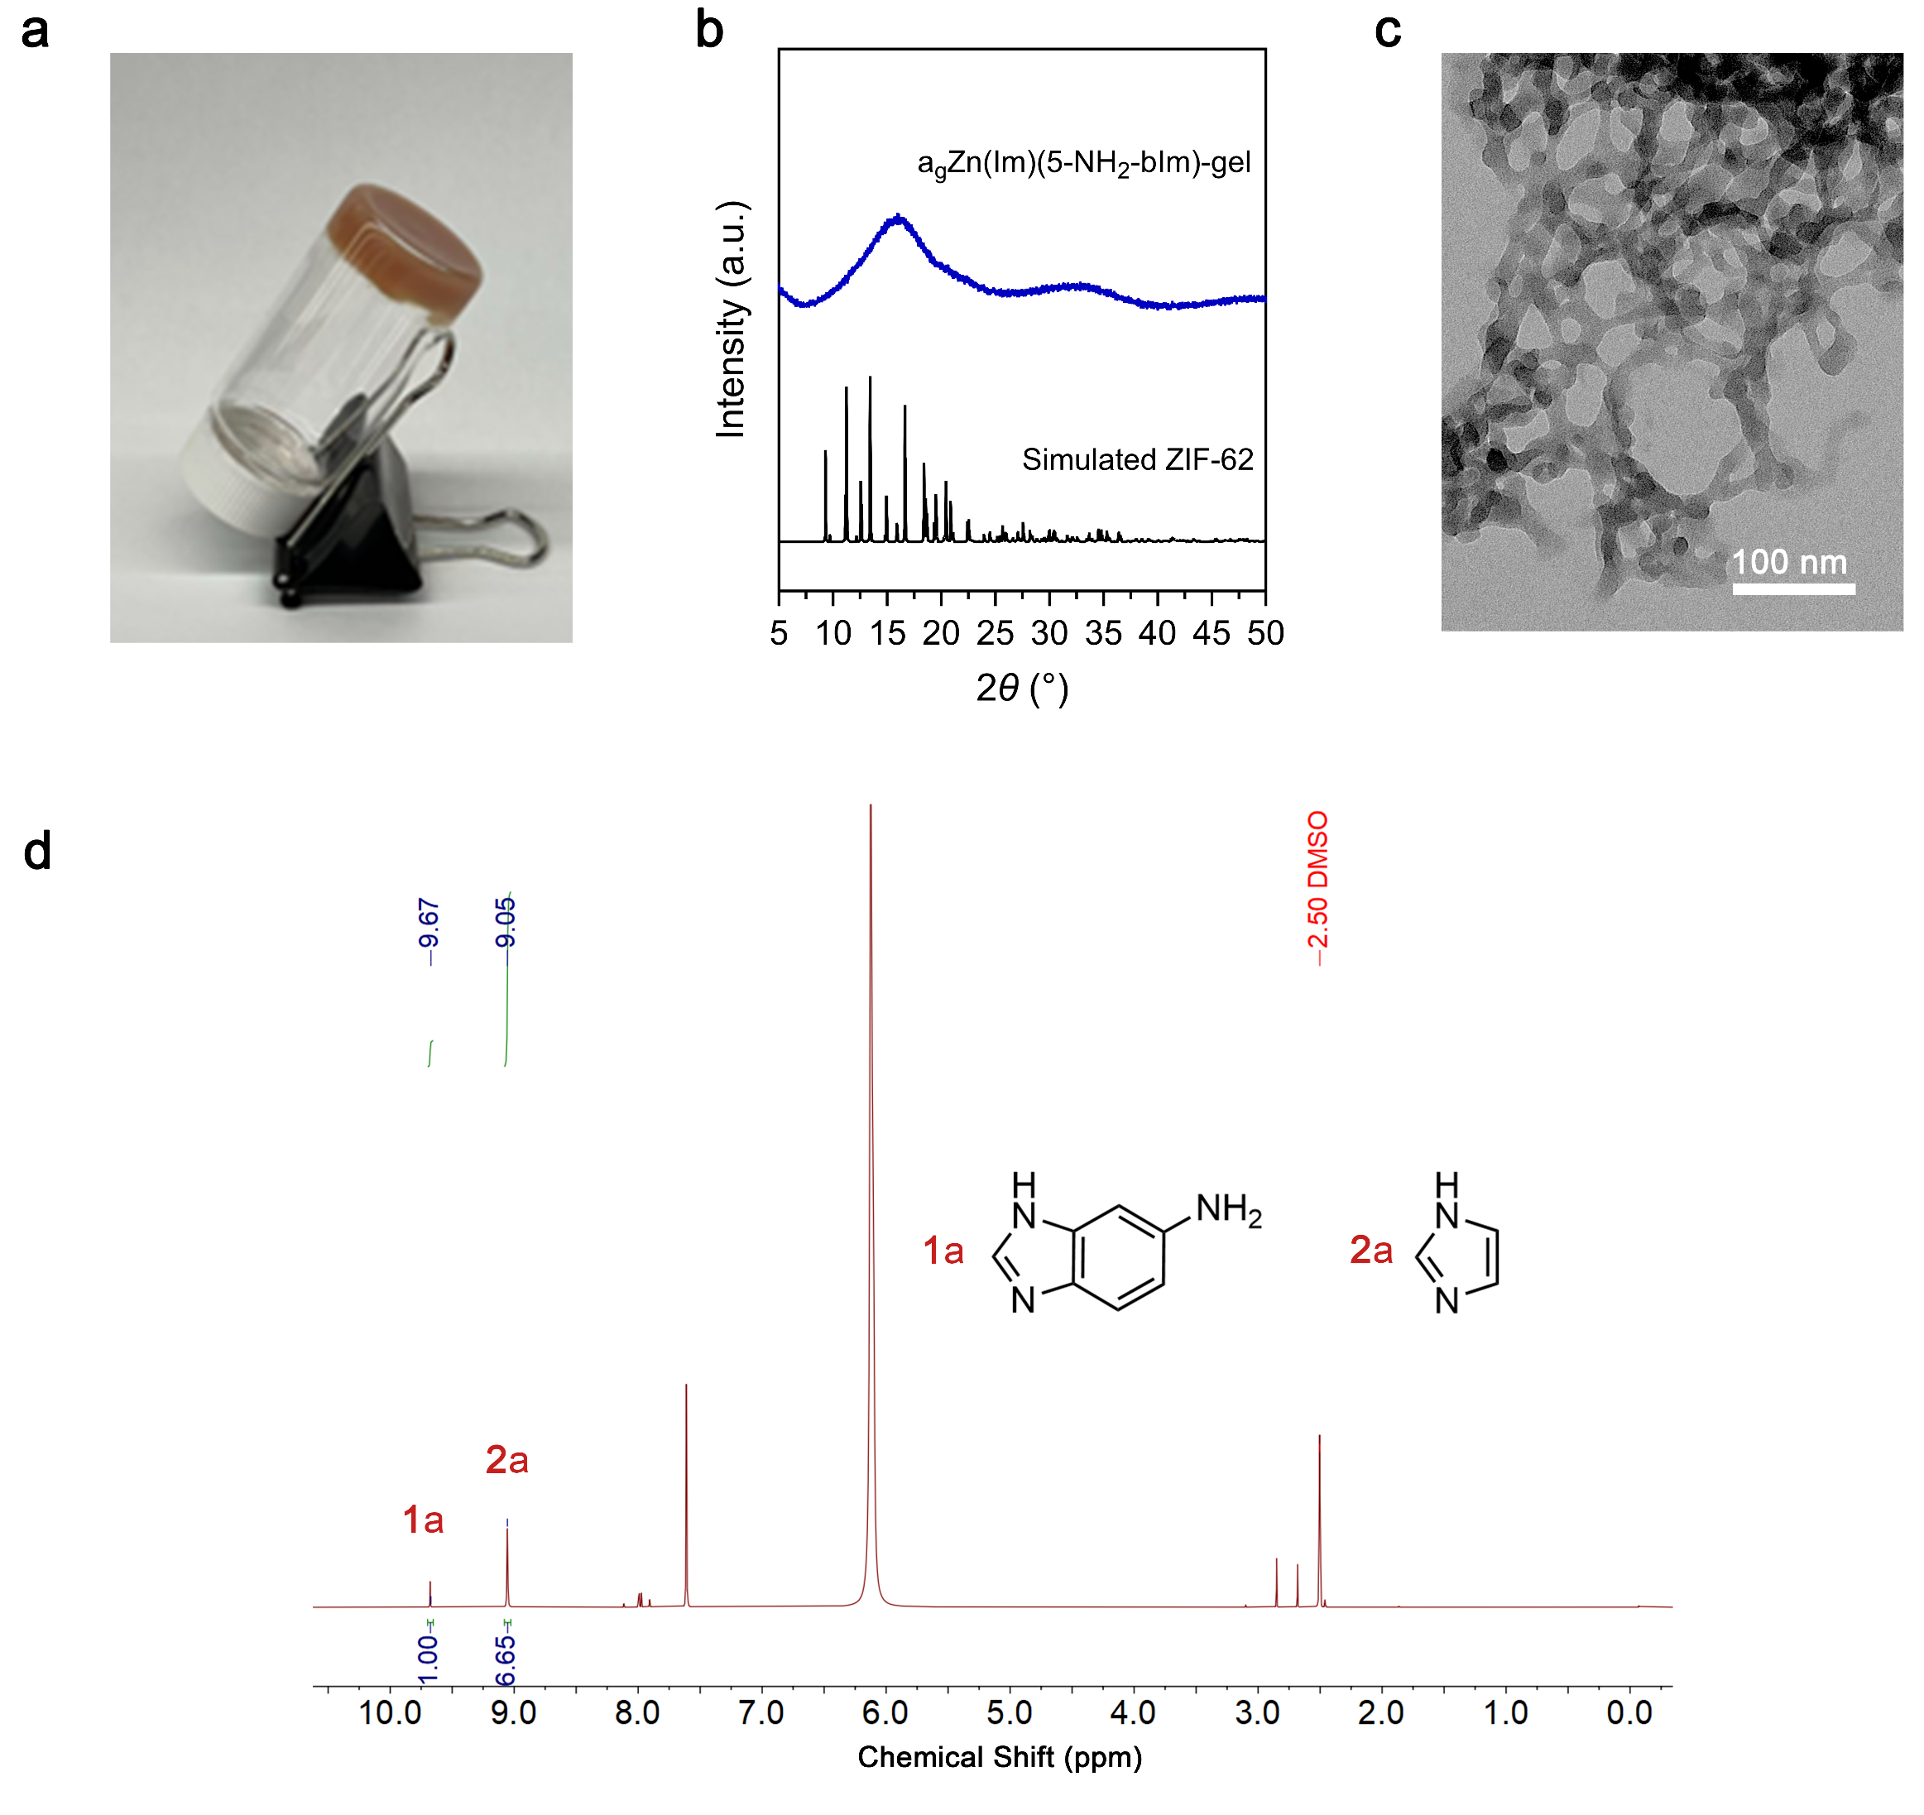

Supplementary Fig. 43 | Synthesis of the a_{g}Zn(Im)(5-NH₂-bIm)-gel. a, Optical photograph of a_{g}Zn(Im)(5-NH₂-bIm)-gel. Self-supporting nature was confirmed by an inverted vial test. b, PXRD pattern of the xerogel. c, TEM image of the fresh gel. d, ¹H NMR spectrum of the digested xerogel.
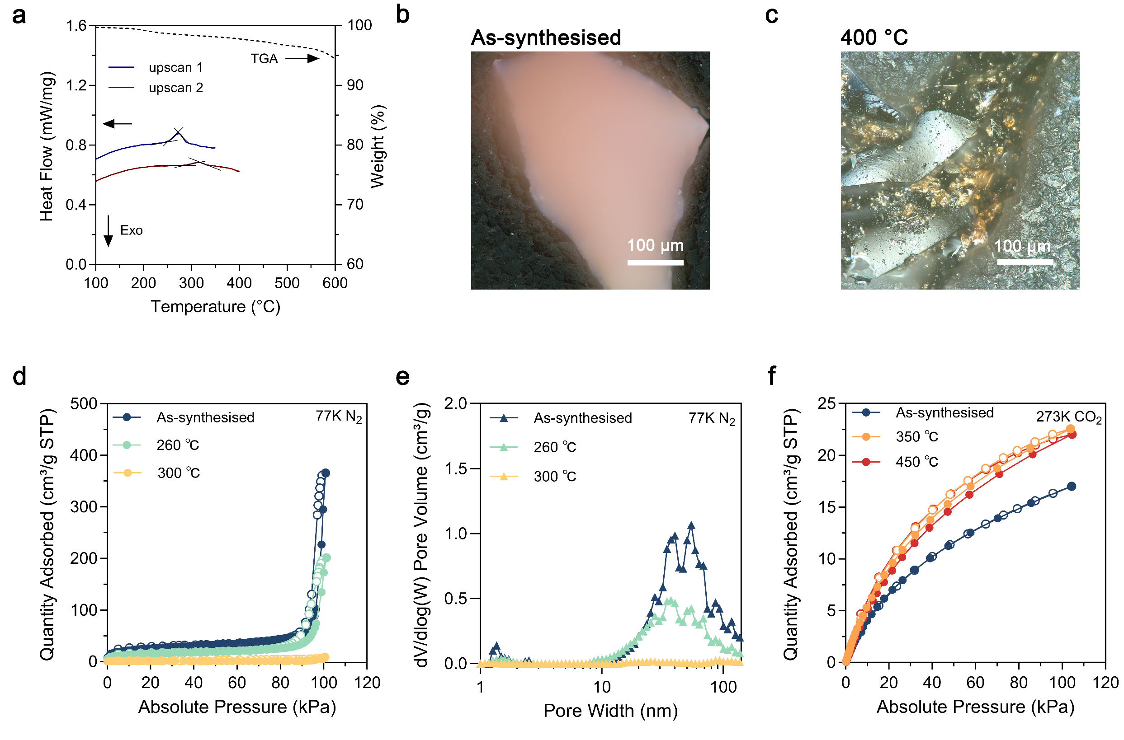

Supplementary Fig. 44 | Glass formation and porosity evolution of the a_{g}Zn(Im)(5-NH₂-bIm)-gel. a, TGA and DSC traces of a_{g}Zn(Im)(5-NH₂-bIm)-gel. b–c, Optical microscopy images of gel monoliths before and after annealing at 400 °C. d–e, N₂ adsorption (solid circles)-desorption (hollow circles) profiles collected at 77 K and the corresponding pore size distributions (calculated by the DFT method). f, CO₂ sorption isotherms recorded at 273 K.

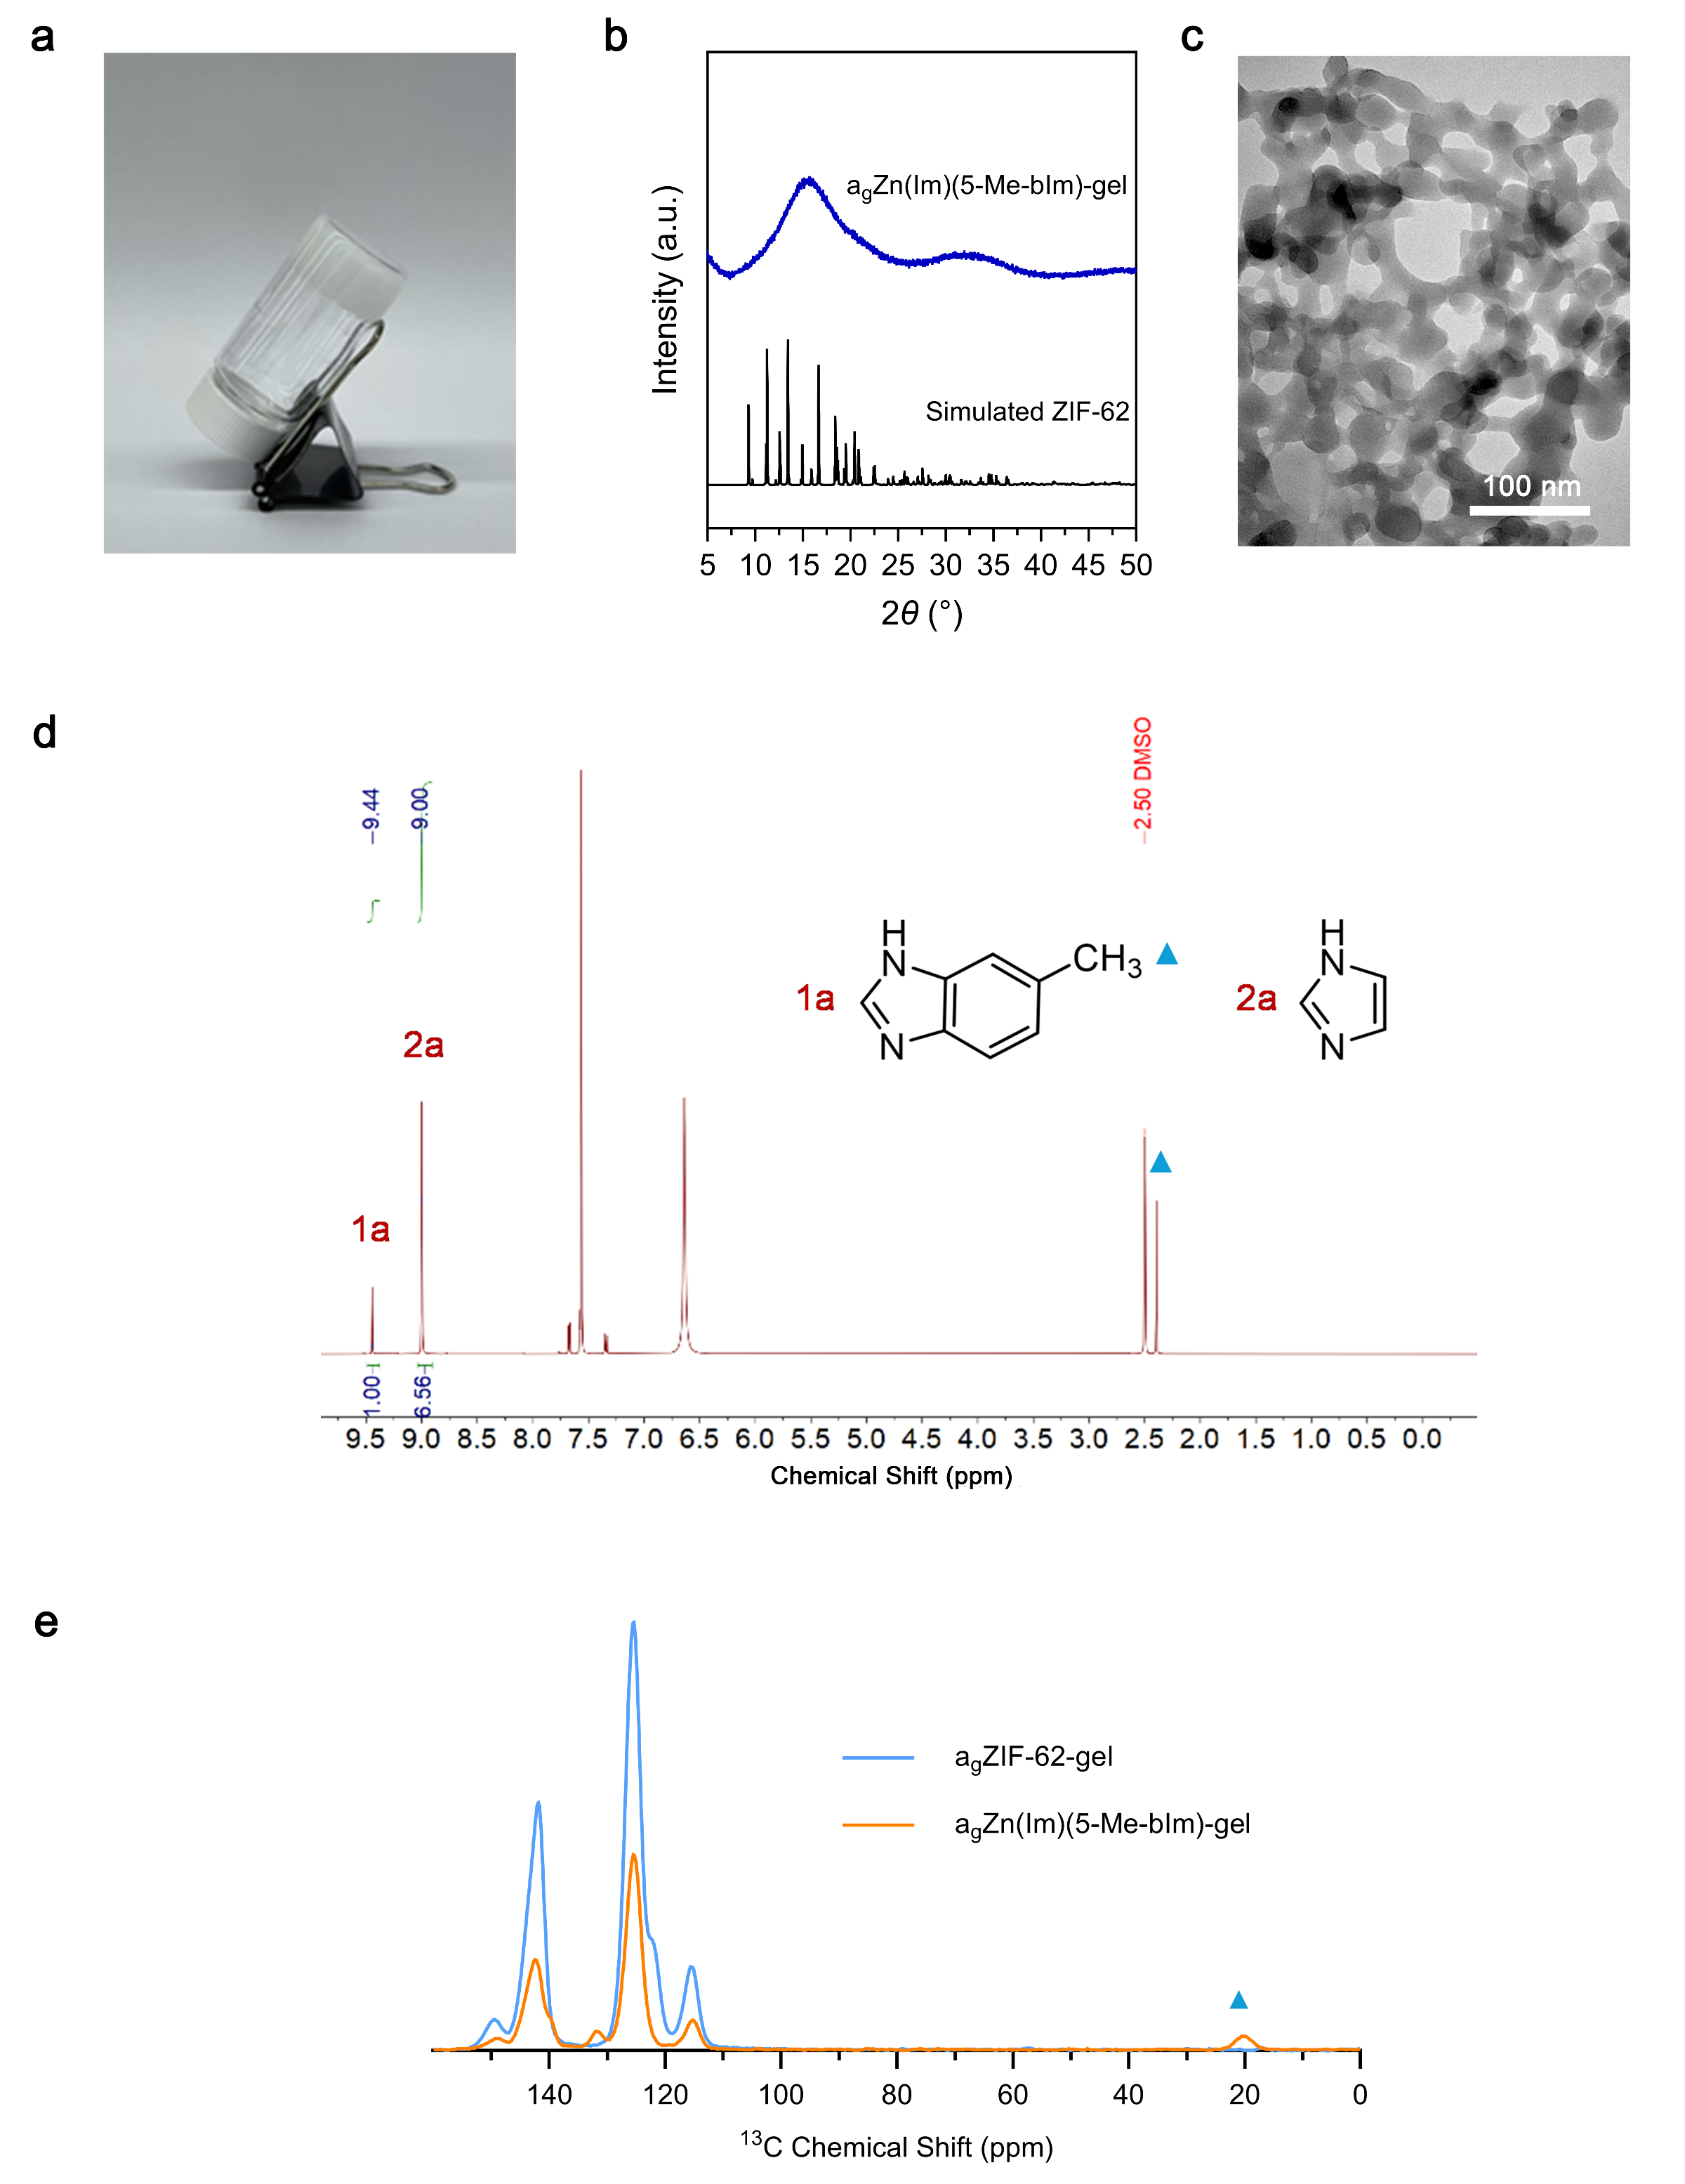
Supplementary Fig. 45 | Synthesis of the a_{g}Zn(Im)(5-Me-bIm)-gel. a, Photograph of the self-supporting a_{g}Zn(Im)(5-Me-bIm)-gel. b, PXRD pattern of the xerogel. c, TEM image of the fresh gel. d, ¹H NMR spectrum of the digested xerogel. A characteristic singlet corresponding to the methyl protons (–CH₃) is observed at ~2.2–2.5 ppm. e, ¹³C CPMAS NMR spectra, with the a_{g}ZIF-62-gel also presented as a comparison. Compared with normal a_{g}ZIF-62-gel, a distinct resonance assigned to the methyl carbon at 20 ppm, confirming the successful incorporation of 5-Me-bIm into the framework.
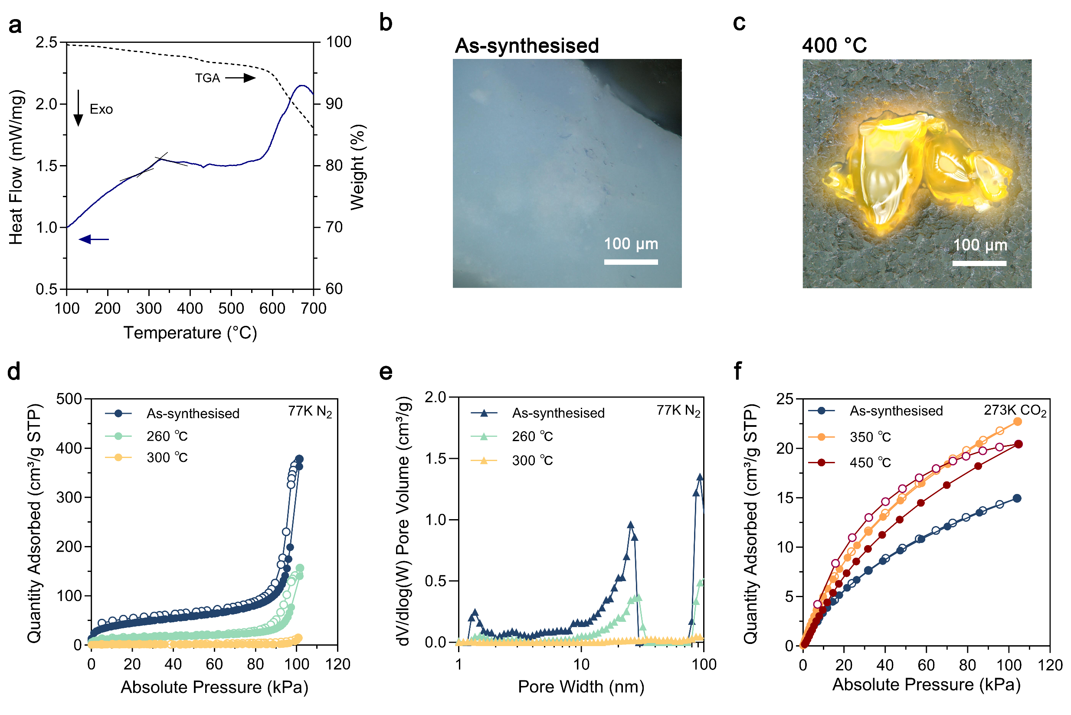

Supplementary Fig. 46 | Glass formation and porosity evolution of the a_{g}Zn(Im)(5-Me-bIm)-gel. a, Simultaneous TGA–DSC measurement of a_{g}Zn(Im)(5-Me-bIm)-gel. b–c, Optical microscopy images of gel monoliths before and after 400 °C annealing. d–e, N₂ adsorption (solid circles)-desorption (hollow circles) profiles collected at 77 K and the corresponding pore size distributions (calculated by the DFT method). f, CO₂ sorption isotherms recorded at 273 K.

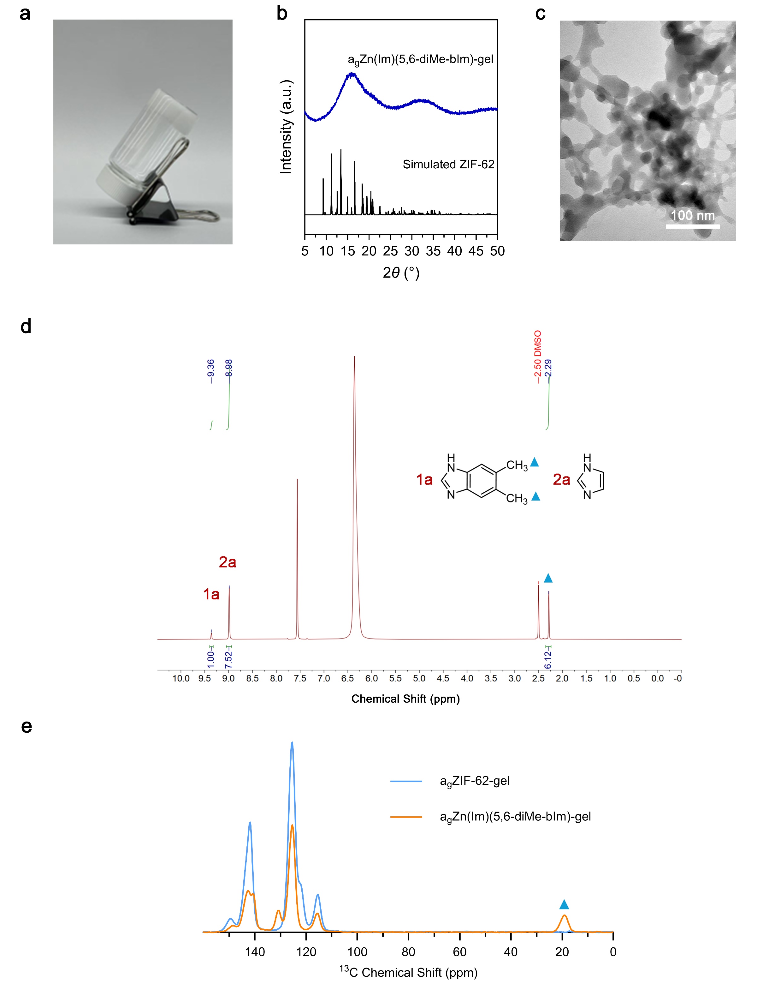

Supplementary Fig. 47 | Synthesis of the a_{g}Zn(Im)(5,6-diMe-bIm)-gel. a, Photograph of the self-supporting a_{g}Zn(Im)(5,6-diMe-bIm)-gel. b, PXRD pattern of the xerogel. c, TEM image of the fresh gel. d, ¹H NMR spectrum of the digested xerogel. The peak corresponding to the methyl protons (–CH₃) is observed at ~2.2–2.5 ppm. e, ¹³C CPMAS NMR spectra of the xerogel. The methyl carbons resonance observed at ~19–21 ppm indicates the incorporation of 5,6-diMe-bIm into the framework.
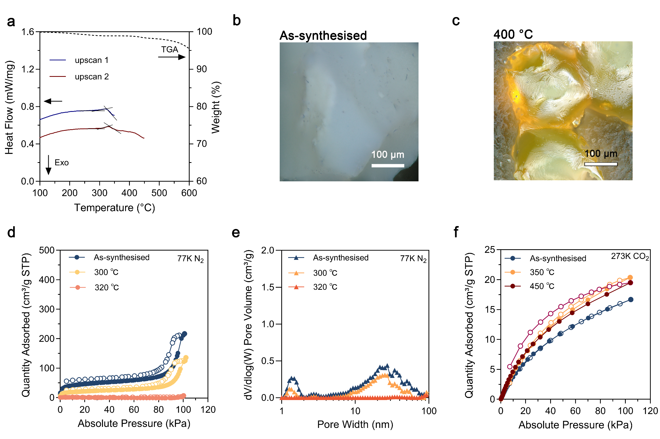

Supplementary Fig. 48 | Glass formation and porosity evolution of the a_{g}Zn(Im)(5,6-diMe-bIm)-gel. a, TGA and DSC traces of a_{g}Zn(Im)(5,6-diMe-bIm)-gel. b–c, Optical microscopy images of gel monoliths before and after 400 °C annealing. d–e, N₂ adsorption (solid circles)-desorption (hollow circles) profiles collected at 77 K and the corresponding pore size distributions (calculated by the DFT method). f, CO₂ sorption isotherms recorded at 273 K.
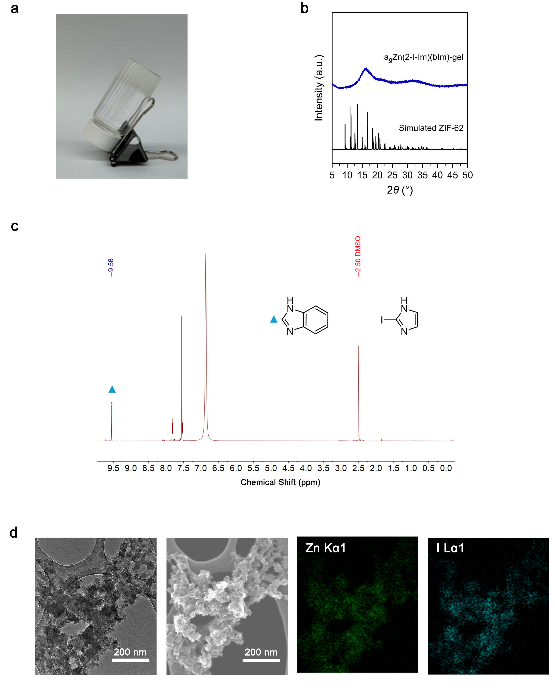

Supplementary Fig. 49 | Synthesis of the a_{g}Zn(2-I-Im)(bIm)-gel. a, Photograph of a_{g}Zn(2-I-Im)(bIm)-gel. b, PXRD pattern of the xerogel. c, ¹H NMR spectrum of the digested xerogel. d, HRTEM and STEM images of the fresh gel with elemental mapping. The uniform distribution of Zn and I confirms the successful incorporation of the I-substituted ligand into the framework.
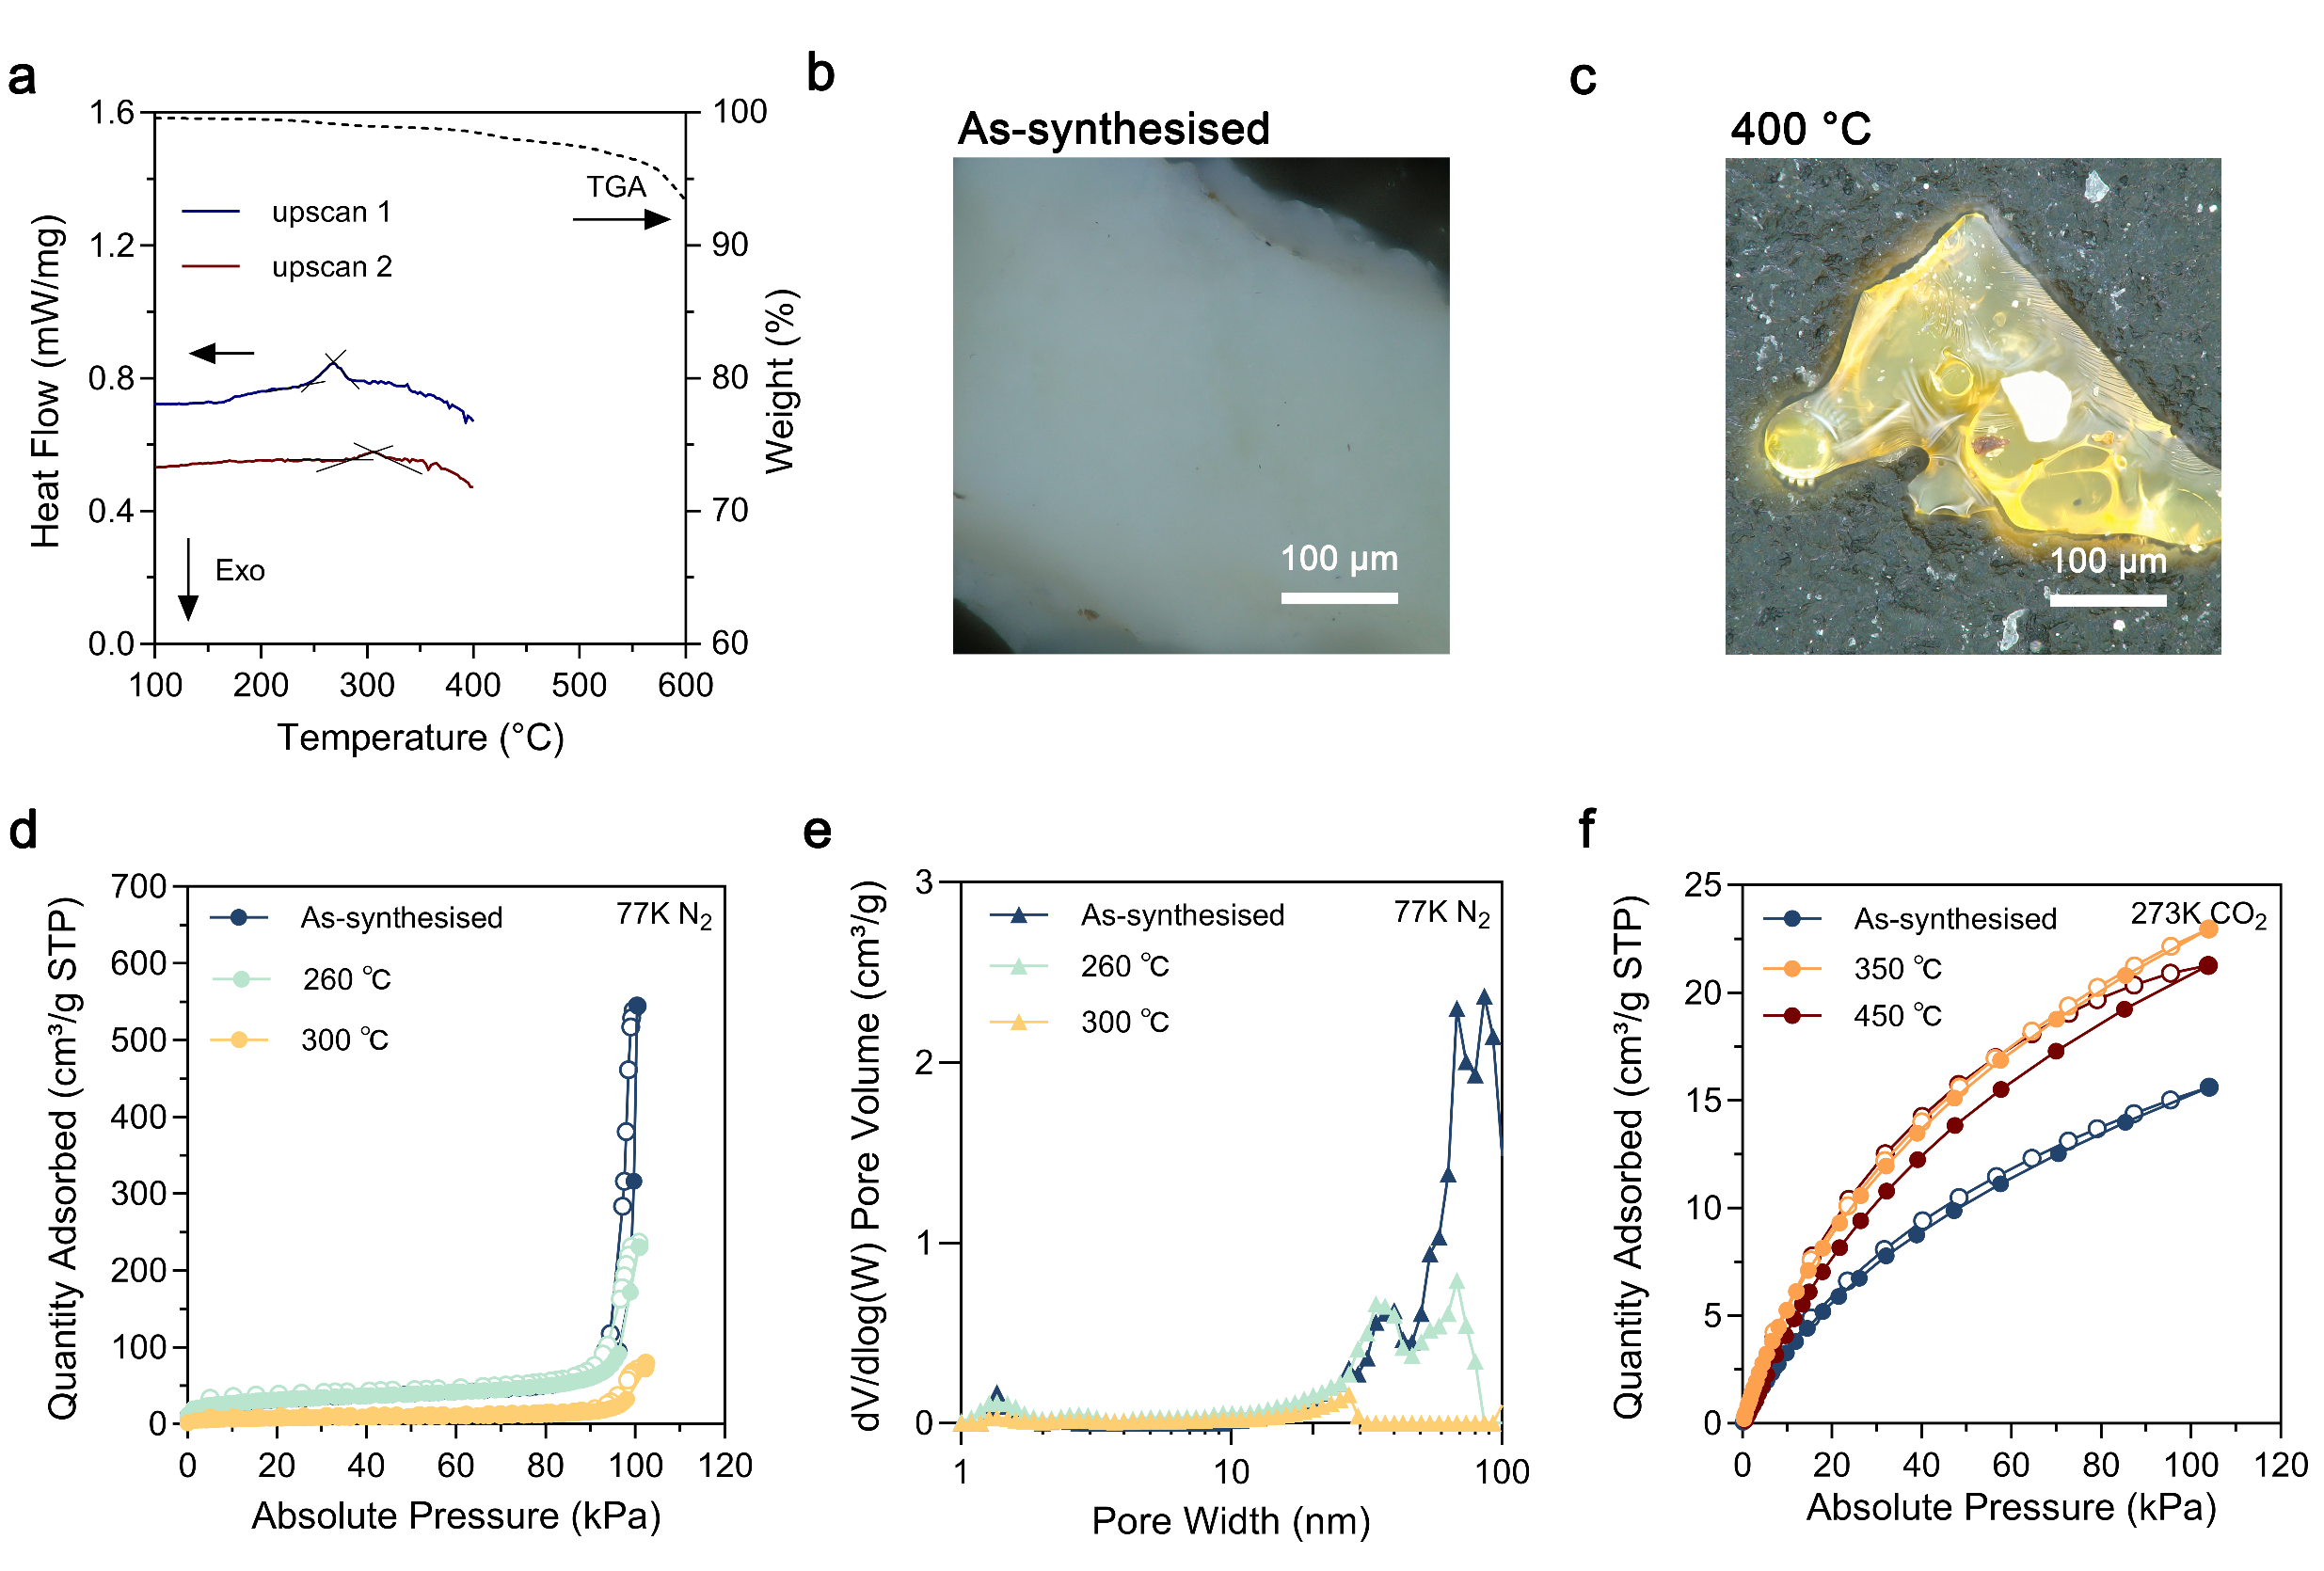

Supplementary Fig. 50 | Glass formation and porosity evolution of the a_{g}Zn(2-I-Im)(bIm)-gel. a, TGA and DSC traces of a_{g}Zn(2-I-Im)(bIm)-gel. b–c, Optical microscopy images of gel monoliths before and after 400 °C annealing. d–e, N₂ adsorption (solid circles)-desorption (hollow circles) profiles collected at 77 K and corresponding pore size distributions (calculated by the DFT method). f, CO₂ sorption isotherms recorded at 273 K.

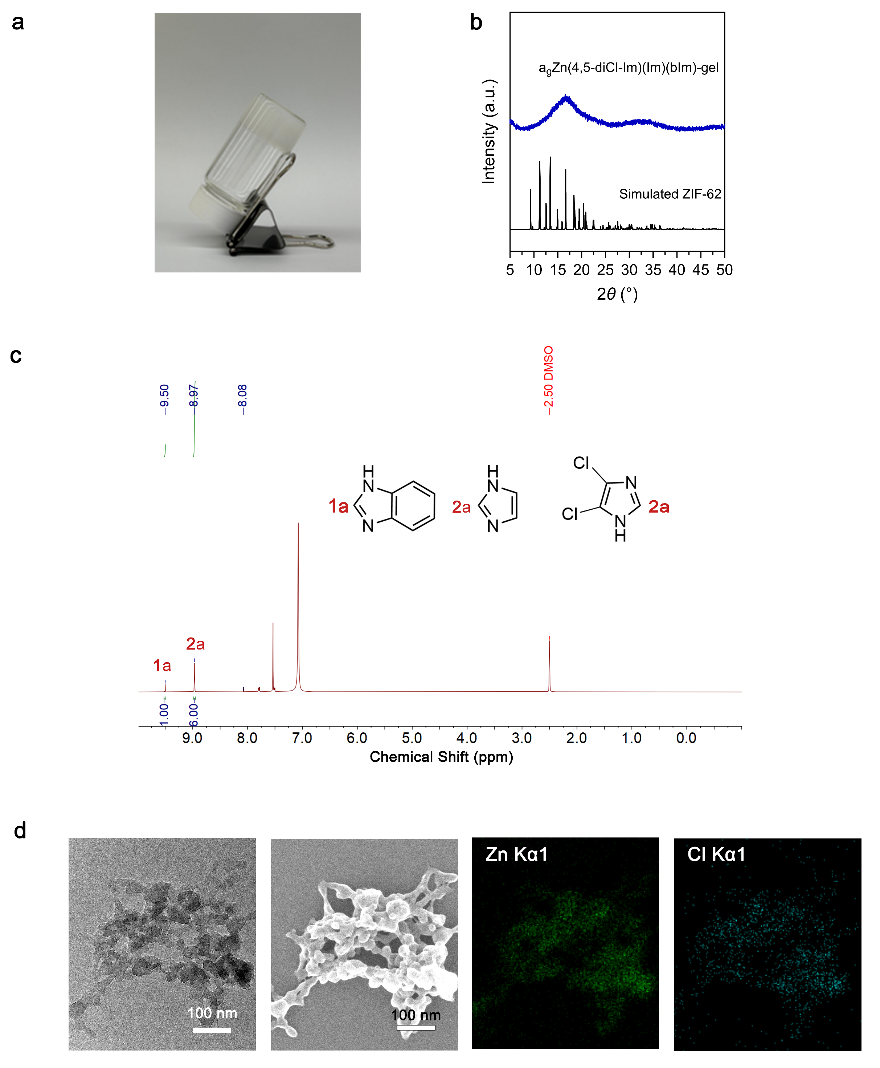

Supplementary Fig. 51 | Synthesis of the a_{g}Zn(4,5-diCl-Im)(Im)(bIm)-gel. a, Photograph of the self-supporting a_{g}Zn(4,5-diCl-Im)(Im)(bIm)-gel. b, PXRD pattern of the xerogel. c, ¹H NMR spectrum of the digested xerogel. d, HRTEM and STEM images of the fresh gel with elemental mapping. The uniform distribution of Zn and Cl confirms the successful incorporation of the Cl-substituted ligand into the framework.

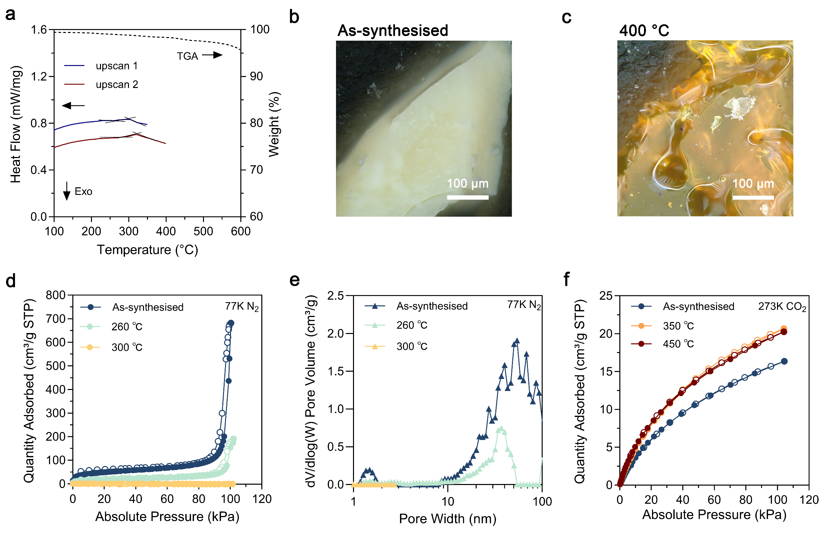

Supplementary Fig. 52 | Glass formation and porosity evolution of the a_{g}Zn(4,5-diCl-Im)(Im)(bIm)-gel. a, TGA and DSC traces of a_{g}Zn(4,5-diCl-Im)(Im)(bIm)-gel. b–c, Optical microscopy images of gel monoliths before and after 400 °C annealing. d–e, N₂ adsorption (solid circles)-desorption (hollow circles) profiles collected at 77 K and corresponding pore size distributions (calculated by the DFT method). f, CO₂ sorption isotherms recorded at 273 K.

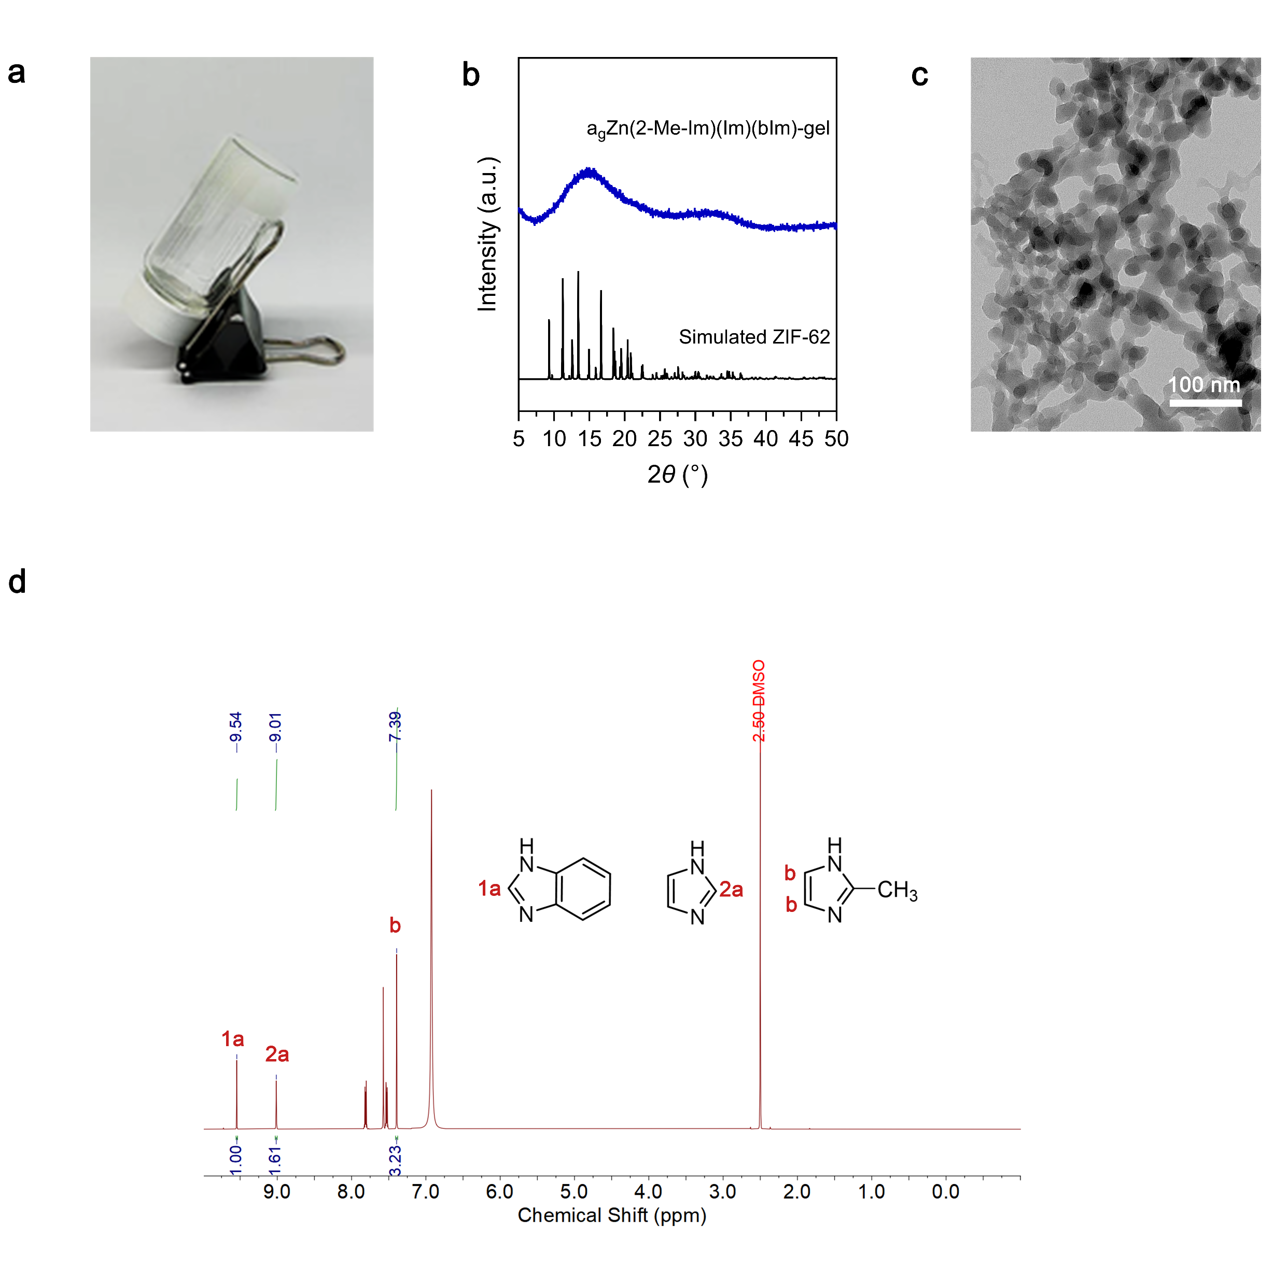

Supplementary Fig. 53 | Synthesis of the a_{g}Zn(2-Me-Im)(Im)(bIm)-gel. a, Photograph of the self-supporting a_{g}Zn(2-Me-Im)(Im)(bIm)-gel. b, PXRD pattern of the xerogel. c, TEM image of the fresh gel. d, ¹H NMR spectrum of the digested xerogel.
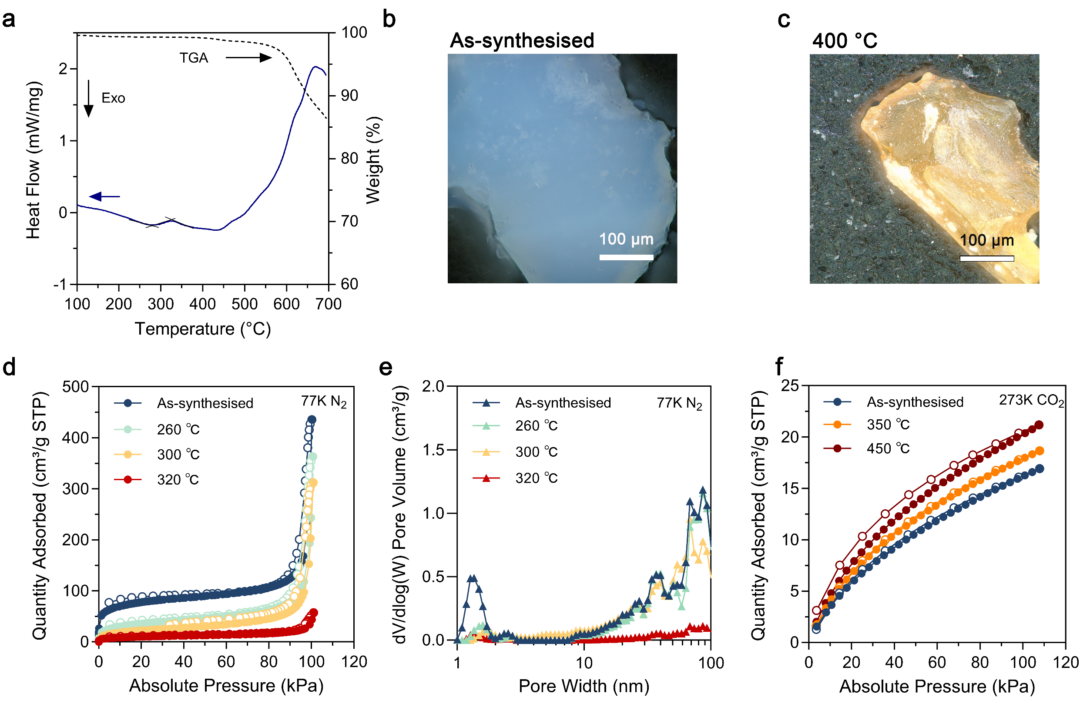

Supplementary Fig. 54 | Glass formation and porosity evolution of the a_{g}Zn(2-Me-Im)(Im)(bIm)-gel. a, Simultaneous TGA–DSC measurement of a_{g}Zn(2-Me-Im)(Im)(bIm)-gel. b–c, Optical microscopy images of gel monoliths before and after 400 °C annealing. d–e, N₂ adsorption (solid circles)-desorption (hollow circles) profiles collected at 77 K and corresponding pore size distributions (calculated by the DFT method). f, CO₂ sorption isotherms recorded at 273 K.

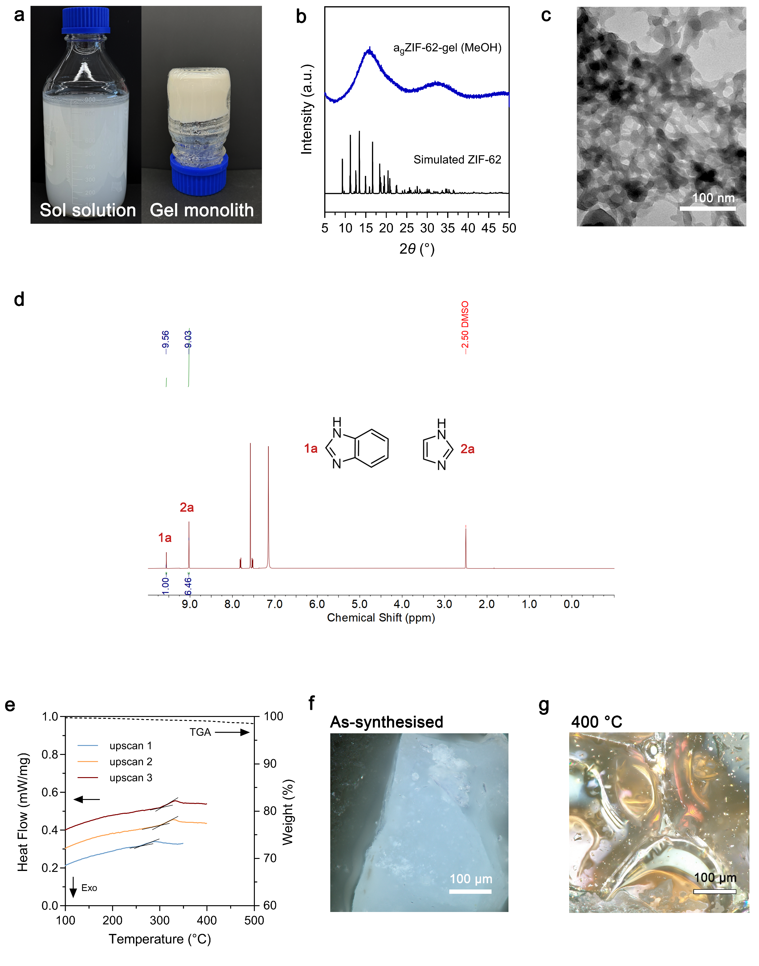

Supplementary Fig. 55 | Large-scale synthesis of a_{g}ZIF-62-gel using methanol solvent. a, Photograph of the methanol reaction system scaled up to 800 mL. b, PXRD pattern of xerogel. c, TEM image of the obtained gel. d, ¹H NMR spectrum of the digested xerogel. e, TGA and DSC curves of obtained xerogel, showing thermal stability and characteristic relaxation behaviour. f–g, Optical microscopy images showing the macroscopic appearance of the samples before and after 400 °C annealing.

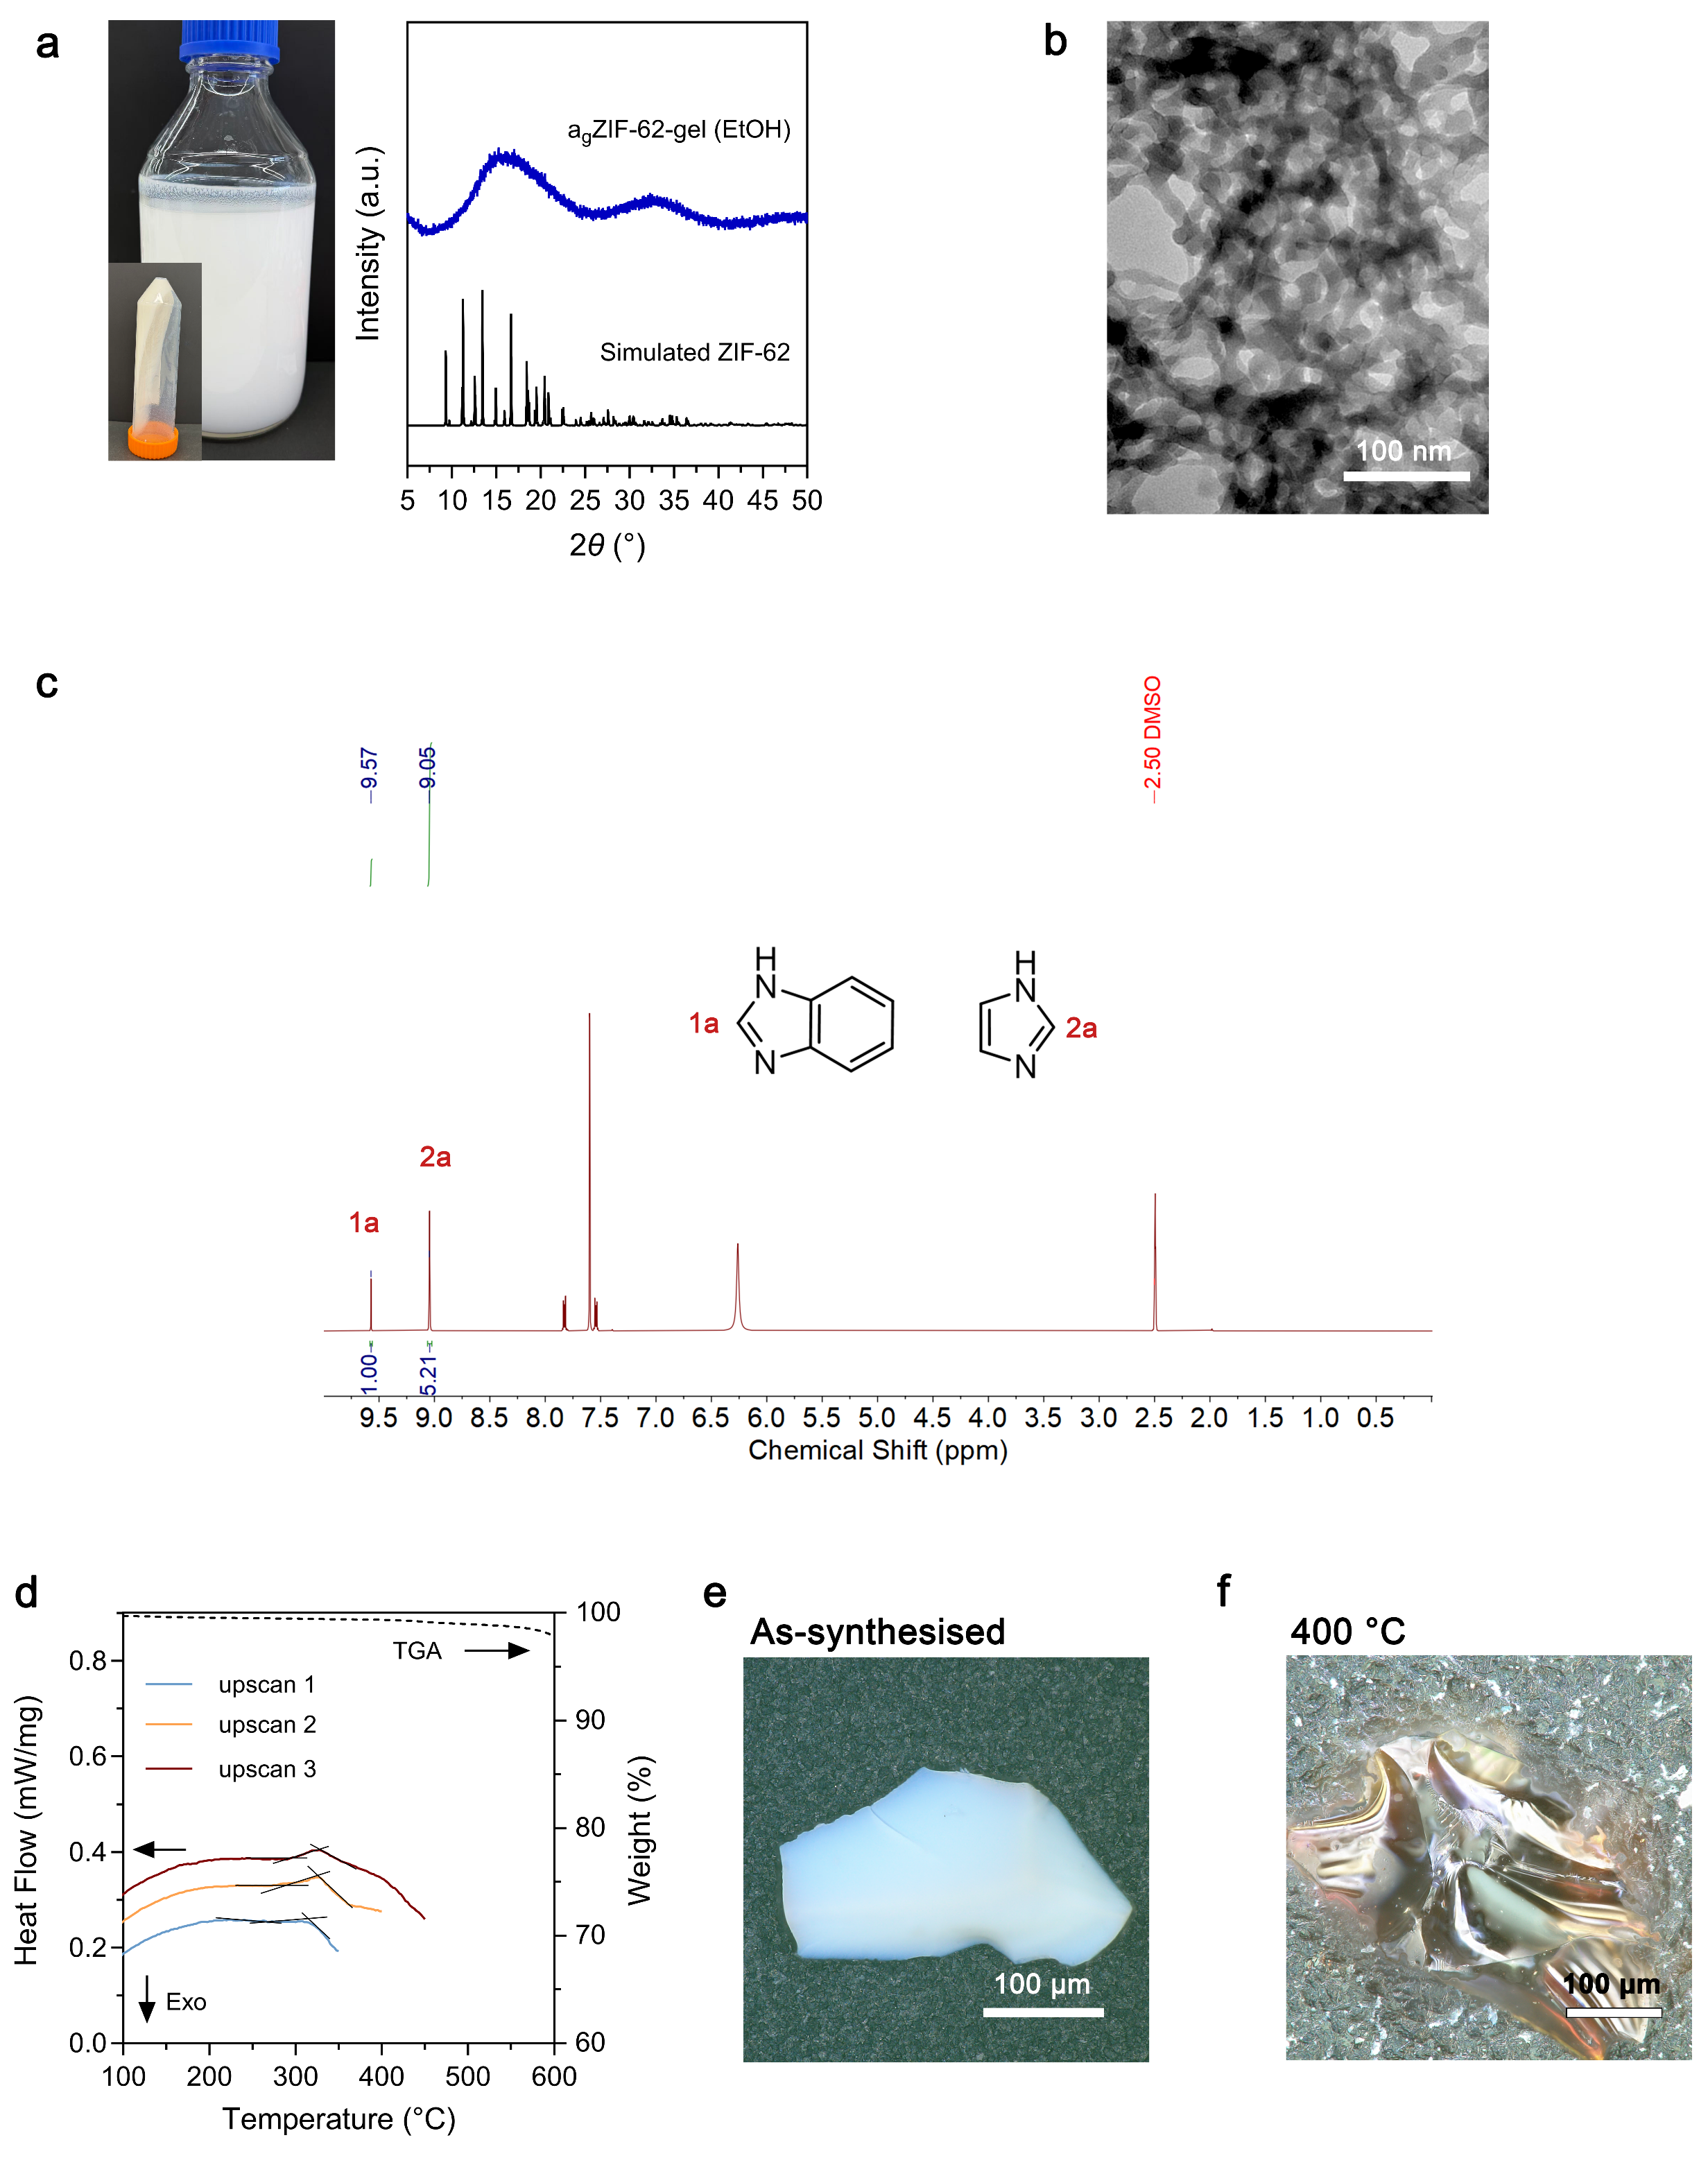

Supplementary Fig. 56 | Large-scale synthesis of agZIF-62-gel using ethanol solvent. a, Photograph of the ethanol-based sol-gel reaction system and its amorphous XRD pattern. b, TEM image of the gel. c, ¹H NMR spectrum of the digested xerogel. d, TGA and DSC curves, demonstrating comparable thermal behaviour. e–f, Optical microscopy images of the gel monoliths before and after annealing at 400 °C.

Supplementary Fig. 57 | CO₂ breakthrough profiles sharpen with increasing relaxation temperature. The 350 °C sample exhibits a steep front and minimal tailing, indicating enhanced transport through a more connected microporous network despite mesoscopic densification.

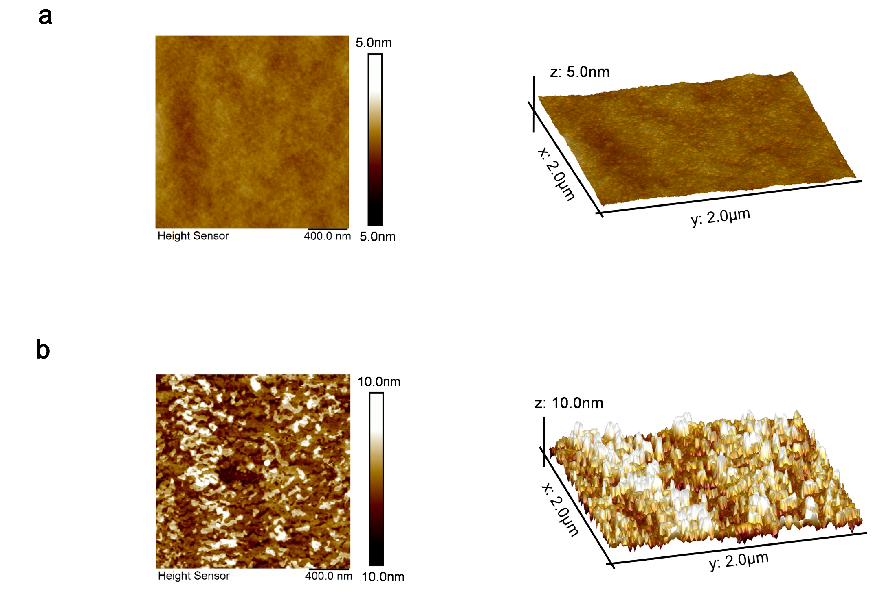
Supplementary Fig. 58 | Evolution of surface roughness after a_{g}ZIF-62-gel coating. AFM images and corresponding 3D surface views of a, 400 °C-annealed a_{g}ZIF-62-gel thin film (~150 nm thick) (R_{q} = 0.747 nm; R_{a} = 0.587 nm), and b, the bare quartz substrate (R_{q} = 3.10 nm; R_{a} = 2.34 nm).

Supplementary Fig. 59 | Specular UV-vis transmittance spectra of 400 °C-annealed a_{g}ZIF-62-gel thin films. Data for the bare quartz substrate are shown for comparison. The thickness of the coating is ~150 nm, determined by SEM.

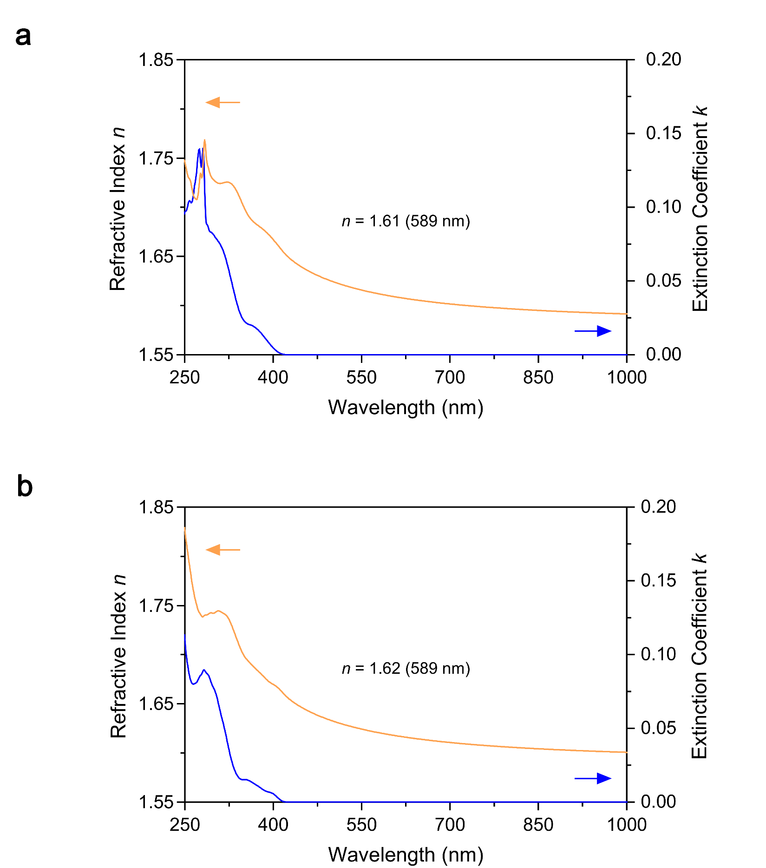

Supplementary Fig. 60 | Refractive index (orange) and extinction coefficient (blue) of thin films prepared from a, a_{g}ZIF-62-gel and b, a_{g}ZIF-62(Co)-gel after annealing at 400 °C, as determined by spectroscopic ellipsometry. The coating substrate is silicon wafer, and the coating thickness is ~200 nm, determined by SEM.

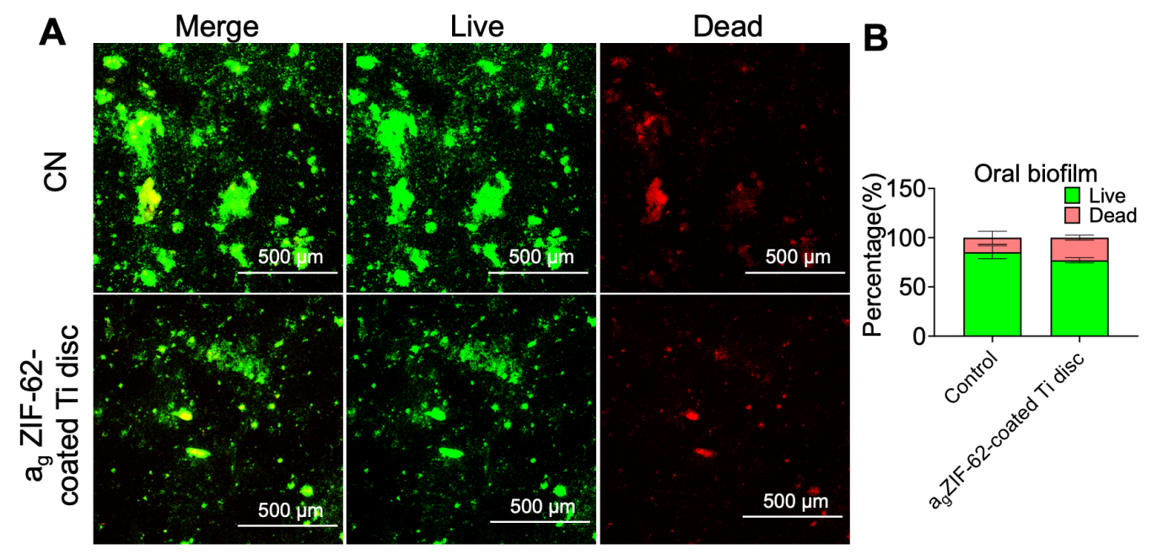

Supplementary Fig. 61 | Antibacterial effects of a_{g}ZIF-62-gel coated Ti discs in vitro. a, Representative Live/Dead fluorescence images of oral biofilms cultured on a_{g}ZIF-62-gel coated Ti discs for 4 days. b, Quantitative analysis of Live/Dead fluorescence intensity across treatment groups. Control: biofilms cultured in growth medium on uncoated discs.

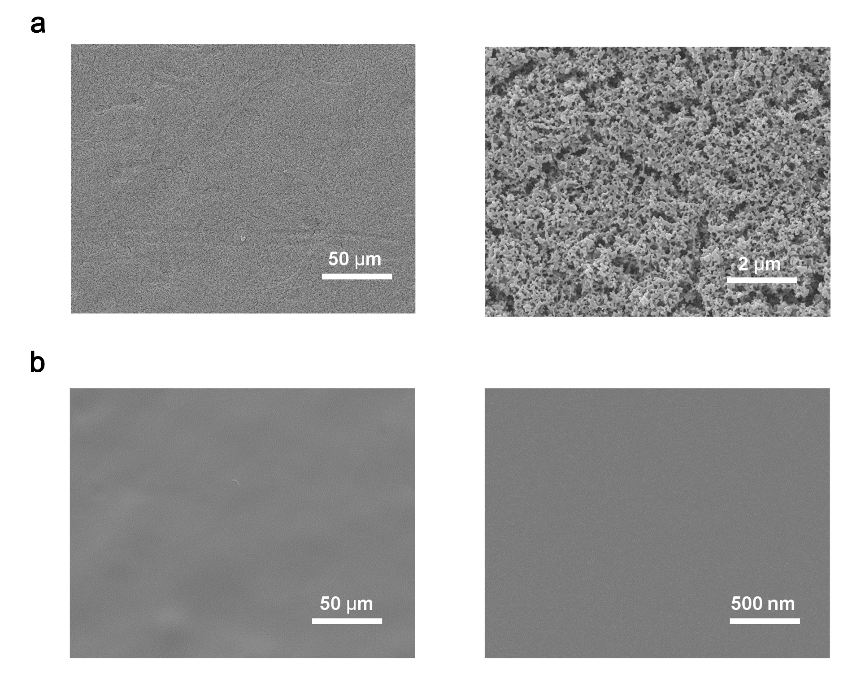

Supplementary Fig. 62 | Top-view SEM images of prepared a_{g}ZIF-62-gel membranes coated on α-Al₂O₃ ceramic support. a, Before thermal treatment. b, After the thermal treatment at 400 °C.

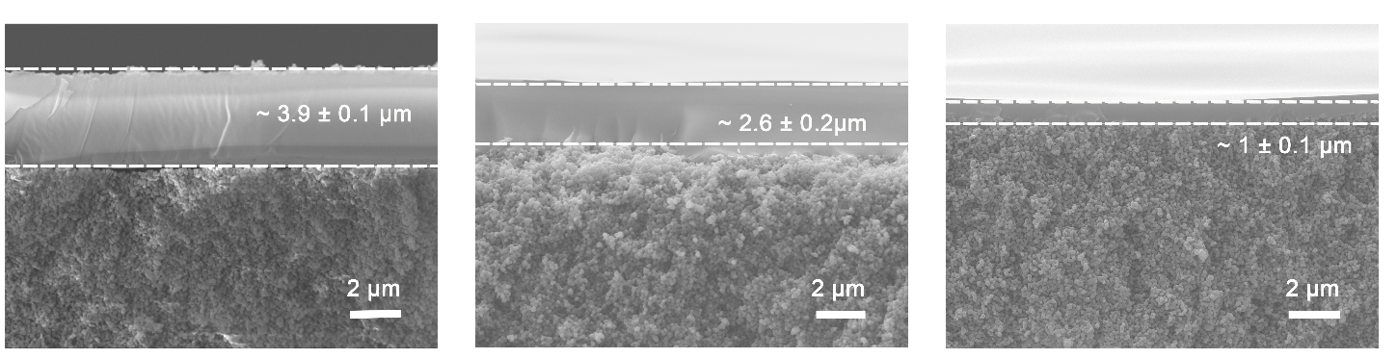

Supplementary Fig. 63 | Cross-sectional SEM images of a_{g}ZIF-62-gel membranes coated on α-Al₂O₃ ceramic support with different thicknesses. All membranes were treated at 400 °C.

Supplementary Fig. 64 | Thickness-dependent gas separation performance of MOF glass membrane with pure gas feeds. a, Gas permeance and b, selectivity as a function of membrane thickness. All membranes are prepared with a thermal treatment at 400 °C.

Supplementary Fig. 65 | Effect of treatment temperature on the gas separation performance with pure gas feeds. a, Gas permeance and b, selectivity as a function of membrane thermal treatment temperature. All membranes have a thickness of around 2.6 µm.

Supplementary Fig. 66 | Effect of treatment temperature on the gas separation performance with mixed gas feeds. Selective layer thickness of all membranes is around 2.6 µm.

Supplementary Fig. 67 | Membrane gas separation performance of the glass membranes from this work benchmarked against literature membrane data, the Robeson upper bound, and the updated upper bound. Solid and open red triangles denote membrane performance measured in this work under pure and mixed gas feeds, respectively. Colour-coded symbols represent membranes of varying materials and architectures reported in the literature² and detailed data in Supplementary Table 6.

Supplementary Fig. 68 | Membrane gas separation performance of the glass membranes from this work benchmarked against literature membrane data, the 2008 Robeson upper bound, and the updated upper bound. Solid and open red triangles denote membrane performance measured in this work under pure and mixed gas feeds, respectively. Colour-coded symbols represent membranes of varying materials and architectures reported in the literature³ and data shown in Supplementary Table 8.

Supplementary Fig. 69 | Membrane performance as a function of feed pressure under mixed gas conditions. Selective layer thickness is around 2.6 µm.

Supplementary Fig. 70 | Operational stability of the membrane under mixed gas (50/50 vol%) conditions. Selective layer thickness is around 2.6 µm.
.

Supplementary Table 1 | Fitting XAS parameters for Zn atoms in gel samples treated at different temperatures.

 | Path | CN | σ² | e0 | delr | Reff | R | R-factor
a_{g}ZIF-62-gel | N | 3.73±0.14 | 0.00579 | 5.953 | 0.09212 | 1.90140 | 1.99353 | 0.00931
a_{g}ZIF-62-gel | C1 | 5.67±0.20 | 0.00897 | 5.953 | 0.07958 | 2.94400 | 3.02358 | 0.00931
a_{g}ZIF-62-gel | C2 | 8.98±0.48 | 0.01459 | 5.953 | 0.17525 | 3.05430 | 3.22955 | 0.00931

 | Path | CN | σ² | e0 | delr | Reff | R | R-factor
300 °C-a_{g}ZIF-62-gel | N | 3.76±0.13 | 0.00557 | 5.924 | 0.09017 | 1.90140 | 1.99157 | 0.00799
300 °C-a_{g}ZIF-62-gel | C1 | 4.00±0.17 | 0.00651 | 5.924 | 0.06643 | 2.94400 | 3.01043 | 0.00799
300 °C-a_{g}ZIF-62-gel | C2 | 8.33±0.61 | 0.03142 | 5.924 | 0.15712 | 3.05430 | 3.21142 | 0.00799

 | Path | CN | σ² | e0 | delr | Reff | R | R-factor
450°C-a_{g}ZIF-62-gel | N | 3.76±0.09 | 0.00364 | 5.190 | 0.08209 | 1.90140 | 1.98349 | 0.01283
450°C-a_{g}ZIF-62-gel | C1 | 4.42±0.27 | 0.00707 | 5.190 | 0.04894 | 2.94400 | 2.99294 | 0.01283
450°C-a_{g}ZIF-62-gel | C2 | 8.94±1.09 | 0.03623 | 5.190 | 0.14159 | 3.05430 | 3.19625 | 0.01283

Supplementary Table 2 | Fitting parameters of the PALS results.
As-synthesised a_{g}ZIF-62-gel
Component | tau (ps) | sigma_tau (ns) | Intensity (%) | Pore diameter (nm)
Component 1 | 125.0 | 0.00465 | 22.1 | -
Component 2 | 341 | 0.00848 | 56.0 | -
Component 3 | 1590.9 | 0.02213 | 21.9 | 0.4880
χ²/d.o.f. = 1.8702

260 ºC-a_{g}ZIF-62-gel
Component | tau (ps) | sigma_tau (ns) | Intensity (%) | Pore diameter (nm)
Component 1 | 125.0 | 0.00527 | 21.9 | -
Component 2 | 323.1 | 0.00848 | 56.3 | -
Component 3 | 1585.4 | 0.02386 | 21.8 | 0.4868
χ²/d.o.f. = 1.8157

350 ºC-a_{g}ZIF-62-gel
Component | tau (ps) | sigma_tau (ns) | Intensity (%) | Pore diameter (nm)
Component 1 | 125 | 0.00780 | 18.4 | -
Component 2 | 313.5 | 0.00881 | 57.1 | -
Component 3 | 1537.4 | 0.02052 | 24.5 | 0.4761
χ²/d.o.f. = 1.5745

400 ºC-a_{g}ZIF-62-gel
Component | tau (ps) | sigma_tau (ns) | Intensity (%) | Pore diameter (nm)
Component 1 | 115.3 | 0.0063 | 16.4 | -
Component 2 | 310.6 | 0.00717 | 56.7 | -
Component 3 | 1485.6 | 0.0156 | 26.9 | 0.4642
χ²/d.o.f. = 1.8952

Supplementary Table 3 | Single-gas permeance (GPU), permeability (Barrer), and selectivity of a_{g}ZIF-62-gel membranes.

Membranes | Thickness | Permeances (GPU) |  | Permeability (Barrer) |  | Ideal selectivity
Membranes | Thickness | H₂ | CO₂ | N₂ | CH₄ | CO₂/N₂ | CO₂/CH₄ | H₂/N₂ | H₂/CH₄
400 °C-a_{g}ZIF-62-gel membranes | 1.0 ± 0.1 µm | 6586 ± 380 | 4492 ± 301 | 623.3 ± 39.6 | 760.7 ± 12.6 | 7.2 ± 0.2 | 5.9 ± 0.3 | 10.6 ± 0.5 | 8.7 ± 0.4
400 °C-a_{g}ZIF-62-gel membranes | 1.0 ± 0.1 µm | 6586 ± 380 | 4492 ± 301 | 623.3 ± 39.6 | 760.7 ± 12.6
400 °C-a_{g}ZIF-62-gel membranes | 3.9 ± 0.1 µm | 2857 ± 228 | 2210 ± 80.0 | 54.8 ± 6.4 | 67.2 ± 3.4 | 40.7 ± 3.7 | 32.9 ± 0.7 | 52.4 ± 2.5 | 42.5 ± 1.5
400 °C-a_{g}ZIF-62-gel membranes | 3.9 ± 0.1 µm | 11141 ± 888 | 8619 ± 311 | 213.5 ± 24.9 | 262.0 ± 13.1
400 °C-a_{g}ZIF-62-gel membranes | 2.6 ± 0.2 µm | 3911 ± 209 | 2321 ± 156 | 65.2 ± 3.4 | 75.4 ± 2.6 | 35.6 ± 1.3 | 30.8 ± 1.1 | 60.0 ± 2.3 | 51.9 ± 1.3
400 °C-a_{g}ZIF-62-gel membranes | 2.6 ± 0.2 µm | 10169 ± 543 | 6035 ± 406 | 169.6 ± 8.9 | 196.0 ± 6.8
375 °C-a_{g}ZIF-62-gel membranes | 2.6 ± 0.2 µm | 4879 ± 545 | 3735 ± 270 | 198.0 ± 12.6 | 245.2 ± 23.8 | 18.9 ± 0.3 | 15.3 ± 0.6 | 24.6 ± 2.3 | 19.9 ± 1.9
375 °C-a_{g}ZIF-62-gel membranes | 2.6 ± 0.2 µm | 12685 ± 1418 | 9711 ± 701 | 514.8 ± 32.7 | 637.4 ± 61.9
450 °C-a_{g}ZIF-62-gel membranes | 2.6 ± 0.2 µm | 3134 ± 167 | 1862 ± 103 | 51.4 ± 5.0 | 65.8 ± 1.9 | 36.4 ± 2.0 | 28.3 ± 0.6 | 60.9 ± 3.8 | 47.6 ± 0.8
450 °C-a_{g}ZIF-62-gel membranes | 2.6 ± 0.2 µm | 8147 ± 435 | 4842 ± 267 | 133.7 ± 13.0 | 171.2 ± 4.9

Supplementary Table 4 | Mixed-gas (50/50 vol%) permeance (GPU), permeability (Barrer), and selectivity of a_{g}ZIF-62-gel membranes.

Membranes | Thickness | CO₂/N₂ |  | CO₂/CH₄ |  | H₂/N₂ |  | H₂/CH₄
Membranes | Thickness | Permeance | Selectivity | Permeance | Selectivity | Permeance | Selectivity | Permeance | Selectivity
Membranes | Thickness | Permeability | Selectivity | Permeability | Selectivity | Permeability | Selectivity | Permeability | Selectivity
350 °C-a_{g}ZIF-62-gel membranes | 2.6 ± 0.2 µm | 5391 ± 386 /  627 ± 266 | 8.6 ± 3.7 | 5147 ± 364 /  830 ± 288 | 6.2 ± 2.2 | 6738 ± 447 /  688 ± 297 | 9.8 ± 1.5 | 6465 ± 485 /  819 ± 165 | 7.9 ± 1.7
350 °C-a_{g}ZIF-62-gel membranes | 2.6 ± 0.2 µm | 14018 ± 1004 / 1630 ± 692 | 8.6 ± 3.7 | 13383 ± 947 / 2156 ± 750 | 6.2 ± 2.2 | 17519 ± 1163 / 1788 ± 773 | 9.8 ± 1.5 | 16810 ± 1262 / 2130 ± 430 | 7.9 ± 1.7
400 °C-a_{g}ZIF-62-gel membranes | 2.6 ± 0.2 µm | 2256 ± 82 /  51.1 ± 1.6 | 44.2 ± 1.3 | 2027 ± 86 /  58.0 ± 2.7 | 34.9 ± 1.6 | 3992 ± 92 /  56.6 ± 2.2 | 70.5 ± 3.2 | 3615 ± 96 /  62.0 ± 5.3 | 58.3 ± 5.2
400 °C-a_{g}ZIF-62-gel membranes | 2.6 ± 0.2 µm | 5867 ± 214 / 132.9 ± 4.2 | 44.2 ± 1.3 | 5271 ± 223 / 150.8 ± 7.0 | 34.9 ± 1.6 | 10378 ± 238 / 147.2 ± 5.7 | 70.5 ± 3.2 | 9399 ± 250 /  161 ± 13.8 | 58.3 ± 5.2
450 °C-a_{g}ZIF-62-gel membranes | 2.6 ± 0.2 µm | 1925 ± 74 /  39.1 ± 1.1 | 49.1± 2.3 | 1921 ± 83 /  54.5 ± 4.5 | 35.2 ± 3.3 | 3183 ± 128 / 43.6 ± 3.1 | 73.0 ± 5.9 | 3180 ± 93 /  54.4 ± 5.8 | 58.4 ± 6.5
450 °C-a_{g}ZIF-62-gel membranes | 2.6 ± 0.2 µm | 5004 ± 191 / 101.7 ± 2.9 | 49.1± 2.3 | 4994 ± 215 / 141.7 ± 11.7 | 35.2 ± 3.3 | 8275 ± 333 / 113.4 ± 8.1 | 73.0 ± 5.9 | 8267 ± 242 / 141.4 ± 15.1 | 58.4 ± 6.5

Supplementary Table 5 | Summary of the CO₂/N₂ separation performance of representative membranes reported in the literature. Blue dot (⬤) and grey dot (⬤) in the upper bound figure (Fig. 4g) represent PIM and other polymers retrieved from the literature².
Materials |  | Thickness  (μm) | CO₂ permeance  (GPU) | CO₂ permeability  (Barrer) | CO₂/N₂ selectivity |  | Ref
 |  |  |  |  | Single Gas | Mix Gas | Ref
Crystalline MOFs ⬤ | MIL-125-TG on α-Al₂O₃ | 2.54 | 370 | 939.8 | 11.5 | 38.7 | 4
Crystalline MOFs ⬤ | MIL-125(Ti) on α-Al₂O₃ | 2.47 | 52 | 128.5 | 52.7 | 48.3 | 5
Crystalline MOFs ⬤ | UiO-66 on α-Al₂O₃ | 0.18 | 2070 | 372.6 | 35.4 | 34.7 | 6
Crystalline MOFs ⬤ | UiO-66 on α-Al₂O₃ | 3.5 | 112.8 | 394.8 | 31.3 | 21.4 | 7
Crystalline MOFs ⬤ | MIL-160 on α-Al₂O₃ | 3.0 | 508.2 | 1524.6 | 33.3 | - | 8
Crystalline MOFs ⬤ | MIL-100 on AAO | 2 | 2700 | 5400 | 3.8 | - | 9
Crystalline MOFs ⬤ | MIL-140A | 0.055 | 2755 (dry) | 151.5 | 60.6 | 59.8 | 10
Crystalline MOFs ⬤ | MIL-140A | 0.055 | 1939.5 (wet) | 106.7 | 79.4 | 79.0 | 10
Crystalline MOFs ⬤ | CAU-10-H on α-Al₂O₃ | 5 | 100 | 500 | 42.0 | - | 11
Crystalline MOFs ⬤ | CAU-1 on α-Al₂O₃ | 3 | 4080 | 12240 | 15.9 | 14.8 | 12
Crystalline MOFs ⬤ | Ni₃(HITP)₂ on AAO | 0.6 | 4750 | 2862 | 10.2 | 9.8 | 13
Crystalline MOFs ⬤ | Zr-TCA on PVDF | - | 1857 | - | 14.1 | 39.2 | 14
Crystalline MOFs ⬤ | ZIF-8 on α-Al₂O₃ | 6 | 102 | 612 | 2.4 | - | 15
Crystalline MOFs ⬤ | ZIF-8 on AAO | 0.1 | 102 | 10.5 | 7 | - | 16
Crystalline MOFs ⬤ | RHT ZIF-8 on AAO | 0.55 | 120 | 66 | 37.3 | - | 17
Crystalline MOFs ⬤ | ZIF-69 on α-Al₂O₃ | 40 | 75 | 3000 | 2.2 | 6.3 | 18
MOF glasses  ⬤ | a_{g}TIF-4 on α-Al₂O₃ | 7 | 44.5 | 311.5 | 25 | 27 | 19
MOF glasses  ⬤ | a_{g}ZIF-62 on α-Al₂O₃ | 70 | 37.6 | 2638 | 23 | 34.5 | 20
MOF glasses  ⬤ | a_{g}ZIF-62 on PTFE | 2-10 | 1649 | - | 83.3 | - | 21
MOF glasses  ⬤ | a_{g}ZIF-62 | 880 | 0.16 | 146.07 | 42.4 | - | 22
MOF glasses  ⬤ | a_{g}ZIF-62 on AAO | 2 | 550.9 | 1101.8 | 28.7 | 31.4 | 23
MOF glasses  ⬤ | a_{g}ZIF-62 | 330 | 1.5 | 500 | 21.8 | 19.5 | 24
MOF glasses  ⬤ | MUF-16_{0.4}/a_{g}ZIF-62_{0.6} | 500 | 204000 | - | 5.7 | 5 | 25
MOF glasses  ⬤ | ZIF-8/ZIF-62 hybrid glass on α-Al₂O₃ | 1.8 | 19 | 34.2 | 32 | 34.6 | 26
MOF glasses  ⬤ | MIL-101/a_{g}Zn-P-dmbIm | - | 69 | 18670 | - | 61 | 27
COFs  ⬤ | r-PATA | 0.92 | 1542.4 | 1419 | 6.7 | 30.6 | 28
COFs  ⬤ | NCOFM-50 on PAN | 0.057 | 1068.2 | 61 | - | 35.4 | 29
COFs  ⬤ | NCOFM-50 on PAN | 0.2 | 370.7 | 74.2 | - | 79.8 | 29
COFs  ⬤ | iCOF@PEI on PAN | 0.018 | 1069 | 19.2 | - | 146 | 30
COFs  ⬤ | iCOF@PEI on PAN | 0.008 | 2101 | 16.8 | - | 104 | 30
Zeolites  ⬤ | Si-CHA on tubular α-Al₂O₃ | 6 | 298 | 1791 | 15 | 16 | 31
Zeolites  ⬤ | SAPO-17 on ceramic tube | 12 | 3000 | 36000 | 10 | 14 | 32
Zeolites  ⬤ | AlPO-18 on tubular α-Al₂O₃ | 8 | 1850 | 14800 | 16 | 45 | 33
MMMs  ⬤ | ZIF-8/PIM-1 | - | - | 4027 | 24.8 | - | 34
MMMs  ⬤ | HZIF-8/PIM-1 | 0.78 |  | 8268 | 25.1 |  | 35
MMMs  ⬤ | [C₅min][BF₄]@ZIF-67/Pebax | 40–45 | - | 408.2 | - | 97.2 | 36
MMMs  ⬤ | ZIF-7/Matrimid | 30–50 |  | 64 | 200 | - | 37
MMMs  ⬤ | ZIF-90@C₃N₄/Pebax | - | - | 111 | 84.4 | - | 38
MMMs  ⬤ | UiO-66-NH₂/PIM-1 | 177 | - | 13000 | - | 32.2 | 39
MMMs  ⬤ | NH₂-MIL-101/Pebax | - | - | 226.3 | 71.3 | - | 40
MMMs  ⬤ | pw-MOF glass | - | - | 1750 | 63.3 | 64.9 | 41
MMMs  ⬤ | PS-MMM | - | - | 1385.44 | 15.48 | - | 42
 | 400 °C-a_{g}ZIF-62-gel | 2.6 | 2321 (pure gas)  2256 (mixed gas) | 6035 (pure gas)  5867 (mixed gas) | 35.6 | 44.2 | This work
 | 450 °C-a_{g}ZIF-62-gel | 2.6 | 1862 (pure gas)  1925 (mixed gas) | 4842 (pure gas)  5004 (mixed gas) | 36.4 | 49.1 | This work
Note: The table summarises representative literature reports on membrane separation performance for the corresponding gas pairs.

Supplementary Table 6 | Summary of the CO₂/CH₄ separation performance of representative membranes reported in the literature. Blue dot (⬤) and grey dot (⬤) in the upper bound figure (Supplementary Fig. 67) represent PIM and other polymers retrieved from the literature².
Materials |  | Thickness  (μm) | CO₂ permeance  (GPU) | CO₂ permeability  (Barrer) | CO₂/CH₄ selectivity |  | Ref
 |  |  |  |  | Single Gas | Mix Gas | Ref
Crystalline MOFs  ⬤ | PDA/UiO-66 on AAO | 0.8 | 1164 | 931.2 | 26.9 | 28.9 | 43
Crystalline MOFs  ⬤ | MIL-160/CAU-10-F on α-Al₂O₃ | 3.0 | 716 | 2148 | - | 78 | 8
Crystalline MOFs  ⬤ | Co(HCOO)₆ | ~11 | 5880.6 | 65010 | - | 12.63 | 44
Crystalline MOFs  ⬤ | CAU-10-H on α-Al₂O₃ | 5 | - | 500 | 95 | 45 | 11
Crystalline MOFs  ⬤ | Bio-MOF-1 on a stainless-steel porous tube | 15 | 3430 | 49500 | - | 2.6 | 45
Crystalline MOFs  ⬤ | SOD-ZMOF on alumina support | 35–40 | 1.9 | 94.1 | 3.6 | 4 | 46
Crystalline MOFs  ⬤ | ZIF-8 on ceramic hollow fiber | 2 | 1194.03 | 2388 | 3.3 | - | 47
Crystalline MOFs  ⬤ | ZIF-8 on α-Al₂O₃ | 7 | 50400 | 354900 | - | 7 | 48
Crystalline MOFs  ⬤ | ZIF-7-8 on AAO | 0.45 | 45 | 20.25 | 24 | 25 | 49
Crystalline MOFs  ⬤ | ZIF-90 on α-Al₂O₃ | 20 | 37.6 | 756 | 7 | 4.7 | 50
Crystalline MOFs  ⬤ | ZIF-69 | 40 | 300 | 12000 | 2.7 | 4.6 | 18
MOF glasses  ⬤ | a_{g}TIF-4 on α-Al₂O₃ | 7 | 44.5 | 311.5 | 26 | 30 | 19
MOF glasses  ⬤ | a_{g}ZIF-62 on α-Al₂O₃ | 70 | 37.6 | 2602 | 26 | 36.6 | 20
MOF glasses  ⬤ | a_{g}ZIF-62 | 880 | 0.16 | 146.07 | 64.10 | - | 22
MOF glasses  ⬤ | a_{g}ZIF-62 on PTFE | 2–10 | 1649 | - | 138.9 | - | 21
MOF glasses  ⬤ | a_{g}ZIF-62 on AAO | 2 | 550.9 | 1101.8 | 30.1 | 33.4 | 23
MOF glasses  ⬤ | a_{g}[(ZIF-62)_{0.7}(ZIF-7)_{0.3}] | 733–846 | 43.1 | 34103.73 | 35.3 | 33.11 | 51
MOF glasses  ⬤ | a_{g}[(ZIF-9)_{0.2}/(ZIF-62)_{0.8}] | 400–470 |  | 20324 | - | 20.5 | 52
MOF glasses  ⬤ | ZIF-8/ZIF-62 hybrid glass on α-Al₂O₃ | 1.8 | 19 | 34.2 | 35 | 30 | 26
COFs  ⬤ | NCOFM-50 on PAN | 0.1 | 506.1 | 51 | / | 35.5 | 29
COFs  ⬤ | NCOFM-50 on PAN | 0.2 | 335.7 | 67.2 | / | 53.6 | 29
COFs  ⬤ | ACOF-1 on α-Al₂O₃ | 8 | 29.6 | 236 | - | 86.4 | 53
COFs  ⬤ | DhaTGAsp on PAN | 0.065 | 316 | 20.5 | - | 49 | 54
COFs  ⬤ | DhaTGAsp on PAN | 0.23 | 143 | 32.8 | - | 78.5 | 54
Zeolite  ⬤ | Si-CHA on tubular α-Al₂O₃ | 6 | 269 | 1612 | 40 | 48 | 31
Zeolite  ⬤ | SSZ-13 on alumina monolith supports | 1.5 | 6870 | 10305 | 46.6 | 72 | 55
MMMs  ⬤ | ZIF-8/PIM-1 | - |  | 6338 | 18.8 |  | 34
MMMs  ⬤ | HZIF-8/PIM-1 | 0.78 |  | 8268 | 18.7 |  | 35
MMMs  ⬤ | ZIF-8-NH₂/PI | 0.3 |  | 778 |  | 34 | 56
MMMs  ⬤ | ZIF-7-NH₂/Pebax 1657 | 50 |  | 96 |  | 40 | 57
MMMs  ⬤ | NH₂-UiO-66/PEI | 9.8–15.9 |  | 437 | 46.8 | 33.9 | 58
MMMs  ⬤ | MIL-125 (Ti)/6FDA–durene | 47–52 |  | 1116 | 37.1 | - | 59
MMMs  ⬤ | MOF-808/PIM-1 | 100–200 |  | 9090 | 13 | 16.2 | 60
MMMs  ⬤ | a_{g}ZIF-62 /PIM | 70 | 84.5 | 5914 | - | 66.6 | 61
MMMs  ⬤ | pw-MOF glass | - | - | 1750 | 52.1 | 53.6 | 41
MMMs  ⬤ | PS-MMM | - | - | 1385.44 | 20.23 | - | 42
 | 400 °C-a_{g}ZIF-62-gel | 2.6 | 2321 (pure gas)  2027 (mixed gas) | 6035 (pure gas)  5271 (mixed gas) | 30.8 | 34.9 | This work
 | 450 °C-a_{g}ZIF-62-gel | 2.6 | 1862 (pure gas)  1921 (mixed gas) | 4842 (pure gas)  4994 (mixed gas) | 28.3 | 35.2 | This work

Supplementary Table 7 | Summary of the H₂/N₂ separation performance of representative membranes reported in the literature. Blue dot (⬤) and grey dot (⬤) in the upper bound figure (Fig. 4h) represent PIM and other polymers retrieved from the literature².
Materials |  | Thickness  (μm) | H₂ permeance  (GPU) | H₂ permeability  (Barrer) | H₂/N₂ selectivity |  | Ref
 |  |  |  |  | Single gas | Mixed gas | Ref
Crystalline MOFs  ⬤ | MIL-125-TG on α-Al₂O₃ | 2.54 | 612 | 1562.1 | 64.9 | - | 4
Crystalline MOFs  ⬤ | NH₂-MIL-125 (Ti) on α-Al₂O₃ | 0.5 | 133.5 | 66.75 | 10.4 | 9.6 | 62
Crystalline MOFs  ⬤ | NH₂-MIL-53 (Al) on macroporous glass frit discs | 15 | 7973 | 119595 | 19.5 | 23.9 | 63
Crystalline MOFs  ⬤ | UiO-66-NH₂ on α-Al₂O₃ | 7.5 | 8270 | 62325 | - | 3.02 | 64
Crystalline MOFs  ⬤ | UiO-66 on α-Al₂O₃ | 0.18 | 1340 | 241 | 23.1 | 22.7 | 6
Crystalline MOFs  ⬤ | UiO-66 on α-Al₂O₃ | 2.2 | 608.4 | 1345.08 | - | 18.35 | 65
Crystalline MOFs  ⬤ | HKUST-1 on α-Al₂O₃ | 25 | 3000 | 75000 | 7.5 | - | 66
Crystalline MOFs  ⬤ | ZIF-7 on alumina supports | 1.5 | 136 | 271.8 | 20.7 | 18 | 67
Crystalline MOFs  ⬤ | ZIF-67 on tubular α-Al₂O₃ | 3–4 | 679 | 2716 | 21.8 | 19.55 | 68
Crystalline MOFs  ⬤ | ZIF-8 on titania supports | 42 | 180 | 7610.4 | 11.6 | - | 69
Crystalline MOFs  ⬤ | ZIF-22 on TiO₂ supports | 40 | 603 | 24240 | 7.1 | - | 70
Crystalline MOFs  ⬤ | ZIF-90 on α-Al₂O₃ | 20 | 746 | 14944.7 | 12.6 | 11.7 | 71
Crystalline MOFs  ⬤ | Oriented crystalline MIP-177 on α-Al₂O₃ | 1.1 | 267 (120 ℃) | 303.6 | 148 | - | 72
MOF glasses  ⬤ | a_{g}ZIF-62 | 880 | 0.58 | 509.23 | 147.71 | - | 22
MOF glasses  ⬤ | ZIF-8/ZIF-62 hybrid glass on α-Al₂O₃ | 1.8 | 19.1 | 31.3 | 40 | - | 26
Organic cage ⬤ | ASPOC on AAO | 0.5 | 379 | 189.5 | 32.0 | - | 73
Organic cage ⬤ | CC3 on AAO | 0.05 | 1630 | 81.5 | 33 | - | 73
Carbon membranes  ⬤ | Ultra-thin carbon membrane on Poly(1-trimethylsilyl 1-propyne) | 0.01 | 2800 | 28 | 66 | - | 74
Carbon membranes  ⬤ | Ultra-thin carbon membrane on Poly(1-trimethylsilyl 1-propyne) | 0.01 | 11145 | 11.45 | 189 | - | 74
GO ⬤ | Graphene oxide on  Porous YSZ hollow fiber | 0.23 | 133 | 30.6 | 64 | - | 75
MMMs ⬤ | Defect ZIF-8/P84 HT | - | - | 123.8 | 75.0 | - | 76
MMMs ⬤ | MIL-177(Ti)/PIM-EA-TB | 108 | 61.8 | 6674 | 20.2 | - | 77
MMMs ⬤ | IPD@ZIF-8/PI | - | - | 7982 | 13 | - | 78
MMMs ⬤ | ZIF-8 decorated graphene nanoribbons/PI | 2.2 | 212 | 466.4 | - | 19 | 79
MMMs ⬤ | ZIF-8 decorated graphene nanoribbons/PI | 2.2 | 775 | 1705 | - | 13 | 79
MMMs ⬤ | Porous framework PAF-120/TPIM | - | - | 2440 | 61 | - | 80
Polymers ⬤ | P33DT-ThC4 | 1-2 | 313 | ~ 626 | ~70 | - | 81
Polymers ⬤ | Conjugated microporous polymers | - | 303 | - | - | 126.3 | 82
Polymers ⬤ | TPBO | - | - | 810 | - | 96 | 83
 | 450 °C-a_{g}ZIF-62-gel | 2.6 | 3911 (pure gas)  3992 (mixed gas) | 10169 (pure gas)  10378 (mixed gas) | 60.0 | 70.5 | This work
 | 450 °C-a_{g}ZIF-62-gel | 2.6 | 3134 (pure gas)  3183 (mixed gas) | 8147 (pure gas)  8275 (mixed gas) | 60.9 | 73.0 | This work

Supplementary Table 8 | Summary of the H₂/CH₄ separation performance of representative membranes reported in the literature. Blue dot (⬤) and grey dot (⬤) in the upper bound figure (Supplementary Fig. 68) represent PIM and other polymers retrieved from the literature³.
Materials |  | Thickness  (μm) | H₂ permeance  (GPU) | H₂ permeability  (Barrer) | H₂/CH₄ selectivity |  | Ref
 |  |  |  |  | Single gas | Mixed gas | Ref
Crystalline MOFs  ⬤ | MIL-125-TG on α-Al₂O₃ | 2.54 | 612 | 1562.1 | 40.7 | - | 4
Crystalline MOFs  ⬤ | NH₂-MIL-125 (Ti) on α-Al₂O₃ | 0.5 | 133.5 | 66.75 | 11.2 | 11.8 | 62
Crystalline MOFs  ⬤ | NH₂-MIL-53 (Al) on macroporous glass frit discs | 15 | 7973 | 119595 | 18.5 | 20.7 | 63
Crystalline MOFs  ⬤ | UiO-66 on α-Al₂O₃ | 0.18 | 1340 | 241 | 14.5 | 14.3 | 6
Crystalline MOFs  ⬤ | ZIF-7 on alumina support | 1.5 | 136 | 333 | 14.7 | 14 | 67
Crystalline MOFs  ⬤ | ZIF-67 on tubular α-Al₂O₃ | 3–4 | 590 | 2360 | 45.4 | 41.86 | 68
Crystalline MOFs  ⬤ | Co-ZIF-L on AAO | 0.04 | 2275 | 91 | 59.1 | 33.3 | 84
Crystalline MOFs  ⬤ | ZIF-8 on titania support | 42 | 180.3 | 7572.6 | 12.6 | 11.2 | 69
Crystalline MOFs  ⬤ | ZIF-90 on α-Al₂O₃ | 20 | 740 | 14880 | 15.9 | - | 71
Crystalline MOFs  ⬤ | ZIF-90 on α-Al₂O₃ | 20 | 851 (225 °C) | 17020 | 77 | - | 50
Crystalline MOFs  ⬤ | ZIF-7–8 on AAO | 0.5 | 82 | 41 | 66 | 71 | 49
Crystalline MOFs  ⬤ | Oriented crystalline MIP-177 on α-Al₂O₃ | 1.1 | 101 | 111.1 | 56.2 | - | 72
MOF glasses  ⬤ | a_{g}ZIF-62 | 880 | 0.58 | 509.23 | 223.47 | - | 22
MOF glasses  ⬤ | ZIF-8/ZIF-62 hybrid glass on α-Al₂O₃ | 1.8 | 19.1 | 31.3 | 45 | - | 26
MOF glasses  ⬤ | a_{g}ZIF-62 on α-Al₂O₃ | 70 | 56.7 | 4156 | 59 | 50.7 | 20
Organic cage ⬤ | ASPOC on AAO | 0.5 | 379 | 189.5 | 19.3 | - | 73
Organic cage ⬤ | CC3 on AAO | 0.05 | 1630 | 81.5 | 20.1 | - | 73
COFs ⬤ | COF-LZU1 on α-Al₂O₃ | 2 | 3301 | 6602 | - | 29.5 | 85
COFs ⬤ | COF-320 on α-Al₂O₃ | 4 | 1671.2 | 6684.8 | 2.5 | - | 86
Zeolite ⬤ | AlPO-18 on tubular α-Al₂O₃ | 8 | 300 | 2400 | 52 | 22 | 33
MMMs ⬤ | Defect ZIF-8/P84 HT | - | - | 123.8 | 177.4 | - | 76
MMMs ⬤ | ZIF-8@PDA/TB | - | - | 664 | 37.7 | - | 87
MMMs ⬤ | ZIF-8/6FBD | 50–70 | - | 444 | 67.9 | - | 88
MMMs ⬤ | CoZIF-95/PI | - | - | 967 | 188 | 134 | 89
MMMs ⬤ | IPD@ZIF-8/PI | - | - | 7982 | 15.1 | 12.6 | 78
MMMs ⬤ | Porous framework PAF-120/TPIM |  |  | 1335 | 78 |  | 80
MMMs ⬤ | ZIF-62 glass/PBI | 45 | - | 459 | - | 57 | 90
Polymers ⬤ | TPBO |  |  | 810 |  | 203 | 83
Polymers ⬤ | PIM-EA-TB | 180 | 42.1 | 7760 |  | 11 | 91
 | 450 °C-a_{g}ZIF-62-gel | 2.6 | 3911 (pure gas)  3615 (mixed gas) | 10169 (pure gas)  9399 (mixed gas) | 51.9 | 58.3 | This work
 | 450 °C-a_{g}ZIF-62-gel | 2.6 | 3134 (pure gas)  3180 (mixed gas) | 8147 (pure gas)  8267 (mixed gas) | 47.6 | 58.4 | This work

Reference
1. Qiao, A. et al. A metal-organic framework with ultrahigh glass-forming ability. Science Advances 4, eaao6827 (2018).
2. Comesaña-Gándara, B. et al. Redefining the Robeson upper bounds for CO₂ /CH₄ and CO₂ /N₂ separations using a series of ultrapermeable benzotriptycene-based polymers of intrinsic microporosity. Energy Environ. Sci. 12, 2733–2740 (2019).
3. Swaidan, R., Ghanem, B. & Pinnau, I. Fine-Tuned Intrinsically Ultramicroporous Polymers Redefine the Permeability/Selectivity Upper Bounds of Membrane-Based Air and Hydrogen Separations. ACS Macro Lett. 4, 947–951 (2015).
4. Wang, C. et al. Titanium-Oxo Cluster Assisted Fabrication of a Defect-Rich Ti-MOF Membrane Showing Versatile Gas-Separation Performance. Angewandte Chemie 134, e202203663 (2022).
5. Wang, C., Ji, T., Wu, Y., He, G. & Liu, Y. Fabrication of MIL-125 Membrane with Unprecedented CO2/N2 Selectivity Using Ti6-oxo Cluster Source. ACS Materials Lett. 5, 1311–1316 (2023).
6. Sun, Y. et al. Fabrication of Highly Oriented Ultrathin Zirconium Metal-Organic Framework Membrane from Nanosheets towards Unprecedented Gas Separation. Angewandte Chemie International Edition 62, e202216697 (2023).
7. Rong, R., Sun, Y., Ji, T. & Liu, Y. Fabrication of highly CO2/N2 selective polycrystalline UiO-66 membrane with two-dimensional transition metal dichalcogenides as zirconium source via tertiary solvothermal growth. Journal of Membrane Science 610, 118275 (2020).
8. Fan, W. et al. Multivariate Polycrystalline Metal–Organic Framework Membranes for CO2/CH4 Separation. J. Am. Chem. Soc. 143, 17716–17723 (2021).
9. Dou, Z. et al. Preparation and Gas Separation Properties of Metal-Organic Framework Membranes. Zeitschrift für anorganische und allgemeine Chemie 641, 792–796 (2015).
10. Yan, J. et al. Amino Acid-Decorated MOF Membranes Toward Facilitated CO2 Separation Under Varying Humidities. Advanced Functional Materials 35, 2506327 (2025).
11. Chiou, D.-S. et al. Highly CO2 Selective Metal–Organic Framework Membranes with Favorable Coulombic Effect. Advanced Functional Materials 31, 2006924 (2021).
12. Jian, Y. et al. Facile synthesis of highly permeable CAU-1 tubular membranes for separation of CO2/N2 mixtures. Journal of Membrane Science 522, 140–150 (2017).
13. Jiang, S., Shi, X., Zu, Y., Sun, F. & Zhu, G. Interfacial growth of 2D MOF membranes via contra-diffusion for CO 2 separation. Materials Chemistry Frontiers 5, 5150–5157 (2021).
14. Lin, Y. et al. Organic-Acid-Mediated Growth of Oriented Membrane from 2D-Structured Zirconium MOF for CO2 Separation. Angewandte Chemie International Edition n/a, e202519421.
15. Zhang, X. et al. New Membrane Architecture with High Performance: ZIF-8 Membrane Supported on Vertically Aligned ZnO Nanorods for Gas Permeation and Separation. Chem. Mater. 26, 1975–1981 (2014).
16. Hu, Y. et al. Zeolitic Imidazolate Framework/Graphene Oxide Hybrid Nanosheets as Seeds for the Growth of Ultrathin Molecular Sieving Membranes. Angewandte Chemie 128, 2088–2092 (2016).
17. Babu, D. J. et al. Restricting Lattice Flexibility in Polycrystalline Metal–Organic Framework Membranes for Carbon Capture. Advanced Materials 31, 1900855 (2019).
18. Liu, Y., Zeng, G., Pan, Y. & Lai, Z. Synthesis of highly c-oriented ZIF-69 membranes by secondary growth and their gas permeation properties. Journal of Membrane Science 379, 46–51 (2011).
19. Xia, H. et al. A long-lasting TIF-4 MOF glass membrane for selective CO2 separation. Journal of Membrane Science 655, 120611 (2022).
20. Wang, Y. et al. A MOF Glass Membrane for Gas Separation. Angewandte Chemie 132, 4395–4399 (2020).
21. Jin, X. et al. Liquid metal interface enables glassy MOF membranes with defect-mediated CO₂ transport. Nat Commun 16, 9510 (2025).
22. Mahdavi, H. et al. Design and Development of a Self-Supporting ZIF-62 Glass MOF Membrane with Enhanced Molecular Sieving for High H2 Separation Efficiency. ACS Omega 10, 7441–7451 (2025).
23. Xie, S. et al. Cathodic Deposition-Assisted Synthesis of Thin Glass MOF Films for High-Performance Gas Separations. Angewandte Chemie International Edition 63, e202401817 (2024).
24. Smirnova, O. et al. Unlocking large-area free-standing MOF-glasses for molecular sieving gas separation membranes. Nat Commun 17, 2575 (2026).
25. Zhang, Y., McHugh, L. N., Bennett, T. D., Yin, B. H. & Telfer, S. G. Metal−Organic Framework Crystal-Glass Composite Membranes for the Separation of Carbon Dioxide. Advanced Functional Materials 35, 2505539 (2025).
26. Zhang, Y. et al. A hybrid ZIF-8/ZIF-62 glass membrane for gas separation. Chem. Commun. 58, 9548–9551 (2022).
27. Li, N. et al. Highly porous MOF integrated with coordination polymer glass membrane for efficient CO2/N2 separation. Journal of Membrane Science 715, 123453 (2025).
28. Zhang, H. et al. Assembly-Dissociation-Reconstruction Synthesis of Covalent Organic Framework Membranes with High Continuity for Efficient CO2 Separation. Angewandte Chemie International Edition 63, e202411724 (2024).
29. Guo, Z. et al. Missing-linker Defects in Covalent Organic Framework Membranes for Efficient CO2 Separation. Angewandte Chemie International Edition 61, e202210466 (2022).
30. Wang, S. et al. Ultrathin ionic COF Membrane via Polyelectrolyte-Mediated Assembly for Efficient CO2 Separation. Advanced Functional Materials 33, 2300386 (2023).
31. Liu, B., Zhou, R., Yogo, K. & Kita, H. Preparation of CHA zeolite (chabazite) crystals and membranes without organic structural directing agents for CO2 separation. Journal of Membrane Science 573, 333–343 (2019).
32. Zhong, S. et al. Aluminophosphate-17 and silicoaluminophosphate-17 membranes for CO2 separations. Journal of Membrane Science 520, 507–514 (2016).
33. Wang, B., Hu, N., Wang, H., Zheng, Y. & Zhou, R. Improved AlPO-18 membranes for light gas separation. Journal of Materials Chemistry A 3, 12205–12212 (2015).
34. He, S. et al. Symbiosis-inspired de novo synthesis of ultrahigh MOF growth mixed matrix membranes for sustainable carbon capture. Proceedings of the National Academy of Sciences 119, e2114964119 (2022).
35. Zhu, B. et al. Boosting membrane carbon capture via multifaceted polyphenol-mediated soldering. Nat Commun 14, 1697 (2023).
36. Sun, Y. et al. Improved CO2/N2 separation performance by relatively continuous and defect-free distribution of IL-encapsulated ZIF-67 in ion gel membranes. Journal of Membrane Science 683, 121818 (2023).
37. Jia, Q., Lasseuguette, E., Lozinska, M. M., Ferrari, M.-C. & Wright, P. A. Hybrid Benzimidazole–Dichloroimidazole Zeolitic Imidazolate Frameworks Based on ZIF-7 and Their Application in Mixed Matrix Membranes for CO2/N2 Separation. ACS Appl. Mater. Interfaces 14, 46615–46626 (2022).
38. Guo, F. et al. Constructing MOF-doped two-dimensional composite material ZIF-90@C3N4 mixed matrix membranes for CO2/N2 separation. Separation and Purification Technology 280, 119803 (2022).
39. Yuan, Z. et al. Boosting carbon capture with CO2-Ultrapermeable molecularly imprinted membranes. Journal of Membrane Science 709, 123107 (2024).
40. Zheng, W. et al. Regulating the pore engineering of MOFs by the confined dissolving of PSA template to improve CO2 capture. Journal of Membrane Science 670, 121373 (2023).
41. Yang, Y. et al. Synthesizing Polymer Woven Metal–Organic Framework Glass Membranes for Exceptional Pressure-Tolerant Carbon Capture. J. Am. Chem. Soc. 148, 1210–1219 (2026).
42. Li, C. et al. Establishing gas transport highways in MOF-based mixed matrix membranes. Science Advances 9, eadf5087 (2023).
43. Wu, W., Li, Z., Chen, Y. & Li, W. Polydopamine-Modified Metal–Organic Framework Membrane with Enhanced Selectivity for Carbon Capture. Environ. Sci. Technol. 53, 3764–3772 (2019).
44. Zou, X. et al. Co3(HCOO)6 Microporous Metal–Organic Framework Membrane for Separation of CO2/CH4 Mixtures. Chemistry – A European Journal 17, 12076–12083 (2011).
45. A. Bohrman, J. & A. Carreon, M. Synthesis and CO 2 /CH 4 separation performance of Bio-MOF-1 membranes. Chemical Communications 48, 5130–5132 (2012).
46. Al-Maythalony, B. A. et al. Quest for Anionic MOF Membranes: Continuous sod-ZMOF Membrane with CO2 Adsorption-Driven Selectivity. J. Am. Chem. Soc. 137, 1754–1757 (2015).
47. Pan, Y., Wang, B. & Lai, Z. Synthesis of ceramic hollow fiber supported zeolitic imidazolate framework-8 (ZIF-8) membranes with high hydrogen permeability. Journal of Membrane Science 421–422, 292–298 (2012).
48. Venna, S. R. & Carreon, M. A. Highly Permeable Zeolite Imidazolate Framework-8 Membranes for CO2/CH4 Separation. J. Am. Chem. Soc. 132, 76–78 (2010).
49. Hou, Q. et al. Ultra-Tuning of the Aperture Size in Stiffened ZIF-8_Cm Frameworks with Mixed-Linker Strategy for Enhanced CO2/CH4 Separation. Angewandte Chemie International Edition 58, 327–331 (2019).
50. Huang, A., Liu, Q., Wang, N. & Caro, J. Organosilica functionalized zeolitic imidazolate framework ZIF-90 membrane for CO2/CH4 separation. Microporous and Mesoporous Materials 192, 18–22 (2014).
51. Li, D. et al. Self-supported flux melted glass membranes fabricated by melt quenching for gas separation. Journal of Membrane Science 695, 122492 (2024).
52. Liu, X. et al. Efficient CO2/CH4 separation achieved by metal–organic framework crystal-glass composite membranes. AIChE Journal 71, e18883 (2025).
53. Fan, H., Mundstock, A., Gu, J., Meng, H. & Caro, J. An azine-linked covalent organic framework ACOF-1 membrane for highly selective CO 2 /CH 4 separation. Journal of Materials Chemistry A 6, 16849–16853 (2018).
54. Guo, Z. et al. Oil–Water–Oil Triphase Synthesis of Ionic Covalent Organic Framework Nanosheets. Angewandte Chemie 133, 27284–27291 (2021).
55. Li, Y. et al. High-performance 7-channel monolith supported SSZ-13 membranes for high-pressure CO2/CH4 separations. Journal of Membrane Science 629, 119277 (2021).
56. Song, S. et al. Mixed matrix composite membranes with MOF-protruding structure for efficient CO2 separation. Journal of Membrane Science 669, 121340 (2023).
57. Qian, J. et al. Improved CO2/CH4 separation performance of mixed-matrix membrane by adding ZIF-7-NH2 nanocrystals. Journal of Applied Polymer Science 138, 50424 (2021).
58. Cui, Y. et al. High CO2 adsorption of ultra-small Zr-MOF nanocrystals synthesized by modulation method boosts the CO2/CH4 separation performance of mixed-matrix membranes. Journal of Membrane Science 689, 122174 (2024).
59. Suhaimi, N. H. et al. Separation of CO2 from CH4 using mixed matrix membranes incorporated with amine functionalized MIL-125 (Ti) nanofiller. Chemical Engineering Research and Design 159, 236–247 (2020).
60. Yahia, M., Lozano, L. A., Zamaro, J. M., Téllez, C. & Coronas, J. Microwave-assisted synthesis of metal–organic frameworks UiO-66 and MOF-808 for enhanced CO2/CH4 separation in PIM-1 mixed matrix membranes. Separation and Purification Technology 330, 125558 (2024).
61. Feng, Y. et al. Thermal treatment optimization of porous MOF glass and polymer for improving gas permeability and selectivity of mixed matrix membranes. Chemical Engineering Journal 465, 142873 (2023).
62. Sun, Y. et al. In-Plane Epitaxial Growth of Highly c-Oriented NH2-MIL-125(Ti) Membranes with Superior H2/CO2 Selectivity. Angewandte Chemie 130, 16320–16325 (2018).
63. Zhang, F. et al. Hydrogen Selective NH2-MIL-53(Al) MOF Membranes with High Permeability. Advanced Functional Materials 22, 3583–3590 (2012).
64. Micero, A., Hashem, T., Gliemann, H. & Léon, A. Hydrogen Separation Performance of UiO-66-NH2 Membranes Grown via Liquid-Phase Epitaxy Layer-by-Layer Deposition and One-Pot Synthesis. Membranes 11, 735 (2021).
65. Yan, J. et al. Cooperative defect tailoring: A promising protocol for exceeding performance limits of state-of-the-art MOF membranes. Journal of Membrane Science 635, 119515 (2021).
66. Varela Guerrero, V., Yoo, Y., C. McCarthy, M. & Jeong, H.-K. HKUST-1 membranes on porous supports using secondary growth. Journal of Materials Chemistry 20, 3938–3943 (2010).
67. Li, Y., Liang, F., Bux, H., Yang, W. & Caro, J. Zeolitic imidazolate framework ZIF-7 based molecular sieve membrane for hydrogen separation. Journal of Membrane Science 354, 48–54 (2010).
68. Nian, P. et al. ZnO Nanorod-Induced Heteroepitaxial Growth of SOD Type Co-Based Zeolitic Imidazolate Framework Membranes for H2 Separation. ACS Appl. Mater. Interfaces 10, 4151–4160 (2018).
69. Bux, H. et al. Zeolitic Imidazolate Framework Membrane with Molecular Sieving Properties by Microwave-Assisted Solvothermal Synthesis. J. Am. Chem. Soc. 131, 16000–16001 (2009).
70. Huang, A., Bux, H., Steinbach, F. & Caro, J. Molecular-Sieve Membrane with Hydrogen Permselectivity: ZIF-22 in LTA Topology Prepared with 3-Aminopropyltriethoxysilane as Covalent Linker. Angewandte Chemie 122, 5078–5081 (2010).
71. Huang, A., Dou, W. & Caro, J. Steam-Stable Zeolitic Imidazolate Framework ZIF-90 Membrane with Hydrogen Selectivity through Covalent Functionalization. J. Am. Chem. Soc. 132, 15562–15564 (2010).
72. Chen, S. et al. Oriented Titanium-MOF Membrane for Hydrogen Purification. Angewandte Chemie International Edition 64, e202413701 (2025).
73. Song, Q. et al. Porous Organic Cage Thin Films and Molecular-Sieving Membranes. Advanced Materials 28, 2629–2637 (2016).
74. Shen, Y. et al. Oxygen-induced structural hierarchy in 10-nm-thick carbon membranes for high-performance hydrogen separation. ChemRxiv https://doi.org/10.26434/chemrxiv-2025-cdw10 (2025).
75. Zhu, J. et al. Facile hydrogen/nitrogen separation through graphene oxide membranes supported on YSZ ceramic hollow fibers. Journal of Membrane Science 535, 143–150 (2017).
76. Mu, Q. et al. Thermal induced in-situ defect engineering of ZIF-8 in mixed matrix membranes with significantly enhanced gas separation properties. Separation and Purification Technology 360, 131195 (2025).
77. Esposito, E. et al. Single and mixed gas permeability studies on mixed matrix membranes composed of MIL-101(Cr) or MIL-177(Ti) and highly permeable polymers of intrinsic microporosity. Journal of Membrane Science 697, 122475 (2024).
78. Shi, Y. et al. Mixed matrix membranes with highly dispersed MOF nanoparticles for improved gas separation. Separation and Purification Technology 277, 119449 (2021).
79. So, S. H. et al. Metal-organic framework/graphene nanoribbon/polyimide mixed-matrix membranes for high-temperature H2/N2 separation. Science Advances 12, eaeb4360 (2026).
80. Hou, R. et al. Highly permeable and selective mixed-matrix membranes for hydrogen separation containing PAF-1. Journal of Materials Chemistry A 8, 14713–14720 (2020).
81. Zhang, M. et al. Electropolymerization of Molecular-Sieving Polythiophene Membranes for H2 Separation. Angewandte Chemie International Edition 58, 8768–8772 (2019).
82. Shao, P. et al. Molecular-Sieving Membrane by Partitioning the Channels in Ultrafiltration Membrane by In Situ Polymerization. Angewandte Chemie International Edition 59, 4401–4405 (2020).
83. Luo, S. et al. Highly Selective and Permeable Microporous Polymer Membranes for Hydrogen Purification and CO2 Removal from Natural Gas. Chem. Mater. 30, 5322–5332 (2018).
84. Li, F. et al. Orientation Control of Metal–Organic Framework Membranes Through Magnetic Induced Room-Temperature Growth. Advanced Functional Materials 36, e25582 (2026).
85. Fan, H. et al. High-Flux Vertically Aligned 2D Covalent Organic Framework Membrane with Enhanced Hydrogen Separation. J. Am. Chem. Soc. 142, 6872–6877 (2020).
86. Lu, H. et al. A novel 3D covalent organic framework membrane grown on a porous α-Al 2 O 3 substrate under solvothermal conditions. Chemical Communications 51, 15562–15565 (2015).
87. Wang, X., Wu, L., Li, N. & Fan, Y. Sealing Tröger base/ZIF-8 mixed matrix membranes defects for improved gas separation performance. Journal of Membrane Science 636, 119582 (2021).
88. Yuan, X. et al. Performance optimization of imidazole containing copolyimide/functionalized ZIF-8 mixed matrix membrane for gas separations. Journal of Membrane Science 644, 120071 (2022).
89. Pang, S., Li, Y., Chen, X. & Huang, A. C-axis oriented ZIF-95 sheets intermixed with polyimide matrix with enhanced gas separation performance. Journal of Membrane Science 679, 121696 (2023).
90. Li, N. et al. In-situ glass transition of ZIF-62 based mixed matrix membranes for enhancing H2 fast separation. Separation and Purification Technology 353, 128500 (2025).
91. Carta, M. et al. An Efficient Polymer Molecular Sieve for Membrane Gas Separations. Science 339, 303–307 (2013).

