Table 1. CpGs significantly associated with both diet-only and diet plus physical activity interventions. Shown are the six CpGs that were significantly associated with DNA methylation change from baseline to 18-month follow-up in both the diet-only and diet plus physical activity analyses at FDR < 0.05. For each CpG, genomic location, UCSC RefGene annotation, relation to CpG island, and model results are presented. Effect estimates represent the change in DNA methylation associated with the intervention period after adjustment for dietary intervention group, age, smoking, estimated cell-type proportions and random subject effects. Positive estimates indicate increased methylation at 18-month follow-up relative to baseline. Abbreviations: Chr, chromosome; se, standard error; FDR, false discovery rate.

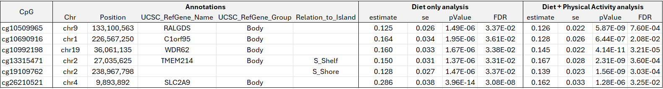

Table 2. Differentially methylated regions associated with longitudinal DNAm changes in the diet-only and diet plus physical activity analyses. For each DMR, the table includes the genomic region, number of CpG probes included in the region, regional P value, Sidak-adjusted P value, direction of DNAm change across CpGs within the region, CpGs included in the DMR, UCSC gene annotation, relation to CpG island, and GREAT-based gene annotation. The direction column indicates whether CpGs within the DMR showed increased methylation (+++) or decreased methylation (---) over time.

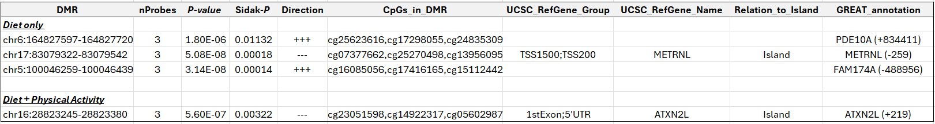

Table 3. Adjusted Cox proportional hazards model for clinical progression in ADNI. Hazard ratios and 95% confidence intervals are shown for the association between the standardized weight-gain DNAm correlation score and subsequent clinical progression. The weight-gain DNAm correlation score was calculated as the z-scored Spearman correlation between each participant’s within-person DNAm change across the first two DNAm visits and the reversed CENTRAL diet-only weight-loss DNAm profile. The Cox model was adjusted for age, sex, APOE ε4 allele count, baseline diagnosis, education, and smoking history. HRs greater than 1 indicate higher risk of progression. Abbreviations: CI, confidence interval; DNAm, DNA methylation; HR, hazard ratio.

