Supplementary Material
Title:
Chikungunya during Pregnancy and Childhood Obesity: A Nationwide Population-based Longitudinal Study using Linked Registry Data in Brazil

Authors
Mio Kushibuchi¹, Orlagh Carroll², Thiago Cerqueira-Silva^{2,3}, Helena Benes Matos da Silva^{1,2}, Carolina Santiago-Vieira¹, Juliana Freitas de Mello e Silva¹, Viviane S. Boaventura^{3,4}, Maria Gloria Teixeira⁵, Rita de Cássia Ribeiro-Silva^{1,6}, Mauricio L. Barreto^{1,5}, Enny Paixao^{1, 2}
Affiliations:
- Center for Data and Knowledge Integration for Health (CIDACS), Gonçalo Moniz Institute, Oswaldo Cruz Foundation (FIOCRUZ), Salvador, Brazil
- Faculty of Epidemiology and Population Health, London School of Hygiene and Tropical Medicine
- Medicine and Precision Public Health (MeSP2)- Gonçalo Moniz Institute (IGM), Fundação Oswaldo Cruz, Salvador, Brazil.
- Faculty of Medicine of Bahia, Universidade Federal da Bahia, Salvador, Brazil.
- Institute of Collective Health (ISC), Federal University of Bahia, Brazil
- School of Nutrition, Federal University of Bahia, Brazil

Corresponding author: Mio Kushibuchi
Address: Edf Tecnocentro, SI 315, Rua Mundo, 121 Trobogy, Salvador, BA, Brazil
Email: Miokushibuchi0119@gmail.com

Table of Contents
Supplementary methods 1: The details of each dataset, including the variables obtained and the linkage 3
Material 1.1: Databases used in the analysis, obtained from the cohort profile 3
Material 1.2: Details on the exclusion criteria 4
Material 1.3: Details on the linkage accuracy 5
Supplementary methods 2: The details of the handling of the missing variables methods 5
2.1 Data sources and structure of missingness 5
2.2 Multiple imputation strategy 5
2.3 Departure from the Missing at Random assumption (delta adjustment) 7
2.4 Post-imputation analysis and pooling 7
Supplementary methods 3: a list of all models presented as main results as well as sensitivity analyses 8
Supplementary Table 1: The number of children having anthropometric measurements at each recommended period below 12 months of age. 9
Supplementary Table 2: The number of observations at each annualized time period and the percentage of missing visits. 9
Supplementary Table 2-2: The number of observations at each annualized period and the percentage of missing visits, by CHIK exposure status. 10
Supplementary Table 3: The number of visits (median, IQR) during the study period, by exposure and outcome categories. 10
Supplementary Table 4: RECORD checklist 11
Supplementary Table 5: Demographics of the individuals excluded from the study due to not having an anthropometric measurement in SISVAN. 16
Supplementary Table 6: Basic demographics of those with visits at all annualized age intervals, compared to those missing observations at some intervals. 17
Supplementary Table 6-2: Basic demographics of those with observed anthropometric measure in each annualized age range. 19
Supplementary Table 7: The mean (SD) of Z scores and the percentage of obese population in each annualized period. 20
Supplementary table 8: OR obtained using different delta values in the departure from MAR analyses of LMM 21
Supplementary Figure1: DAG 22
Supplementary Figure 2: The actual z-score trajectories plotted against the curve predicted by LMM 23
Supplementary Figure 3: Results for sensitivity analyses (i) to (iii) using the CS method. 23
Supplementary Figure 4: The results for the sensitivity analyses (i), (ii) and(iv) using the LMM method. 24
Supplementary Figure 5: The results for sensitivity analyses (v), the LMM model stratified by sex. 24
Supplementary Figure 6: The results of sensitivity analyses (vi), the LMM model including only non-exposed from municipalities with at least one exposed case. 25
Supplementary Figure 7: The results of sensitivity analyses (vii), the LMM model stratified by urbanicity of residence. 25
References 25

Supplementary methods 1: The details of each dataset, including the variables obtained and the linkage

Material 1.1: Databases used in the analysis, obtained from the cohort profile
Information on the maternal-child dyads and pregnancy characteristics was obtained from the CIDACS (Centro de Integração de Dados e Conhecimento para a Saúde) Birth Cohort. The population of this cohort comprises individuals whose records intersect between the Unified Registry for Social Programs (Cadastro Único para Programas Sociais, CADU), which represents families who have applied for government social benefits, and the Live Birth Information System (Sistema de Informações Sobre Nascidos Vivos, SINASC).¹ This cohort represents the poorest half of the Brazilian live births.^{2,3}
The exposure variable was obtained from the Information System for Notifiable Diseases (SINAN)⁴, which contained records of CHIK, Dengue (DEN), and Zika (ZIK). In Brazil, cases suspected of these infections must be reported to SINAN. Each notification undergoes epidemiological investigation by a designated public health team, and are classified as confirmed, inconclusive, or ruled out, based on clinical criteria, local epidemiological patterns and laboratory tests.⁴ The outcome variable was obtained from the Food and Nutrition Surveillance System (SISVAN), which is the registry for children’s growth monitoring in primary health care facilities and covers 45% of public health service users.⁵

Database | Description | Variable used | Sensitivity
SINASC (Sistema de  Informação sobre  Nascidos Vivos/  Information  System of Live  Birth) | SINASC is the birth registry of Brazil, completed by a health professional who was present at the delivery | Information about the mother (age, educational attainment, marital status, and race/ethnicity), the pregnancy (the last menstruation date, the number of previous gestations, whether the pregnancy was a singleton, and the number of antenatal care visits), and the newborn (birth date, sex, the municipality of residence, birth weight, and gestational age at birth). | Records information of 97% of Brazilian live births
Cadu (Cadastro único para Programas Sociais/ Unified System for Social Programs) | Cadu is an integrated system in which all households and individuals receiving any social programs, including the conditional cash transfer program Bolsa Familia, are registered. It contains socioeconomic information about these families. | Whether the mother of the newborn is registered in the Cadu, and the urbanicity of the residence. | More than 50% of  the Brazilian  population
SINAN (Sistema de  Informação sobre  Agravos de  Notificação/  Information  System for  Notifiable  Diseases) | SINAN contains all the registered cases of specific infectious diseases including Chikungunya, Dengue and Zika. The health professional who diagnosed these infections in the local health center registers all cases in this system. The system is disease specific. | Date of symptom onset, date of registry, and the diagnosis (either clinical or lab-confirmed) of the CHIKV, DENV and ZIKV infection | Depends on the  disease
SISVAN (Sistema de Vigilância Alimentar e Nutricional/ Brazilian Food and Nutrition Surveillance System) | SISVAN contains the anthropometric and food consumption records for pregnant women and children, obtained in primary care facilities. | Date of anthropometric measurement, date of birth, sex, height in cm (length for those below 24m of age), weight in kg. | 45% of children under 5 years of age who are public health service users (Brazilian National Health System), with heterogeneity across populations.⁵

Material 1.2: Details on the exclusion criteria
Criteria | Numbers | Reason | Number excluded by CHIK status | Number of SISVAN observations excluded | Number of SISVAN obs excluded by CHIK status
Individuals with invalid SISVAN measurements | 135,981 | SISVAN observations with following were excluded, based on the WHO Anthro recommendation: (a) the corrected age at visit became a negative value for preterm individuals with less than 24 months of age; (b) the date of birth in SISVAN and SINAN were inconsistent; (c) Z score values were extreme values, suggesting error in the data. | Exposed: 165  Non-exposed: 135,816 | 3,686,502 | Exposed: 235  Non-exposed: 222,893
Non-singleton births | 46,633 | Having multiple fetuses is a high risk of birth complications and low birth weight, which may affect the anthropometric measurements. | Exposed: 22  Non-exposed: 46,611 | 360,648 | Exposed: 407  Non-exposed: 360,241
Births from mothers younger than 14.9 years or older than 49.9 Years | 36,741 | The reproductive age defined by the WHO is 15 to 49 years. There is high possibility that the extreme values were errors in the data record, and if the value is true, the young (or old) maternal age may be associated with extreme unmeasured confounder (such as disability or severe social deprivation). | Exposed: 23  Non-exposed:36,718 | 250,642 | Exposed: 317  Non-exposed: 250,325
Births with missing gestational age at birth | 84928 | Gestational age information is needed to define the timing of exposure. | No exposed individuals, for gestational age was necessary to define exposure | 608,649 | N/A
Births with gestational ages below 20 weeks or above 42 weeks | 129595 | There is high possibility of errors in data records, and even if the value is true, severe early- or late- term birth may be associated with later anthropometric measurements. | Exposed: 124 (>42 wks)  Non-exposed: 129,263 >42 wks and 208 <20 wks | 996,786 | Exposed: 1,717  Non-exposed: 995,069 preterm and 1,368 post-term
Births with weights of below 500g or above 6000g | 2545 | There is high possibility of errors in data records, and even if the value is true, t severe low or high birth weight may be associated with later anthropometric measurements. | Exposed: 4 (<500g)  Non-exposed: 2,450 <500g and 91 above 6000+ g | 118,026 | Exposed: 49  Non-exposed: 17,977 lbw and 799 hbw
Births exposed to in-utero DENV or ZIKV | 10706 | The outcome may have been associated with the exposure to other Arboviruses, especially given that ZIKV is known to cause congenital Zika syndrome. | Exposed: 401 DEN and 64 ZIK  Non-exposed: 7,761 DEN and 2,480 ZIK | 68,483 | Exposed: 4427 obs for DEN and 911 obs for ZIK  Non-eposed: 64,056 obs for DEN and 163,424 obs for ZIK
Births with registry in CHIK-sinan who were subsequently ruled out or inconsistent in the epidemiological survey | 2254 | These individuals likely had a febrile illness due to causes other than CHIK. In order to have a healthy control population, we excluded these people from our study. | N/A | 18,269 (All Non-exposed) | N/A
Births with inconsistent CHIKV infection status (more than 2 infection registries which were more than 30 days apart, or infection date before January 2015) | 15 | It was uncertain whether both registries were of the same episode, and there was high possibility that at least one of the registries was a misclassification. We were not sure which of the multiple registries was the actual date the symptom started. Because CHIK became prevalent in Brazil after 2015, we are uncertain of the diagnostic accuracy of CHIK before 2015. | N/A | 79 (All Exposed) | N/A
Non CHIK-exposed individuals with discarded/inconsistent DEN or ZIK registry | 12459 | These individuals likely had a febrile illness due to causes other than CHIK. In order to have a healthy control population, we excluded these people from our study. | N/A | 106607 (All non-exposed) | N/A

Material 1.3: Details on the linkage accuracy
A detailed information is available in Ali 2019⁶ and Paixao 2024². In summary, record linkage was performed using CIDACS-RL, a validated tool developed for large-scale Brazilian administrative data. This approach combines deterministic and probabilistic matching techniques, using key identifiers such as name, mother's name, date of birth, sex, and municipality of residence. Prior to linkage, datasets underwent rigorous preprocessing, including name and date standardization, imputation of missing values, and duplicate removal.
The CIDACS-RL algorithm uses Apache Lucene for indexing and blocking to reduce computational demands, followed by a hybrid matching approach. Categorical variables were matched deterministically, while names and dates were compared probabilistically using similarity functions like the Dice coefficient. The linkage process was conducted within CIDACS's secure data infrastructure, adhering to strict data security protocols and ethical governance. CIDACS-RL has been previously validated with >90% sensitivity and specificity.

Supplementary methods 2: The details of the handling of the missing variables methods

2.1 Data sources and structure of missingness
This study used routinely collected anthropometric data from the Brazilian Food and Nutrition Surveillance System (SISVAN) as the primary outcome source. SISVAN records all anthropometric measurements done in public primary health care centers. The Ministry of Health (MOH) recommends at least one anthropometric visit at ages 15 days, 1, 2, 4, 6, 9, 12, 18, and 24 months and once annually after that; however, preliminary analyses of the percentage of people presenting at these specific age ranges were very low (Supplementary Table 1).
Missing visits may happen when the child and the caregiver do not visit the health center despite the MOH recommendation, the child did go, but the results were not adequately recorded (such as a recording error), or the child went to a private facility (which is less likely in this population for we have limited our population to those in CADU, the poorest half of the Brazilian population).
Therefore, we annualized the visits to visit in the first year of life (age 0-11 months), second year of life (age 12-23 months), third year of life (age 24-35 months), fourth year of life (age 36-47 months), and fifth year of life (age 48-61 months). When multiple anthropometric records were available for the individual in the age range, we used the measurement closest to age 6, 18, 30, 42, and 54 months. After annualization, the percentage of individuals missing observation for each annualized period was 34-58% (Supplementary Table 2).
In addition to outcome missingness, several baseline covariates derived from SINASC (Live Birth Information System) and socioeconomic data from the CADU (Brazilian national registry for social programs) contained missing values. The highest proportion of missingness was observed for maternal race (4.6%), while other baseline covariates had lower levels of missingness. Exposure was ascertained from SINAN (Information System for Notifiable Diseases) and was treated as fully observed, with individuals without a registered maternal CHIKV infection classified as unexposed by design.
Follow-up was administratively censored on 30 December 2021. Children born between 2015 and 2018, therefore, had varying lengths of follow-up, with younger birth cohorts censored at earlier ages. Mortality during follow-up was rare (approximately 0.1%) and was treated as truncation of follow-up rather than as a competing risk.

2.2 Multiple imputation strategy
Missing values in annualized obesity Z-score outcomes (WLZ for those below 24 months of age and BAZ for those 24 months or above) and baseline covariates were handled using multiple imputations by chained equations (MICE). Imputation was performed on a wide-format dataset, with one row per child and separate variables for obesity Z-scores at each annualized age (e.g. z_bmi_0y, z_bmi_1y, …).
The imputation models included all baseline covariates used in the analysis, as well as all observed annualized obesity Z-scores measurements, to leverage the longitudinal structure of the outcome. Month and year of conception were included as auxiliary variables to improve imputation of baseline covariates but did not themselves contain missing values and were not imputed.
Imputation was conducted separately for children exposed and unexposed to in-utero CHIKV infection to allow for differential outcome distributions between exposure groups. Imputation models were specified by variable type: predictive mean matching for continuous z-BMI values, logistic regression for binary variables, and multinomial regression for categorical variables.
Variables to be imputed | Variables used to impute | Method used to impute
Baseline covariate
Maternal age (category) | All the covariates, the Z scores, and the month of conception and year of conception | Polyreg
Maternal education (category) |  | Polyreg
Maternal race (binary) |  | Logreg
Number of antenatal care (category) |  | Polyreg
Urbanicity of residence (binary) |  | Logreg
Outcomes
Z score (Z-WFL) for 0-11 months | All the covariates, the Z scores, and the month of conception and year of conception | PMM
Z score (Z-WFL) for 12-23 months |  | PMM
Z score (Z-BMI) for 24-35 months |  | PMM
Z score (Z-BMI) for 36-47 months |  | PMM
Z score (Z-BMI) for 48-60 months |  | PMM

Initial imputation diagnostics were performed using a random subsample of approximately 500,000 children, with 20 imputations and 10 iterations, to assess convergence and stability of the imputation models. Based on these diagnostics, the final analyses used five imputations with five iterations (m = 5, maxit = 5). Convergence was assessed using trace plots and distributional checks.
Imputed values beyond a child’s last observed annualized age interval were excluded after imputation and prior to analysis to ensure that estimates were based only on age periods during which the child was under observation (e.g.: if a child had visits at 1st and 3rd years, Z scores were imputed for years 2nd, 4th and 5th, using the data of baseline covariates and the Z score of 1st and 3rd years. Then, the imputed Z score for 4th and 5th year were excluded from the analyses).
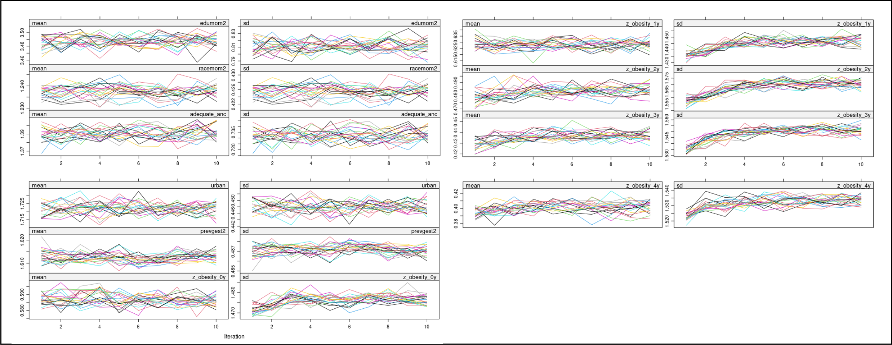

2.3 Departure from the Missing at Random assumption (delta adjustment)
Although the primary analyses assumed missingness was missing at random, exploratory analyses suggested that children with at least one measurement indicating obesity had a higher median number of visits than those with all measurements within the normal range (Supplementary Table 3). This suggests that the unobserved anthropometric measures may differ systematically from those observed. In particular, caregivers of children with higher adiposity may be more likely to attend anthropometric monitoring visits, raising concern that missing outcomes could be biased toward lower adiposity.
To assess the robustness of results to departures from the MAR assumption, we conducted multiple imputations with delta adjustment for the linear mixed-effects models.^{7,8} Fixed constants (delta values of ±0.05, ±0.20, ±0.50, and ±1.0) were added to or subtracted from all imputed obesity Z-scores values to simulate scenarios in which children without observed measurements were systematically less or more obese than those observed. The primary interpretation focused on scenarios in which missing values were assumed to be lower than observed values, reflecting reduced health-care utilization among children with lower adiposity.

2.4 Post-imputation analysis and pooling
Statistical analyses were conducted separately within each imputed dataset using the models described in the main Methods section. Estimates from the five imputed datasets were combined using Rubin’s rules to obtain pooled point estimates and standard errors.

Supplementary methods 3: a list of all models presented as main results as well as sensitivity analyses
 | Analyses name | Description
Cross sectional | Main analyses | Cross-sectional analyses for each annualized age range using logistic and linear regression, using multiple imputation to impute baseline covaraites and missing Z score measrues before the last observed measure. OR for the imputed datasets were pooled across imputation using Rubins rules.
Cross sectional | Sensitivity (i) | A complete-case analysis (CCA) restricted to individuals with complete baseline information and anthropometric measurements at all five annualised intervals.
Cross sectional | Sensitivity (ii) | A CCA analysis including individuals with complete baseline information who had at least one anthropometric measurement at any annualised interval, retaining all available annualised measurements without requiring complete follow-up.
Cross sectional | Sensitivity (iii) | An analysis using imputed baseline covariates while restricting to observed annualised anthropometric measurements, using Rubins rule to pool estimates.
Linear mixed methods | Main analyses | Linear mixed model using multiply imputed data, pooling the Estimates obtained across imputed datasets using Rubin's rules.
Linear mixed methods | Main analyses | Departure from MAR analyses: Fixed constants were added or subtracted from all imputed Z scores to simulate scenarios in which children without measurements weresystematically more or less obese than the value imputed based on MAR
Linear mixed methods | Sensitivity (i) | A CCA restricted to individuals with complete baseline information and anthropometric measurements at all five annualised intervals
Linear mixed methods | Sensitivity (ii) | an analysis including individuals with complete baseline information who had at least one anthropometric measurement at any annualised interval, retaining all available annualised measurements without requiring complete follow-up
Linear mixed methods | Sensitivity (iv) | A CCA including all individuals with complete baseline covariates and using all available z-score measurements, rather than the annualised values. Unlike the annualised approach, where only one measurement per age rage was retained, this analysis incorporated every available anthropometric observation (e.g., measurements at 1, 6, and 9 months were all used, where only that of 6 months was used in the main analyses).
Linear mixed methods | Sensitivity (v) | An analysis using multiple imputation as in the main analyses, stratified by sex.
Linear mixed methods | Sensitivity (vi) | An analysis using multiple imputations as in the main analyses, but with the non-exposed population filtered to those who were born in municipalities with at least one CHIK-exposed case.
 | Sensitivity (vii) | An analysis using multiple imputations as in the main analyses, stratified by urbanicity of residence. Urbanicity was included in the LMM model as a covariate for the main analyses but was excluded from the model and rather used to stratify.

Supplementary Table 1: The number of children having anthropometric measurements at each recommended period below 12 months of age.
 | Overall  (N=3136495) |  | CHIK exposure status
 | Overall  (N=3136495) |  | Non-exposed  (N=3134229) | Exposed  (N=2266)
Recommended visit intervals
1-15 days | 99421 (3.2) |  | 99400 (3.2) | 21 (0.9)
16-28 days | 88940 (2.8) |  | 88907 (2.8) | 33 (1.5)
1-2 months | 193999 (6.2) |  | 193889 (6.2) | 110 (4.9)
3-4 months | 342349 (10.9) |  | 342152 (10.9) | 197 (8.7)
5-6 months | 401289 (12.8) |  | 401013 (12.8) | 276 (12.2)
7-9 months | 651809 (20.8) |  | 651334 (20.8) | 475 (21.0)
10-12 months | 768992 (24.5) |  | 768414 (24.5) | 578 (25.5)
Visited at least once before 6 months of age | 634845 (20.2) |  | 634454 (20.2) | 391 (17.3)

Supplementary Table 2: The number of observations at each annualized time period and the percentage of missing visits.
Age range | Number who came in the Nth year interval | Number who were followed until their Nth birthday (end date of the Nth interval) | percent who had a measure in Nth year, among those who were followed during that age period
1st year | 1331878 | 3134315 | 42.5
2nd year | 1919555 | 3132530 | 61.3
3rd year | 1834824 | 3131216 | 58.6
4th year | 1645886 | 2496058 | 65.9
5th year | 1113903 | 1793666 | 62.1
Footnote: Among the 1,113,903 annualized observations of the 5th year, 1,706 observations were after the fifth birthday of the infant, with the maximum days being 2 days after the birthday.

Supplementary Table 2-2: The number of observations at each annualized period and the percentage of missing visits, by CHIK exposure status.

Age range | Exposure strata | Number who came in the Nth year interval | Number who were followed until their Nth birthday (end date of the Nth interval) | percent who had a measure in Nth year, among those who were followed during that age period
1st year | Exposed | 974 | 2265 | 43.0
 | Non-exposed | 1330904 | 3132047 | 42.5
2nd year | Exposed | 1505 | 2263 | 66.5
 | Non-exposed | 1918050 | 3130264 | 61.3
3rd year | Exposed | 1396 | 2262 | 61.7
 | Non-exposed | 1833428 | 3128953 | 58.6
4th year | Exposed | 1090 | 1987 | 54.9
 | Non-exposed | 1644796 | 2491340 | 66.0
5th year | Exposed | 763 | 1110 | 68.7
 | Non-exposed | 1113140 | 1789812 | 62.2

Supplementary Table 3: The number of visits (median, IQR) during the study period, by exposure and outcome categories.
 | Median number of visits | IQR
By outcome status
Never had obesity during the study period (N=2,655,812) | 4 | [2-7]
Had a measure of obesity at least once during the study period (N=481,071) | 6 | [3-12]
By exposure status
Non-exposed | 4 | [2-8]
Exposed | 4 | [2-8]

Supplementary Table 4: RECORD checklist
Section | Item No | STROBE Items | Location in Manuscript (STROBE) | RECORD Items | Location in Manuscript (RECORD)
Title and abstract | 1 | (a) Indicate the study's design with a commonly used term in the title or the abstract  (b) Provide in the abstract an informative and balanced summary of what was done and what was found | (a) The study design, longitudinal study, is stated in the title  (b) The methods section of the abstract summarizes what we did, and the results section summarizes what was found | RECORD 1.1: The type of data used should be specified in the title or abstract. When possible, the name of the databases used should be included.  RECORD 1.2: If applicable, the geographic region and timeframe within which the study took place should be reported in the title or abstract.  RECORD 1.3: If linkage between databases was conducted for the study, this should be clearly stated in the title or abstract. | RECORD 1.1: The type of data used (administrative databases) and the names of databases (CIDACS Birth Cohort, CADU, SINASC, SINAN, SISVAN) are specified in the abstract under the Methods section.  RECORD 1.2: The geographic region (Brazil) and timeframe (births from 2015-2018, follow-up until December 31, 2021) are reported in the abstract.  RECORD 1.3: Linkage between databases (SINASC, CADU, SINAN, and SISVAN linked within the CIDACS Birth Cohort) is clearly stated in the abstract under Methods.
Introduction  Background/rationale | 2 | Explain the scientific background and rationale for the investigation being reported | The scientific background and rationale for the investigation is explained in the second to fourth paragraph of the introduction
Objectives | 3 | State specific objectives, including any prespecified hypotheses | The objectives of this study is stated in the last paragraph of the introduction
Methods  Study design | 4 | Present key elements of study design early in the paper | The key elements of the study design (cohort study following children from birth until the last anthropometric measurement before age 5, death, or the end of the study at December 31 2021) are described at the beginning of the Methods, under Study design
Setting | 5 | Describe the setting, locations, and relevant dates, including periods of recruitment, exposure, follow-up, and data collection | The study setting, population, and time frame are described under Study design and Study population. Children were born between Jan 1, 2015 and Dec 31, 2018 in Brazil. Data were obtained from linked administrative databases (CIDACS Birth Cohort, CADU, SINASC, SINAN, SISVAN). Follow-up extended to Dec 31, 2021, with periods of exposure and outcomes clearly defined.
Participants | 6 | (a) Cohort study: Give the eligibility criteria, and the sources and methods of selection of participants. Describe methods of follow-up  (b) Cohort study: For matched studies, give matching criteria and number of exposed and unexposed | (a) Eligibility criteria, sources, and selection are described under Study population. Exclusions included non-singletons, implausible dates, missing gestational age, implausible birthweight, and exposure to ZIKV or DENV. Participants were followed until the last anthropometric measurement before age 5, death, or the end of the study at December 31 2021  (b) Not applicable | RECORD 6.1: The methods of study population selection (such as codes or algorithms used to identify subjects) should be listed in detail. If this is not possible, an explanation should be provided.  RECORD 6.2: Any validation studies of the codes or algorithms used to select the population should be referenced. If validation was conducted for this study and not published elsewhere, detailed methods and results should be provided.  RECORD 6.3: If the study involved linkage of databases, consider use of a flow diagram or other graphical display to demonstrate the data linkage process, including the number of individuals with linked data at each stage. | RECORD 6.1: Methods of study population selection are described in detail under Study population and Study design. Inclusion criteria included all singleton live births between Jan 1, 2015 and Dec 31, 2018 in the CIDACS Birth Cohort. Exclusions were applied for non-singletons, implausible dates, missing or implausible gestational age and birthweight, and exposure to ZIKV or DENV.  RECORD 6.2: The CIDACS Birth Cohort has been previously validated and is referenced in the manuscript. The probabilistic linkage methodology and data quality have been published elsewhere and are cited in the Data source section.  RECORD 6.3: A flow diagram (Figure 1) demonstrates the data linkage process, showing the number of individuals at each stage: initial SISVAN observations corresponding to the individuals in CIDACS Birth Cohort (29,663,511 records for 3,598,352 individuals), exclusions applied, and final study population (2,266 CHIK-exposed and 3,134,229 non-exposed individuals).
Variables | 7 | Clearly define all outcomes, exposures, predictors, potential confounders, and effect modifiers. Give diagnostic criteria, if applicable. | Definitions of exposures, outcomes, predictors, confounders, and effect modifiers are described in Exposures, Outcome, and Covariates. Exposures: maternal CHIK infection during pregnancy, obtained from the SINAN dataset. Outcomes: obesity, obtained from the SISVAN dataset, measured both as a binary variable of Z score above 3 or as a continuous outcome. | RECORD 7.1: A complete list of codes and algorithms used to classify exposures, outcomes, confounders, and effect modifiers should be provided. If these cannot be reported, an explanation should be provided. | RECORD 7.1: Classification codes and algorithms are provided: Exposure was defined using SINAN arbovirus notifications. Mothers who were registered in SISVAN for CHIK, with a symptom onset date between her date of conception and date of birth, with the epidemiological surveillance results as "confirmed as CHIK" were defined as exposed. Those registered in CHIK dataset as inconsistent or discarded, as well as those registered in SISVAN for ZIKA and DENGUE were excluded from the study population, and those with no recorded febrile symptoms were defined as unexposed. Obesity outcome was defined as BMI-for-age or weight-for-length Z-score >+3 using WHO growth standards, calculated from SISVAN anthropometric measurements. Covariates including maternal characteristics were obtained from SINASC. Detailed variable definitions are provided in the Exposures, Outcome, and Covariates sections.
Data sources/measurement | 8 | For each variable of interest, give sources of data and details of methods of assessment (measurement). Describe comparability of assessment methods if there is more than one group | Sources of data and methods of assessment are detailed under Data source. Maternal and child data came from SINASC, social information from CADU, exposures from SINAN, and anthropometric measurements from SISVAN. Assessment methods were consistent across exposed and unexposed groups because they rely on the same national surveillance systems.
Bias | 9 | Describe any efforts to address potential sources of bias | Efforts to reduce bias are described in Statistical analysis and Limitations. The missing pattern of obesity measure was hypothesized to be MNAR, which is the major limitation of this study. We attempted to overcome this limitation through triangulating the outcomes using different analytic approaches. We also attempted handling the missing observations both using multiple imputation and using complete case analyses, both of which may be biased under MNAR; all the results are presented as sensitivity analyses. Other biases such as the misclassification bias of the exposure, or the live birth bias, are mentioned explicitly in the limitations section.
Study size | 10 | Explain how the study size was arrived at | Study size was determined by including all eligible live births in the CIDACS Birth Cohort between 2015 and 2018 after applying exclusion criteria. No formal sample size calculation was performed.
Quantitative variables | 11 | Explain how quantitative variables were handled in the analyses. If applicable, describe which groupings were chosen, and why | Quantitative variables were categorized where appropriate (e.g., maternal age into 3 groups, gestational age into term/preterm, education into categories). Some categories were collapsed (e.g., maternal education none/1–3 years, race white/non-white) to ensure sufficient statistical power
Statistical methods | 12 | (a) Describe all statistical methods, including those used to control for confounding  (b) Describe any methods used to examine subgroups and interactions  (c) Explain how missing data were addressed  (d) Cohort study: If applicable, explain how loss to follow-up was addressed  (e) Describe any sensitivity analyses | (a) Statistical methods are described under Statistical analysis: For the cross-sectional analyses, we used a logistic regression and linear regression, with robust sandwich variance estimators clustered at the region level used to estimate standard errors. For the longitudinal model, we used the linear mixed model to predict Z score trajectories for the exposed and non-exposed. Both complete case analyses and a multiple imputation using MICE was used for both methods.  (b) Subgroup analyses were conducted for individuals who had an observed anthropometric measures at all annualized visit intervals  (c) Up to 57% of the annualized outcome was missing and up to 5% of the baseline covariates. Both complete case analyses and multiple imputation, as well as the delta analyses to assess the departure from Missing At Random, were performed.  (d) All hospitalizations and deaths are registered in the national registry, thus there were no loss to follow-up  (e) Six sensitivity analyses were conducted, three for each analytical methods. The details are given in the sensitivity analyses section. | RECORD 12.1: Authors should describe the extent to which the investigators had access to the database population used to create the study population.  RECORD 12.2: Authors should provide information on the data cleaning methods used in the study.  RECORD 12.3: State whether the study included person-level, institutional-level, or other data linkage across two or more databases. The methods of linkage and methods of linkage quality evaluation should be provided. | RECORD 12.1: The investigators had access to the complete CIDACS Birth Cohort database population for the study period (2015-2018 births). This is described under Data source, which states that data came from linked national surveillance systems available to CIDACS researchers  RECORD 12.2: Data cleaning methods are described under Study population and Statistical analysis. Exclusion criteria were applied for data quality: implausible dates (different birth dates recorded in SISVAN and SINASC), implausible Z scores based on the criteria defined by WHO (Z score below -5 or above +5 for BMI, similar cirteria for height and weight for age Z scores), implausible birth weight (<500g or >6000g), missing gestational age, and inconsistent CHIKF notification records. Missing data patterns and handling are detailed in the Statistical analysis section.  RECORD 12.3: The study included person-level linkage across five databases (SINASC, CADU, SINAN, SISVAN, and death records). Linkage was performed using probabilistic record linkage methods within the CIDACS Birth Cohort platform, as described under Data source. The linkage quality and validation have been published in previous CIDACS studies, which are cited in the manuscript.
Results  Participants | 13 | (a) Report the numbers of individuals at each stage of the study (e.g., numbers potentially eligible, examined for eligibility, confirmed eligible, included in the study, completing follow-up, and analysed)  (b) Give reasons for non-participation at each stage  (c) Consider use of a flow diagram | (a) Numbers of individuals at each stage are reported in Results, Study population and baseline characteristics and shown in Figure 1. From 11,737,639 live births, exclusions were applied, leaving 2,695 CHIK-exposed and 3,266,474 non-exposed individuals  (b) Reasons for non-participation (exclusions: non-singletons, implausible dates, implausible birthweight, missing gestational age, other arbovirus exposures, inconsistent CHIKF records) are described in Study population (Methods).  (c) A flow diagram of inclusion/exclusion is provided in Figure 1. | RECORD 13.1: Describe in detail the selection of the persons included in the study (i.e., study population selection) including filtering based on data quality, data availability and linkage. The selection of included persons can be described in the text and/or by means of the study flow diagram. | RECORD 13.1: Selection of persons is described in detail in the Methods section under Study population and baseline characteristics, and shown in Figure 1. The flow diagram shows filtering based on data quality of the anthropometric measurements in SISVAN (exclusions for implausible Z score values and implausible dates), and data availability (exclusions for missing essential variables such as the gestational age). Participants were further excluded in case the mother had a febrile event with unknown origin recorded in any of the three Arbovirus records. The final study population included those with at least one valid anthropometric measurement during follow-up.
Descriptive data | 14 | (a) Give characteristics of study participants (e.g., demographic, clinical, social) and information on exposures and potential confounders  (b) Indicate the number of participants with missing data for each variable of interest  (c) Cohort study: Summarise follow-up time (e.g., average and total amount) | (a) Characteristics of study participants (demographics, maternal and pregnancy variables, covariates) are shown in Table 1.  (b) Numbers of missing data for each variable are given in Table 1. The characteristics of those who were excluded due to not having any valid anthropometric measures are compared to those in the study in Supplementary Table 5, and the characteristics of those with complete observation for all annualized interval, compared to those without, are shown in Supplementary Table 6.  (c) Follow-up time is summarized in Results: median follow-up for hospitalization was 19.1 months [IQR: 27.9], and for death was 25.8 months [IQR: 23.2].
Outcome data | 15 | Cohort study: Report numbers of outcome events or summary measures over time | Numbers of outcome events are reported in Table 1 and Supplementary Table 7.
Main results | 16 | (a) Give unadjusted estimates and, if applicable, confounder-adjusted estimates and their precision (e.g., 95% confidence interval). Make clear which confounders were adjusted for and why they were included  (b) Report category boundaries when continuous variables were categorized  (c) If relevant, consider translating estimates of relative risk into absolute risk for a meaningful time period | (a) The odds for becoming obese at a given age range are presented in Forest plot, in Figure 2. The Z score trajectory predicted from the LMM model is shown as growth curve in Figure 3.  (b) Category boundaries for the outcome is defined in the outcome section, with a cutoff of BMI or WFL Z score at +3 for the definition of obesity.  (c) Not applicable
Other analyses | 17 | Report other analyses done—e.g., analyses of subgroups and interactions, and sensitivity analyses | Three main analyses (cross-sectional, linear mixed models, and the departure from MAR analyses) were done and presented. In addition, we performed six sensitivity analyses. All analyses conducted are summarized in Supplementary Material.
Discussion  Key results | 18 | Summarise key results with reference to study objectives | Key results are summarized in the first paragraph of Discussion: those exposed to CHIK in-utero had a higher risk of obesity, as well as a higher predicted Z score for BMI and WFL. The impact of CHIK exposure was largest at the second to third year of life.
Limitations | 19 | Discuss limitations of the study, taking into account sources of potential bias or imprecision. Discuss both direction and magnitude of any potential bias | Limitations are discussed in Discussion, including the MNAR of obesity measures, live birth bias, passive surveillance and misclassification, lack of confounders (income, living conditions), and under-ascertainment. | RECORD 19.1: Discuss the implications of using data that were not created or collected to answer the specific research question(s). Include discussion of misclassification bias, unmeasured confounding, missing data, and changing eligibility over time, as they pertain to the study being reported. | RECORD 19.1: Discussion of using data not created for the research question is provided in the Discussion under Limitations. This includes: (1) Misclassification bias from passive surveillance systems potentially under-ascertaining CHIKF cases; (2) Unmeasured confounding from lack of socioeconomic data (income, living conditions); (3) Missing data for anthropometric measurements, hypothesized to be Missing Not At Random (MNAR), with sensitivity analyses conducted; (4) Changing eligibility over time not applicable as inclusion was based on birth cohort
Interpretation | 20 | Give a cautious overall interpretation of results considering objectives, limitations, multiplicity of analyses, results from similar studies, and other relevant evidence | Interpretation is provided throughout Discussion, linking findings to previous literature, hypothesized biological mechanisms, and public health implications, while acknowledging uncertainty and imprecision of mortality estimates.
Generalisability | 21 | Discuss the generalisability (external validity) of the study results | Generalisability is discussed in Discussion: findings are relevant to Brazil and globally, given the expansion of endemic areas to Europe with climate change and globalization.
Other information  Funding | 22 | Give the source of funding and the role of the funders for the present study and, if applicable, for the original study on which the present article is based | Funding sources (Wellcome Trust, Royal Society) are reported in the Abstract and under Funding at the end of the manuscript. | RECORD 22.1: Authors should provide information on how to access any supplemental information such as the study protocol, raw data, or programming code. | RECORD 22.1: Information on data accessibility is provided in the Data availability statement. Due to data protection regulations and the sensitive nature of individual-level health records, raw data cannot be made publicly available. Analytic code and detailed statistical protocols are available from the corresponding author upon reasonable request.

Supplementary Table 5: Demographics of the individuals excluded from the study due to not having an anthropometric measurement in SISVAN.
 | Overall CIDACS Birth Cohort  (N=5,795,263) |  | Whether included in SISVAN |  | SMD
 | Overall CIDACS Birth Cohort  (N=5,795,263) |  | Not in SISVAN  (N=2,332,892) | In SISVAN  (N=3,462,371) | SMD
Sex
Female | 2827287 (48.8) |  | 1133880 (48.6) | 1693407 (48.9) | 0.006
Male | 2966860 (51.2) |  | 1197896 (51.3) | 1768964 (51.1) | 0.005
Missing | 1116 (0.0) |  | 1116 (0.0) | 0 (0.0) | 0.031
Birth weight
500g and below | 8310 (0.1) |  | 5463 (0.2) | 2847 (0.1) | 0.038
501-1000g | 27348 (0.5) |  | 22044 (0.9) | 5304 (0.2) | 0.107
1001-1500g | 42506 (0.7) |  | 24404 (1.0) | 18102 (0.5) | 0.059
1501-2500g | 427084 (7.4) |  | 188473 (8.1) | 238611 (6.9) | 0.045
2501-4000g | 4989548 (86.1) |  | 1976417 (84.7) | 3013131 (87.0) | 0.066
4001-6000g | 297540 (5.1) |  | 114930 (4.9) | 182610 (5.3) | 0.016
6001g and above | 190 (0.0) |  | 80 (0.0) | 110 (0.0) | 0.000
Missing | 2737 (0.0) |  | 1081 (0.0) | 1656 (0.0) | 0.001
Gestational weeks
19wks and below | 762 (0.0) |  | 549 (0.0) | 213 (0.0) | 0.014
20-27wks | 30617 (0.5) |  | 23163 (1.0) | 7454 (0.2) | 0.101
28-31wks | 59687 (1.0) |  | 30992 (1.3) | 28695 (0.8) | 0.048
32-36wks | 549862 (9.5) |  | 232722 (10.0) | 317140 (9.2) | 0.028
37-46wks | 5018564 (86.6) |  | 1996683 (85.6) | 3021881 (87.3) | 0.049
Missing | 135771 (2.3) |  | 48783 (2.1) | 86988 (2.5) | 0.028
Marital status
Divorced | 57434 (1.0) |  | 26554 (1.1) | 30880 (0.9) | 0.025
Married | 1237935 (21.4) |  | 603892 (25.9) | 634043 (18.3) | 0.183
Single | 2878114 (49.7) |  | 1149885 (49.3) | 1728229 (49.9) | 0.013
Union | 1540156 (26.6) |  | 524268 (22.5) | 1015888 (29.3) | 0.157
Widowed | 9200 (0.2) |  | 4267 (0.2) | 4933 (0.1) | 0.010
Missing | 72424 (1.2) |  | 24026 (1.0) | 48398 (1.4) | 0.034
Maternal education
None | 35298 (0.6) |  | 10742 (0.5) | 24556 (0.7) | 0.033
1-3 years | 178728 (3.1) |  | 47833 (2.1) | 130895 (3.8) | 0.103
4-7 years | 1264990 (21.8) |  | 399265 (17.1) | 865725 (25.0) | 0.194
8-11 years | 3769543 (65.0) |  | 1558649 (66.8) | 2210894 (63.9) | 0.062
12 or more years | 449444 (7.8) |  | 284896 (12.2) | 164548 (4.8) | 0.270
Missing | 97260 (1.7) |  | 31507 (1.4) | 65753 (1.9) | 0.043
Maternal race
Asian | 15735 (0.3) |  | 7001 (0.3) | 8734 (0.3) | 0.009
Black | 350478 (6.0) |  | 145694 (6.2) | 204784 (5.9) | 0.014
Indigenous | 61358 (1.1) |  | 24778 (1.1) | 36580 (1.1) | 0.001
Mixed | 3600790 (62.1) |  | 1350623 (57.9) | 2250167 (65.0) | 0.146
White | 1495487 (25.8) |  | 702678 (30.1) | 792809 (22.9) | 0.164
Missing | 271415 (4.7) |  | 102118 (4.4) | 169297 (4.9) | 0.024
Maternal age
14 or below | 59337 (1.0) |  | 22557 (1.0) | 36780 (1.1) | 0.010
15 to 19 | 1174411 (20.3) |  | 418264 (17.9) | 756147 (21.8) | 0.098
20 to 34 | 3977025 (68.6) |  | 1637801 (70.2) | 2339224 (67.6) | 0.057
35 to 49 | 584199 (10.1) |  | 254149 (10.9) | 330050 (9.5) | 0.045
50 or above | 279 (0.0) |  | 115 (0.0) | 164 (0.0) | 0.000
NA | 12 (0.0) |  | 6 (0.0) | 6 (0.0) | 0.001
Number of ANCs
2+ less | 729508 (12.6) |  | 305161 (13.1) | 424347 (12.3) | 0.025
adequate | 4298045 (74.2) |  | 1725524 (74.0) | 2572521 (74.3) | 0.008
one less | 467633 (8.1) |  | 185324 (7.9) | 282309 (8.2) | 0.008
NA | 300077 (5.2) |  | 116883 (5.0) | 183194 (5.3) | 0.013
Number of previous gestations
1-2 previous parity | 2627601 (45.3) |  | 1056257 (45.3) | 1571344 (45.4) | 0.002
3 or more previous parity | 940034 (16.2) |  | 334497 (14.3) | 605537 (17.5) | 0.086
no previous parity | 1901848 (32.8) |  | 819071 (35.1) | 1082777 (31.3) | 0.082
Missing | 325780 (5.6) |  | 123067 (5.3) | 202713 (5.9) | 0.025
Urbanicity
Urban | 1316662 (22.7) |  | 373344 (16.0) | 943318 (27.2) | 0.276
Rural | 4310265 (74.4) |  | 1885669 (80.8) | 2424596 (70.0) | 0.253
Missing | 168336 (2.9) |  | 73879 (3.2) | 94457 (2.7) | 0.026

Supplementary Table 6: Basic demographics of those with visits at all annualized age intervals, compared to those missing observations at some intervals.
 | Overall  (N=3136495) |  | Completeness of annualized observation |  | SMD
 | Overall  (N=3136495) |  | Missing observations (N=2902895) | Observed in all annualized period (N=233600) | SMD
Sex
female | 1532031 (48.8) |  | 1416944 (48.8) | 115087 (49.3) | 0.0091
male | 1604464 (51.2) |  | 1485951 (51.2) | 118513 (50.7) | 0.0091
Birth weight
501-1000g | 4383 (0.1) |  | 4103 (0.1) | 280 (0.1) | 0.0059
1001-1500g | 14674 (0.5) |  | 13710 (0.5) | 964 (0.4) | 0.009
1501-2500g | 200965 (6.4) |  | 186427 (6.4) | 14538 (6.2) | 0.0082
2501-4000g | 2750234 (87.7) |  | 2545442 (87.7) | 204792 (87.7) | 0.0006
4001-6000g | 165305 (5.3) |  | 152317 (5.2) | 12988 (5.6) | 0.0138
NA | 934 (0.0) |  | 896 (0.0) | 38 (0.0) | 0.0095
mean (SD) | 3224.78 (512.77) |  | 3223.85 (512.88) | 3236.29 (511.33) | 0.0243
Gestational weeks
20-27wks | 6589 (0.2) |  | 6085 (0.2) | 504 (0.2) | 0.0013
28-31wks | 25235 (0.8) |  | 23318 (0.8) | 1917 (0.8) | 0.0019
32-36wks | 289511 (9.2) |  | 266996 (9.2) | 22515 (9.6) | 0.0151
37-41wks | 2815160 (89.8) |  | 2606496 (89.8) | 208664 (89.3) | 0.0152
mean (SD) | 38.60 (1.94) |  | 38.61 (1.93) | 38.60 (1.97) | 0.0051
Marital status
Divorced | 28706 (0.9) |  | 26917 (0.9) | 1789 (0.8) | 0.0176
Married | 585072 (18.7) |  | 535663 (18.5) | 49409 (21.2) | 0.0678
Single | 1561904 (49.8) |  | 1460526 (50.3) | 101378 (43.4) | 0.1389
Stable Union | 915273 (29.2) |  | 838311 (28.9) | 76962 (32.9) | 0.0881
Widowed | 4471 (0.1) |  | 4158 (0.1) | 313 (0.1) | 0.0025
NA | 41069 (1.3) |  | 37320 (1.3) | 3749 (1.6) | 0.0268
Maternal education
none | 20578 (0.7) |  | 18494 (0.6) | 2084 (0.9) | 0.0293
1-3 years | 113767 (3.6) |  | 100904 (3.5) | 12863 (5.5) | 0.0982
4-7 years | 762421 (24.3) |  | 695775 (24.0) | 66646 (28.5) | 0.1038
8-11 years | 2034159 (64.9) |  | 1893830 (65.2) | 140329 (60.1) | 0.107
12 or more years | 152814 (4.9) |  | 146105 (5.0) | 6709 (2.9) | 0.1111
NA | 52756 (1.7) |  | 47787 (1.6) | 4969 (2.1) | 0.0354
Maternal race
asian | 7980 (0.3) |  | 7432 (0.3) | 548 (0.2) | 0.0043
black | 187909 (6.0) |  | 175804 (6.1) | 12105 (5.2) | 0.038
indigenous | 32089 (1.0) |  | 30633 (1.1) | 1456 (0.6) | 0.0474
pardo | 2024150 (64.5) |  | 1864717 (64.2) | 159433 (68.3) | 0.085
white | 738954 (23.6) |  | 692000 (23.8) | 46954 (20.1) | 0.0904
NA | 145413 (4.6) |  | 132309 (4.6) | 13104 (5.6) | 0.0479
Maternal age
15 to 19 | 693572 (22.1) |  | 649510 (22.4) | 44062 (18.9) | 0.0869
20 to 34 | 2140071 (68.2) |  | 1975279 (68.0) | 164792 (70.5) | 0.0542
35 to 49 | 302846 (9.7) |  | 278100 (9.6) | 24746 (10.6) | 0.0336
NA | 6 (0.0) |  | 6 (0.0) | 0 (0.0) | 0.002
mean (SD) | 25.11 (6.41) |  | 25.06 (6.40) | 25.72 (6.39) | 0.1032
Number of ANC
adequate | 2410247 (76.8) |  | 2219816 (76.5) | 190431 (81.5) | 0.1242
one less | 262556 (8.4) |  | 245462 (8.5) | 17094 (7.3) | 0.0422
2+ less | 395022 (12.6) |  | 373819 (12.9) | 21203 (9.1) | 0.1218
NA | 68670 (2.2) |  | 63798 (2.2) | 4872 (2.1) | 0.0077
Previous gestations
1-2 previous parity | 1442292 (46.0) |  | 1330049 (45.8) | 112243 (48.0) | 0.0447
3 or more previous parity | 548232 (17.5) |  | 503385 (17.3) | 44847 (19.2) | 0.0481
no previous parity | 975192 (31.1) |  | 911895 (31.4) | 63297 (27.1) | 0.095
NA | 170779 (5.4) |  | 157566 (5.4) | 13213 (5.7) | 0.01
Urbanicity of residence
rural | 836822 (26.7) |  | 748555 (25.8) | 88267 (37.8) | 0.2599
urban | 2213458 (70.6) |  | 2074998 (71.5) | 138460 (59.3) | 0.2587
NA | 86215 (2.7) |  | 79342 (2.7) | 6873 (2.9) | 0.0126
Year of conception
2014 | 806371 (25.7) |  | 712240 (24.5) | 94131 (40.3) | 0.3416
2015 | 820050 (26.1) |  | 749780 (25.8) | 70270 (30.1) | 0.0949
2016 | 710059 (22.6) |  | 646555 (22.3) | 63504 (27.2) | 0.114
2017 | 657824 (21.0) |  | 652129 (22.5) | 5695 (2.4) | 0.6365
2018 | 142191 (4.5) |  | 142191 (4.9) | 0 (0.0) | 0.321
Outcomes
Ever overweight | 1091528 (34.8) |  | 958130 (33.0) | 133398 (57.1) | 0.4992
Ever obese | 480979 (15.3) |  | 414673 (14.3) | 66306 (28.4) | 0.3494

Supplementary Table 6-2: Basic demographics of those with observed anthropometric measure in each annualized age range.
 |  | Individuals with observations in each annualized range
 | Overall  (N=3,136,495) | First year  (N=1,331,878) | Second year  (N=1,919,555) | Third year  (N=1,834,824) | Fourth year  (N=1,645,886) | Fifth year  (N=1,113,903)
Sex
female | 1532031 (48.8) | 650595 (48.8) | 939033 (48.9) | 896290 (48.8) | 805515 (48.9) | 546768 (49.1)
male | 1604464 (51.2) | 681283 (51.2) | 980522 (51.1) | 938534 (51.2) | 840371 (51.1) | 567135 (50.9)
Birth weight
501-1000g | 4383 (0.1) | 1889 (0.1) | 2223 (0.1) | 2436 (0.1) | 2201 (0.1) | 1474 (0.1)
1001-1500g | 14674 (0.5) | 6392 (0.5) | 7933 (0.4) | 8440 (0.5) | 7351 (0.4) | 5028 (0.5)
1501-2500g | 200965 (6.4) | 85136 (6.4) | 118236 (6.2) | 117183 (6.4) | 105366 (6.4) | 71072 (6.4)
2501-4000g | 2750234 (87.7) | 1166471 (87.6) | 1686973 (87.9) | 1608578 (87.7) | 1443262 (87.7) | 977394 (87.7)
4001-6000g | 165305 (5.3) | 71766 (5.4) | 103621 (5.4) | 97585 (5.3) | 87212 (5.3) | 58601 (5.3)
NA | 934 (0.0) | 224 (0.0) | 569 (0.0) | 602 (0.0) | 494 (0.0) | 334 (0.0)
mean (SD) | 3224.78 (512.77) | 3227.79 (514.29) | 3233.45 (507.84) | 3226.73 (512.73) | 3226.36 (512.24) | 3225.59 (511.73)
Gestational weeks
20-27wks | 6589 (0.2) | 3032 (0.2) | 3433 (0.2) | 3858 (0.2) | 3530 (0.2) | 2447 (0.2)
28-31wks | 25235 (0.8) | 11195 (0.8) | 13715 (0.7) | 15019 (0.8) | 13424 (0.8) | 9142 (0.8)
32-36wks | 289511 (9.2) | 126617 (9.5) | 168713 (8.8) | 171490 (9.3) | 155228 (9.4) | 105777 (9.5)
37-41wks | 2815160 (89.8) | 1191034 (89.4) | 1733694 (90.3) | 1644457 (89.6) | 1473704 (89.5) | 996537 (89.5)
mean (SD) | 38.60 (1.94) | 38.59 (1.96) | 38.65 (1.89) | 38.61 (1.95) | 38.60 (1.95) | 38.59 (1.96)
Marital status
Divorced | 28706 (0.9) | 13150 (1.0) | 17157 (0.9) | 15632 (0.9) | 13577 (0.8) | 8608 (0.8)
Married | 585072 (18.7) | 279383 (21.0) | 360788 (18.8) | 330397 (18.0) | 293842 (17.9) | 199859 (17.9)
Single | 1561904 (49.8) | 629460 (47.3) | 931070 (48.5) | 898058 (48.9) | 806703 (49.0) | 540006 (48.5)
Stable Union | 915273 (29.2) | 389345 (29.2) | 580523 (30.2) | 562849 (30.7) | 506698 (30.8) | 348492 (31.3)
Widowed | 4471 (0.1) | 2006 (0.2) | 2576 (0.1) | 2415 (0.1) | 2169 (0.1) | 1473 (0.1)
NA | 41069 (1.3) | 18534 (1.4) | 27441 (1.4) | 25473 (1.4) | 22897 (1.4) | 15465 (1.4)
Maternal education
none | 20578 (0.7) | 7926 (0.6) | 13592 (0.7) | 13689 (0.7) | 12529 (0.8) | 8751 (0.8)
1-3 years | 113767 (3.6) | 48747 (3.7) | 76764 (4.0) | 75456 (4.1) | 69534 (4.2) | 48983 (4.4)
4-7 years | 762421 (24.3) | 318361 (23.9) | 481366 (25.1) | 470441 (25.6) | 428654 (26.0) | 298622 (26.8)
8-11 years | 2034159 (64.9) | 866574 (65.1) | 1229770 (64.1) | 1166896 (63.6) | 1040182 (63.2) | 694939 (62.4)
12 or more years | 152814 (4.9) | 66866 (5.0) | 82955 (4.3) | 75090 (4.1) | 64956 (3.9) | 41869 (3.8)
NA | 52756 (1.7) | 23404 (1.8) | 35108 (1.8) | 33252 (1.8) | 30031 (1.8) | 20739 (1.9)
Maternal race
asian | 7980 (0.3) | 3450 (0.3) | 4803 (0.3) | 4482 (0.2) | 3982 (0.2) | 2666 (0.2)
black | 187909 (6.0) | 76317 (5.7) | 112402 (5.9) | 106336 (5.8) | 95357 (5.8) | 63793 (5.7)
indigenous | 32089 (1.0) | 9581 (0.7) | 20704 (1.1) | 20137 (1.1) | 15490 (0.9) | 8464 (0.8)
pardo | 2024150 (64.5) | 829004 (62.2) | 1260926 (65.7) | 1221305 (66.6) | 1108144 (67.3) | 752456 (67.6)
white | 738954 (23.6) | 348529 (26.2) | 428655 (22.3) | 394811 (21.5) | 343233 (20.9) | 231555 (20.8)
NA | 145413 (4.6) | 64997 (4.9) | 92065 (4.8) | 87753 (4.8) | 79680 (4.8) | 54969 (4.9)
Maternal age
15 to 19 | 693572 (22.1) | 266243 (20.0) | 406336 (21.2) | 403286 (22.0) | 368648 (22.4) | 256184 (23.0)
20 to 34 | 2140071 (68.2) | 928962 (69.7) | 1321980 (68.9) | 1253970 (68.3) | 1120246 (68.1) | 754533 (67.7)
35 to 49 | 302846 (9.7) | 136673 (10.3) | 191236 (10.0) | 177563 (9.7) | 156988 (9.5) | 103184 (9.3)
NA | 6 (0.0) | 0 (0.0) | 3 (0.0) | 5 (0.0) | 4 (0.0) | 2 (0.0)
mean (SD) | 25.11 (6.41) | 25.48 (6.39) | 25.28 (6.41) | 25.14 (6.40) | 25.06 (6.40) | 24.95 (6.39)
Number of ANC
adequate | 2410247 (76.8) | 1085711 (81.5) | 1502330 (78.3) | 1408009 (76.7) | 1254829 (76.2) | 841135 (75.5)
one less | 262556 (8.4) | 95424 (7.2) | 154743 (8.1) | 155344 (8.5) | 141736 (8.6) | 98709 (8.9)
2+ less | 395022 (12.6) | 124422 (9.3) | 221190 (11.5) | 230263 (12.5) | 211646 (12.9) | 148595 (13.3)
NA | 68670 (2.2) | 26321 (2.0) | 41292 (2.2) | 41208 (2.2) | 37675 (2.3) | 25464 (2.3)
Previous gestations
1-2 previous parity | 1442292 (46.0) | 628346 (47.2) | 894632 (46.6) | 845286 (46.1) | 755511 (45.9) | 507482 (45.6)
3 or more previous parity | 548232 (17.5) | 229134 (17.2) | 348755 (18.2) | 334281 (18.2) | 296712 (18.0) | 199047 (17.9)
no previous parity | 975192 (31.1) | 409510 (30.7) | 572747 (29.8) | 550682 (30.0) | 496168 (30.1) | 338318 (30.4)
NA | 170779 (5.4) | 64888 (4.9) | 103421 (5.4) | 104575 (5.7) | 97495 (5.9) | 69056 (6.2)
Urbanicity of residence
rural | 836822 (26.7) | 376233 (28.2) | 567214 (29.5) | 546212 (29.8) | 496741 (30.2) | 338296 (30.4)
urban | 2213458 (70.6) | 918443 (69.0) | 1300736 (67.8) | 1238469 (67.5) | 1102734 (67.0) | 743014 (66.7)
NA | 86215 (2.7) | 37202 (2.8) | 51605 (2.7) | 50143 (2.7) | 46411 (2.8) | 32593 (2.9)
Year of conception
2014 | 806371 (25.7) | 297134 (22.3) | 448720 (23.4) | 478566 (26.1) | 511964 (31.1) | 468049 (42.0)
2015 | 820050 (26.1) | 349873 (26.3) | 472287 (24.6) | 520120 (28.3) | 486442 (29.6) | 292416 (26.3)
2016 | 710059 (22.6) | 287931 (21.6) | 456057 (23.8) | 446942 (24.4) | 276664 (16.8) | 323921 (29.1)
2017 | 657824 (21.0) | 318843 (23.9) | 460907 (24.0) | 304845 (16.6) | 341714 (20.8) | 29517 (2.6)
2018 | 142191 (4.5) | 78097 (5.9) | 81584 (4.3) | 84351 (4.6) | 29102 (1.8) | 0 (0.0)
Outcomes
Ever overweight | 1091528 (34.8) | 568020 (42.6) | 794402 (41.4) | 757840 (41.3) | 668146 (40.6) | 452820 (40.7)
Ever obese | 480979 (15.3) | 255000 (19.1) | 356626 (18.6) | 346538 (18.9) | 308591 (18.7) | 212865 (19.1)

Supplementary Table 7: The mean (SD) of Z scores and the percentage of obese population in each annualized period.
 | N observations | Obesity (N, %) | Z score (mean, SD)
1st year
Exposed | 974 | 60 (6.2%) | 0.85 (1.48)
Non-exposed | 1330904 | 67361 (5.1%) | 0.58 (1.47)
2nd year
Exposed | 1505 | 126 (8.4%) | 0.81 (1.57)
Non-exposed | 1918050 | 95731 (5%) | 0.64 (1.45)
3rd year
Exposed | 1396 | 86 (6.2%) | 0.59 (1.68)
Non-exposed | 1833428 | 99868 (5.4%) | 0.47 (1.57)
4th year
Exposed | 1090 | 86 (7.9%) | 0.55 (1.64)
Non-exposed | 1644796 | 88428 (5.4%) | 0.40 (1.54)
5th year
Exposed | 763 | 62 (8.1%) | 0.62 (1.69)
Non-exposed | 1113140 | 60366 (5.4%) | 0.37 (1.53)
Note: this was calculated using only observed Z scores (excluding the imputed values).

Supplementary table 8: OR obtained using different delta values in the departure from MAR analyses of LMM
Delta | Age years | Estimate | LCI | UCI
-1.0 | 0 | 0.272 | 0.171 | 0.372
-1.0 | 1 | 0.215 | 0.144 | 0.286
-1.0 | 2 | 0.150 | 0.075 | 0.224
-1.0 | 3 | 0.103 | -0.002 | 0.209
-1.0 | 4 | 0.209 | 0.103 | 0.315
-0.5 | 0 | 0.276 | 0.176 | 0.375
-0.5 | 1 | 0.200 | 0.131 | 0.269
-0.5 | 2 | 0.141 | 0.068 | 0.213
-0.5 | 3 | 0.139 | 0.035 | 0.243
-0.5 | 4 | 0.223 | 0.119 | 0.326
-0.2 | 0 | 0.278 | 0.179 | 0.377
-0.2 | 1 | 0.191 | 0.122 | 0.260
-0.2 | 2 | 0.135 | 0.063 | 0.207
-0.2 | 3 | 0.161 | 0.057 | 0.265
-0.2 | 4 | 0.231 | 0.128 | 0.333
-0.1 | 0 | 0.279 | 0.180 | 0.378
-0.1 | 1 | 0.188 | 0.119 | 0.256
-0.1 | 2 | 0.133 | 0.061 | 0.205
-0.1 | 3 | 0.168 | 0.065 | 0.272
-0.1 | 4 | 0.234 | 0.131 | 0.336
0 (MAR) | 0 | 0.279 | 0.180 | 0.378
0 (MAR) | 1 | 0.184 | 0.116 | 0.253
0 (MAR) | 2 | 0.131 | 0.060 | 0.203
0 (MAR) | 3 | 0.175 | 0.072 | 0.279
0 (MAR) | 4 | 0.236 | 0.134 | 0.338
0.1 | 0 | 0.280 | 0.181 | 0.379
0.1 | 1 | 0.181 | 0.113 | 0.250
0.1 | 2 | 0.130 | 0.058 | 0.202
0.1 | 3 | 0.183 | 0.079 | 0.286
0.1 | 4 | 0.239 | 0.137 | 0.341
0.2 | 0 | 0.281 | 0.182 | 0.380
0.2 | 1 | 0.178 | 0.109 | 0.247
0.2 | 2 | 0.128 | 0.056 | 0.200
0.2 | 3 | 0.190 | 0.086 | 0.293
0.2 | 4 | 0.242 | 0.139 | 0.344
0.5 | 0 | 0.283 | 0.184 | 0.383
0.5 | 1 | 0.169 | 0.100 | 0.238
0.5 | 2 | 0.122 | 0.050 | 0.195
0.5 | 3 | 0.211 | 0.107 | 0.315
0.5 | 4 | 0.250 | 0.147 | 0.353
1.0 | 0 | 0.287 | 0.186 | 0.388
1.0 | 1 | 0.154 | 0.082 | 0.225
1.0 | 2 | 0.113 | 0.038 | 0.188
1.0 | 3 | 0.247 | 0.141 | 0.353
1.0 | 4 | 0.263 | 0.157 | 0.370

Supplementary Figure1: DAG
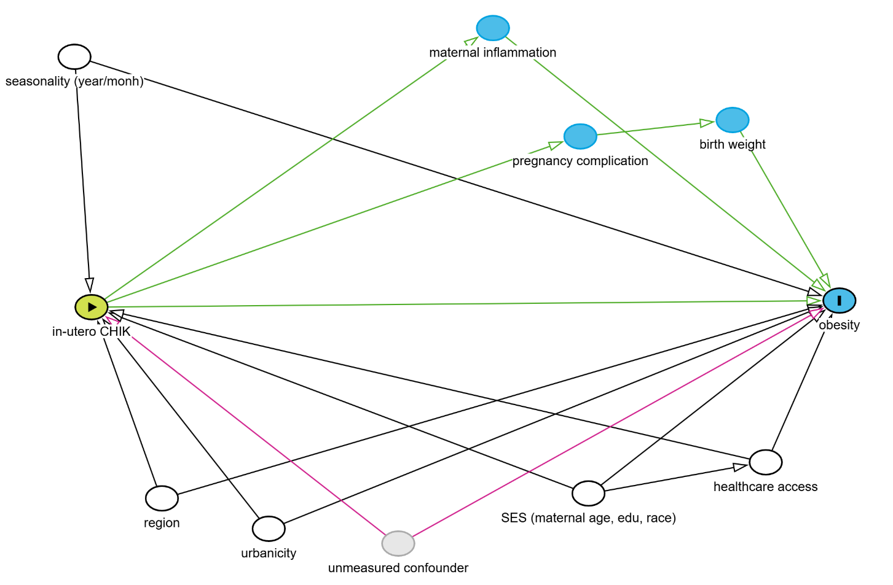
Covariates included in the models and their categories were the following.
- Maternal education: none, 1-3, 4-7, 8-11, and 12 or more years.^{9,10}
- Self-reported maternal race/skin color, based on the categories defined by the Brazilian Institute of Geography and Statistics: White, Black (Preto), Parda, Indigenous, and Yellow (Asian).^{11,12}
- Maternal age: 15-19, 20-34, and 35-49 years old.^{12,13}
- The adequacy of antenatal care visits was used as a proxy of healthcare access. It was calculated based on the Brazilian Ministry of Health guidelines¹⁴, which were categorized as adequate for gestational age, one visit fewer than recommended, or two or more visits fewer than recommended.
The recommendations were as shown below:
Gestational age at delivery | Recommended minimum ANC visits
< 22 weeks | ≥ 1 visit
22–27 weeks | ≥ 2 visits
28–31 weeks | ≥ 3 visits
32–36 weeks | ≥ 4 visits
≥ 37 weeks | ≥ 6 visits

- Year and month of conception:¹⁵ They were derived by subtracting the gestational weeks from the date of birth, both obtained from SINASC. Year of conception (2014 to 2018, 5 categories) and month of conception (January to December) were treated as two different variables.
- Region and urbanicity: region as urban or rural, which was self-reported by the respondent, and region, into the five regions of Brazil (North, Northeast, Center-west, Southeast, and South). ^{15,16}

Supplementary Figure 2: The actual z-score trajectories plotted against the curve predicted by LMM
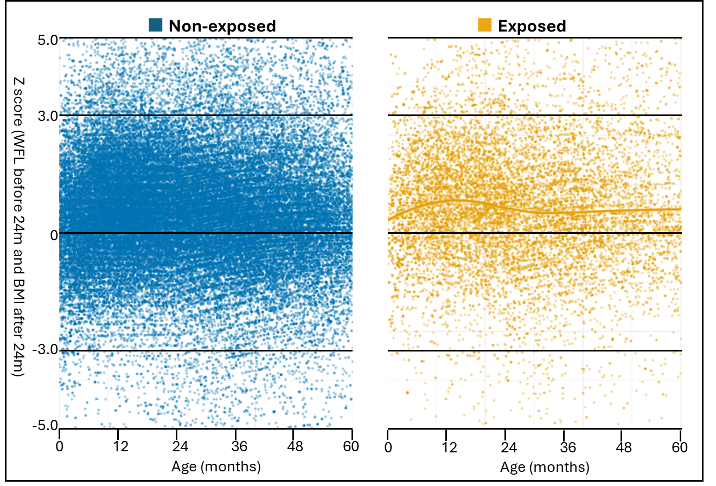
Footnote: For the non-exposed, 100,000 individuals were randomly selected for plotting.

Supplementary Figure 3: Results for sensitivity analyses (i) to (iii) using the CS method.
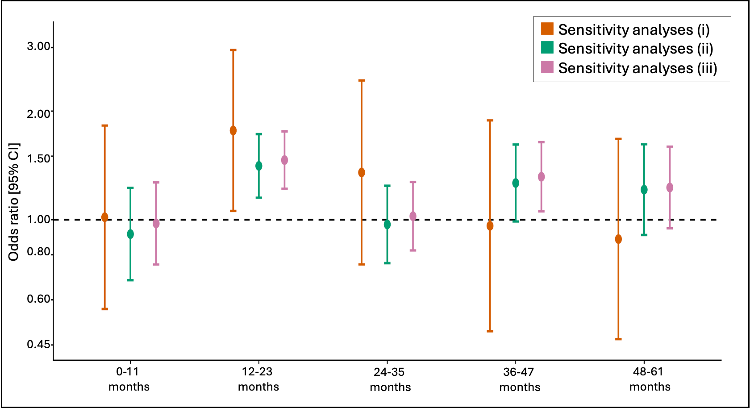

Supplementary Figure 4: The results for the sensitivity analyses (i), (ii) and(iv) using the LMM method.
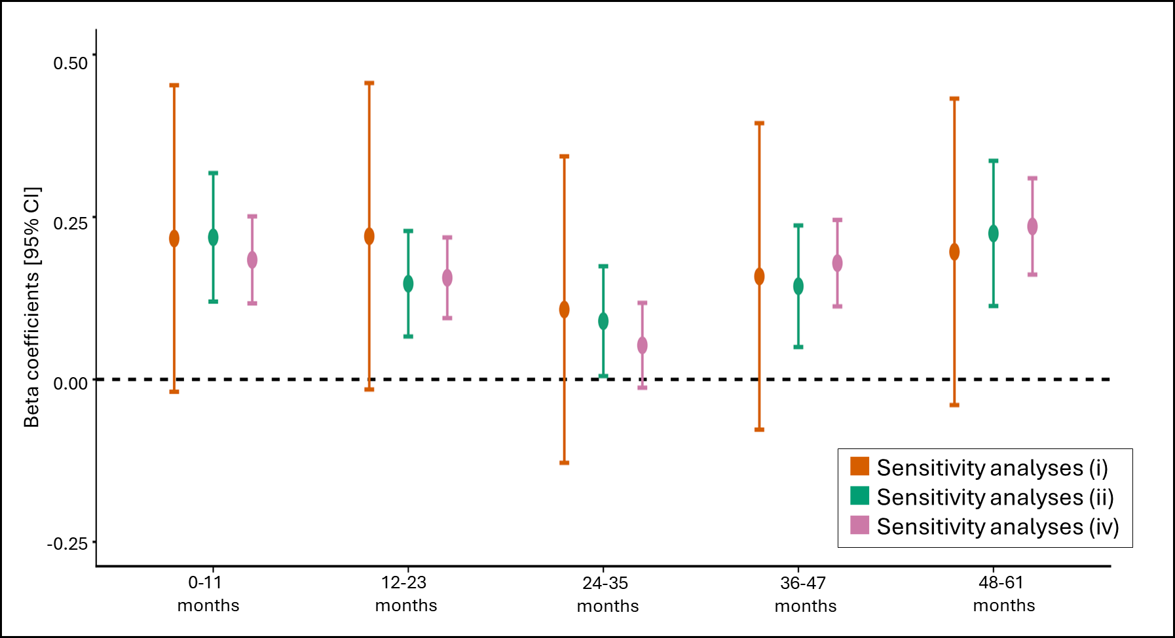

Supplementary Figure 5: The results for sensitivity analyses (v), the LMM model stratified by sex.
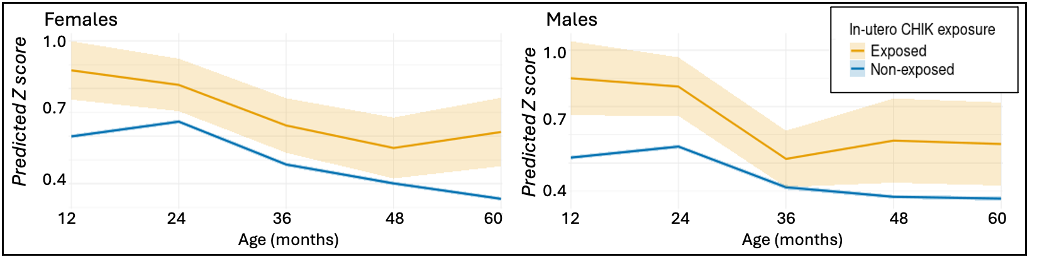
Footnote: the Z-score represents the weight for length Z score (WLZ) for those younger than 24 months, and BMI for age Z score (BAZ) for those 24 months or older. The plotted Z-scores are a predicted conditional effect for the most common confounder combination (non-white, 20 to 34 years old mother with 8-11 years of education, in an urban area with adequate antenatal care visits, with conception date in June 2015).

Supplementary Figure 6: The results of sensitivity analyses (vi), the LMM model including only non-exposed from municipalities with at least one exposed case.
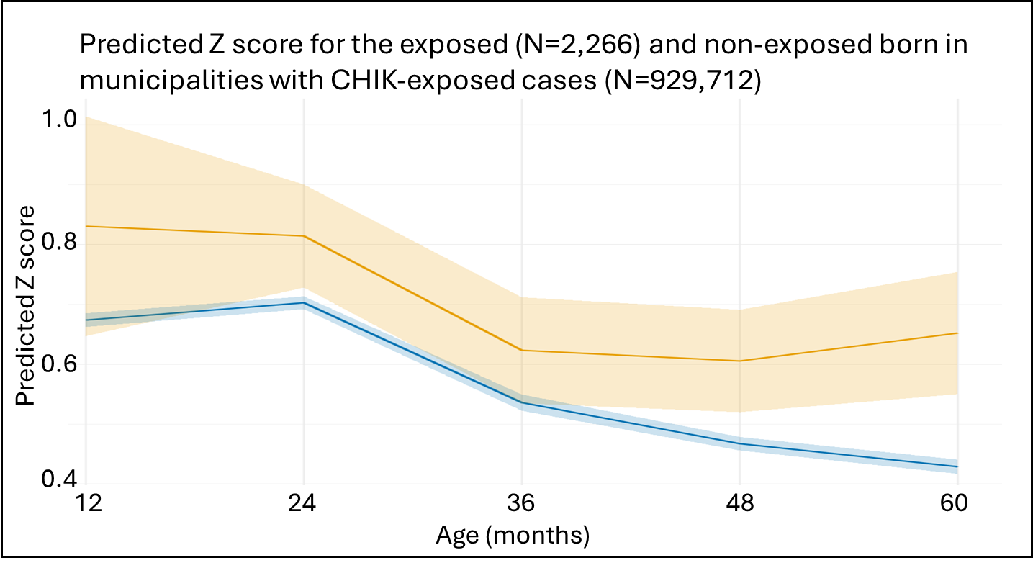
Footnote: the Z-score represents the weight for length Z score (WLZ) for those younger than 24 months, and BMI for age Z score (BAZ) for those 24 months or older. The plotted Z-scores are a predicted conditional effect for the most common confounder combination (non-white, 20 to 34 years old mother with 8-11 years of education, in an urban area with adequate antenatal care visits, with conception date in June 2015).

Supplementary Figure 7: The results of sensitivity analyses (vii), the LMM model stratified by urbanicity of residence.
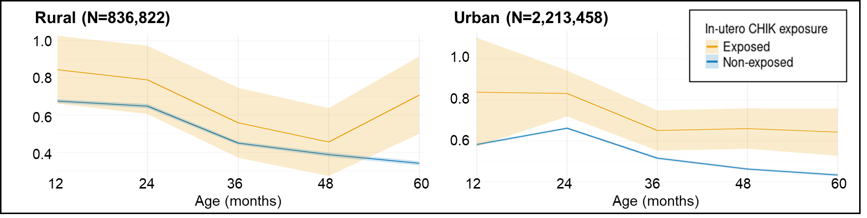

References
1. Bonilha, E. de A. et al. Cobertura, completude e confiabilidade das informações do Sistema de Informações sobre Nascidos Vivos de maternidades da rede pública no município de São Paulo, 2011. Epidemiol. Serv. Saude 27, e201712811 (2018).
2. Paixao, E. S. et al. A nationwide longitudinal investigation on the role of prenatal exposure to infectious diseases on the onset of chronic conditions in children and adolescents in Brazil. Wellcome Open Res. 9, 320 (2024).
3. Paixao, E. S. et al. Cohort Profile: Centro de Integração de Dados e Conhecimentos para Saúde (CIDACS) Birth Cohort. Int. J. Epidemiol. 50, 37–38 (2021).
4. SINAN. https://portalsinan.saude.gov.br/.
5. Silva, N. de J. et al. Qualidade dos dados antropométricos infantis do Sisvan, Brasil, 2008-2017. Rev. Saude Publica 57, 62 (2023).
6. Ali, M. S. et al. Administrative data linkage in Brazil: Potentials for health technology assessment. Front. Pharmacol. 10, 984 (2019).
7. Leacy, F. P., Floyd, S., Yates, T. A. & White, I. R. Analyses of sensitivity to the missing-at-random assumption using multiple imputation with delta adjustment: Application to a tuberculosis/HIV prevalence survey with incomplete HIV-status data. Am. J. Epidemiol. 185, 304–315 (2017).
8. James R. Carpenter, Jonathan W. Bartlett, Tim P. Morris, Angela M. Wood, Matteo Quartagno, Michael G. Kenward. Multiple Imputation and Its Application, 2nd Edition. (Wiley, 2023).
9. Fritel, X. et al. Chikungunya Virus Infection during Pregnancy, Réunion, France, 2006. Emerg. Infect. Dis. 16, 418–425 (2010).
10. Rocha, S. G. M. O. et al. Environmental, socioeconomic, maternal, and breastfeeding factors associated with childhood overweight and obesity in Ceará, Brazil: A population-based study. Int. J. Environ. Res. Public Health 17, 1557 (2020).
11. Cerqueira-Silva, T. et al. Risk of death following chikungunya virus disease in the 100 Million Brazilian Cohort, 2015-18: a matched cohort study and self-controlled case series. Lancet Infect. Dis. 24, 504–513 (2024).
12. Trude, A. C. B., Surkan, P. J., Cheskin, L. J. & Gittelsohn, J. A multilevel, multicomponent childhood obesity prevention group-randomized controlled trial improves healthier food purchasing and reduces sweet-snack consumption among low-income African-American youth. Nutr. J. 17, 96 (2018).
13. Ogwuche, J. et al. Arbovirus surveillance in pregnant women in north-central Nigeria, 2019-2022. medRxiv (2023) doi:10.1101/2023.08.04.23293671.
14. Barbosa de Andrade, R. et al. Adequacy of prenatal care in northeast Brazil: Pilot data comparing attainment of standard care criteria for first-time adolescent and adult pregnant women. Int. J. Womens Health 12, 1023–1031 (2020).
15. Gardini Sanches Palasio, R., Marques Moralejo Bermudi, P., Luiz de Lima Macedo, F., Reis Santana, L. M. & Chiaravalloti-Neto, F. Zika, chikungunya and co-occurrence in Brazil: space-time clusters and associated environmental-socioeconomic factors. Sci. Rep. 13, 18026 (2023).
16. Ferreira, C. M. et al. Prevalence of childhood obesity in Brazil: systematic review and meta-analysis. J. Pediatr. (Rio J.) 97, 490–499 (2021).

