SUPPLEMENTARY INFORMATION

Basal forebrain parvalbumin neuron dysfunction links network oscillation deficits to hippocampal pathology in Alzheimer’s disease

Eunjin Hwang, Hyun Soo Shim, Hojin Lee, Seung Chan Kim, Min-Ho Nam, Seung Jae Hyeon,
Hea-Jin Kim, Ji Eun Kim, Hyeok Ju Park, Jiwan Woo, Eun Mi Hwang, Thor D. Stein, Junghee Lee
Jee Hyun Choi, Hoon Ryu

Corresponding authors:
Prof. Jee Hyun Choi, Center for Neuroscience, BSI, KIST, Seoul 02792, Republic of Korea.
Email: jeechoi@kist.re.kr
and
Prof. Hoon Ryu, Center for Neuroscience, BSI, KIST, Seoul 02792, Republic of Korea.
Email: hoonryu@kist.re.kr

Supplementary Table 1. Information of postmortem brain tissues from normal subjects, mild cognitive impairment AD (neuropathological and clinical AD: NPCAD), and severe AD cases, respectively.
Case | Diagnosis | Sex | Age | Braak stage | CERAD
1 | Normal | F | 92 | I | C0
2 | Normal | F | 87 | I | C0
3 | Normal | F | 83 | II | C2
4 | Normal | M | 94 | II | C1
5 | Normal | F | 94 | III | C0
1 | NPCAD | M | 92 | III | C2
2 | NPCAD | M | 82 | VI | C3
3 | NPCAD | F | 88 | II | C1
4 | NPCAD | F | 93 | III | C2
5 | NPCAD | F | 83 | III | C1
1 | AD | F | 92 | VI | C1
2 | AD | M | 89 | IV | C2
3 | AD | F | 93 | IV | C3
4 | AD | M | 83 | V | C3
5 | AD | F | 93 | VI | C3

Supplementary Table 2. Primer sequences used for the qRT-PCR.
Amplicon | Primer Sequences
Gapdh  (mouse form) | F: 5’-CCGTGTTCCTACCCCCAAT-3’
Gapdh  (mouse form) | R: 5’-CCGTGTTCCTACCCCCAAT-3’
Cst3  (mouse form) | F: 5’-ACAACAAGGGCAGCAACGAT-3’
Cst3  (mouse form) | R: 5’-GCAGCTGAATTTTGTCAGGGA-3’
Apoe  (mouse form) | F: 5’-GTGCTGTTGGTCACATTGCT-3’
Apoe  (mouse form) | R: 5’-AGTGCCGTCAGTTCTTGTGT-3’
B2m  (mouse form) | F: 5’-TGGTCTTTCTGGTGCTTGTC-3’
B2m  (mouse form) | R: 5’-TGGGGGTGAATTCAGTGTGA-3’
Vip  (mouse form) | F: 5’-AGCAGAAAATGGCACACCCT-3’
Vip  (mouse form) | R: 5’-ATTTGCTTTCTGAGGCGGGT-3’
Chat  (human form) | F: 5’-AGTGCATGCAACACCTGGTA-3’
Chat  (human form) | R: 5’-AAGTGCTGCCGAGCAAAGAT-3’
Pv  (human form) | F: 5’-TTTGCTGCTGCAGACTCCTT-3’
Pv  (human form) | R: 5’-GGCCAGAAGCGTCTTTGTTT-3’

Supplementary Table 3. Statistical association between pathological, electrophysiological, and behavioral features. List of triplets of cross-modal connections. From Spearman’s rank correlation matrix, significant connections (p<0.05 for rejecting null hypothesis of no correlation) linking features from different modalities (pathology, behavior and EEG) were obtained. The features which have connections to other two modalities are arranged as pathology-behavior-EEG triplets.
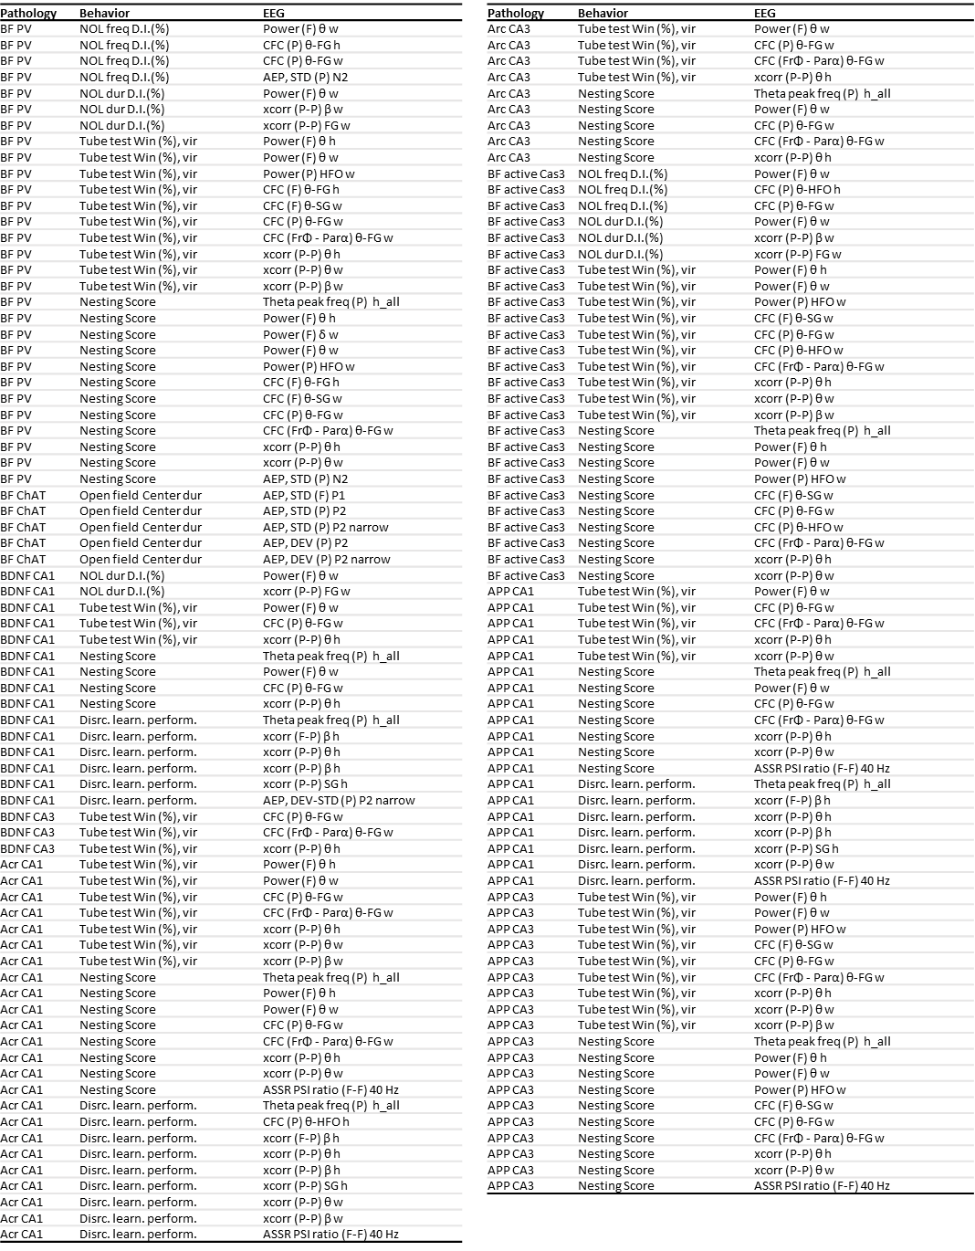

Supplementary Figure Legends

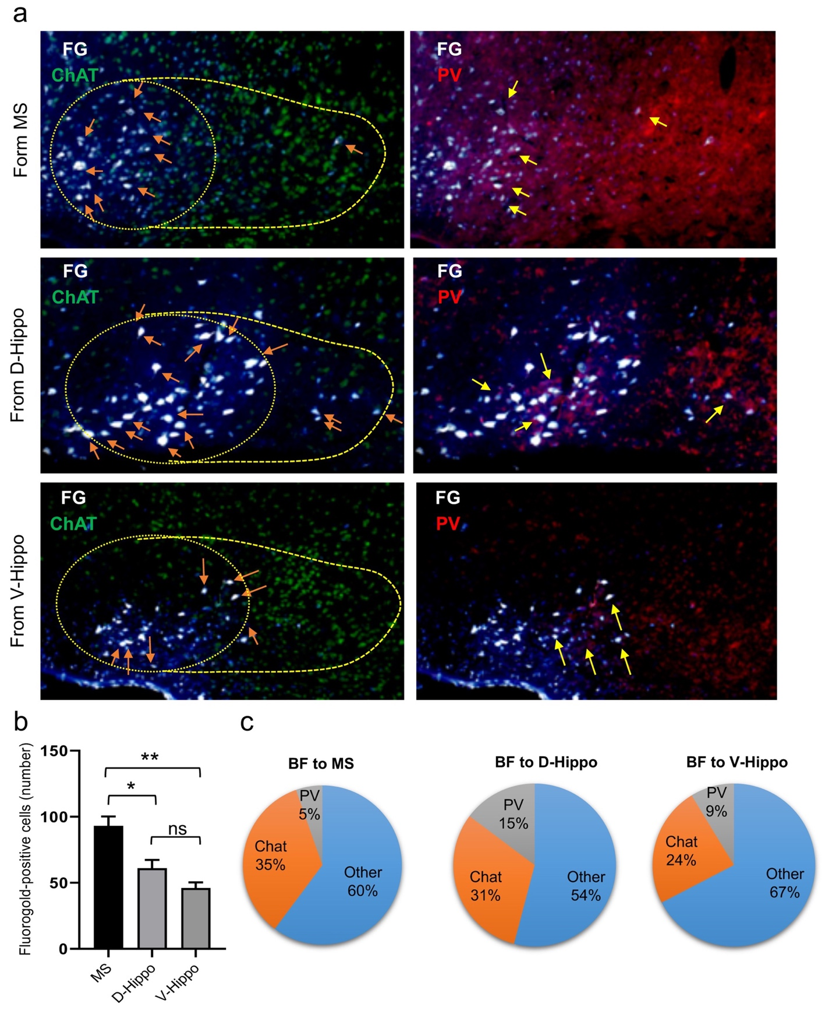
Supplementary Figure 1. A PV- and ChAT-positive neuron in the BF projected to the MS and hippocampus.
(a) Photographs showing the colocalization with ChAT (orange arrow) or PV (yellow arrow)-positive cells and the distribution of the retrogradely labeled cells in the BF after injections of fluorogold (FG) into the MS and dorsal and ventral hippocampus.
(b) The mean number of retrogradely labeled cells in the BF after injection of FG into the MS was larger than that recorded in the hippocampal area.
(c) Thirty-five percent of the ChAT- and 5% of the PV-immunoreactive cells in the BF region were double labeled with retrogradely labeled cells projecting to the MS. Moreover, 31% of the ChAT- and 15% of the PV-positive cells in the BF region colocalized with FG-positive cells projecting to the dorsal hippocampus. Finally, 24% of the ChAT- and 9% of the PV-positive neurons projected from the BF to the ventral hippocampus.
Statistical significance was analyzed by one-way ANOVA followed by Tukey’s multiple-comparisons test. Data are presented as mean ± SEM. * P < 0.05, ** P < 0.01.

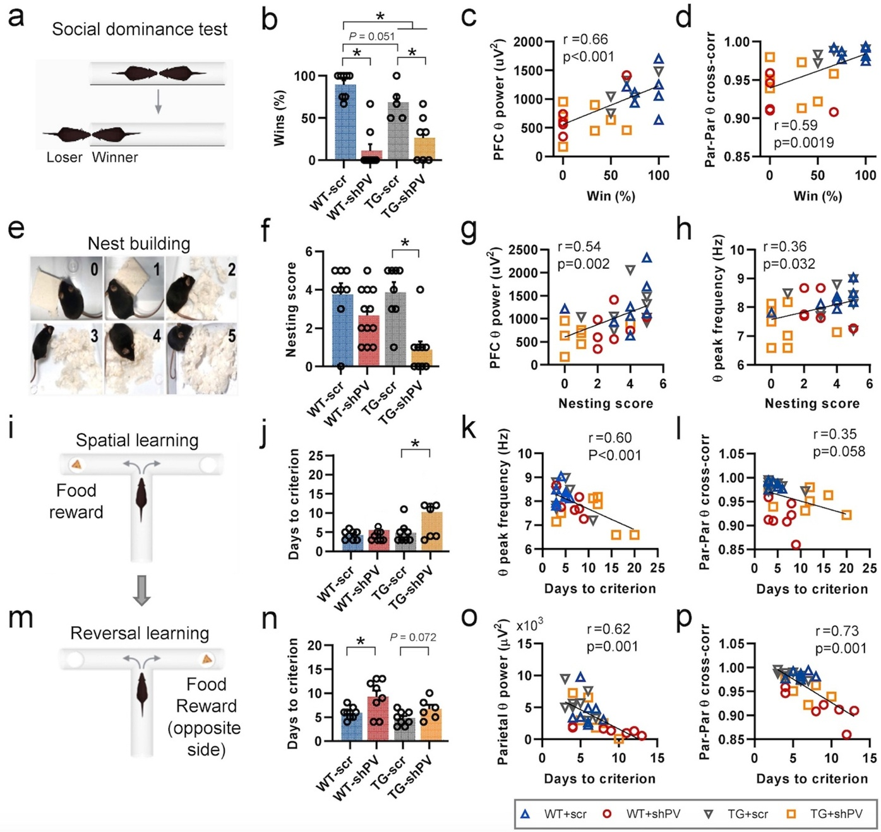
Supplementary Figure 2. Correlation between behavioral scores and treadmill EEG parameters.
(a) Schematic representation of the social dominance test.
(b) Percent wins showed that dominance was significantly reduced after knockdown of BF-PV in both the WT and TG groups. TG groups of scrambled and shPV showed a significantly lower winning rate compared with WT-scr mice, whereas TG-scr mice exhibited a lower winning rate, with marginal significance (P = 0.051) compared with WT-scr animals (WT-scr, N = 8; WT-shPV, N = 8; TG-scr, N = 5; TG-shPV, N = 7). Percent wins were calculated by matching with the same genotype.
(c) Percent wins in the dominance test were positively correlated with PFC theta power during treadmill walking.
(d) Percent wins in the dominance test were positively correlated with the cross-correlation of Par theta rhythm during walking.
(e) Exemplary scoring for nest building.
(f) Nest-building scores showed that TG-shPV mice had significant impairment in building nests (WT-scr, N = 8; WT-shPV, N = 12; TG-scr, N = 8; TG-shPV, N = 9).
(g) Nest-building scores were positively correlated with PFC theta power during walking.
(h) Nest-building scores were positively correlated with Par theta peak frequency during habituation.
(i, m) Schematic representation of spatial learning and its reversal in a T-maze. When a subject entered the correct arm (with food reward) and consumed the reward in at least 6 trials among 10 trials on 3 consecutive days, it was determined that the acquisition criterion was met. After the subject reached the learning criterion, the correct arm was changed to the opposite T-arm and 10 daily trials were repeated until the criterion was reached again (reversal learning criterion).
(j) The days necessary to reach the acquisition criterion revealed that TG-shPV mice showed inferior performance in spatial learning compared with TG-scr mice (WT-scr, N = 8; WT-shPV, N = 8; TG-scr, N = 8; TG-shPV, N = 6). In WT groups, the performance was comparable.
(k) The days necessary to reach the learning criterion were negatively correlated with Par theta peak frequency measured during habituation, indicating that a faster theta frequency was associated with a better learning performance.
(l) The days necessary to reach the learning criterion were negatively correlated with the cross-correlation of Par theta rhythm during walking.
(n) The days necessary to reach the reversal learning criterion revealed that WT-shPV mice showed inferior performance in reversal learning compared with WT-scr mice (WT-scr, N = 8; WT-shPV, N = 8; TG-scr, N = 8; TG-shPV, N = 6). In TG groups, the performance was marginally significantly different (P = 0.072).
(o) The days necessary to reach the reversal learning criterion were negatively correlated with theta power during walking, indicating that a stronger theta power was associated with a better reversal learning performance.
(p) The days necessary to reach the reversal learning criterion were negatively correlated with the cross-correlation of Par theta rhythm during walking.
Statistical significance was analyzed by two-way ANOVA followed by Tukey’s multiple-comparisons test. Data are presented as mean ± SEM. * P < 0.05.

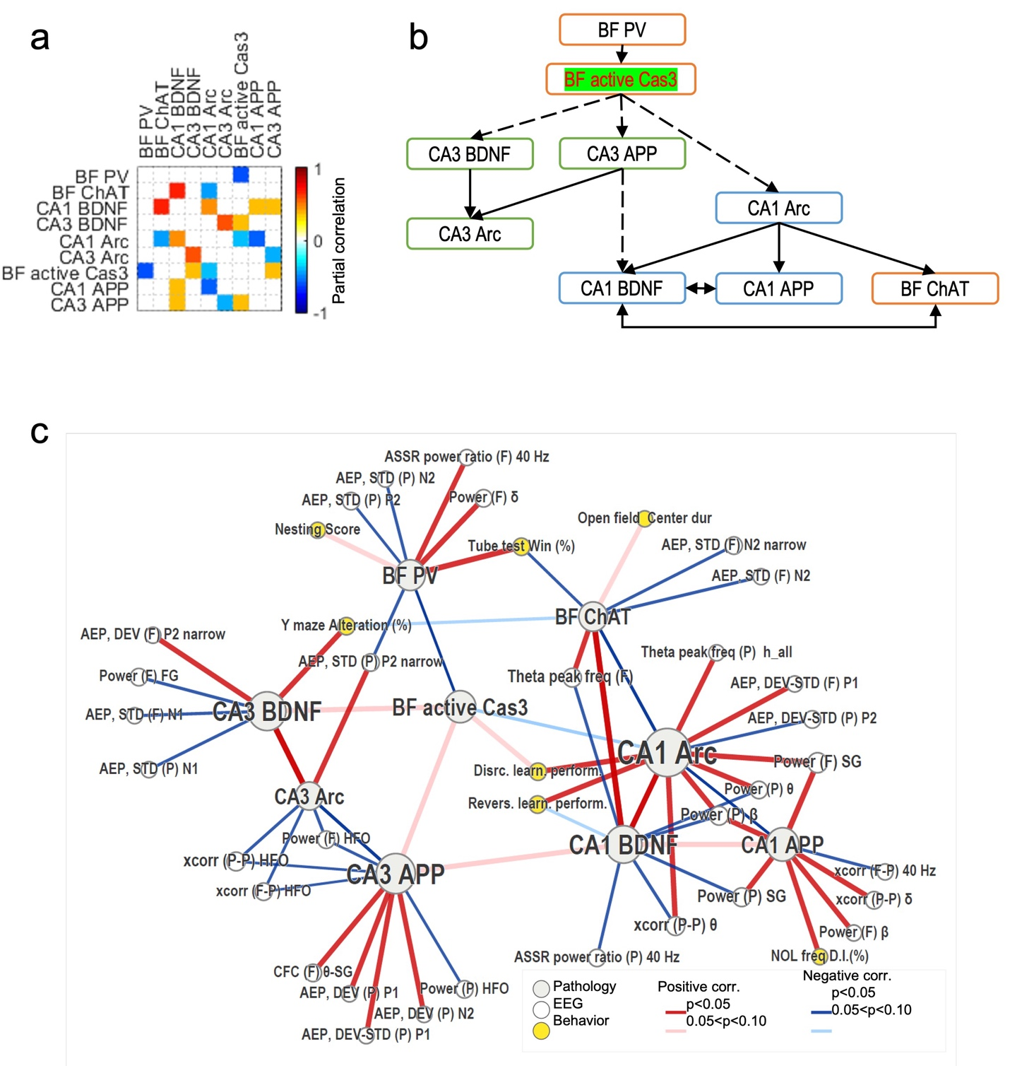
Supplementary Figure 3. Partial correlation analysis.
(a) Heatmap of the significant partial correlation between multimodal features within pathological features. The α level for statistical significance of correlation was set to 0.1.
(b) Schematic diagram showing the cascade effects following BF-PV knockdown inferred from a. First, BF active Cas3 was negatively correlated with BF-PV. Subsequently, associations between active-Cas3 and CA3 BDNF, CA3 APP, and CA1 Arc were detected. The solid lines indicate connections with a significance level of 0.05 and the dashed lines indicate additional links with a significance level of 0.10.
(c) Partial correlation network of pathological features, EEG findings, and behavior features. The color and width of the links indicate the sign and strength of correlation, respectively. P in the legend indicates the P-values to reject the null hypothesis of no correlation between the nodes. The links between the EEG and pathology nodes were omitted if 0.05 < P < 0.10. The network was visualized using the Gephi software (Bastian M., et al., 2009).

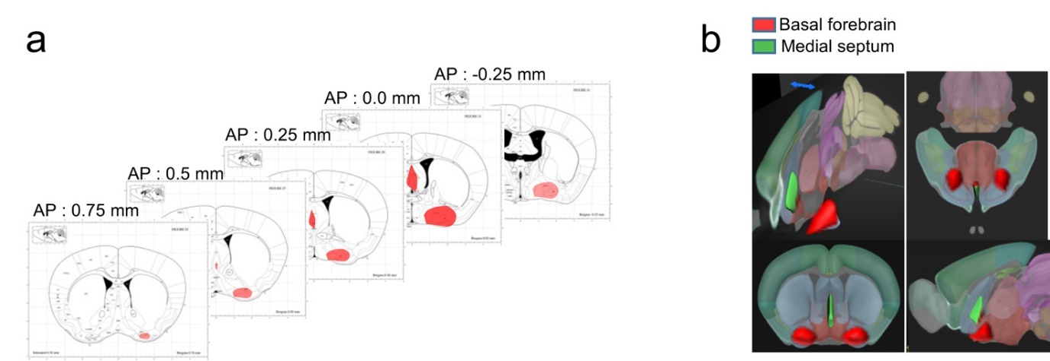Supplementary Figure 4. 3-dimensional view of virus expression.
(a) mCherry signals were found from AP 0.75 to -0.25 mm based on bregma.
(b) 3-dimensional view of mCherry expression. (3D background image was quoted Allen Brain Map.)
(3D background image was quoted Allen Brain Map.)

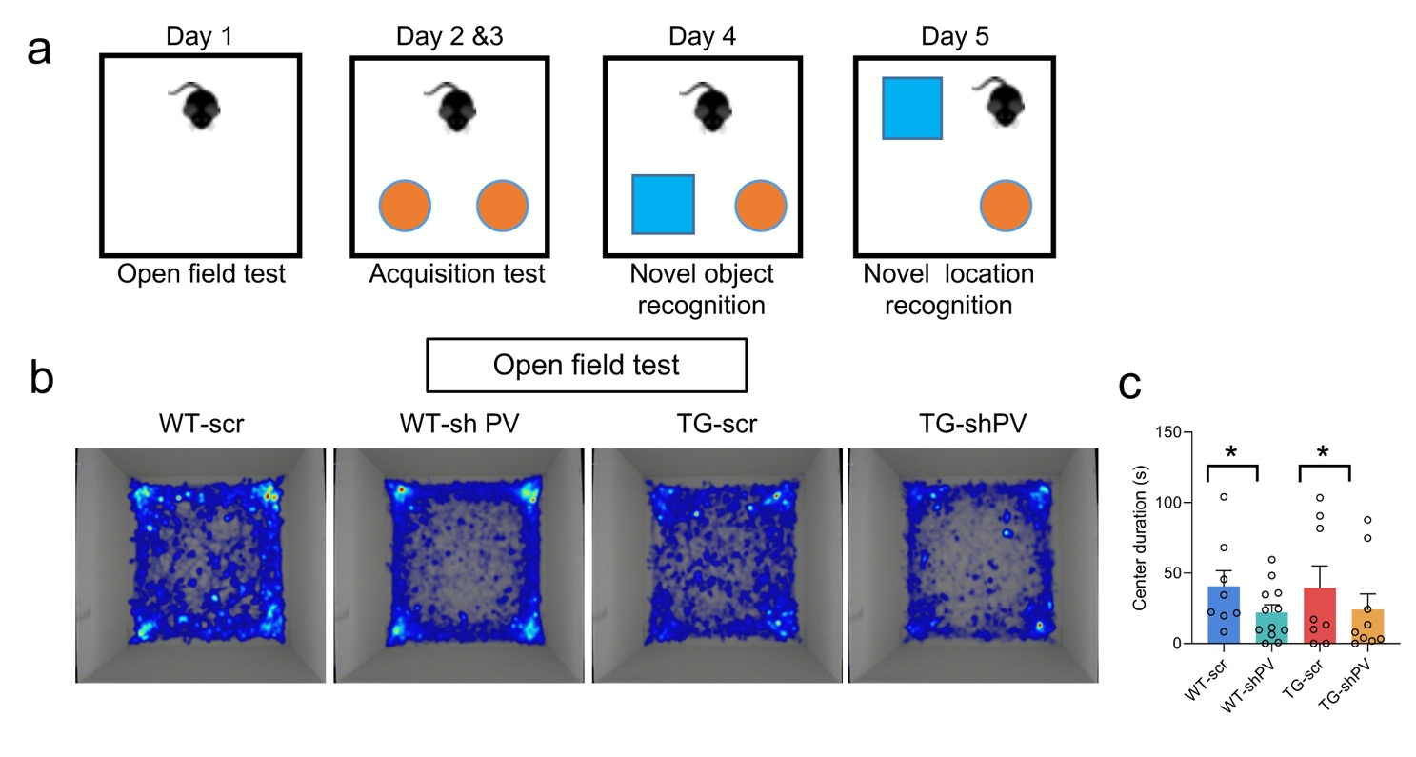
Supplementary Figure 5. Gene-silencing of PV in BF induces anxiety-like behavior in open field test.
(a) Schematic diagram of open field and novel object tests.
(b) Representative heat map of duration time of mice in the open field.
(c) PV knockdown in both WT and TG mice significant decrease in center duration compared to control (scr; scrambled shRNA) groups (WT-scr, N = 8; WT-shPV, N = 12; TG-scr, N = 8; TG-shPV, N = 9). Statistical significance was analyzed by two-way ANOVA followed by Tukey’s multiple-comparisons test. Data are presented as mean ± SEM. * P < 0.05.

g
Supplementary Figure 6. Heatmap comparison of EEG features.
(a) Diagram for questions about significant difference in WT-scr vs TG (①) and WT-scr vs. WT-shPV (②) and no difference in WT-shPV vs. TG (③).
(b) Heatmap comparison of PFC EEG obtained from baseline. EEG features are normalized to WT-scr. Right-side of the EEG heatmaps, significance maps are presented. Red colored cells in the statistical result maps for question asking the significant difference in WT-scr vs TG (①) and WT-scr vs. WT-shPV (②) and no difference in WT-shPV vs. TG (③) depicted in a.
(c) Heatmap comparison of Par EEG obtained from baseline.
(d) Heatmap comparison of cross-regional EEG features obtained from baseline.
(e) Heatmap comparison of PFC EEG obtained from treadmill walking.
(f) Heatmap comparison of Par EEG obtained from treadmill walking.
(g) Heatmap comparison of cross-regional EEG features obtained from treadmill walking. Fp, PFC phase; Pa, Par amplitude; Pp, Par phase; Fa, PFC amplitude.
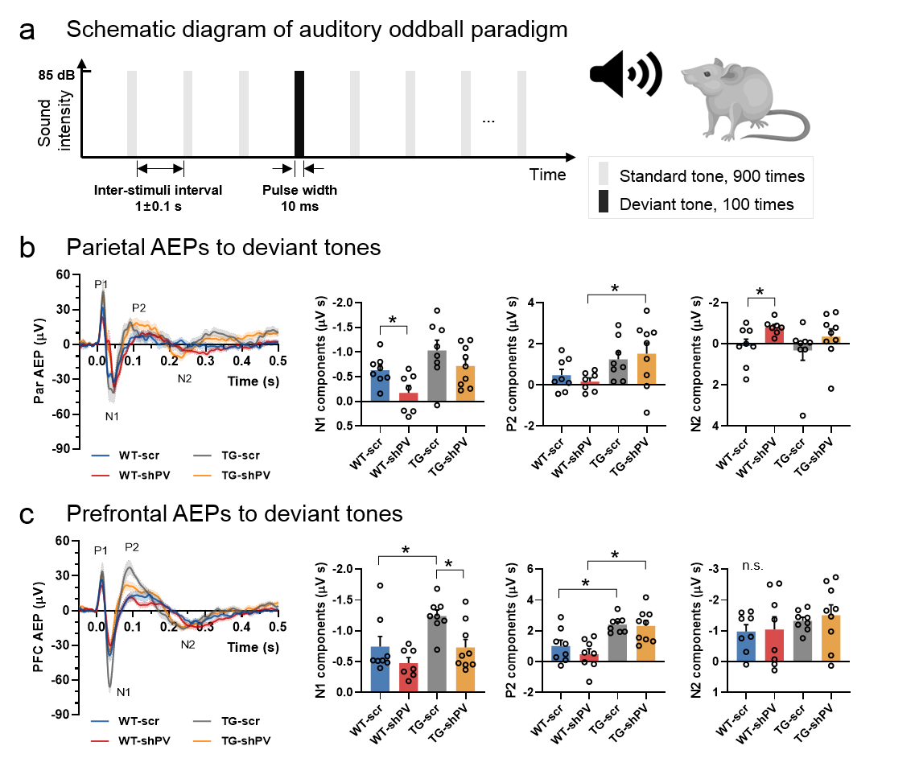
Supplementary Figure 7. Auditory evoked potentials (AEPs).
(a) Schematic diagram of auditory oddball paradigm
(b) (left) Par AEPs to deviant tones of auditory oddball paradigm. Shades indicate SEM of the AEPs. (right) Magnitudes of ERP components based on the area under the component of N1, P2 and N2, respectively (WT-scr, N=8; WT-shPV, N = 7; TG-scr, N = 8; TG-shPV, N = 9). Area for N1, P2, N2 were determined with intervals 25–50 ms, 60–175 ms, and 200–350 ms, respectively, after the tone onset. Statistical significance was analyzed by two-way ANOVA followed by Tukey’s multiple-comparisons test. Data are presented as mean ± SEM. * P < 0.05.
(c) (left) PFC AEPs to deviant tones of auditory oddball paradigm. Shades indicate SEM of the AEPs. (right) Magnitudes of ERP components based on the area under the component of N1, P2 and N2, respectively (WT-scr, N=8; WT-shPV, N = 7; TG-scr, N = 8; TG-shPV, N = 9). Area for N1, P2, N2 were determined with intervals 25–50 ms, 60–175 ms, and 200–350 ms, respectively, after the tone onset.Statistical significance was analyzed by two-way ANOVA followed by Tukey’s multiple-comparisons test. Data are presented as mean ± SEM. * P < 0.05.
(d) Heatmap comparison of PFC and Par AEPs obtained from auditory oddball paradigm. EEG features are normalized to WT-scr. Large percent to WT-scr is due to small values of WT-scr. Right-side of the EEG heatmaps, significance maps are presented. Red colored cells in the statistical result maps for question asking the significant difference in WT-scr vs TG (①) and WT-scr vs. WT-shPV (②) and no difference in WT-shPV vs. TG (③) (see the diagram in Supplementary Figure 6a).

Supplementary Figure 8. Auditory steady-state responses (ASSRs).
(a) Schematic diagram of auditory steady-state stimulation paradigm
(b) Phase-locking and power features of 40 Hz ASSRs (WT-scr, N=8; WT-shPV, N = 7; TG-scr, N = 8; TG-shPV, N = 9). PLV, phase-locking value; ITPL, inter-trial phase-locking. ITPL and power was presented in a ratiometric way, by dividing values obtained from stimulation period by pre-stim baseline values.
(c) Cortical connectivity features of 40 Hz (WT-scr, N=8; WT-shPV, N = 7; TG-scr, N = 8; TG-shPV, N = 9). Xcorr, cross-correlation coefficient; PSI, phase synchronization index. F-F, prefrontal-prefrontal; F-P, prefrontal-parietal; P-P, parietal-parietal.
(d) Heatmap comparison of ASSRs. EEG features are normalized to WT-scr. Large percent to WT-scr is due to small values of WT-scr. Right-side of the EEG heatmaps, significance maps are presented. Red colored cells in the significance maps indicate P<0.05 for unpaired t-test between designated pairs of groups for EEG features at the same row. Red colored cells in the statistical result maps for question asking the significant difference in WT-scr vs TG (①) and WT-scr vs. WT-shPV (②) and no difference in WT-shPV vs. TG (③) (see the diagram in Supplementary Figure 3a). It is noted that only genotype difference in pre-stim baseline 40 Hz power was found in ASSR test.

a Correlation network with pathological features of positive correlation to BF-PV
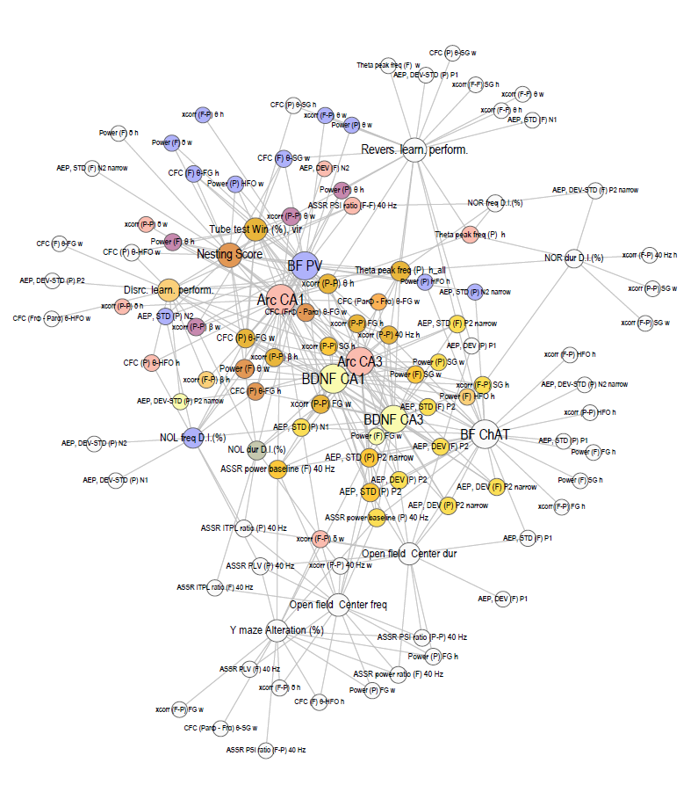
b Correlation network with in vitro electrophysiology
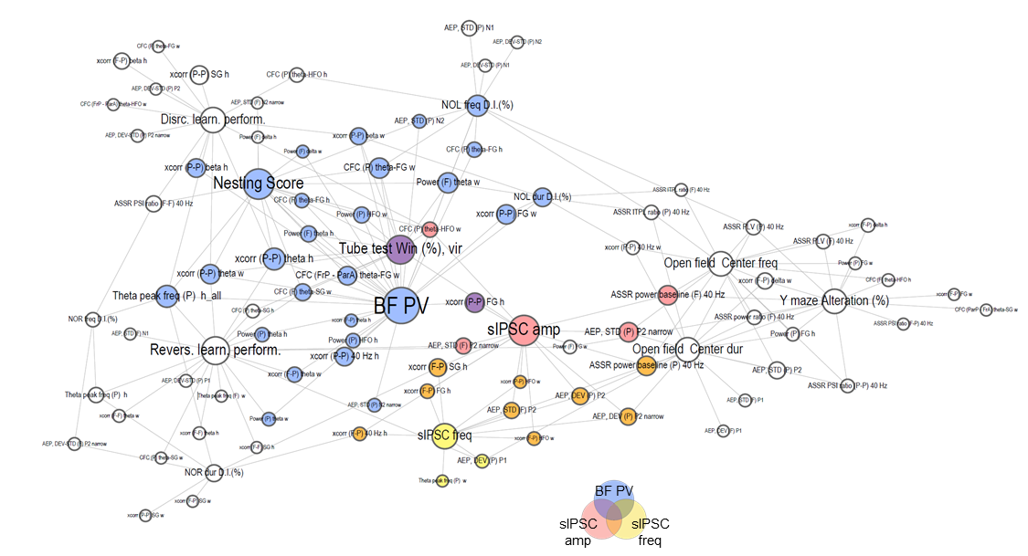
Supplementary Figure 9. Cross-modal correlation networks.
(a) Cross-modal correlation network of pathophysiology, EEG, and behaviors. Patho-features of positive correlation to BF-PV were selected, which were BF-BDNF and CA1-Arc.
(b) Cross-modal correlation network of BF-PV, in vitro electrophysiology, EEG, and behaviors. Color of EEG/behavior nodes is mixture of its nearest neighbors, indicating the connectedness to the pathological features. Size of nodes indicates degree of connection.

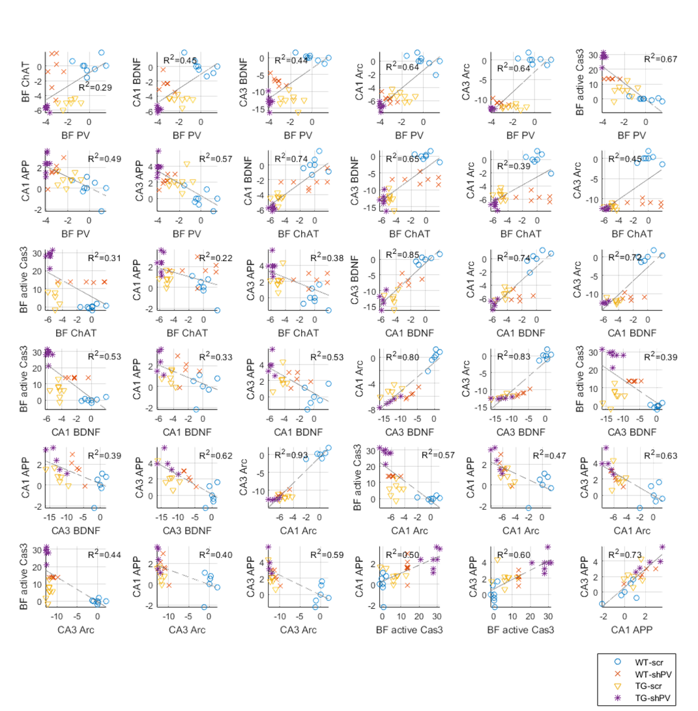
a
Supplementary Figure 10. Linear regression between pathological features.
(a) Scatter plots of pathological features. Dashed lines indicate linear regression lines.
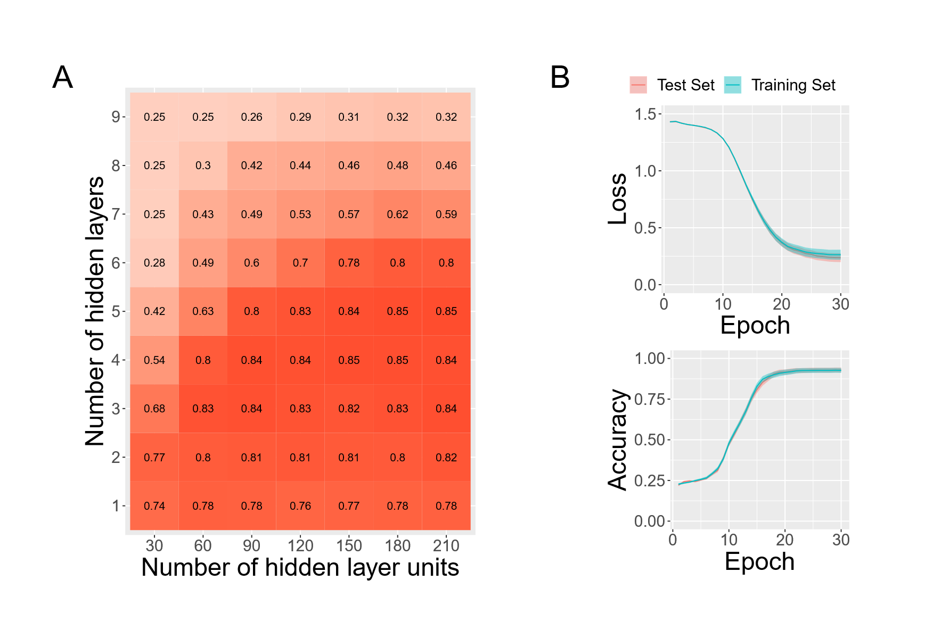
Supplementary Figure 11. Architecture searching and training history.
a
b
(a) Prediction accuracies of various network architectures exhibits that ANN with 5 hidden layers and 180 hidden layer units has the highest accuracy. This architecture is selected for feature attribution analysis.
(b) Loss and accuracy history of the selected ANN demonstrate the reliability of the training process. Shade indicates confidence interval.

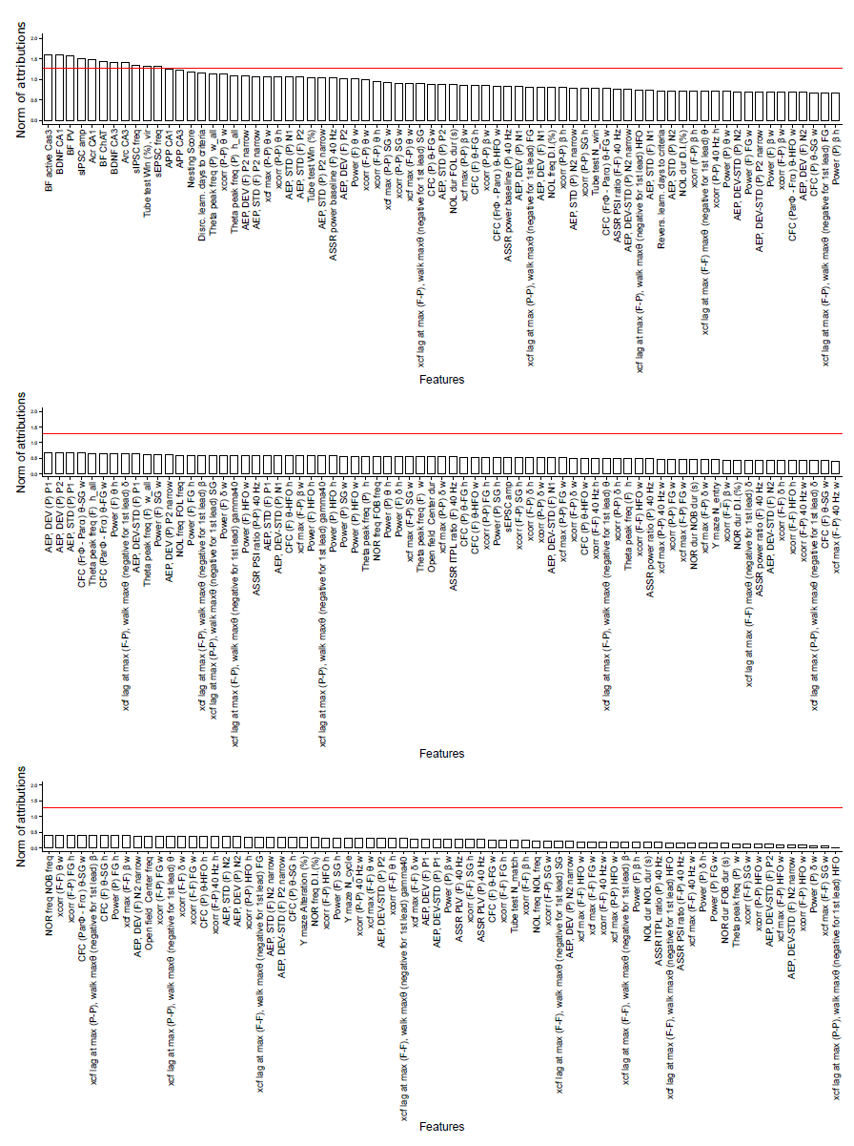
a
Supplementary Figure 12. Norms of attribution values for total 218 features.
(a) Norm of attributions of features, which is $\sqrt[ ]{\sum_{g}{{(d_{i}^{g})}^{2}}}$ for i^{th} feature, show their overall attribution for predicting genotypes. It is demonstrated that a small proportion of features, including most of the pathological features, sIPSC characteristics, and winning rate in tube test, have much higher attributions than others. Red lines indicate the boundary between the high attribution (top 5% norm) features and the rest.

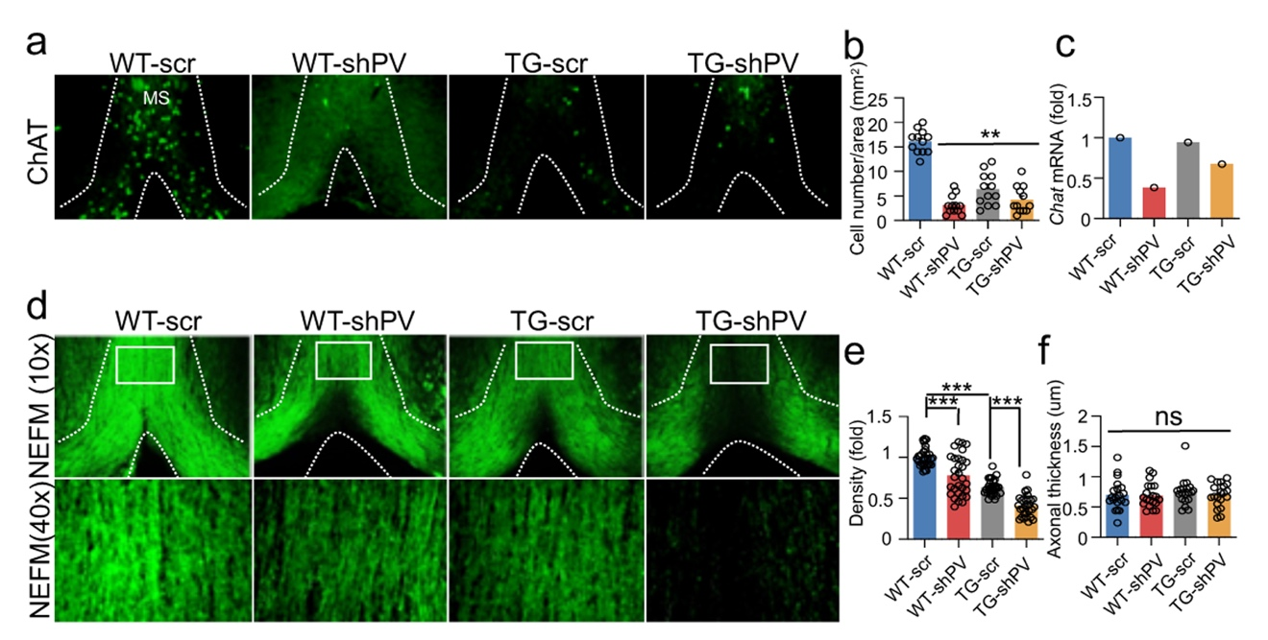
Supplementary Figure 13. PV downregulation induced loss of cholinergic neurons and neurofilaments in MS.
(a and b) ChAT-positive cells were significantly decreased in the MS of TG mice brains compared to WT. Knockdown of PV by shRNA reduced ChAT immunoreactivity in WT-shPV mice brains (12 ROIs from N = 3 mice per group). Statistical significance was analyzed by two-way ANOVA followed by Tukey’s multiple-comparisons test. Data are presented as mean ± SEM. ** P < 0.01.
(c) Knockdown of PV by shRNA led to decrease of mRNA level of Chat in the MS.
(d - f) NEFM-positive immunoreactive signals were significantly decreased in the MS of TG mice brains compared to WT (10 cells per mouse; N = 3 mice per group). Knockdown of PV by shRNA reduced NEFM immunoreactivity in WT-shPV mice brains. However, there was no significant difference in the axonal thickness in the MS. Statistical significance was analyzed by two-way ANOVA followed by Tukey’s multiple-comparisons test. Data are presented as mean ± SEM. *** P < 0.001.

