ACE2/ANG-(1-7)/Mas receptor axis activation prevents inflammation, glial activation and cognitive decline in a rat model of STZ induced impairment of learning and memory
Virendra Tiwari^{1,2}, Jitendra Singh¹, Priya Tiwari^{2,3}, Swati Chaturvedi^{2,4}, Shivangi Gupta^{1,2}, Akanksha Mishra^{1,5}, Sonu Singh^{1,6}, Muhammad Wahajuddin^{2,4}, Kashif Hanif^{2,3}, Shubha Shukla^{1,2}
¹Division of Neuroscience and Ageing biology, CSIR- Central Drug Research Institute, Lucknow-226031, (U.P.), India.
²Academy of Scientific and Innovative Research (AcSIR), Ghaziabad-201002, India.
³Division of Pharmacology, CSIR- Central Drug Research Institute, Lucknow-226031, (U.P.), India.
⁴Division of Pharmaceutics and Pharmacokinetics, CSIR - Central Drug Research Institute, Lucknow-226031, (U.P.), India.
⁵Department of Cell Biology and Anatomy, New York Medical College, Valhalla, NY 01595, USA.
⁶Department of Neuroscience, School of Medicine, University of Connecticut (Uconn) Health Center, 263 Farmington Avenue, L-4078, Farmington, CT 06030, USA.

Corresponding author:
Dr. Shubha Shukla
Principal Scientist,
Division of Neuroscience and Ageing biology,
CSIR-Central Drug Research Institute,
Sector 10, Jankipuram Extension, Sitapur Road, Lucknow-226031,
Uttar Pradesh, India
Fax no.: +91 522 2771941; Tel: +91 522 2772450, Ext- 4604
E-mail address: shubha_shukla@cdri.res.in

Materials and methods
DIZE was purchased from Santa-Cruz Biotechnology (cat no. sc-205651) and freshly prepared on a daily basis. DIZE was administered to STZ lesioned rats at the dose of 10 mg/kg/day and 15 mg/kg/day by intraperitoneal (i.p.) injection. All other rats received equivalent doses of vehicle (saline) injections [1-4].
A competitive ACE2 antagonist, based on the structure of a commercially available compound, MLN4760 was procured from Merck Millipore (CAS 305335-31-3). The ACE2 inhibitor was co-administered with DIZE in respective experiments, in an identical vehicle as DIZE, at 10μM conc. in a similar way as in the previously used MLN-4760 studies [5]
Cell culture and treatment
Mouse neuroblastoma cell line (Neuro-2A/N2A cell) was procured from the National Centre for Cell Sciences, Pune, India, and maintained at the tissue culture facility of CSIR-Central Drug Research Institute (CSIR-CDRI), Lucknow. Cells were maintained in DMEM containing 10% FBS at 37℃ in a humidified atmosphere of 5% CO₂/95% air. STZ was prepared as a fresh stock solution in serum-free media. N2A cells were incubated with STZ 2.5 mM [6] in the absence or presence of DIZE (25 μM) and DIZE alone for 24 h. Cells were treated with DIZE after 30 min of STZ addition.
MTT assay for cytotoxicity assessment
MTT assay was performed for estimation of cell viability [7]. N2A cells were seeded at a density of 1X10⁴ cells/well in 96-well plates. After the treatment period, MTT salt (20 μl/well containing 200 μl of cell suspension; 5 mg/ml in PBS) was added. The assay is a visible proof for ability of cells to convert yellow 3-(4, 5-dimethylthiazol-2-yl)-2, 5 diphenyltetrazolium bromide tetrazolium salt into a purple MTT formazan, by the mitochondrial dehydrogenase activity of live cells (measured spectrophotometrically at 590 nm).
Blood pressure and heart rate measurement
To study the alteration in hemodynamic parameters, Non-invasive blood pressure (NIBP) was monitored (Columbus instrument, Model NIBP-8). Rats were habituated in restrainer for 15 min, thrice a day, for one week prior to commencement of the experiment. During the experiment, rats were placed inside restrainer with their tails exposed to hot air blower. Both the cuffs (Occlusion and sensor) were inflated and deflated many times (minimum 8-10 cycles) along the tail to measure systolic blood pressure (SBP), diastolic blood pressure (DBP), mean arterial blood pressure (MAP), and heart rate (HR). The data was recorded and analyzed using graph pad prism software [8].
Results:
Effect of ACE2 activator DIZE on cell viability in N2A cell line after STZ treatment
The cell viability of STZ was determined with MTT reagent using various concentration of STZ (1mM, 2.5mM, 5mM, 7.5mM, 10mM and 12.5mM) after two distinctive time intervals 24h/48h (Supplementary Fig. 1A). The sample size in each group was capped at n=6. The cell viability was found to be decreased by approximately 50% as compared to control cells after exposure of 2.5mM to 12.5 mM dose of STZ to N2A cells for 24. However, exposure of cells with 1mM dose of STZ for 24 h did not exhibited signs of significant cell death compared to controls. Increasing the exposure time to 48 h augmented cytotoxicity (Supplementary Fig. 1B), whereupon cell viability consistently reduced with the concentration range used. Based on our initial findings, a concentration of STZ at 2.5mM was employed for rest of the study. The efficacy of DIZE to curb STZ mediated cytotoxicity was estimated by using the MTT reduction assay. The different concentrations of DIZE used ranged from 5μM to 40μM. In presence of STZ (2.5mM), DIZE at the concentrations of 25μM to 40μM has potency to enhance N2A cell viability (Supplementary Fig. 1C and D). However, DIZE concentration of 25μM was found to be the minimum dose that led to a significant reduction in STZ induced cell death. Therefore, 25μM DIZE was used for further experiments in this study.
Treatment of ACE2 selective inhibitor antagonize DIZE mediated protection by reducing cell viability in N2A cells
To assess the inhibitory dose of MLN-4760, an ACE2 selective inhibitor, the cell viability assay was performed with different concentrations of MLN-4760 (1 μM, 10 μM, 100 μM) along with DIZE (25 μM) 30 minutes after STZ (2.5 mM) treatment at 24 h time point only. The cell viability was found to be approximately decreased by 50-60% at 10 μM and 100 μM dose of MLN-4760 in DIZE treated N2A cells (Supplementary Fig. 2A). However, 1 μM dose of MLN-4760 failed to cause any significant alteration in cell viability in cells treated with STZ and DIZE (Supplementary Fig. 2A). Based on these results, the 10 μM dose of MLN-4760 was considered as a minimum effective dose for further experiments to antagonize the effect of DIZE.
Effect of DIZE on hemodynamic parameters in ICV STZ induced rat model of AD-like phenotype
To assess the role of DIZE on hemodynamic parameters, NIBP was performed to measure blood pressure in ICV STZ induced rats. In this study, there was no significant difference in SBP (Supplementary Fig. 3A), DBP (Supplementary Fig. 3C), MBP (Supplementary Fig. 3C), and heart rate (HR) (Supplementary Fig. 3D) between ICV-STZ treated and control groups of SHRs. Further treatment with DIZE (10 mg/kg, i.p and 15 mg/kg, i.p) alone or after STZ administration exerted no visible effect on the SBP, DBP, MBP and HR (P > 0.05, Supplementary Fig. 3A, B, C, and D).

Figure legends
Fig 1 Effect of ACE2 activator DIZE on cell viability in STZ exposed N2A cells . A. The bar graph shows cell viability of N2A cells after treatment with STZ for 24 hr B. The cell viability of N2A cells after 48 h of exposure to STZ. The effect of DIZE on STZ induced toxicity in N2A cells. Treatment was given with DIZE (30 min) after exposure to STZ (2.5 mM) C. at 24 hr and D. at 48 hr. Data are expressed as mean ± SEM of n = 6. Data were analyzed by one-way ANOVA, followed by Bonferroni’s post hoc test (*P < 0.05, **P < 0.01, ***P < 0.001). *Control vs STZ.
Fig 2 MLN-4760 reduced cell viability in STZ exposed N2A cell. A. The bar graph shows cell viability of STZ (2.5 mM) treated N2A cells after DIZE and MLN-4760 treatment for 24 hr. Data are expressed as mean ± SEM of n = 6. Data were analyzed by one-way ANOVA, followed by Bonferroni’s post hoc test (*P < 0.05, **P < 0.01, ***P < 0.001; #P < 0.05, ##P < 0.01, ###P < 0.001; $P < 0.05, $$P < 0.01, $$$P < 0.001). *Control vs STZ; #STZ vs STZ+ DIZE; $DIZE vs DIZE+ MLN-4760.
Fig 3 Effect of DIZE on hemodynamic parameters in rat model of ICV STZ AD-like phenotype. The bar graphs show quantification of relative hemodynamic parameters after treatment with DIZE in STZ lesioned rats. A. Systolic blood pressure B. Diastolic blood pressure C. Medial blood pressure. D. Heart rate (beats/min). Data were analyzed by one-way ANOVA, followed by Bonferroni’s post hoc test (*P < 0.05, **P < 0.01, ***P < 0.001; #P < 0.05, ##P < 0.01, ###P < 0.001). *Control vs STZ; #STZ vs STZ+ DIZE.

Supplementary Figure 1
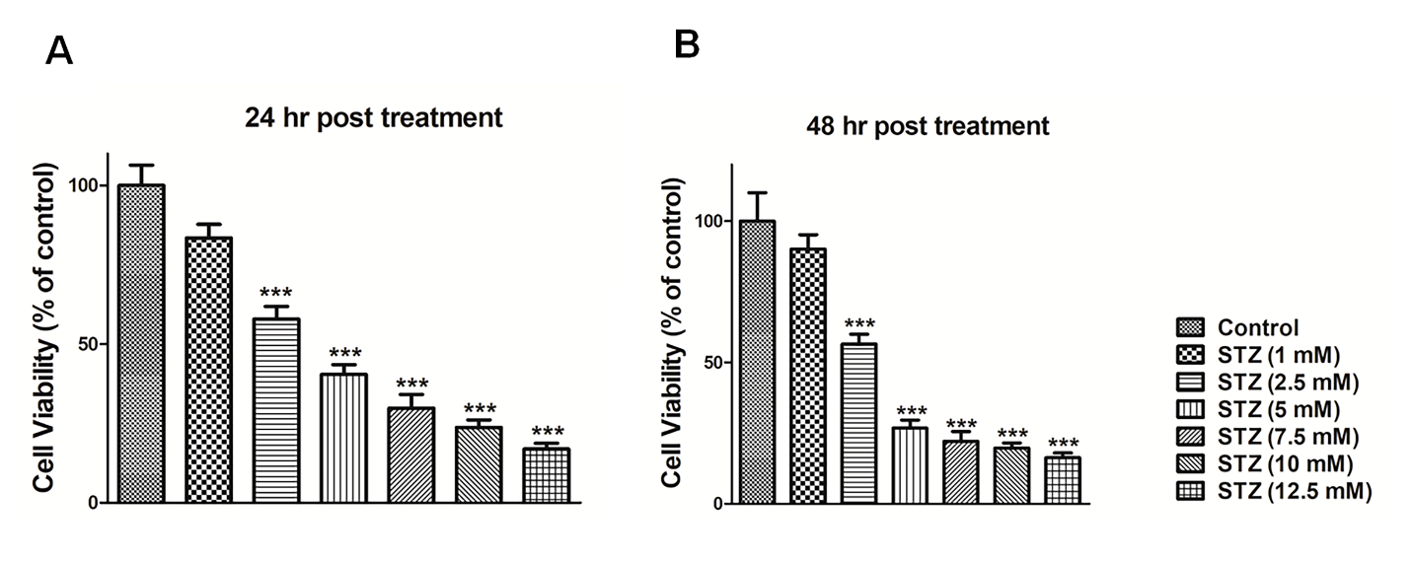
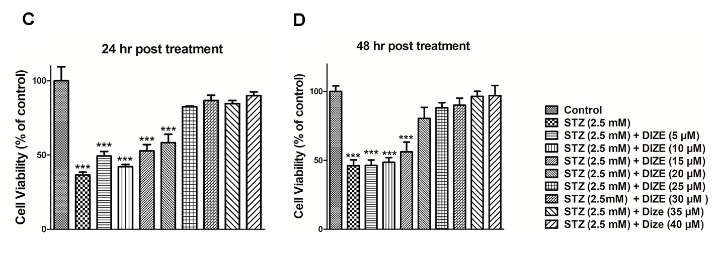

Supplementary Figure 2
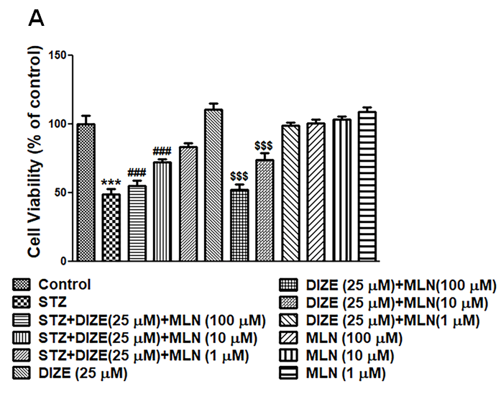
Supplementary Figure 3
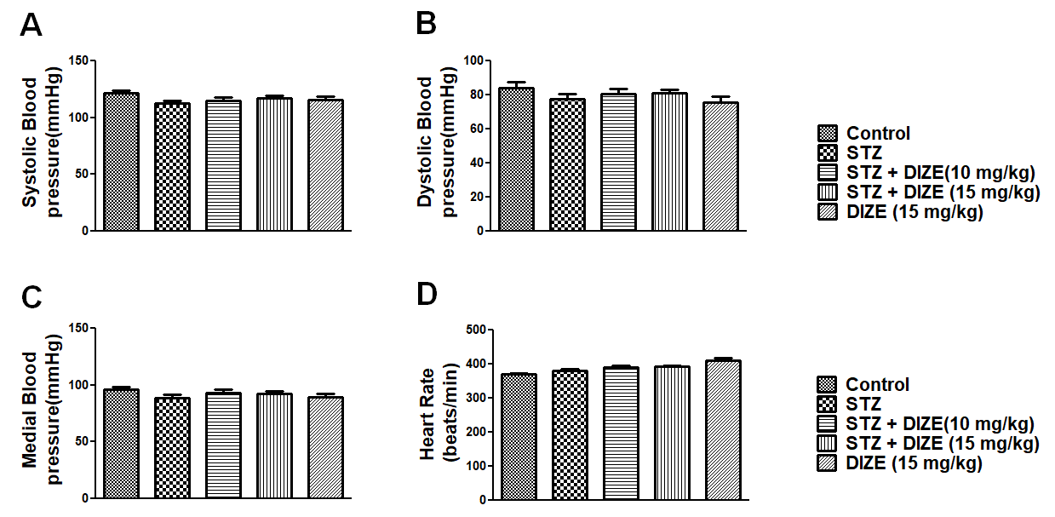
References

1. Goru SK, Kadakol A, Malek V, Pandey A, Sharma N, Gaikwad AB (2017) Diminazene aceturate prevents nephropathy by increasing glomerular ACE2 and AT2 receptor expression in a rat model of type1 diabetes. Br J Pharmacol 174 (18):3118-3130. doi:10.1111/bph.13946
2. Bruce EB, Sakarya Y, Kirichenko N, Toklu HZ, Sumners C, Morgan D, Tumer N, Scarpace PJ, Carter CS (2018) ACE2 activator diminazene aceturate reduces adiposity but preserves lean mass in young and old rats. Exp Gerontol 111:133-140. doi:10.1016/j.exger.2018.07.008
3. Kamel AS, Abdelkader NF, Abd El-Rahman SS, Emara M, Zaki HF, Khattab MM (2018) Stimulation of ACE2/ANG(1-7)/Mas Axis by Diminazene Ameliorates Alzheimer's Disease in the D-Galactose-Ovariectomized Rat Model: Role of PI3K/Akt Pathway. Mol Neurobiol 55 (10):8188-8202. doi:10.1007/s12035-018-0966-3
4. Evans CE, Miners JS, Piva G, Willis CL, Heard DM, Kidd EJ, Good MA, Kehoe PG (2020) ACE2 activation protects against cognitive decline and reduces amyloid pathology in the Tg2576 mouse model of Alzheimer's disease. Acta Neuropathol 139 (3):485-502. doi:10.1007/s00401-019-02098-6
5. Gowrisankar YV, Clark MA (2016) Angiotensin II regulation of angiotensin-converting enzymes in spontaneously hypertensive rat primary astrocyte cultures. J Neurochem 138 (1):74-85. doi:10.1111/jnc.13641
6. Pabbidi RM, Cao DS, Parihar A, Pauza ME, Premkumar LS (2008) Direct role of streptozotocin in inducing thermal hyperalgesia by enhanced expression of transient receptor potential vanilloid 1 in sensory neurons. Mol Pharmacol 73 (3):995-1004. doi:10.1124/mol.107.041707
7. Niranjan R, Nath C, Shukla R (2010) The mechanism of action of MPTP-induced neuroinflammation and its modulation by melatonin in rat astrocytoma cells, C6. Free Radic Res 44 (11):1304-1316. doi:10.3109/10715762.2010.501080
8. Syed AA, Lahiri S, Mohan D, Valicherla GR, Gupta AP, Riyazuddin M, Kumar S, Maurya R, Hanif K, Gayen JR (2016) Evaluation of anti-hypertensive activity of Ulmus wallichiana extract and fraction in SHR, DOCA-salt- and L-NAME-induced hypertensive rats. J Ethnopharmacol 193:555-565. doi:10.1016/j.jep.2016.10.008

