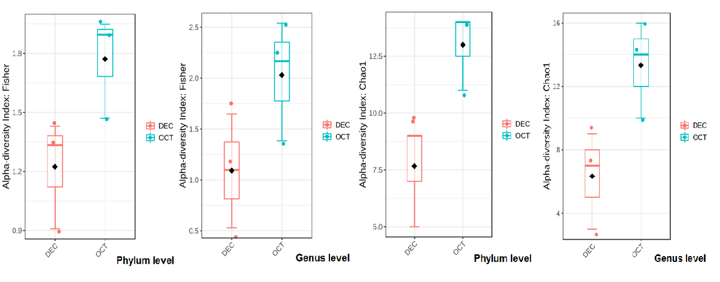
Supplementary Figure SF1: Box-Plot comparison of diversity indices at phylum level vs. genus level.

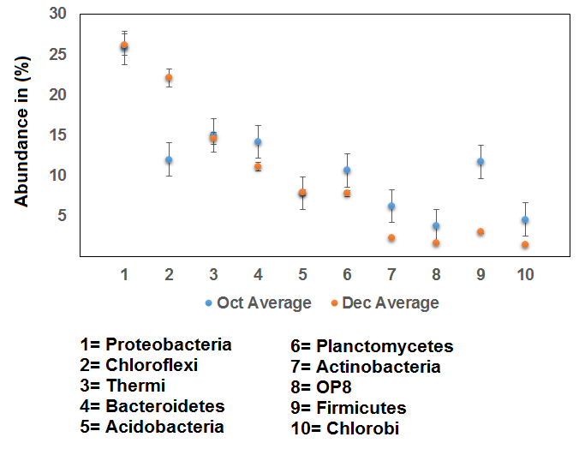
Supplementary Figure SF2: Scatter Plot comparison of top ten abundant phylum in Oct vs. Dec

Supplementary Figure SF3: Bar Plot comparison of top ten abundant genera in Oct vs. Dec

