Supplementary information
For
Well dispersed heteropolyacids on clay supports catalysed glycolysis and aminolysis of PET polymer wastes
Gopal Jeya,¹ Elumalai Ganesan², Aimi Asilah Haji Tajuddin², Yoshikazu Ito², Ravikumar Dhanalakshmi¹ and Vajiravelu Sivamurugan¹*
¹PG and Research Department of Chemistry, Pachaiyappa’s College, Chennai-600030, Tamilnadu, India.
²Institute of Applied Physics, Graduate School of Pure and Applied Sciences, University of Tsukuba, 1-1-1 Tennodai, Tsukuba 305-8571, Japan

Figure S1. Pore size distribution of (a) Supported Kaolin Catalysts, (b) Supported Bentonite Catalysts

Figure S2. FTIR spectrum of pure and impregnated kaolin catalysts

Figure S3. FTIR spectrum of pure and impregnated bentonite catalysts

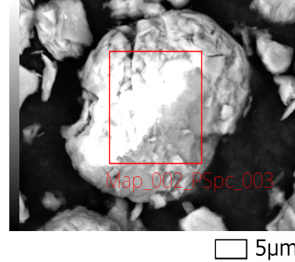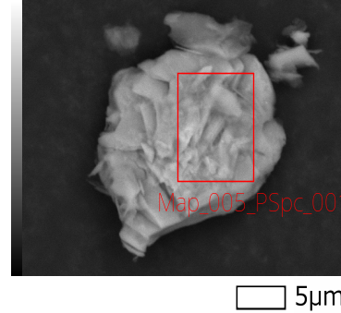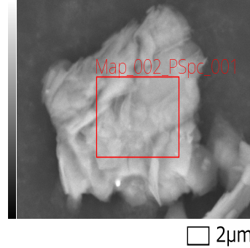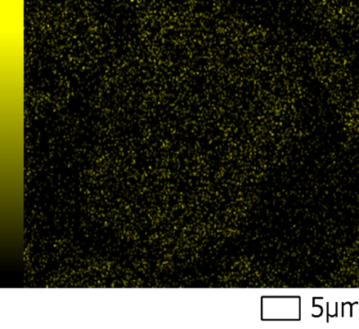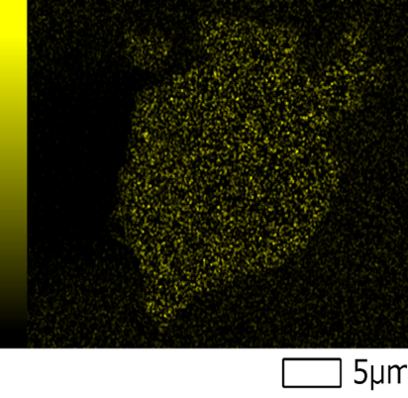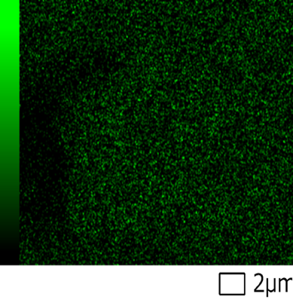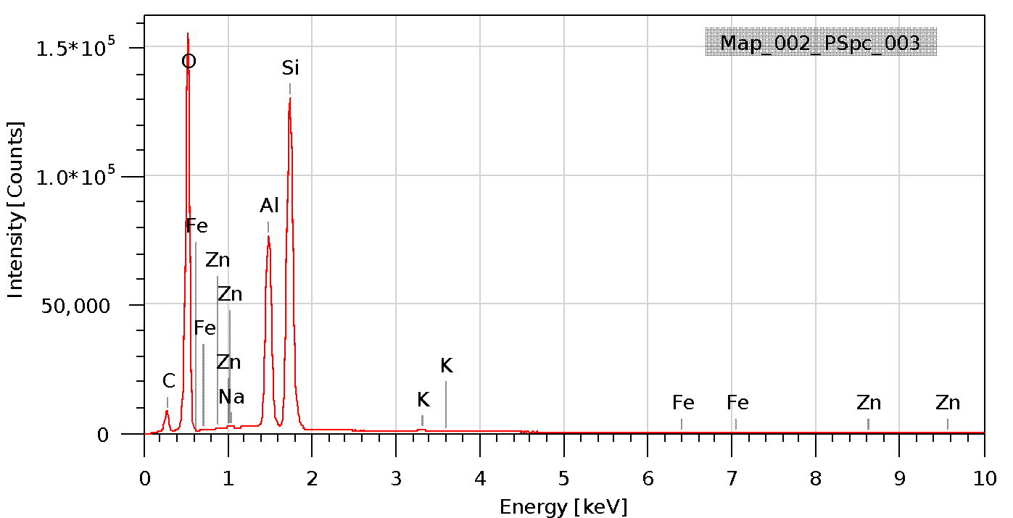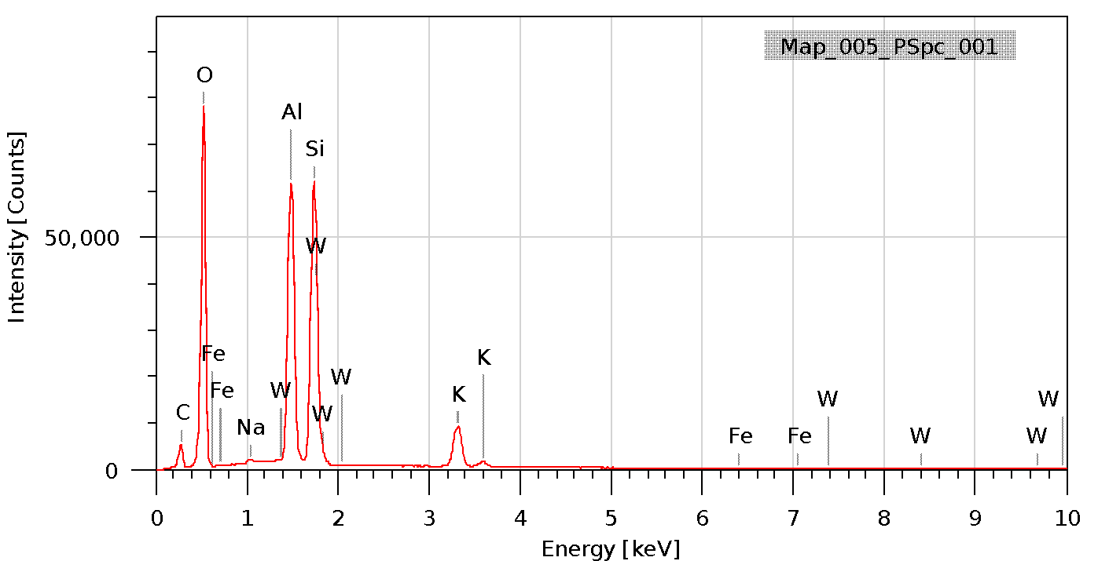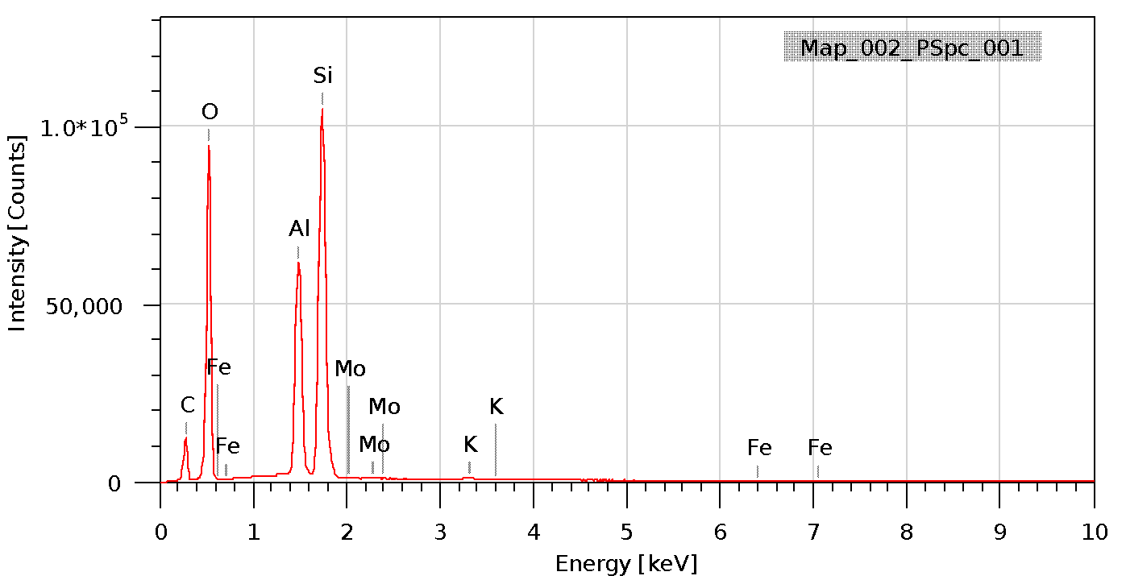

(a)
(b)
(c)
Figure S4. SEM images, element mapping and EDX analysis for (a) Zn-kaolin, (b) PWA-Kaolin and (c) PMA-Kaolin
Figure S5. SEM images, element mapping and EDX analysis for (a) Zn-Bentonite (b) PWA-Bentonite and (c) PMA-Bentonite

Table S1. SEM- EDX mapping Mass percentage and atomic percentage of Kaolin catalysts
Elements | 5wt% Zn-Kaolin |  | 5wt% PWA-Kaolin |  | 5wt% PMA-Kaolin
 | Mass % | Atomic % | Mass% | Atomic % | Mass% | Atomic %
O | 59.43±0.15 | 71.81±0.19 | 54.40±0.20 | 69.52±0.26 | 53.93±0.18 | 67.11±0.23
Na | 0.11±0.01 | 0.09±0.01 | 0.31±0.01 | 0.28±0.01 | - | -
Al | 13.65±0.06 | 9.78±0.04 | 16.85±0.08 | 12.77±0.06 | 15.15±0.07 | 11.18±0.05
Si | 26.39±0.09 | 18.16±0.06 | 19.55±0.09 | 14.23±0.07 | 30.33±0.11 | 21.50±0.08
K | 0.13±0.01 | 0.07±0.00 | 5.26±0.06 | 2.75±0.03 | 0.19±0.01 | 0.09±0.01
Fe | 0.14±0.01 | 0.05±0.01 | 0.21±0.02 | 0.08±0.01 | 0.23±0.02 | 0.08±0.01
M* | 0.16±0.03 (Zn) | 0.05±0.01 (Zn) | 3.43±0.10 (W) | 0.38±0.01 (W) | 0.18±0.02 (Mo) | 0.04±0.00 (Mo)

Figure S6. SEM images of (a) pure kaolin
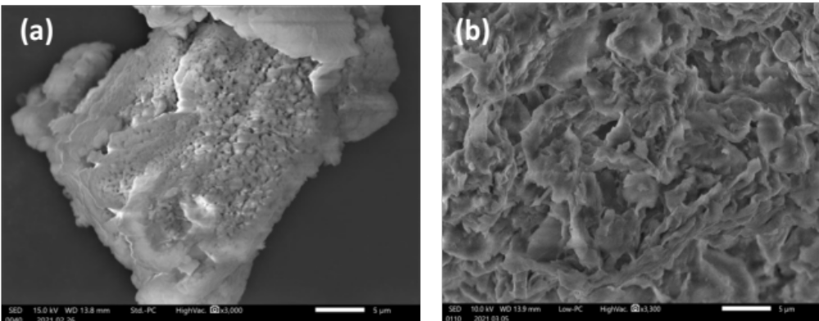

Figure S7. SEM images of (a) pure Bentonite and (b) Al-Bentonite

Figure S8. XPS Spectra of Zn²⁺ loaded kaolin

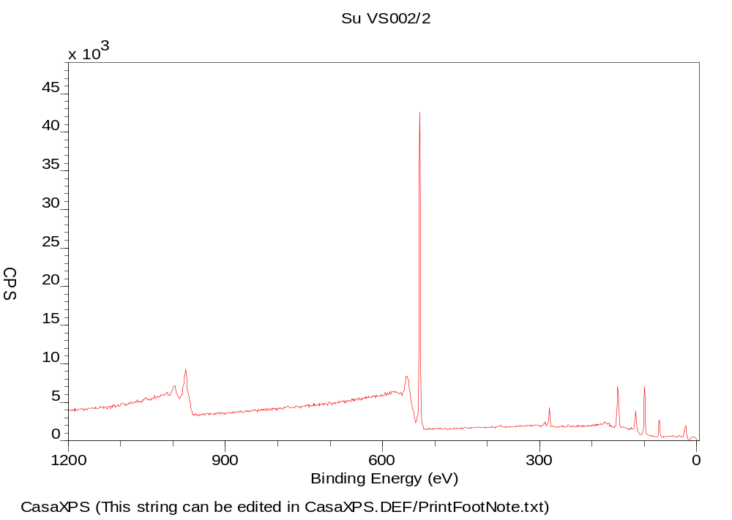

Figure S9. XPS Spectra of PWA loaded kaolin

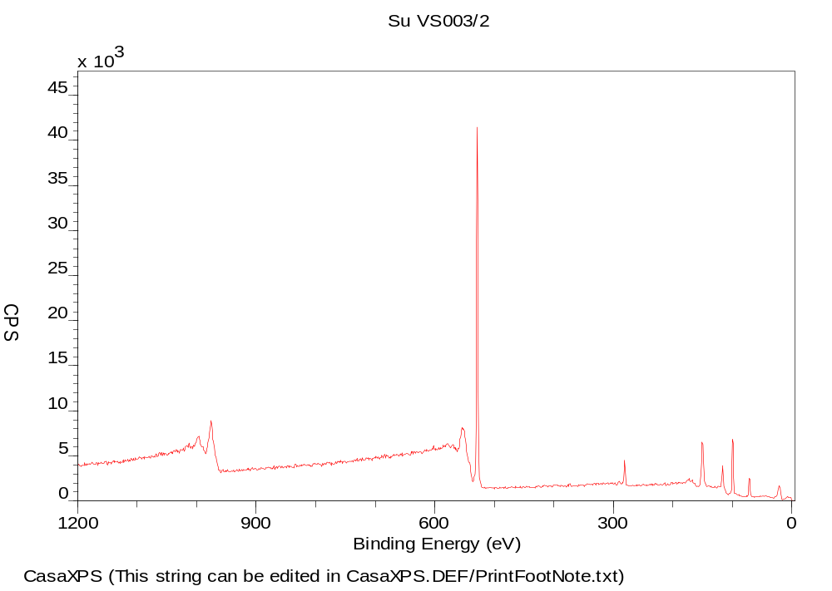
Figure S10. XPS Spectra of PMA loaded kaolin
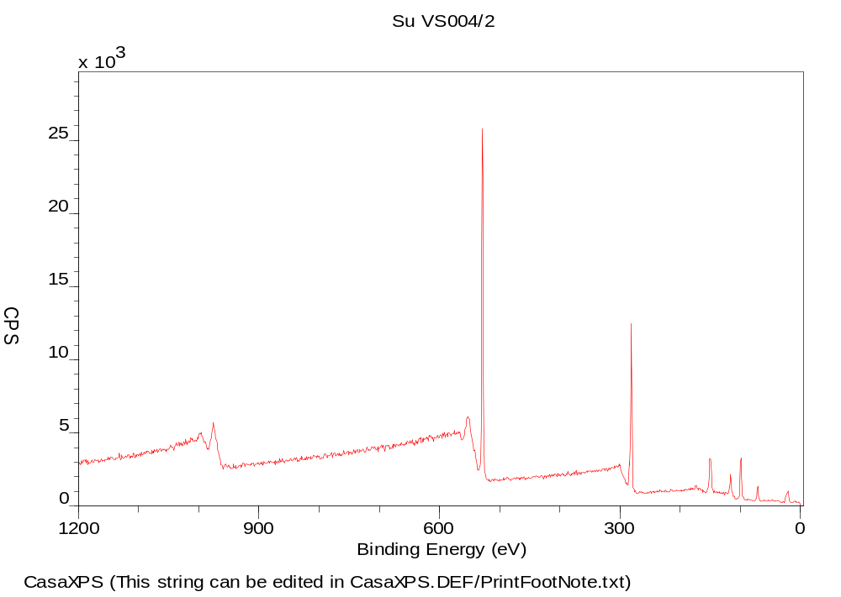

Figure S11. XPS Spectra of Al³⁺ loaded kaolin

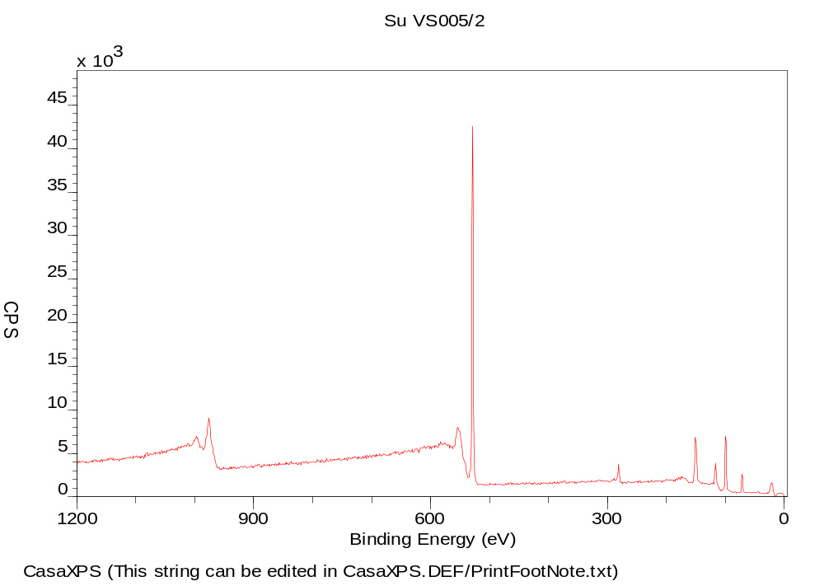
Figure S12. XPS Spectra of pure kaolin

(a)
(b)
(c)
(d)
(e)
(f)
Figure S13. XPS spectra of (a) Zn-Kaolin, (b) Al³⁺ in Zn-Kaolin, (c) W⁶⁺ in PWA-Kaolin, (d) Mo⁶⁺ in PMA-Kaolin, (e) Al³⁺ in Al-Kaolin and (f) Al³⁺ in pure Kaolin

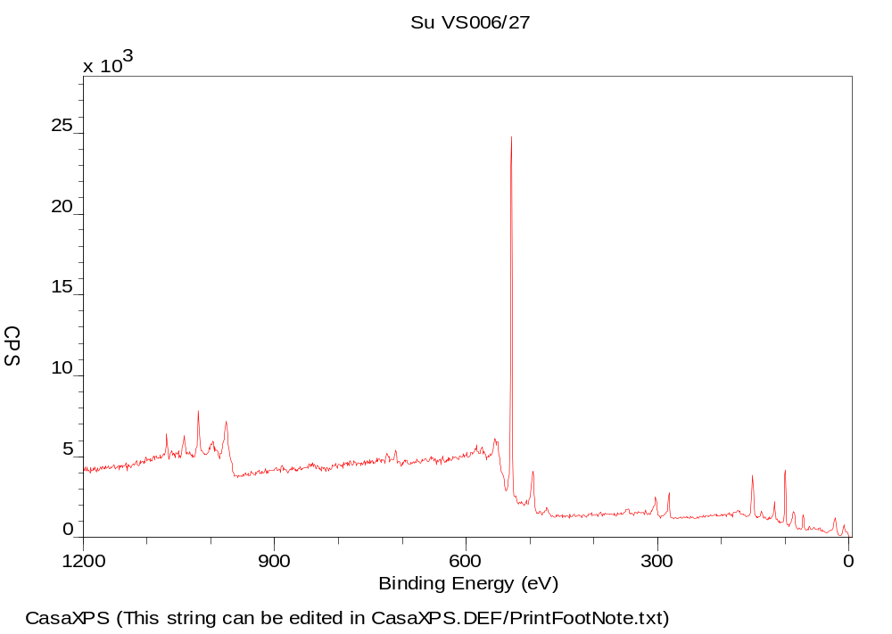
Figure S14. XPS Spectra of Zn²⁺ loaded bentonite

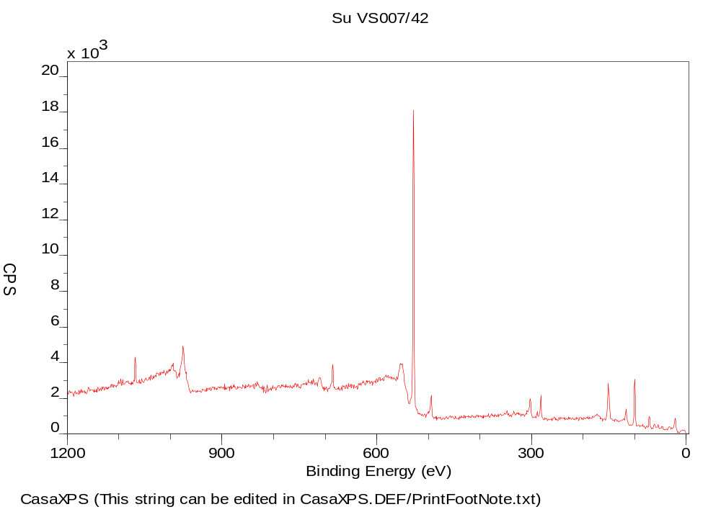
Figure S15. XPS Spectra of PWA loaded bentonite

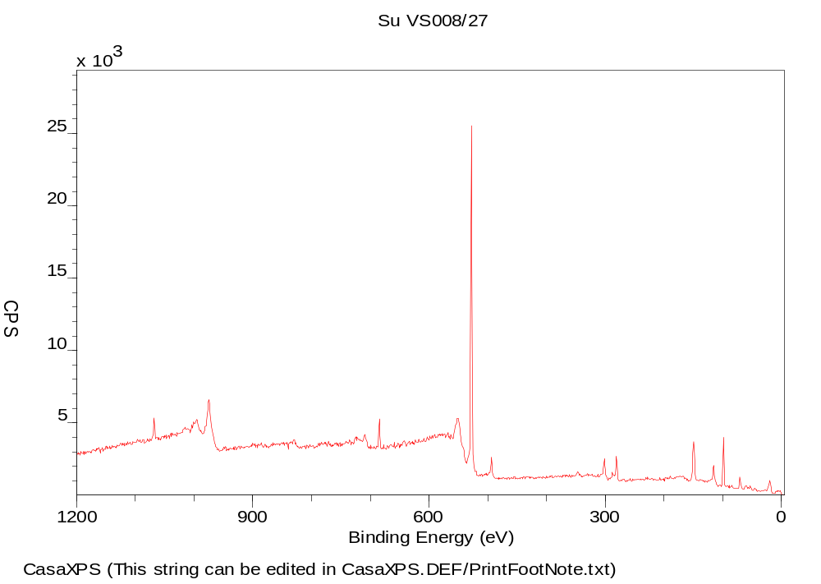
Figure S16. XPS Spectra of PMA loaded bentonite

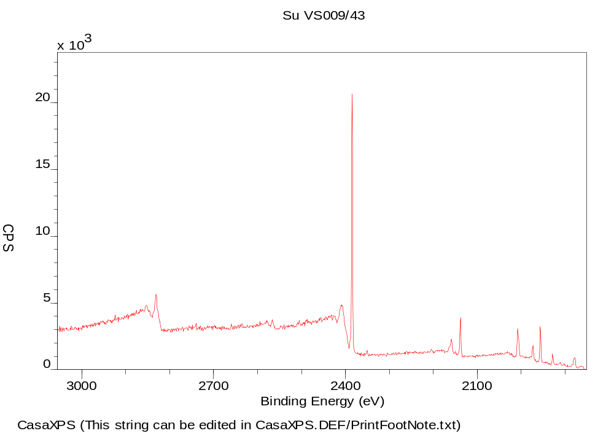
Figure S17. XPS Spectra of Al³⁺ loaded bentonite

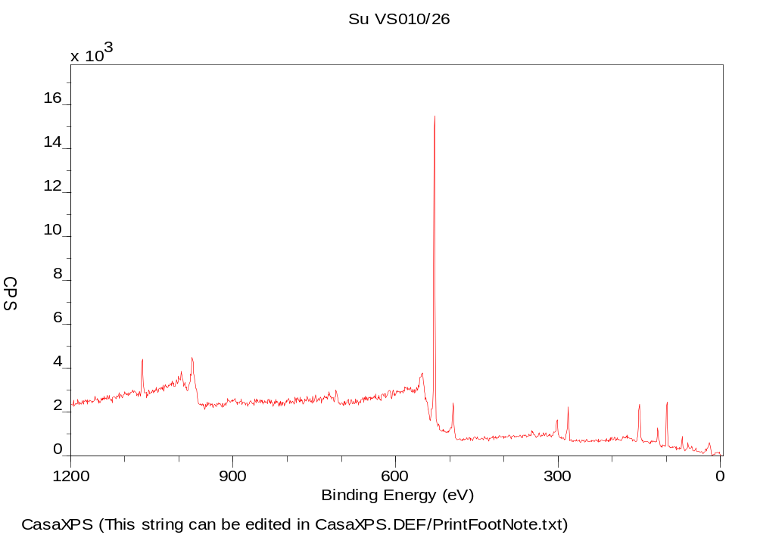

Figure S18. XPS Spectra of pure bentonite

(a)
(b)
(c)
(d)
(e)
(f)
Figure S19. XPS spectra of (a) Zn-Bentonite, (b) Al³⁺ in Zn-Bentonite, (c) W⁶⁺ in PWA-Bentonite, (d) Mo⁶⁺ in PMA-Bentonite, (e) Al³⁺ in Al-Bentonite and (f) Al³⁺ in pure Bentonite

Table S2. Binding energies values (eV) for Zn²⁺, W⁶⁺ of PWA, Mo⁶⁺ of PMA and Al-Kaolin spectra and surface M/Al compositions of samples and reference ZnO, PWA and PMA.
Catalysts | Metals | Binding energy (eV) | M/Al ratio (surface) | Atomic (%)
Zn-Kaolin | Zn2p_{3/2}  Zn2p_{1/2} | 1022.12  1045.16 | 0.1854  0.0618 | 2.07  0.69
 | Al 2p B | 75.75 | - | 7.02
 | Al 2p A | 74.72 | - | 4.14
PWA-Kaolin | W 4f_{7/2} | 36.06 | 0.0055 | 0.07
 | W 4f_{5/2} | 38.19 | 0.0039 | 0.05
 | Al 2p B | 75.51 | - | 7.93
 | Al 2p A | 74.63 | - | 4.65
PMA-Kaolin | Mo 3d_{5/2} | 232.74 | 0.0033 | 0.04
 | Mo 3d_{3/2} | 235.73 | 0.0016 | 0.02
 | Al 2p B | 75.62 | - | 7.69
 | Al 2p A | 74.79 | - | 4.36
Al-Kaolin | Al 2p B | 75.42 | 0.2553 | 3.09
 | Al 2p A | 74.52 | 0.1264 | 1.53
Pure Kaolin | Al 2p B | 75.64 | - | 9.19
 | Al 2p A | 74.65 | - | 2.91

Table S3. Binding energies values (eV) for Zn²⁺, W⁶⁺ of PWA, Mo⁶⁺ of PMA and Al-Bentonite spectra and surface M/Al compositions of samples
Catalysts | Metals | Binding energy (eV) | M/Al ratio (surface) | Atomic (%)
Zn-Bentonite | Zn2p_{3/2}  Zn2p_{1/2} | 1022.99  1045.10 | 0.3161  0.1053 | 2.07  0.69
 | Al 2p A | 74.69 | - | 8.73
PWA-Bentonite | W 4f_{7/2} | 35.62 | 0.0129 | 0.11
 | W 4f_{5/2} | 37.82 | 0.0094 | 0.08
 | Al 2p B | 75.15 | - | 6.99
 | Al 2p A | 74.54 | - | 1.52
PMA-Bentonite | Mo 3d_{5/2} | 231.97 | 0.0156 | 0.13
 | Mo 3d_{3/2} | 235.08 | 0.0016 | 0.09
 | Al 2p A | 74.59 | - | 8.3
Al-Bentonite | Al 2p B | 75.31 | 1.19 | 9
Pure Kaolin | Al 2p A | 74.65 | - | 7.55

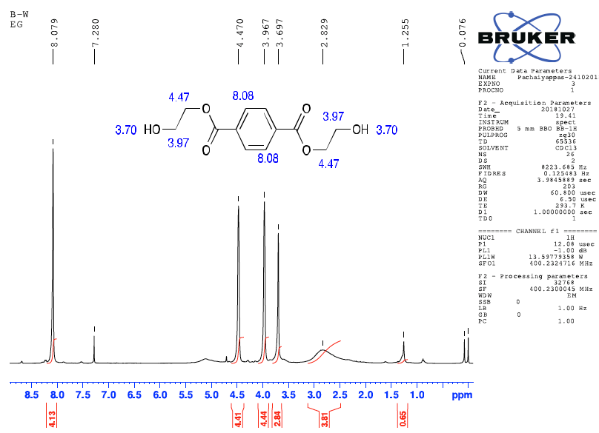

Figure S20. ¹H NMR spectra of depolymerized PET using ethylene glycol

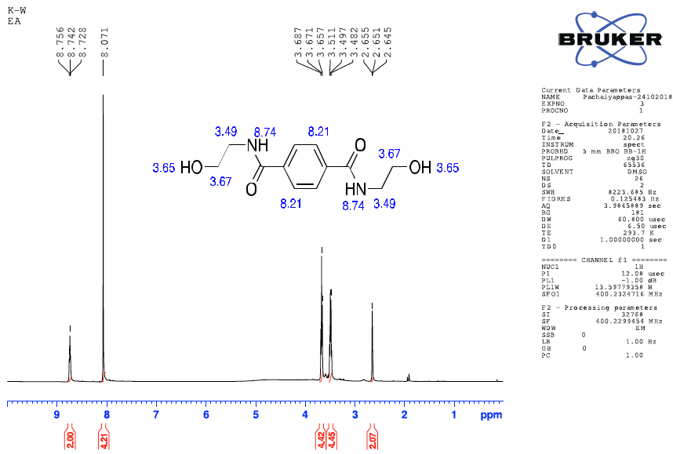

Figure S21. ¹H NMR spectra of depolymerized PET using Ethanolamine

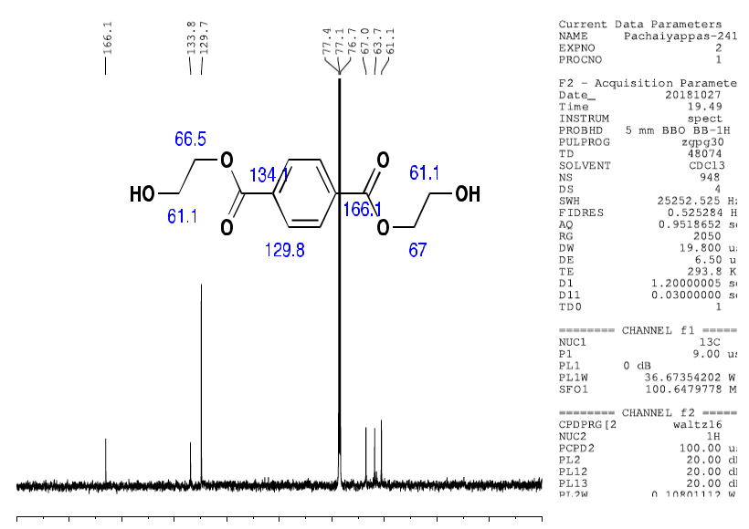

Figure S22. ¹³C NMR spectra of depolymerized PET using ethylene glycol

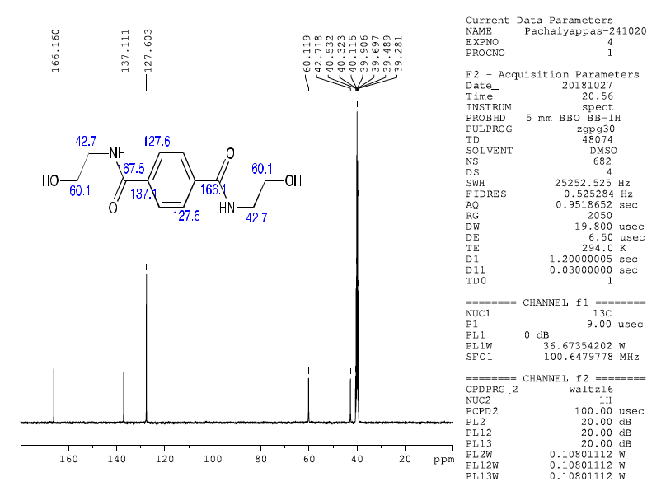

Figure S23. ¹³C NMR spectra of depolymerized PET using Ethanolamine

Figure S24. FT-IR spectra of depolymerized PET using ethylene glycol (BHET)

Figure S25. FT-IR spectra of depolymerized PET using Ethanolamine (BHETA)

Figure S26. Mass spectrum of depolymerized PET using Ethanolamine (BHETA)

