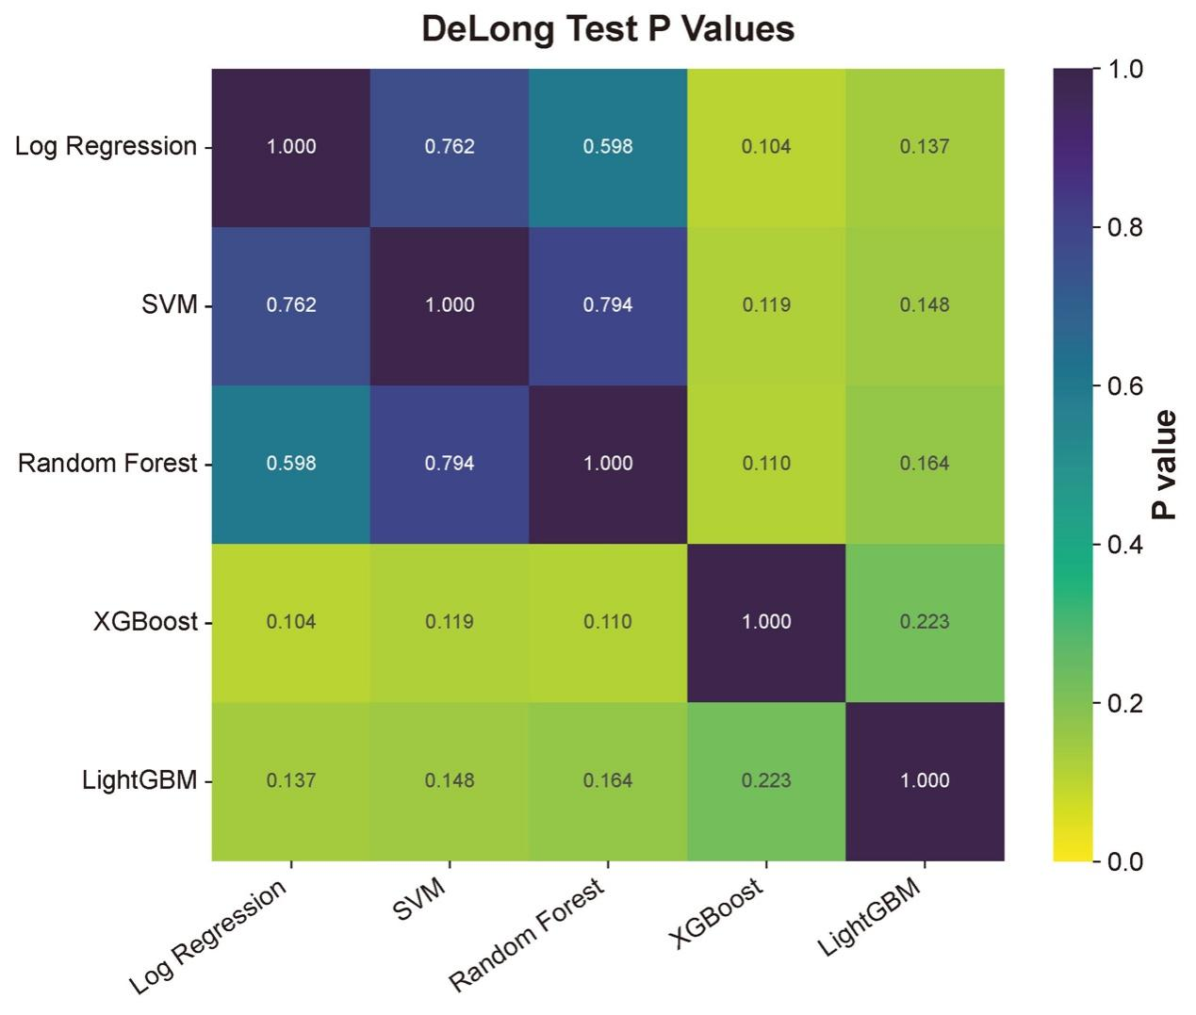
Supplementary Figure S1. Pairwise DeLong test heatmap for model AUC comparison.
Heatmap showing pairwise statistical comparisons of AUCs among the five evaluated machine learning models. The DeLong test was used to compare ROC performance between models.

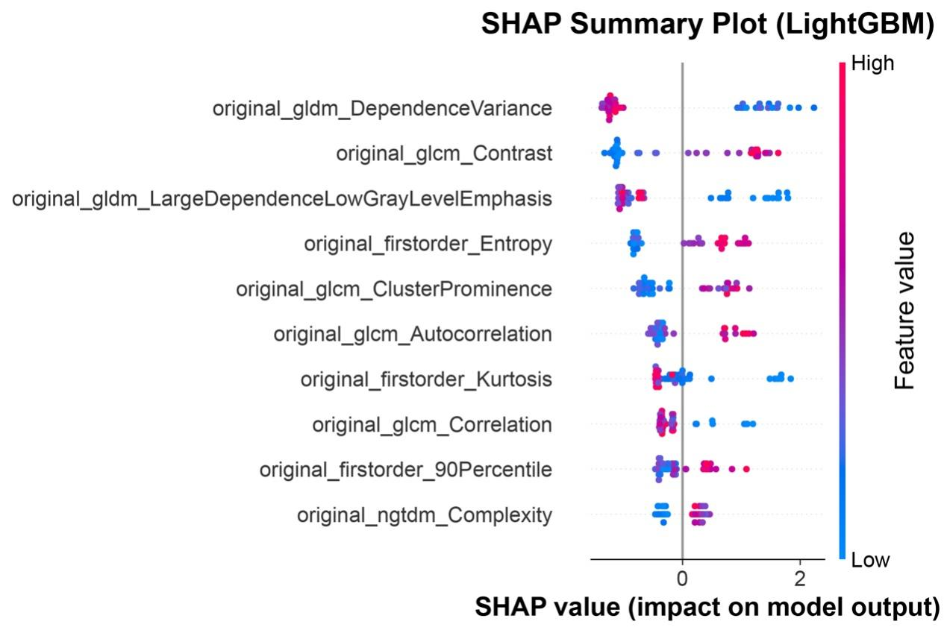
Supplementary Figure S2. SHAP summary plot of the LightGBM model.
Global SHAP summary plot showing feature contributions in the LightGBM model. This analysis was used as a complementary interpretability assessment to the primary XGBoost SHAP analysis.

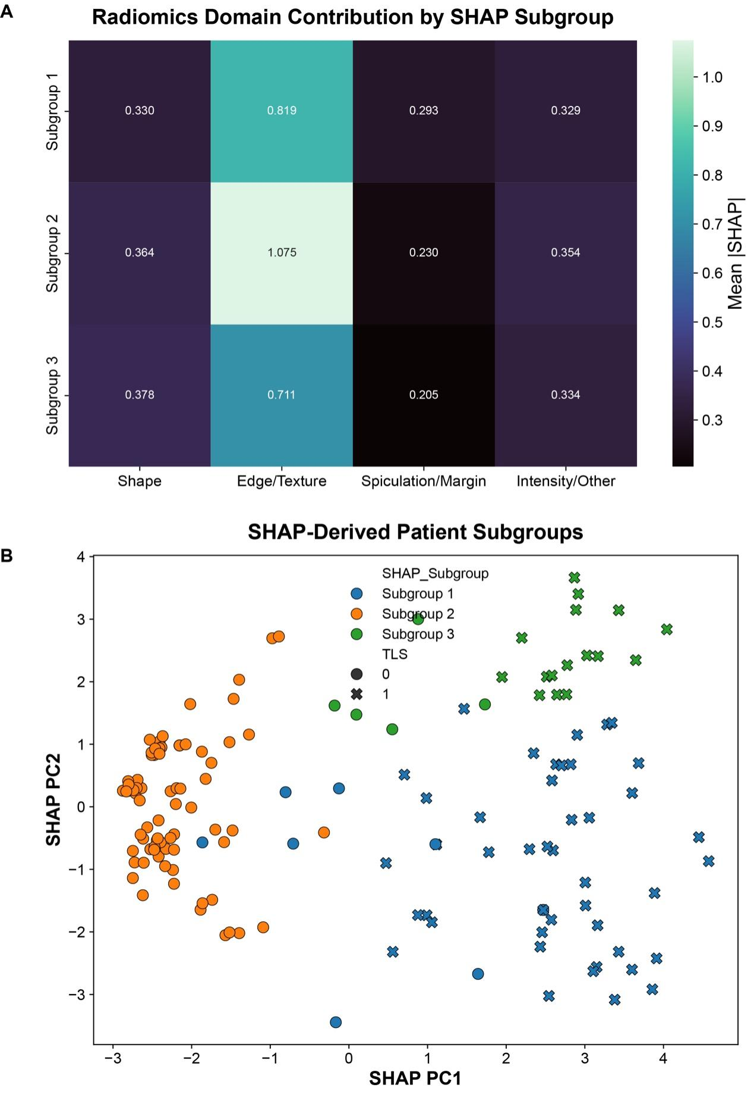 Supplementary Figure S3. Exploratory SHAP-derived radiomic phenotyping of PDAC patients.
(A) Domain-level SHAP contribution profiles across three exploratory SHAP-derived subgroups.
(B) Principal component analysis of patients in the SHAP attribution space, showing the distribution of the three exploratory subgroups.

Supplementary Figure S2. SHAP summary plot of the LightGBM model.
Global SHAP summary plot showing feature contributions in the LightGBM model. This analysis was used as a complementary interpretability assessment to the primary XGBoost SHAP analysis.

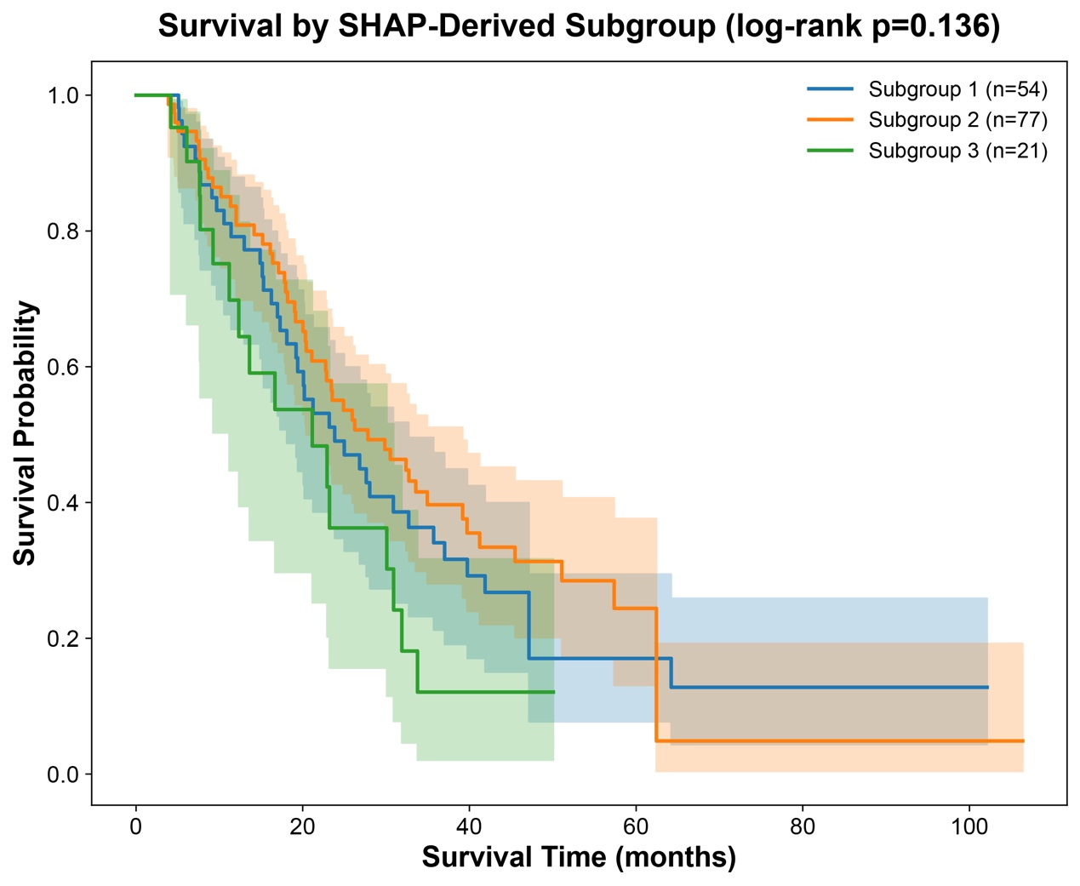
Supplementary Figure S4. Exploratory survival analysis according to SHAP-derived radiomic subgroups.
Kaplan–Meier curves comparing overall survival among the three exploratory SHAP-derived radiomic subgroups. This analysis was hypothesis-generating and did not show a statistically significant survival difference in the current cohort.

