Additional file 1
Biventricular dysfunction, pre-existing cardiac disease, and mortality in sepsis: an echocardiographic cohort study
Supplementary Methods
Data source. The Medical Information Mart for Intensive Care IV (MIMIC-IV, version 3.1) is a publicly available, de-identified critical-care database from a single academic medical centre in the United States. The MIMIC-IV-ECHO module (version 1.0) adds a structured measurement table in which each echocardiographic report is decomposed into discrete, machine-readable measurements, each linked to a study identifier, a study type (transthoracic, stress, or transoesophageal), and a measurement timestamp. The table contains approximately 28 million measurements from 206,488 studies in 91,372 patients (2008–2022). Institutional review board approval and informed consent were waived because the data are de-identified.
Cohort definition. Sepsis was defined by the Sepsis-3 criteria as implemented in the MIMIC-IV derived sepsis-3 table (suspected infection accompanied by an acute increase of ≥2 points in the Sequential Organ Failure Assessment [SOFA] score). Only the first ICU admission of each patient was eligible. Patients were required to have a resting transthoracic echocardiogram performed within 72 hours of ICU admission that reported both a left ventricular ejection fraction (LVEF) and a qualitative right ventricular (RV) systolic function assessment; the earliest qualifying study was used.
Echocardiographic measurement processing. LVEF was stored as a lower and an upper bound. A single value was computed as the midpoint of the interval when the interval was closed and narrow (upper bound <100% and width ≤15 percentage points) and as the lower bound otherwise; LV systolic dysfunction was defined as LVEF <50% (and, in a sensitivity analysis, <40%). RV systolic function was taken from the qualitative report and mapped to a binary classification (normal versus dysfunction) and a four-level ordinal grade as detailed in Table S2. Pulmonary artery systolic pressure (PASP) was estimated from the reported peak tricuspid-regurgitation gradient with an assumed right atrial pressure. The availability of quantitative RV-related measurements is shown in Table S1; tricuspid annular plane systolic excursion (TAPSE) was reported in only 3.1% of patients and was therefore not used, which motivated reliance on the qualitative RV assessment together with PASP.
Covariate definitions. The SOFA score was the value at sepsis onset taken from the Sepsis-3 derivation (the worst score within the 24-hour window surrounding the time of suspected infection), and the Charlson comorbidity index was obtained from the corresponding derived table. Atrial fibrillation was identified from discharge diagnosis codes (ICD-9 427.31; ICD-10 I48). The maximum serum lactate within 24 hours of ICU admission was extracted from laboratory events and natural-log transformed after single imputation with the cohort median (available in 76.0% of patients; 6,242 patients had a measured value). Vasopressor exposure was defined as receipt of any vasopressor within 24 hours; the maximum norepinephrine-equivalent dose within 24 hours was used in a sensitivity analysis. Acute kidney injury was graded by the maximum Kidney Disease: Improving Global Outcomes (KDIGO) stage within 48 hours and entered into all models as a single ordinal variable (stages 0–3). Pre-existing cardiac disease was a composite of heart failure (ICD-9 428; ICD-10 I50), coronary artery disease (ICD-9 410–414; ICD-10 I20–I25), valvular disease (ICD-9 394–397 and 424; ICD-10 I05–I08 and I34–I38), and cardiomyopathy (ICD-9 425; ICD-10 I42); component prevalences (the categories are not mutually exclusive) were 46.5%, 44.1%, 18.6%, and 7.6%, respectively. Because these comorbidities were ascertained from discharge codes, the composite is a proxy for chronic cardiac substrate.
Statistical analysis. Missing covariate data were limited to lactate (median-imputed as above); patients without a recorded vasopressor or KDIGO stage were treated as unexposed and stage 0, respectively. Quantitative echocardiographic measurements were analysed in the subgroups in which they were reported. The proportional-hazards assumption of the 90-day Cox model was assessed with scaled Schoenfeld residuals: it was satisfied for the three biventricular-phenotype terms (the exposure of interest; all P>0.10), whereas several covariates showed evidence of non-proportionality, as is expected in a large sample and which does not affect interpretation of the phenotype estimates. Departure from additivity of the joint LV–RV effect was evaluated on the multiplicative scale with a likelihood-ratio test of the LV×RV interaction term and on the additive scale by the relative excess risk due to interaction (RERI) from the adjusted risk ratios, with a 95% confidence interval obtained by the delta method. To assess the role of chronic cardiac substrate, the primary model was additionally fitted with the pre-existing-cardiac-disease covariate omitted (Table S5). Analyses were performed in R (version 4.5.2) using the survival, sandwich, and rms packages, and adjusted risk ratios were obtained by modified Poisson regression with robust (sandwich) variance. The study is reported in accordance with the STROBE statement.
Table S1. Availability of quantitative echocardiographic measurements in the analytic cohort (N = 8,209).
Echocardiographic measurement | Available, n (%)
Left ventricular ejection fraction | 8,209 (100)†
Right ventricular systolic function (qualitative) | 8,209 (100)†
Tricuspid-regurgitation gradient (PASP) | 6,015 (73.3)
Tricuspid-regurgitation velocity | 6,009 (73.2)
Right ventricular basal diameter | 2,683 (32.7)
Tricuspid annular plane systolic excursion | 257 (3.1)
†Required for cohort inclusion. The peak tricuspid-regurgitation gradient was reported for 6,015 patients and the corresponding velocity for 6,009; the small difference reflects six studies in which a gradient was recorded without a separately stored velocity. PASP was analysed in 6,013 patients after exclusion of two implausible values. The low availability of TAPSE precluded its use as a quantitative measure of RV function, motivating reliance on the qualitative RV assessment and PASP. PASP, pulmonary artery systolic pressure; TAPSE, tricuspid annular plane systolic excursion.
Table S2. Reported right ventricular systolic function categories, classification, and distribution in the analytic cohort.
Reported category (verbatim) | Classification | Ordinal grade | n (%)
“Nl RV function” | Normal | 0 | 5,378 (65.5)
“Low normal function” | Normal | 0 | 540 (6.6)
“Mild global RV hypo” | Dysfunction | 1 | 755 (9.2)
“Apical free wall hypo” | Dysfunction | 1 | 195 (2.4)
“Basal RV hypo (McConnell’s sign)” | Dysfunction | 1 | 34 (0.4)
“Moderate global RV hypo” | Dysfunction | 2 | 539 (6.6)
“Severe global hypo” | Dysfunction | 3 | 322 (3.9)
“RV function depressed” | Dysfunction | 3 | 446 (5.4)
Reported categories are the verbatim free-text terms stored in the structured echocardiographic report (including the annotation “McConnell’s sign,” which appears in the source data). Studies reporting RV function as “RV not well seen,” “cannot assess RV function,” or “hyperdynamic” (450 patients in total) were excluded because they do not map onto an ordered severity of RV dysfunction. The binary exposure grouped grade 0 as normal and grades 1–3 as dysfunction. The “RV function depressed” term is an unranked global descriptor; it was assigned to the severe grade for the primary ordinal analysis, and a sensitivity analysis excluding it is reported in the footnote to Table S4. Percentages are of the 8,209-patient analytic cohort. RV, right ventricular.
Table S3. Estimated pulmonary artery systolic pressure and 28-day mortality.
PASP quartile (mmHg) | Patients, n | 28-day mortality (%)
Quartile 1 (≤25) | 1,573 | 22.2
Quartile 2 (>25–32) | 1,508 | 24.0
Quartile 3 (>32–41) | 1,518 | 26.6
Quartile 4 (>41) | 1,414 | 33.0
Among 6,013 patients with a plausible estimated PASP. The adjusted odds ratio for 28-day mortality was 1.15 (95% CI 1.09–1.20) per 10-mmHg increase (unadjusted 1.18, 1.13–1.23); the continuous relationship is shown in Fig. S1. Adjustment used the covariate set described in the footnote to Table 2. CI, confidence interval; PASP, pulmonary artery systolic pressure.
Table S4. Right ventricular dysfunction grade and 28-day mortality.
RV dysfunction grade | Patients, n | 28-day mortality (%)
0 (normal) | 5,918 | 23.6
1 (mild) | 984 | 31.4
2 (moderate) | 539 | 36.0
3 (severe) | 768 | 34.4
RV grade is defined in Table S2. The adjusted odds ratio for 28-day mortality was 1.13 (95% CI 1.07–1.19) per one-grade increase (unadjusted 1.24, 1.18–1.30). The non-monotonic crude mortality at the severe grade is attributable to the heterogeneous “RV function depressed” descriptor: in a sensitivity analysis excluding that category (n = 7,763), the gradient became strictly monotonic and the adjusted trend strengthened to 1.20 (95% CI 1.12–1.28) per grade. Adjustment used the covariate set described in the footnote to Table 2. CI, confidence interval; RV, right ventricular.
Table S5. Sensitivity analyses for the association between biventricular phenotype and mortality.
Analysis | Isolated LV, OR (95% CI) | Isolated RV, OR (95% CI) | Biventricular, OR (95% CI)
Primary (28-day mortality) | 1.27 (1.08–1.49) | 1.35 (1.13–1.60) | 1.50 (1.29–1.74)
Omitting prior-cardiac-disease covariate | 1.04 (0.89–1.22) | 1.21 (1.02–1.44) | 1.20 (1.05–1.39)
Excluding prior cardiac disease | 1.66 (1.08–2.55) | 1.03 (0.74–1.43) | 2.21 (1.42–3.43)
Additional adjustment for invasive ventilation | 1.23 (1.04–1.45) | 1.33 (1.12–1.59) | 1.49 (1.28–1.74)
Norepinephrine-equivalent dose | 1.27 (1.08–1.50) | 1.36 (1.14–1.62) | 1.52 (1.30–1.76)
Complete-case (measured lactate) | 1.33 (1.11–1.60) | 1.35 (1.11–1.63) | 1.56 (1.32–1.84)
In-hospital mortality | 1.25 (1.05–1.49) | 1.32 (1.10–1.59) | 1.45 (1.24–1.70)
LVEF threshold <40% | 1.23 (1.00–1.52) | 1.29 (1.10–1.50) | 1.50 (1.28–1.76)
Values are adjusted odds ratios for mortality relative to normal biventricular function. Unless otherwise indicated the outcome is 28-day mortality and the model uses the covariate set in the footnote to Table 2 (full cohort, N = 8,209). “Omitting prior-cardiac-disease covariate” refits the primary model in the full cohort with the pre-existing-cardiac-disease term removed; the attenuation of the isolated-LV and biventricular estimates identifies this variable as a negative confounder (suppressor). “Excluding prior cardiac disease” restricts the cohort to the 2,813 patients without pre-existing cardiac disease (term omitted). “Additional adjustment for invasive ventilation” adds invasive mechanical ventilation within 24 hours to the primary model. “Norepinephrine-equivalent dose” replaces the binary vasopressor indicator with the maximum norepinephrine-equivalent dose. “Complete-case (measured lactate)” restricts to the 6,242 patients with a measured (non-imputed) lactate. “LVEF threshold <40%” redefines LV systolic dysfunction at that threshold. CI, confidence interval; LV, left ventricular; LVEF, left ventricular ejection fraction; OR, odds ratio; RV, right ventricular.
Table S6. Adjusted associations of each ventricular phenotype with 28-day mortality within prespecified subgroups.
Subgroup | No. | Isolated LV, OR (95% CI) | Isolated RV, OR (95% CI) | Biventricular, OR (95% CI)
Overall | 8,209 | 1.27 (1.08–1.49) | 1.35 (1.13–1.60) | 1.50 (1.29–1.74)
Age <65 y | 3,226 | 1.04 (0.74–1.45) | 1.22 (0.89–1.68) | 1.50 (1.13–1.99)
Age ≥65 y | 4,983 | 1.35 (1.12–1.63) | 1.40 (1.13–1.72) | 1.49 (1.25–1.79)
Male | 4,494 | 1.26 (1.01–1.56) | 1.51 (1.19–1.93) | 1.52 (1.25–1.86)
Female | 3,715 | 1.33 (1.03–1.71) | 1.20 (0.93–1.55) | 1.53 (1.21–1.95)
Septic shock | 2,149 | 1.31 (0.97–1.76) | 1.19 (0.87–1.61) | 1.79 (1.41–2.27)
No septic shock | 6,060 | 1.24 (1.01–1.51) | 1.42 (1.15–1.75) | 1.30 (1.07–1.59)
Mechanical ventilation | 4,082 | 1.36 (1.10–1.69) | 1.18 (0.94–1.49) | 1.50 (1.23–1.83)
No mechanical ventilation | 4,127 | 1.05 (0.81–1.36) | 1.55 (1.19–2.02) | 1.43 (1.13–1.81)
AKI (KDIGO ≥1) | 6,228 | 1.32 (1.10–1.58) | 1.31 (1.08–1.58) | 1.55 (1.32–1.82)
No AKI | 1,981 | 1.02 (0.68–1.53) | 1.64 (1.05–2.56) | 1.25 (0.83–1.89)
Adjusted odds ratios for 28-day mortality relative to normal biventricular function, estimated separately within each subgroup. All models include the prespecified covariate set (footnote to Table 2), except that the variable defining a subgroup was omitted within that subgroup (age within age strata, sex within sex strata, vasopressor use within the septic-shock strata, and KDIGO stage within the no-AKI stratum). Septic shock was defined as vasopressor use within 24 hours together with a serum lactate >2 mmol/L; where lactate was missing the imputed value was used, which may misclassify shock status within this subgroup. Likelihood-ratio P values for phenotype-by-subgroup interaction (3 df) were 0.03 (age), 0.57 (sex), 0.13 (septic shock), 0.11 (mechanical ventilation), and 0.51 (acute kidney injury). The biventricular estimate was consistent across all subgroups (also shown in Figure 4B); the isolated-phenotype estimates were more variable, reflecting smaller subgroup numbers and their weaker, more context-dependent associations. The nominal age interaction was driven by the isolated phenotypes, the biventricular estimate being essentially identical across age strata. AKI, acute kidney injury; CI, confidence interval; KDIGO, Kidney Disease: Improving Global Outcomes; LV, left ventricular; OR, odds ratio; RV, right ventricular.
Table S7. Twenty-eight-day mortality within each ventricular phenotype, stratified by pre-existing cardiac disease.
Phenotype | With cardiac disease, No. | 28-day mortality (95% CI) | Without cardiac disease, No. | 28-day mortality (95% CI)
Normal biventricular | 2,376 | 21.7% (20.1–23.4) | 2,371 | 24.1% (22.4–25.9)
Isolated LV | 1,058 | 25.1% (22.6–27.8) | 113 | 38.1% (29.6–47.3)
Isolated RV | 624 | 32.2% (28.7–36.0) | 226 | 28.8% (23.3–35.0)
Biventricular | 1,338 | 33.3% (30.8–35.8) | 103 | 54.4% (44.8–63.7)
Counts and 28-day mortality (Wilson 95% confidence intervals) within each phenotype, stratified by pre-existing cardiac disease (the discharge-code proxy for chronic cardiac substrate; column totals are 5,396 and 2,813, matching Table 1). Among patients with isolated LV or biventricular dysfunction, 28-day mortality was substantially higher in those without pre-existing cardiac disease—that is, with acute, de novo dysfunction—than in those with it, directly illustrating the greater lethality of acute dysfunction and the negative-confounding (suppressor) role of pre-existing disease. For isolated RV dysfunction, mortality in the de novo group (28.8%) approximated that of patients with normal biventricular function in the same stratum (24.1%), consistent with the attenuation of the adjusted isolated-RV association to the null among patients without pre-existing cardiac disease (Table S5). The de novo dysfunction subgroups are small and the confidence intervals correspondingly wide. CI, confidence interval; LV, left ventricular; RV, right ventricular.
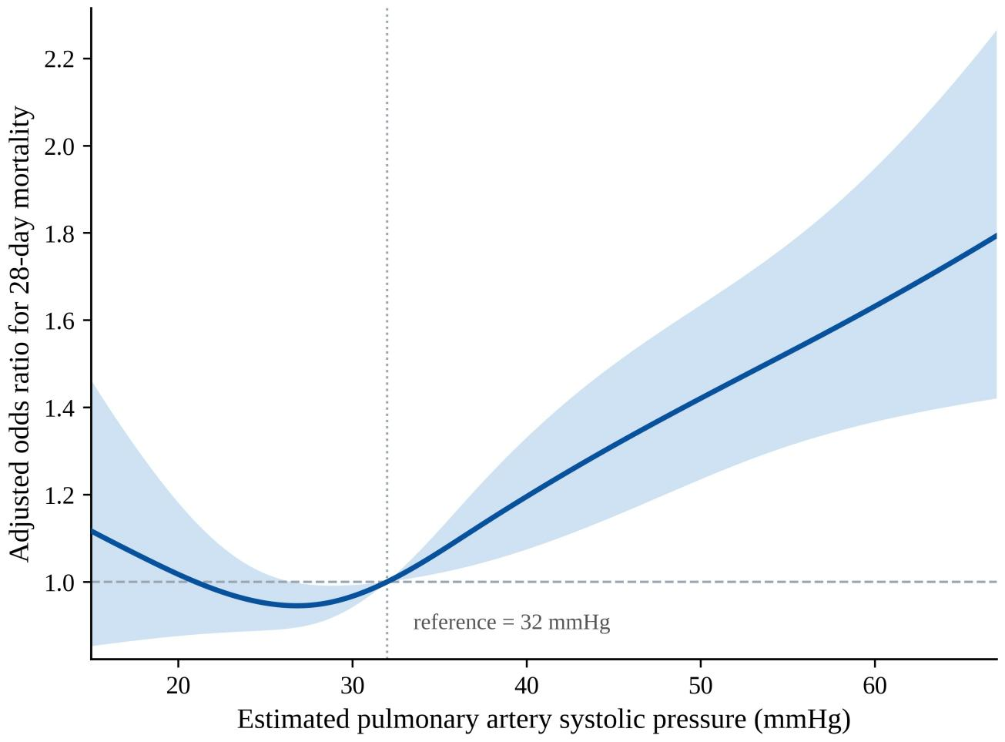
Fig. S1. Adjusted association between estimated pulmonary artery systolic pressure (PASP) and 28-day mortality. Restricted cubic spline (four knots at the 5th, 35th, 65th, and 95th percentiles of PASP) showing the adjusted odds ratio for 28-day mortality across the observed range of PASP, with the median PASP (32 mmHg) as the reference; the shaded band denotes the 95% confidence interval. The model is adjusted for the prespecified covariate set (see the footnote to Table 2). Above the reference value, the adjusted odds ratio rose with increasing PASP in an approximately log-linear fashion, consistent with the positive per-10-mmHg estimate in Table S3; below the reference value the association was essentially flat, with wide confidence intervals. PASP, pulmonary artery systolic pressure.

