Supplementary Materials for manuscript SARS-CoV-2 air and surface contamination on a COVID-19 ward and at home

All supplementary tables are in a separate Excel-file and can be accessed through https://figshare.com/s/66db6e1dcc2b49b67d04.

Noteworthy, the following tables are only there:
- Table S1: Patient characteristics
- Table S2: Statistical tests
- Table S3: List of air samples
- Table S5: List of surface samples
Other supplementary table and figures can be found from this document.

Table S4: Statistics of active air collections sorted by collection method
 |  |  | Andersen | Biospot | Button | Decati | eFilter
 | Collection time (h) | Mean | 0.2, 0.3 and 0.5 | 3.1 | 0.3 | 3.1 | 0.5
 | Collection time (h) | SD | NA | 0.88 | 0.08 | 0.64 | 0.00
 | Collection time (h) | Range | NA | 1.5-4.0 | 0.25-0.5 | 2.0-4.0 | 0.5-0.5
 | Days from the onset of symptoms of the index patient | Mean | 6.6 | 8.0 | 6.5 | 7.2 | 5.5
 | Days from the onset of symptoms of the index patient | SD | 1.52 | 3.34 | 3.28 | 3.53 | 2.12
 | Days from the onset of symptoms of the index patient | Range | 4-8 | 3-12 | 4-14 | 2-12 | 4-7
 | Distance from the index patient (m) | Mean | 1-2 | 1.54 | 0.2-0.3 | 1.43 | 1-2
 | Distance from the index patient (m) | SD | 0.00 | 0.58 | 0.00 | 0.42 | 0.00
 | Distance from the index patient (m) | Range | NA | 0.95-2.5 | NA | 0.95-2.0 | NA
 | PCR result | pos% | 40.0 | 0.0 | 22.2 | 18.2 | 0.0
 | PCR result | 95% CI | 9.4-79.1 | NA | 4.9-54.4 | 4.0-46.7 | NA
 | PCR result | N(pos)/N(all) | 2/5 | 0/9 | 2/9 | 2/11 | 0/2
SD=standard deviation, CI=confidence interval
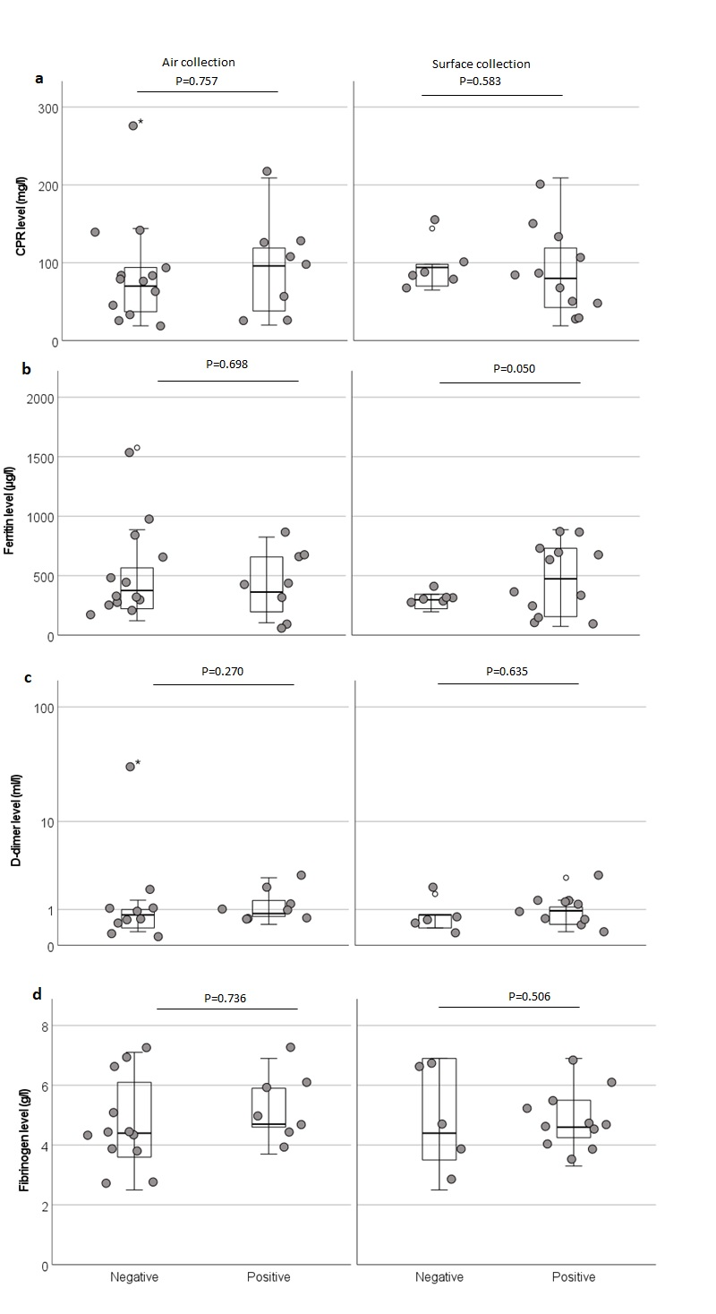
Fig. S1 Environmental contamination compared to index patient’s laboratory results: a CRP, b ferritin level, c D-dimer level, and d fibrinogen.

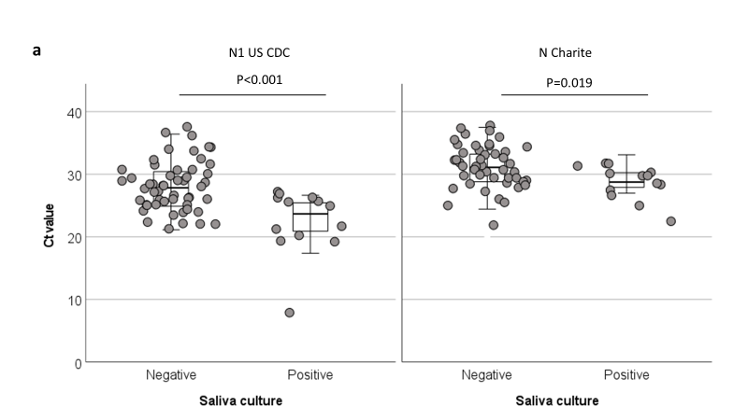

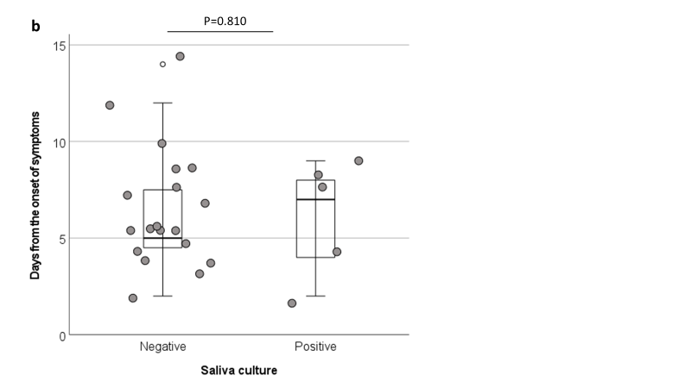
Fig. S2 Saliva culture results. a Comparison between saliva culture and PCR results. b Comparison between saliva culture results and days from the onset of symptoms.

Table S6: Information about the follow-up saliva samples of patients P46, P47, P50, and P51
 | Collection | Patient | Information | Virus culture (Ct post-culture) | N Charité PCR | N1 US CDC PCR | PCR total | qPCR (copies/ml)
 | 23 | P46 | 3rd symptom day | pos (15.57) | 28.45 | 22.26 | + | 1.20E+06
 | 23 | P46 | 4th symptom day | pos (8.54) | 27.93 | 22.44 | + | 2.08E+06
 | 23 | P46 | 5th symptom day | pos (10.42) | 29.75 | 23.67 | + | 9.67E+05
 | 23 | P46 | 6th symptom day | pos (9.36) | 26.97 | 20.90 | + | 4.42E+06
 | 23 | P46 | 7th symptom day | neg (32.58) | 28.74 | 25.53 | + | 6.33E+05
 | 23 | P46 | 8th symptom day | neg (28.90) | 28.62 | 23.72 | + | 2.05E+06
 | 23 | P46 | 9th symptom day | neg (no ct) | 31.23 | 28.18 | + | 1.60E+05
 | 23 | P46 | 10th symptom day | neg (no ct) | 31.91 | 27.29 | + | 1.89E+05
 | 23 | P46 | 11th symptom day | neg (no ct) | 32.82 | 28.39 | + | 7.39E+04
 | 23 | P46 | 12th symptom day | neg (34.55) | 31.07 | 25.70 | + | 3.00E+05
 | 23 | P47 | 3rd day of P46 symptoms | neg | No ct | No ct | - | NA
 | 23 | P47 | 4th day of P46 symptoms | neg | No ct | No ct | - | NA
 | 23 | P47 | 5th day of P46 symptoms | neg | No ct | No ct | - | NA
 | 23 | P47 | 6th day of P46 symptoms | neg | No ct | No ct | - | NA
 | 23 | P47 | 7th day of P46 symptoms | neg | No ct | No ct | - | NA
 | 26 | P50 | 5th day from symptoms | neg (31.43) | 31.66 | 27.75 | + | 7.24E+04
 | 26 | P50 | 6th day from symptoms | pos (18.98) | 30.26 | 26 | + | 3.60E+05
 | 26 | P50 | 7th day from symptoms | neg (30.48) | 28.81 | 24.94 | + | 8.39E+05
 | 26 | P50 | 8th day from symptoms | neg (30.92) | 28.47 | 25.91 | + | 1.98E+05
 | 26 | P50 | 9th day from symptoms | neg (31.00) | 27.08 | 24.25 | + | 4.33E+05
 | 26 | P50 | 10th day from symptoms | neg (32.71) | 32.02 | 27.91 | + | 3.36E+04
 | 26 | P50 | 11th day from symptoms | neg | 31.13 | 28.24 | + | 2.53E+04
 | 26 | P50 | 12th day from symptoms | neg | 35.57 | 32.98 | + | 8.00E+03
 | 26 | P50 | 13th day from symptoms | neg | No Ct | 35.87 | + | No Ct
 | 26 | P50 | 14th day from symptoms | neg | No Ct | 34.75 | + | 6.42E+03
 | 26 | P51 | 5th day from symptoms | neg (33.49) | 32.75 | 28.81 | + | 6.10E+04
 | 26 | P51 | 6th day from symptoms | neg (30.23) | 29.63 | 24.83 | + | 2.02E+05
 | 26 | P51 | 7th day from symptoms | pos (17.76) | 28.75 | 25.43 | + | 5.81E+05
 | 26 | P51 | 8th day from symptoms | neg (28.43) | 29.13 | 25.60 | + | 3.47E+05
 | 26 | P51 | 9th day from symptoms | pos (14.25) | 29.47 | 25.26 | + | 1.69E+05
 | 26 | P51 | 10th day from symptoms | neg | 28.62 | 25.08 | + | 1.08E+05
 | 26 | P51 | 11th day from symptoms | neg | 24.43 | 21.12 | + | 9.22E+06
 | 26 | P51 | 12th day from symptoms | neg | 32.36 | 30.36 | + | 2.99E+04
 | 26 | P51 | 13th day from symptoms | neg | 33.94 | 30.92 | + | 6.37E+03
 | 26 | P51 | 14th day from symptoms | neg | 32.33 | 28.81 | + | 4.78E+04
 | 26 | P51 | 15th day from symptoms | neg | 30.67 | 26.58 | + | 2.25E+05
 | 26 | P51 | 16th day from symptoms | neg | 33.45 | 30.42 | + | No Ct
 | 26 | P51 | 17th day from symptoms | neg | 27.09 | 23.43 | + | 5.12E+05

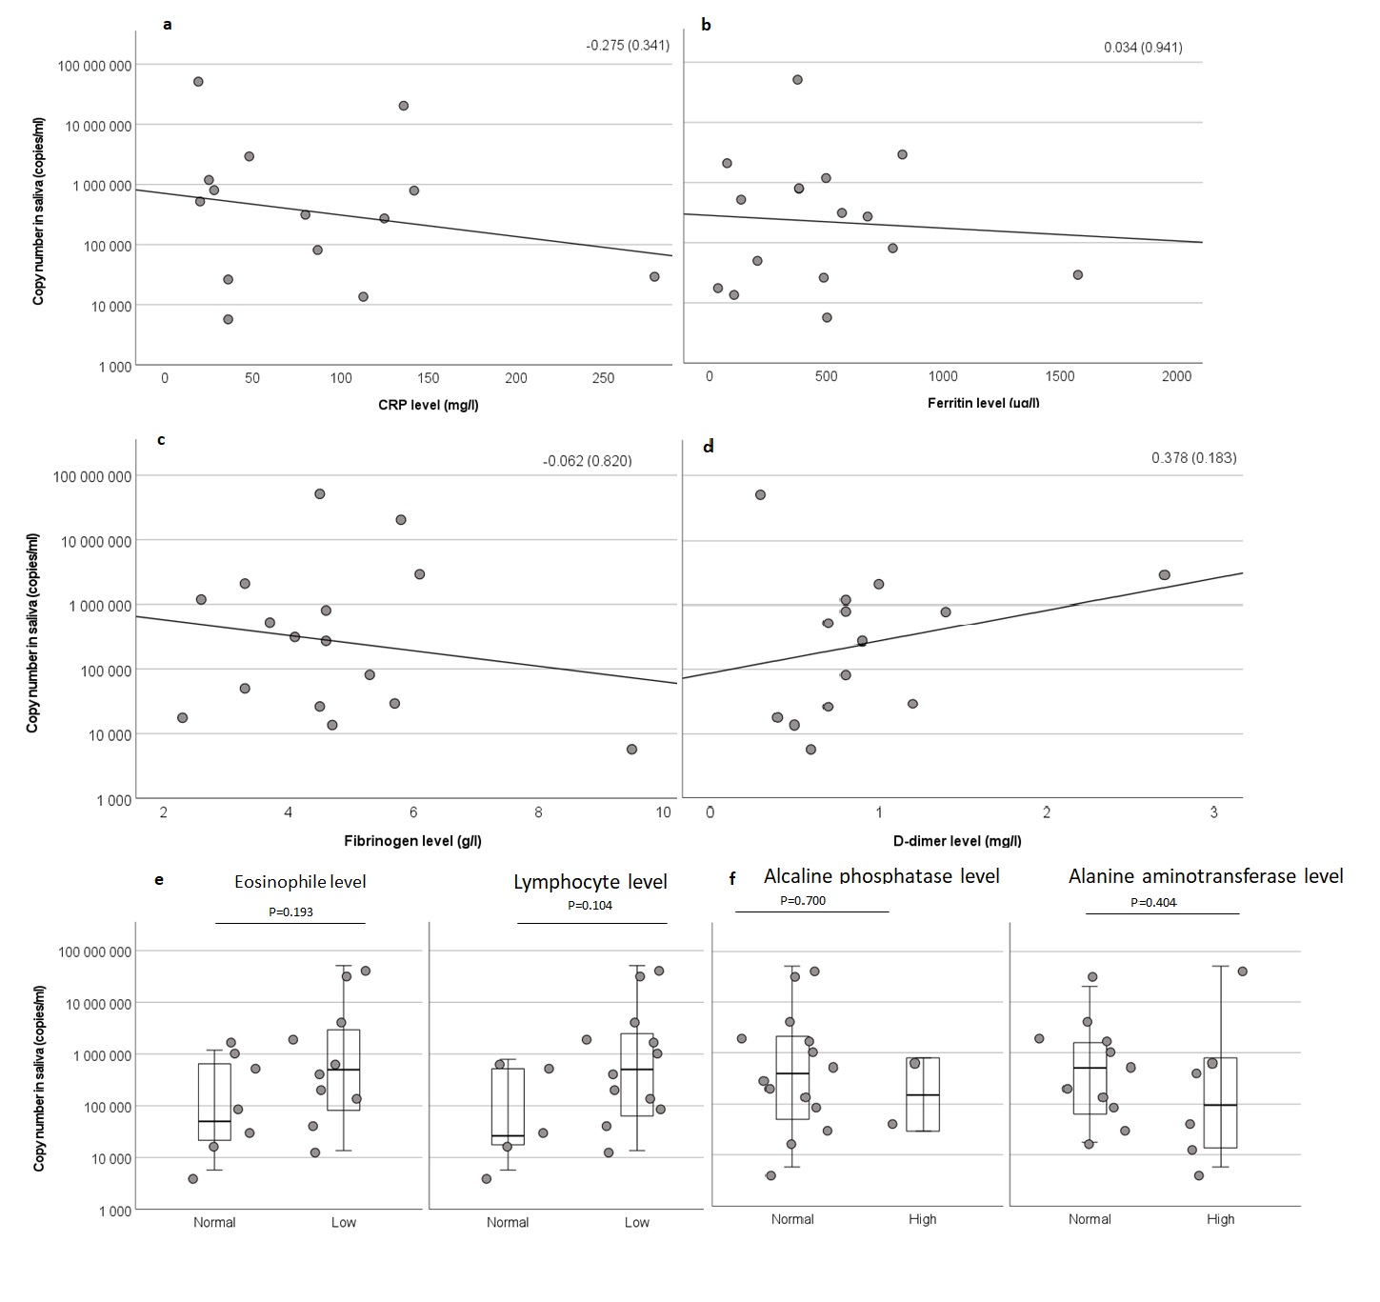
Fig. S3 Correlation between SARS-CoV-2 RNA copy number in saliva and laboratory results: a C-reactive protein (CRP), b ferritin, c fibrinogen, d D-dimer, e lymphocyte and eosinophile levels, and f alkaline phosphatase and alanine amino transferase levels. Spearmans’ rho values (with corresponding p-values) are indicated in (a-d) and p-values of Independent-Samples Mann-Whitney U-test in (e-f).
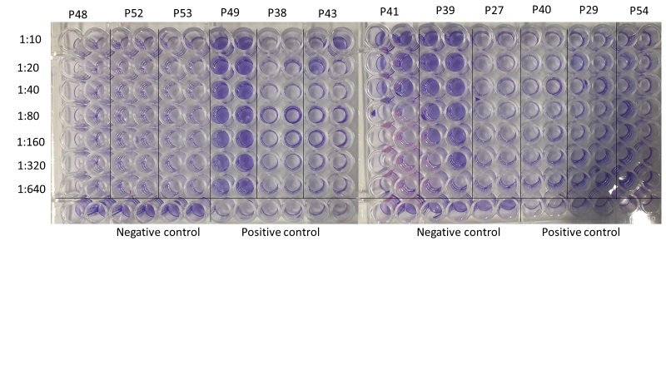
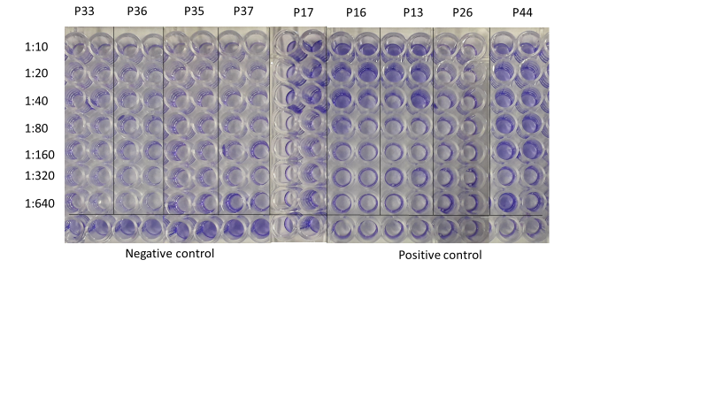
Fig. S4 Microneutralization results against Fin/20 strain with serum dilutions from 1:10 to 1:640. Positive control is the virus without serum and negative control is the cells without serum or the virus. Violet color indicates living cells which means that virus has been neutralized.

Table S7: Primer sequences
 | Primer/probe | Sequence | Reference
 | Charité_N_F | CACATTGGCACCCGCAATC | ¹
 | Charité_N_R | GAGGAACGAGAAGAGGCTTG | ¹
 | Charité_N_P | FAM-ACTTCCTCAAGGAACAACATTGCCA-BBQ | ¹
 | USCDC_N1_F | GACCCCAAAATCAGCGAAAT | ²
 | USCDC_N1_R | TCTGGTTACTGCCAGTTGAATCTG | ²
 | USCDC_N1_P | FAM-ACCCCGCATTACGTTTGGTGGACC-BHQ1 | ²

Safety measures used in families of home-treated patients

1) In family of P11, no specific measures were taken to isolate the patient from the rest of the family and no mask or respirators were used. Index patient had very mild symptoms and was PCR negative from saliva on the collection day. Saliva sample from a highly exposed family member was PCR positive, but the family member didn’t have any symptoms.
2) In family of P33, patient was constantly separated from other family members right after the onset of symptoms. He stayed in separated room with closed door and used separated bathroom. Family members used FFP2-respirators and protective gloves. Index patient had fever and respiratory symptoms, and the culture and PCR-results from saliva were positive. Environmental contamination was detected both in surfaces and air of the patient’s room. Saliva samples as well as SARS-CoV-2 antibody tests from all family members were negative.
3) In family of P37, no specific measures were taken to isolate the patient from family. Additionally, no respiratory protection was used. Index patient had mild respiratory symptoms, but no fever. Index patients’ saliva was PCR positive but culture negative and no PCR positive environmental samples were detected. Saliva sample of one of the two tested family members was positive with both PCRs and family member had mild respiratory symptoms.
4) In family of P46, family member and patient used protective measures including all-time use of surgical mask and intensified cleaning. Saliva of the index patient was positive in PCR and virus culture but all the samples from the environment stayed negative. Saliva samples from the family member were negative. Despite of the high positivity in patients’ saliva, no notable transmission into environment occurred. Family member didn’t develop COVID-19 symptoms at any point after the collection, antibody samples were not obtained.
5) In family of P50 and P51, intensified cleaning was used, but no respiratory protection was obtained to protect family members from the infection. First infected member (a child) infected all other family members. A child had a high fever and respiratory symptoms. Other family members got their first symptoms three to four days after first symptoms of the child. Fecal samples were collected from two cats who also developed respiratory symptoms at the same time with other family members when their symptoms were already settled, but these samples were PCR negative. PCR-positive air and environmental samples as well as culture positive saliva samples were collected from both adults.

Supplementary methodology: Protocol optimization
SARS-CoV-2 ability to infect VE6 cells in room temperature
To optimize passive air sampling protocol, the ability of SARS-CoV-2 to infect Vero E6 (VE6) cells in room temperature (RT) outside incubator and major differences between collecting samples to living cells versus collecting them to growth media which was transported to cells later in the laboratory were tested VE6 passaged SARS-CoV-2/Finland/1/2020 virus strain (Fin/20, passage 8, titer 10⁶ PFU/ml based on end-point titration) ³. 10-fold dilution series of the virus (10 000-1 copies of infectious virus) were pipetted into three 6-well plates of VE6 cells and into 35/10 MM cell culture dishes without cells containing 1 ml culture media (MEM). One of the 6-well plates was put straight to the incubator (37 °C), one was incubated in RT for 2 h (corresponding the time the cells have to be in RT during hospital collection) and one was kept in RT for 2 h and media was changed before putting into 37 °C. Cell culture dishes were kept at RT for 1 h, virus containing media was poured into the 50 ml falcon tube, which were put into the container with cold accumulators for 1h to imitate the transportation from the hospital and cultured in 6-well plates. Cells were grown for 4 days and checked for cytopathic effect (CPE).
CPE was observed in wells with approximately 1 copy of infectious virus in all cases indicating that cells were also infected at RT. When the virus was added to Petri dishes with MEM and transferred to cells later, CPE was also detected with approximately 1 copy of infectious virus, indicating that SARS-CoV-2 stayed stable in MEM for the time needed for transport into the lab. This is also supported by earlier studies reporting a good stability of SARS-CoV-2 in transport media⁴. One should note, however, that this test doesn’t effectively describe the situation with non-cell culture adapted strains and hence can’t be used to estimate the sensitivity of the culturing protocol and was only used to compare the protocols to each other.

Stability of SARS-CoV-2 on MCE and gelatin filters
SARS-CoV-2 stability on two filters used for Button sampling was tested by pipetting a dilution series of 10 000, 1000, 100, 10, 1, and 0 infectious virus particles in 10 µl onto MCE filters and gelatin filters (Sartorius Stedim Biotech). MCE filters were incubated at RT for time points of 15 min, 30 min, 1 h, 1.5 h, and 2 h and gelatin filters for 30 min after which the filters were moved to tubes with 3 ml of culture media. Tubes were kept in a container with cold accumulators for 1 h as before to imitate the sample transportation into the laboratory. MCE filter tubes were vortexed for 1 min at low speed. Medias from all the filter samples were poured to 6 well plates of VE6 cells and grown at 37 °C for 4 days.
Results are presented in Table S8. 30 min after adding the virus onto the filter, infectious virus was cultured from gelatin filter with approximately 1 copy whereas with MCE filter, the smallest virus amount was 1000 copies. After 1h, no infectious virus could be cultured from MCE filter indicating that virus inactivates on the filter relatively fast. Based on these results, gelatin filter was selected for collections over MCE filter and the collection time of approximately 30 min was used to maximize the changes of collecting enough virus from the air and culturing infectious virus before it is inactivated on the filter. One should note that in this set up, the virus was added onto the filter all at once, whereas in the hospital it can be assumed to be collected gradually. This set up also doesn’t compare the ability of the filters to collect the virus or tell if the stability is different in the collector with a heavier airflow.

Table S8: Stability of SARS-CoV-2 in MCE filters and gelatin filters.
 |  | MCE filter |  |  |  | Gelatin filter
 | Infectious virus particles | 15 min | 30 min | 1.5 h | 2 h | 30 min
 | 10 000 | + | + | + | - | +
 | 1000 | + | + | - | - | +
 | 100 | + | - | - | - | +
 | 10 | - | - | - | - | +
 | 1 | - | - | - | - | +
 | 0 | - | - | - | - | -

+: Sample was positive in cell culture
-: Sample was negative in cell culture

Selecting PCR protocol
N Charité PCR was initially used due to being routinely used in the laboratory. After reports about more sensitive options being available, US CDC N1 (US CDC)², China CDC N (China CDC)⁵, Institut Pasteur RdRP IP4 (IP4), and Institut Pasteur RdRP IP2 (IP2)⁶ were compared to N Charité PCR¹. RNA extracted from strains C1P1⁷, VoC1⁸, and SARS-CoV-2/Finland/1/2020³ as 1:10, 1:100, 1:1000, and 1:10 000 dilutions was used in protocol comparison. All the PCRs were performed with TaqMan Fast Virus 1-Step Master Mix (ThermoFisher) according to fast cycling mode and annealing temperatures of 55 °C (US CDC), 58 °C (N Charité, IP2, and IP4), and 63 °C (China CDC). IP2 and IP4 were done as multiplex. All PCRs were performed with Stratagene Mx3005P (Agilent Technologies).
Ct-values are presented in Table S9 and Fig. S5. On average, Ct-values compared to N Charité were 5.0 cycles lower (SD 0.84) with US CDC, 1.5 cycles higher (SD 1.04) with China CDC, 2.4 cycles lower (SD 2.98) with IP4, and 1.9 cycles lower (SD 1.36) with IP2. Samples had gone through one extra freeze-and-thaw-cycle for China CDC, IP4, and IP2 PCRs which might slightly affect the Ct-values. US CDC PCR, which gave the lowest Ct-values, was also tested for specificity with MERS RNA and four SARS-CoV-2 negative saliva samples which all were negative. Due to these results and results by Etievant et al.⁹ US CDC PCR was considered to be most sensitive and specific enough to be used in the project in addition to N Charité PCR.
Table S9: Ct-value comparison of five PCR protocols: N Charité, US CDC N1, China CDC N, Institut Pasteur RdRP IP4, and Institut Pasteur RdRP IP2
 | Sample | Dilution | N Charité | US CDC N1 | China CDC N | RdRP IP4 | RdRP IP2
 | VoC1 | 1:10 | 17.99 | 13.63 | 19.86 | 19.86 | 16.10
 | VoC1 | 1:100 | 22.41 | 16.49 | 23.16 | 17.86 | 19.90
 | VoC1 | 1:1000 | 25.89 | 19.76 | 27.24 | 21.64 | 23.04
 | VoC1 | 1:10 000 | 29.18 | 23.5 | 29.76 | 29.76 | 27.18
 | C1P1 | 1:10 | 13.60 | 9.07 | 15.41 | 15.41 | 11.90
 | C1P1 | 1:100 | 16.83 | 12.81 | 20.95 | 13.29 | 14.39
 | C1P1 | 1:1000 | 20.64 | 15.90 | 21.64 | 21.64 | 17.91
 | C1P1 | 1:10 000 | 25.06 | 18.91 | 25.16 | 19.62 | 21.58
 | Fin/20 | 1:10 | 27.95 | 22.71 | 29.23 | 23.25 | 25.97
 | Fin/20 | 1:100 | 30.98 | 26.16 | 32.85 | 26.36 | 30.00
 | Fin/20 | 1:1000 | 34.37 | 30.56 | 35.83 | 30.03 | 36.05
 | Fin/20 | 1:10 000 | No Ct | 33.96 | 40.21 | 42.26 | No Ct
 | Negative saliva 1 | Undiluted | No Ct | No Ct | NA | NA | NA
 | Negative nasal swab 1 | Undiluted | No Ct | No Ct | NA | NA | NA
 | Negative nasal swab 3 | Undiluted | No Ct | No Ct | NA | NA | NA
 | Negative nasal swab 4 | Undiluted | No Ct | No Ct | NA | NA | NA
 | MERS | Undiluted | No Ct | No Ct | NA | NA | NA
 | H2O | No Ct | No Ct | No Ct | No Ct | No Ct | No Ct
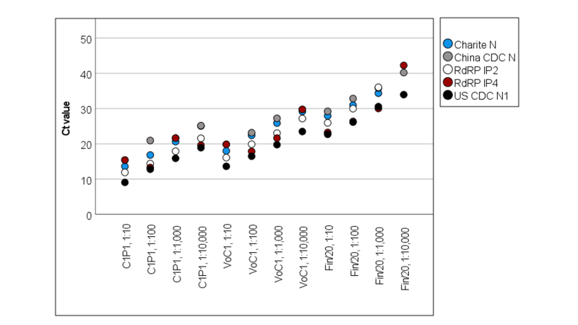
Fig. S5 Ct-value comparison of five PCR protocols: N Charité, US CDC N1, China CDC N, Institut Pasteur RdRP IP4, and Institut Pasteur RdRP IP2.
Optimizing saliva collection and handling
The inhibitory effect of saliva in PCR and virus culture was estimated with three saliva samples from a SARS-CoV-2-negative person. Saliva 1 was taken in the morning before eating or drinking anything, saliva 2 right after eating, and saliva 3 after eating and rinsing the mouth. Dilution series (10⁻¹-10⁻⁴) of the Fin/20 strain was prepared in all saliva samples and PBS as a control. All the dilution series and unspiked samples were cultured in VE6 cells in 6-well plates by adding 100 µl of the sample to 900 µl of media, incubating 1 h, washing the cells with culture media, and adding 3 ml of fresh media. Dilution series in saliva 1 was also cultured in two additional ways. First, samples were centrifuged at 16 100 g for 5 min and the supernatant was cultured as above. Second, 75 µl of spiked saliva was added to 3 ml of media and the sample was left to the cells. Cells were grown at 37 C for five days and checked for CPE and estimated for contamination caused by other microbe flora in the mouth. RNA was extracted from all spiked saliva samples and PBS controls with Trizol (100 µl of sample to 900 µl of reagent) and tested with N Charité PCR.
No difference was detected in culturing sensitivity between virus diluted in different saliva samples (Table S10) indicating that food in the saliva didn’t notably decrease sensitivity in virus culture. Centrifuging the saliva before culturing got rid of fungal contamination but also appeared to slightly decrease sensitivity. Hence, centrifugation was not used in the study as other culturing protocol appeared more sensitive despite the fungal growth. Virus diluted in saliva 2 taken after eating had higher Ct-values in PCR than other saliva samples or virus diluted in PBS which indicates that food remains can inhibit PCR (Fig. S6). No notable difference was detected between virus diluted in saliva taken before eating and after rinsing mouth as compared to virus in PBS. Because of these results, patients were asked to rinse their mouth before sampling whenever possible.

Table S10: Culturing results of saliva spike test. Both CPE and growth of contaminants by other micorbe flora from the mouth (Cont.) are reported for three different saliva-samples with different virus dilutions and culturing protocols.
 | PBS |  | Saliva 1 |  | Saliva 2 |  | Saliva 3 |  | Saliva 1 |  | Saliva 1
 | Media change after 1h |  | Media change after 1h |  | Media change after 1h |  | Media change after 1h |  | Centrifuge and media change after 1h |  | No media change or centrifugation
Virus dilution | CPE | Cont. | CPE | Cont. | CPE | Cont. | CPE | Cont. | CPE | Cont. | CPE | Cont.
1:10 | + | - | + | + | + | + | + | + | + | - | + | +
1:100 | + | - | + | + | + | + | + | + | + | - | + | +
1:1000 | + | - | + | + | + | + | + | + | + | - | + | +
1:10 000 | + | - | - | + | + | + | + | + | - | - | + | +
Unspiked | - | - | - | - | - | - | - | - | - | - | + | -
Ctrl | - | - | - | - | - | - | - | - | - | - | - | -
Saliva 1: Saliva before eating
Saliva 2: Saliva after eating
Saliva 3: Saliva after eating and rinsing mouth

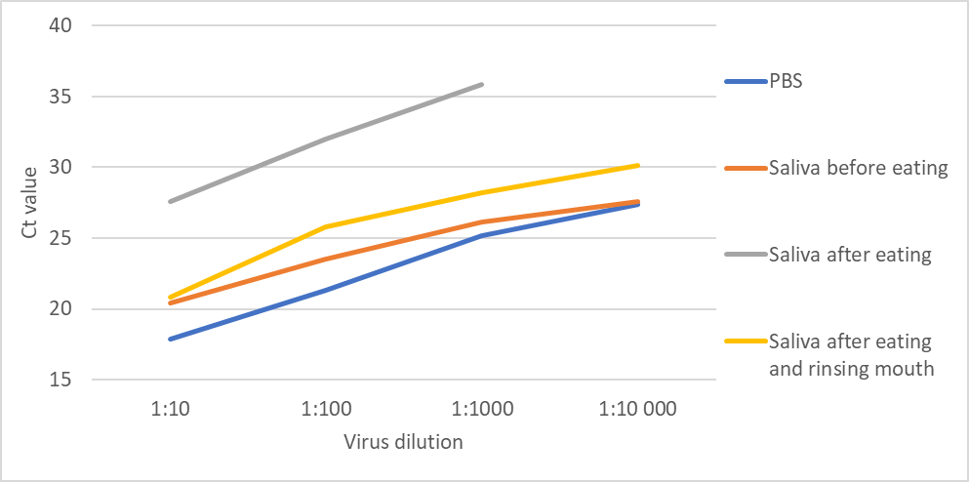
 | Unspiked saliva | 1:10 | 1:100 | 1:1000 | 1:10 000
PBS | neg | 17.89 | 21.34 | 25.165 | 27.38
Saliva before eating | neg | 20.46 | 23.52 | 26.16 | 27.57
Saliva after eating | neg | 27.61 | 31.98 | 35.83 | No Ct
Saliva after eating and rinsing mouth | neg | 20.84 | 25.82 | 28.22 | 30.17
Fig. S6 Inhibitory effect of saliva in detection of SARS-CoV-2 RNA by PCR. Saliva samples taken before eating, after eating, and after eating and rinsing mouth were spiked with a dilution series of Fin/20 strain RNA and tested with N Charité PCR.

Supplementary references

1 Corman, V. M. et al. Detection of 2019 novel coronavirus (2019-nCoV) by real-time RT-PCR. Euro Surveill 25, doi:10.2807/1560-7917.ES.2020.25.3.2000045 (2020).
2 CDC. A CDC 2019-Novel Coronavirus (2019-nCoV) Real-Time RT-PCR Diagnostic Panel, <https://www.fda.gov/media/134922/download> (2020).
3 Haveri, A. et al. Serological and molecular findings during SARS-CoV-2 infection: the first case study in Finland, January to February 2020. Euro Surveill 25, doi:10.2807/1560-7917.ES.2020.25.11.2000266 (2020).
4 Chin, A. W. H. & Poon, L. L. M. Stability of SARS-CoV-2 in different environmental conditions - Authors' reply. Lancet Microbe 1, e146, doi:10.1016/S2666-5247(20)30095-1 (2020).
5 CDC, C. China CDC Primers and Probes for Detection 2019-nCoV, <http://ivdc.chinacdc.cn/kyjz/202001/t20200121_211337.html > (2020).
6 Institut Pasteur, P. Protocol: Real-Time RT-PCR Assays for the Detection of SARS-CoV-2, <https://www.who.int/docs/default-source/coronaviruse/real-time-rt-pcr-assays-for-the-detectionof-sars-cov-2-institut-pasteur-paris.pdf?sfvrsn=3662fcb6_2> (2020).
7 Cantuti-Castelvetri, L. et al. Neuropilin-1 facilitates SARS-CoV-2 cell entry and infectivity. Science 370, 856-860, doi:10.1126/science.abd2985 (2020).
8 Virtanen, J. et al. Kinetics of Neutralizing Antibodies of COVID-19 Patients Tested Using Clinical D614G, B.1.1.7, and B 1.351 Isolates in Microneutralization Assays. Viruses 13, doi:10.3390/v13060996 (2021).
9 Etievant, S. et al. Performance Assessment of SARS-CoV-2 PCR Assays Developed by WHO Referral Laboratories. J Clin Med 9, doi:10.3390/jcm9061871 (2020).

