Supplementary figures
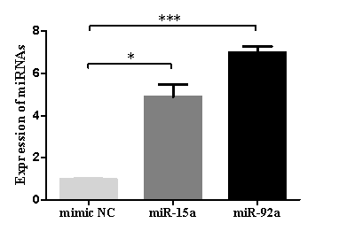
Figure S1 Over-expression efficiency of miR-15a and miR-92a in M2 macrophages.

Figure S2 Target gene prediction of miR-15a and miR-92a by bioinformatics analyses. (A) Venn's diagram of target genes of miR-15a predicted by four databases. (B) Interaction between ten hub genes for miR-15a by Cytoscape (left panel) and genes ranked according to score (right panel). (C) Venn's diagram of target genes of miR-92a predicted by four databases. (D) Interaction between ten hub genes for miR-92a by Cytoscape (left panel) and genes ranked according to score (right panel).

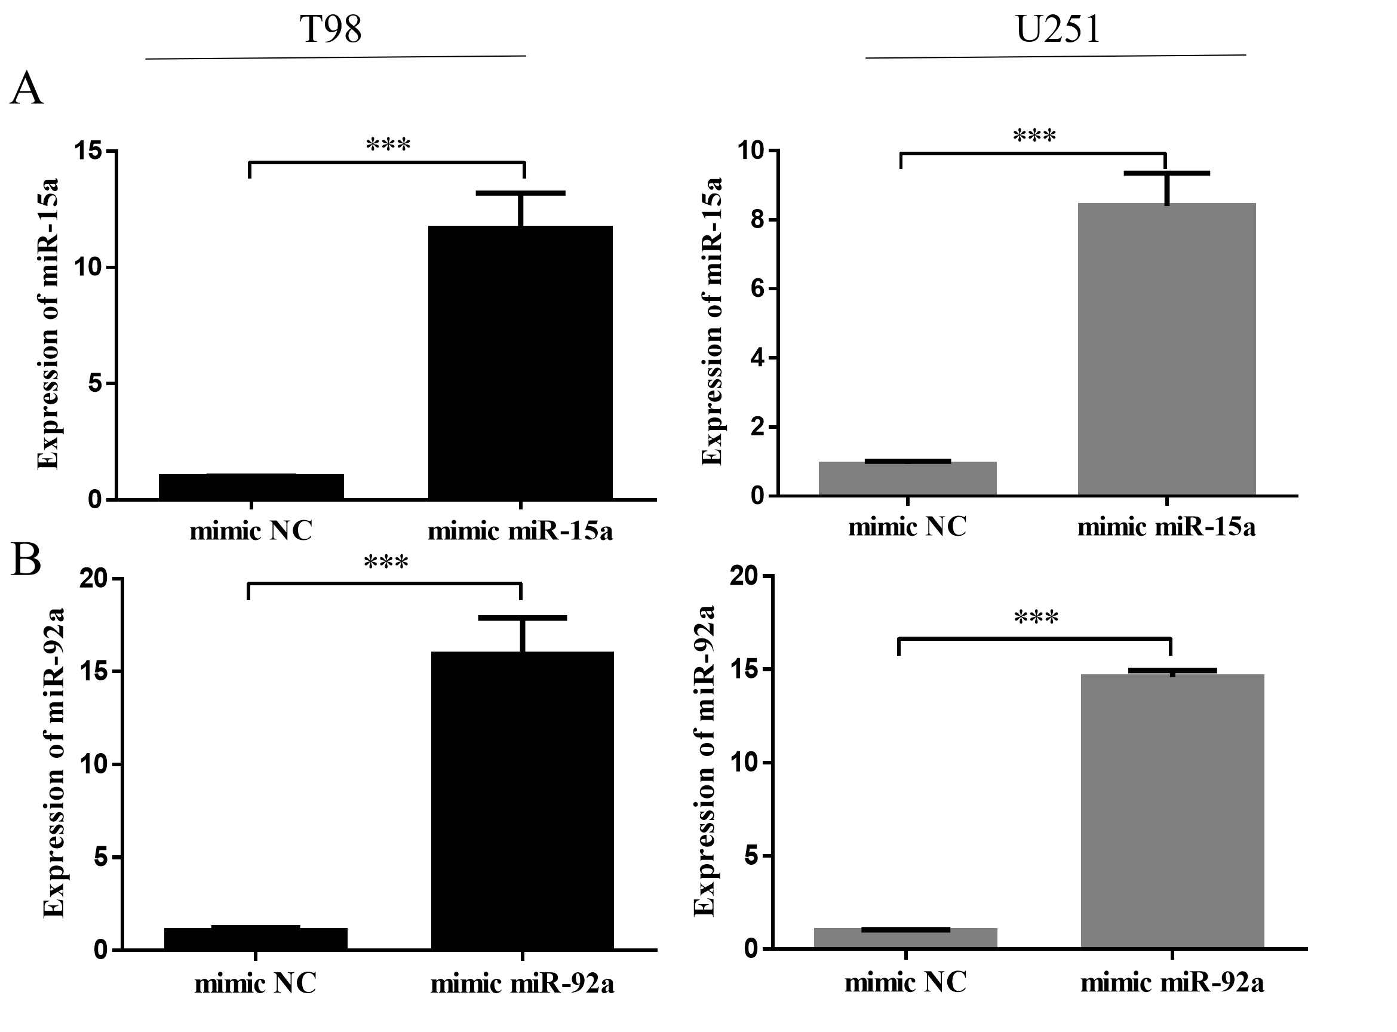
Figure S3 Over-expression efficiency of (A) miR-15a and (B) miR-92a in T98 and U251 cell lines.

