Fig S1 Gross image of tissues and HE staining of hepatocellular carcinoma. a Macroscopic specimen of tissues. HCC tissues, para-carcinoma tissues (tissues no more than 1cm away from the tumor edge and tissues more than 1cm away from the tumor edge) and normal liver tissues (tissues that are at least 5cm away from tumor edge) were collected. b Histochemical staining of HCC, ×100.

Fig S2 Correlations of expression of SOD1 and drive genes in HCC and normal liver tissues. Pathway1: Wnt/β-catenin pathway; Pathway2: Inflammatory pathway; Pathway3: Liver metabolic pathway; Pathway4: Chromatin regulators; Pathway5: Ras/ERK pathway; Pathway6: Matabolism and epigenomics; Pathway7: Telomere maintenace; Pathway8: Oxidative stress pathway; Pathway9: AKT/mTOR pathway; Pathway10: TP53 /cell-cycle pathway; Pathway11: Angiogenesis.

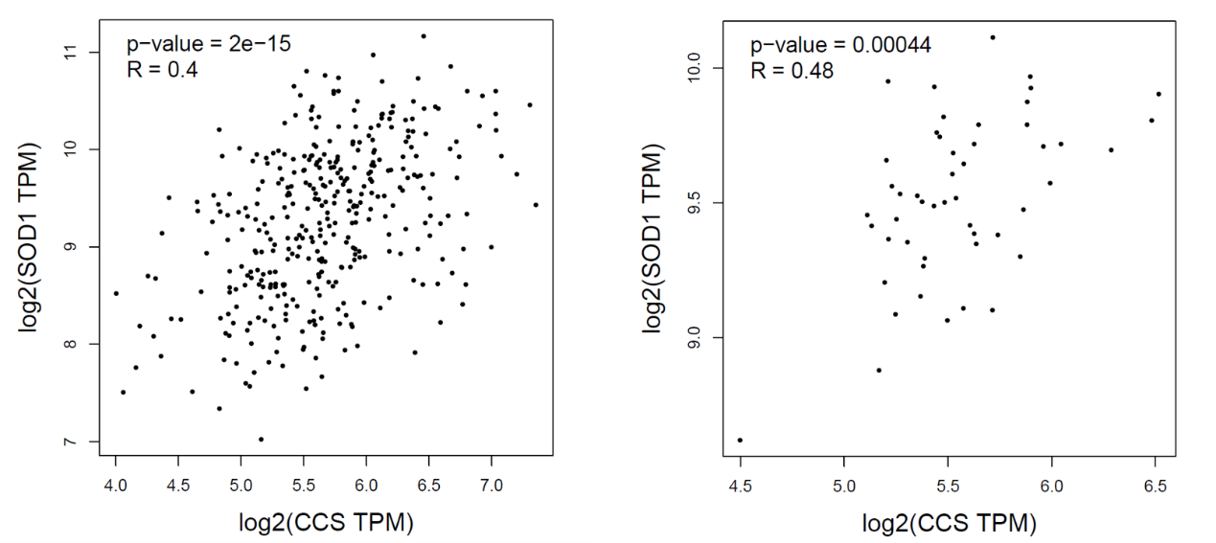
Fig S3 Correlation of CCS and SOD1 gene expression levels in human hepatocellular carcinoma (left) and normal liver tissues (right).

Table S1 Correlation between expression levels of CCS and clinicopathological features
Clinicopathological features |  | CCS expression |  | P
 |  | Low | High | P
Gender | Male | 21 | 6 | 1.000
 | Female | 4 | 1
Hepatitis B | Positive | 20 | 6 | 1.000
 | Negative | 5 | 1
Liver cirrhosis | Present | 11 | 15 | 0.394
 | Absent | 14 | 2
Preoperative AFP | ≤ 20 ng/mL | 8 | 2 | 1.000
 | > 20 ng/mL | 17 | 5
Tumor size | ≤ 5 cm | 8 | 4 | 0.379
 | > 5cm | 17 | 3
Tumor number | Single | 21 | 5 | 0.590
 | Multiple | 4 | 2
Child-Pugh grade | A | 19 | 7 | 0.296
 | B | 6 | 0
BCLC stage | A | 15 | 5 | 0.683
 | C | 10 | 2
Edmondson grade | Ⅱ or Ⅱ-Ⅲ | 17 | 7 | 0.150
 | Ⅲ | 8 | 0
MVI | Present | 14 | 3 | 0.687
 | Absent | 11 | 4
Vascular invasion | Present | 2 | 7 | 1.000
 | Absent | 6 | 17
Extrahepatic metastasis | Present | 3 | 1 | 1.000
 | Absent | 22 | 6
TNM stage | Ⅰ-Ⅲ | 21 | 6 | 1.000
 | Ⅳ | 4 | 1

