Supporting Information

Serum Bile Acid Profiles Improve Clinical Prediction of Nonalcoholic Fatty Liver in T2DM patients

Running title: Serum Bile Acid Profiles of NAFL
Tao Wu^{1, 2}, Ming Yang¹, Hanchen Xu¹, Lei Wang¹, Huafeng Wei¹, Guang Ji^{1*}
¹ Institute of Digestive Disease, Longhua Hospital, Shanghai University of Traditional Chinese Medicine, Shanghai, China.
² Institute of Interdisciplinary Integrative Medicine Research, Shanghai University of Traditional Chinese Medicine, Shanghai, China.
Tables and Figures in Main manuscript and Supporting Information
Information | Exploration cohort | Validation cohort | Both
Clinical information |  |  | Table1
Serum BAs | Figure S1 | Figure S4, Figure S5 | Table S1
AUC | Table S3 |  | Table 2, Figure S2
OPLS-DA analysis | Figure 1, Figure 2A | Figure S6
Spearman correlations | Figure 2B | Figure S5 | Table S2, Figure S3
Decision curve analysis | Figure 3A | Figure 3B | Table 3
Schematic illustration |  |  | Figure 4
List of Supporting Information
Fig. S1. Major components of bile acid profiles in serum from T2DM patients without NAFL and T2DM patients with NAFL as analyzed by UPLC-TQMS in exploration cohort.
Fig. S2. Receiver-Operator Characteristic curves of five models based on different predictor sets for exploration and validation cohort.
Fig. S3. Spearman correlations between the 5 NAFL-associated bile acids and clinical indices that included in exploration and validation cohort.
Fig. S4. Major components of bile acid profiles in serum from T2DM patients without NAFL and T2DM patients with NAFL as analyzed by UPLC-TQMS in validation cohort.
Fig. S5. Serum concentrations and Spearman correlations among the 5 NAFL-associated BAs in T2DM patients without NAFL and T2DM patients with NAFL as analyzed by UPLC-TQMS in validation cohort.
Fig. S6. OPLS-DA analysis of 24 serum BAs from T2DM patients with and without NAFL in validation cohort.
Table S1. Serum bile acid profiles of T2DM patients without NAFL and T2DM patients with NAFL in exploration and validation cohort.
Table S2. Spearman correlations between the five NAFL-associated bile acids and clinical indicators that included in exploration and validation cohort.
Table S3. Parameters of 5 models based on five NAFL-associated bile acids and clinical indicators in validation cohort.

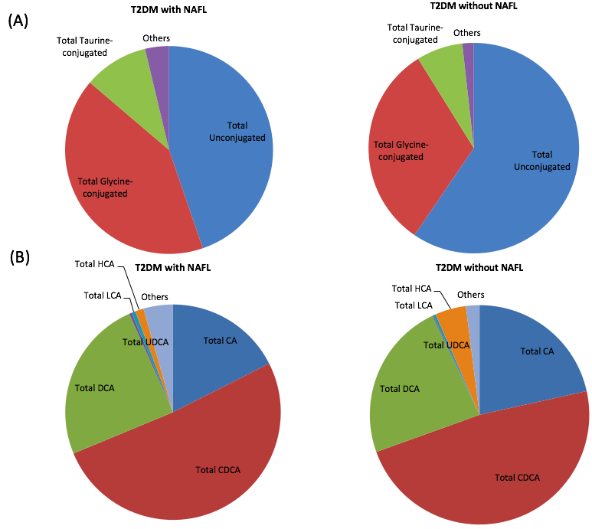
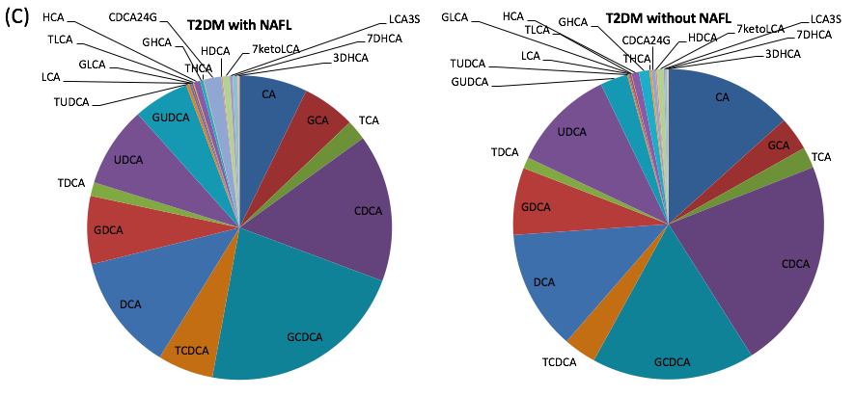
Fig. S1. Major components of bile acid profiles in serum from from T2DM patients with or without NAFL analyzed by UPLC-TQMS in exploration cohort. (A): total BA, unconjugated, glycine-conjugated, taurine-conjugated BAs. (B): total CA, CDCA, DCA, UDCA, LCA, HCA and others. (C): total 24 bile acids. Abbreviations: T2DM, type 2 diabetes mellitus; NAFL, nonalcoholic fatty liver; TBA, Total bile acids; CA, cholic acid; GCA, glycocholic acid; TCA, taurocholic acid; CDCA, chenodeoxycholic acid; GCDCA, glycochenodeoxycholic acid; TCDCA, taurochenodeoxycholic acid; DCA, deoxycholic acid; GDCA, glycodeoxycholic acid; TDCA, taurodeoxycholic acid; UDCA, ursodeoxycholic acid; GUDCA, glycoursodeoxycholic acid; TUDCA, tauroursodeoxycholic acid; LCA, lithocholic acid; GLCA, glycolithocholic acid; TLCA, taurolithocholic acid; HCA, hyocholic acid; GHCA, glycohyocholic acid; THCA, taurohyocholic acid; HDCA, hyodeoxycholic acid; GHDCA, glycohyodeoxycholic acid; THDCA, taurohyodeoxycholic acid; DHCA, dehydrocholic acid; GDHCA, glycodehydrocholic acid; TDHCA, taurodehydrocholic acid; 7-KLCA, 7-ketolithocholicacid; LCA-3S, lithocholic acid-3 sulfate; 3-DHCA, 3-dehydrocholic acid; 7-DHCA, 7-dehydrocholic acid; CDCA-24G, acyl CDCA-24 glucuronide.

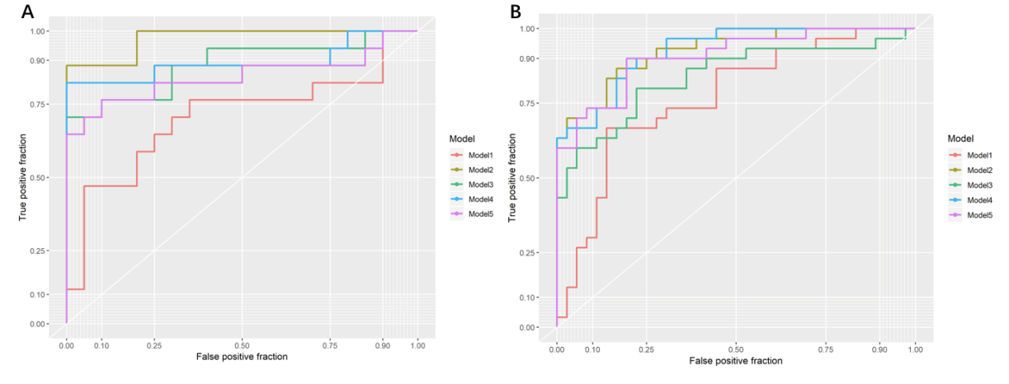
Fig. S2. Receiver-Operator Characteristic curves of five models based on different predictor sets for exploration and validation cohort. (A): exploration cohort; (B): Validation cohort. Model 1, clinical factors, including age, sex, BMI, WHR, FPG, 2h PG, ALT, TG, HDL and LDL; Model 2, all metabolites; Model 3, biomarker metabolites; Model 4, clinical factors plus all metabolites ; Model 5, clinical factors plus biomarker metabolites.
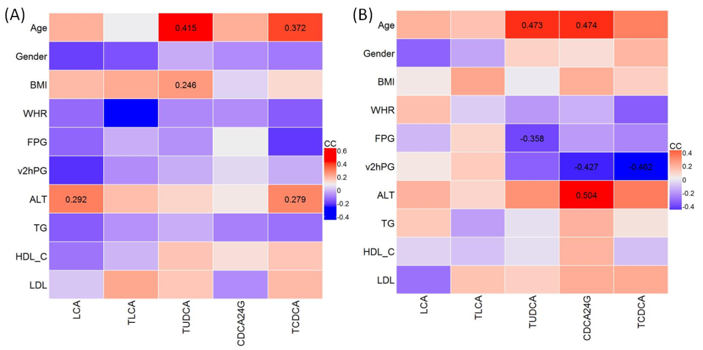 Fig. S3. Spearman correlations between the 5 NAFL-associated bile acids and clinical indices that included in exploration and validation cohort. (A): exploration cohort; (B): validation cohort. The displayed numbers of the correlation in the figures means significant correlation coefficients between bile acids and clinical indices. BMI, body mass index; WHR, waist-hip ratio; FPG, fasting plasma glucose; 2 h PG, 2 h plasma glucose; ALT, alanine aminotransferase; TG, triglyceride; HDL, high-density lipoprotein; LDL, low-density lipoprotein; LCA, lithocholic acid; TLCA, taurolithocholic acid; TUDCA, tauroursodeoxycholic acid; CDCA-24G, acyl CDCA-24 glucuronide; TCDCA, taurochenodeoxycholic acid.

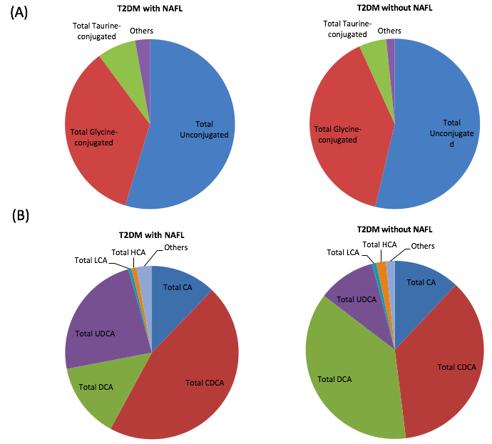 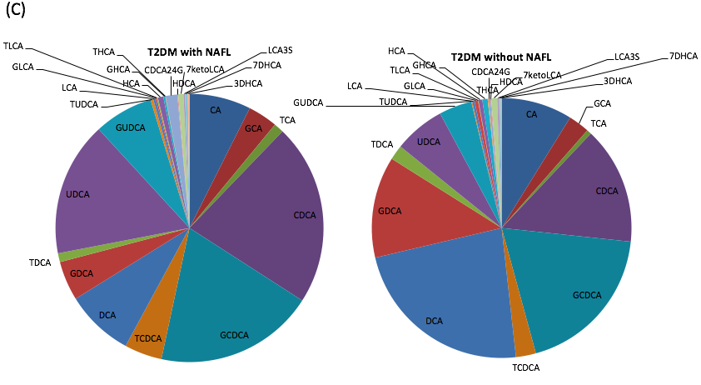Fig. S4. Major components of bile acid profiles in serum from T2DM patients with or without NAFL analyzed by UPLC-TQMS in validation cohort. (A): total BA, unconjugated, glycine-conjugated, taurine-conjugated BAs. (B): total CA, CDCA, DCA, UDCA, LCA, HCA and others. (C): total 24 bile acids. Abbreviations: T2DM, type 2 diabetes mellitus; NAFL, nonalcoholic fatty liver; TBA, Total bile acids; CA, cholic acid; GCA, glycocholic acid; TCA, taurocholic acid; CDCA, chenodeoxycholic acid; GCDCA, glycochenodeoxycholic acid; TCDCA, taurochenodeoxycholic acid; DCA, deoxycholic acid; GDCA, glycodeoxycholic acid; TDCA, taurodeoxycholic acid; UDCA, ursodeoxycholic acid; GUDCA, glycoursodeoxycholic acid; TUDCA, tauroursodeoxycholic acid; LCA, lithocholic acid; GLCA, glycolithocholic acid; TLCA, taurolithocholic acid; HCA, hyocholic acid; GHCA, glycohyocholic acid; THCA, taurohyocholic acid; HDCA, hyodeoxycholic acid; GHDCA, glycohyodeoxycholic acid; THDCA, taurohyodeoxycholic acid; DHCA, dehydrocholic acid; GDHCA, glycodehydrocholic acid; TDHCA, taurodehydrocholic acid; 7-KLCA, 7-ketolithocholicacid; LCA-3S, lithocholic acid-3 sulfate; 3-DHCA, 3-dehydrocholic acid; 7-DHCA, 7-dehydrocholic acid; CDCA-24G, acyl CDCA-24 glucuronide.

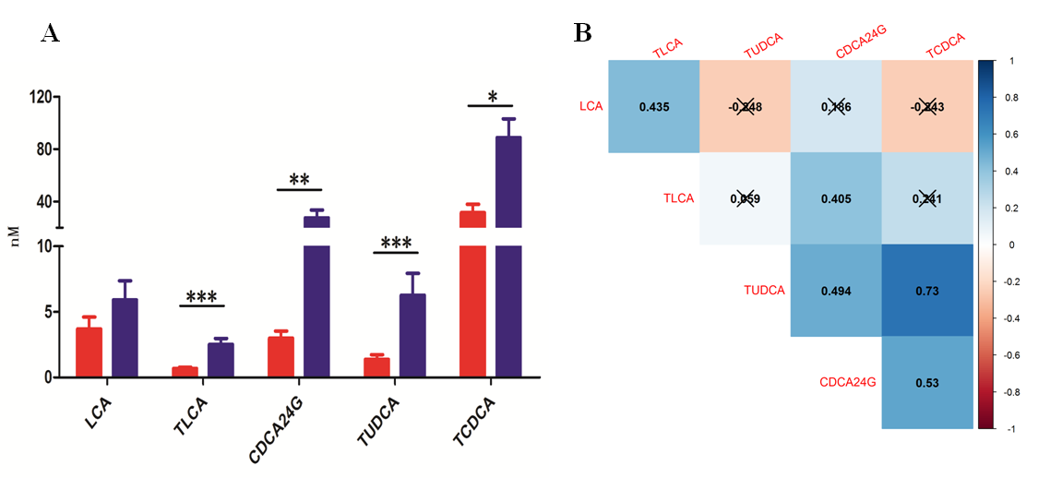
Fig. S5. Serum concentrations and Spearman correlations among the 5 NAFL-associated BAs in T2DM patients with or without NAFL analyzed by UPLC-TQMS in validation cohort. (A): * p<0.05, ** p<0.01, *** p<0.001, compared with T2DM patients without NAFL. (B): Strong correlations (P<0.05) were observed between LCA and TLCA (ρ=0.435); TLCA and CDCA24G (ρ=0.405); TUDCA and CDCA24G (ρ=0.494); TUDCA and TCDCA (ρ=0.73); CDCA24G and TCDCA (ρ=0.53). “✖” means no significant correlation between the two BAs, ie P>0.05. No “✖” means significant correlation between the two BAs, ie P<0.05.
T2DM, type 2 diabetes mellitus; NAFL, nonalcoholic fatty liver; UPLC-TQMS, ultra-performance liquid chromatography-triple quadrupole mass spectrometry; LCA, lithocholic acid; TLCA, taurolithocholic acid; TUDCA, tauroursodeoxycholic acid; CDCA-24G, acyl CDCA-24 glucuronide; TCDCA, taurochenodeoxycholic acid.  represents T2DM with NAFLD, represents T2DM without NAFLD.
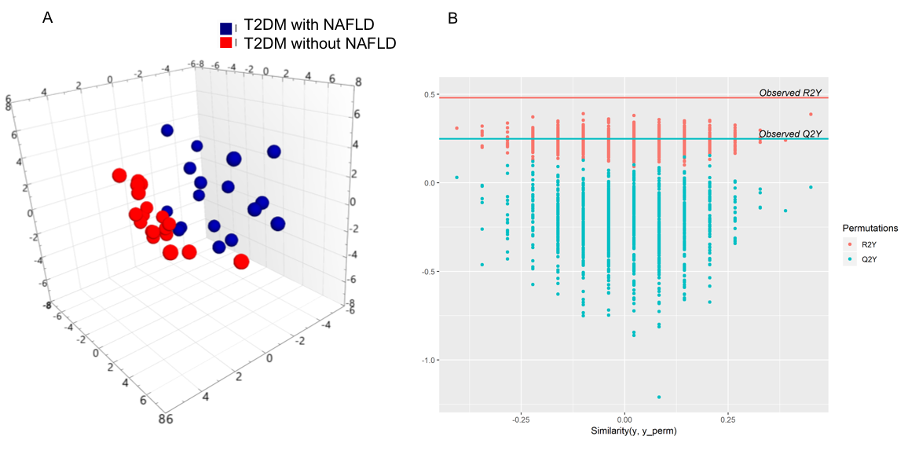Fig. S6. OPLS-DA analysis of 24 serum BAs from T2DM patients with and without NAFL in validation cohort. (A), 3D OPLS-DA Plots, R2X=0.552, R2Y=0.828, Q2Y=0.660; (B), Permutation analysis. T2DM, type 2 diabetes mellitus; NAFL, nonalcoholic fatty liver; OPLS-DA, orthogonal projections to latent structures discriminant analysis.

Tables
Table S1. Serum Bile Acid Profiles of T2DM patients with or without NAFL in exploration and validation cohort.
Variables | Exploration cohort |  |  | Validation cohort
 | T2DM patients without NAFL(n=36) | T2DM patients with NAFL(n=30) | P-value | T2DM patients without NAFL(n=20) | T2DM patients with NAFL(n=17) | P-value
Total Unconjugated | 956.45(532.625-2353.7) | 1275.15(684.975-1919.775) |  | 395.6(215.375-763.2) | 1062.6(454.1-1686.6)*
Total Glycine-conjugated | 695.45(407.025-1034.15) | 835.65(582.875-1972.45) |  | 478.65(352.725-592.425) | 708.2(326.1-955.5)
Total Taurine-conjugated | 81.7(38.825-176.9) | 191.15(107.8-394.225)** |  | 48.7(35.75-88.075) | 115.5(63.4-219)**
Total CA | 252.5(111.675-562.425) | 352.25(129.825-696.15) |  | 71.95(36.725-163.25) | 179.3(106.1-311.7)*
CA | 128.85(30.625-429.6) | 79.15(41.425-295.625) |  | 25.65(6.55-94.15) | 73.4(29.1-156.5)
GCA | 47.6(23.725-113.075) | 70.6(45.325-206.825) |  | 28.2(20.175-44.3) | 52.7(24-117.6)
TCA | 7.8(4.15-33.525) | 20.6(9.05-62.575)* |  | 4.25(3.25-9.275) | 18.7(5.9-34.9)***
Total CDCA | 994.35(456.55-1930.625) | 1007.15(632.775-1843.2) |  | 391.7(184.475-542.975) | 809(597-1223.9)**
CDCA | 374.65(100.825-816.85) | 363.85(163.225-686.475) |  | 50.55(18.675-180.35) | 304.9(135.8-798.9)**
GCDCA | 351.65(203.975-735.55) | 447.55(311.95-890.525) |  | 181.35(119.75-384.125) | 332.3(215.5-446.9)
TCDCA | 56.85(23.05-105.85) | 117.6(60.7-193.35)** | 0.003 | 20.75(12.825-42.3) | 75(39.9-134.9)*** | <0.001
Total DCA | 378.95(56.3-610.025) | 527.25(242.475-1039.05) |  | 397.5(267.625-511.525) | 130.8(14.8-446.2)
DCA | 193.55(50.35-332.975) | 314.75(73.85-669.525) |  | 185.6(100.9-295.025) | 104(14-205.5)
GDCA | 74.15(9.7-262.75) | 145.4(45.4-312) |  | 118.55(76.95-216.075) | 22.3(0.8-127.4)*
TDCA | 6.7(0.975-43) | 24.4(14.025-64.6)* |  | 14.4(7.125-35.475) | 5(2.6-26.2)
Total UDCA | 150.1(86.4-351.6) | 246.25(176.325-523.975) |  | 77.5(44.525-174.475) | 451.2(125.8-564.1)**
UDCA | 100.4(41.125-217.025) | 153.95(97.2-296.525) |  | 42.1(25.1-77.575) | 271.6(43.6-462.2)*
GUDCA | 51.4(19.5-112.725) | 92.3(46.125-278.525)* |  | 34.6(11.475-86.075) | 95.3(48.6-190.4)*
TUDCA | 1.8(0.675-3.7) | 4.55(2.2-8.2)** | 0.009 | 0.9(0.225-1.75) | 3.4(2.3-10.2)** | 0.003
Total LCA | 4.65(1.075-10.775) | 14.85(2.675-27.7)* |  | 8(4.125-16) | 7.1(1.5-21)
LCA | 0.25(0-3.525) | 7.8(0.825-13.175)** |  | 2.15(0-6.7) | 4.1(0.1-10.5)
GLCA | 2.2(0.4-6.975) | 2.9(0-8.5) |  | 3.75(1.975-7.175) | 0(0-3.1)*
TLCA | 0.6(0.6-0.825) | 3.4(1.1-4.15)*** | <0.001 | 0.6(0.5-0.8) | 3.1(1.1-3.6)** | 0.002
Total HCA | 39.65(23.775-57.125) | 28.9(16.9-46.65) |  | 14.7(12.125-21.675) | 15.8(7.8-22.7)
HCA | 14.9(5.075-24.15) | 14.6(7.275-25.8) |  | 3.85(1.175-7.75) | 13(3.4-17.1)*
GHCA | 6.9(3.95-14.5) | 8(3.8-14.3) |  | 4.9(3.175-8.85) | 3.1(1.6-5.6)
THCA | 1(0.7-1.6) | 1.15(0.3-2.625) |  | 0.8(0.2-0.925) | 0.4(0.3-0.9)
CDCA24G | 4.45(1.8-10.8) | 22.35(16-43.625)*** | <0.001 | 2.15(1.65-3) | 16.9(11.4-28)*** | <0.001
HDCA | 0.5(0-2.175) | 2.55(0.25-5.15)* |  | 1.25(0-1.625) | 1.2(1.1-2.7)
7ketoLCA | 9.65(3.35-26.275) | 11.75(6.95-21.125) |  | 4.65(2.55-8.575) | 8.5(2.6-15.5)
LCA3S | 1.95(0.675-6) | 7.55(0-14.05) |  | 2.35(1.25-3.2) | 0(0-5)
7DHCA | 3.1(0.825-12.725) | 7.1(3.15-12.025) |  | 1.35(0.55-2.25) | 6(2.3-12)**
3DHCA | 3.25(1.3-5.35) | 3.45(2.35-7.5) |  | 0.9(0.225-1.475) | 3.3(1-5.1)**
Data are mean ± SEM (nmol/l). * p<0.05, ** p<0.01, *** p<0.001, compared with T2DM without NAFLD. TBA, Total bile acids; CA, cholic acid; GCA, glycocholic acid; TCA, taurocholic acid; CDCA, chenodeoxycholic acid; GCDCA, glycochenodeoxycholic acid; TCDCA, taurochenodeoxycholicacid; DCA, deoxycholic acid; GDCA, glycodeoxycholicacid; TDCA, taurodeoxycholic acid; UDCA, ursodeoxycholic acid; GUDCA, glycoursodeoxycholic acid; TUDCA, tauroursodeoxycholic acid; LCA, lithocholicacid; GLCA, glycolithocholic acid; TLCA, taurolithocholicacid; HCA, hyocholic acid; GHCA, glycohyocholic acid; THCA, taurohyocholic acid; HDCA, hyodeoxycholic acid; GHDCA, glycohyodeoxycholicacid; THDCA, taurohyodeoxycholic acid; DHCA, dehydrocholic acid; GDHCA, glycodehydrocholic acid; TDHCA, taurodehydrocholic acid; 7-KLCA, 7-ketolithocholicacid; LCA-3S, lithocholic acid-3 sulfate; 3-DHCA, 3-dehydrocholic acid; 7-DHCA, 7-dehydrocholicacid; CDCA-24G, acyl CDCA-24glucuronide.

Table S2. Spearman correlations between the five NAFL-associated bile acids and clinical indicators that included in exploration and validation cohort.
Correlations | LCA | TLCA | TUDCA | CDCA24G | TCDCA
Gender | -0.218* | -0.136 | 0.036 | -0.01 | 0.019
Age | 0.194* | 0.078 | 0.387*** | 0.249* | 0.285**
BMI | 0.145 | 0.215* | 0.159 | 0.09 | 0.093
WHR | -0.018 | -0.174 | -0.082 | -0.051 | -0.173
FPG | -0.099 | 0.041 | -0.139 | 0.038 | -0.187
2hPG | -0.114 | 0.008 | -0.099 | -0.094 | -0.132
TG | -0.041 | -0.087 | -0.006 | 0.011 | -0.034
HDL-C | -0.066 | -0.023 | 0.114 | 0.145 | 0.101
ALT | 0.242* | 0.137 | 0.197* | 0.257** | 0.303**
LDL | -0.056 | 0.194* | 0.177 | 0.02 | 0.224*
7ketoLCA | -0.173 | -0.237* | 0.42*** | 0.324*** | 0.286**
UDCA | -0.224* | -0.097 | 0.679*** | 0.417*** | 0.326***
HDCA | 0.619*** | 0.419*** | -0.202* | 0.202* | 0.062
CDCA | -0.245* | -0.224* | 0.321*** | 0.362*** | 0.315**
DCA | 0.535*** | 0.354*** | -0.197* | -0.013 | -0.093
7DHCA | -0.216* | -0.125 | 0.293** | 0.364*** | 0.196*
3DHCA | -0.258** | -0.119 | 0.299** | 0.383*** | 0.316**
HCA | -0.133 | -0.202* | 0.303** | 0.395*** | 0.255**
CA | -0.19 | -0.295** | 0.156 | 0.259** | 0.23*
GLCA | 0.488*** | 0.451*** | -0.247* | -0.174 | -0.003
GUDCA | -0.161 | -0.017 | 0.902*** | 0.348*** | 0.517***
GCDCA | -0.089 | 0.16 | 0.635*** | 0.316** | 0.798***
GDCA | 0.532*** | 0.518*** | -0.071 | -0.068 | 0.156
GHCA | -0.065 | -0.019 | 0.348*** | -0.047 | 0.406***
GCA | 0.068 | 0.152 | 0.558*** | 0.233* | 0.758***
TDCA | 0.56*** | 0.59*** | 0.016 | 0.009 | 0.303**
LCA-3S | 0.665*** | 0.383*** | -0.18 | 0.078 | -0.07
THCA | 0.04 | 0.138 | 0.337*** | -0.012 | 0.408***
TCA | 0.191 | 0.335*** | 0.591*** | 0.299** | 0.861***
Note: BMI, body mass index; WHR, waist-hip ratio; FPG, fasting plasma glucose; 2 h PG, post-load plasma glucose; ALT, alanine aminotransferase; TG, triglyceride; HDL, high-density lipoprotein; LDL, low-density lipoprotein; TBA, total bile acids; CA, cholic acid; GCA, glycocholic acid; TCA, taurocholic acid; CDCA, chenodeoxycholic acid; GCDCA, glycochenodeoxycholic acid; TCDCA, taurochenodeoxycholic acid; DCA, deoxycholic acid; GDCA, glycodeoxycholic acid; TDCA, taurodeoxycholic acid; UDCA, ursodeoxycholic acid; GUDCA, glycoursodeoxycholic acid; TUDCA, tauroursodeoxycholic acid; LCA, lithocholic acid; GLCA, glycolithocholic acid; TLCA, taurolithocholic acid; HCA, hyocholic acid; GHCA, glycohyocholic acid; THCA, taurohyocholic acid; HDCA, hyodeoxycholic acid; GHDCA, glycohyodeoxycholic acid; THDCA, taurohyodeoxycholic acid; DHCA, dehydrocholic acid; GDHCA, glycodehydrocholic acid; TDHCA, taurodehydrocholic acid; 7-KLCA, 7-ketolithocholic acid; LCA-3S, lithocholic acid-3 sulfate; 3-DHCA, 3-dehydrocholic acid; 7-DHCA, 7-dehydrocholic acid; CDCA-24G, acyl CDCA-24 glucuronide.

Table S3. Parameters of 5 models based on five NAFL-associated bile acids and clinical indices in exploration cohort.
Model | R2X(cum) | R2Y(cum) | Q2(cum)
Model 1 | 0.259 | 0.200 | 0.040
Model 2 | 0.523 | 0.480 | 0.248
Model 3 | 0.589 | 0.357 | 0.300
Model 4 | 0.284 | 0.485 | 0.215
Model 5 | 0.224 | 0.469 | 0.216
Note: Model 1, clinical factors; Model 2, all metabolites; Model 3, biomarker metabolites; Model 4, clinical factors plus all metabolites; Model 5, clinical factors plus biomarker metabolites.

