Supplementary Information

Self-Powered Infrared 2D Nb₈PtSe₂₀ Sensors for Nighttime UAV Perception
Jiangdong Zhang¹, Pingwei Liu¹, Peng Yu^{1*}, Yue li Zhang^{1, 2}, Guowei Yang¹
¹State Key Laboratory of Optoelectronic Materials and Technologies, Guangzhou Key Laboratory of Flexible Electronic Materials and Wearable Devices, School of Materials Science and Engineering, Sun Yat-sen University, Guangzhou 510275, P.R. China
²School of Integrated Circuit, Sun Yat-sen University, Shenzhen 518107, PR China
These authors equally contributed to this work: J.D.Z., P.W.L.
*e-mail: yupeng9@mail.sysu.edu.cn

Table of Contents
1. Supplementary Figures 1–23
Supplementary Fig. 1. Synthesized processes of Nb₈PtSe₂₀.
Supplementary Fig. 2. Optical image of Nb₈PtSe₂₀ crystal.
Supplementary Fig. 3. SEM&EDS characterization of Nb₈PtSe₂₀.
Supplementary Fig. 4. Raman mapping results at different Raman peaks.
Supplementary Fig. 5. Angle-resolved polarized Raman spectroscopy planar and 3D plots.
Supplementary Fig. 6. Polar coordinate plots of angle-resolved polarized Raman spectroscopy.
Supplementary Fig. 7. Temperature-dependent Raman spectrum of Nb₈PtSe₂₀.
Supplementary Fig. 8. ADRDM characterization of Nb₈PtSe₂₀.
Supplementary Fig. 9. Electrical performance characteristics of Nb₈PtSe₂₀ nanoflake-based device.
Supplementary Fig. 10. Response time and responsivity of the device from visible to mid-infrared.
Supplementary Fig. 11. Long-term stability and reliability test of the Nb₈PtSe₂₀ photodetector.
Supplementary Fig. 12. SPCM at different wavelengths under zero bias voltage.
Supplementary Fig. 13. Thermoelectricity performance of Nb₈PtSe₂₀ nanoflake-based device.
Supplementary Fig. 14. Linearly tunable bidirectional photoresponse of Nb₈PtSe₂₀.
Supplementary Fig. 15. Light power-dependent broad-spectrum response characteristics at laser positions of −1, −0.5, 0.5, and 1.
Supplementary Fig. 16. Blackbody radiation characterization of the Nb₈PtSe₂₀ photodetector.
Supplementary Fig. 17. SSIM between original and reconstructed images.
Supplementary Fig. 18. Schematic of the in-sensor image processing procedure.
Supplementary Fig. 19. Experimental and simulated results of in-sensor image processing based on a single Nb₈PtSe₂₀ device.
Supplementary Fig. 20. Position-dependent photocurrent of the 3 × 3 Nb₈PtSe₂₀ array at zero bias under 671 nm and 10.6 μm illuminations.
Supplementary Fig. 21. Experimental and simulated results of in-sensor image processing based on a Nb₈PtSe₂₀ 3 × 3 array.
Supplementary Fig. 22. Confusion matrices of the detection network under different input modalities on the RGBTDronePerson dataset.
Supplementary Fig. 23. Visualization results of small-target detection by the multimodal detection network based on Nb8PtSe20 detectors in various nighttime UAV scenarios.
2. Supplementary Notes 1–4
Supplementary Note 1. Thermal imaging simulation at 671 nm and 1064 nm.
Supplementary Note 2. Reflective imaging simulation at 10.6 μm.
Supplementary Note 3. Infrared thermal image reconstruction based on the experimentally measured blackbody radiation response of the Nb₈PtSe₂₀ photodetector.
Supplementary Note 4. Multimodal in-sensor convolutional vision transformer network architecture and training configuration.
3. Supplementary Tables 1–3
Supplementary Table 1. Comparison of the six-membered-ring areas of some 2D materials.
Supplementary Table 2. EDS results of four points of Nb₈PtSe₂₀.
Supplementary Table 3. Comparison of the photocurrent responsivity in the infrared spectral ranges of most 2D materials.

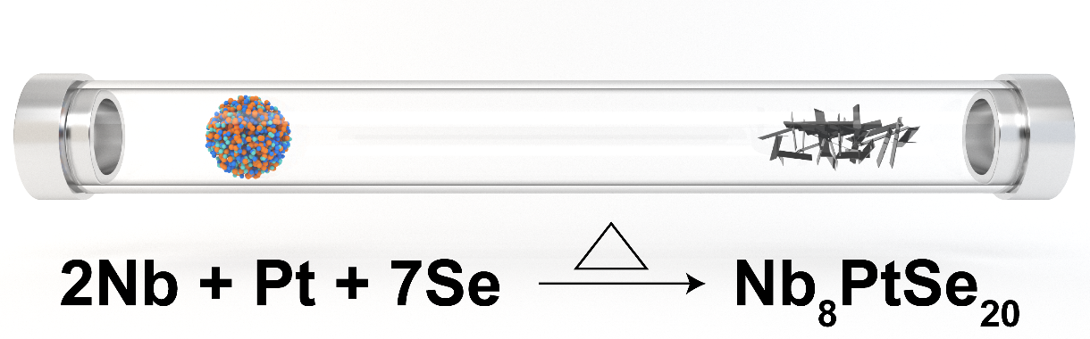
Supplementary Fig. 1 | Synthesized processes of Nb₈PtSe₂₀.
High-quality Nb₈PtSe₂₀ single crystals were synthesized via a high-temperature solid-state reaction, as illustrated in Supplementary Fig. 1. Bright and rod-like crystals were extracted from the quartz tube, as shown in Supplementary Fig. 2.

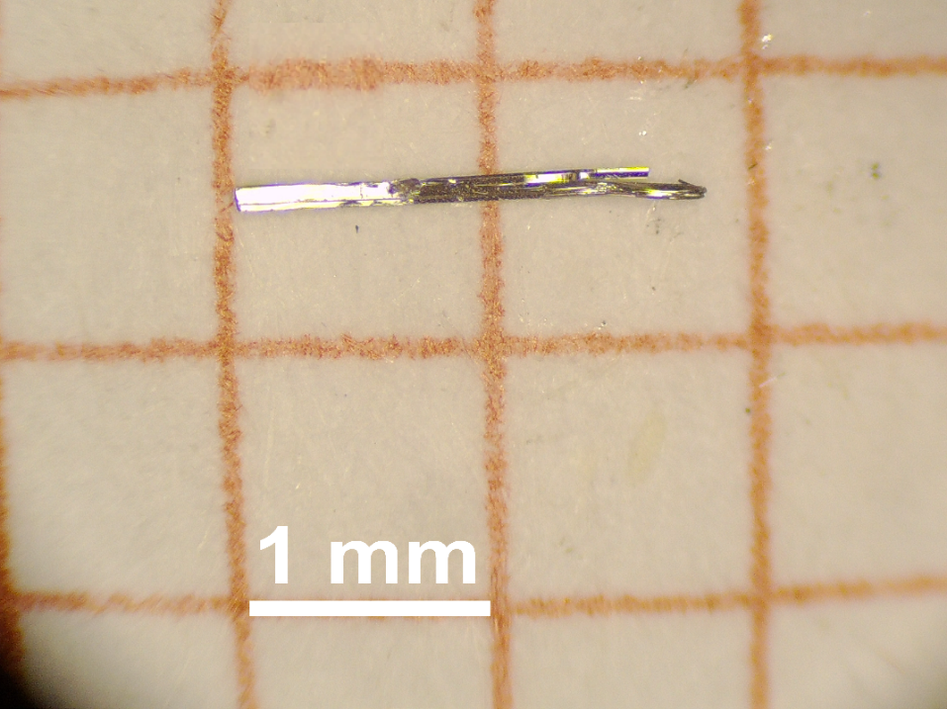
Supplementary Fig. 2 | Optical image of Nb₈PtSe₂₀ crystal.
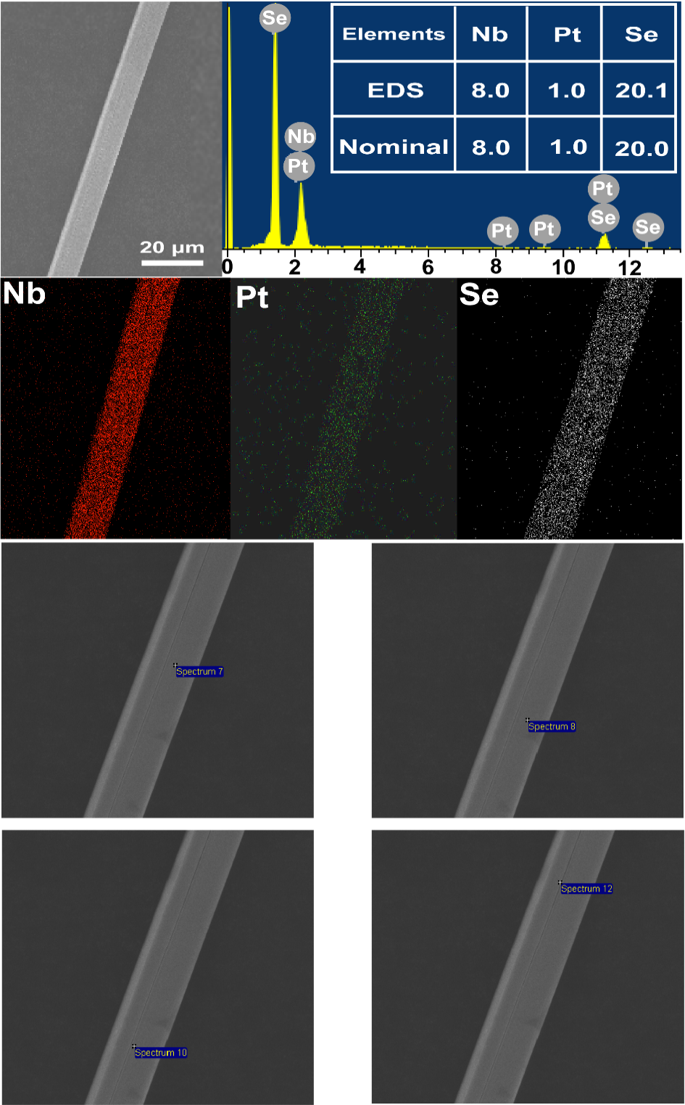
Supplementary Fig. 3 | SEM&EDS characterization of Nb₈PtSe₂₀. Scanning electron microscopy (SEM) image and energy dispersive X-ray spectroscopy (EDS) result, and corresponding element mappings for Nb₈PtSe₂₀ single crystal.
Using semi-quantitative energy-dispersive spectroscopy (EDS) analysis, we measured four locations on the SEM sample surface and obtained elemental ratios of Nb, Pt, and Se as 8.0:1.0:20.1, which closely match the theoretical stoichiometry of Nb₈PtSe₂₀. Additionally, EDS mapping analysis was performed on the material region.

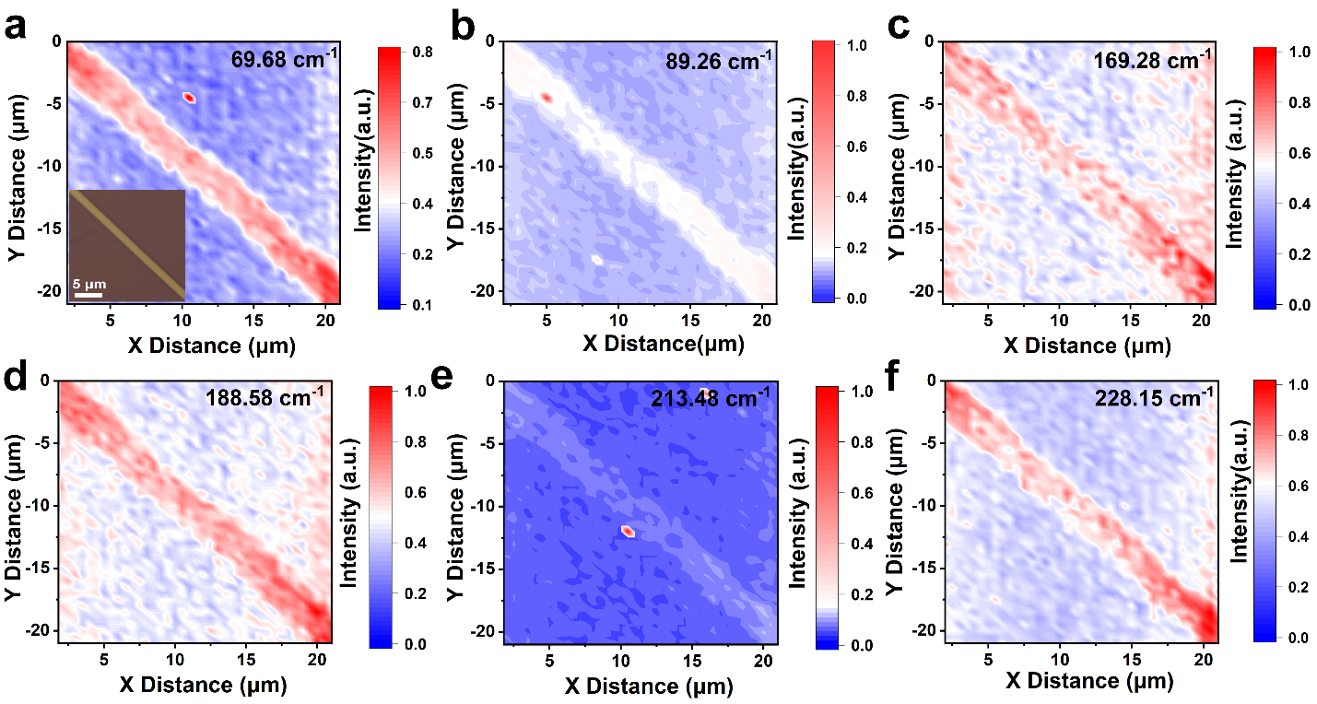
Supplementary Fig. 4 | Raman mapping results at different Raman peaks. Raman intensity color contour maps at characteristic peaks of a) 69.68 cm⁻¹, b) 89.26 cm⁻¹, c) 169.28 cm⁻¹, d) 188.58 cm⁻¹, e) 213.48 cm⁻¹, and f) 228.15 cm⁻¹.
In the Raman color contour maps obtained for the six characteristic peaks, the boundary between the nanosheets and the silicon substrate is clearly discernible. Moreover, the intensity of the Raman characteristic peaks in the nanoflake region shows minimal variation, indicating uniformity across the sample.

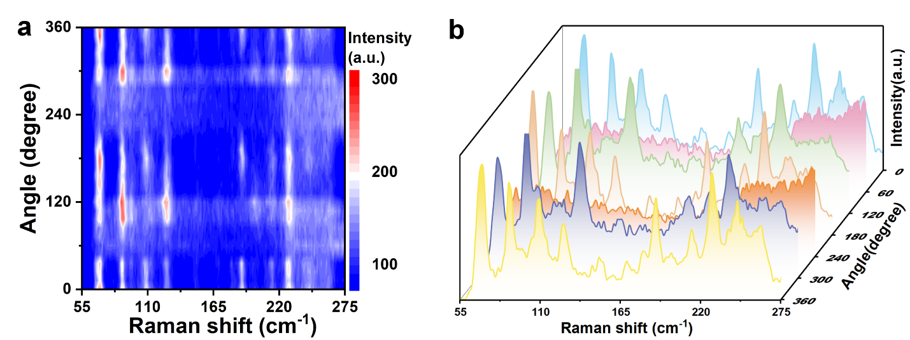
Supplementary Fig. 5 | Angular-resolved polarized Raman spectroscopy planar and 3D plots. a) False-color plot of the polarized Raman spectroscopy of spectroscopy, where the color reflects the intensity of the Raman peaks. b) Three-dimensional spatial distribution of polarization angle-dependent Raman intensity.
Supplementary Fig. 5a shows the contour plot of Raman scattering intensity variation with changes in the angle of incident polarized light, revealing the angular dependence of the Raman modes. Additionally, the three-dimensional plot presented in Supplementary Fig. 5b visually illustrates the spatial distribution pattern of Raman intensity as a function of the polarization angle.
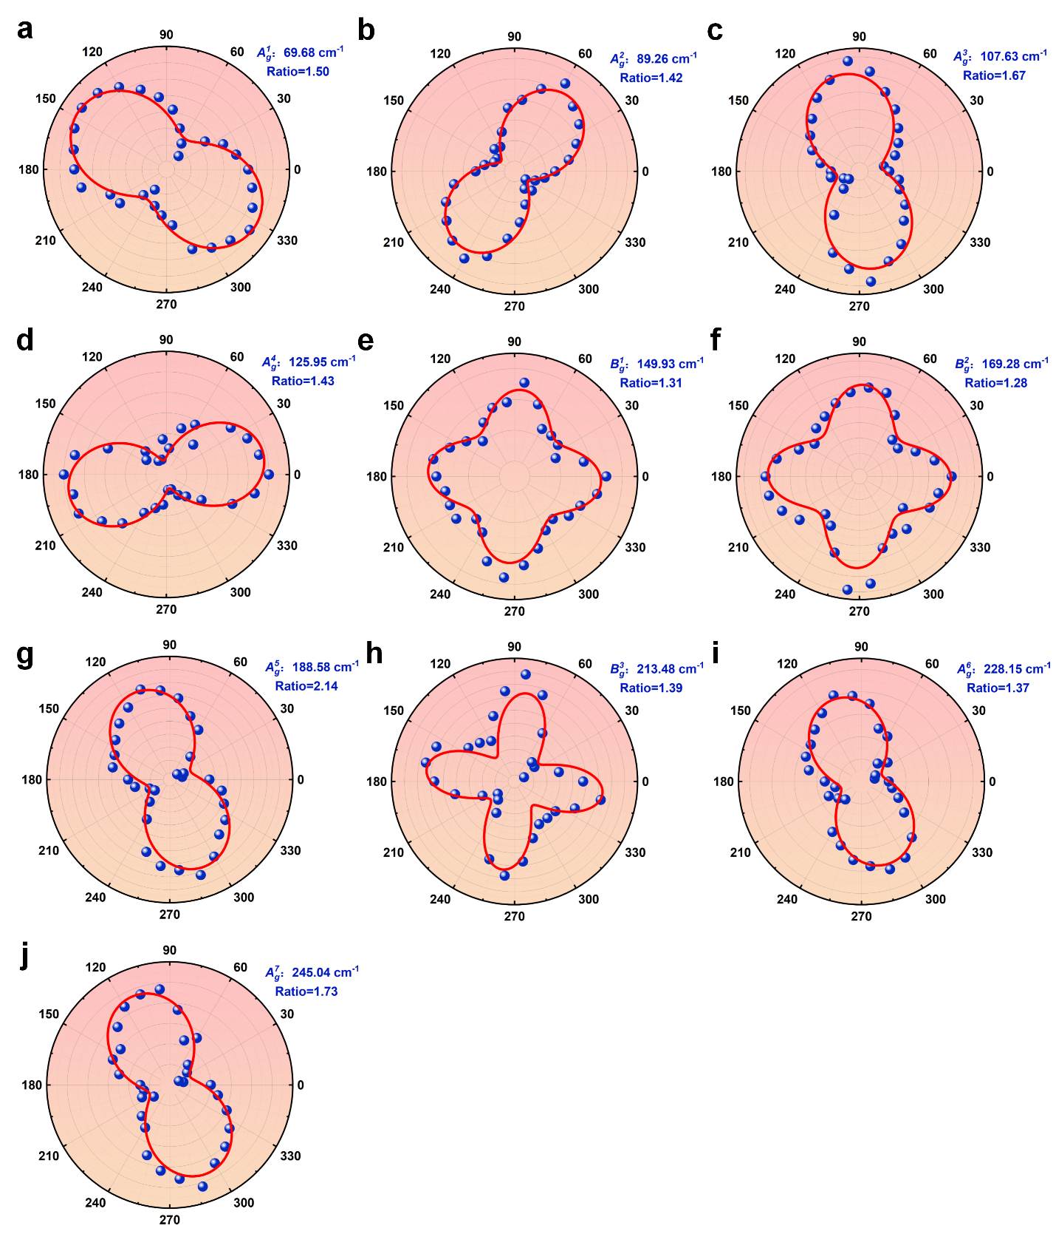
Supplementary Fig. 6 | Polar coordinate plots of angle-resolved polarized Raman spectroscopy. a-j) Polar plots of Raman peak intensity with polarization angle at $A_{g}^{1}$, $A_{g}^{2}$, $A_{g}^{3}$, $A_{g}^{4}$，$B_{g}^{1}$, $B_{g}^{2}$, $A_{g}^{5}$, $B_{g}^{3}$, $A_{g}^{6}$, $A_{g}^{7}$ respectively.
To quantitatively analyze the anisotropic Raman intensity, the Raman tensor fitting method was employed to process the polarized Raman intensities. The intensity of Raman signals can be expressed as $I ∝{\left|e_{i}∙R∙e_{s}\right|}^{2}$, where e_{i} and e_{s} represent the unit polarization vectors of the incident and scattered light¹, respectively, and R is the 3 × 3 Raman tensor for the Raman vibrational modes. When θ is defined as the angle of incident polarization relative to x-axis of Nb₈PtSe₂₀, the incident light polarization vector is expressed as $e_{i}=\left(\cos{θ},sin{θ},0\right)$, whereas the scattered light polarization vector is written as $e_{s}=\left(\cos{θ},sin{θ},0\right)Τ$. For the space group C2/m and the point group $C_{2h}$, the Raman tensors of $A_{g}$ and $B_{g}$ modes can be expressed as follows:
$R(A_{g})=\left[\begin{matrix}a & 0 & d \\ 0 & b & 0 \\ d & 0 & c\end{matrix}\right]R(B_{g})=\left[\begin{matrix}0 & e & 0 \\ e & 0 & f \\ 0 & f & 0\end{matrix}\right]$ $\left(1\right)$
where a, b, c, d, e, and f are tensor elements determined by the Raman scattering cross-section. The angle-dependent Raman intensities for the $A_{g}$ and $B_{g}$ modes can be derived as follows:
$I^{∥}\left(A_{g}\right)∝{\left|a\cos^{2}θ+b \sin^{2}θ\right|}^{2}$ $\left(2\right)$
$I^{∥}\left(B_{g}\right)∝{\left|e\sin\left(2θ\right)\right|}^{2}$ $\left(3\right)$
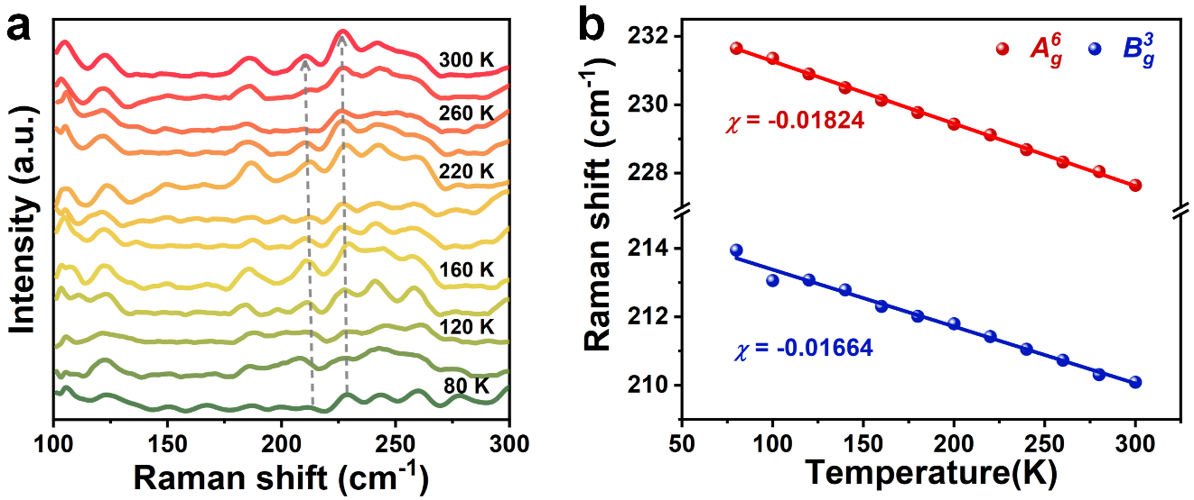
Supplementary Fig. 7 | Temperature-dependent Raman spectrum of Nb₈PtSe₂₀. a) Temperature-dependent Raman spectroscopy of Nb₈PtSe₂₀ from 80 to 300 K. b) Temperature dependence of Raman shifts of $A_{g}^{6}$ and $B_{g}^{3}$.
To further investigate the interlayer interactions and thermal expansion behavior of Nb₈PtSe₂₀, temperature-dependent Raman spectroscopy (TDRS) measurements were conducted on the Nb₈PtSe₂₀ nanoflakes. The relationship between the Raman peak positions and temperature can be fitted using the Gr$\ddot{u}$neisen equation²:
$ω\left(T\right)=ω_{0}+χ∙T$ $\left(4\right)$
where ω₀ represents the Raman peak frequency at 0 K, χ denotes the first-order temperature coefficient, and T is temperature, respectively.

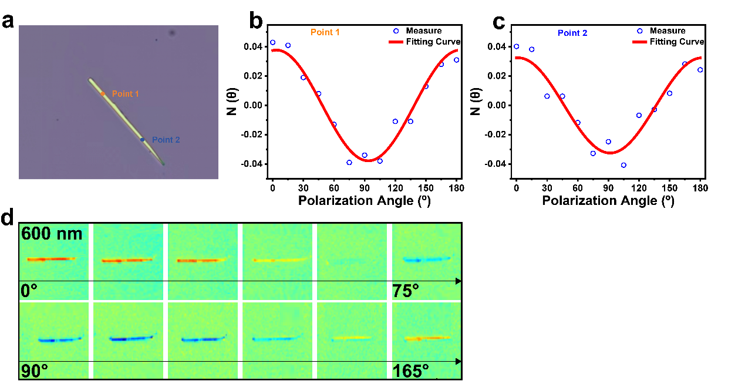
Supplementary Fig. 8 | ADRDM characterization of Nb₈PtSe₂₀. ADRDM results of Nb₈PtSe₂₀ nanoflakes. a) Optical image of Nb₈PtSe₂₀ nanoflakes. Point 1 and point 2 refer to the testing positions. b) ADRDM results for point 1. c) ADRDM results for point 2. d) ADRDM mapping measurement.
To investigate the in-plane optical anisotropy of Nb₈PtSe₂₀, we employed angle-resolved differential reflectance microscopy (ADRDM). Under normal incidence of polarized light, anisotropic materials exhibit polarization-angle-dependent reflectance along the x- and y-axes. The normalized reflectance difference Δr along the x- and y-axes is defined as:
$\frac{Δr}{r}=2\frac{r_{x}-r_{y}}{r_{x}+r_{y}}=2N$ $\left(5\right)$
where r_{x} and r_{y} represent the reflectance along the x- and y-axes, respectively, while N is related to the reflectance intensity of the incident polarized light (with a wavelength of 600 nm in the experiment) at a specific angle θ. N is determined by the following equation:
$N\left(θ\right)=\frac{r_{x-r_{y}}}{r_{x}+r_{y}}\cos\left(2θ\right)$ $\left(6\right)$
The initial polarization direction is defined as 0°, corresponding to the y-axis in the horizontal plane.
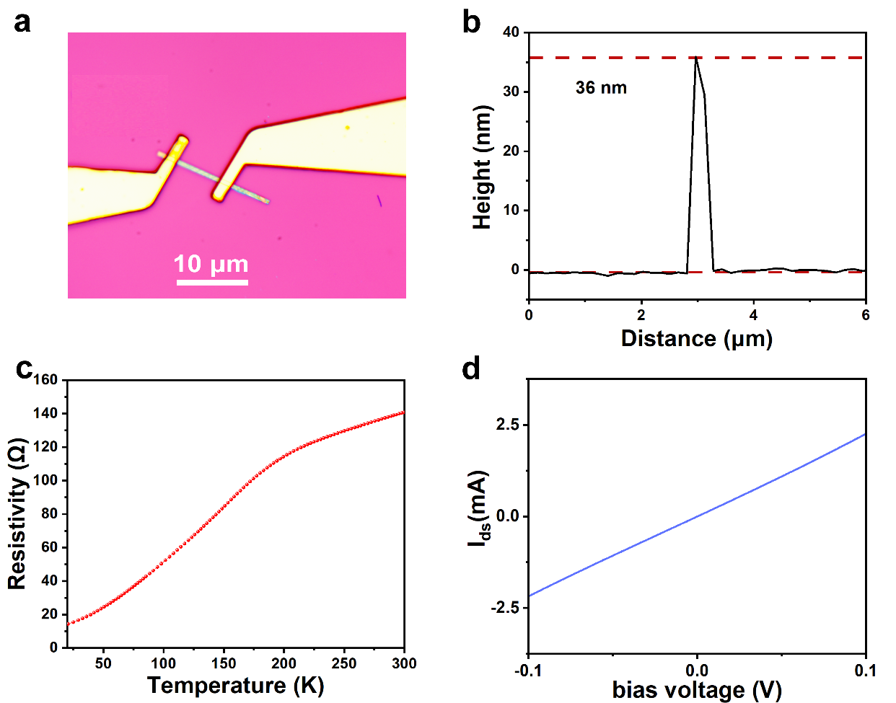
Supplementary Fig. 9 | Electrical performance characteristics of Nb₈PtSe₂₀ nanoflake-based device. a) The optical image of Nb₈PtSe₂₀ device. b) The thickness of Nb₈PtSe₂₀ nanoflake. c) Temperature-dependent resistance of the Nb₈PtSe₂₀ device. d) The $I_{ds}-V_{ds}$ curves of the device.
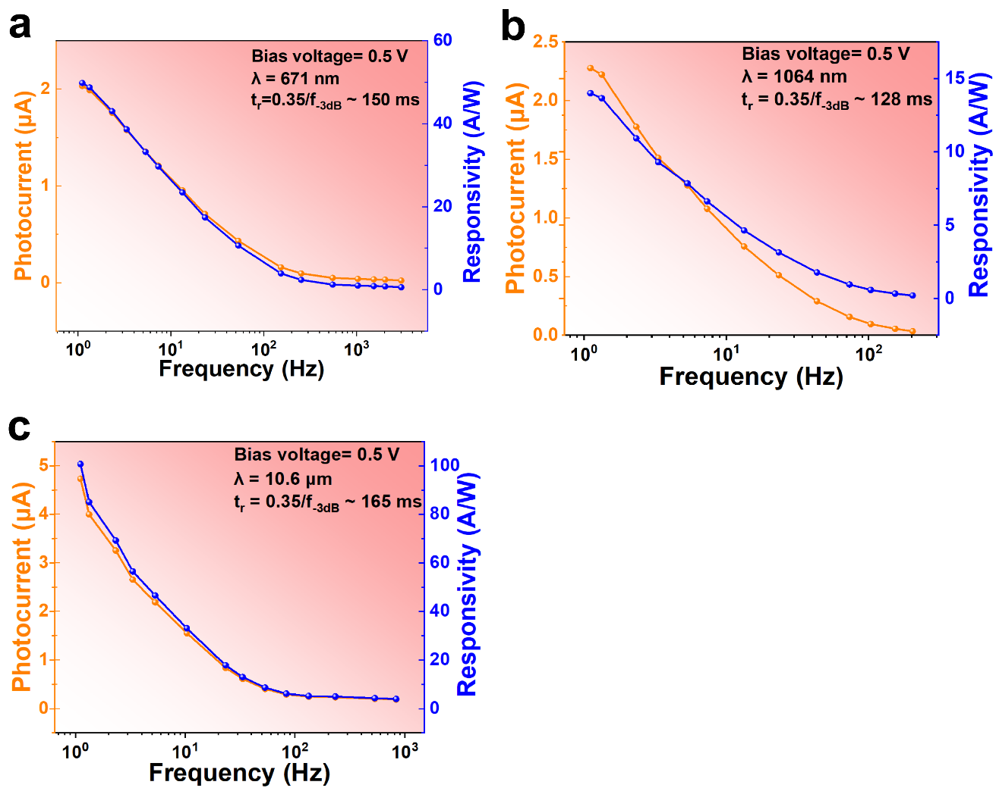
Supplementary Fig. 10 | The response time and responsivity of the device from visible to mid-infrared. a-c) The photocurrent and responsivity of the device as a function of laser frequency under illumination at 671 nm, 1064 nm, and 10.6 μm at bias voltage of + 0.5 V respectively.
The response time ($τ_{rise}=\frac{0.35}{f_{-3 dB}}$) of our devices is estimated from the -3 dB bandwidth—the frequency at which the responsivity drops to 0.707 of its maximum value.
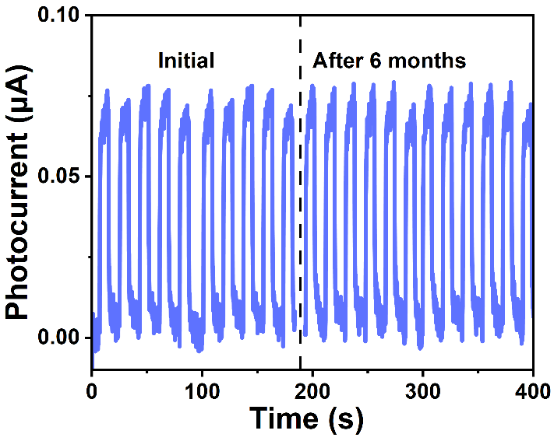
Supplementary Fig. 11 | Long-term stability and reliability test of the Nb₈PtSe₂₀ photodetector.
We used the scanning photocurrent microscopy (SPCM) method to explore the photoelectric response mechanism of Nb₈PtSe₂₀ devices.
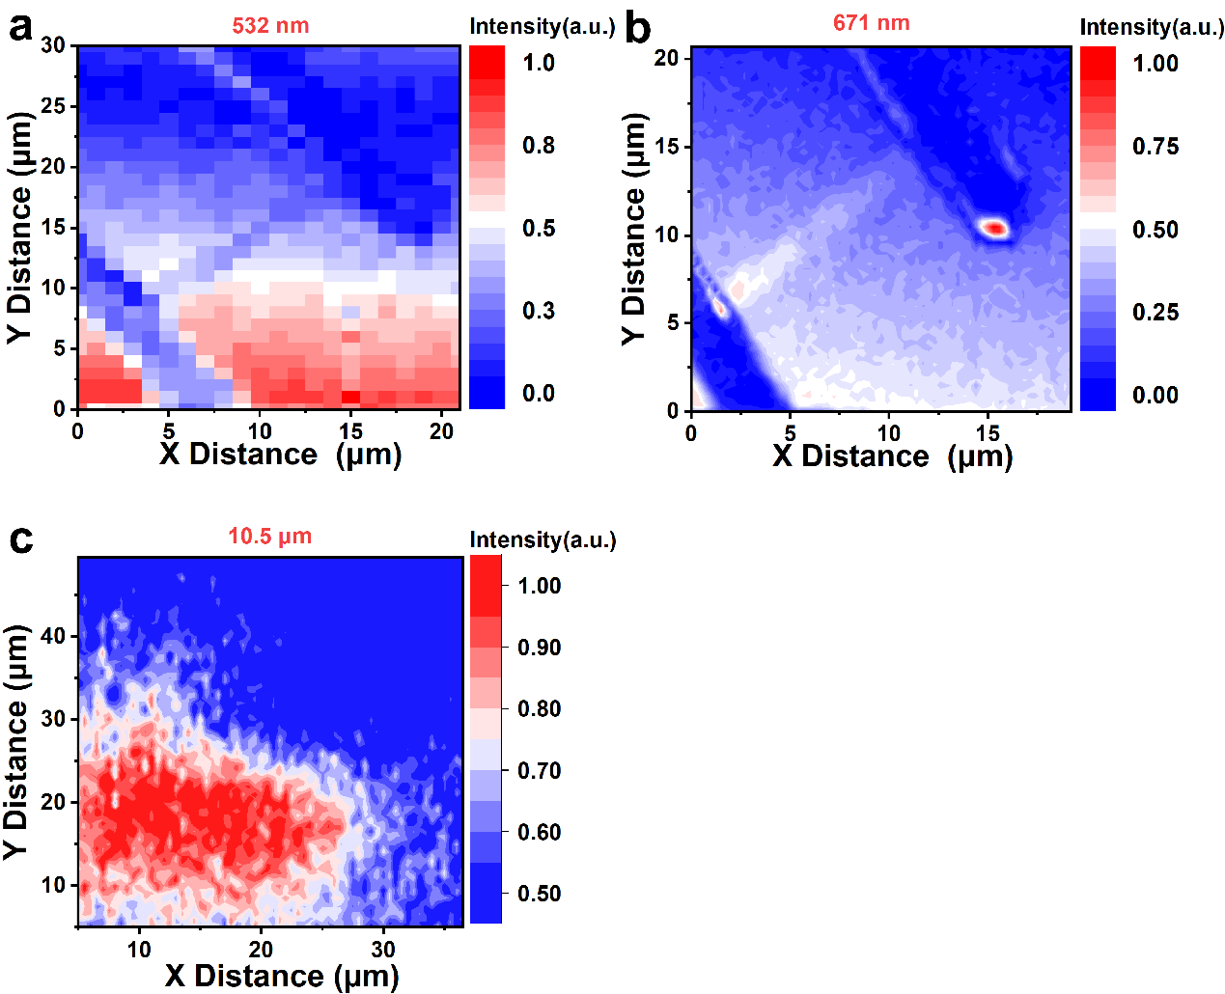
Supplementary Fig. 12 |SPCM at different wavelengths under zero bias voltage. a-c) SPCM images of Nb₈PtSe₂₀ device obtained at zero bias conditions under the laser illumination of 532 nm, 671 nm, and 10.5 μm, respectively.
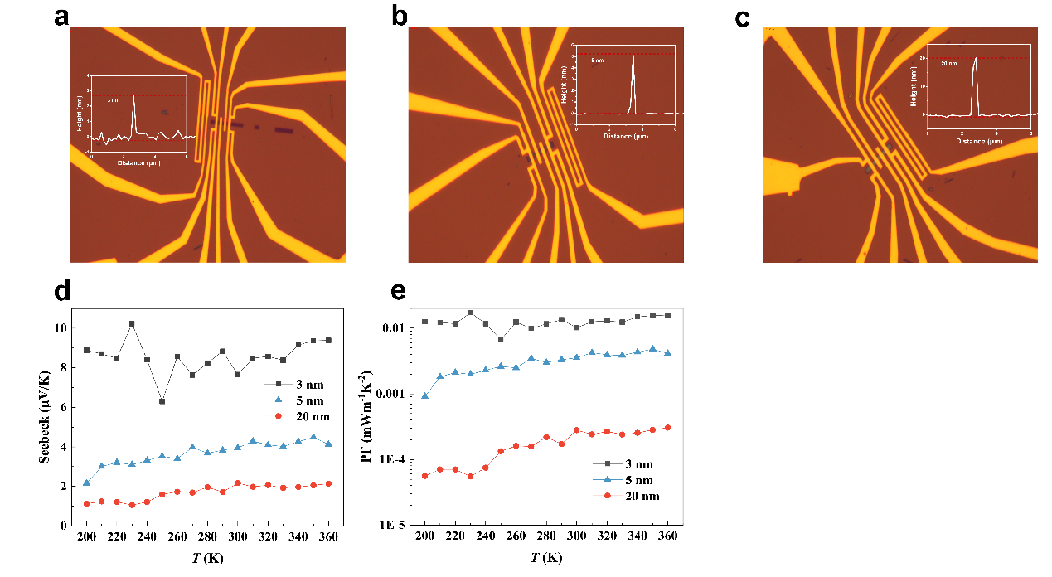
Supplementary Fig. 13 | Thermoelectricity performance for Nb₈PtSe₂₀ nanoflake-based device. a-c) Optical images of Nb₈PtSe₂₀ nanoflakes with different thicknesses. The inset is the corresponding height profiles. d) Temperature-dependent Seebeck coefficient of Nb₈PtSe₂₀ nanoflakes with thicknesses of 3 nm, 5 nm, and 20 nm. e) Temperature-dependent power factor of Nb₈PtSe₂₀ nanoflakes with thicknesses of 3 nm, 5 nm, and 20 nm.

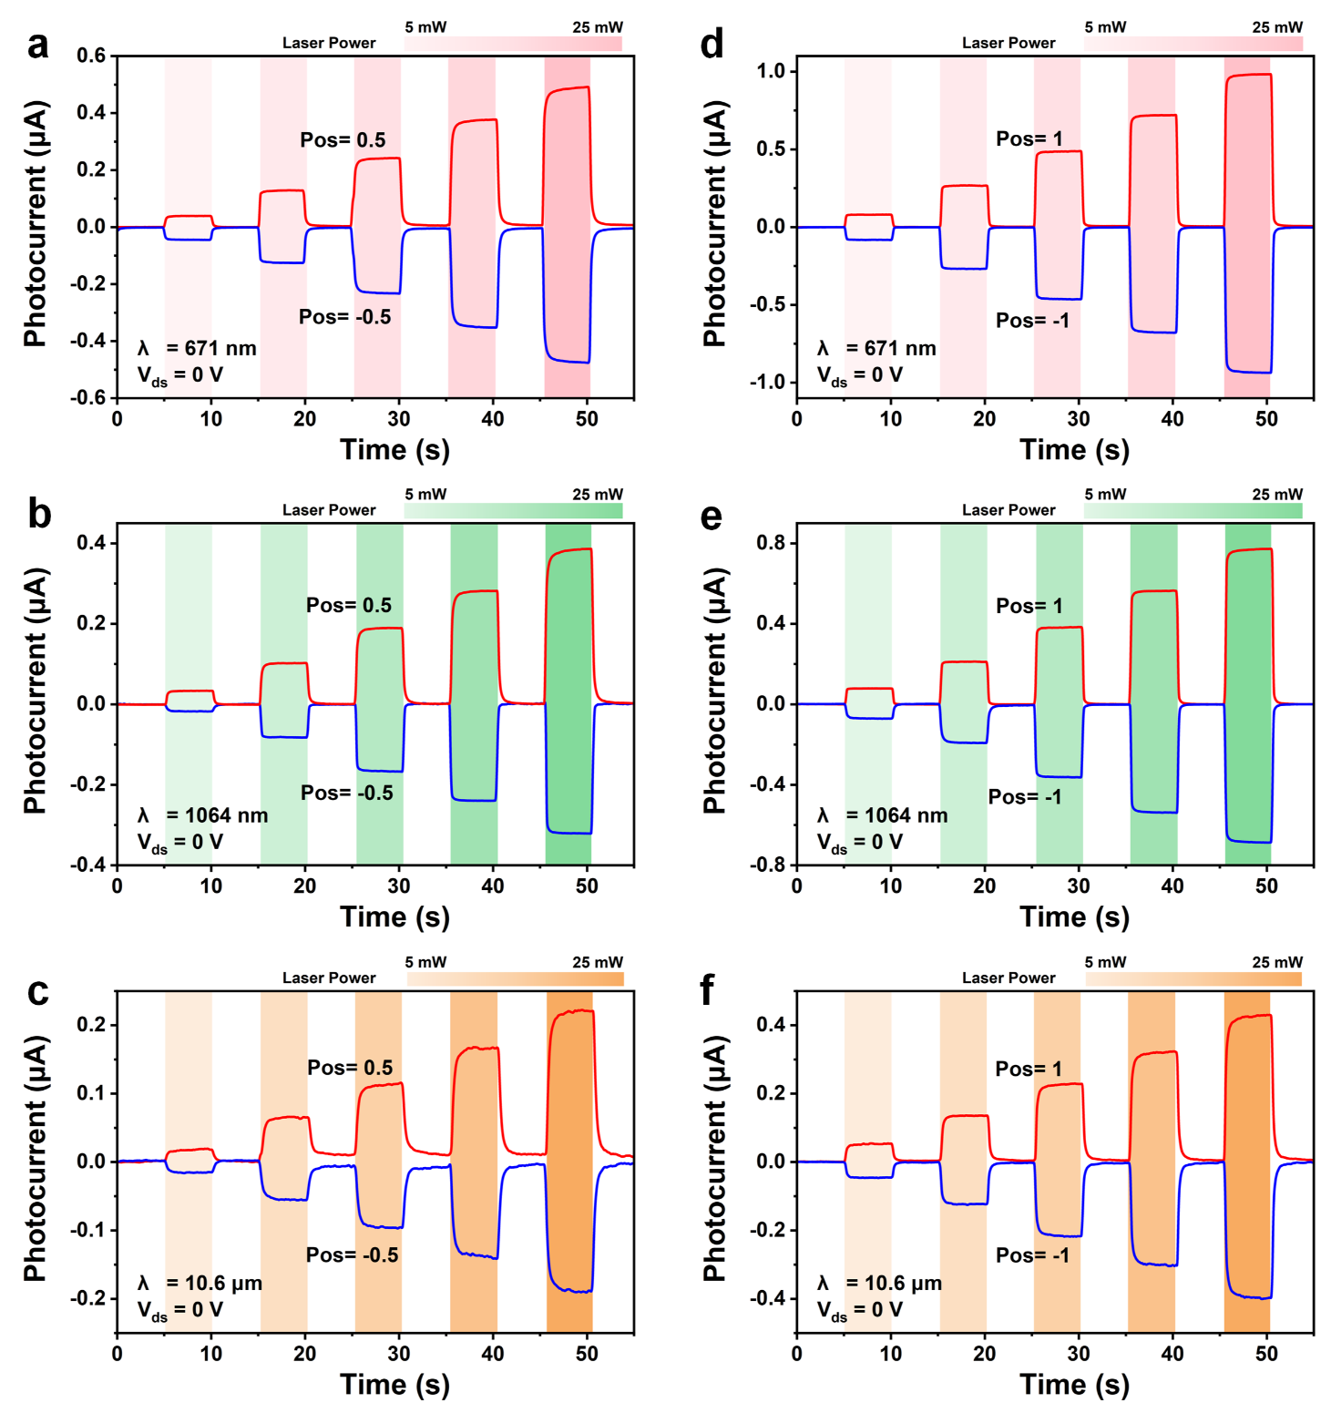
Supplementary Fig. 14 | Linearly tunable bidirectional photoresponse of Nb₈PtSe₂₀. a-c) The light power-dependent broad-spectrum response characteristics of Nb₈PtSe₂₀ nanoflakes at laser positions of 0.5 and -0.5 for 671 nm, 1064 nm and 10.6 μm, respectively. d-f) The light power-dependent broad-spectrum response characteristics of Nb₈PtSe₂₀ nanoflakes at laser positions of 1 and -1 for 671 nm, 1064 nm and 10.6 μm, respectively.
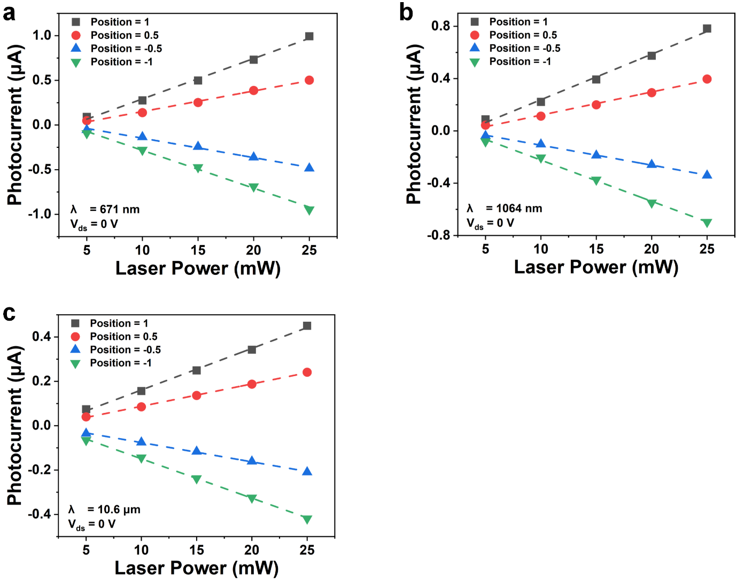
Supplementary Fig. 15 | The light power-dependent broad-spectrum response characteristics of Nb₈PtSe₂₀ nanoflakes at laser positions of -1,-0.5, 0.5 and 1. a) light power-dependent photocurrent response of Nb₈PtSe₂₀ nanoflakes at a wavelength of 671 nm, b) light power-dependent photocurrent response of Nb₈PtSe₂₀ nanoflakes at a wavelength of 1064 nm, c) light power-dependent photocurrent response of Nb₈PtSe₂₀ nanoflakes at a wavelength of 10.6 μm.

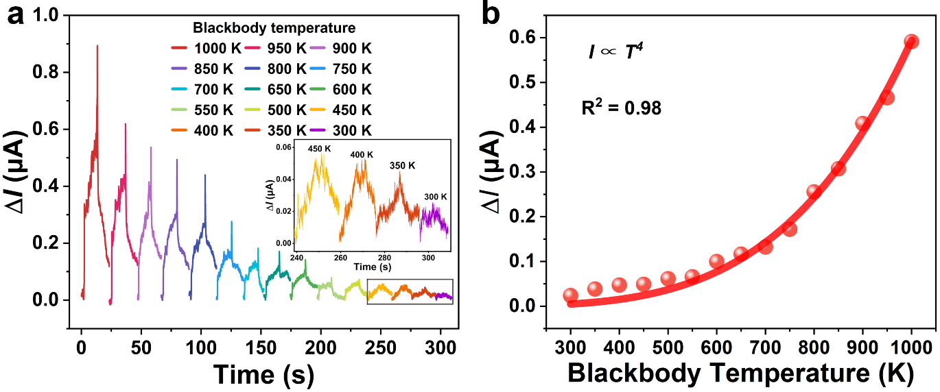
Supplementary Fig. 16 | Blackbody radiation characterization of the Nb₈PtSe₂₀ photodetector. a) Photocurrent responses of the Nb₈PtSe₂₀ photodetector at different blackbody temperatures. The inset shows the photocurrent responses at blackbody temperatures of 300–450 K, demonstrating the detectability of weak thermal radiation signals. b)Thermal radiation current response as a function of blackbody temperature.

Supplementary Note 1: Thermal imaging simulation at 671 nm and 1064 nm.
To quantitatively demonstrate the passive thermal imaging characteristics in the visible and SWIR bands shown in Fig. 3a, b, we established a thermal radiation transfer model based on Planck’s law. The thermal radiation signal received by the detector from a target at temperature T at wavelength λ can be expressed as:
$$\begin{aligned}P_{thermal}\left(λ,T\right)= ε\left(λ\right)B\left(λ,T\right)+N_{detector}\#\left(7\right)\end{aligned}$$
where ε(λ) is the emissivity of the object, B(λ,T) is the Planck blackbody spectral radiance, and N_{detector} is the detector noise. According to Wien’s displacement law, the peak thermal radiation wavelength (λ_{peak}) at human body temperature (T = 310 K) is approximately 9.35 μm. Both 671 nm and 1064 nm are significantly lower than this peak value, and their corresponding spectral radiances B(0.671 μm, 310 K) and B(1.064 μm, 310 K) are only 7.99×10⁻²² and 9.96×10⁻¹² W·m⁻²·sr⁻¹·μm⁻¹, respectively, which are effectively zero in practical terms. Consequently, the detected signal consists solely of detector noise, which is visualized through Gaussian noise simulation with different coefficients. The results demonstrate that the resulting images contain no discernible thermal features of the target, confirming that passive thermal imaging at these two wavelengths is physically infeasible at ambient temperature.

Supplementary Note 2: Reflective imaging simulation at 10.6 μm.
Similarly, to demonstrate the reflective imaging characteristics in the LWIR band shown in Fig. 3c, we established a reflective radiation transfer model based on Kirchhoff’s law. In reflective imaging mode, the signal received by the detector consists primarily of the reflected component from the target surface and detector noise:：
$$\begin{aligned}P_{reflection}\left(λ\right)= ρ\left(λ\right)P_{incident}\left(λ\right)+N_{detector}\#\left(8\right)\end{aligned}$$
where ρ(λ) is the surface reflectivity of the object, and P_{incident}(λ) is the reflected component from external illumination or ambient radiation. According to Kirchhoff’s law of thermal radiation, for an opaque object, ρ(λ) = 1 − ε(λ). In the LWIR band, the emissivity of human skin is approximately ε = 0.98³, yielding a reflectivity of approximately 0.02. To simulate reflective imaging in this band, we use an LWIR thermal image I_{original}(x,y) as a reference representing the spatial distribution of incident radiation. The reflected signal is calculated as:
$\begin{aligned}I_{\text{reflection}}\left(x,y\right)=ρ⋅I_{\text{original}}\left(x,y\right)+N_{detector}\#\left(9\right)\end{aligned}$The resulting image signal intensity is compressed to approximately 2% of the original thermal image, retaining only a blurred pedestrian contour with extremely low contrast (Fig. 3c, left). These results collectively highlight the irreplaceable role of LWIR passive thermal radiation imaging for all-weather, illumination-free sensing.

Supplementary Note 3: Infrared thermal image reconstruction based on the experimentally measured blackbody radiation response of the Nb₈PtSe₂₀ photodetector.
Blackbody detection serves as a practical benchmark for evaluating the infrared sensing performance of photodetectors. Here, the actual blackbody radiation power P incident on the device is determined by the blackbody temperature T, background temperature T₀, aperture radius of the blackbody radiation source r, distance between the aperture and detector d, detector active area A, and blackbody radiance E_{r}. According to the Stefan–Boltzmann law⁴：
$$\begin{aligned}E_{r}=\frac{2π^{5}k_{B}^{4}}{15h^{3}c^{2}}⋅\left(T^{4}-T_{0}^{4}\right)\#\left(10\right)\end{aligned}$$
where c is the speed of light, h is Planck’s constant, and k_{B} is the Boltzmann constant. Here, T₀ = 296 K, d = 5 cm, r = 20 mm, and A = 18 μm². Thus, P can be calculated by:
$$\begin{aligned}P=\frac{E_{r}∙r^{2}∙A}{d^{2}}\#\left(11\right)\end{aligned}$$
From the above two equations, we obtain P ∝ T⁴. Combined with the fitted I ∝ T⁴ relationship in Supplementary Fig. S16b, we can deduce that the device thermal radiation photocurrent exhibits a linear relationship with the incident blackbody radiation power (I ∝ P).
Based on the experimentally validated blackbody radiation response characteristics, we further reconstructed the infrared thermal radiation intensity distribution acquired by the Nb₈PtSe₂₀ device under low-visibility conditions based on a physics-driven mapping model from temperature to radiation power, photocurrent, and pixel value. The specific procedure is as follows. First, the pixel values of the original infrared image are linearly mapped onto the scene temperature range, which can be expressed as:
$$\begin{aligned}T=T_{min}+\frac{\text{pixel}}{255}×\left(T_{max}-T_{min}\right)\#\left(12\right)\end{aligned}$$
where T_{min} and T_{max} denote the minimum and maximum temperatures in the scene, respectively. Subsequently, the absolute temperature T of each pixel in the scene is converted to the spatial infrared radiation power P reaching the device surface. This process can be expressed as:
$$\begin{aligned}P=κ\left(T^{4} − T_{\text{0}}^{4}\right)\#\left(13\right)\end{aligned}$$
where the coefficient κ = 1.633×10⁻¹⁹ W·K⁻⁴ is determined by the Stefan–Boltzmann constant, the effective receiving area of the device, the blackbody source aperture radius, and the detection distance. This T⁴ nonlinear relationship forms the physical basis for pixel value redistribution throughout the reconstruction process.
Furthermore, based on the linear relationship I ∝ P, the radiation power of each pixel is converted to the photocurrent response of the Nb₈PtSe₂₀ device, yielding a spatial distribution map of photocurrent (I). Finally, the photocurrent matrix is mapped back to the 0–255 grayscale space:
$$\begin{aligned}\text{pixel}=\frac{I-I(T_{min})}{I(T_{max})-I(T_{min})}×255\#\left(14\right)\end{aligned}$$
This simulation procedure strictly preserves the dynamic response range of the original scene while incorporating the intrinsic photoelectric conversion characteristics of the device and the T⁴ thermal radiation nonlinearity.

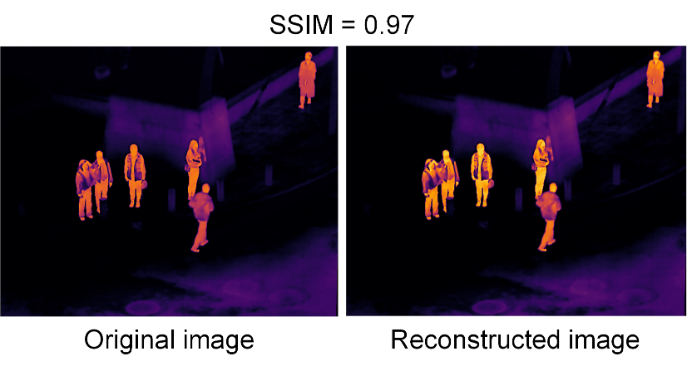
Supplementary Fig. 17 | The SSIM between original and reconstructed images.
The SSIM between the reconstructed image and the original infrared image is 0.97, indicating that the luminance, contrast, and structural information of the image are highly preserved after simulation through the above-mentioned physics-based mapping model.

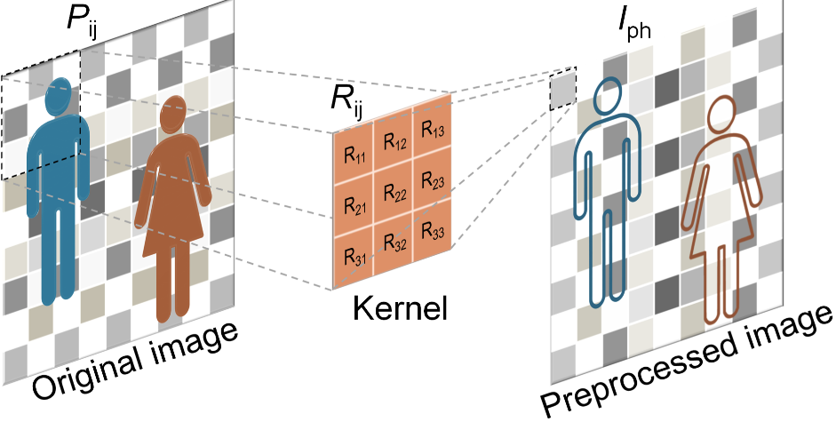
Supplementary Fig. 18 | The schematic of the in-sensor image processing procedure.

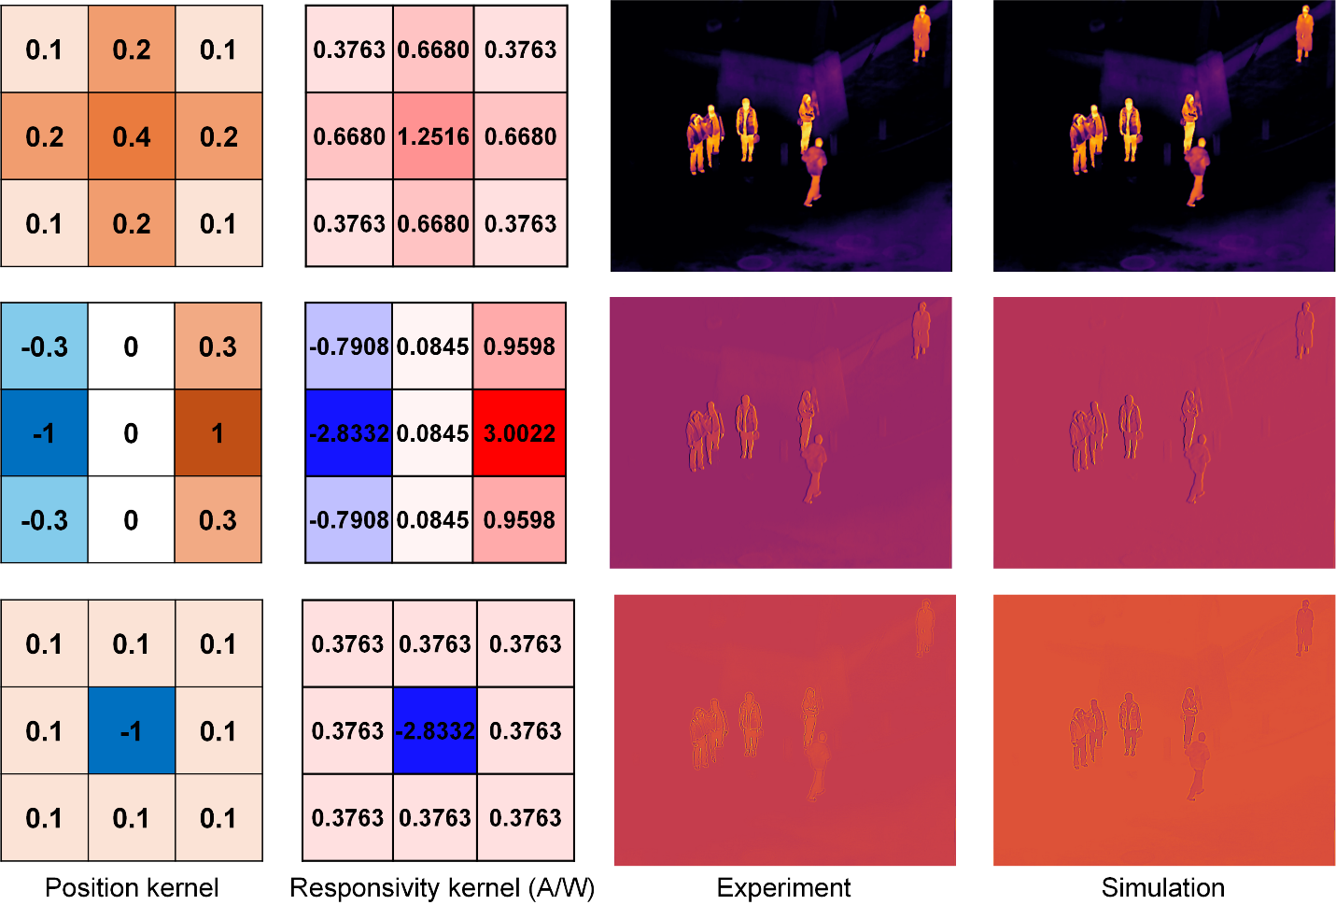
Supplementary Fig. 19 | Experimental and simulated results of in-sensor image processing based on a single Nb₈PtSe₂₀ device. The reconstructed thermal images undergo denoising, edge detection, and sharpening processing (top to bottom).
Supplementary Fig. 20 | Position-dependent photocurrent of the 3×3 Nb₈PtSe₂₀ array at zero bias under 671 nm and 10.6 μm illuminations.
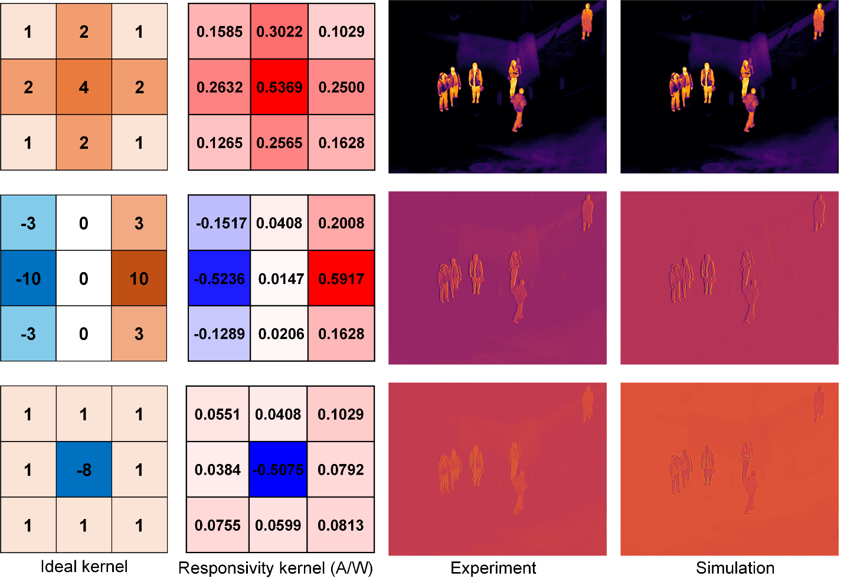
Supplementary Fig. 21 | Experimental and simulated results of in-sensor image processing based on a Nb₈PtSe₂₀ 3×3 array. The reconstructed thermal images undergo denoising, edge detection, and sharpening processing (top to bottom).

Supplementary Note 4: Multimodal in-sensor convolutional vision transformer network architecture and training configuration.
The multimodal in-sensor convolutional Vision Transformer (ViT) detection network was designed to leverage the broadband photoresponse of Nb₈PtSe₂₀ sensor arrays for all-weather UAV-based small-object detection. The architecture integrates a dual-stream backbone with Transformer-based cross-modal fusion modules, a feature pyramid neck for multi-scale feature aggregation, and a dense prediction head for object localization and classification.
The backbone employs a parallel dual-stream architecture to independently process visible (RGB) and thermal infrared (IR) modalities, preserving modality-specific features while enabling subsequent cross-modal interaction. Each stream begins with a StemConv module that performs initial feature extraction and spatial downsampling, followed by Space-to-Depth Convolution (SPDConv) layers that progressively reduce spatial resolution while expanding channel dimensions to capture hierarchical semantic information. The RGB stream processes visible-light texture and color information, whereas the IR stream extracts thermal contours and temperature gradients that remain invariant under low-visibility conditions. This dual-stream design ensures that complementary information from visible and thermal modalities is preserved throughout the feature extraction process, providing a robust foundation for subsequent cross-modal fusion.
To bridge the semantic gap between visible texture and thermal contours, Generalized Pre-trained Transformer (GPT) modules are strategically inserted at multiple hierarchical levels within the backbone. These Transformer modules employ multi-head self-attention mechanisms to model long-range dependencies and cross-modal correlations between the two feature streams. At each fusion stage, the GPT module receives concatenated features from both the RGB and IR streams, computes cross-attention weights to identify semantically aligned regions across modalities, and generates fused feature representations that integrate complementary information. Following the dual-stream backbone and Transformer fusion modules, the network employs a Feature Pyramid Network (FPN) structure to aggregate multi-scale features and enhance scale adaptability for small-target detection. The detection head adopts a dense prediction architecture with three parallel branches operating at different spatial resolutions, each responsible for predicting bounding box coordinates, objectness scores, and class probabilities. This multi-scale architecture ensures effective localization and classification of small objects in high-resolution UAV imagery.
The network was trained and evaluated on the RGBTDronePerson dataset (https://nnnnerd.github.io/RGBTDronePerson), a multimodal benchmark for nighttime UAV-based tiny pedestrian detection. The dataset contains aligned RGB-thermal image pairs captured under low-visibility conditions, with annotations for three classes: person, rider, and crowd. The model was trained from scratch (no pre-trained weights) using the Stochastic Gradient Descent (SGD) optimizer with an initial learning rate of 0.01, momentum of 0.937, and weight decay of 0.0005. A cosine annealing learning rate scheduler was employed to gradually reduce the learning rate over 100 training epochs. To ensure reproducibility, all experiments were conducted within the PyTorch framework using a fixed random seed.
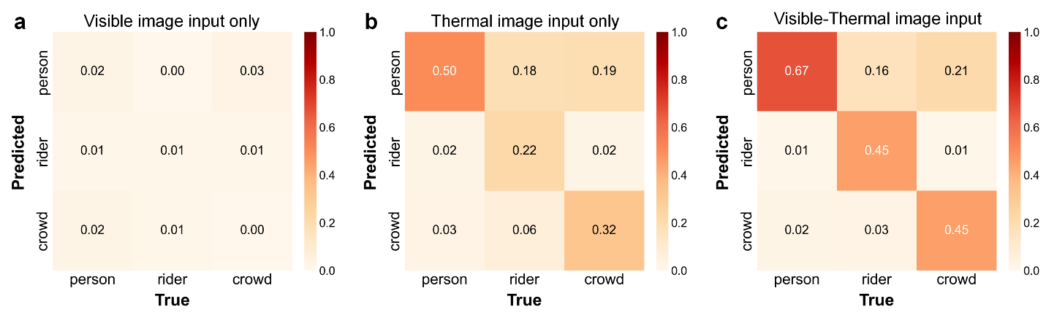
Supplementary Fig. 22 |Confusion matrices of the detection network under different input modalities across three classes on the RGBTDronePerson dataset. a) Visible image input only, b) Thermal image input only, c) Visible-Thermal image input.
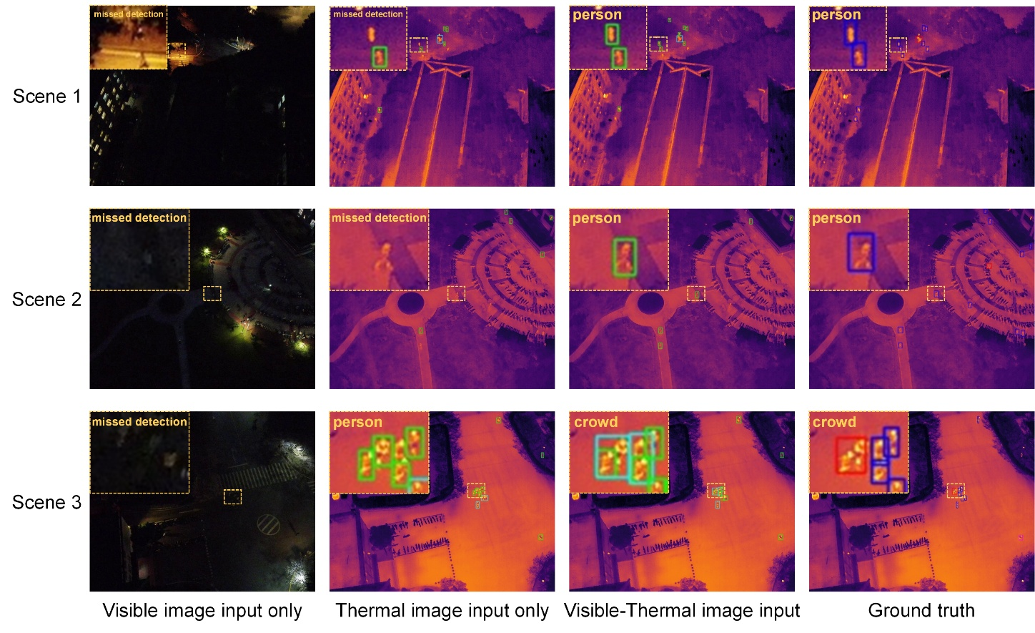
Supplementary Fig. 23 | Visualization results of small-target detection by the multimodal detection network based on Nb₈PtSe₂₀ detectors in various nighttime UAV scenarios. From left to right, the columns correspond to visible image input only, thermal image input only, visible-thermal multimodal input, and the ground truth, respectively. The magnified local regions (yellow dashed boxes) emphasize the differences in detection details for tiny targets (e.g., "person" and "crowd") across different input modalities.
Supplementary Fig. 23 presents the visualized results of tiny pedestrian detection across three complex nighttime UAV scenarios (Scenes 1–3) under different modalities, providing complementary validation for the main text. With visible image input only (first column), targets are completely concealed in darkness due to extremely low illumination and severe background interference. This visual perception failure leads to typical "missed detections" across all scenes. When relying solely on thermal image input (second column), although the thermal radiation profiles of the targets emerge, the lack of crucial spatial textures and geometric edge details significantly limits the detector's ability to distinguish targets against complex backgrounds or in crowded areas. For instance, some "person" instances remain undetected in Scenes 1 and 2. In the high-density Scene 3, relying solely on infrared features hinders accurate category classification, causing the detector to erroneously predict "crowd" instances as "person". In contrast, the visible-thermal multimodal perception capability enabled by the Nb₈PtSe₂₀ detectors (third column) demonstrates significant performance advantages. It not only accurately localizes and detects individual pedestrians ("person") in Scenes 1 and 2, but also correctly identifies dense crowds ("crowd") in Scene 3.
A comparison with the ground truth reveals that the bounding boxes generated by multimodal outputs exhibit high consistency in localization accuracy and classification performance. This further validates the robustness and feasibility of the multimodal detection strategy based on the Nb₈PtSe₂₀ detectors under extreme illumination and complex scenarios.

Supplementary Table 1: Comparison of the six-membered-ring areas of some 2D materials.
Materials | Six-membered-ring areas ($Å^{2}$) | Reference
Graphene | 5.24 | [5]
h-BN | 5.45 | [6]
MoS₂ | 8.59 | [7]
WSe₂ | 9.37 | [8]
NbSe₂ | 10.26 | [9]
Nb₈PtSe₂₀ | 14.96 | This work

Supplementary Table 2: EDS results of four points of Nb₈PtSe₂₀.
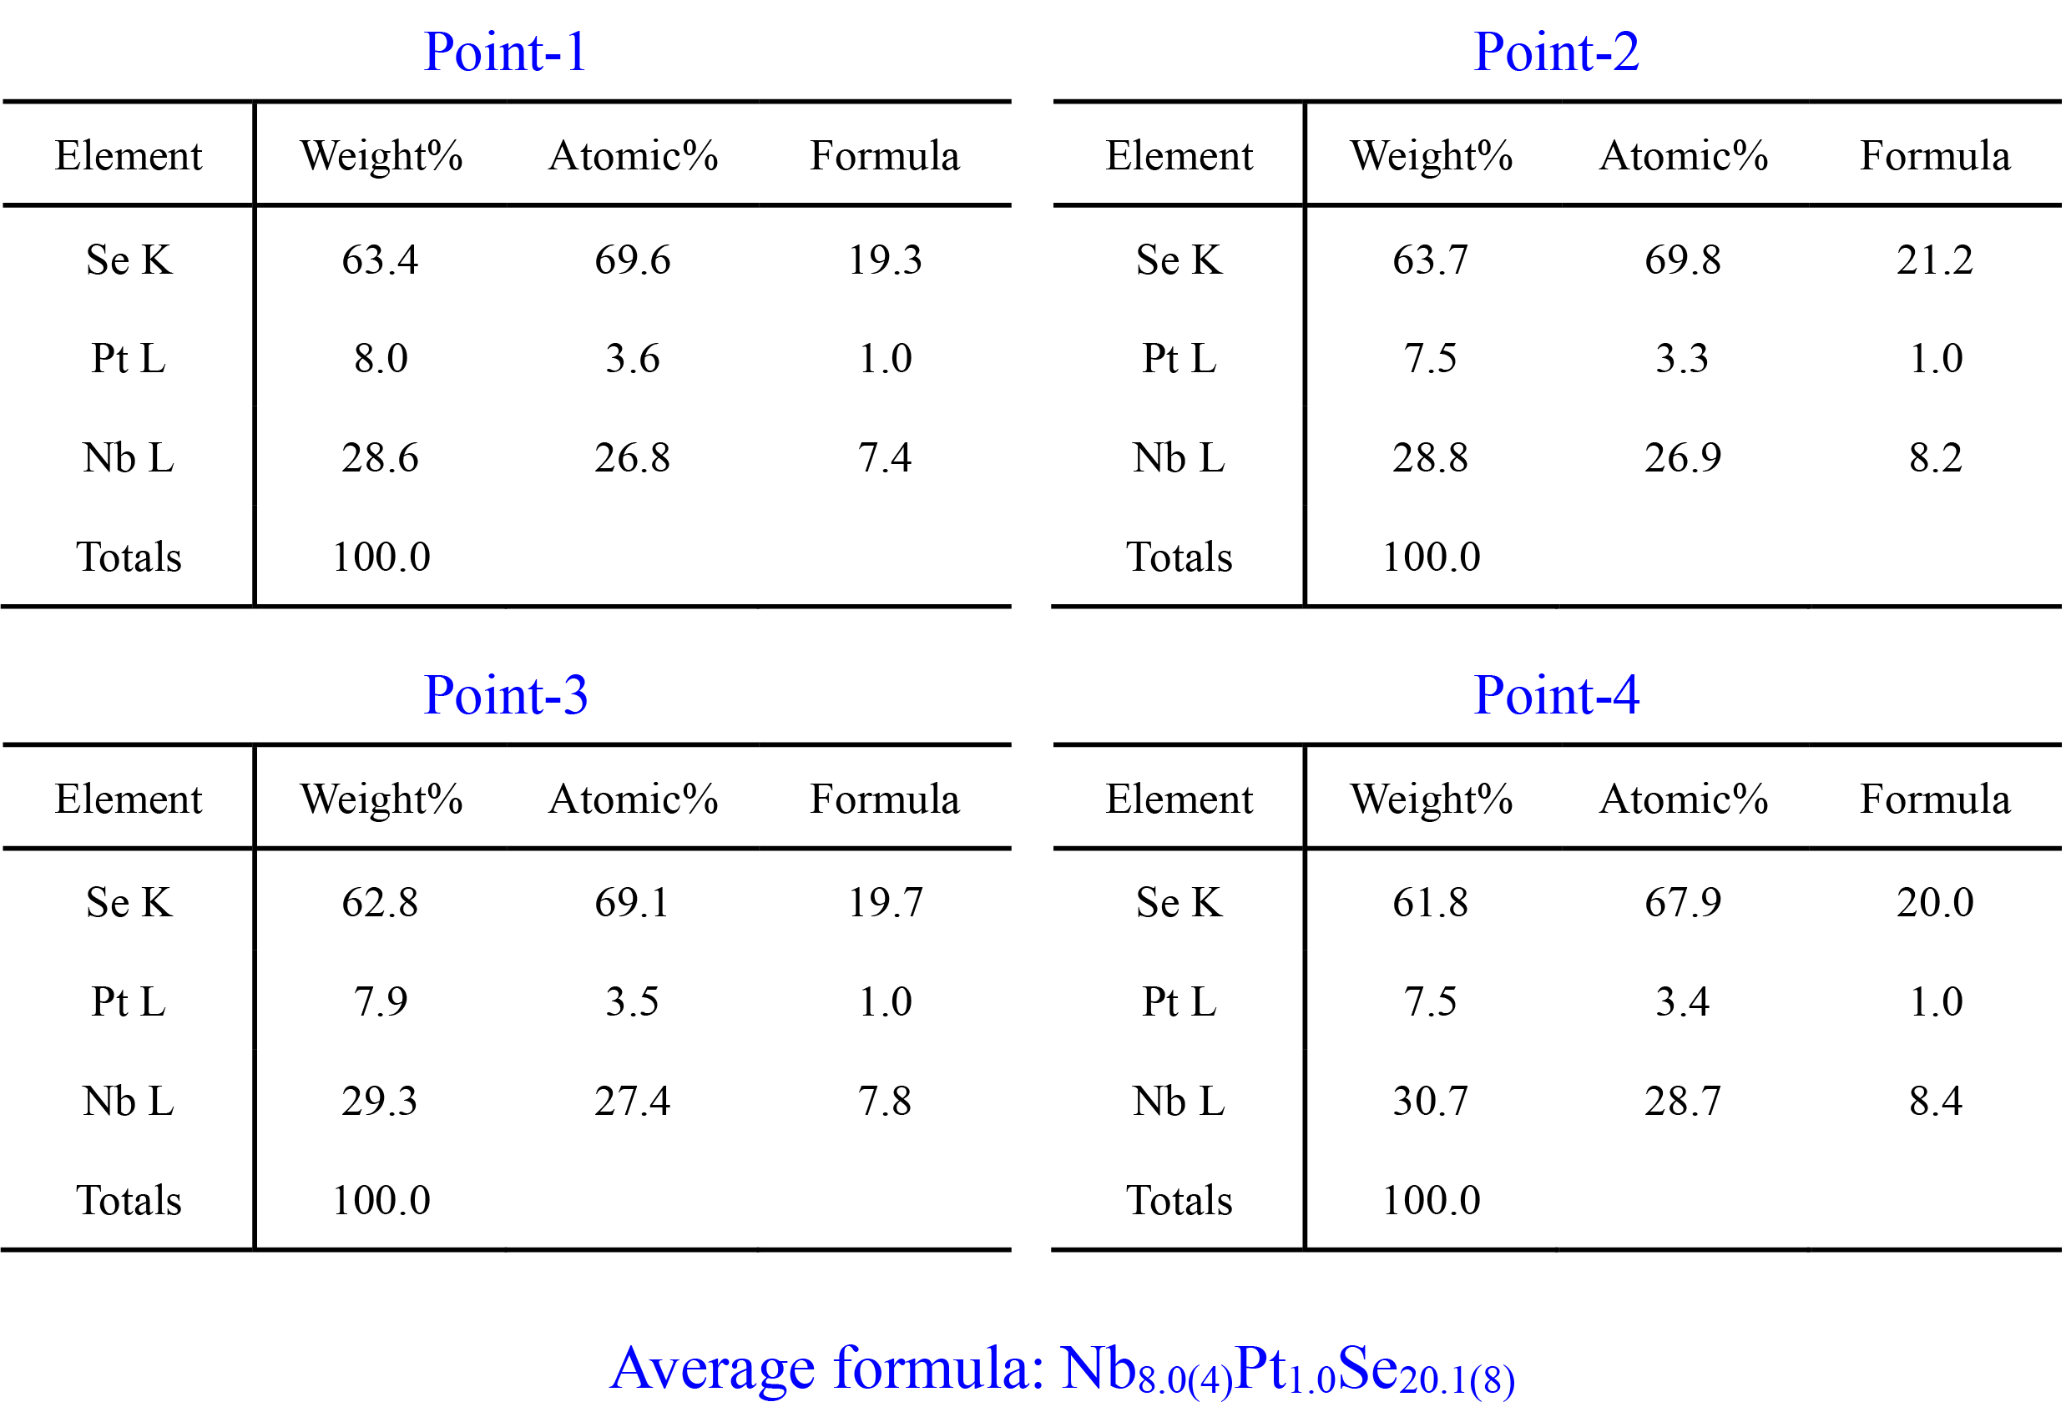

Supplementary Table 3: Comparison of the photocurrent responsivity in the infrared spectral ranges of most 2D materials.
Materials | Wavelength (μm) | Responsivity (A/W) | Reference
NbS₃ | 0.83 | 2.5×10⁻² | [10]
PtS₂ | 0.83 | 0.3 | [11]
MoTe₂ | 1.06 | 2.4×10⁻² | [12]
GeAs | 1.6 | 6 | [13]
Graphene | 1.47 | 0.2 | [14]
Ta₂NiSe₅ | 4.6 | 0.86 | [15]
InSb | 8.05 | 0.1 | [16]
b-AsP | 8.05 | 0.0102 | [17]
MoS₂ | 9.5 | 0.0218 | [18]
HgCdTe | 10 | 0.3 | [19]
PtSe₂ | 0.632-10 | 4.5 | [20]
TaIrTe₄ | 0.532-10.6 | 2.5×10⁻⁵ | [21]
Nb₈PtSe₂₀ | 0.671-10.6 | 14.3-100.6 | This work

References
1 Li, P. et al. Penta-PdPSe: A New 2D Pentagonal Material with Highly In-Plane Optical, Electronic, and Optoelectronic Anisotropy. Adv. Mater. 33, 2102541 (2021).
2 Wu, D. et al. 2D AgTiPS₆: a Cross-Stacked In-Plane Anisotropic Semiconductor for Broadband and Polarization-Sensitive Photodetection. Adv. Mater. 37, 2416041 (2025).
3 Jones, B. F. A reappraisal of the use of infrared thermal image analysis in medicine. IEEE Trans. Med. Imaging 17, 1019-1027 (1998).
4 Jiang, H. et al. Synergistic-potential engineering enables high-efficiency graphene photodetectors for near- to mid-infrared light. Nat. Commun. 15, 1225 (2024).
5 Novoselov, K. S. et al. Electric Field Effect in Atomically Thin Carbon Films. Science 306, 666-669 (2004).
6 Liu, L., Feng, Y. P. & Shen, Z. X. Structural and electronic properties of h-BN. Physical Review B 68, 104102 (2003).
7 Kadantsev, E. S. & Hawrylak, P. Electronic structure of a single MoS₂ monolayer. Solid State Commun. 152, 909-913 (2012).
8 Cheng, Q. et al. WSe₂ 2D p-type semiconductor-based electronic devices for information technology: Design, preparation, and applications. InfoMat 2, 656-697 (2020).
9 Wang, H. et al. High-quality monolayer superconductor NbSe₂ grown by chemical vapour deposition. Nat. Commun. 8, 394 (2017).
10 Wang, Y. et al. Air-Stable Low-Symmetry Narrow-Bandgap 2D Sulfide Niobium for Polarization Photodetection. Adv. Mater. 32, 2005037 (2020).
11 Wang, Z. et al. A Noble Metal Dichalcogenide for High-Performance Field-Effect Transistors and Broadband Photodetectors. Adv. Funct. Mater. 30, 1907945 (2020).
12 Huang, H. et al. Highly sensitive visible to infrared MoTe₂ photodetectors enhanced by the photogating effect. Nanotechnology 27, 445201 (2016).
13 Guo, J. et al. Few-Layer GeAs Field-Effect Transistors and Infrared Photodetectors. Adv. Mater. 30, 1705934 (2018).
14 Zhang, B. Y. et al. Broadband high photoresponse from pure monolayer graphene photodetector. Nat. Commun. 4, 1811 (2013).
15 Zhang, S. et al. H-BN-Encapsulated Uncooled Infrared Photodetectors Based on Tantalum Nickel Selenide. Adv. Funct. Mater. 33, 2305380 (2023).
16 Kimukin, I., Biyikli, N., Kartaloglu, T., Aytur, O. & Ozbay, E. High-speed InSb photodetectors on GaAs for mid-IR applications. IEEE J. Sel. Top. Quantum Electron. 10, 766-770 (2004).
17 Long, M. et al. Room temperature high-detectivity mid-infrared photodetectors based on black arsenic phosphorus. Sci. Adv. 3, e1700589 (2017).
18 Xie, Y. et al. Room-Temperature Ultrabroadband Photodetection with MoS₂ by Electronic-Structure Engineering Strategy. Adv. Mater. 30, 1804858 (2018).
19 Madejczyk, P. et al. Engineering steps for optimizing high temperature LWIR HgCdTe photodiodes. Infrared Physics & Technology 81, 276-281 (2017).
20 Yu, X. et al. Atomically thin noble metal dichalcogenide: a broadband mid-infrared semiconductor. Nat. Commun. 9, 1545 (2018).
21 Lai, J. et al. Broadband Anisotropic Photoresponse of the “Hydrogen Atom” Version Type-II Weyl Semimetal Candidate TaIrTe₄. ACS Nano 12, 4055-4061 (2018).

