Decadal debris records reveal legacy accumulation and emerging fishing-derived plastic inputs across the North Pacific.
Sarah-Jeanne Royer^{1*}, Wouter-Jan Strietman², Peter Puskic¹, Matthias Egger^{1,3}, Rafael Bergstrom⁴, Kevin O’Brien⁵, Laurent Lebreton^{1,6}
¹ The Ocean Cleanup, Rotterdam, The Netherlands
² ﻿Wageningen Social & Economic Research, Wageningen, The Netherlands
³ Empaqtify, St. Gallen, Switzerland
⁴ Sustainable Coastlines Hawaiʻi, Oʻahu, United States
⁵ Papahānaumokuākea Marine Debris Project, Hawaiʻi, Oʻahu, United States
⁶ The Modelling House, Raglan, New Zealand
*Corresponding author: sarah-jeanne.royer@theoceancleanup.com

Supplementary Results
SR1. Detailed debris mass and counts by region and cleanup event
Full details of debris collection dates, locations, weights, and cleanup effort by region and event are provided in Supplementary Table S1. The NPGP dataset comprised seven collection events between 2015 and 2024, ranging from 618 kg (System 001/B, 2019) to 6,453 kg (System 03, September 2023). PNMS collections covered three islands across 2024–2025, with the largest single event yielding 8,182 kg at Kamole Island in June–July 2024. MHI collections included 45 small-scale monthly cleanups at Kahuku Beach (average surface area ~1,500 m²) and three large-scale events at Kahuku and Kalaupapa, yielding 4,524 kg and 4,221 kg, respectively. Total item counts by region were: NPGP 87,837 items; PNMS 78,195 items; MHI 91,808 items (Supplementary Table S1).
SR2. Detailed item counts and category breakdown
Full item-count data by category across all three regions are provided in Supplementary Fig. S1 and Supplementary Data File 1. In the NPGP, the largest numerical contributions came from fragments greater than 5 cm (35%), fishing gear excluding nets and ropes (14%), household items (16%), and crates (14%). In the PNMS, fragments greater than 5 cm (35%) and floats/buoys (20%) dominated, followed by household items (14%), food and drink items (13%), and aquaculture gear (12%). In the MHI, fragments greater than 5 cm (31%), aquaculture gear (24%), and food and drink items (21%) were most abundant. Items represented by fewer than 10 individuals are excluded from figures but included in Supplementary Data File 1.
SR3. Brand analysis
Full brand data are available in Supplementary Data File 1; key patterns are summarised here and in Fig. 5 of the main text. Brand markings were identified on 11,327 items across 2,594 distinct brands. The most represented brand was Master Kong (930 items), a Chinese food and beverage company, particularly abundant in the MHI (507 items) and PNMS (345 items). Chinese float and buoy manufacturers dominated ALDFG-related brands: Zhejiang (914 items), Yufa (471 items), and Sun Brand (408 items). Chinese beverage brands were also prominent, including Nongfu Spring (367 items), Wahaha (344 items), and C'estbon (155 items). Japanese float manufacturers — Sanshin Kako (263 items), Nichimo (196 items), Donan Float (100 items), Uroko Float (92 items), Viny Float (88 items), Oyama Blow (88 items), and Sanko (54 items) — were particularly well represented in the NPGP. Indonesian brand Aqua (308 items) and Korean brand Namyang (72 items) were present across all regions. International brands, including Nestlé (274 items), Coca-Cola (187 items), Aje (60 items; Peru), and Gatorade (51 items), appeared at lower frequencies.
SR4. Polymer types
Polymer type was identified for 4,925 items using recycling codes and ATR-FTIR spectroscopy (Supplementary Fig. S3). HDPE (Type 2) dominated in the NPGP (1,367 of 1,701 identified items; 80%), consistent with the prevalence of durable fishing floats, crates, and jerry cans. PET (Type 1) dominated in the PNMS (1,271 of 2,311 identified items; 55%) and MHI (802 of 1,436 identified items; 56%), driven by beverage bottle abundance. PP (Type 5) occurred most notably in the NPGP (229 items; 12%), consistent with some float and rope materials. PVC (Type 3), LDPE (Type 4), and PS (Type 6) were each present in low numbers across regions. A small number of items were labelled PLA, ABS, or mixed PE+PP. These polymer distributions are consistent with the broader compositional differences between gyre accumulation zones, favouring buoyant, durable polyolefins, and island shorelines, favouring PET-dominated consumer packaging.
SR5. Colour distributions
Colour was recorded for 19,064 items across all regions (Supplementary Fig. S4). Blue (5,189 items; 27%) and black (3,363 items; 18%) were the most common colours overall, followed by white (2,887 items; 15%) and clear (2,676 items; 14%). In the NPGP, black (1,607 items; 22%) and white (1,448 items; 20%) dominated, consistent with fishing and aquaculture gear. The MHI exhibited a more even distribution, with clear (1,104 items; 21%), blue (917 items; 18%), black (661 items; 13%), and white (649 items; 12%) all prominent, reflecting a higher proportion of consumer packaging. The PNMS was overwhelmingly dominated by blue (2,997 items; 38%) and clear (1,474 items; 19%), with additional contributions from black (1,095 items; 14%), white (790 items; 10%), and yellow (976 items; 12%). Only the ten most frequent colours per region are shown in Supplementary Fig. S4; categories with fewer than 10 items are included in Supplementary Data File 1.
SR6. ONE APUS container spill
Across all regions, 1,622 items were attributed to the ONE APUS container spill of November 2020 (Supplementary Fig. S5). By item count, the PNMS accounted for the largest number of attributed items (1,072 items; 66%), followed by the MHI (347 items; 21%) and the NPGP (116 items; 7%), with the remaining 87 items (5%) not attributable to a specific collection site. As a proportion of total cleanup mass, ONE APUS items represented 0.4–0.5% in the NPGP, 0.7–1.5% in the MHI, and 2.1–6.0% in the PNMS, with the highest values recorded at Kuaihelani in 2024 (6.0%) and Kamole in 2024 (4.1%), declining in 2025. Footwear dominated recovered items across all regions: sandals, shoes, and shoe soles together comprised approximately 68% of all structured ONE APUS debris. A total of 136 identifiable brands were recorded, with Croc (220 items) the most abundant overall, followed by Wilson (100 items), Nike (62 items), Puma (60 items), and ProPenn (31 items; Supplementary Fig. S6). Temporal tracking was only possible at James Campbell National Wildlife Refuge (Kahuku, Oʻahu) through monthly cleanups, where no clear temporal pulse was detected. These patterns are consistent with the higher proportional representation of recently released floating debris observed across Hawaiian sites.
SR7. Fishing net physical characteristics, extended data
Full measurements for all 181 collected nets are provided in Supplementary Data File 2, including the 7 nets subsequently identified as non-fishing gear and excluded from the discard pathway analysis. Of the 174 nets retained for full assessment, mesh size distributions spanned 5–550 mm, with the majority concentrated in the 40–150 mm range. Cut-out photographs (10 × 10 cm) of net panels and full-net floor photographs are archived separately (Fig. S7). Expert input by respondent, including gear type assessments, origin hypotheses, and confidence ratings, is summarised in Supplementary Table S3.

Supplementary Discussion
SD1. COVID-19 and the production date signal
The notable dip in production-dated items between 2020 and 2022, followed by a sharp increase in 2023, warrants brief discussion as it coincides with the global disruption caused by the COVID-19 pandemic. Global plastic production decreased in 2020 for the first time in decades, driven by reduced industrial output, supply chain disruptions, and a contraction in maritime trade and fishing activity ((UNEP), 2022). Reduced fishing effort across multiple North Pacific fleets during 2020–2021, combined with port closures and restricted vessel movements, may have temporarily reduced both the volume of plastic produced and the quantity entering the ocean through sea-based pathways during this period. The subsequent sharp increase in production-dated items in 2023 is consistent with a rebound in both industrial production and maritime activity following the lifting of pandemic restrictions. However, this pattern may equally reflect variability in cleanup effort and timing across sites, particularly for the PNMS and MHI, where shorelines are periodically cleaned rather than continuously monitored, making it difficult to distinguish a genuine production signal from a sampling artefact. This pattern is noted as an interesting temporal signal that future monitoring programs with more continuous sampling resolution would be well placed to investigate further.
SD2. Vessel-derived waste as a secondary source of PET bottles in Hawaiian waters
While we consider buoyancy and windage-driven expulsion from the NPGP, combined with the inherently shorter material lifespan of PET relative to durable polyolefins, to be the primary explanation for the high abundance of PET beverage bottles in the PNMS and MHI, vessel-derived waste cannot be excluded as a secondary contributor. Commercial cargo ships, cruise vessels, and fishing fleets transiting or approaching the Hawaiian Islands routinely generate beverage-related waste at high volumes, and although MARPOL Annex V prohibits discharge of plastics at sea, documented non-compliance and episodic leakage of operational wastes remain well-recognised contributors to coastal debris in regions with heavy vessel traffic (GESAMP, 2016; Macfadyen et al., 2009; Serra-gonçalves et al., 2023; Willis et al., 2022). PET beverage bottles are a recurrent signature of ship-sourced litter in the Pacific around port approaches and tourism hubs (Carson et al., 2013; Metcalfe and Bentley, 2020), and monitoring programs in the Northwestern Hawaiian Islands have documented episodic pulses of vessel-associated debris including PET bottles during cleanup efforts (NOAA Marine Debris Program, 2021). The fact that nearly all expiration-dated bottles in our dataset originate from the 2020s is consistent with both mechanisms, rapid gyre expulsion combined with material degradation of older PET items, and contemporary vessel discharge, and distinguishing between them definitively would require tracking of individual items or isotopic source fingerprinting beyond the scope of the current study.
SD3. The ONE APUS container spill as a transport tracer
The ONE APUS container spill of November 2020 provides a rare quasi-experimental case study of how a discrete, well-characterised pulse of consumer goods disperses across the North Pacific and offers independent empirical support for the windage-driven expulsion mechanism discussed in the main text. By item count, the PNMS accounted for the largest number of attributed items (1,072 items; 66%), followed by the MHI (347 items; 21%) and the NPGP (116 items; 7%). As a proportion of total cleanup mass, ONE APUS items represented 0.4–0.5% in the NPGP, 0.7–1.5% in the MHI, and 2.1–6.0% in the PNMS, with the highest value recorded at Kuaihelani in 2024 (6.0%) and Kamole in 2024 (4.1%), declining in 2025. The temporal progression of detections, with initial recoveries in the NPGP in 2023 followed by higher proportions across Hawaiian sites in 2024–2025, is consistent with multi-year advection by basin-scale currents and mesoscale variability, and mirrors the distributional patterns observed for PET bottles and recently dated items across the broader dataset. Footwear dominated recovered items across all regions, with sandals, shoes, and shoe soles comprising approximately 68% of all structured ONE APUS debris, closely matching the known cargo manifest of sports and lifestyle goods. A total of 136 identifiable brands were recorded, with Croc (220 items) the most abundant overall, followed by Wilson (100 items), Nike (62 items), Puma (60 items), and ProPenn (31 items). Temporal tracking was only possible at James Campbell National Wildlife Refuge through monthly cleanups, where no clear temporal pulse was detected, likely reflecting the continuous nature of debris arrival rather than a discrete stranding event. These patterns provide empirical benchmarks for Lagrangian transport models, including beaching rates, retention times, and dispersal pathways for high-buoyancy cargo items, that are typically difficult to validate with observational data alone, and reinforce the need for early-warning frameworks and rapid-response monitoring protocols for future maritime accidents in the North Pacific.
SD4. The trawling paradox: mechanisms explaining trawl net abundance in a region without trawling, and the role of mesoscale eddies in ALDFG generation
The high abundance of trawl net fragments in floating litter collected in the NPGP presents an apparent paradox, as active demersal trawling does not occur in the deep offshore waters of the North Pacific Subtropical Gyre, where depths exceed 4,000 m, continental shelf habitat is absent, and target species associated with trawl fisheries are not present in commercial quantities. Although pelagic trawl fisheries can operate over deep offshore waters, large-scale pelagic trawling is not characteristic of the central oligotrophic gyre environment due to its low productivity and the absence of commercially exploitable target species in sufficient densities (Karl and Church, 2017). Demersal trawling in the broader Pacific is largely confined to the continental shelves of the western Pacific and Asia, where China, Japan, South Korea, Taiwan, Vietnam, Thailand, and Indonesia operate extensive fleets targeting demersal fish and shrimp in the Yellow Sea, East China Sea, and South China Sea (Kroodsma et al., 2018). In the central and eastern Pacific, geomorphological constraints and regulatory frameworks, including explicit bottom trawl prohibitions across many Pacific Island nations to protect coral reefs and seamount ecosystems, further limit demersal trawling to isolated shelf areas such as the continental shelf of Papua New Guinea (FAO, 2021; Macfadyen et al., 2009).
Several non-exclusive mechanisms explain how trawl nets originating from Asian shelf fisheries appear in the NPGP. Gear fragments generated during net repair and replacement, whether discarded at sea or improperly disposed of at port, can be entrained in the Kuroshio Extension and North Pacific Current and transported thousands of kilometres into the subtropical gyre, as demonstrated by Lagrangian transport modelling of floating debris from Asian coastlines (Lebreton et al., 2019; Maximenko et al., 2018). The predominance of relatively recent net material, 61% classified as less than five years old, is consistent with active, ongoing inputs maintaining the trawl net signal in the NPGP, though this pattern may also partly reflect the selective loss of older material through advanced degradation, fragmentation, and sinking over time.
A further question raised by the dataset is where along the pathway from vessel to gyre these net fragments most commonly enter the ocean. Mesoscale eddies in the western North Pacific and along the Kuroshio Extension are associated with elevated primary productivity and concentrated fish biomass, making them preferential fishing grounds for trawl and other active gear types (Xing et al., 2023). If gear waste generation is proportional to fishing intensity, then eddy-associated fishing hotspots may represent disproportionate sources of ALDFG entering the offshore circulation system, as net fragments discarded or lost in these dynamic, high-activity zones are likely to be rapidly entrained in mesoscale circulation and transported toward the subtropical gyre. This hypothesis, that mesoscale oceanographic features not only concentrate fish and fishing effort but also concentrate ALDFG generation, represents a tractable and important question for future work integrating fishing effort data with oceanographic dispersal modelling and debris provenance analysis of the kind developed in this study.

Supplementary Methods
SM1. Study sites and sample collection; full details
North Pacific Garbage Patch (NPGP). Offshore plastic debris was collected from the NPGP across seven datasets. The first dataset comprised 652 surface net tows conducted between 7 July and 19 September 2015 across 25°N–41°N and 129–156°W by 18 participating vessels, yielding 668 kg (Lebreton et al., 2018). The second dataset was collected using System 001/B between 27 June and 7 November 2019 at 33.0–35.1°N and 143.0–145.6°W, yielding 618 kg (Lebreton et al., 2022). The third dataset was collected using System 002 between 20 October and 1 December 2021, yielding 796 kg. Four complete offshore cleanup system extractions were also analysed: the first on 9 June 2023 using System 002 (4,605 kg); the second on 4 September 2023 using System 03 (6,453 kg); the third on 14 March 2024 using System 03 (5,600 kg); and the fourth on 4 July 2024 using System 03 (6,130 kg). Extractions were conducted between 29.5–33.3°N and 135.2–141.7°W. All collected material consisted of items larger than approximately 1.6 cm in maximum dimension, though some smaller particles may have been trapped inside containers.
Papahānaumokuākea National Marine Sanctuary (PNMS). Stranded plastic debris was collected by the PMDP at three island locations. At Kuaihelani, collections were conducted in April 2024 (3,101 kg) and April 2025 (2,188 kg). Due to the presence of the invasive alga Chondria on Kuaihelani, all sorting and inspection were carried out on-site to prevent spread, and material could not be transported off the island. At Kamole Island, collections were conducted in June–July 2024 (8,182 kg) and August 2025 (4,925 kg). At Kapou (Papaʻāpoho), one collection was conducted in August 2025 (3,794 kg). Debris from Kamole and Kapou was processed at PMDP facilities on Oʻahu. To obtain representative samples from the high volume of debris at each island, items were sorted from randomly selected locations around the island perimeter. All items greater than 1.6 cm in maximum dimension were included.
Main Hawaiian Islands (MHI). Debris was collected by SCH across two islands. On Oʻahu, 45 small-scale monthly cleanups (each less than 500 kg) were conducted every second Thursday from January 2024 to December 2025 at James Campbell National Wildlife Refuge, Kahuku Beach, with an average covered surface area of approximately 1,500 m² per event. One large-scale cleanup was conducted at Kahuku Beach in June 2025. Two large-scale cleanups were conducted at Kalaupapa, Molokaʻi, in September 2024 and July 2025, each spanning approximately one week and covering X to Y m² of coastline. Total debris collected was 4,524 kg on Oʻahu and 4,221 kg on Molokaʻi. All items greater than approximately 1.6 cm in maximum dimension were included.
Minor methodological differences across sites may introduce small biases in item counts for the smallest size fractions, which should be interpreted with caution. In the NPGP, the passive collection systems retain material above approximately 1.5 cm, meaning that some smaller items recoverable by manual shoreline collection may not always be captured. In the PNMS, where cleanup operations emphasize recovery by weight, there may be a slight bias toward larger objects even within the greater than 5 cm fraction. These differences are unlikely to affect the principal findings, which are based on items greater than 5 cm with identifiable provenance markers, but are noted here in the interest of transparency.

SM2. Debris classification and provenance analysis; full details
Sorting procedure. Directly upon retrieval, debris was transported to sorting facilities and divided into two fractions: nets and ropes (fibers) and hard plastics (rigids; Supplementary Fig. S8). Fibers were dried at ambient temperature, weighed, and, for small-scale cleanups, counted. Fiber fractions were subsequently stored in large bags and repurposed or disposed of. Hard plastic items and fragments greater than 5 cm were displayed on a clean surface and individually sorted into 112 predefined categories across nine material types following the OSPAR Beach Litter Monitoring Guidelines (OSPAR, 2010). Additional subcategories were added to account for items frequently observed in the study area, including eel traps, baits, and oyster spacers. Both intact items and identifiable fragments were allocated to the corresponding category; item counts, therefore, reflect the combined total of intact objects and identifiable fragments rather than complete objects only. For each category, item counts and total weights were recorded. A full list of categories is provided in Supplementary Table S2. A workflow diagram of processing and analysis steps is shown in Supplementary Fig. S8, and photographs of the most common items are shown in Supplementary Fig. S9.
Fragments smaller than 5 cm were weighed only, as their volume precluded individual counting or provenance analysis. These fragments were further categorised into size classes using a stainless-steel sieve tower following Lebreton et al. (2018): less than 0.5 mm, 0.5–1.5 mm, 1.5–5 mm, 0.5–1.5 cm, and 1.5–5 cm. Fragment weights were recorded but excluded from the analyses presented here to ensure methodological consistency and comparability across regions. In the PNMS, only debris greater than 5 cm was collected, consistent with this standardised approach.
Source and origin analysis. After classification, each hard plastic item was individually inspected for bearing identifiable origin markers potentially associated with geographic origin, including written language, brand, polymer type, and production or expiration dates, then photographed, counted, and weighed. Potential geographic association was attributed from language markings only where the language was spoken exclusively in a single country. English and Spanish were excluded as standalone origin indicators due to their global use. Where a kanji character could belong to both Chinese and Japanese, no geographic association was attributed. Brand origin was determined by identifying the country where the company is established, verified through publicly available websites, and distinguished from countries where the brand sells goods. Colour, presence or absence of a cap, and presence or absence of bite marks were also recorded for each item. Native speakers assisted with the identification of Asian languages. A total of 19,768 items bearing identifiable provenance-related indicators were individually recorded across the three regions.
Polymer identification. Polymer type was identified using recycling codes where present. For a subset of items, attenuated total reflectance Fourier transform infrared spectroscopy (ATR-FTIR) was used following established protocols (Jung et al., 2018), providing confirmatory polymer identification where recycling codes were absent or ambiguous.
ONE APUS identification. Items attributed to the ONE APUS container spill of November 2020 were identified based on a combination of item type, brand markings, and consistency with the known cargo manifest of the vessel, which included sporting goods, footwear, and lifestyle products. Attribution was conservative: only items whose type and brand were directly consistent with documented spill cargo were included.
Statistical analysis. A significant decrease in production dates between 2020 and 2022 and a large increase in 2023 were assessed using chi-square tests and one-way ANOVA (p < 0.05). Item provenance data were managed in Microsoft Excel, and all statistical analyses were conducted in MATLAB R2023b.
SM3. Fishing net analysis; full details
Sample selection and preparation. A total of 181 fishing net fragment greater than 50 cm from the NPGP were selected from debris collected across three extraction events: 42 net fragments from extractions 15 and 17 in October–December 2021 using System 002; 51 net fragments from extraction 73 using System 002 in June 2023; and 88 net fragments from extraction 1 using System 03 in September 2023. Each fragment was randomly selected from each extraction, provided it was relatively easy to disentangle, and exceeded 50 cm at its longest dimension. The analysed subset consisted exclusively of multifilament twine nets, reflecting both their higher occurrence in recovered material and their suitability for disentanglement. Seven nets were subsequently identified as non-fishing gear (cargo nets and fruit or vegetable mesh bags) and excluded from the discard pathway analysis, leaving 174 nets for full assessment. Two additional nets were too large to fully disentangle and were excluded from edge-damage analysis only.
Physical and morphological assessment. Following the Fishing Net Assessment Protocol (Strietman, 2021), each net was untangled and stretched on a warehouse floor for analysis. Recorded characteristics included weight, overall dimensions, surface area, number of pieces, mesh size, stretch orientation, number of strands, construction type (knotted versus knotless), twine diameter, and twist type (S-, Z-, or braided). Small cut-outs (10 × 10 cm) of each net were photographed on a white board with a ruler (Supplementary Fig. S7). Polymer composition was determined using ATR-FTIR (Agilent Cary 630) following Jung et al. (2018).
Condition and age estimation. Indicators of environmental exposure, biofouling, fraying, and fading, were recorded for each net and used as proxies for relative age, reflecting cumulative mechanical stress and prolonged marine exposure. These characteristics were combined into a numerical classification of exposure level (low, moderate, or high) and a qualitative classification of nets as relatively recent (less than 5 years) or older.
Discard pathway assessment. The number and configuration of cut versus torn edges on each side of the net were assessed by trawl gear fisheries experts to distinguish between accidental loss and intentional discard. Cut marks with a regular pattern along net sides indicated deliberate sectioning during repair or replacement. Tear marks with an irregular or frayed pattern indicated mechanical damage consistent with accidental loss or operational wear. Based on this assessment, nets were classified into one of three categories: (1) all sides ripped or torn, indicative of accidental gear loss through entanglement or operational damage; (2) three sides cut and one side torn, consistent with net offcuts generated during repair or replacement operations where sectioning was incomplete; or (3) all sides cut, consistent with deliberate and complete sectioning of net material during routine maintenance. Categories (2) and (3) together were classified as showing characteristics most consistent with inadequate fishing gear waste management rather than accidental loss, and together accounted for 87% of the 174 assessed nets.
Expert consultation. Expert input on gear type, target species, geographic origin, and flag state was collected from 18 specialists across the North Pacific region, including technical specialists from manufacturers and universities based in the United States, Micronesia, Indonesia, Japan, Vietnam, Taiwan, New Zealand, and the Netherlands (Supplementary Table S3). Engagement proceeded in three stages: known gear experts were contacted first and asked to contribute and recommend additional specialists within their networks; The Ocean Cleanup engaged social media followers to identify additional experts; and a PDF containing net photographs and measured characteristics was shared with all contacted experts. Where experts recognized most nets, detailed follow-up discussions were conducted to obtain gear type assessments, origin hypotheses, and confidence ratings.

Reference
(UNEP), U.N.E.P., 2022. From pollution to solution: A Global Assessment of Marine Litter and Plastic Pollution.
Carson, H.S., Lamson, M.R., Nakashima, D., Toloumu, D., Hafner, J., Maximenko, N., McDermid, K.J., 2013. Tracking the sources and sinks of local marine debris in Hawai’i. Mar. Environ. Res. 84, 76–83. https://doi.org/10.1016/j.marenvres.2012.12.002
FAO, 2021. Classification and illustrated definition of fishing gears., Technical Guidelines for Responsible Fisheries. Rome.
GESAMP, 2016. Sources, Fate and Effects of Microplastics in the Marine Environment: Part 2 of a Global Assessment. Rep. Stud. GESAMP No. 90, 96 p.
Jung, M.R., Horgen, F.D., Orski, S. V., Rodriguez C., V., Beers, K.L., Balazs, G.H., Jones, T.T., Work, T.M., Brignac, K.C., Royer, S.-J.J., Hyrenbach, K.D., Jensen, B.A., Lynch, J.M., 2018. Validation of ATR FT-IR to identify polymers of plastic marine debris, including those ingested by marine organisms. Mar. Pollut. Bull. 127, 704–716. https://doi.org/10.1016/j.marpolbul.2017.12.061
Karl, D.M., Church, M.J., 2017. Ecosystem Structure and Dynamics in the North Pacific Subtropical Gyre : New Views of an Old Ocean. Ecosystems 20, 433–457. https://doi.org/10.1007/s10021-017-0117-0
Kroodsma, D.A., Mayorga, J., Hochberg, T., Miller, N.A., Boerder, K., Ferretti, F., Wilson, A., Bergman, B., White, T.D., Block, B.A., Woods, P., Sullivan, B., Costello, C., Worm, B., 2018. Tracking the global footprint of fisheries. Science 908, 904–908.
Lebreton, L., Egger, M., Slat, B., 2019. A global mass budget for positively buoyant macroplastic debris in the ocean. Sci. Rep. 10, 58755. https://doi.org/10.1038/s41598-019-49413-5
Lebreton, L., Royer, S.-J., Peytavin, A., Strietman, W.J., Smeding-Zuurendonk, I., Egger, M., 2022. Industrialised fishing nations largely contribute to floating plastic pollution in the North Pacific subtropical gyre. Sci. Rep. 12, 1–11. https://doi.org/10.1038/s41598-022-16529-0
Lebreton, L., Slat, B., Ferrari, F., Sainte-Rose, B., Aitken, J., Marthouse, R., Hajbane, S., Cunsolo, S., Schwarz, A., Levivier, A., Noble, K., Debeljak, P., Maral, H., Schoeneich-Argent, R., Brambini, R., Reisser, J., 2018. Evidence that the Great Pacific Garbage Patch is rapidly accumulating plastic. Sci. Rep. 8, 1–18. https://doi.org/10.1038/s41598-018-22939-w
Macfadyen, G., Huntington, T., Cappell, R., 2009. Abandoned, lost or otherwise discarded fishing gear, FAO Consutlants, Lymington. United Kingdom of Great Britain and Northern Ireland, FAO Fisheries and Aquaculture Technical Paper 523.
Maximenko, N., Hafner, J., Kamachi, M., Macfadyen, A., 2018. Numerical simulations of debris drift from the Great Japan Tsunami of 2011 and their verification with observational reports. Mar. Pollut. Bull. 132, 5–25. https://doi.org/10.1016/j.marpolbul.2018.03.056
Metcalfe, R., Bentley, A., 2020. Net cuttings waste from fishing in the North-East Atlantic : best practices for mitigation. Swedish Agency Mar. Water Manag.
NOAA Marine Debris Program, 2021. 2021 Hawai’i Marine Debris Action Plan.
OSPAR, 2010. Guideline for monitoring marine litter on the beachs in the OSPAR Maritime Area. OSPAR Comm. 1, 84.
Serra-gonçalves, C., Lavers, J.L., Tait, H.L., Fischer, A.M., Bond, A.L., 2023. Assessing the effectiveness of MARPOL Annex V at reducing marine debris on Australian beaches. Mar. Pollut. Bull. 191, 114929. https://doi.org/10.1016/j.marpolbul.2023.114929
Strietman, W.J., 2021. Fishing nets on the coastline of the Arctic and North-East Atlantic : a source analysis.
Willis, K.A., Serra-Gonçalves, C., Richardson, K., Schuyler, Q.A., Pedersen, H., Anderson, K., Stark, J.S., Vince, J., Hardesty, B.D., Wilcox, C., Nowak, B.F., Lavers, J.L., Semmens, J.M., Greeno, D., MacLeod, C., Frederiksen, N.P.O., Puskic, P.S., 2022. Cleaner seas: reducing marine pollution. Rev. Fish Biol. Fish. 32, 145–160. https://doi.org/10.1007/s11160-021-09674-8
Xing, Q., Yu, H., Wang, H., Chai, F., 2023. Mesoscale eddies modulate the dynamics of human fishing activities in the global midlatitude ocean 1–17. https://doi.org/10.1111/faf.12742

List of supplementary tables and figures
Table S1: Summary of cleanup events in which plastic debris was categorized using the catch analysis method and the sourcing of the debris. For each event, the table provides the date, total weight of debris extracted, the responsible organization, and the collection location.

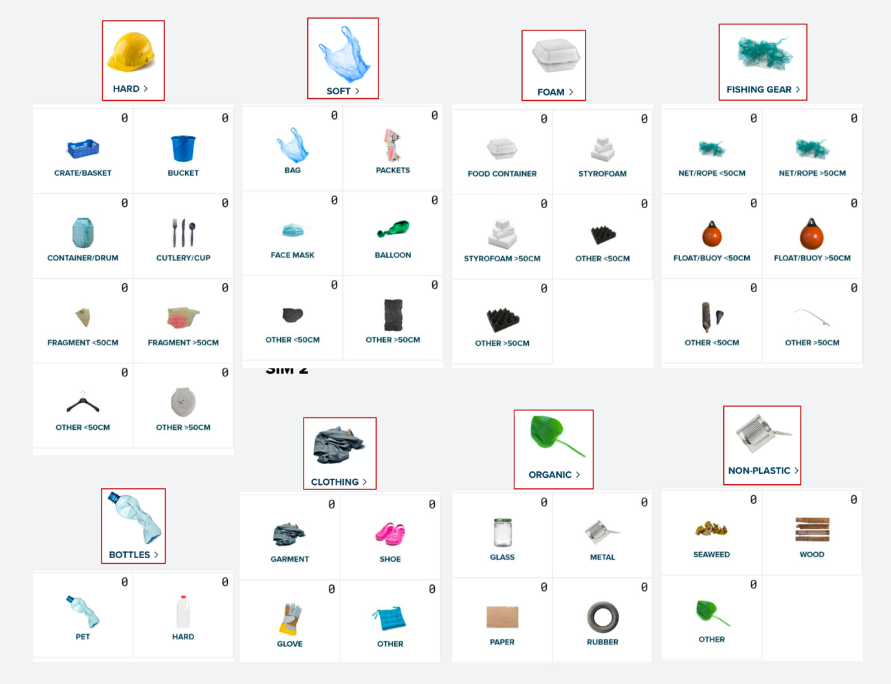Table S2: Example of the pre-defined categories from the 112 predefined categories across nine different material types following the OSPAR Beach Litter Monitoring Guideline (OSPAR, 2010); this classification framework was first applied to North Pacific offshore debris in Lebreton et al. (2022). The complete list of categories is provided in the supplementary information.

Table S3: Overview of fishing gear experts consulted during the physical and morphological net assessment. A total of 17 experts and expert pairs were consulted across Indonesia, Japan, the Netherlands, Taiwan, New Zealand, the United States, Vietnam, and the Micronesia region. Expert names have been removed and institutional affiliations replaced with broad category descriptors to preserve anonymity. The number of discussions reflects the number of separate consultation sessions conducted with each expert or expert group. Key information retained summarises the principal findings and conclusions drawn from each consultation as they relate to gear type identification, fleet attribution, and discard pathway assessment.

Expert descriptor | Affiliation category | Country | Number of Discussions | Key Information Retained
University researcher | University | Indonesia | 1 | Confirmed multinational fishing effort; similar gear used across Taiwan, China, Indonesia, Japan, Philippines. Supports conclusion that origin cannot be linked to a single fleet.
Gear manufacturer experts (×2) | Gear manufacturer | Netherlands | 1 | Identified PE twined netting typical for China, India, SE Asia; knotless construction possibly Japanese/Peruvian.
University researcher | University | Japan | 1 | Confirmed nets used across Japan, Korea, Taiwan; difficult to identify user fleet → supports global gear convergence.
Trawl gear specialist | Fishery sector expert | USA (West Coast) | 2 | Identified nets as trawl netting; cut-out repair waste; explained bottom trawl practices.
Net gear specialist | Gear manufacturer | USA (West Coast) | 2 | Assessed all measurements and photos to infer the gear type and likely target species of all nets examined, but could not determine the area of origin or fleet.
Net gear specialist | Gear manufacturer | USA (West Coast) | 1 | Did not recognise origin based on knowledge of gear used on the West Coast of the USA.
Gear manufacturer expert | Gear manufacturer | Netherlands | 1 | Did not recognise origin. Supports evidence of globally widespread similar net types.
Regional fisheries experts (×2) | Regional fisheries organisation | Micronesia region | 1 | Did not recognise origin based on knowledge of gear used in the Micronesia region; confirmed that minimal trawling takes place in the Micronesia region.
Marine gear consultant | Gear manufacturer | Netherlands | 2 | Assessed all measurements and photos to infer the gear type and likely target species of all nets examined, but could not determine the area of origin or fleet.
Anonymous gear expert | Confidential | Vietnam | 1 | Has knowledge of gear used in SE Asian fleets but had no recognition of the nets. Helps eliminate SE Asian (artisanal) fleets as a (major) contributor.
Gear consultant | Gear manufacturer | Taiwan | 1 | Explained high gear variability and global sourcing of gear. Supports distinction between gear origin and fleet origin.
Fisheries institute expert | Research institute | New Zealand | 1 | Noted low trawling in Pacific Islands; noted possible FAD net contributions.
University researcher (fisheries) | University | Japan | 2 | Of the 181 nets analysed, 108 had expert comments, of which about 32 (30%) were plausibly attributed to Chinese fisheries based on characteristic materials and construction, while only 6 (6%) were compatible with Japanese fisheries; no other fisheries were identified, and a small number of nets may originate from non-fishing uses, with two potentially linked to aquaculture.
Anonymous fishing gear technicians (×2) | Gear manufacturer | Japan | 1 | Of the 181 nets analysed, 108 had expert comments, of which about 32 (30%) were plausibly attributed to Chinese fisheries based on characteristic materials and construction, while only 6 (6%) were compatible with Japanese fisheries; no other fisheries were identified, and a small number of nets may originate from non-fishing uses, with two potentially linked to aquaculture.
Fishery sector expert | Research institute / NGO | Netherlands | 1 | Suggested likelihood of banana prawn trawl origin. This was considered but weighed against broader expert consensus.
Independent fisheries consultant | Independent fisheries consultant | Netherlands | 1 | Physically examined all nets of the 2021 sample to examine the sides of the nets and to hypothesize the cause of ending up in the marine environment.
Fishing gear expert | Gear manufacturer | Netherlands | 1 | Physically examined all nets of the 2023 sample and to hypothesize the cause of ending up in the marine environment.

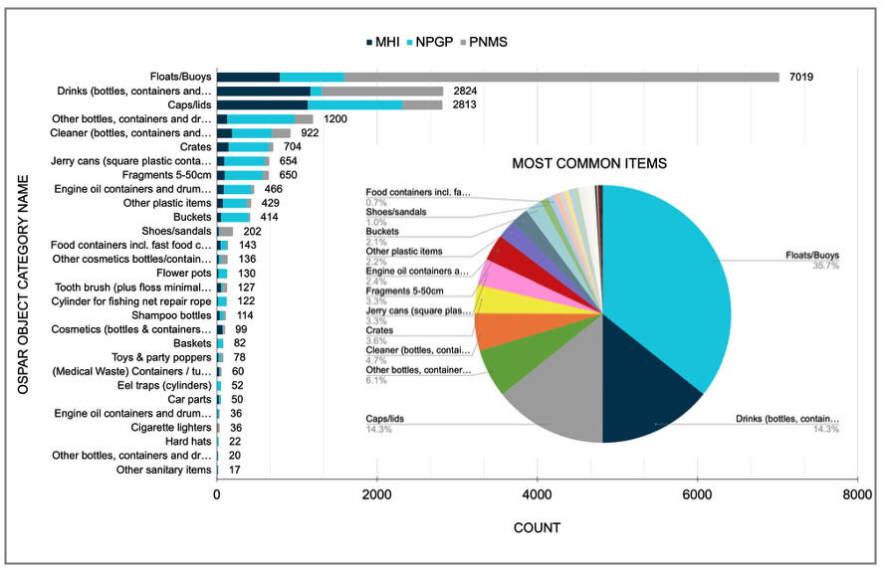
Figure S1. Stacked bar plot showing the total count of the most common debris items with identifiable clues of origin and/or dates collected from the Papahānaumokuākea National Marine Sanctuary (PNMS), the Main Hawaiian Islands (MHI), and the North Pacific Garbage Patch (NPGP). The bars display the absolute number of items recorded for each object category, including floats/buoys, drink bottles and containers, caps/lids, cleaner bottles, jerry cans, crates, engine-oil containers, buckets, footwear, fragments (5–50 cm), and other frequently observed items. Categories with fewer than n = 10 items are not represented in the stacked bars but are provided in the Supplementary Information. An inset pie chart summarizes the overall relative proportions of these object categories across all three regions combined.
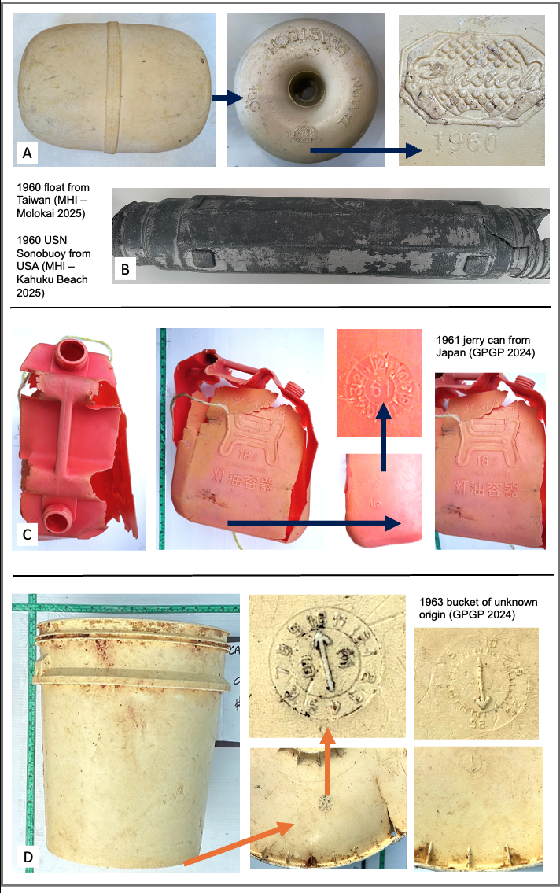
Figure S2: Oldest debris items with identifiable production dates and inferred origins collected from the North Pacific. Items include (A) a white Plastech float (500 g) produced in 1960 in Taiwan, collected in the Main Hawaiian Islands (MHI), Molokaʻi (September 2025); (B) a U.S. Navy sonobuoy float (4900 g) with an exact production date of 1960-04-09, collected in the MHI, Oʻahu (Kahuku Beach; June 2025); (C) an orange jerry can (840 g) produced in 1961 in Japan, collected in the North Pacific Garbage Patch (NPGP; July 2025); and (D) a white bucket (1026 g) with unknown origin with an exact production date of 1963-10-24, collected in the NPGP (March 2024).

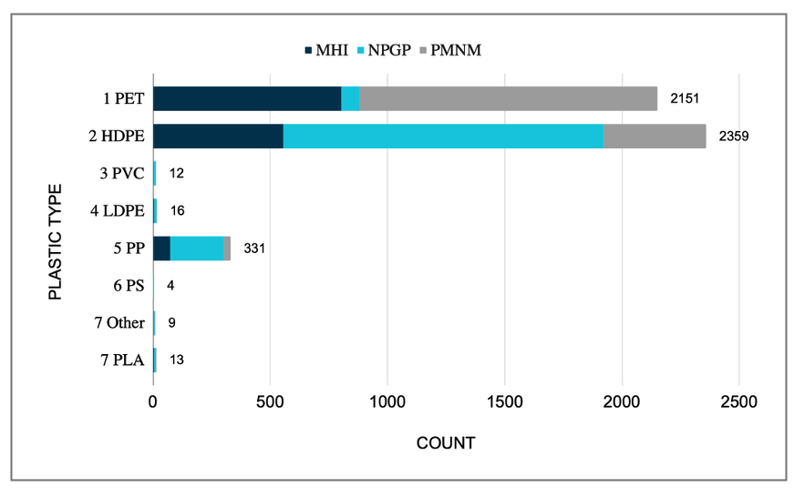
Figure S3: Polymer composition of debris collected from the Papahānaumokuākea National Marine Sanctuary (PNMS), the Main Hawaiian Islands (MHI), and the North Pacific Garbage Patch (NPGP). A total of 4,925 items with identifiable polymer types were analyzed, and the figure presents the total count of the primary polymer categories: polyethylene terephthalate (PET; #1), high-density polyethylene (HDPE; #2), polyvinylchloride (PVC; #3), low-density polyethylene (LDPE; #4), polypropylene (PP; #5), polystyrene (PS; #6), Other polymers (#7), and polylactic acid (PLA).

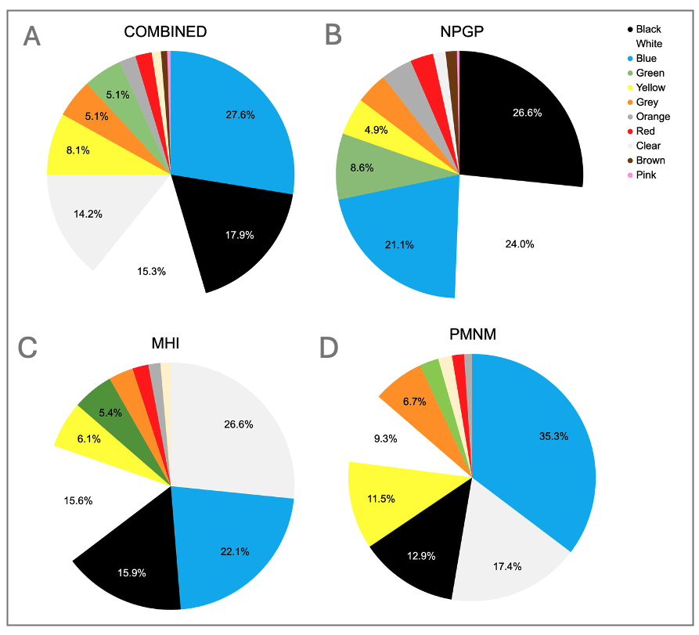
Figure S4. Colour distribution of plastic debris collected from all study regions combined (A), the North Pacific Garbage Patch (NPGP; B), the Main Hawaiian Islands (MHI; C), and the Papahānaumokuākea National Marine Sanctuary (PNMS; D). A total of 19,064 items were analyzed, and each pie chart shows the relative proportions of the ten most common debris colours, including blue, black, white, clear, yellow, orange, green, grey, red, and beige. Colour categories not shown in the charts but are provided in the Supplementary Information (SI).

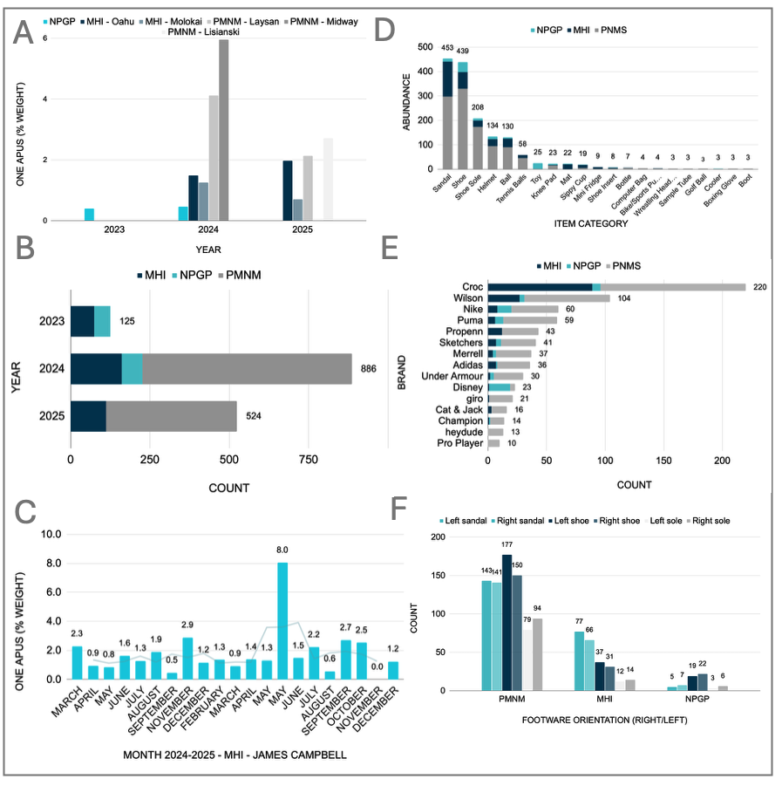
Figure S5. ONE APUS container-spill debris collected across three study regions: the North Pacific Garbage Patch (NPGP), the Main Hawaiian Islands (MHI), and the Papahānaumokuākea National Marine Sanctuary (PNMS). A total of 1,622 items were analyzed. (A) Percentage of ONE APUS debris mass relative to the total mass of hard plastic debris collected for each sampling event across regions and locations. (B) Distribution (item counts) of debris types originating from the ONE APUS spill, recovered annually across the three regions. (C) Time series of ONE APUS debris collected during monthly cleanups at James Campbell National Wildlife Refuge on Oʻahu, expressed as a percentage of total weight per cleanup. (D) Total counts for each item category across the three regions.
(E) Top 15 brands identified across all regions; additional brands are provided in the Supplementary Information (SI). (F) Distribution of sandals, shoes, and soles by right versus left orientation across the three regions.

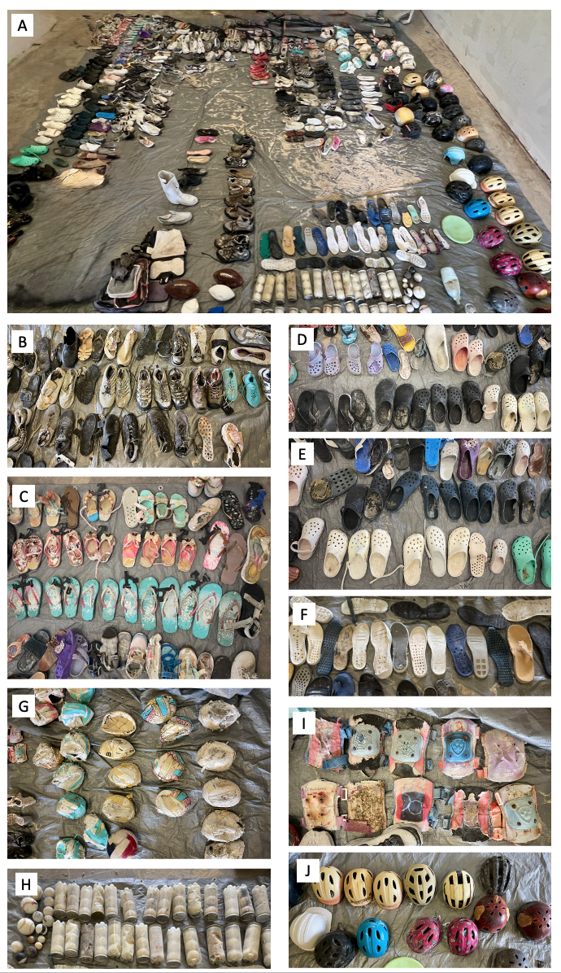
Figure S6: Photographic inventory of debris items attributed to the ONE APUS container spill (November 2020), recovered across the North Pacific Garbage Patch (NPGP), the Main Hawaiian Islands (MHI), and the Papahānaumokuākea National Marine Sanctuary (PNMS). Photographs depict items collected at the PNMS in 2024, which yielded the largest single-site recovery of ONE APUS-attributed debris in this study; equivalent item types were identified across all three collection sites. (A) Complete inventory of ONE APUS-attributed items recovered at the PNMS in 2024, arranged by category at the sorting facility. (B) Athletic footwear. (C) Flip-flops. (D–E) Clog-style sandals (Crocs), the most numerically abundant item type across all sites. (F) Soles of athletic footwear. (G) Wilson-branded volleyball balls. (H) Tennis balls. (I) Protective padding for skating and skateboarding. (J) Bicycle helmets and other recreational helmet types.
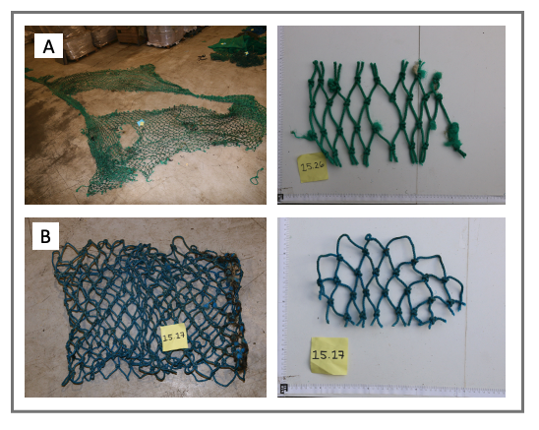
Figure S7: Exemplary picture of a green (A) and blue (B) untangled and stretched-out nets from the NPGP, along with their respective 10 X 10 cm cut-out piece of a larger net piece used for further analysis.

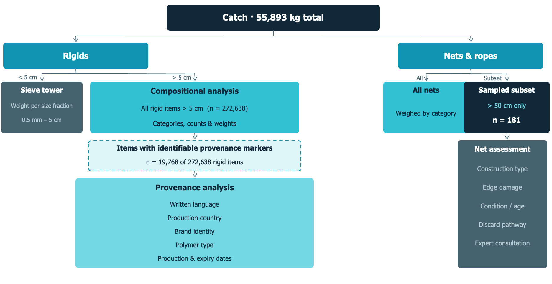
Figure S8. A. Workflow diagram illustrating the processing and analysis steps applied to the collected catch. Debris is first separated into rigid plastics, nets, and ropes. Rigid plastics are divided by size: items smaller than 5 cm undergo sieve-tower analysis to determine weight across four size fractions (0.5–1.5 mm, 1.5–5 mm, 0.5–1.5 cm, and 1.5–5 cm); all rigid items larger than 5 cm (n = 272,638) are subjected to full compositional analysis, including object categorisation, counts, and weights. Of these, items bearing identifiable provenance-related indicators (n = 19,768) were individually examined for written language, production country, brand identity, polymer type, and production and expiration dates. Nets and ropes are weighed by category across all recovered fragments; a sampled subset of fragments greater than 50 cm (n = 181) was additionally subjected to detailed physical and morphological assessment, including construction type, edge damage pattern, condition, and estimated time at sea, likely discard pathway, and expert consultation on gear origin.
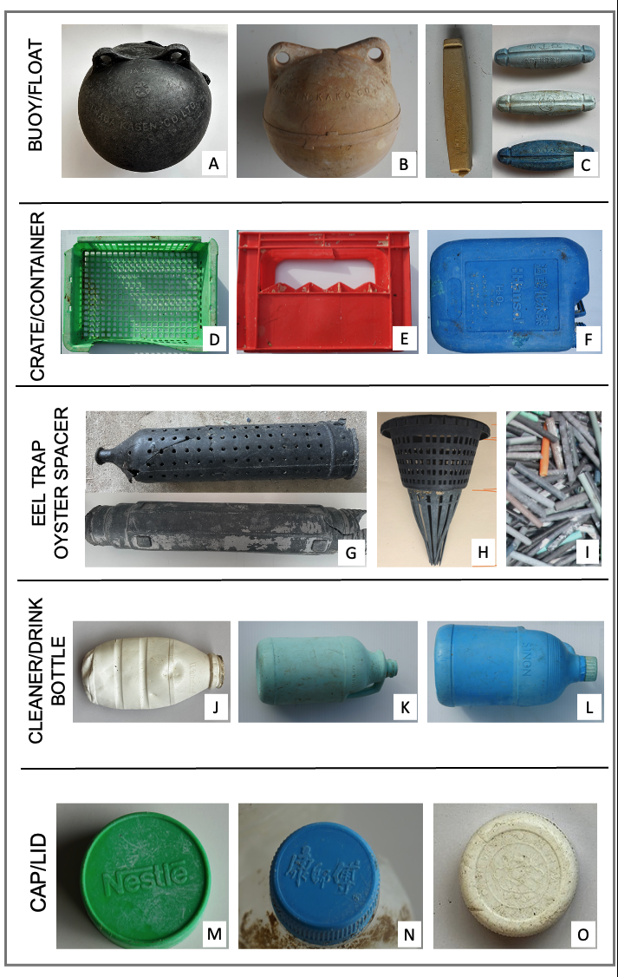
Figure S9: Representative debris items bearing identifiable provenance-related markers collected from the Papahānaumokuākea National Marine Sanctuary (PNMS), the Main Hawaiian Islands (MHI), and the North Pacific Garbage Patch (NPGP). Items include (A–C) buoys and floats bearing manufacturer markings: (A) Inaba Kasen (Japan), (B) Sanshin Kako (Japan), and (C) Yufa and Sun-brand buoys (China); (D–F) crates and containers: (D) Sanko crate (Japan), (E) Coca-Cola crate, and (F) Hansol chemical H₂O₂ container; (G–I) aquaculture and fishing gear: (G) eel trap cylinder, (H) eel trap entrance, and (I) oyster spacers; (J–L) cleaner and beverage bottles: (J) Wahaha bottle (China), (K) Kao bleach bottle (Japan), and (L) Sinon Corporation bottle (China); and (M-O) caps and lids: (M) Nestlé lid (multinational), (N) Master Kong PET bottle cap (China), and (O) Wahaha PET bottle cap (China).

