Graphical abstract: Vitamin C attenuates TCA-induced cardiac tissue injury
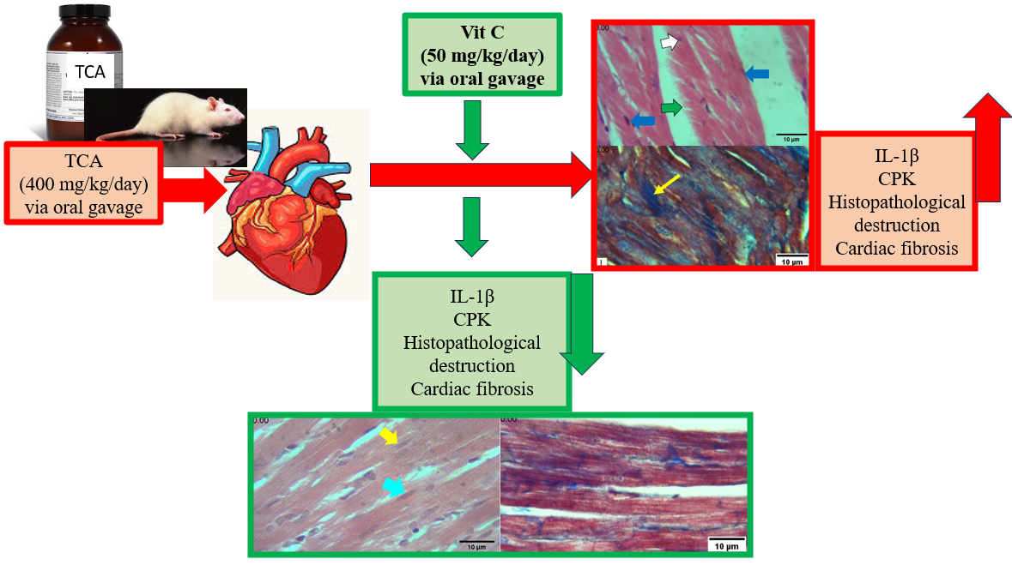
Vitamin C attenuates TCA-induced cardiac tissue injury

