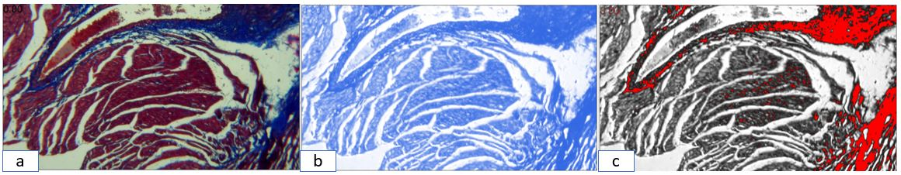
Figure S1. Quantitative assessment of cardiac interstitial fibrosis using Masson’s trichrome staining and Fiji/ImageJ analysis.
Representative Cardiac sections stained with Masson’s trichrome. (a) Original stained section; (b) isolated collagen channel obtained by color deconvolution; (c) thresholded collagen-positive areas (red) used for fibrosis quantification. Four to five randomly selected cortical fields per animal were analyzed, and the collagen-positive area fraction (%Area) was calculated.

Supplementary Table S1. One-way ANOVA test statistics and post-hoc multiple comparisons for IL-1β and CPK levels among experimental groups.

 |  | Adjusted P Value OF  IL-1β | F (df between, df within) IL-1β | Adjusted P Value OF  CPK |  | F (df between, df within) CPK
Overall ANOVA |  |  | F(3, 12)= 26.11 |  |  | F(3, 8)= 60.84
Control vs. TCA | A-B | ****  <0.0001 | - | ****  <0.0001 |  | -
Control vs. VitC | A-C | ns  0.2775 | - | ns  0.0531 |  | -
Control vs. TAC+VitC | A-D | **  0.0020 | - | ****  <0.0001 |  | -
TCA vs. VitC | B-C | ***  0.0002 | - | ****  <0.0001 |  | -
TCA vs. TAC+VitC | B-D | *  0.0211 | - | ns  0.0949 |  | -
VitC vs. TAC+VitC | C-D | ns  0.0546 | - | **  0.0013 |  | -

Overall ANOVA F-values (df between, df within) are shown for each parameter. Adjusted p-values are from post-hoc multiple comparisons. Group codes: A – Control, B – TCA, C – VitC, D – TAC+VitC. Significance.
****: P≤0.0001, ***: P≤0.001, **: P≤0.01, *: P≤0.05, ns = not significant
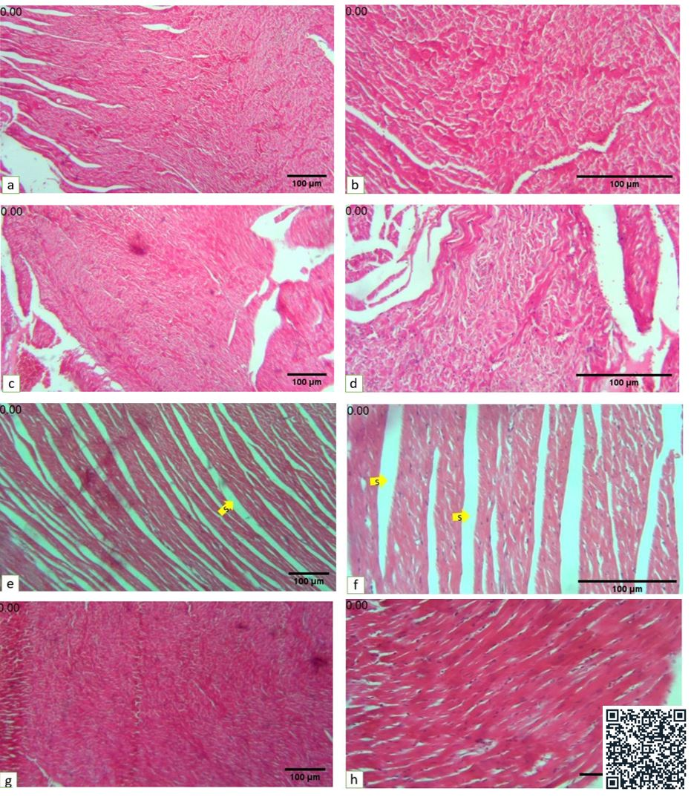
Figure S1: H&E staining of heart tissues. a,b: Control sample: the space between cardiac muscles and fascicles is normal. c, d: vitamin C group: cardiac muscles are normal. e,f: receiving TCA, yellow arrows (S) show large separation areas between cardiac muscles and muscular fascicles are clear (s). g,h: treated with TCA and vitamin C: the separation areas are reduced among cardiac muscles and improves. (a, c, e, g: 18X), (b, d, f, h: 45X), Scale bar=100µm
https://drive.google.com/file/d/15iipVH6ENqPn_-oI5mPWMpihOhvBrSZ9/view?usp=sharing

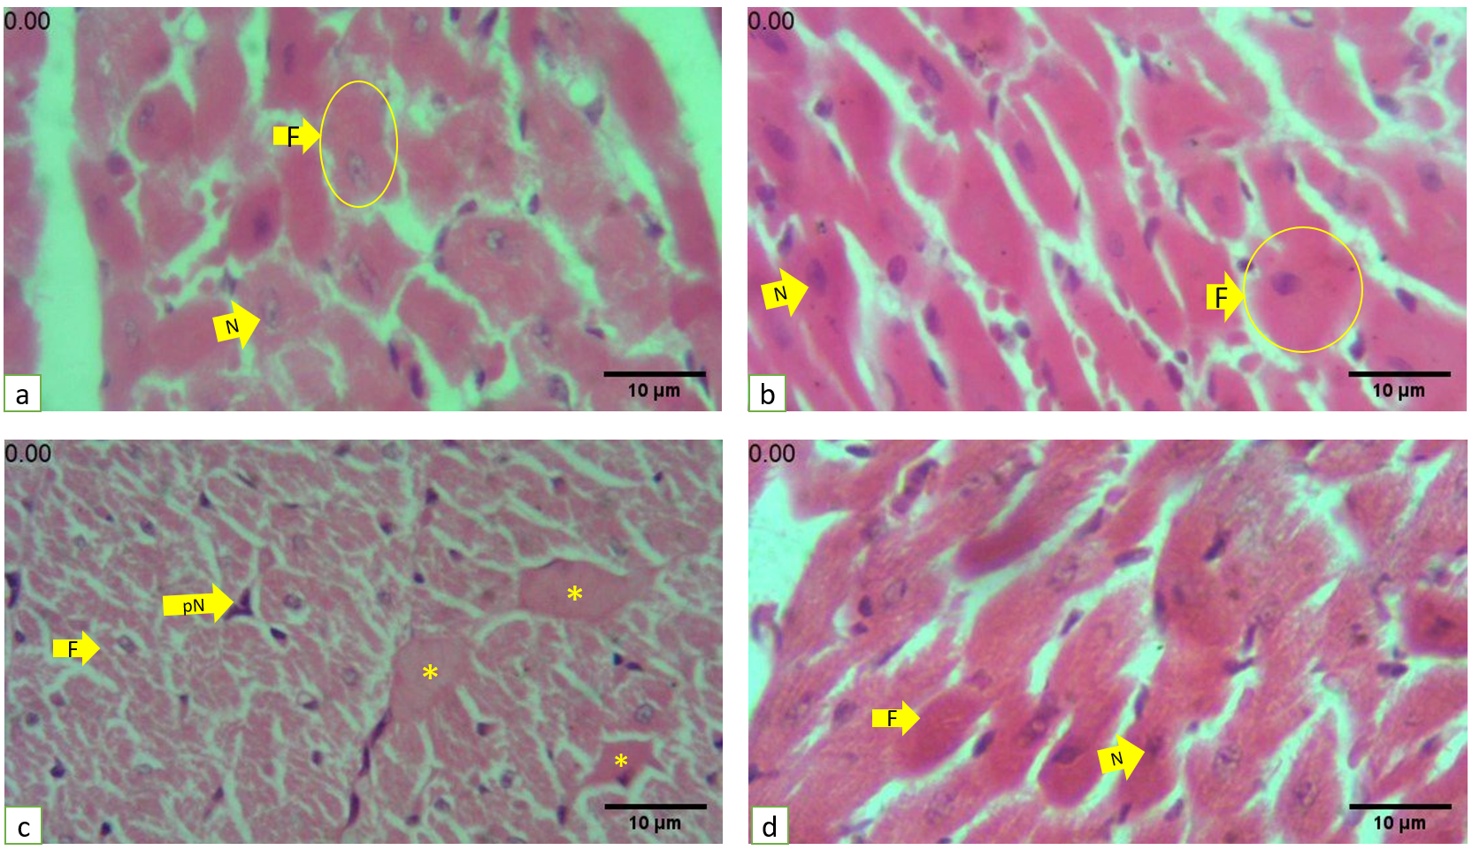
Figure S2: H&E staining of cardiac tissue in transverse section. a and b: Cardiac transverse section of Control and vitamin C groups: Nuclei of the Cardiocytes are euchromatin and located in the central location. c: TCA group: cardiac cells are abnormal and have hypochromic (pale) cytoplasm, and the cytoplasmic integrity is not seen in the muscles (F), dark and pyknotic nuclei of myocytes are observed (PN), (*) indicates the hyalinized area in the cardiac tissue. d: TCA and vitamin C, in which the normal morphology (F) The nuclei (N) are situated in the central region of the heart muscle in cross-section. a, b, c, and d: magnification 180X. Scale bar=10µm
https://drive.google.com/file/d/1rWOfOjuWn2JMOYK-0stiferFBU3atSZL/view?usp=sharing

Figure 2: link to video histopathology of H&E staining of cardiac tissues in longitudinal section.
https://drive.google.com/file/d/1by4I2jZ7DeYzAZtPGEnxZSh7FOoi8bHY/view?usp=sharing

Figure 3: link to video of fibrotic pattern of Masson’s trichrome staining
https://drive.google.com/file/d/1BHHXWreZF6vG2UsRSUH5eKCZwqV7Cwe/view?usp=sharing
Supplementary Table S2. Comparison of histopathological scores among groups

Histopathology parameters |  | Control  (A) | TAC  (B) | Vit C  (C) | TAC + Vit C  (D) | Kruskal–Wallis H (df=3, N=120) = | P value  (B vs. D)
Sarcolemma damage | Mean ± SE | 0.1667±  0.06920 | 2.733±  0.1065 | 0.3000±  0.08510 | 0.8000±  0.1213 | 81.15 | ****  <0.0001
Sarcolemma damage | IQR | (0.000, 0.000) | (3.000, 3.000) | (0.000, 1.000) | (0.000, 1.000) | 81.15 | ****  <0.0001
Sarcolemma damage | MIR | 35.83 | 104.0 | 41.70 | 60.50 | 81.15 | ****  <0.0001
Cardiocyte breakage | Mean ± SE | 0.06667±  0.04632 | 2.433±  0.1143 | 0.3667±  0.08949 | 0.8667±  0.1244 | 82.86 | ****  <0.0001
Cardiocyte breakage | IQR | (0.000, 0.000) | (2.000, 3.000) | (0.000, 1.000) | (0.000, 1.000) | 82.86 | ****  <0.0001
Cardiocyte breakage | MIR | 31.40 | 103.1 | 44.45 | 63.03 | 82.86 | ****  <0.0001
Myofibril loss | Mean ± SE | 0.3000±  0.08510 | 2.833±  0.06920 | 0.3333±  0.08754 | 1.067±  0.1168 | 85.62 | ****  <0.0001
Myofibril loss | IQR | (0.000, 1.000) | (3.000, 3.000) | (0.000, 1.000) | (1.000, 1.250) | 85.62 | ****  <0.0001
Myofibril loss | MIR | 35.95 | 104.9 | 37.33 | 63.80 | 85.62 | ****  <0.0001
Cardiocyte’s necrosis | Mean ± SE | 0.1667±  0.06920 | 2.467±  0.1148 | 0.4667±  0.1148 | 1.233±  0.1240 | 80.64 | ***  0.0010
Cardiocyte’s necrosis | IQR | (0.000, 0.000) | (2.000, 3.000) | (0.000, 1.000) | (1.000, 2.000) | 80.64 | ***  0.0010
Cardiocyte’s necrosis | MIR | 30.58 | 101.0 | 41.70 | 68.68 | 80.64 | ***  0.0010
Nuclear pyknosis | Mean ± SE | 0.2000±  0.07428 | 2.100±  0.1208 | 0.4667±  0.1148 | 0.9000±  0.1385 | 65.85 | ****  <0.0001
Nuclear pyknosis | IQR | (0.000, 0.000) | (2.000, 3.000) | (0.000, 1.000) | (0.000, 1.000) | 65.85 | ****  <0.0001
Nuclear pyknosis | MIR | 35.10 | 99.03 | 45.70 | 62.17 | 65.85 | ****  <0.0001
Fiber separation | Mean ± SE  IQR | 0.2667±  0.08212  (0.000, 1.000) | 2.867±  0.06312  (3.000, 3.000) | 0.6333±  0.1221  (0.000, 1.000) | 0.8000±  0.1304  (0.000, 1.000) | 77.50 | ****  <0.0001
Fiber separation | MIR | 34.93 | 105.0 | 48.22 | 53.88 | 77.50 | ****  <0.0001
Lipofuscin accumulation | Mean ± SE | 0.1000±  0.05571 | 1.300±  0.1189 | 0.2000±  0.07428 | 0.2667±  0.08212 | 58.46 | ****  <0.0001
Lipofuscin accumulation | IQR | (0.000, 0.000) | (1.000, 2.000) | (0.000, 0.000) | (0.000, 1.000) | 58.46 | ****  <0.0001
Lipofuscin accumulation | MIR | 43.90 | 95.90 | 49.30 | 52.90 | 58.46 | ****  <0.0001
Hyalinization | Mean ± SE | 0.1667±  0.06920 | 1.367±  0.1015 | 0.3667±  0.08949 | 0.6333±  0.1312 | 48.65 | ***  0.0005
Hyalinization | IQR | (0.000, 0.000) | (1.000, 2.000) | (0.000, 1.000) | (0.000, 1.000) | 48.65 | ***  0.0005
Hyalinization | MIR | 39.17 | 92.77 | 49.57 | 60.50 | 48.65 | ***  0.0005
Total Morphology | Mean ± SE | 0.1000±  0.04804 | 2.150±  0.1457 | 0.2750±  0.07996 | 0.7750±  0.09798 | 95.09 | ****  <0.0001
Total Morphology | IQR | (0.000, 0.000) | (1.000, 3.000) | (0.000, 0.7500) | (0.000, 1.000) | 95.09 | ****  <0.0001
Total Morphology | MIR | 46.85 | 131.6 | 57.14 | 86.41 | 95.09 | ****  <0.0001
Vascular congestion | Mean ± SE | 0.1000±  0.05571 | 2.733±  0.08212 | 1.000±  0.1269 | 1.70±  0.1369 | 88.82 | **  0.0055
Vascular congestion | IQR | (0.000, 0.000) | (2.000, 3.000) | (0.750, 1.250) | (1.000, 2.000) | 88.82 | **  0.0055
Vascular congestion | MIR | 20.85 | 99.07 | 49.95 | 71.15 | 88.82 | **  0.0055
Fibrosis | Mean ± SE | 0.03333±  0.03333 | 2.733±  0.08212 | 0.2000±  0.07428 | 0.6667±  0.1107 | 90.76 | ****  <0.0001
Fibrosis | IQR | (0.000, 0.000) | (2.000, 3.000) | (0.000, 0.000) | (0.000, 1.000) | 90.76 | ****  <0.0001
Fibrosis | MIR | 34.47 | 105.2 | 41.80 | 60.50 | 90.76 | ****  <0.0001

Descriptive statistics (Mean ± SE, IQR, and mean ranks) and Kruskal–Wallis test results for histopathological scores across groups (Control, TCA, Vit C, TCA+Vit C). For each parameter, H(df, N) with df = 3 and N = 120; rightmost columns show H(3, 120) and p. Significance: **** P≤0.0001, *** P≤0.001, ** P≤0.01, * P≤0.05.

Supplementary Table S3: Kruskal–Wallis H values and post-hoc Dunn’s test results for total

 |  | Adjusted P Value  Total Morphology | Kruskal–Wallis H Morphology (df=3, N=120) | Adjusted P Value  Congestion | Kruskal–Wallis H (df=3, N=120) = | Adjusted P Value  Fibrosis | Kruskal–Wallis H Fibrosis (df=3, N=120)
Kruskal–Wallis H |  |  | 95.09 |  | 88.82 |  | 90.76
Control vs. TCA | A-B | ****  <0.0001 | - | ****  <0.0001 | - | ****  <0.0001 | -
Control vs. VitC | A-C | ns  >0.9999 | - | **  0.0049 | - | ns  >0.9999 | -
Control vs. TAC+VitC | A-D | ***  0.0002 | - | ****  <0.0001 | - | **  0.0086 | -
TCA vs. VitC | B-C | ****  <0.0001 | - | ****  <0.0001 | - | ****  <0.0001 | -
TCA vs. TAC+VitC | B-D | ****  <0.0001 | - | **  0.0055 | - | ****  <0.0001 | -
VitC vs. TAC+VitC | C-D | *  0.0129 | - | ns  0.0912 | - | ns  0.1325 | -

morphology, congestion, and fibrosis.
Kruskal–Wallis H values are reported with degrees of freedom (df) and total sample size (N). Adjusted p-values are from Dunn’s multiple comparisons. Group codes: A – Control, B – TCA, C – VitC, D – TAC+VitC. ****: P≤0.0001, ***: P≤0.001, **: P≤0.01, *: P≤0.05, ns = not significant.

Table S5. Quantitative assessment of cardiac fibrosis in control, TCA, VIT C, and TCA+VITC.
Values are expressed as mean ± SEM. Statistical analysis was performed using nested one-way ANOVA. Adjusted P values indicate differences between the control, TCA, VIT C, group, and treatment groups (TCA+VIT C). Significance thresholds: *P < 0.05; **P < 0.01; **P < 0.001;****P <0.0001; ns = not significant.

Group | % Fibrosis |  | Nested one-way ANOVA  (F, DFn, Dfd) | P value | Subcolumns  differ  P value | Chi-square, df | Adjusted P Value
 | Mean ± SEM | Total Mean ± SEM | (20.12, 3, 16) | <0.0001  **** | >0.9999  ns | 0.000, 1 | Pvalue _{A & B}  <0.0001  ****  Pvalue _{A & C=}  0.7981  ns  Pvalue _{B & C=}  <0.0001  ****  Pvalue _{A & D=}  0.6982  ns  Pvalue _{B & D=}  0.0002  ***  Pvalue _{C & D=}  0.9964  ns
Control (A) | 3.469±0.7016 | 5.731±0.5550
Control (A) | 6.148±1.087
Control (A) | 6.776±1.597
Control (A) | 7.120±1.128
Control (A) | 5.603±1.425
TCA (B) | 16.08±2.964 | 15.53±1.651
TCA (B) | 14.38±5.219
TCA (B) | 15.09±4.919
TCA (B) | 16.42±3.786
TCA (B) | 15.43±2.799
VITC  (C) | 4.876±0.5458 | 7.024±0.6176
VITC  (C) | 8.585±1.908
VITC  (C) | 6.797±1.527
VITC  (C) | 7.505±1.212
VITC  (C) | 7.626±1.582
TCA+ VITC (D) | 7.226±1.347 | 7.335±0.6874
TCA+ VITC (D) | 7.166±1.699
TCA+ VITC (D) | 6.986±1.776
TCA+ VITC (D) | 5.167±0.8620
TCA+ VITC (D) | 10.13±1.460

