CCL21/CCR7 axis-driven CD8⁺ T cell recruitment and neuroinflammation in diabetic peripheral neuropathy

Ya Wu¹, Liye Chong², Danmeng Dong³, Lijie Zhu¹, Hao Luo⁴, Xiaoyun Xie^{2*}

¹ Department of Endocrinology and Metabolism, Shanghai Tenth People’s Hospital, Tongji University School of Medicine, Shanghai, China.
² Department of Interventional and Vascular Surgery, Shanghai Tenth People’s Hospital, Tongji University School of Medicine, Shanghai, China.
³ School of Medicine, Anhui University of Science and Technology, Huainan, China.
⁴ Department of General Medicine, Shanghai Tenth People’s Hospital, Tongji University School of Medicine, Shanghai, China.

*Correspondence:
Xiaoyun Xie
drxiaoyunxie@163.com

Materials and Methods
scRNA-seq
Single-cell suspensions were loaded into the Chromium™ Controller (10x Genomics) according to the manufacturer’s protocol to generate Gel Beads in Emulsion (GEMs). Each GEM encapsulated a single cell, a barcoded gel bead, and reagents required for cell lysis and reverse transcription. Within the droplets, cells were lysed and released RNA molecules hybridized to primers containing both cell-specific barcodes and unique molecular identifiers (UMIs). Reverse transcription was then performed to synthesize barcoded cDNA from individual RNA molecules, enabling unambiguous identification and quantification of transcripts at the single-cell level.
Sequencing libraries were prepared using the 10x Genomics library construction kit and sequenced on the Illumina® NovaSeq™ 6000 platform. Raw sequencing data were processed using CeleScope v1.5.2 (Singleron Biotechnologies) for extraction and correction of cell barcodes and UMIs. Adapter and polyA sequences were trimmed, and high-quality reads were aligned to the human reference genome (GRCh38/hg38) using STAR v2.6.1b, retaining only uniquely mapped reads. Gene annotation was performed with FeatureCounts.
Downstream quality control, dimensionality reduction, and clustering analyses were conducted in Python using Scanpy v1.8.1. Cells were retained if they met the following quality control criteria: (1) more than 200 detected genes and fewer than the 98th percentile of gene counts; (2) UMI counts below the 98th percentile; (3) mitochondrial gene content less than 10%; and (4) expression of a given gene in at least 5 cells.
Expression matrices were normalized using the NormalizeData and ScaleData functions in Seurat v2.3. Subsequently, highly variable genes were identified with the FindVariable function, and the top 600 variable genes were selected for principal component analysis (PCA). The first 16 principal components and a resolution parameter of 1.2 were used in the FindClusters function to delineate 30 distinct cell clusters. Major cell types were then annotated based on canonical marker genes, resulting in the identification of ten primary cell populations: B cells, basophils, CD4⁺ T cells, CD8⁺ T cells, dendritic cells, erythrocytes, monocytes, NK cells, neutrophils, and platelets.
Differential gene expression analysis was performed using the scanpy.tl.rank_genes_groups function with the Wilcoxon rank-sum test. Genes with a log₂ (fold change) > 0.25 and an adjusted P < 0.05 were considered significantly differentially expressed.
Gene Ontology (GO) enrichment and Kyoto Encyclopedia of Genes and Genomes (KEGG) pathway analyses of differentially expressed genes (DEGs) were performed using the clusterProfiler package in R (v4.0.0). The differentiation trajectory of CD8⁺ T cells was reconstructed with Monocle2 (v2.22.0).

Supplementary Table 1 Baseline characteristics of DPN and control patients with sciatic nerves collected
ID number | Age (years) | Gender | Diabetic course (years) | Comorbidity
DPN1 | 72 | Male | 26 | Hypertention, chronic obstructive pulmonary disease
DPN2 | 70 | Male | 19 | Hypertention, hyperlipidemia, hyperuricemia
DPN3 | 73 | Male | 24 | Stroke, hypertention, hyperlipidemia
DPN4 | 79 | Male | 15 | Coronary artery disease, hypertention, hypothyroidism, hyperlipidemia
Control1 | 78 | Male | 0 | Severe lower extremity peripheral arterial disease, hypertention, hyperlipidemia
Control2 | 82 | Male | 0 | Severe lower extremity peripheral arterial disease, hyperlipidemia, Alzheimer’s disease
Control3 | 72 | Male | 0 | Severe lower extremity peripheral arterial disease, coronary artery disease, obesity, hyperlipidemia

Supplementary Table 2 Baseline characteristics of T2DM and DPN patients with blood samples collected for scRNA-seq
ID number | Age (years) | Gender | Diabetic course (years) | HbA1c (%) | BMI (kg/m²)
DM_1 | 63 | Male | 6 | 12.5 | 23.5
DM_2 | 37 | Male | 5 | 8.2 | 24.2
DM_3 | 36 | Male | 4 | 11.8 | 25.4
DM_4 | 33 | Male | 3 | 9.6 | 23.7
DPN_1 | 39 | Male | 7 | 6.3 | 23.7
DPN_2 | 34 | Male | 5 | 10.7 | 23.4
DPN_3 | 63 | Male | 5 | 9.9 | 23.7
DPN_4 | 40 | Male | 6 | 13.4 | 24.9

Supplementary Table 3 Antibodies used in WB and IF
Antibodies | Manufacturers | Applications
CCR7 | Boster Biological Technology, China (Catalog No. BM4218) | WB and IF
CCL21 | AiFang biological, China (Catalog No. AFKL82485) | WB
CCL21 | AiFang biological, China (Catalog No. AF07415) | IF
CD3E | ABclonal Technology, China (Catalog No. A19017) | IF
CD4 | ABclonal Technology, China (Catalog No. A26036PM) | IF
CD8A | ABclonal Technology, China (Catalog No. A23305PM) | IF
Cleaved-caspase3 | Affinity Biosciences, China (Catalog No. BF0711) | IF
β-Actin | ABclonal Technology, China (Catalog No. AC026) | WB
GAPDH | ABclonal Technology, China (Catalog No. A19056) | WB
WB, western blot. IF, immunofluorescence.

Supplementary Fig. 1 CCL19 and CCL21 expression in sciatic nerve tissue from DPN patients and controls. A Immunofluorescence staining of CCL19. Scale bar = 50 μm. B Quantitative analysis of CCL21 in (A). C Immunofluorescence staining of CCL21. Scale bar = 50 μm. D Quantitative analysis of CCL21 in (C). *P<0.05.
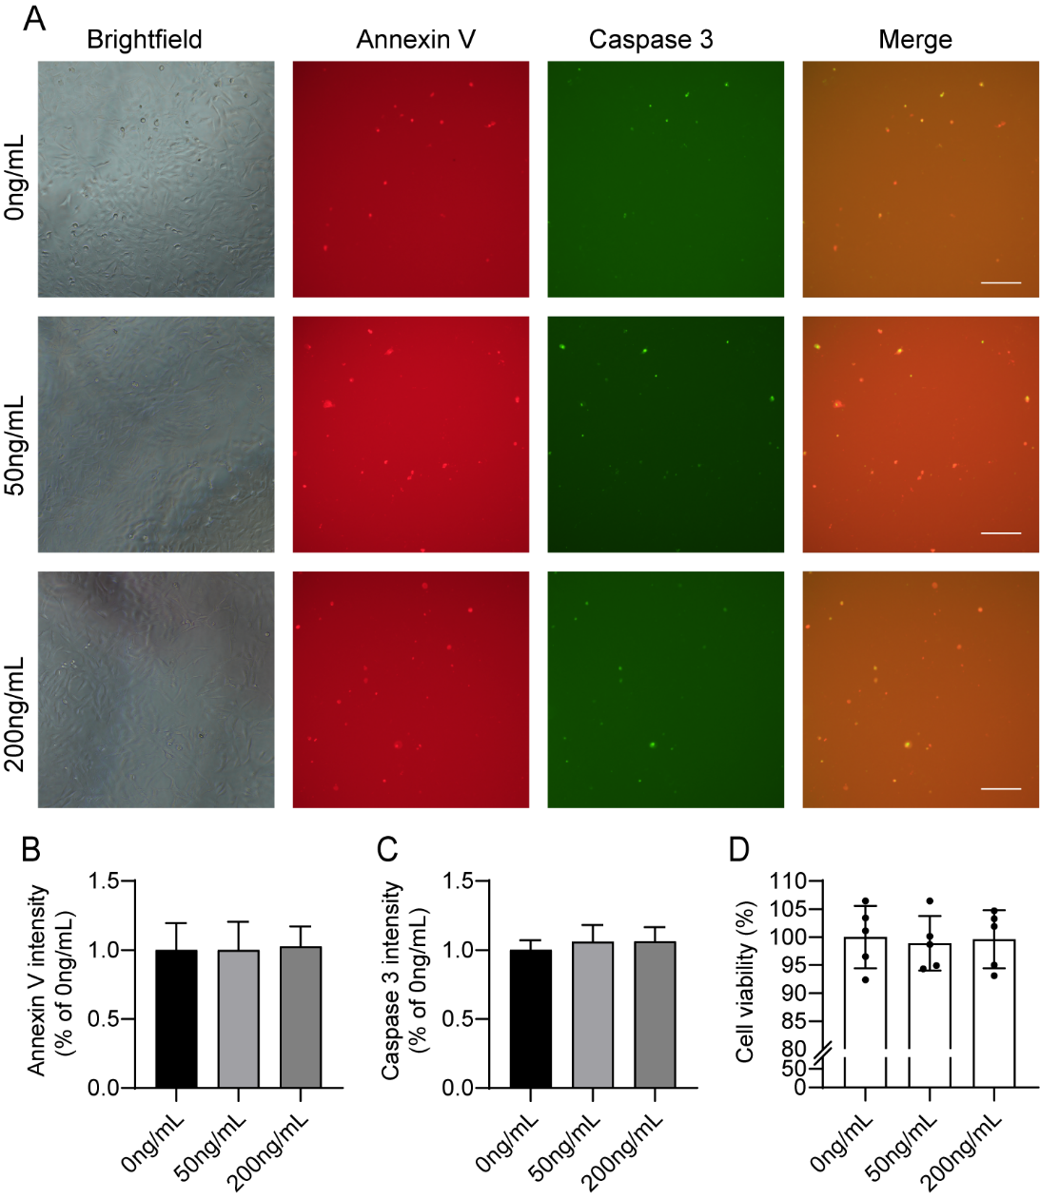
Supplementary Fig. 2 Effects of CCL21 on the function of HSCs. A Immunofluorescence staining for Annexin V and Caspase 3 in HSCs after stimulation with various 0, 50, or 200ng/mL CCL21 for 72 h, Scale bar = 200 μm. B and C Quantitative analysis of Annexin V and Caspase 3 in (A). D CCK8 assay illustrating changes in the proliferation of HSCs following exposure to 0, 50, or 200ng/mL CCL21 for 72 h.

