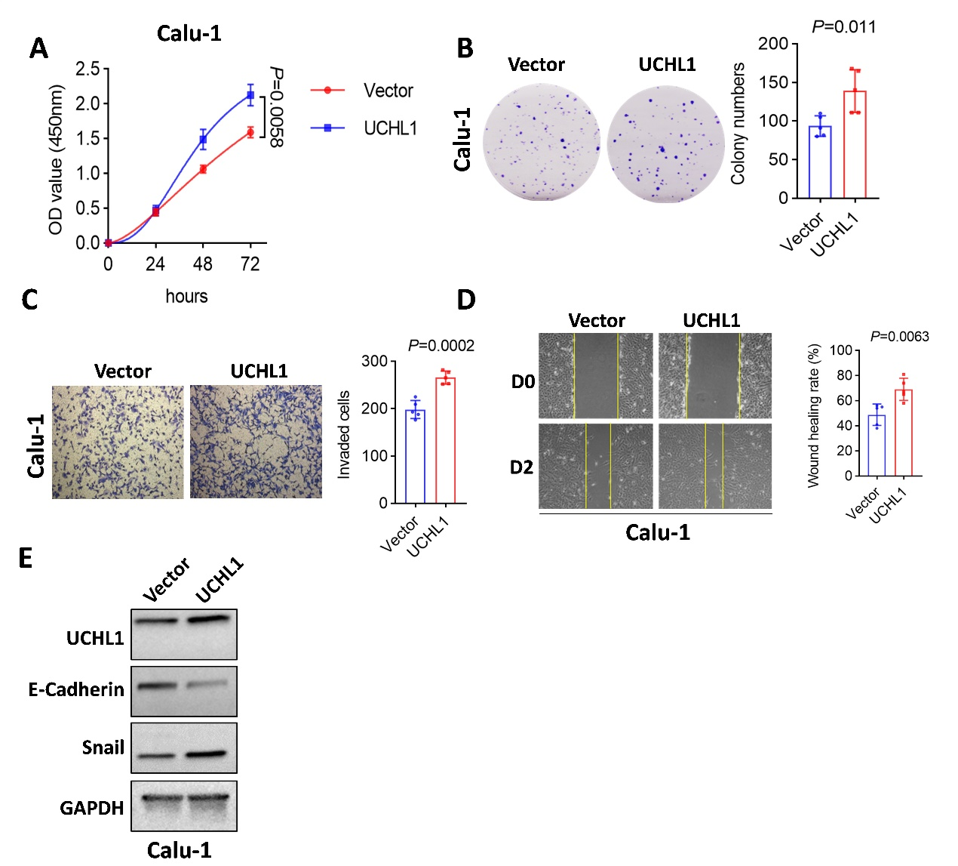
Figure S1. UCHL1 overexpression enhances malignant phenotypes in lung cancer cells
(A) CCK-8 assay showing the effect of UCHL1 overexpression on the proliferation of Calu-1 cells. (B) Colony formation assay showing enhanced clonogenic ability in UCHL1-overexpressing Calu-1 cells. (C) Transwell invasion assay showing increased invasive ability following UCHL1 overexpression in Calu-1 cells. (D) Wound-healing assay showing enhanced migratory ability in UCHL1-overexpressing Calu-1 cells. (E) Western blot analysis of E-cadherin and Snail expression in Calu-1 cells after UCHL1 overexpression. Data are presented as mean ± SD from three independent experiments.

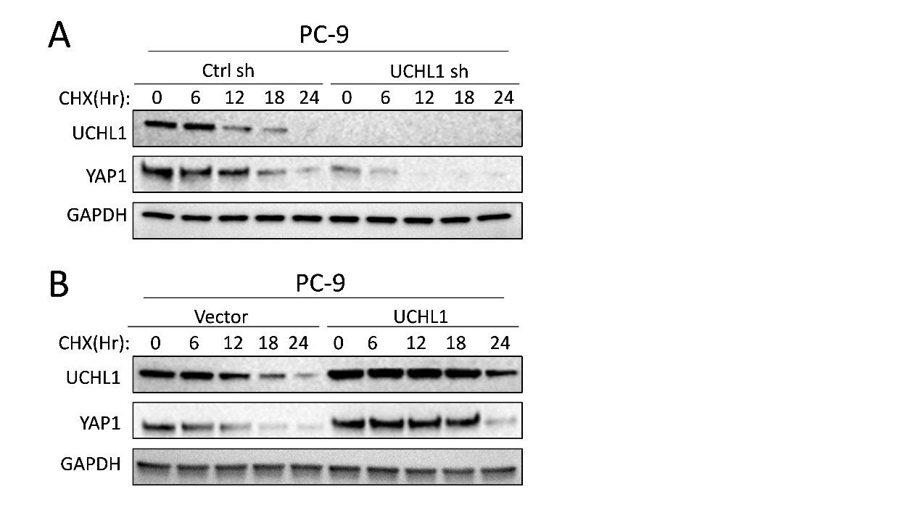
Figure S2. UCHL1 regulates YAP1 protein stability
(A) Quantification of YAP1 protein levels in the CHX chase assay following UCHL1 overexpression. (B) Quantification of YAP1 protein levels in the CHX chase assay following UCHL1 knockdown. Data are presented as mean ± SD from three independent experiments.

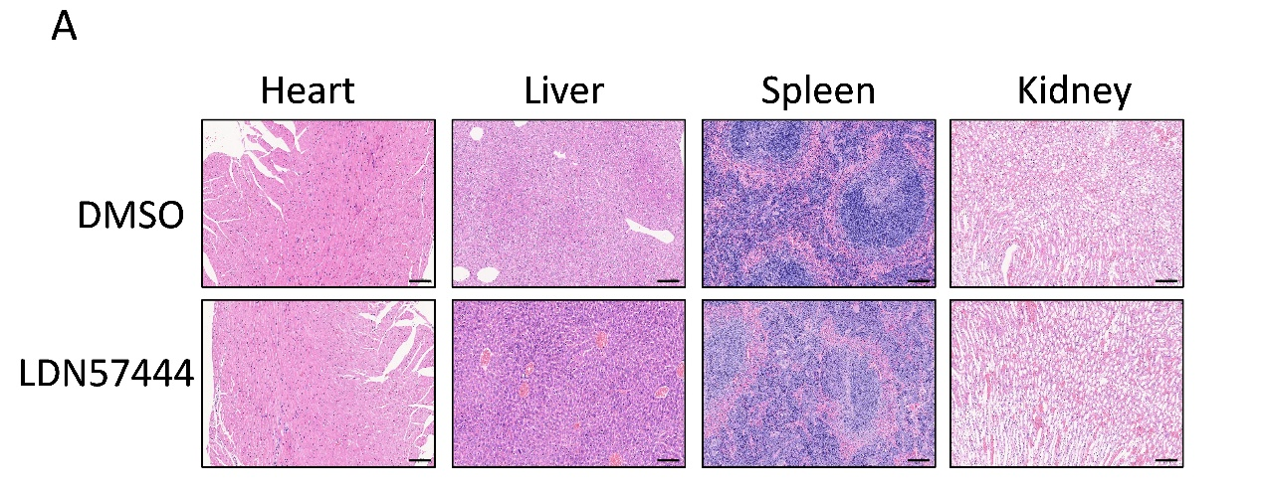

Figure S3. Evaluation of the safety of LDN-57444 treatment in vivo
(A) Representative H&E staining of the heart, liver, spleen and kidney from mice treated with DMSO or LDN-57444, showing no obvious histopathological damage in the major organs under the indicated treatment conditions. Data are presented as mean ± SD from three independent experiments.

