Field Testing of Storm-Resilient Floating Mat Systems for Grass Cultivation and Bio-char Generation
Nirmal Kumar¹, Damar David Wilson¹, Amit Singh², Bhupinder Singh³, Abishek Kafle³, Weihang Zhu³, Sandeep Kumar², Ram L. Ray¹*, Venkatesh Balan³.
¹Cooperative Agricultural Research Center, College of Agriculture, Food and Natural Resources, Prairie View A&M University, Prairie View, TX 77446. USA;
²Biomass Research Laboratory, Department of Civil and Environmental Engineering, Kaufman Hall Room 135, Old Dominion University, Norfolk, VA 23529, USA;
³Department of Engineering Technology, Biotechnology Program, Cullen College of Engineering, University of Houston, Sugar Land, TX 77479, USA.

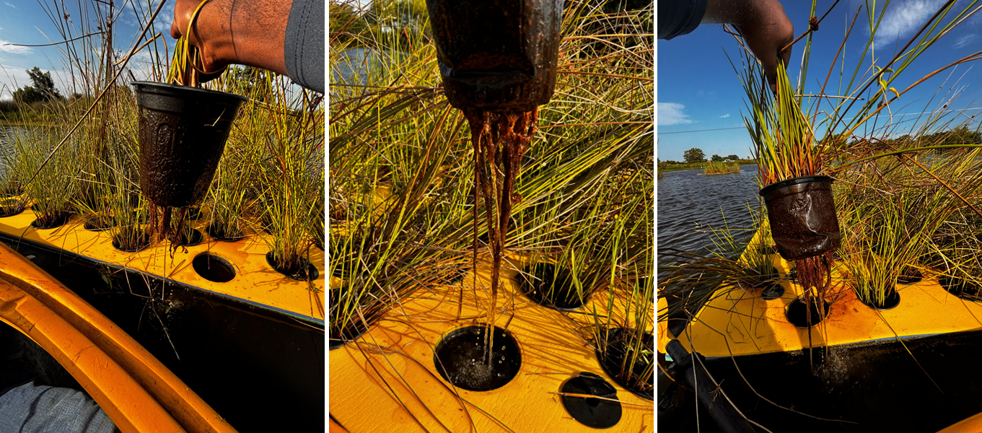
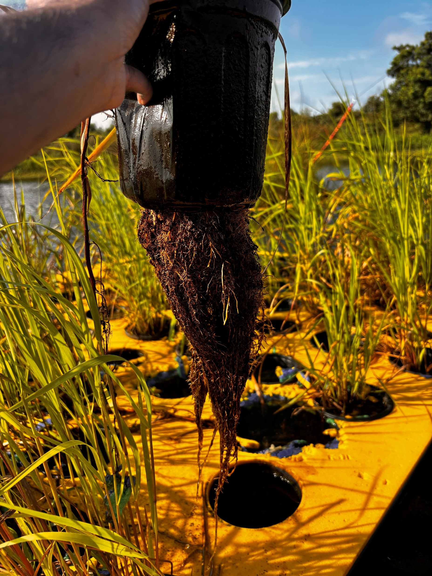
Supporting Information

(a) Common rush (5.8 cm)
01 August 2025
(b) Switchgrass (18 cm)
01 August 2025
Fig. S1 The field assessment demonstrates clear differences in below-ground growth between the two emergent species under identical floating-treatment conditions. Here, Switchgrass (b) developed substantially longer and more extensive root systems than common rush (a), suggesting enhanced rhizosphere formation and potentially greater nutrient uptake capacity and phytoremediation potential.
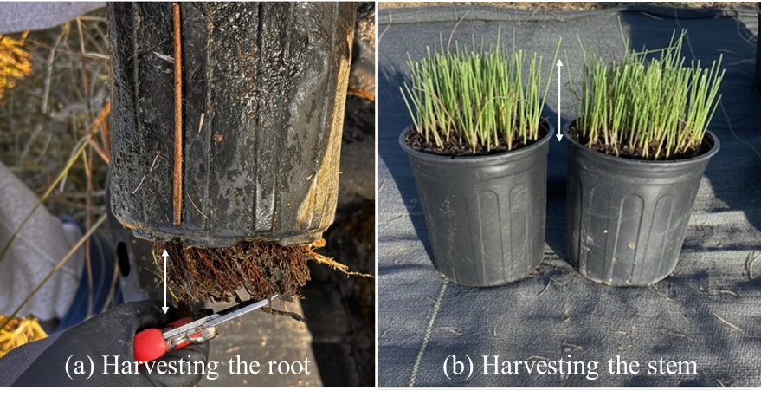
Fig. S2 The method used to harvest (a) the root and (b) the stem of common rush and switchgrass in December 2025.

Fig. S3 The daily rainfall and wind speed from June to December 2025 will be assessed to determine their effect on the floating mat.
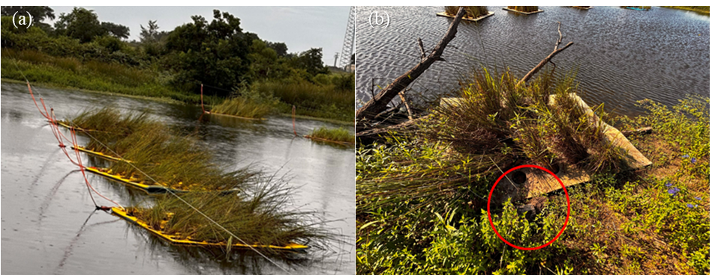
Fig. S4 Environmental Impacts on FTW Systems. The structural integrity and positioning of FTWs are significantly influenced by weather and biological factors. Here, (a) shows wind damage, where high-velocity, storm-induced gusts cause significant inclination of plant stems, and (b) Biological Interference, where turtles can release mats from their fixed positions by biting through the nylon mooring ropes underwater, and physical displacement, where unanchored mats are transported to the bank by buoyancy and shoreline currents, which can dislodge plant pots from their mat potholes.

Fig. S5 The daily maximum temperature and potential evapotranspiration from June to December 2025 will be assessed to evaluate their effects on the floating mat.
Table S1 The weather parameters used to assess the durability of floating mat systems
Sr. No | Weather parameters | Data sources
1 | Rainfall | NASA GPM gauge [33]
2 | Max. Temperature | RTMA [34]
3 | PET | GridMET [35]
4 | Wind speed | RTMA [34]

