Supplemental material for
GEDI spaceborne LiDAR reveals natural constraints and low-threshold human impacts on aboveground biomass across mainland China
Guoshuai Hou ª, Haonan Zhang ^{a,} *, Lianhao Sun ª, Yonglei Shi ^{b}
ª Chishui National Ecological Quality Comprehensive Monitoring Stations, Nanjing Institute of Environmental Sciences, Ministry of Ecology and Environment (MEE), Nanjing 210042, China
^{b} Co-Innovation Center for the Sustainable Forestry in Southern China, Nanjing Forestry University, Nanjing 210037, China

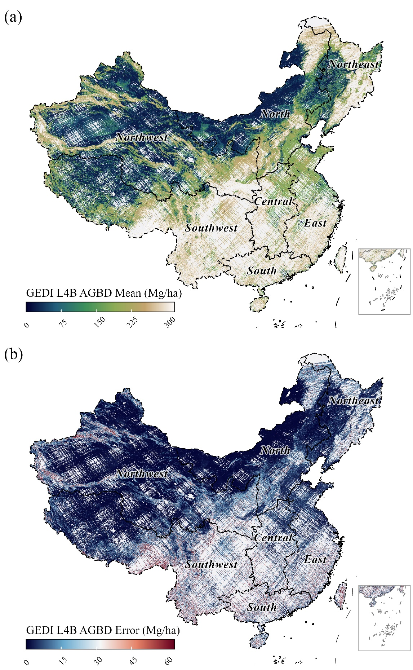
Figure S1. The GEDI L4B gridded AGBD product utilized for cross-product consistency screening. Panels illustrate (a) the grid-cell mean AGBD and (b) the associated standard error across China.
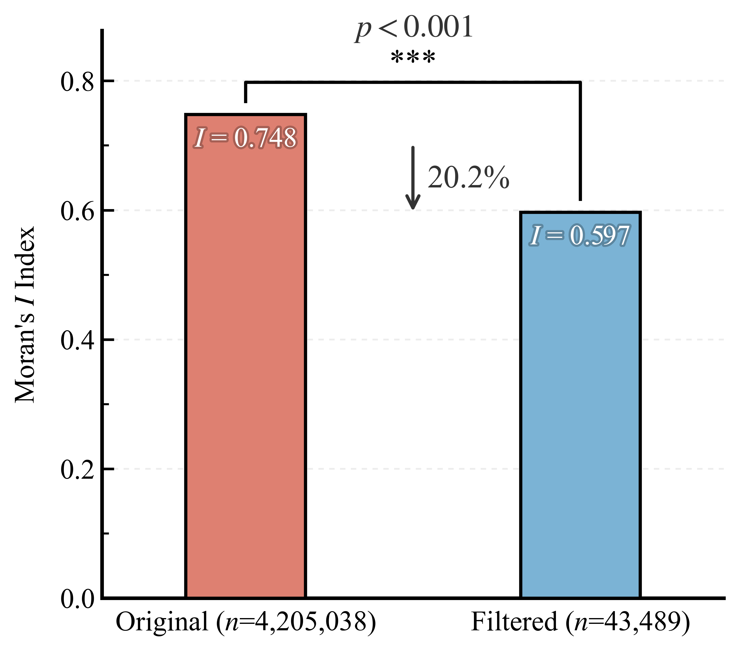
Figure S2. Mitigation of spatial autocorrelation through the filtering and spatial optimization protocol. The Moran’s I decreased significantly from the raw GEDI L4A retrievals (n = 4,205,038; Moran’s I = 0.748) to the retained high-confidence dataset (n = 43,489; Moran’s I = 0.597), representing a reduction of 20.2%.
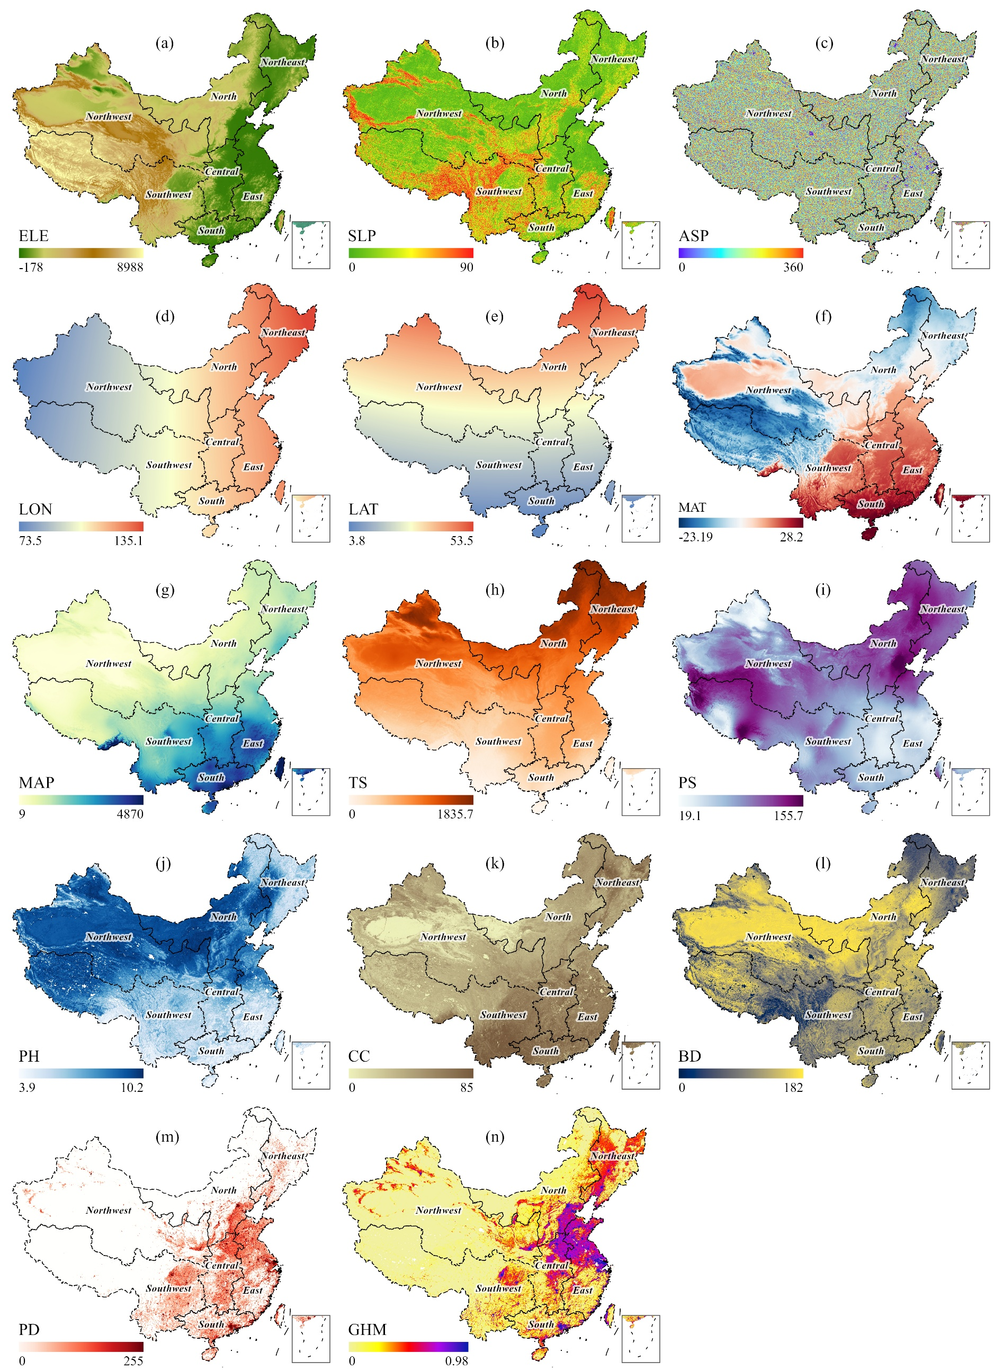
Figure S3. Spatial patterns of the multisource environmental covariates employed in the AGBD modeling framework across mainland China. (a-c) Topographic factors, including elevation (ELE), slope (SLP), and aspect (ASP); (d-e) Geographic location, comprising longitude (LON) and latitude (LAT); (f-i) Bioclimatic variables, representing mean annual temperature (MAT), mean annual precipitation (MAP), temperature seasonality (TS), and precipitation seasonality (PS); (j-l) Edaphic properties, including soil pH (PH), clay content (CC), and bulk density (BD); and (m-n) Anthropogenic drivers, represented by population density (PD) and the global human modification (GHM) index.
Table S1. Summary of GEDI L4A data processing and filtering criteria.
Processing | Parameter | Criterion | Description
Quality control | Quality flag | L4_quality_flag = 1 | Retain only high-quality biomass estimates verified by the L4A algorithm
Quality control | Degradation | Degrade_flag = 0 | Exclude waveforms with degraded geolocation or signal quality
Quality control | Solar elevation | Solar_elevation < 0 | Restrict to nighttime observations to minimize solar background noise
Quality control | Beam sensitivity | Sensitivity > 0.98 | Ensure sufficient laser energy penetration for ground detection
Uncertainty filtering | Elevation | Elevation > 0 m | Remove non-physical zero or negative biomass values
Uncertainty filtering | Slope | Slope < 30° | Filter out estimates with high measurement uncertainty
Uncertainty filtering | Biomass range | L4A_{me} > 0 | Remove non-physical zero or negative biomass values
Uncertainty filtering | Relative uncertainty | L4A_{se} / L4A_{me} < 30% | Filter out estimates with high measurement uncertainty
Cross-product consistency | L4B range | 0 < L4B_{me} < 3000 | Exclude NoData values and extreme outliers in the reference L4B product
Cross-product consistency | L4B consistency | L4A_{me} - L4B_{me} < 2 × L4B_{se} | Retain observations meeting the L4A-L4B consistency criterion
Spatial resampling | Spatial grid | 10km spatial grid | Reduce spatial autocorrelation by resampling to a regular equal-area grid
Spatial resampling | Grid optimization | Max sensitivity and min deviation | Select the single highest-quality representative footprint per grid cell
Note: L4A_{me} and L4A_{se} represent the mean AGBD estimate and its prediction standard error at the GEDI L4A footprint level. Correspondingly, L4B_{me} and L4B_{se} denote the grid-cell mean AGBD and its standard error for the L4B product.

Table S2. Region-specific optimized hyperparameters for XGBoost models.
Region | n_ estimators | max_depth | learning_rate | subsample | colsample_bytree | reg_alpha | reg_lambda
East | 527 | 5 | 0.013 | 0.84 | 0.53 | 4.86 | 1.44
South | 1668 | 7 | 0.006 | 0.62 | 0.66 | 1.57 | 1.68
North | 2421 | 8 | 0.006 | 0.95 | 0.55 | 2.78 | 6.88
Central | 981 | 4 | 0.005 | 0.52 | 0.70 | 0.01 | 5.52
Northeast | 1909 | 5 | 0.007 | 0.52 | 0.76 | 0.27 | 4.55
Northwest | 1787 | 6 | 0.007 | 0.70 | 0.52 | 3.54 | 0.01
Southwest | 825 | 9 | 0.008 | 0.62 | 0.70 | 0.09 | 4.18
National | 1216 | 7 | 0.013 | 0.84 | 0.59 | 0.01 | 3.26
Note: n_estimators denotes the number of boosting trees; max_depth is the maximum tree depth; learning_rate represents the step size; subsample and colsample_bytree correspond to the row and feature subsampling ratios; and reg_alpha and reg_lambda are the L1 and L2 regularization strengths, respectively.
References
Abrams, M., Crippen, R., Fujisada, H., 2020. ASTER Global Digital Elevation Model (GDEM) and ASTER Global Water Body Dataset (ASTWBD). Remote Sens. 12, 1156. https://doi.org/10.3390/rs12071156
Center for International Earth Science Information Network-CIESIN-Columbia University, 2018. Gridded population of the world, version 4 (GPWv4): Population density, revision 11. NASA Socioeconomic Data and Applications Center (SEDAC), Palisades, New York, USA. https://doi.org/10.7927/H49C6VHW
Dubayah, R.O., Armston, J., Kellner, J.R., Duncanson, L., Healey, S.P., Patterson, P.L., Hancock, S., Tang, H., Bruening, J., Hofton, M.A., Blair, J.B., Luthcke, S.B., 2022. GEDI L4A footprint level aboveground biomass density, version 2.1. ORNL DAAC, Oak Ridge, Tennessee, USA. https://doi.org/10.3334/ORNLDAAC/2056
Dubayah, R.O., Armston, J., Healey, S.P., Yang, Z., Patterson, P.L., Saarela, S., Stahl, G., Duncanson, L., Kellner, J.R., 2022. GEDI L4B gridded aboveground biomass density, version 2. ORNL DAAC, Oak Ridge, Tennessee, USA. https://doi.org/10.3334/ORNLDAAC/2056
Fick, S.E., Hijmans, R.J., 2017. WorldClim 2: new 1-km spatial resolution climate surfaces for global land areas. Int. J. Climatol. 37, 4302-4315. https://doi.org/10.1002/joc.5086
Hengl, T., Mendes de Jesus, J., Heuvelink, G.B.M., Ruiperez Gonzalez, M., Kilibarda, M., Blagotić, A., Shangguan, W., Wright, M.N., Geng, X., Bauer-Marschallinger, B., Guevara, M.A., Vargas, R., MacMillan, R.A., Batjes, N.H., Leenaars, J.G.B., Ribeiro, E., Wheeler, I., Mantel, S., Kempen, B., 2017. SoilGrids250m: Global gridded soil information based on machine learning. PLOS ONE 12, e0169748. https://doi.org/10.1371/journal.pone.0169748
Theobald, D.M., Oakleaf, J.R., Moncrieff, G., Voigt, M., Kiesecker, J., Kennedy, C.M., 2025. Global extent and change in human modification of terrestrial ecosystems from 1990 to 2022. Sci. Data 12, 606. https://doi.org/10.1038/s41597-025-04892-2

