Electronic Supplementary Material
Assessment of Groundwater Storage Variability and Recharge Dynamics in Nigeria's Major Aquifer Systems (2002-2024): An Integrated GRACE/GRACE-FO, GLDAS, and Borehole-Validated Satellite Gravimetry Analysis
Samuel Olaide Okediji
Department of Applied Geophysics, Federal University of Agriculture Abeokuta, Nigeria
samuelolaideokediji@gmail.com | ORCID: 0009-0001-3220-971X

ESM Table S1
Table S1 Chad Basin observation borehole water level decline 1960-2012. Positive values indicate artesian head above ground surface; negative values indicate water level below ground. Source: Miller et al. (1968) and Adamu et al. (2017).
Year | Dalori (Middle Zone) | Sabsawa (Middle Zone) | Gajibo (Lower Zone)
1960 | +5.8 m (artesian) | +12.5 m (artesian) | +12.5 m (artesian)
1965 | -18.2 m | +3.9 m (artesian) | +10.2 m (artesian)
2007 | -36.2 m | -4.0 m | +1.2 m (artesian)
2012 | -43.2 m | -6.8 m | +0.3 m
Net 1960-2012 | -49.0 m | -19.3 m | -12.2 m
Annual rate | -0.94 m yr-1 | -0.37 m yr-1 | -0.23 m yr-1

ESM Table S2
Table S2 Borehole validation summary across the six aquifer zones. Direct validation: monthly time series correlation against satellite anomalies. Indirect validation: formation-specific hydraulic parameters constraining Sy and aquifer geometry assumptions.
Zone | Sample Boreholes | Source Period | Depth Range (m) | T Range (m2 day-1) | Validation Type
Chad Basin | 15 USGS + 3 long-term | 1963-2012 | 55-400+ | 5.5-10,800 | Direct (1960-2012 time series)
Sokoto Basin | 40 hydrochemical | 2017 | 30-250 | 300-5,000 | Indirect (formation parameters)
Basement Complex | 34 VES sites | 2009-2020 | 2.45-37.88 | 0.01-50 | Indirect (geometry, Sy)
Niger Delta | 10 coastal boreholes | 2021 | 195-265 | 50-8,000 | Indirect (formation parameters)
Middle Niger | 17 VES at Lokoja | 2019 | 15-55 | 38-146,440 | Indirect (geometry, Sy)
Benue Trough | 30 VES + 12 LGAs | 2018, 2020, 2022 | 3-65 | 0.19-684 | Indirect (geometry, Sy)

ESM Fig S1
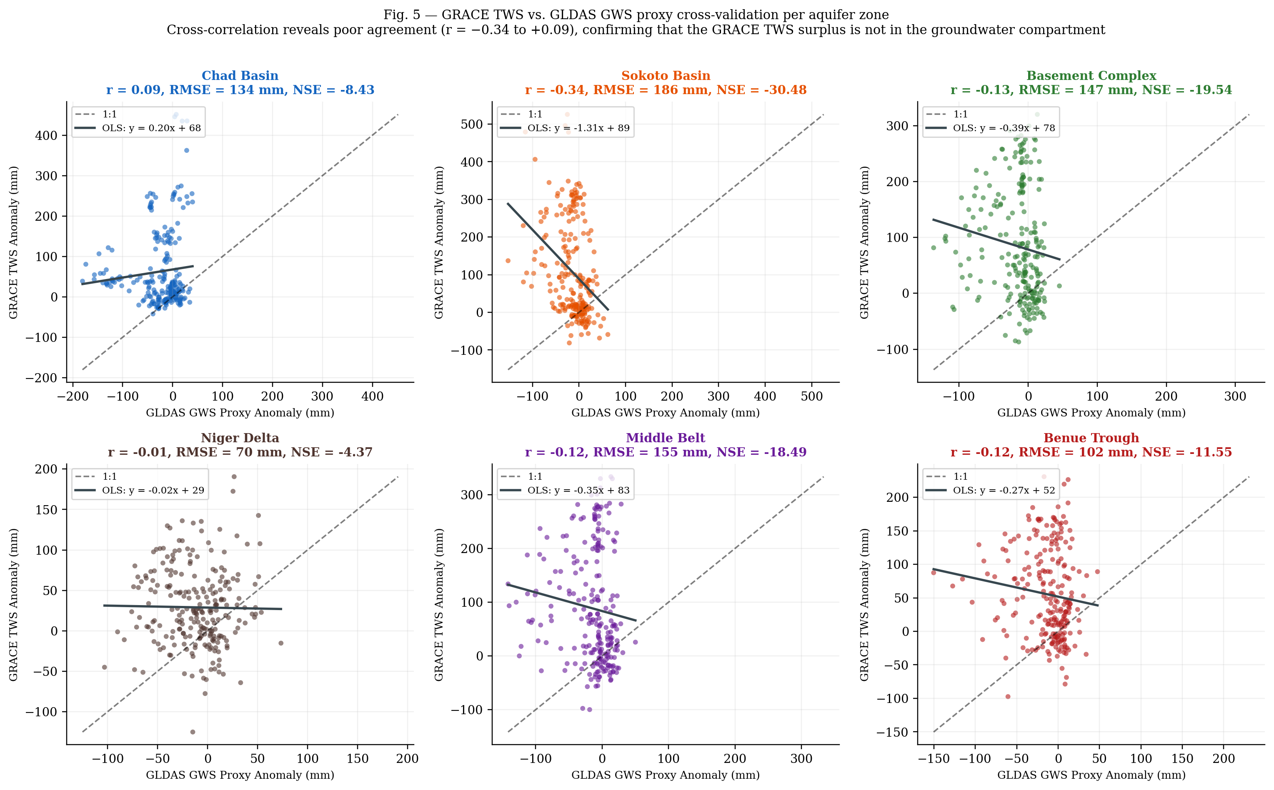
Fig. S1 Scatter plots of GRACE TWS anomaly versus GLDAS GWS proxy anomaly per aquifer zone (n = 238 overlapping months). Pearson correlations are weak (r = -0.34 to +0.09), with five of six zones showing weak negative correlation. RMSE 70-186 mm; NSE uniformly negative across all zones. Systematic departure from the 1:1 line quantifies the non-groundwater component in the GRACE TWS signal.

ESM Fig S2
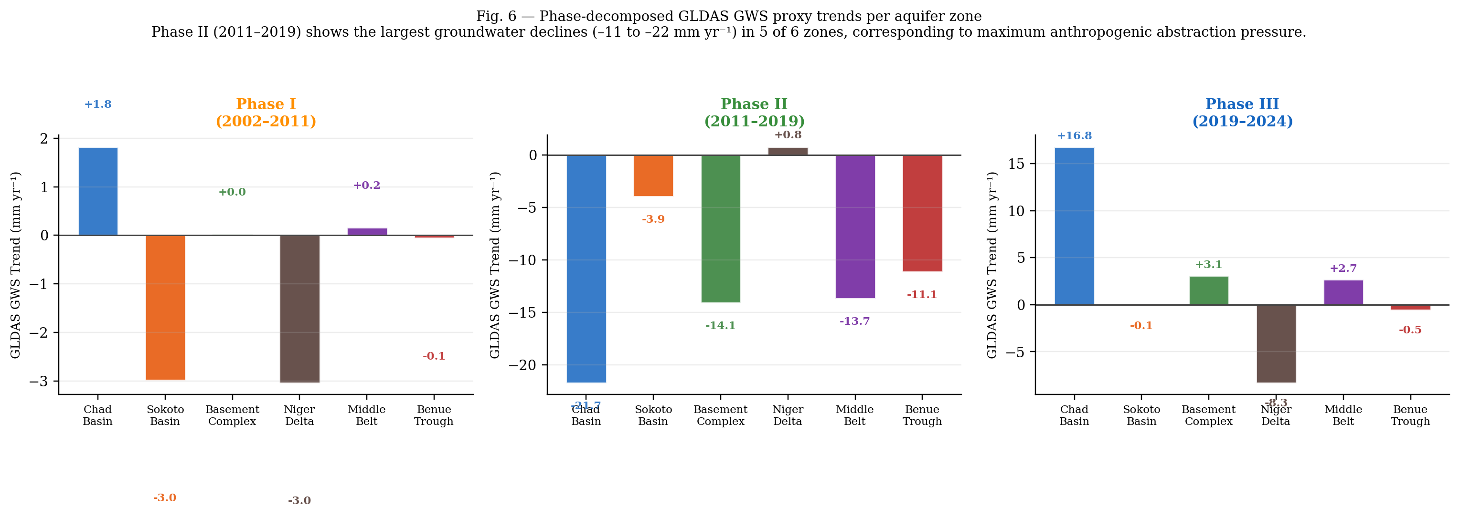
Fig. S2 Phase-decomposed GLDAS GWS proxy trends per aquifer zone. Phase I (2002-2010): near-zero trends in all zones (range -3.0 to +1.8 mm yr-1). Phase II (2011-2018): steepest declines in five of six zones (-11 to -22 mm yr-1) coinciding with documented motorised irrigation expansion. Phase III (2019-2024): partial recovery in northern zones; continued decline in the Niger Delta driven by urban demand growth.

ESM Fig S3
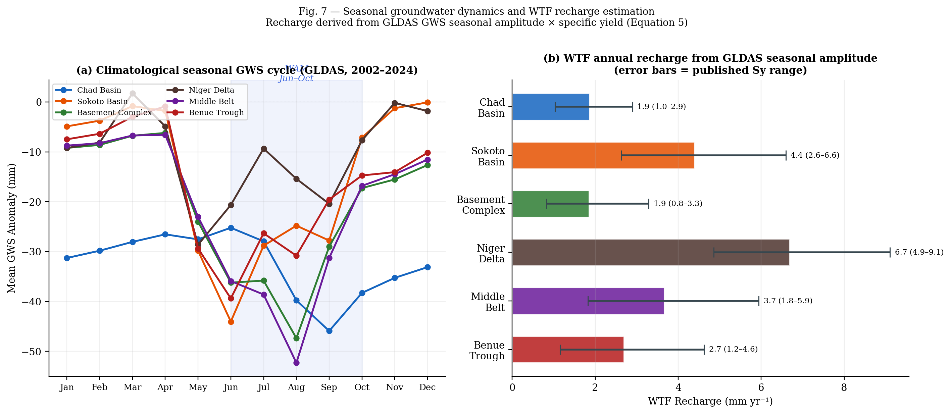
Fig. S3 Water Table Fluctuation (WTF) recharge estimation. (a) Climatological monthly GLDAS GWS seasonal cycle per zone (2002-2024 mean); West African Monsoon recharge season (June-October) shaded. (b) WTF annual recharge estimates per zone with sensitivity bars spanning published specific yield ranges per formation type.

ESM Fig S4
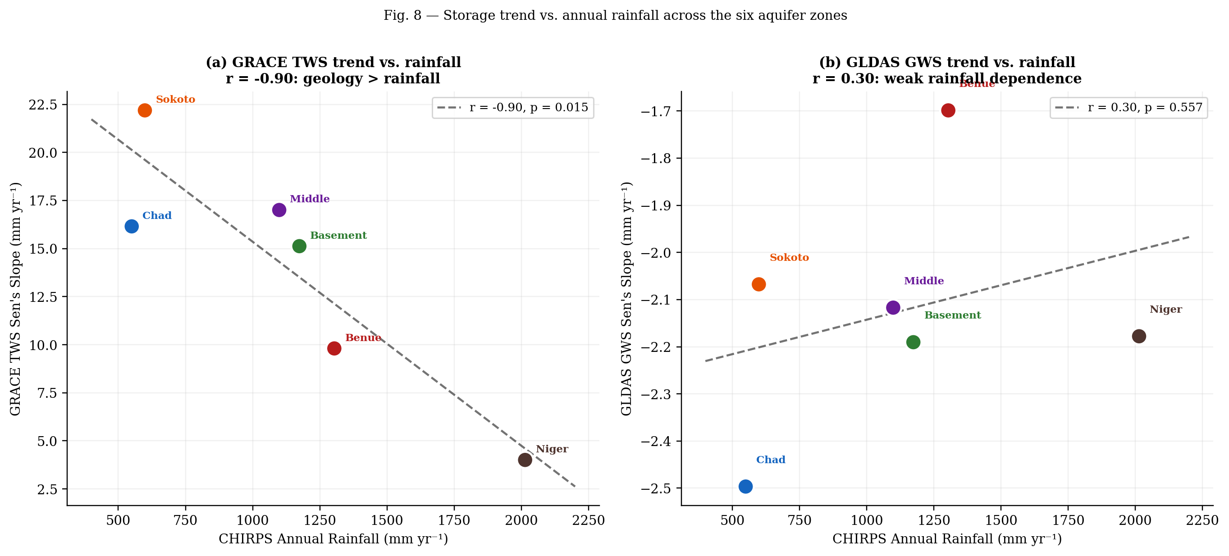
Fig. S4 Storage trend versus CHIRPS annual rainfall across the six aquifer zones. (a) GRACE TWS Sen's slope: r = -0.71 (inverse correlation with rainfall). (b) GLDAS GWS Sen's slope: r = -0.04 (no rainfall dependence). The contrast confirms that GRACE TWS signal in northern semi-arid zones is dominated by soil moisture and surface water seasonality, while the groundwater compartment tracked by GLDAS is approximately stationary regardless of rainfall.

ESM Fig S5
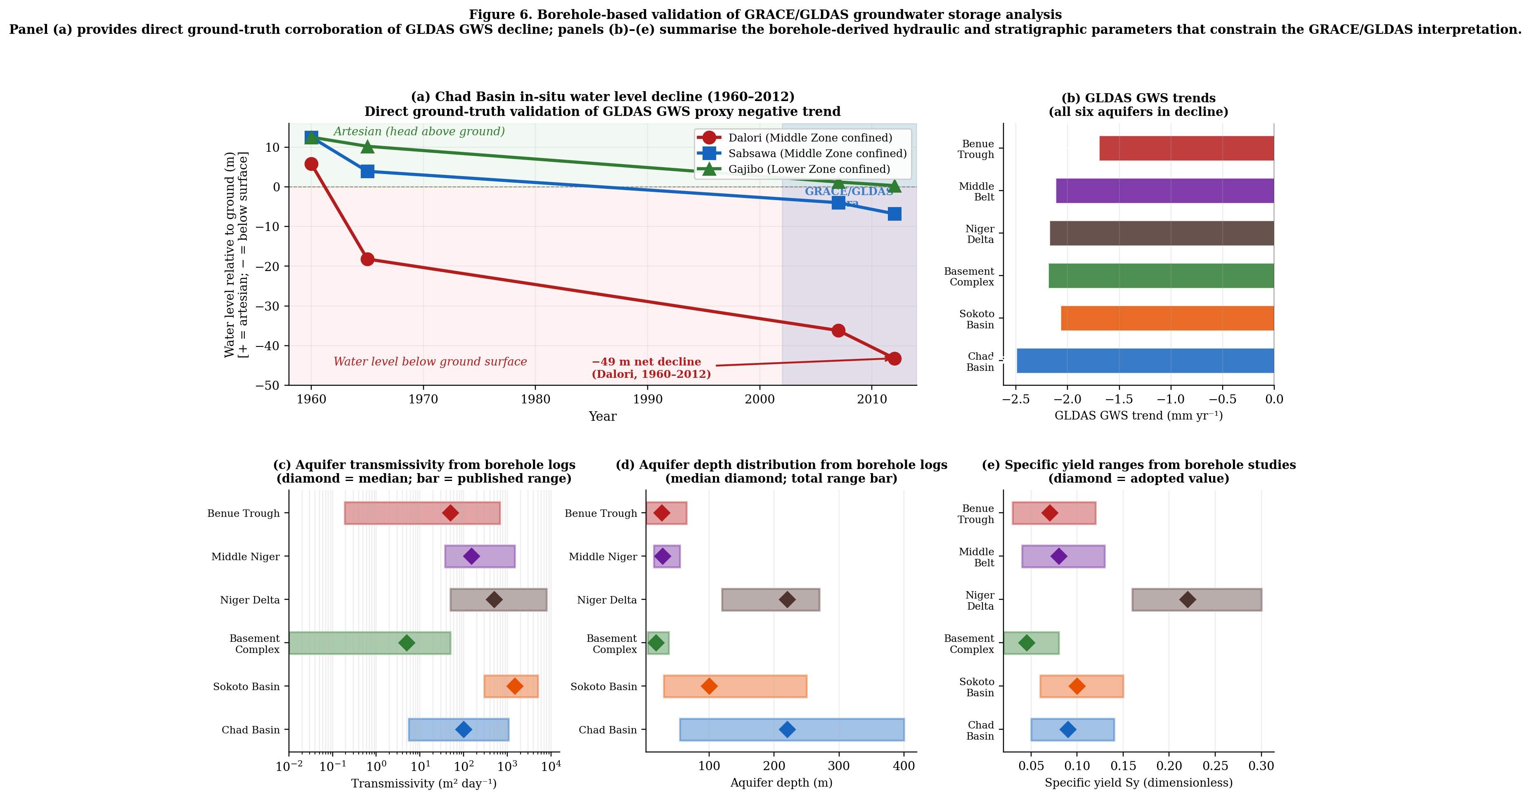
Fig. S5 Borehole-based validation of satellite groundwater storage estimates. Top: Chad Basin Middle Zone water level decline 1960-2012 at Dalori, Sabsawa, and Gajibo (Adamu et al. 2017; Miller et al. 1968). Bottom: cross-zone hydraulic parameter compilation from 90+ archival borehole sites supporting the formation-specific Sy parameterisation propagated through Equation 5 of the main paper.

