Real-time Multi-instrument Autonomous Materials Screening for Discovery of Novel Phase-change Memory Materials

Chih-Yu Lee ¹, Haotong Liang ¹, Austin McDannald ², Carlos A Rios Ocampo^{1,3}, A. Gilad Kusne ^{1,2}, Ichiro Takeuchi ^{1,4*}
¹ Department of Materials Science and Engineering, University of Maryland, College Park, MD, USA
² Materials Measurement Science, Division of the National Institute of Standards and Technology, Gaithersburg, MD, USA
³ Institute of Research in Electronics and Applied Physics, University of Maryland, College Park, Maryland, USA
⁴ Maryland Quantum Materials Center, University of Maryland, College Park, MD, USA
*Corresponding authors

S1 Demonstration of autonomous live experiment using MAD.
The video is available at: https://youtu.be/_X9Xb2-gIyY.

S2 NMF model selection.
The entire set of experimentally mapped data was used to evaluate the reconstruction error. At N = 7, the model captures approximately 90% of the explained variance. Considering the trade-off between achieving a reasonable minimum number of phases in a ternary compound system, minimizing NMF reconstruction error, and avoiding excessive model complexity, N = 7 was selected.
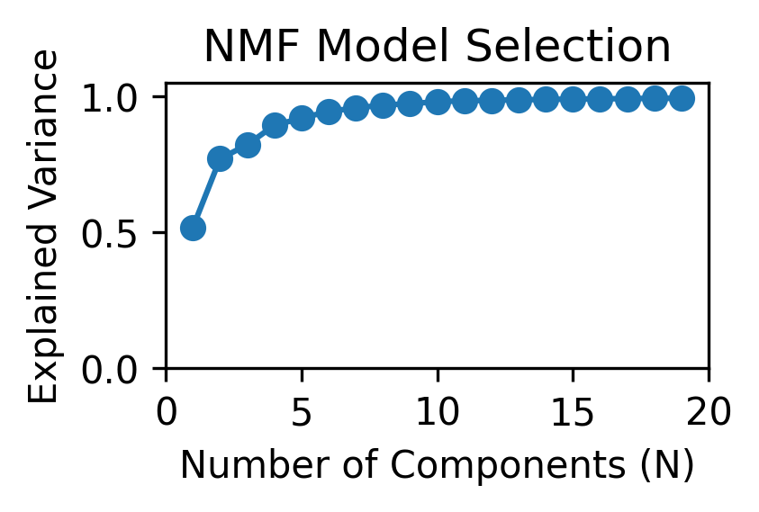

S3 Results of live experiment for the entire wafer.
The animation is available at: Github.
A snapshot is shown below as an example, reflecting the results from the 157th iteration. The correlation with the functional property (FP) is extracted from the coregionalized matrix in the Gaussian Process (GP). Performances are evaluated based on the ground truth (all) obtained from experimental measurements and on the data observed up to that iteration (measured).

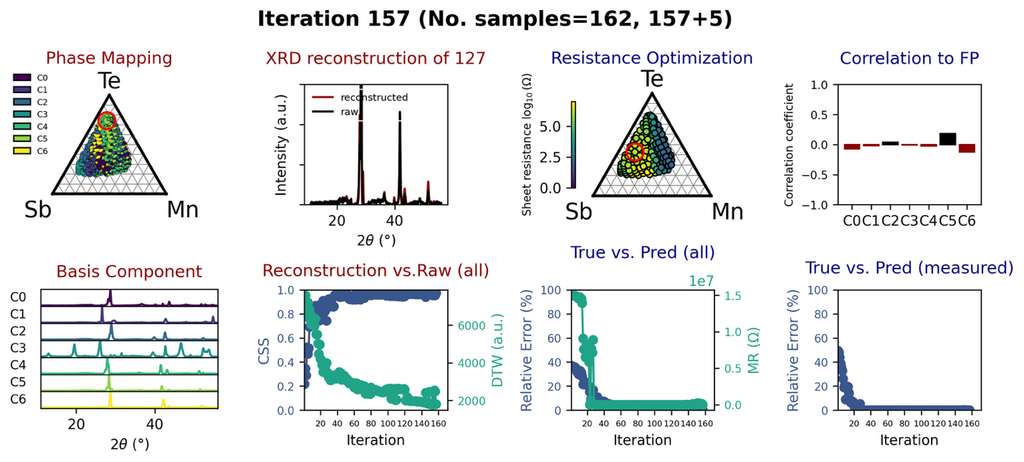

S4 Acquisition functions in Bayesian optimization and associated decision paths.
We adopt a max uncertainty (MU) maximum-uncertainty acquisition strategy because the objective of phase mapping is to accurately resolve phase boundaries and mixed-phase regions. The GP predictive variance of the NMF-derived abundances quantifies uncertainty in the local phase constitution across composition space. High variance naturally occurs near poorly sampled or structurally ambiguous regions; sampling these points maximizes information gain and accelerates convergence of the reconstructed phase diagram. Let $A_{i, j}$ be the GP’s posterior variance for each abundance of component $j$ for composition $i$ ($i=1,…,177;j=1,…,7$). The mean predicted variance for each composition is:

$${\overset{ˉ}{A}}_{i}= \sqrt{ \sum_{j=1}^{7}{A_{i,j}}}$$

The next composition to measure is chosen as the one with the highest mean predicted variance:

$$i_{next}=\arg{\max{{\overset{ˉ}{A}}_{i}}}$$

The mean predicted abundance ${\overset{ˉ}{A}}_{i}$ is calculated for each composition from the seven NMF components. The next composition to measure is selected as the one with the maximum ${\overset{ˉ}{A}}_{i}$, corresponding to the composition with the highest expected abundance.

The decision path of phase mapping is displayed as animation and available at: Github. A snapshot is taken at the 15th iteration. MAD endeavored to map the edge compositions at the beginning and proceeded with phase boundaries.
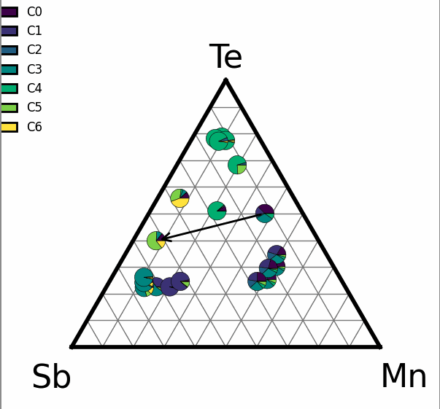

Expected improvement (EI) is used as the acquisition function of phase mapping.
EI for composition $i$:
$${\text{EI}}_{i}=(μ_{i}-f_{best}) Φ(Z_{i})+σ_{i} ϕ(Z_{i}),Z_{i}=\frac{μ_{i}-f_{best}}{σ_{i}}$$

where $μ_{i}$ and $σ_{i}$are GP-predicted mean and standard deviation for $f(x_{i})$, $f_{best}$ is the best observed functional property, and Φ (⋅) and $ϕ(⋅)$ are the CDF and PDF of the standard normal distribution, respectively. Next composition is chosen as the one with highest EI score:

$$i_{next}=\arg{\max{{EI}_{i}}}$$

S5 Performance metrics of MAD.
A. The cosine similarity score (CSS) between the reconstructed XRD pattern and the experimental measurement was calculated using the cosine similarity function:

$$CSS \left(x,y\right)= \frac{x∙y}{\left\|x\right\|\left\|y\right\|}= \frac{\sum_{i=1}^{N}{x_{i}y_{i}}}{\sqrt{\sum_{i=1}^{N}{{x_{i}}^{2}}} \sqrt{\sum_{i=1}^{N}{{y_{i}}^{2}}}}$$

where $x$ represents the reconstructed XRD intensity vector, $y$ represents the experimentally measured XRD pattern, and $N$ is the number of measured data points. The resulting similarity score takes a value between 0 and 1. 1 indicates perfect spectral agreement, and 0 indicates no similarity.

B. Dynamic time warping (DTW) distance was used to measure the minimum cumulative cost required to align two diffraction intensity profiles through an optimal warping path (window size), particularly capturing local peak shifts, broadening, or distortions. It is computed as:

$$DTW\left(x,y\right)= \min_{πP_{w}}{\sum_{\left(i,j\right) π}{\left|x_{i}-y_{i}\right|}}$$
where $x$ represents the reconstructed XRD intensity vector, $y$ represents the experimentally measured XRD pattern, and $P_{w}$ denotes admissible warping paths. In this work, the warping path (20 data points) corresponds to $≈4°$ in $2θ$and DTW was computed for each diffraction pattern independently across all scanned positions, and the overall DTW score was defined as the average DTW distance across all the compositions. Lower DTW values indicate better alignment and agreement between the patterns.

C. Mean squared error (MSE) quantifies the overall prediction accuracy by measuring the averaged squared differences between the predicted resistance (${\hat{y}}_{i}$) and experimentally measured values ($y_{i}$):

$$MSE= \frac{1}{N}\sum_{i=1}^{N}{{({\hat{y}}_{i}-y_{i})}^{2}}$$

where N represents the number of total measured data points.

D. Minimum regret distance (MR) quantifies how far the best measured composition is from the true global maximum. It is calculated as the Euclidean norm between the true global maximum value and the highest predicted value among the measured set:

$$MR= \left\|y_{max}^{true}- {\hat{y}}_{max}^{measured}\right\|$$

where

$${\hat{y}}_{max}^{measured}=\max\left({\hat{y}}_{i}\right|i ϵ measured)$$

S6 Resistance mapping of crystalline state and the contrast between amorphous and crystalline state.
(a) Sheet resistance measured on the same annealed wafer used for post-XRD characterization. Notably, several compositions remain insulating even though well-defined diffraction peaks are observed, while most compositions transition to a conducting state (on the order of hundreds of ohms). (b) The contrast between amorphous and crystalline states ΔR ($R_{\text{amo}}-R_{\text{cry}})$, reveals a distinct region exhibiting up to four orders of magnitude difference. The composition with the highest contrast is highlighted with a red circle.

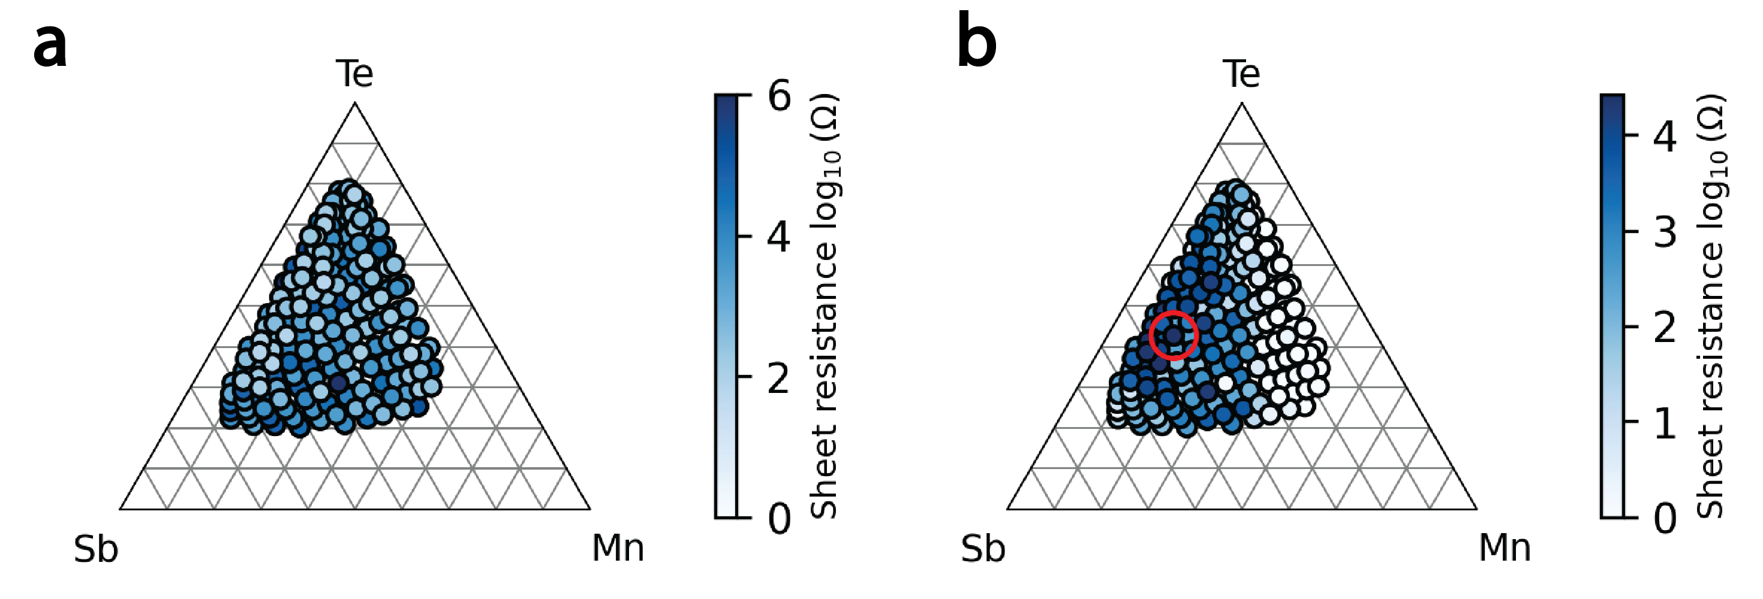

S7 Correlations extracted from coregionalized matrix.
First, the coregionalization matrix is computed as:

$$B=WW^{T}+diag(κ)$$
Then, to convert $B$ into correlation values, each covariance term $B_{ij}$ is normalized by the standard deviations of tasks $i$ and $j$:

$$\text{corr}(i,j)=\frac{B_{ij}}{\sqrt{B_{ii}} \sqrt{B_{jj}}}$$

An example is shown below as a correlation value of +1 indicates that the two tasks vary in an identical manner; a value of -1 reflects the tasks vary in completely opposite directions. However, since one task is formulated with a negative sign to convert the objective into a minimization problem, the sign of the correlation should be interpreted accordingly.
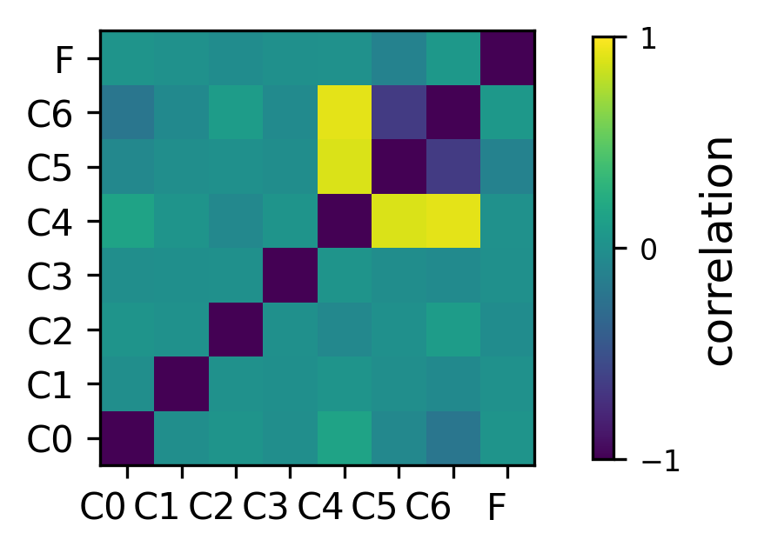
S9 Peak identification and phase matching.

