Supplemental Figures
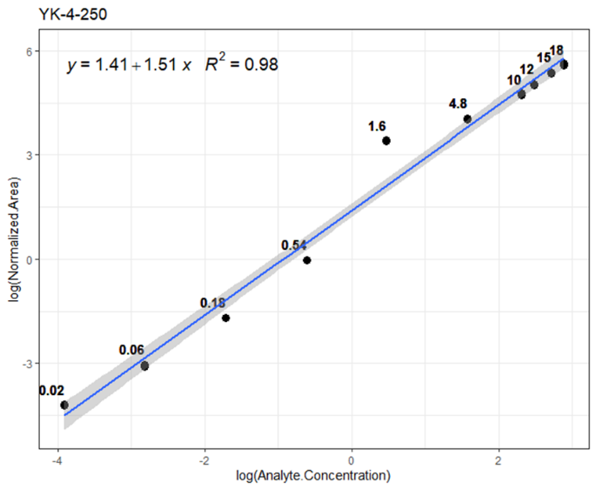

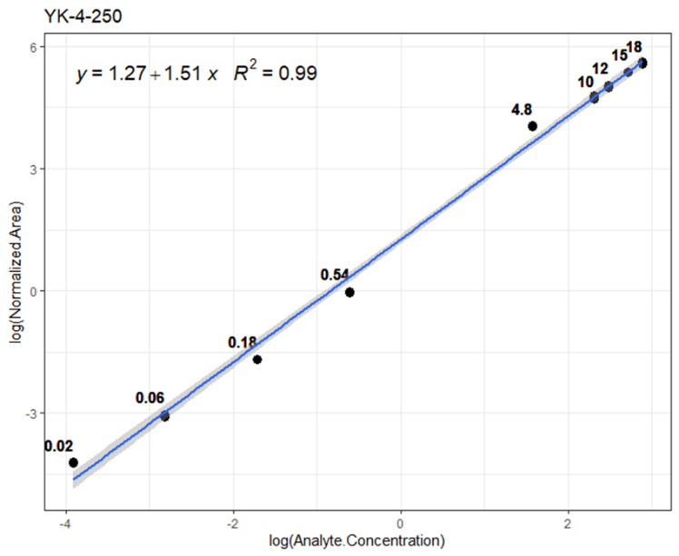

Figure S1. Calibration curves for YK-4-250 quantification in mouse plasma. Calibration standards (0.02–18.0 μg/mL) were analyzed by LC-MS, and the logarithm of the peak-area ratio of YK-4-250 to nimodipine (internal standard) was plotted against analyte concentration. Linear regression yielded y = 1.27 + 1.51x (R² = 0.99).

Chromatography conditions: HPLC: Vanquish Flex UHPLC System Thermo Fisher Scientific Analytic Column: Agilent Zorbax SB-C18 Column (2.1 × 50 mm, 3.5 μm). Guard column: Agilent Zorbax SB-C8 Column (2.1 × 12.5 mm, 5 μm) Column temperature: 30 ℃ Mobile phase: Buffer A: 0.1 % formic acid; Buffer B: 100 % Methanol with 0.1 % formic acid. Isocratic 63% Buffer B for 12 minutes, followed by 100 % Buffer B for 3 minutes and 63 % Buffer B for 3 minutes Flow rate: 0.200 mL/min.

Mass Spectrometry Conditions: Instrument: Q-Exactive hybrid quadrupole-Orbitrap mass spectrometer, equipped with an H-ESI source. Polarity: positive MS detector mode: MS1 full scan Scan range: 300 - 800 m/z Resolution: 70,000 K Automatic gain control (AGC): 3 x10⁶ Quantification ions: m/z 669.3673 for YK-4-250 ([M+H]⁺) and m/z 419.1813 for Nimodipine IS ([M+H]⁺).

Lock mass: Nimodipine (419.1813) was used as lock mass with a mass tolerance of 10 ppm.

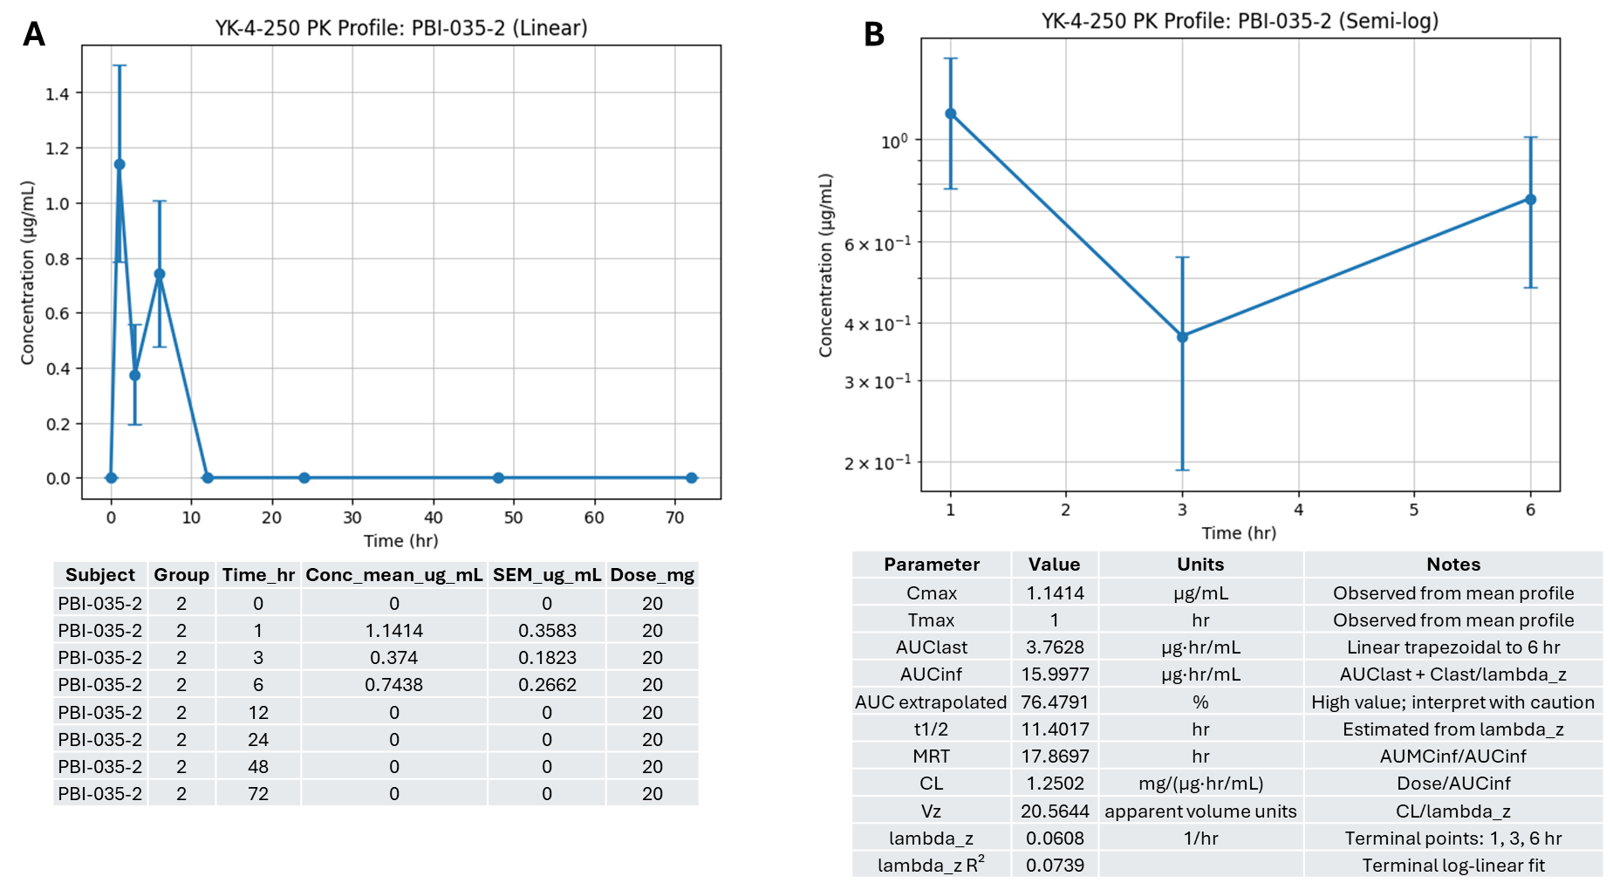

Figure S2. PK profile of Cohort PBI-035-2 (Male Normal, 20 mg/kg)

Analyses of Cohort PBI-035-2 (Male Normal, 20 mg/kg).
Figure S2A (Linear Scale) tracks the mean plasma concentration of YK-4-250 in non-irradiated male mice following a 20 mg/kg dose over 72 hours. The curve exhibits an immediate rapid surge, achieving a peak C_{max} of 1.1414 μg/mL at the 1-hour interval (T_{max} = 1 hr). Following this apex, the concentration decreases to 0.374 μg/mL at 3 hours, climbs to a secondary minor elevation of 0.7438 μg/mL at 6 hours, and subsequently declines below the detection threshold (0 μg/mL) from 12 hours through 72 hours.
Figure S2B (Semi-log Scale) plots the non-zero plasma concentrations from Group PBI-035-2 on a logarithmic y-axis against time to examine the elimination profile. The plot visualizes only the measured values at 1 hour (1.1414 μg/mL), 3 hours (0.374 μg/mL), and 6 hours (0.7438 μg/mL) before the drug becomes unquantifiable. Due to the fluctuating up-and-down pattern among these three early time points, the terminal log-linear regression line demonstrates an extremely low coefficient of determination (λz\ R² = 0.0739). Consequently, the extrapolated parameter calculations for this group, such as the high AUCextrap % of 76.41 %, carry a notable degree of estimation uncertainty.

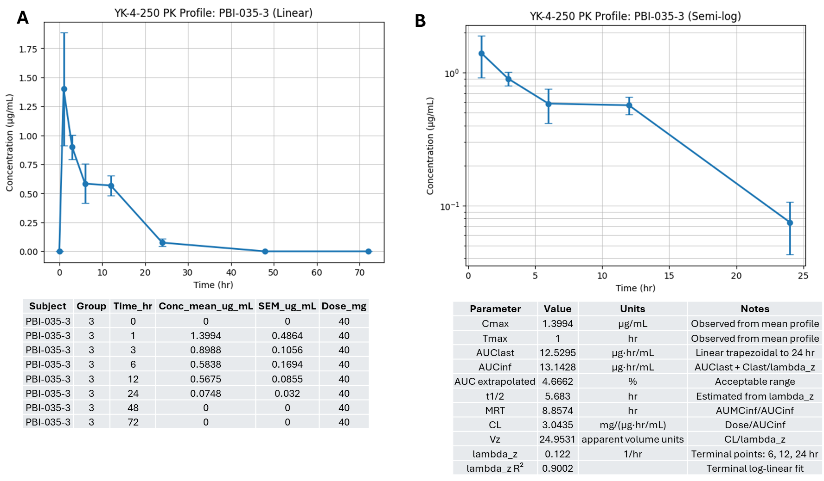

Figure S3. PK profile of Cohort PBI-035-3 (Male Normal, 40 mg/kg)

Analyses for Cohort PBI-035-3 (Male Normal, 40 mg/kg).
Figure S3A (Linear Scale) describes the plasma concentration-time course for non-irradiated male mice receiving an increased dose of 40 mg/kg. Absorption occurs rapidly, reaching an observed C_{max} of 1.3994 μg/mL at 1 hour post-dose T_{max} = 1 hr. After this peak, the plasma concentration steadily decreases over time, moving through 0.8988 μg/mL at 3 hours, 0.5838 μg/mL at 6 hours, 0.5675 μg/mL at 12 hours, and dropping to a final measurable level of 0.0748 μg/mL at 24 hours before falling below the limit of quantification at 48 and 72 hours.
This semi-logarithmic plot Figure S3B displays the elimination trend lines across the measurable time span for Group PBI-035-3. The log-linear regression is fitted using the terminal elimination points at 6, 12, and 24 hours. In contrast to the 20 mg/kg group, these points align in a consistent downward log-linear trajectory, yielding a strong goodness-of-fit value (λz R² = 0.9002). This reliable terminal slope yields a calculated t_{1/2} of 5.6830 hours and a low AUC extrapolation percentage of 4.67 %, confirming that the systemic exposure estimates are well-supported by the observed data.
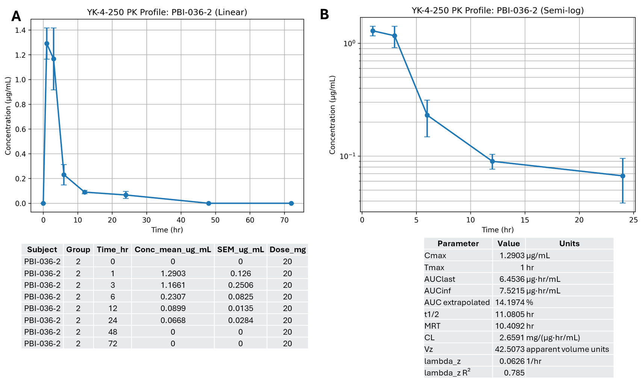
Figure S4. PK Profile of Cohort PBI-036-2 (Female Normal, 20 mg/kg)

Analyses of Cohort PBI-036-2 (Female Normal, 20 mg/kg)
Figure S4A (Linear Scale) tracks the PK profile in non-irradiated female mice at the 20 mg/kg dose level. The drug is absorbed rapidly, with plasma concentrations peaking at a C_{max} of 1.2903 μg/mL at the 1-hour time point (T_{max} = 1 hr). The concentration decreases to 1.1661 μg/mL at 3 hours, followed by a more distinct clearance phase that lowers levels to 0.2307 μg/mL at 6 hours, 0.0899 μg/mL at 12 hours, and 0.0668 μg/mL at 24 hours, eventually dropping to zero by 48 hours.
This semi-logarithmic Figure S4B (Semi-log Scale) highlights the systemic clearance phase for the non-irradiated, 20 mg/kg female group. The terminal regression line utilizes the measured values across the extended clearance window. The calculated terminal elimination rate constant (λz = 0.06260/hr) corresponds to a calculated elimination t_{1/2} of 11.0805 hours. The model fit achieves an intermediate coefficient of determination (λz R² = 0.785), resulting in a moderately extrapolated area percentage (AUCextrap % = 14.20 %).

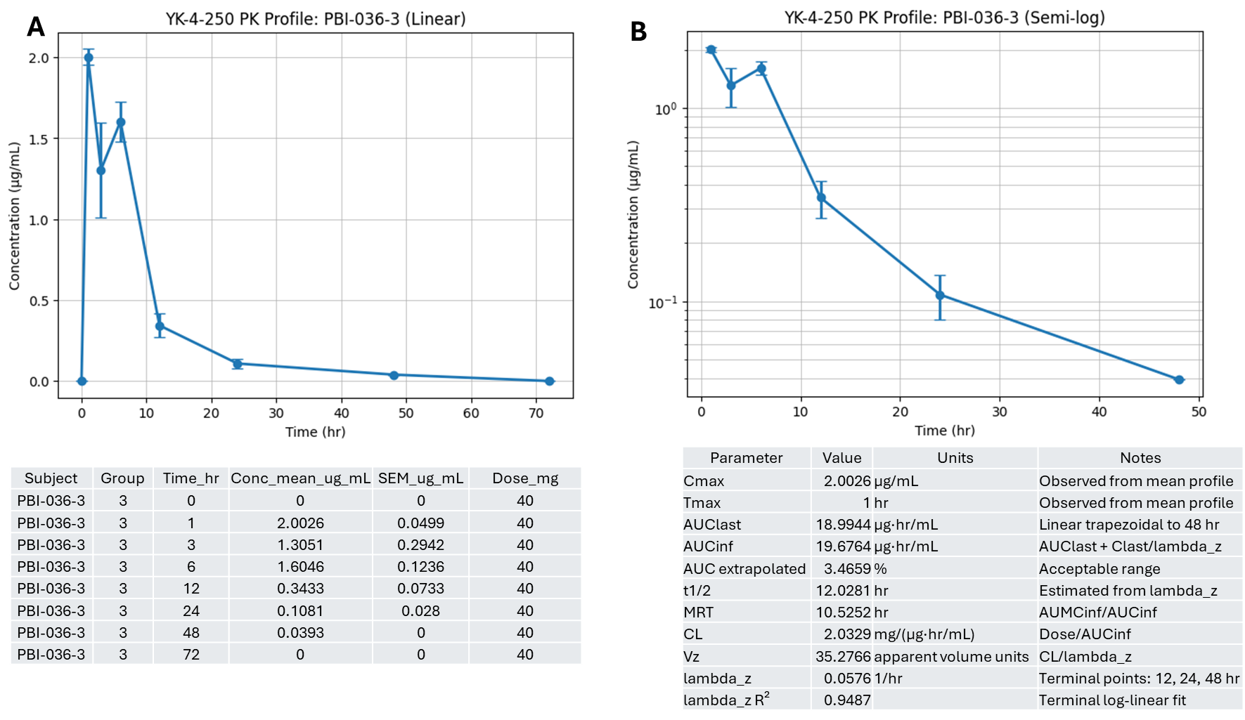

Figure S5. PK Profile of Cohort PBI-036-3 (Female Normal, 40 mg/kg)

Analyses of Cohort PBI-036-3 (Female Normal, 40 mg/kg)
Figure S5A (Linear Scale) illustrates the impact of doubling the dose to 40 mg/kg in non-irradiated female mice. Peak systemic exposure increases to a C_{max} of 2.0026 μg/mL, which is achieved rapidly at 1 hour post-dose (T_{max} = 1 hr). The concentration drops slightly to 1.3051 μg/mL at 3 hours, exhibits a small secondary peak of 1.6046 μg/mL at 6 hours, and then progressively clears to 0.3433 μg/mL at 12 hours, 0.1081 μg/mL at 24 hours, and 0.0393 μg/mL at 48 hours before falling below quantifiable limits by 72 hours.
This semi-logarithmic Figure S5B displays the terminal elimination analysis for the 40 mg/kg non-irradiated female group. The terminal log-linear regression line is fitted using the 12, 24, and 48-hour data points. These points follow a highly consistent log-linear elimination pathway, resulting in an excellent goodness-of-fit value λzR² = 0.9487). This stable terminal trajectory yields a calculated terminal t_{1/2} of 12.0281 hours and an AUC extrapolation percentage of 3.47 %, indicating high reliability for the total systemic exposure calculations (AUC_{inf} = 19.6764 μg·hr/mL).
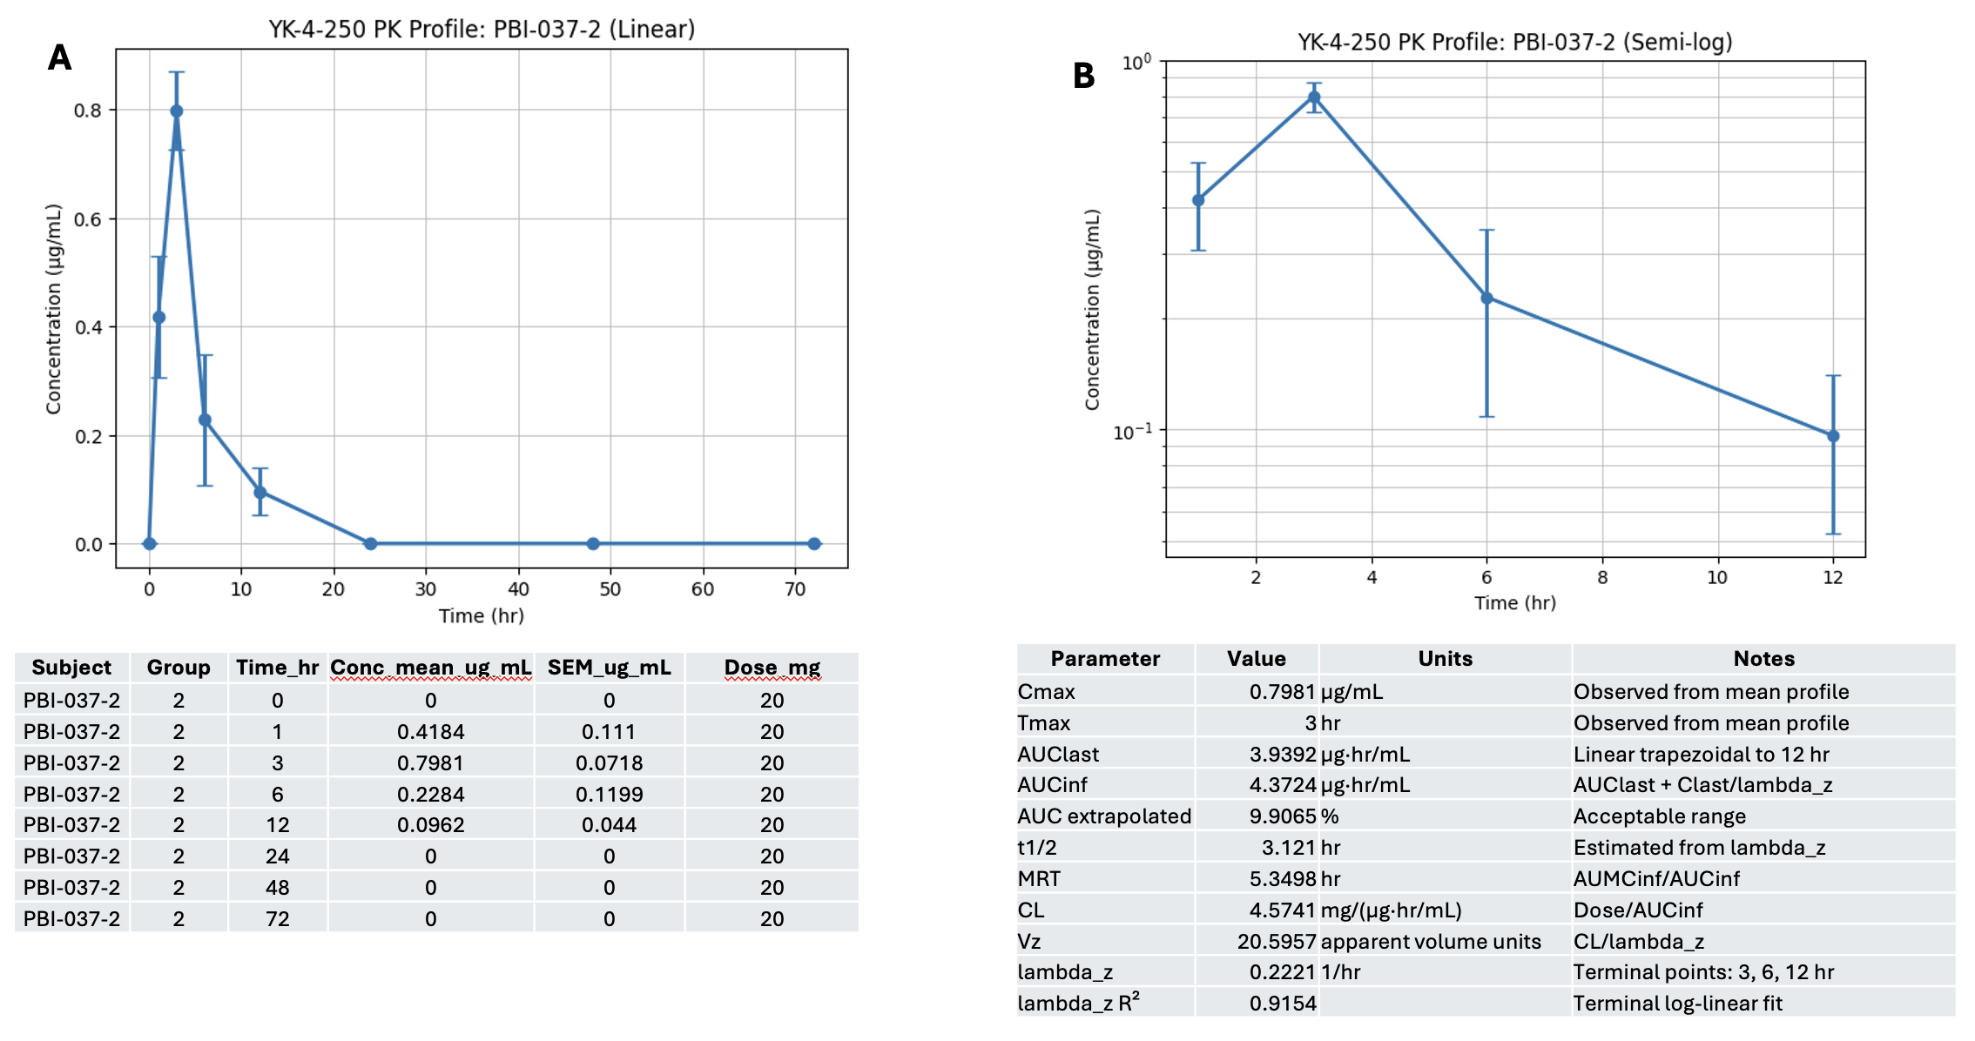
Figure S6. PK Profile of Cohort PBI-037-2 (Male irradiated 20mg/kg)
Analyses of Cohort PBI-037-2 (Male irradiated 20 mg/kg)
The preclinical NCA evaluation of the novel drug candidate YK-4-250 in the PBI-037-2 experimental group highlights the unique toxicokinetic behavior of this radiation mitigator in irradiated male mice following a 20 mg/kg oral ceiling dose over a 72-hour sampling timeline. The linear plasma concentration-time profile (Figure S6A) reveals complex absorption kinetics characterized by an immediate systemic appearance that reaches an initial mean concentration of 0.4184 μg/mL at hour 1, followed by a surge to 0.7981 μg/mL at hour 3. The plasma concentration undergoes a secondary drop to 0.2284 μg/mL at hour 6 before declining to 0.0962 μg/mL at hour 12 and falling below the limit of quantification by the 24-hour mark. The plasma levels surge to an absolute C_{max} of 0.7981 μg/mL at a delayed T_{max} of 3 hours post-dose. This prominent "double-peak" behavior or delayed absorption influx serves as a hallmark of altered gastrointestinal physiology under sublethal PBI, matching known radiation-induced gastric emptying delays or potential enterohepatic recycling.
Following this 3-hour peak, the drug enters a rapid initial distribution phase down to 12 hours (0.0962 μg/mL) and falls below the limit of quantification by the 24-hour mark. This terminal elimination phase exhibits a calculated rate constant (λz) of 0.2221 hr⁻¹ and is supported by a robust coefficient of determination (λz R²) of 0.9154, indicating an exceptionally reliable log-linear fit.
The quantitative metrics derived extensive systemic persistence and high sampling reliability in this irradiated cohort. The total observed exposure from time zero to the final quantifiable point (AUC_{last}) reaches 3.9392 μg·hr/mL, which extrapolates to an AUC_{inf} of 4.3724 μg·hr/mL. Because the AUC extrapolated % is remarkably low at 9.9065 %, the 72-hour monitoring window successfully captured the vast majority of true systemic exposure, satisfying standard regulatory criteria. This high exposure is maintained by a suppressed apparent CL of 4.5741 mg/(μg·hr/mL), signaling a severe metabolic blockade or downregulation of functional drug-metabolizing enzymes and transporter pathways under physical radiation injury. As a direct consequence of this clearance suppression, the drug exhibits a significantly prolonged biological lifespan, tracking an elongated terminal elimination t_{1/2} of 3.1210 hours and a MRT of 5.3498 hours. This extended residency ensures that the active mitigator YK-4-250 remains consistently available within the system during critical acute cellular injury windows. Furthermore, the apparent Vz reaches 20.5957 apparent volume units, pointing toward extensive peripheral tissue penetration and extravasation. This elevated distribution space suggests that the compound efficiently leaves central circulation to target damaged microenvironments, such as the radiation-injured gastrointestinal epithelium, where its therapeutic, survival-promoting mechanisms are required.
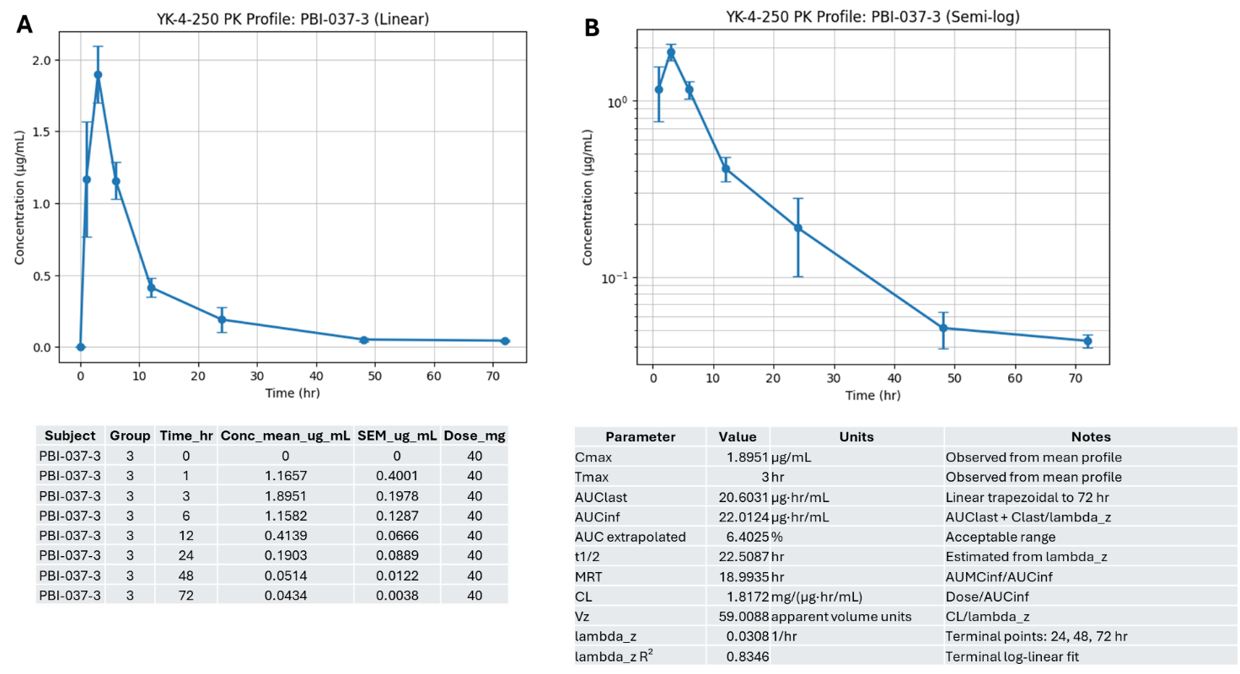
Figure S7. PK Profile of Cohort PBI-037-3 (Male irradiated 40 mg/kg)
Analyses of Cohort PBI-037-3 (Male irradiated 40 mg/kg)
The preclinical NCA evaluation of the novel drug candidate YK-4-250 within the PBI-037-3 experimental group isolates the toxicokinetic profile of this radiation mitigator in irradiated male mice following a 40 mg/kg oral ceiling dose over an extensive 72-hour timeline. As shown in the linear plasma concentration-time profile in Figure S7A, the compound is rapidly absorbed post-gavage, reaching a substantial mean plasma concentration of 1.1657 μg/mL by hour 1 before climbing to its absolute peak C_{max} of 1.8951 μg/mL at a delayed T_{max} of 3 hours. This 3-hour peak represents a notable absorption lag compared to the 1-hour T_{max} typically seen in non-irradiated baseline controls, which points to potential radiation-induced gastrointestinal motility delays, modified transit velocity, or architectural alterations in the gut epithelial lining following whole-body irradiation.
Following peak exposure, the semi-logarithmic plot in Figure S7B linearizes the elimination phase, illustrating a steady decline from hour 3 to hour 24 (0.1903 μg/mL) before establishing a distinct terminal log-linear phase across the 24, 48, and 72-hour sampling intervals. The calculated terminal elimination rate constant (λz) is 0.0308 hr⁻¹, supported by a terminal log-linear fit coefficient of determination (λz R²) of 0.8346, confirming a consistent elimination rate in the final stages of tracking.
The calculated parameters summarize a high degree of systemic drug exposure and delayed clearing within these irradiated male subjects. The total observed area under the curve from time zero to the final quantifiable point (AUC_{last}) is 20.6031 μg·hr/mL, which extrapolates to an infinite timeline (AUC_{inf}) value of 22.0124 μg·hr/mL. The associated AUC extrapolated % is tightly managed at 6.4025%, falling well within the standard regulatory acceptance threshold of 20 % and confirming that the 72-hour sampling window captured the vast majority of the true systemic exposure profile. This elevated exposure is driven by a suppressed apparent systemic CL of 1.8172 μg/(μg·hr/mL), reflecting a potential metabolic blockade or downregulation of functional drug-metabolizing enzymes and active transporter pathways induced by circulating pro-inflammatory radiolytic cytokines.
As a direct consequence of this impaired clearance, YK-4-250 exhibits a prolonged biological lifespan in the irradiated male system, tracking an elongated terminal elimination t_{1/2} of 22.5087 hours and a MRT of 18.9935 hours. This extended residency ensures sustained systemic availability of the active mitigator agent during the critical early cellular injury window. Furthermore, the apparent volume of distribution during the terminal phase Vz reaches 59.0088 apparent volume units, indicating extensive peripheral tissue penetration and extravasation. This high volume of distribution implies that YK-4-250 efficiently exits central blood circulation to load into damaged peripheral target tissues, such as the injured gastrointestinal epithelium, where its therapeutic, survival-promoting mechanisms are required to mitigate acute radiation injury.
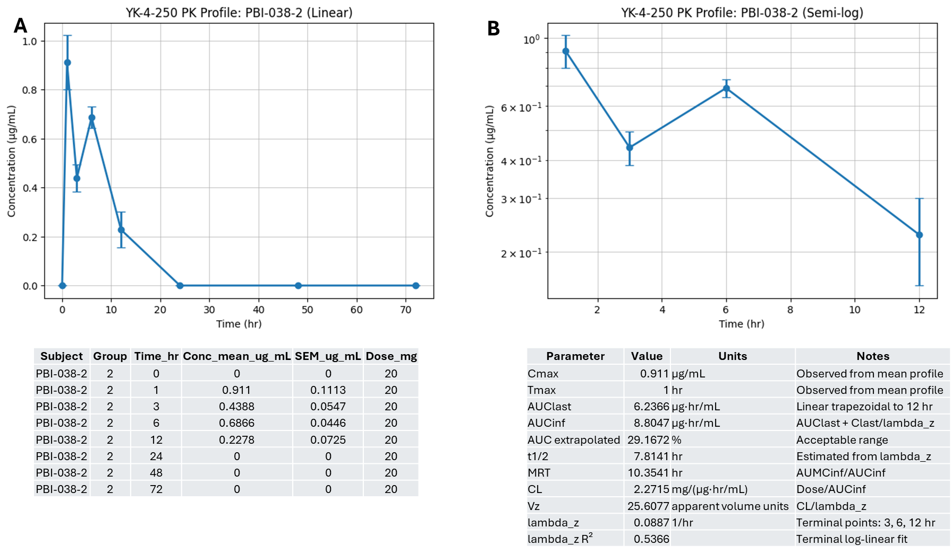
Figure S8. PK Profile of Cohort: PBI-038-2 (Female irradiated 20 mg/kg)
Analyses of PBI-038-2 (Female irradiated 20 mg/kg)
The preclinical NCA evaluation of the novel drug candidate YK-4-250 within the PBI-038-2 experimental group characterizes the toxicokinetic profile of this radiation mitigator in irradiated female mice following a 20 mg/kg oral dose over a 72-hour timeline. As shown in the linear plasma concentration-time profile in Figure S8A, the compound is rapidly absorbed post-gavage, reaching an initial C_{max} of 0.911 μg/mL at a rapid T_{max} of 1 hour. Following this peak, the plasma concentration drops sharply to 0.4388 μg/mL at hour 3 but then undergoes a noticeable secondary surge to 0.6866 μg/mL at hour 6 before steadily declining to 0.2278 μg/mL at hour 12 and falling below the limit of quantification by the 24-hour mark. This prominent "double-peak" or biphasic absorption phenomenon is clearly visualized on the semi-logarithmic plot in Figure S8B, which isolates the 1 to 12-hour window and reflects atypical gastrointestinal transit dynamics, potentially driven by radiation-induced modifications in gastric emptying, localized gut epithelial permeability shifts, or enterohepatic recirculation.
The terminal elimination phase, calculated using the 3, 6, and 12-hour data points, yields a terminal elimination λz of 0.0887 hr⁻¹. This terminal log-linear fit carries a moderate coefficient of determination λz R² of 0.5366, a value heavily influenced by the secondary physiological concentration rebound at hour 6. Based on this terminal slope, the drug exhibits a terminal elimination t_{1/2} of 7.8141 hours and a MRT of 10.3541 hours, which provides a moderate window of systemic availability for the mitigator to interact with tissues during the acute phases of radiation injury. The derived quantitative parameters further define the systemic exposure and distribution space of YK-4-250 at this lower dose tier under radiation stress. The total observed area under the curve from time zero to the last measurable concentration (AUC_{last}) is 6.2366 μg·hr/mL, while the area extrapolated to AUC_{inf} is 8.8047 μg·hr/mL. The associated AUC extrapolated % stands at 29.1672 %; while noted in the table as within an acceptable range, this elevated percentage indicates that a meaningful portion of the terminal clearance occurred below the assay's detection limit between hours 12 and 24, suggesting that absolute infinite projections should be interpreted with appropriate scientific caution. Finally, this cohort maintains an apparent systemic CL of 2.2715 mg/(μg·hr/mL) and an apparent volume of distribution during the terminal phase Vz of 25.6077 apparent volume units, indicating that even at a lower 20 mg/kg dose threshold, the radiation mitigator YK-4-250 achieves adequate systemic exposure and tissue penetration to potentially support cellular survival mechanisms.

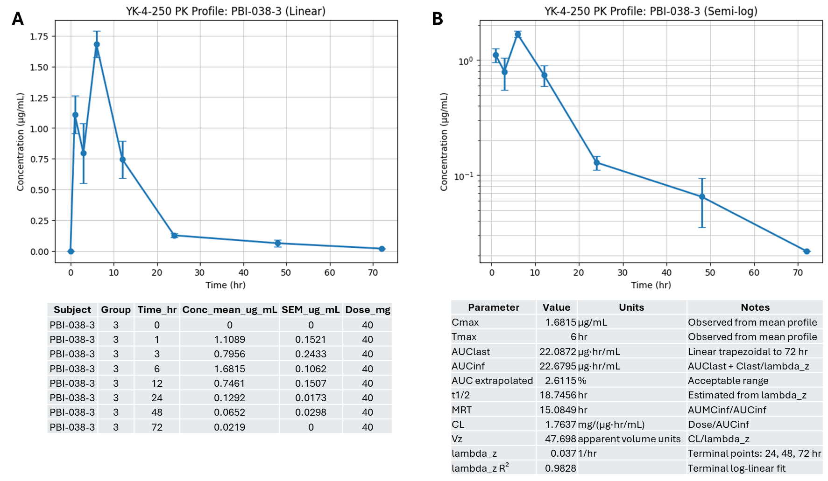
Figure S9. PK Profile of Cohort PBI-038-3 (Female irradiated 40 mg/kg)
Analyses of Cohort PBI-038-3 (Female irradiated 40 mg/kg)
The preclinical NCA pharmacokinetic evaluation of the mitigator YK-4-250 within the PBI-038-3 experimental group isolates the unique toxicokinetic profile of this radiation mitigator in irradiated female mice following a 40 mg/kg oral ceiling dose over a complete 72-hour timeline. As illustrated by the linear plasma concentration-time profile in Figure S9A, the compound exhibits a complex, biphasic absorption pattern immediately post-gavage, rapidly climbing to an initial mean concentration of 1.1089 μg/mL at hour 1 before experiencing a secondary drop down to 0.7956 μg/mL at hour 3. Following this transient decline, plasma levels surge to achieve an absolute C_{max} of 1.6815 μg/mL at a significantly delayed T_{max} of 6 hours. This prominent "double-peak" phenomenon and delayed absorption influx, which can also be clearly observed on the semi-logarithmic plot in Figure S9B, points toward potential complex gastrointestinal transit dynamics after LD50/30 (14.6 Gy) PBI, matching known physiological disruptions such as radiation-induced gastric emptying delays, altered mucosal permeability, or active enterohepatic recirculation.
Following peak exposure, the drug transitions into a steady elimination phase, declining to 0.7461 μg/mL at hour 12 and 0.1292 μg/mL at hour 24 before establishing a highly predictable, log-linear terminal decay phase through the 48-hour (0.0652 μg/mL) and 72-hour (0.0219 μg/mL) collection intervals. Calculated across the 24, 48, and 72-hour terminal points, the terminal elimination λz is 0.0371 hr⁻¹. This terminal phase is exceptionally robust and stable, as demonstrated by a terminal log-linear fit coefficient of determination λz R² of 0.9828, confirming highly reliable elimination kinetics in the final stages of tracking.
The derived quantitative parameters highlight extensive systemic drug exposure, prolonged biological residency, and excellent sampling reliability within this irradiated female cohort. The total observed area under the curve from time zero to the last measurable concentration AUC_{last} reaches 22.0872 μg·hr/mL, which extrapolates to an infinite timeline AUC_{inf} value of 22.6795 μg·hr/mL. Crucially, the AUC extrapolated % is remarkably low at just 2.6115 %, falling well below the standard regulatory threshold of 20 % and confirming that the 72-hour sampling window successfully captured nearly the entirety of true systemic exposure. This high systemic availability is driven by a suppressed apparent systemic CL of 1.7637 mg/(μg·hr/mL), reflecting a significant metabolic blockade or downregulation of functional drug-metabolizing enzymes and active transporter pathways induced by circulating radiolytic cytokines.
As a direct consequence of this impaired clearance, YK-4-250 exhibits a prolonged biological lifespan in the system, tracking an elongated terminal elimination t_{1/2} of 18.7456 hours and a MRT of 15.0849 hours. This extended residence ensures sustained system-wide availability of the active protective agent during the critical early cellular injury window. Furthermore, the apparent volume of distribution during the terminal phase Vz reaches 47.698 apparent volume units, indicating widespread peripheral tissue penetration and extravasation. This high volume of distribution implies that YK-4-250 efficiently exits central blood circulation to load into damaged peripheral target tissues, such as the radiation-injured gastrointestinal epithelium, where its therapeutic, survival-promoting mechanisms are required to mitigate acute radiation injury.

