Supporting information
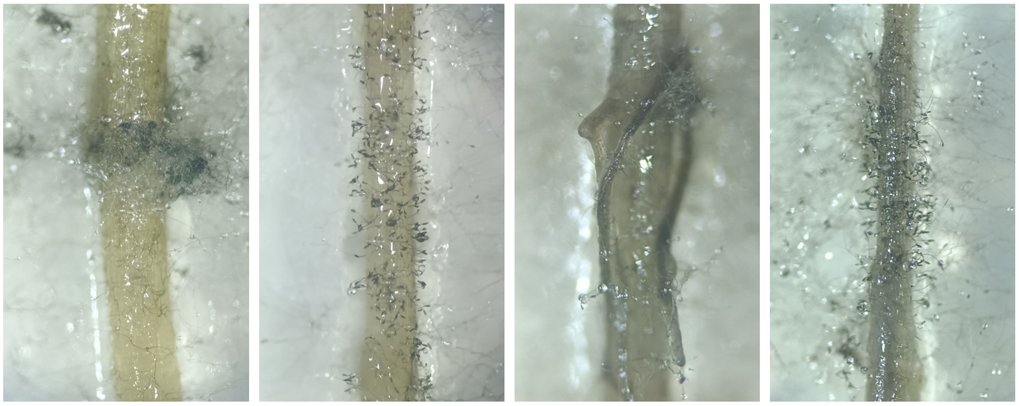

Fig. S1 Different phenotypical growth of B. sorokiniana on detached roots at 13dpi.

Table S1 Replication numbers (n per treatment).
 | 0mM Si | 0.25mM Si | 0.5mM Si | 2mM Si | 4mM Si
Control | 4 | 4 | 5 | 3 | 4
84144 | 5 | 4 | 5 | 5 | 5
84145 | 4 | 6 | 5 | 5 | 6

Table S2 Results of two-way ANOVA of plant element concentrations to Si supplementation level and varying plant tissues, and their interactive influence on these responses.
Plant element | Figure | Statistical analysis
 |  | Si |  | Plant tissue |  | Si x Plant tissue
 |  | F | p | F | p | F | p
K | S2a | 13.60 | <.001 | 765.42 | <.001 | 3.39 | <.001
P | S2b | 14.41 | <.001 | 391.83 | <.001 | 3.19 | 0.015
Statistically significant (p <.05) results highlighted in bold.

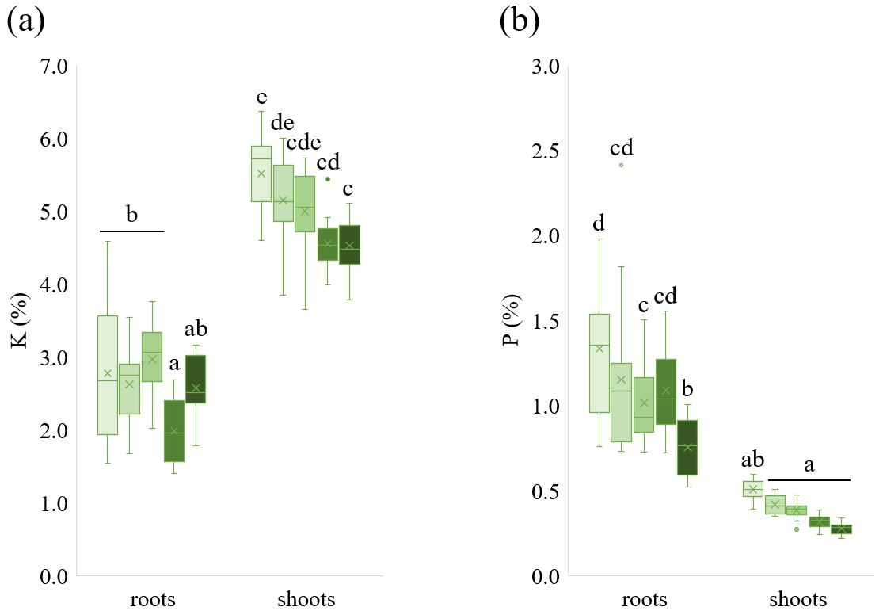

Fig. S2 K (a) and P (b) concentrations (%) in wheat roots and shoots with increasing Si supplementation. Mean and median values indicated with crosses and horizontal lines, respectively (n = 16). Different letters indicate significant differences among treatments within each tissue type according to two-way ANOVA followed by Tukey’s post hoc test (p < 0.05).

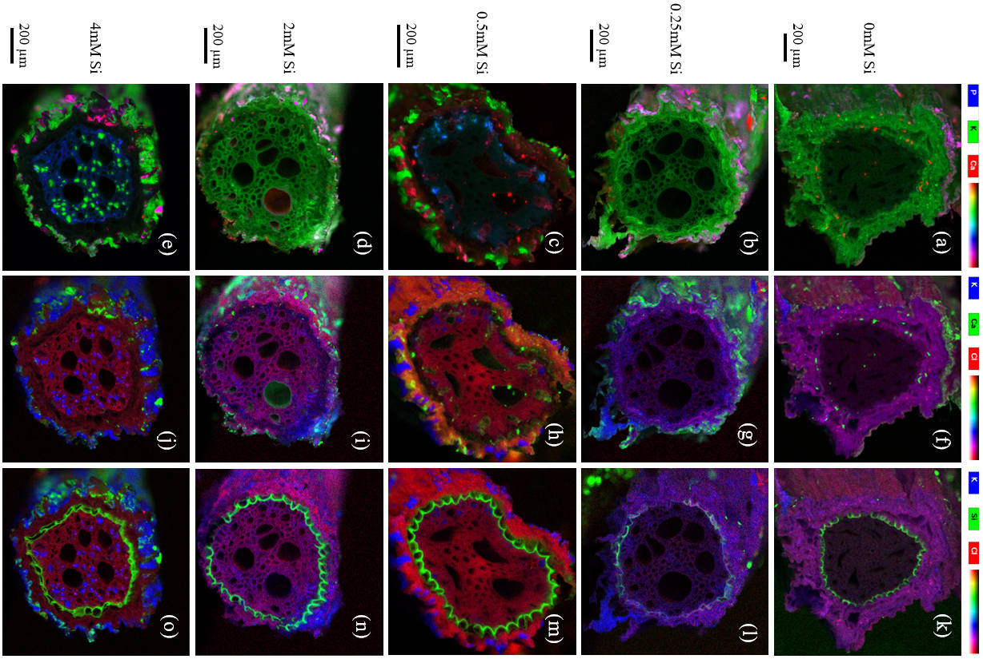

Fig. S3 P, K, Ca, Cl and Si deposition in wheat roots with increasing Si supplementation. Pseudo-colour XRM images of cross sectioned roots, magnifications for increasing Si supplementations respectively 200x, 230x, 300x, 250x and 250x. a-e) P, K and Ca in respectively blue, green and red, f-j) K, Ca and Cl in respectively blue, green and red, k-o) K, Si and Cl in respectively blue, green and red.

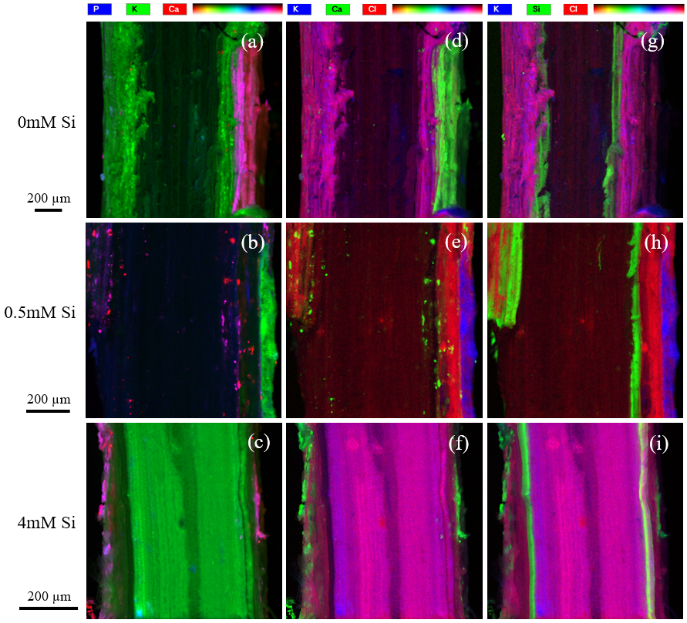

Fig. S4 P, K, Ca, Cl and Si deposition in wheat roots with increasing Si supplementation. Pseudo-colour XRM images of longitudinally sectioned roots, magnifications for increasing Si supplementations respectively 180x, 300x and 400x. a-c) P, K and Ca in respectively blue, green and red, d-f) K, Ca and Cl in respectively blue, green and red, g-i) K, Si and Cl in respectively blue, green and red.

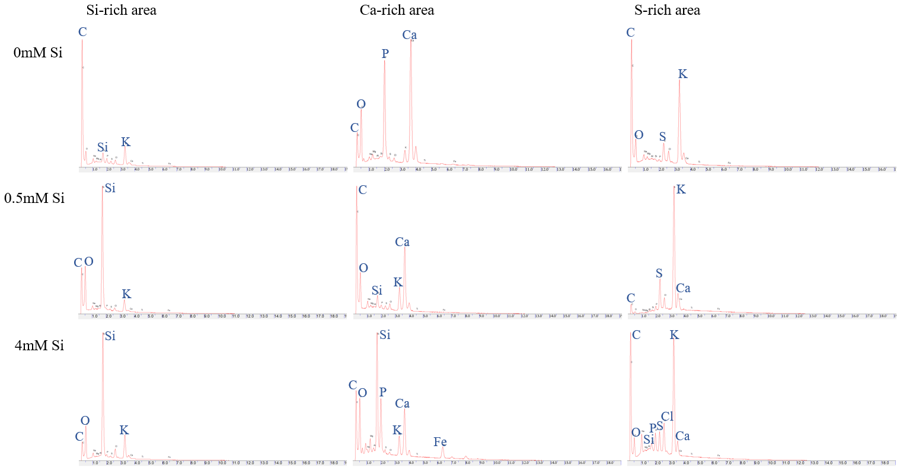

Fig. S5 Energy Dispersive Spectroscopy (EDS) graphs of element rich areas in root samples.

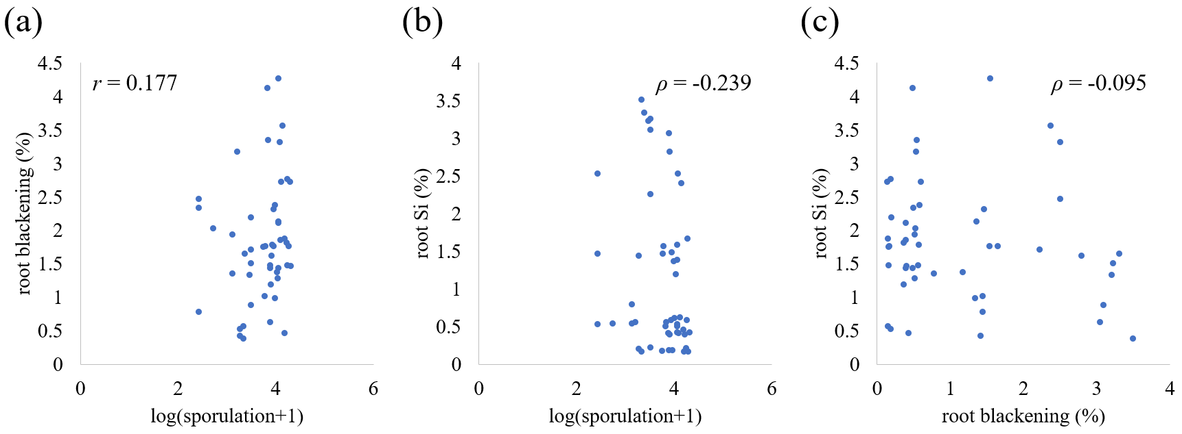

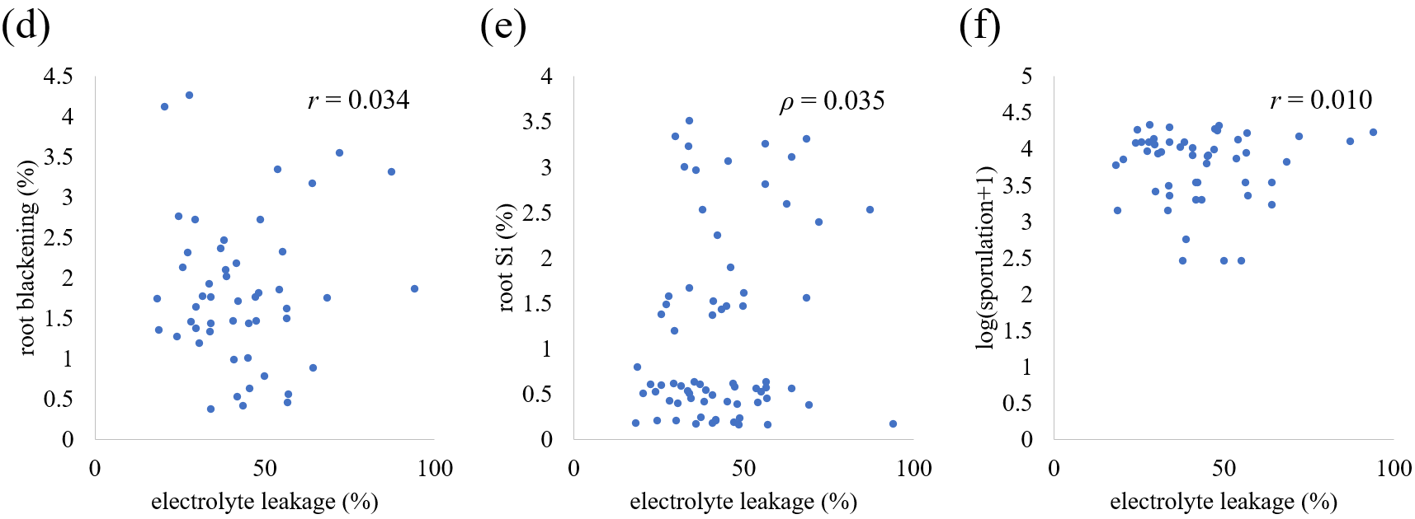

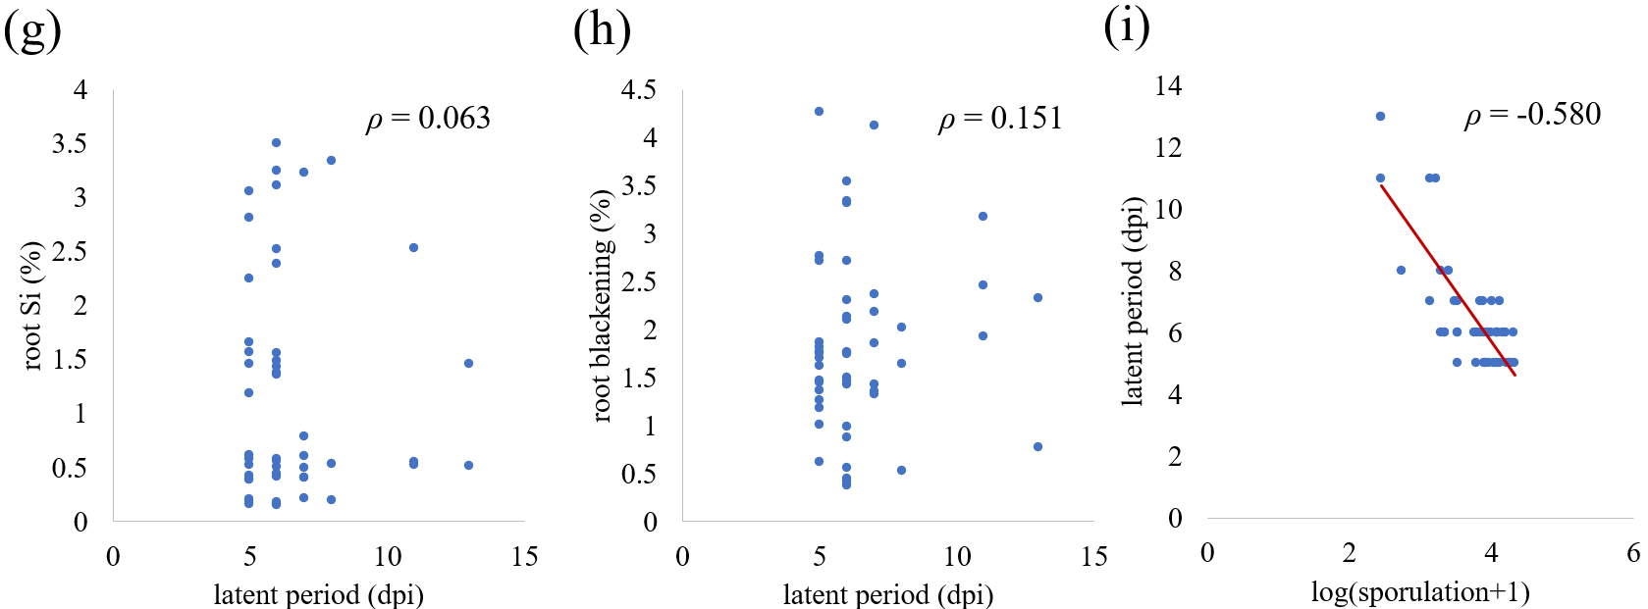

Fig. S6 Correlation analysis between Si treatment responses, plant traits, and pathogen performance. a) Root blackening vs sporulation (Pearson, r = 0.177 and p = 0.218), b) root Si vs sporulation (Spearman, ρ = -0.239 and p = 0.094), c) root blackening vs root Si (Spearman, ρ = -0.095 and p = 0.512), d) root blackening vs electrolyte leakage (Pearson, r = 0.034 and p = 0.816), e) root Si vs electrolyte leakage (Spearman, ρ = 0.035 and p = 0.811), f) sporulation vs electrolyte leakage (Pearson, r = 0.010 and p = 0.943), g) latent period vs root Si (Spearman, ρ = 0.063 and p = 0.896), h) root blackening vs latent period (Spearman, ρ = 0.151 and p = 0.442), i) sporulation vs latent period (Spearman, ρ = -0.580 and p = <0.001).

