Supplementary results and tables

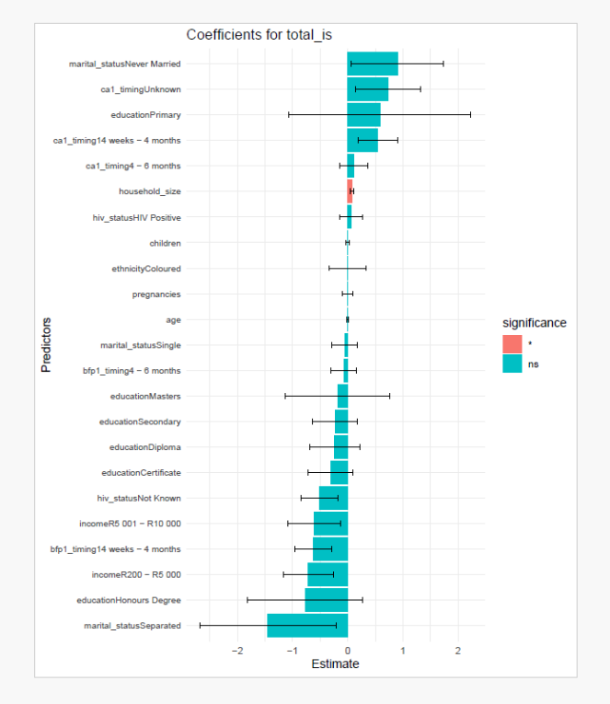
Supplementary Figure 1A: Multivariable regression coefficients for factors associated with instrumental social support among perinatal women in the Eastern Cape, South Africa
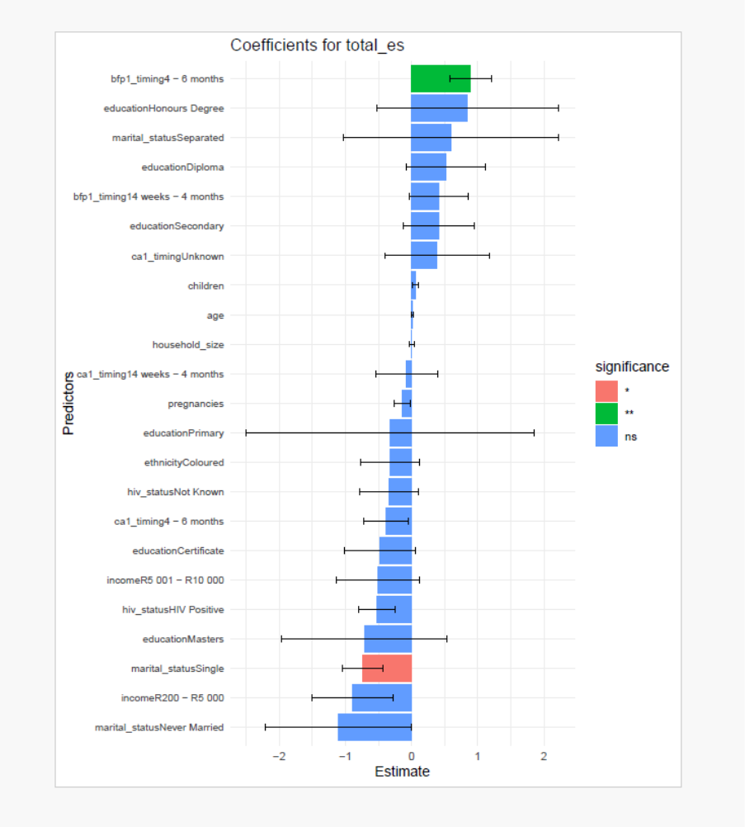
Supplementary Figure 1B: Multivariable regression coefficients for factors associated with emotional social support among perinatal women in the Eastern Cape, South Africa
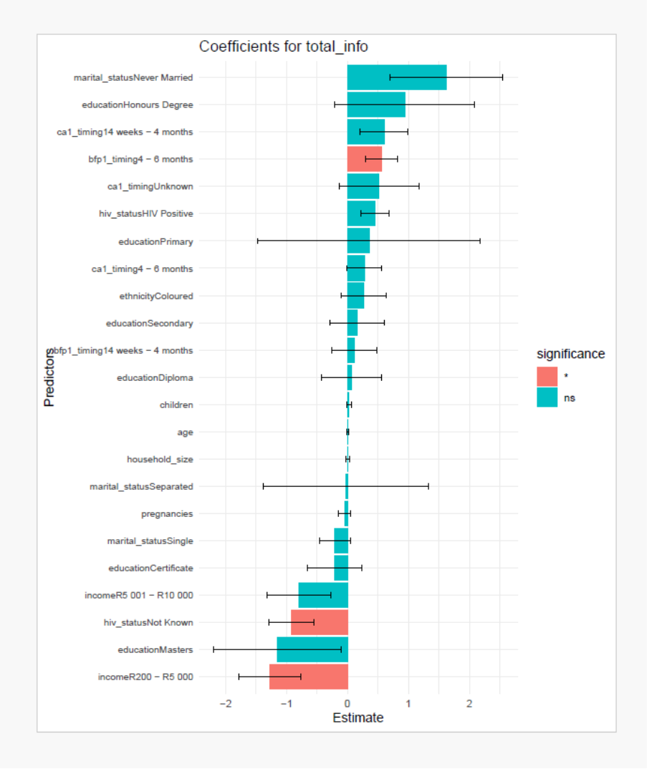
Supplementary Figure 1C: Multivariable regression coefficients for factors associated with informational social support among perinatal women in the Eastern Cape, South Africa
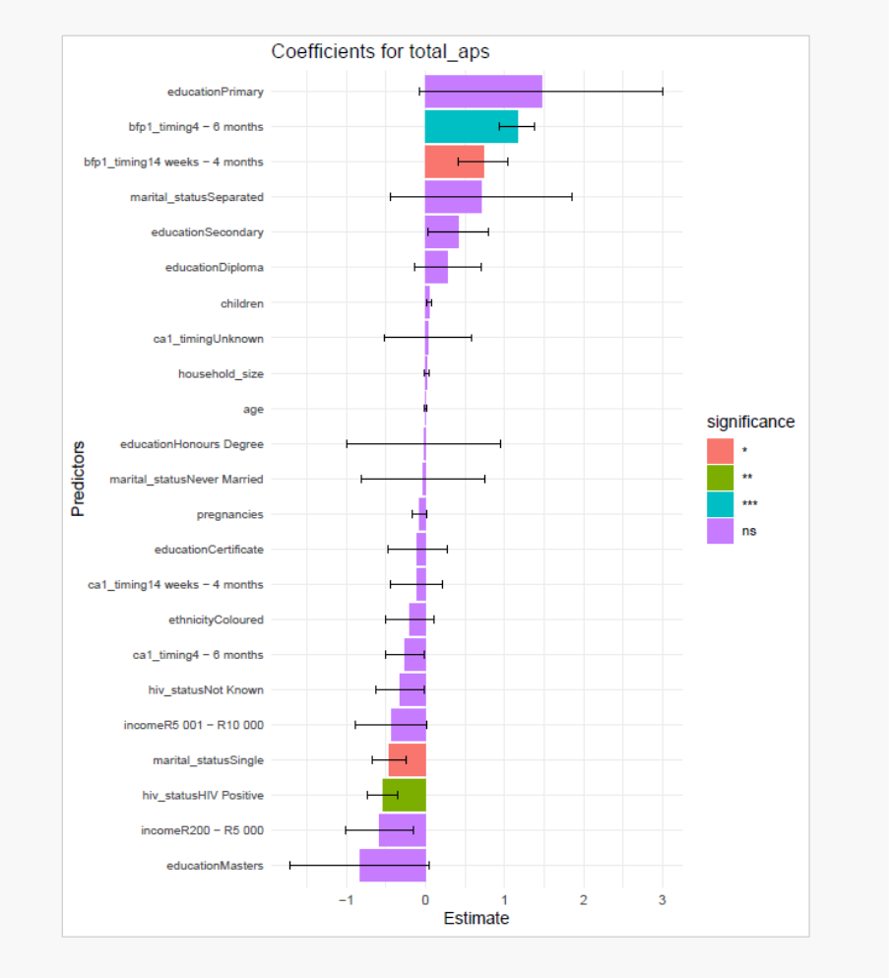
Supplementary Figure 1D: Multivariable regression coefficients for factors associated with appraisal social support among perinatal women in the Eastern Cape, South Africa
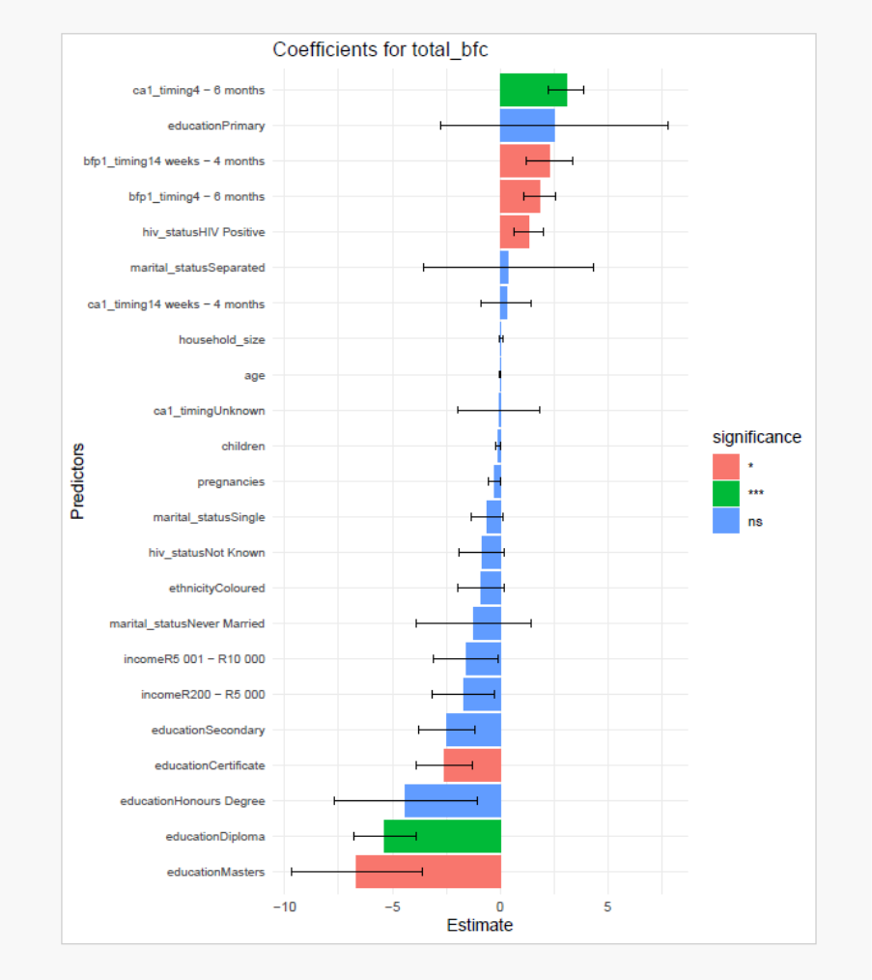
Supplementary Figure E: Multivariable regression coefficients for factors associated with breastfeeding confidence among perinatal women in the Eastern Cape, South Africa

Questionnaire
Section A: Socio-demographic Information
Instruction: Please complete this section by marking with an X the column that best describes you.
- Mother ’s Age 2. Race
Below 20 years
20 – 24 years
25 – 29 years
30 – 34 years
Asian
Black
Coloured
White
- Highest Level of Education 4. Income
Primary
Secondary
Matric
Lower
Middle
Upper

- Household size 6. Number of children
0 - 1
2 - 4
5 and more
1 - 4
5 - 7
8 and above

7. Gravidity 8. HIV status
Primigravida
Gravida 2 - 4
Gravida 5 and more
HIV negative
HIV positive

9 | Year diagnosed with HIV |  | Year first initiation of HAART
10 | Was the ARV changed after last delivery? | Yes |  | No
11 | Previous regimen |  | Current regimen
12 | Duration of previous regimen |  | Duration of current regimen

13. Child’s age 14. Period of breastfeeding
0 – 14 weeks
14 weeks – 4 months
4 months – 6 months
0 – 14 weeks
14 weeks – 4 months
4 months – 6 months

Section B: KIND OF EBF SUPPORT RECEIVED
Were you supported with any of the following ways to promote EBF, and by whom?
Instrumental support | Yes | No
- Were any of your home chores done for you? | 1 | 2 | By whom | HCW |  | Partner |  |  | Mother |  |  | Other family members
- Did someone prepare meals for you? | 1 | 2 | By whom | HCW |  | Partner |  |  | Mother |  |  | Other family members
- Was there someone to do yours and your baby’s laundry? | 1 | 2 | By whom | HCW |  | Partner |  |  | Mother |  |  | Other family members
- Was help provided on EBF initiation such as putting baby to the breast? | 1 | 2 | By whom | HCW |  | Partner |  |  | Mother |  |  | Other family members
- Someone showed me how to hold the baby for breastfeeding | 1 | 2 | By whom | HCW |  | Partner |  |  | Mother |  |  | Other family members
- I was offered solutions to my breastfeeding problems such as given ginger for dry breast or cabbage leaves for engorgement | 1 | 2 | By whom | HCW |  | Partner |  |  | Mother |  |  | Other family members
Emotional support | Yes | No
- Approved of me exclusively breastfeeding my baby | 1 | 2 | By whom | HCW |  | Partner |  |  | Mother |  |  | Other family members
- Told me I was doing well caring for my baby | 1 | 2 | By whom | HCW |  | Partner |  |  | Mother |  |  | Other family members
- Made me feel confident even when I made mistakes | 1 | 2 | By whom | HCW |  | Partner |  |  | Mother |  |  | Other family members
- Listened to me talk about my baby and EBF | 1 | 2 | By whom | HCW |  | Partner |  |  | Mother |  |  | Other family members
- Believed that I am a good mother | 1 | 2 | By whom | HCW |  | Partner |  |  | Mother |  |  | Other family members
- Showed concern when I felt sad or depressed | 1 | 2 | By whom | HCW |  | Partner |  |  | Mother |  |  | Other family members
- Praised me for my efforts to exclusively breastfeeding | 1 | 2 | By whom | HCW |  | Partner |  |  | Mother |  |  | Other family members
Informational support | Yes | No
- Were your questions on EBF answered? | 1 | 2 | By whom | HCW |  | Partner |  |  | Mother |  |  |  | Other family members
- Was correct, consistent information/advice on EBF given? | 1 | 2 | By whom | HCW |  | Partner |  |  | Mother |  |  |  | Other family members
- Conflicting information on EBF was sometimes given to me | 1 | 2 | By whom | HCW |  | Partner |  |  | Mother |  |  |  | Other family members
- Was given information on how to successfully EBF | 1 | 2 | By whom | HCW |  | Partner |  |  | Mother |  |  |  | Other family members
- Benefits of EBF were explained to me
- Did you receive information about using mom-connect | 1 | 2 | By whom | HCW |  | Partner |  |  | Mother |  |  |  | Other family members
- Did you receive any online informational support about EBF | 1 | 2 | By whom | HCW |  | Partner |  |  | Mother |  |  |  | Other family members
- Were you advised or attended physical EBF support group | 1 | 2 | By whom | HCW |  | Partner |  |  | Mother |  |  |  | Other family members
- Was given written information on EBF to read later | 1 | 2 | By whom | HCW |  | Partner |  |  | Mother |  |  |  | Other family members
Appraisal support.
37. Comments on my confidence in EBF made me want to continue | 1 | 2 | By whom | HCW |  | Partner |  |  | Mother |  |  |  | Other family members
38. Verbal appraisal by others made want to continue with EBF | 1 | 2 | By whom | HCW |  | Partner |  |  | Mother |  |  |  | Other family members
39. Praised me as my baby was growing well and looked content | 1 | 2 | By whom | HCW |  | Partner |  |  | Mother |  |  |  | Other family members
40 Respected and supported by my infant feeding choice | 1 | 2 | By whom | HCW |  | Partner |  |  | Mother |  |  |  | Other family members

Section C: BREASTFEEDING CONFIDENCE
Here are statements that describe the activities of breastfeeding. Please encircle the number that best describes the feeding confidence you have for each statement. There are no right or wrong answer for each statement
1 2 3 4 5
Strongly disagree Disagree Neutral Agree Strongly agree

No. | STATEMENT | Strongly disagree  Strongly agree
41. | I do not like EBF/ I found it uncomfortable | 1 | 2 | 3 | 4 | 5
42. | I always enjoy EBF including breastfeeding in public places | 1 | 2 | 3 | 4 | 5
43. | Formula feeding is easy and equally beneficial | 1 | 2 | 3 | 4 | 5
44. | I have a problem in breastfeeding my baby in a public place | 1 | 2 | 3 | 4 | 5
45. | I have been stopped or made to feel uncomfortable about breastfeeding in a public place | 1 | 2 | 3 | 4 | 5
46. | I am able to manage some of the breastfeeding challenges with some support | 1 | 2 | 3 | 4 | 5
47. | It was difficult to make a decision from conflicting EBF advice I received | 1 | 2 | 3 | 4 | 5
48. | I feel confident when making decisions on EBF issues | 1 | 2 | 3 | 4 | 5
Supplementary Material A: Multivariable regression coefficients for factors associated with breastfeeding confidence among perinatal women in the Eastern Cape, South Africa

