Table S1. Schedule of (MDS-)UPDRS assessments for the first 12 months of each study
Study | SC | BL | Week 2 | Week 3 | Week 4 | Month 1 | Week 5 | Week 12 | Month 3 | Month 6 | Month 9 | Month 12
STEADY-PD III (UPDRS) |  | X | X |  | X |  |  |  | X | X | X | X
FS1 (UPDRS) | X |  |  |  |  | X |  |  | X | X | X | X
FS-TOO (UPDRS) | X¹ | X |  |  |  | X |  |  | X | X | X | X
SURE-PD3 (MDS-UPDRS) | X¹ | X |  | X |  |  | X | X |  | X | X | X
PPMI v1 (MDS-UPDRS) | X | X |  |  |  |  |  |  |  | X | X | X
¹Did not use Screening visit data for FS-TOO and SURE-PD3 trials

Table S2. (MDS-)UPDRS Part 3 threshold changes or treatment initiation by treatment arms
 | 7-point Composite  (7-point/Tx) | 6-point Composite  (6-point/Tx) | 5-point Composite  (5-point/Tx) | 4-point Composite  (4-point/Tx)
STEADY-PD III  Isradipine (ISR) vs. Placebo (PLB) | 68.8% vs. 77.7%  (ISR: 28.2% / 40.6%)  (PLB: 36.1% / 41.6%) | 72.4% vs. 78.9%  (ISR: 37.1% / 35.3%)  (PLB: 46.4% / 32.5%) | 74.7% vs. 83.1%  (ISR: 42.9% / 31.8%)  (PLB: 54.2% / 28.9%) | 78.8% vs. 86.1%  (ISR: 54.7% / 24.1%)  (PLB: 62.0% / 24.1%)
FS1  Creatine (CR) vs. Minocycline (MIN) vs. PLB | 56.7% vs. 59.1% vs 65.7%  (CR: 35.8% / 20.9%)  (MIN: 30.3% / 28.8%)  (PLB: 47.8% / 17.9%) | 61.2% vs. 63.6% vs 67.2%  (CR: 41.8% / 19.4%)  (MIN: 36.4% / 27.3%)  (PLB: 49.3% / 17.9%) | 67.2% vs. 69.7% vs 68.7%  (CR: 47.8% / 19.4%)  (MIN: 53.0% / 16.7%)  (PLB: 55.2% / 13.4%) | 73.1% vs. 71.2% vs 77.6%  (CR: 59.7% / 13.4%)  (MIN: 59.1% / 12.1%)  (PLB: 67.2% / 10.4%)
FS-TOO  GPI-1485 (GPI) vs. Coenzyme Q10 (COQ) vs. PLB | 57.7% vs. 59.2% vs 56.3%  (GPI: 46.5% / 11.3%)  (COQ: 35.2% / 23.9%)  (PLB: 35.2% / 21.1%) | 60.6% vs. 66.2% vs 62.0%  (GPI: 52.1% / 8.5%)  (COQ: 45.1% / 21.1%)  (PLB: 42.3% / 19.7%) | 62.0% vs. 74.6% vs 69.0%  (GPI: 54.9% / 7.0%)  (COQ: 57.7% / 16.9%)  (PLB: 52.1% / 16.9%) | 70.4% vs. 76.1% vs 77.5%  (GPI: 63.4% / 7.0%)  (COQ: 62.0% / 14.1%)  (PLB: 62.0% / 15.5%)
SURE-PD 3  Inosine (INO) vs. PLB | 76.4% vs. 79.2%  (INO: 48.0% / 28.4%)  (PLB: 46.3% / 32.9%) | 77.7% vs. 83.2%  (INO: 53.4% / 24.3%)  (PLB: 57.0% / 26.2%) | 81.8% vs. 85.2%  (INO: 62.2% / 19.6%)  (PLB: 61.1% / 24.2%) | 83.8% vs. 89.3%  (INO: 66.2% / 17.6%)  (PLB: 66.4% / 22.8%)

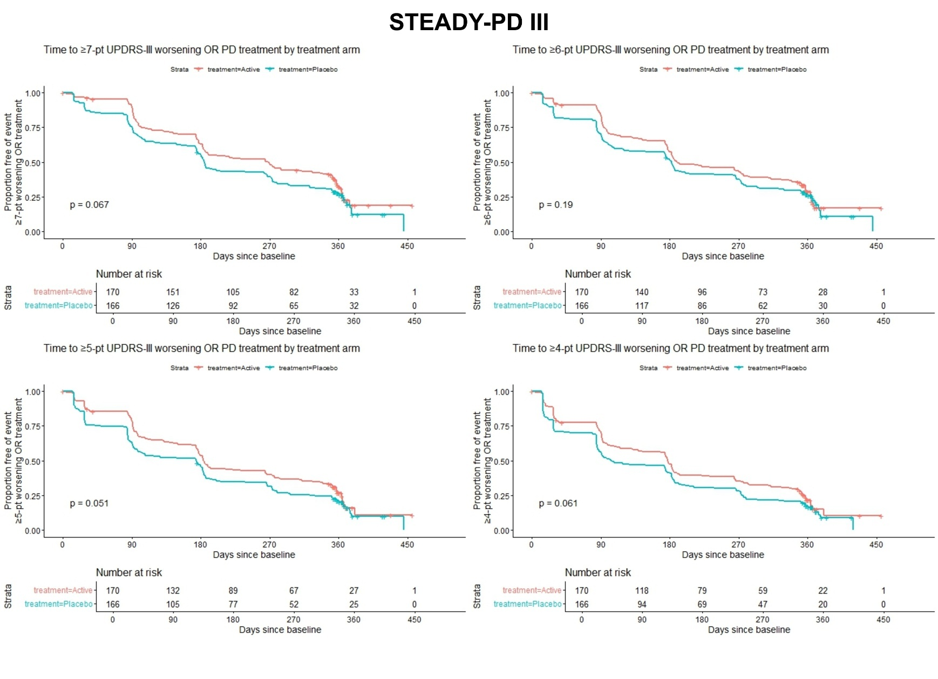
Figure S1. Kaplan-Meier plots of time to (A) 7-, (B) 6-, (C) 5-, or (D) 4-point worsening of UPDRS Part III (untreated) or initiation of symptomatic medication among STEADY-PD III participants stratified by randomized treatment arms (log-rank p-value shown).

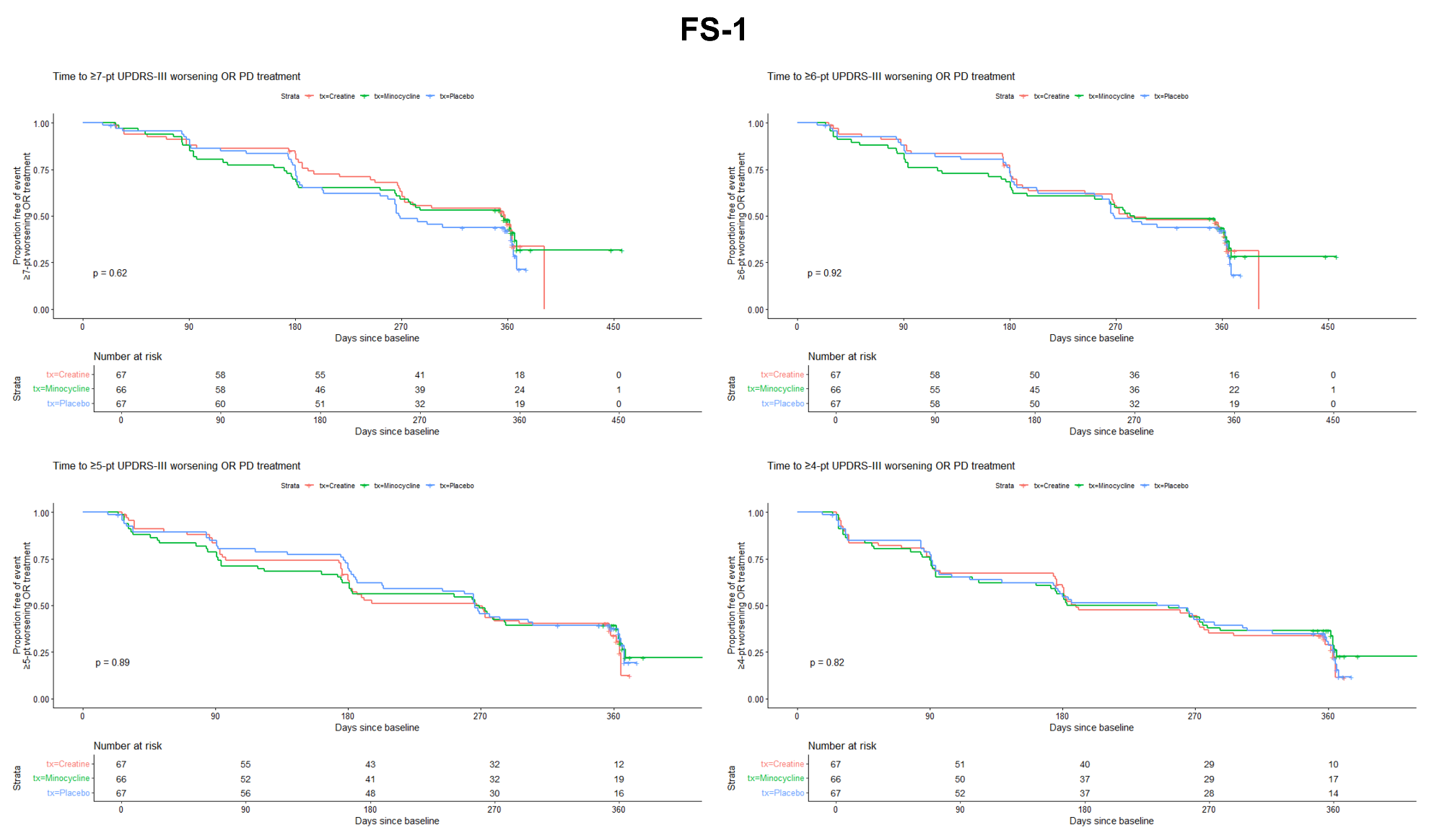
Figure S2. Kaplan-Meier plots of time to 7-, 6-, 5-, or 4-point worsening of UPDRS Part III (untreated) or initiation of symptomatic medication among FS-1 participants stratified by randomized treatment arms (log-rank p-value shown).

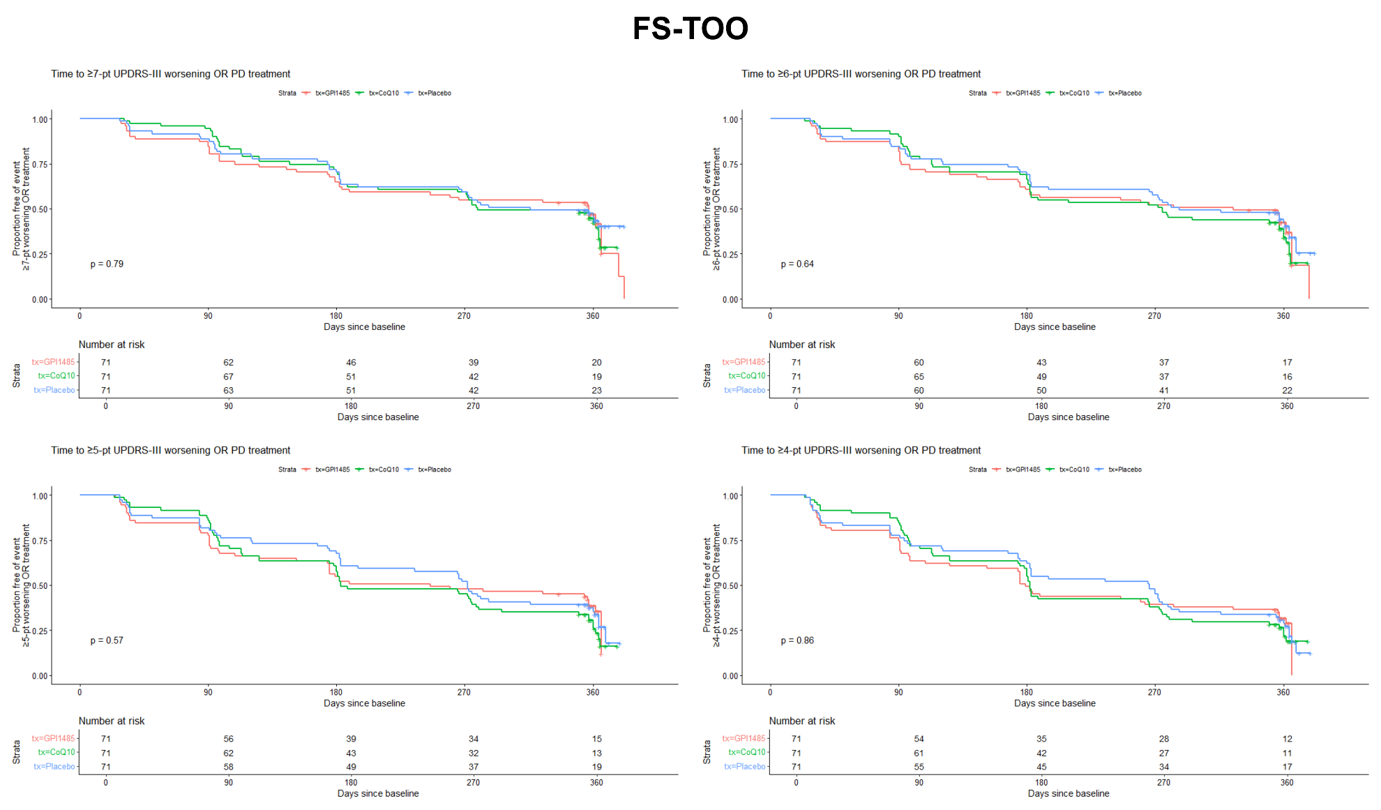
Figure S3. Kaplan-Meier plots of time to 7-, 6-, 5-, or 4-point worsening of UPDRS Part III (untreated) or initiation of symptomatic medication among FS-TOO participants stratified by randomized treatment arms (log-rank p-value shown).

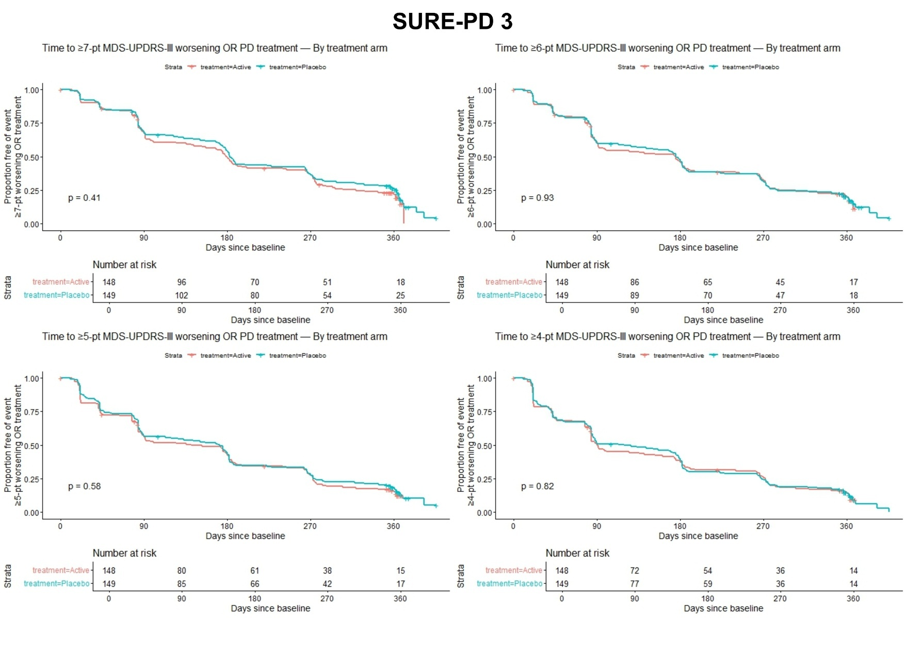
Figure S4. Kaplan-Meier plots of time to 7-, 6-, 5-, or 4-point worsening of MDS-UPDRS Part III (untreated) or initiation of symptomatic medication among SURE-PD3 participants stratified by randomized treatment arms (log-rank p-value shown).

Table S3. (MDS-)UPDRS Part 2 threshold changes or treatment initiation by treatment arms
 | 4-point Composite  (4-point/Tx) | 3-point Composite  (3-point/Tx) | 2-point Composite  (2-point/Tx)
STEADY-PD III  Isradipine (ISR) vs. Placebo (PLB) | 67.6% vs. 77.1%  (ISR: 30.0% / 37.6%)  (PLB: 38.0% / 39.2%) | 75.9% vs. 83.1%  (ISR: 50.0% / 25.9%)  (PLB: 48.8% / 34.3%) | 82.4% vs. 89.8%  (ISR: 62.4% / 20.0%)  (PLB: 65.7% / 24.1%)
FS1  Creatine (CR) vs. Minocycline (MIN) vs. PLB | 59.7% vs. 69.7% vs. 61.3%  (CR:35.8% / 23.9%)  (MIN: 48.5% / 21.2%)  (PLB: 32.8% / 28.4%) | 74.6% vs. 74.3% vs. 67.2%  (CR: 55.2% / 19.4%)  (MIN: 57.6% / 16.7%)  (PLB: 40.3% / 26.9%) | 82.1% vs. 80.4% vs. 76.1%  (CR: 70.1% / 11.9%)  (MIN: 71.2% / 9.1%)  (PLB: 56.7% / 19.4%)
FS-TOO  GPI-1485 (GPI) vs. Coenzyme Q10 (COQ) vs. PLB | 53.5% vs. 57.8% vs. 59.1%  (GPI: 36.6% / 16.9%)  (COQ: 32.4% / 25.4%)  (PLB: 39.4% / 19.7%) | 63.4% vs. 59.1% vs. 69.0%  (GPI: 53.5% / 9.9%)  (COQ: 38.0% / 21.1%)  (PLB: 53.5% / 15.5%) | 76.0% vs. 69.0% vs. 76.1%  (GPI: 71.8% / 4.2%)  (COQ: 52.1% / 16.9%)  (PLB: 63.4% / 12.7%)
SURE-PD 3  Inosine (INO) vs. PLB | 62.2% vs. 65.1%  (INO: 21.6% / 40.5%)  (PLB: 26.8% / 38.3%) | 69.6% vs. 73.8%  (INO: 35.1% / 34.5%)  (PLB: 40.9% / 32.9%) | 82.4% vs. 84.6%  (INO: 56.1% / 26.4%)  (PLB: 59.7% / 24.8%)

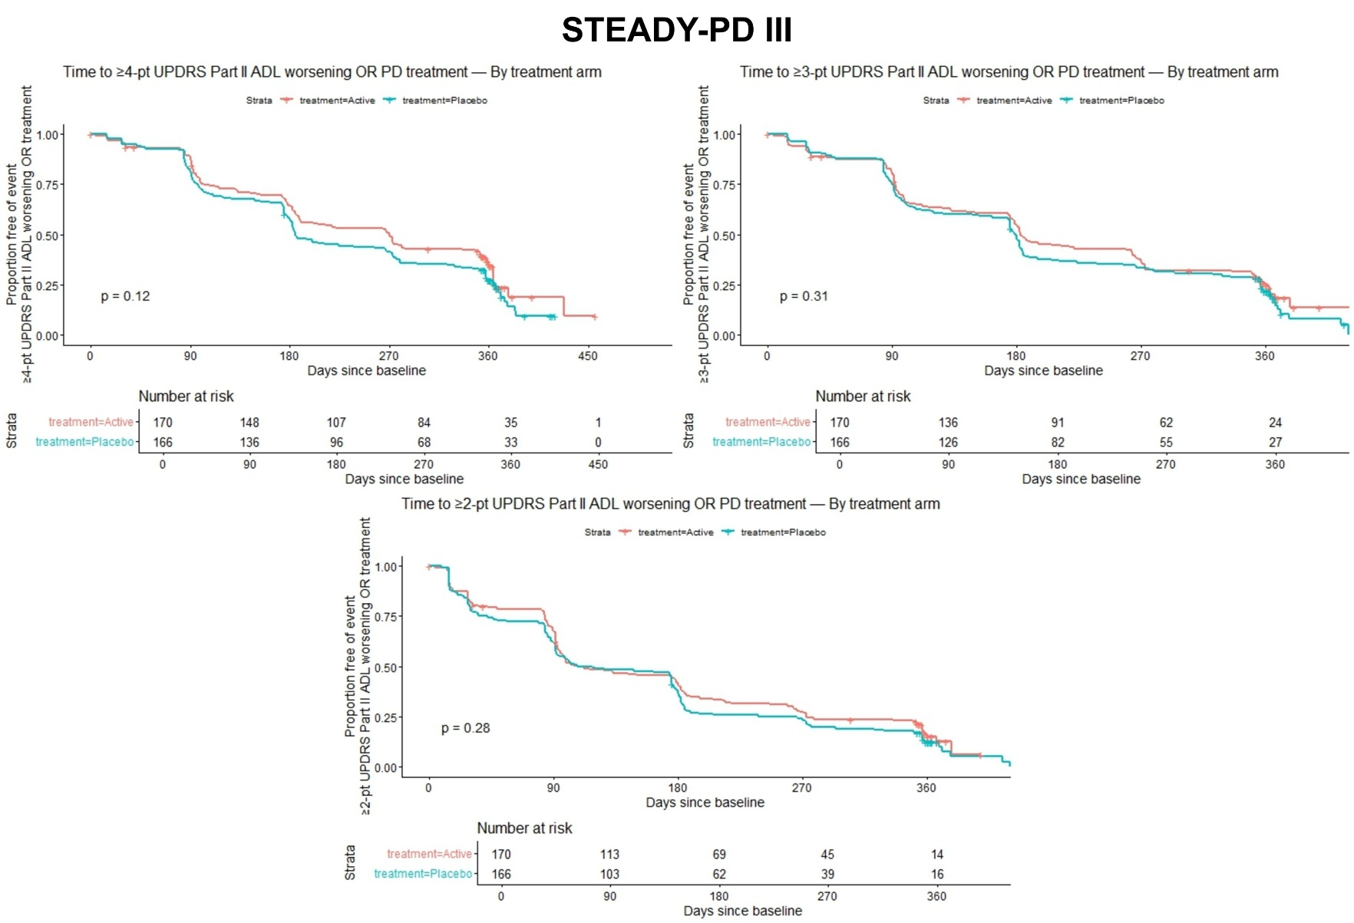
Figure S5. Kaplan-Meier plots of time to 4, 3-, or 2-point worsening of UPDRS Part II (untreated) or initiation of symptomatic medication among STEADY-PD III participants stratified by randomized treatment arms (log-rank p-value shown).

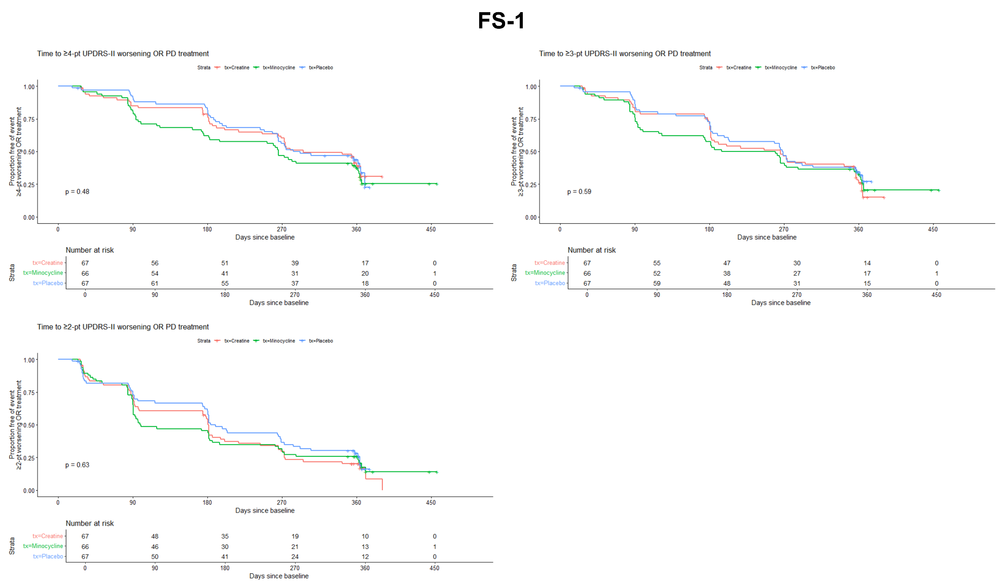
Figure S6. Kaplan-Meier plots of time to 4, 3-, or 2-point worsening of UPDRS Part II (untreated) or initiation of symptomatic medication among FS-1 participants stratified by randomized treatment arms (log-rank p-value shown).

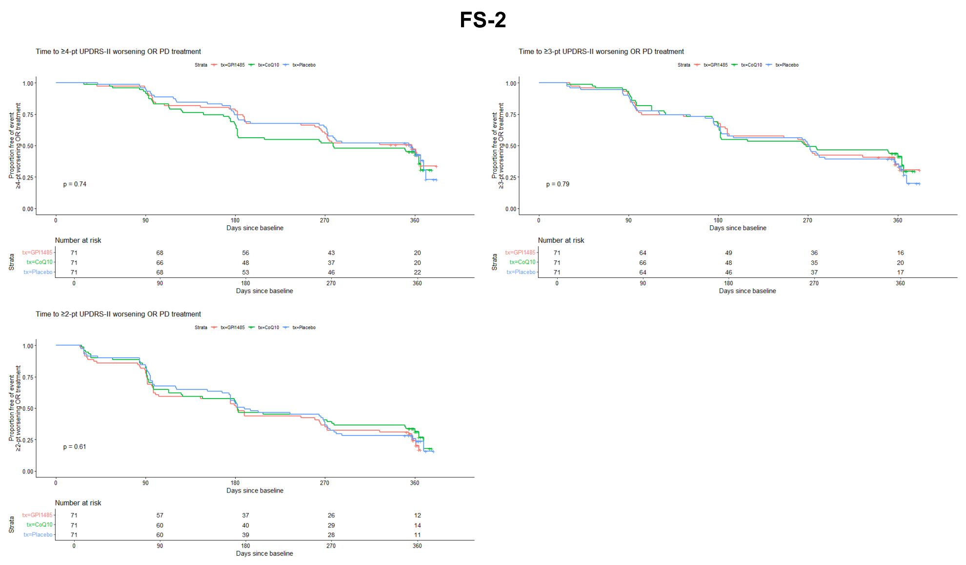
Figure S7. Kaplan-Meier plots of time to 4, 3-, or 2-point worsening of UPDRS Part II (untreated) or initiation of symptomatic medication among FS-TOO participants stratified by randomized treatment arms (log-rank p-value shown).

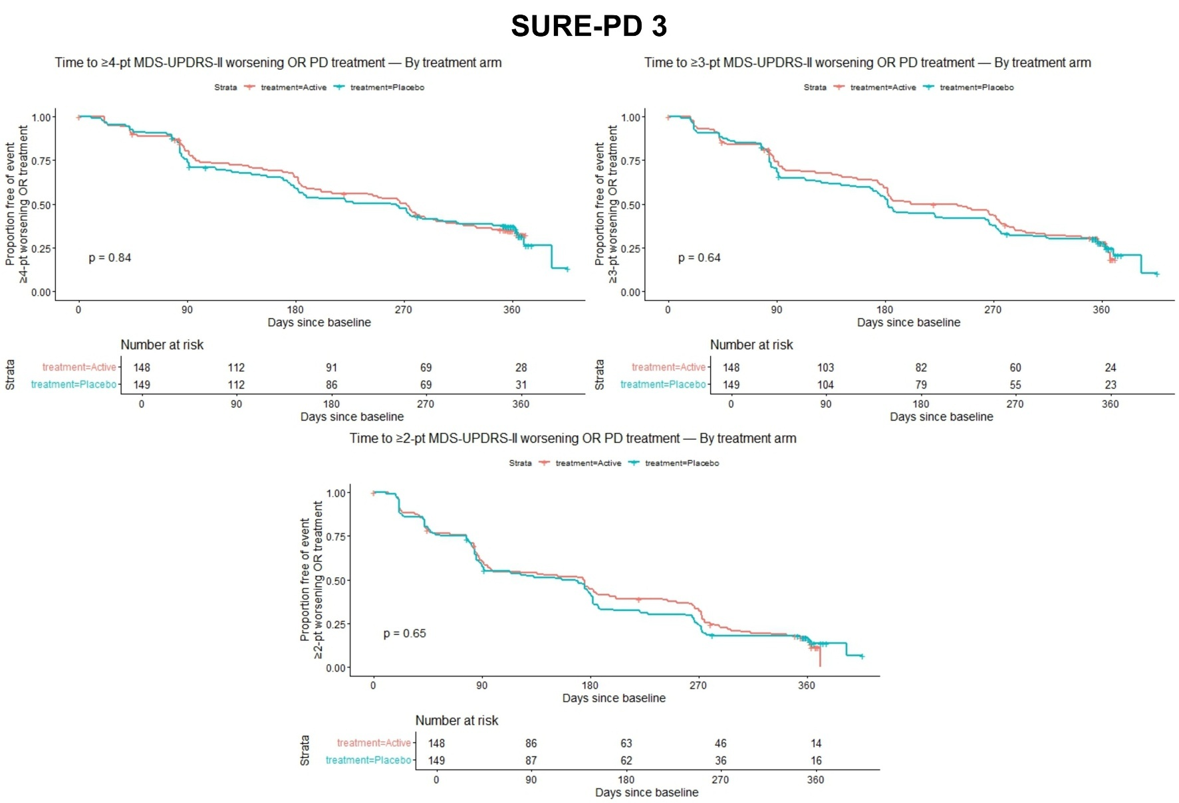
Figure S8. Kaplan-Meier plots of time to 4, 3-, or 2-point worsening of MDS-UPDRS Part II (untreated) or initiation of symptomatic medication among SURE-PD3 participants stratified by randomized treatment arms (log-rank p-value shown).

Table S4. (MDS-)UPDRS Part 3 threshold changes or treatment initiation by absence or presence of allowable symptomatic treatment at baseline
 | 7-point Composite  (7-point/Tx) | 6-point Composite  (6-point/Tx) | 5-point Composite  (5-point/Tx) | 4-point Composite  (4-point/Tx)
STEADY-PD III  No Amantadine/Antichol vs. Yes Amantadine/Antichol. | 73.3% vs. 72.7%  (No: 33.0% / 40.3%)  (Yes: 24.2% / 48.5%) | 75.6% vs. 75.8%  (No: 42.6% / 33.0%)  (Yes: 33.3% / 42.4%) | 79.2% vs. 75.8%  (No: 50.2% / 29.0%)  (Yes: 33.3% / 42.4%) | 82.8% vs. 78.8%  (No: 59.7% / 23.1%)  (Yes: 45.5% / 33.3%)
SURE-PD 3  No MAO-B Inhibitor vs. Yes MAO-B Inhibitor | 77.8% vs. 77.7%  (No: 50.3% / 27.6%)  (Yes: 42.0% / 35.7%) | 80.5% vs. 80.4%  (No: 58.4% / 22.2%)  (Yes: 50.0% / 30.4%) | 83.8% vs. 83.0%  (No: 64.9% / 18.9%)  (Yes: 56.3% / 26.8%) | 87.6% vs. 84.8%  (No: 70.3% / 17.3%)  (Yes: 59.8% / 25.0%)

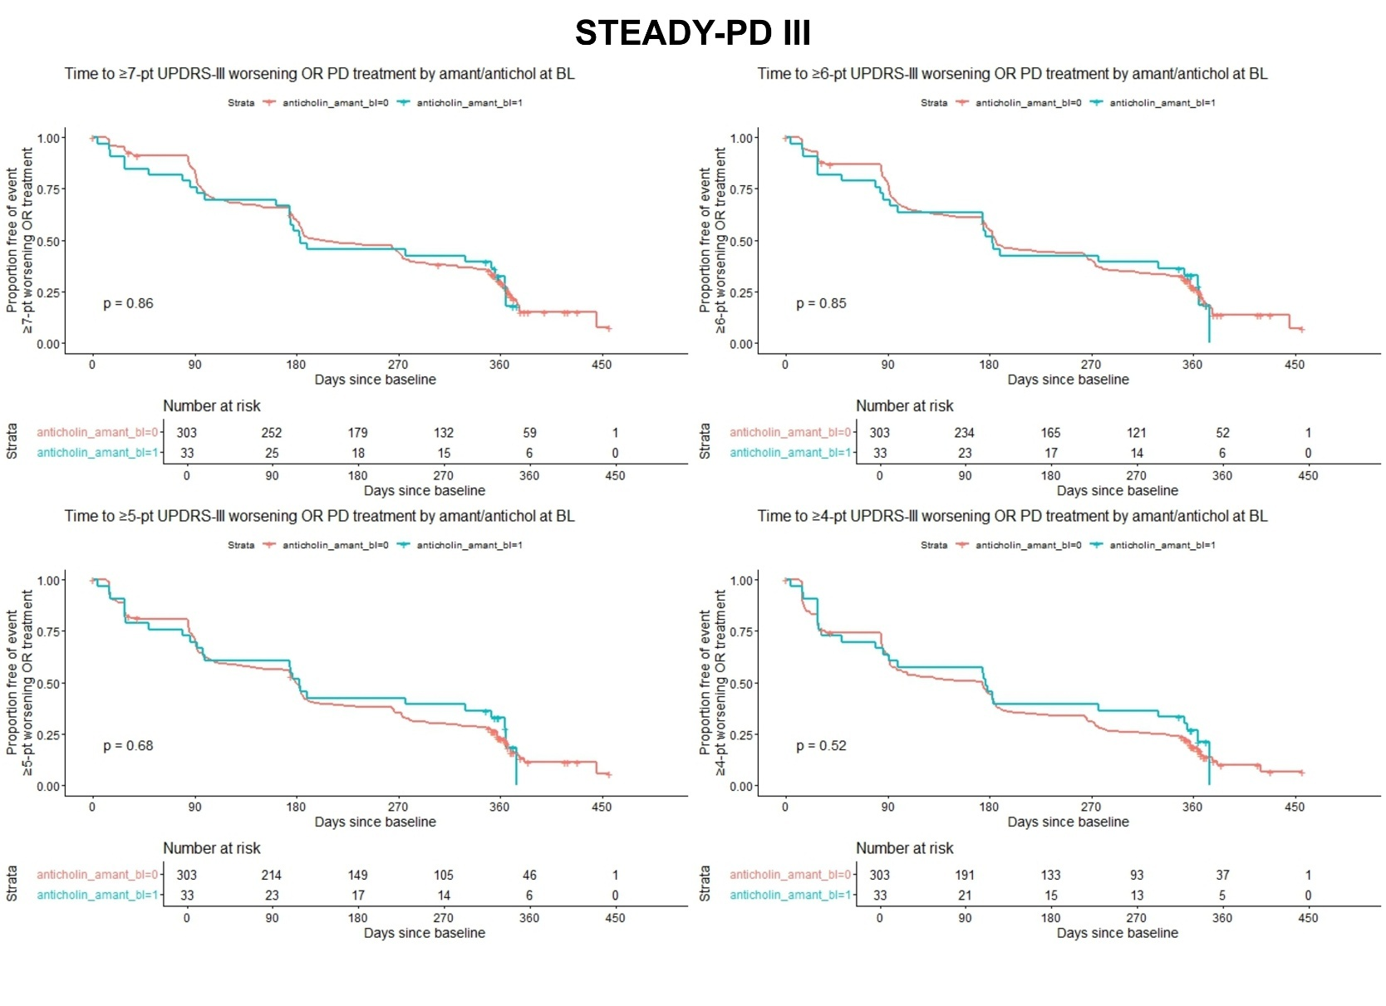
Figure S9. Kaplan-Meier plots of time to 7-, 6-, 5-, or 4-point worsening of UPDRS Part III (untreated) or initiation of symptomatic medication among STEADY-PD III participants stratified by baseline amantadine/anticholinergic use (log-rank p-value shown).

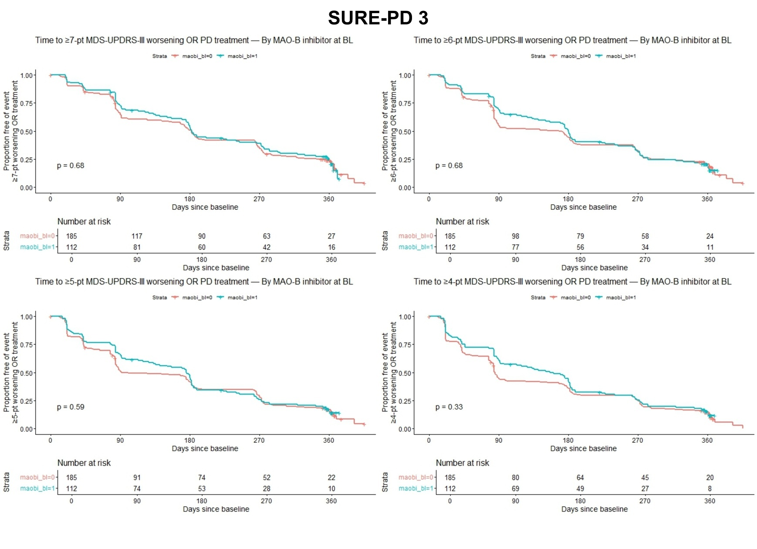
Figure S10. Kaplan-Meier plots of time to 7-, 6-, 5-, or 4-point worsening of MDS-UPDRS Part III (untreated) or initiation of symptomatic medication among SURE-PD3 participants stratified by baseline MAO-B inhibitor use (log-rank p-value shown).

Table S5. (MDS-)UPDRS Part 2 threshold changes or treatment initiation by absence or presence of allowable symptomatic treatment at baseline
 | 4-point Composite  (4-point/Tx) | 3-point Composite  (3-point/Tx) | 2-point Composite  (2-point/Tx)
STEADY-PD III  No Amantadine/Antichol vs. Yes Amantadine/Antichol. | 71.6% vs. 78.8%  (No: 34.7% / 37.0%)  (Yes: 27.3% / 51.5%) | 79.5% vs. 78.8%  (No: 49.5% / 30.0%)  (Yes: 48.5% / 30.3%) | 85.8% vs.% 87.9%  (No: 64.4% / 21.4%)  (Yes: 60.6% / 27.3%)
SURE-PD 3  No MAO-B Inhibitor vs. Yes MAO-B Inhibitor | 64.3% vs. 62.5%  (No: 27.0% / 37.3%)  (Yes: 19.6% / 42.9%) | 73.5% vs. 68.8%  (No: 42.7% / 30.8%)  (Yes: 30.4% / 38.4%) | 84.9% vs. 81.3%  (No: 62.7% / 22.2%)  (Yes: 50.0% / 31.3%)

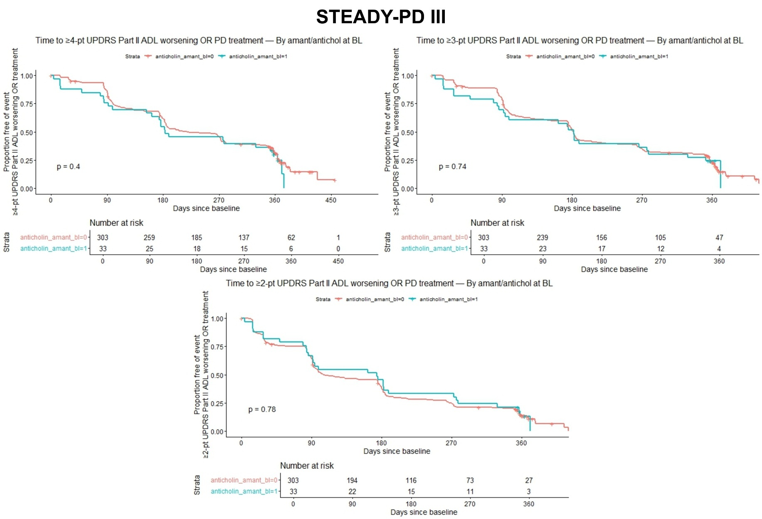
Figure S11. Kaplan-Meier plots of time to 4, 3-, or 2-point worsening of UPDRS Part II (untreated) or initiation of symptomatic medication among STEADY-PD III participants stratified by baseline amantadine/anticholinergic use (log-rank p-value shown).

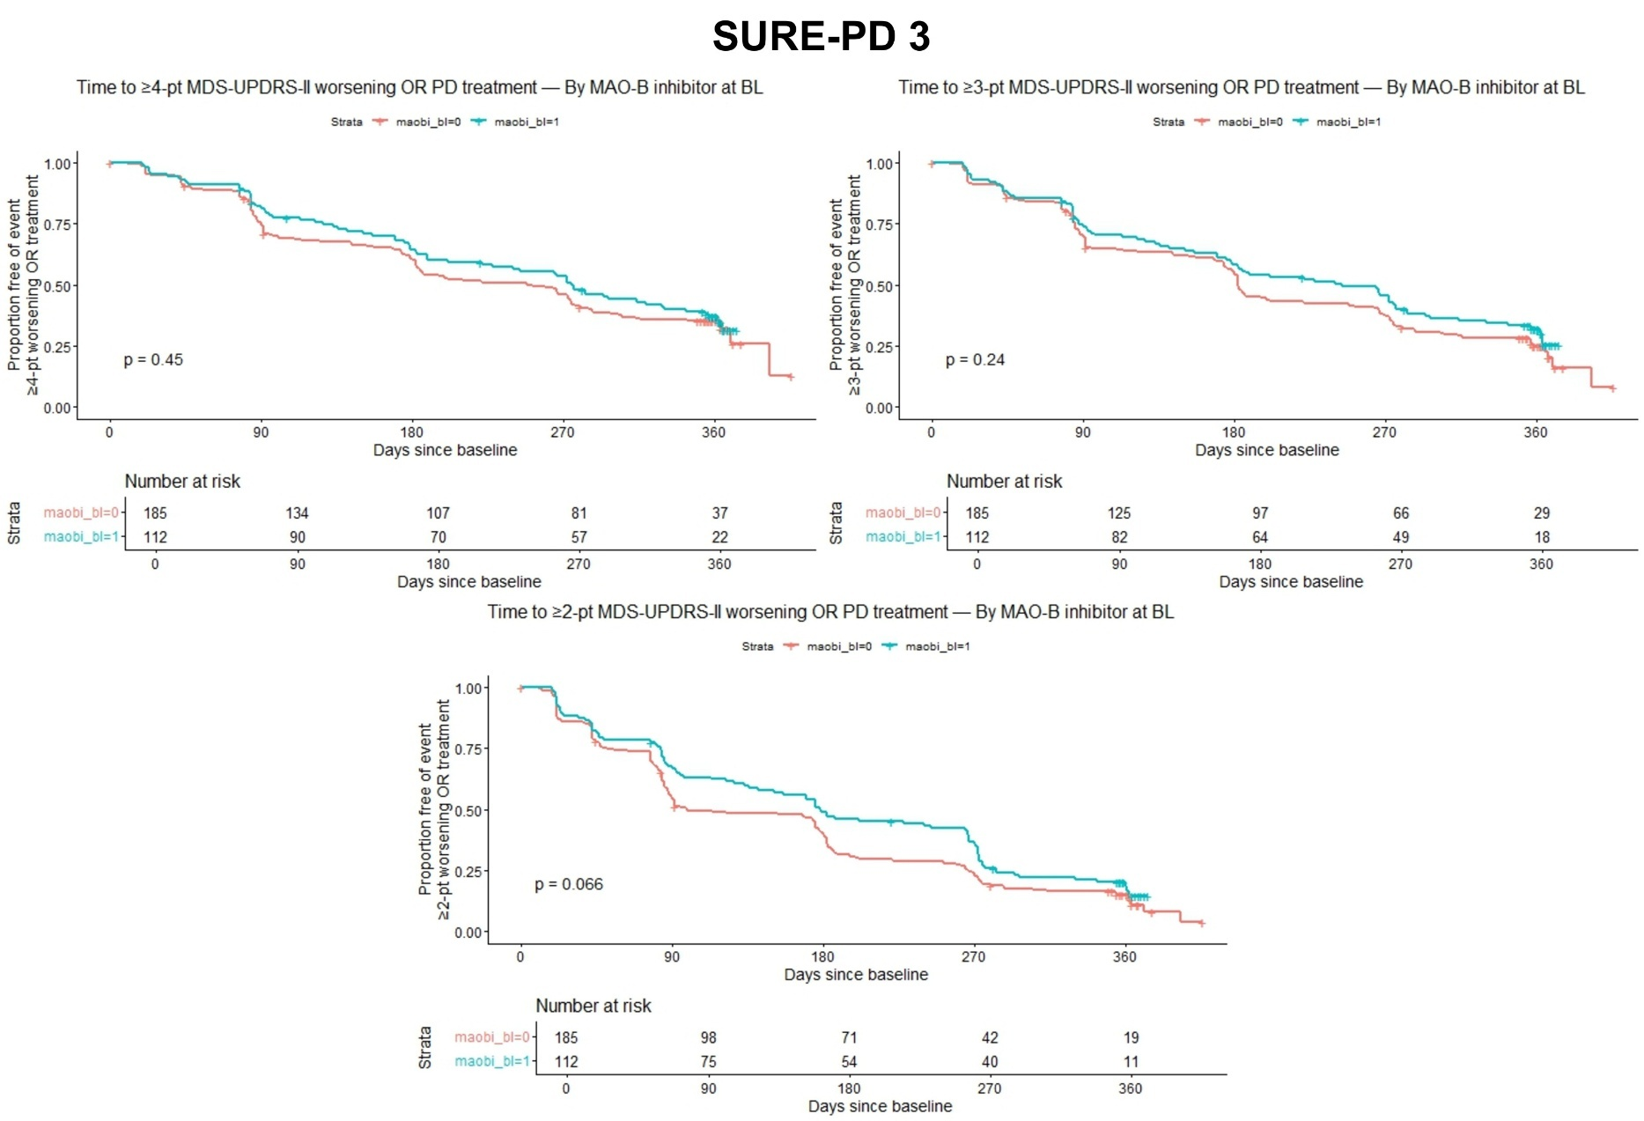
Figure S12. Kaplan-Meier plots of time to 4, 3-, or 2-point worsening of MDS-UPDRS Part II (untreated) or initiation of symptomatic medication among SURE-PD3 participants stratified by baseline MAO-B inhibitor use (log-rank p-value shown).
Table S6. (MDS-)UPDRS Part 2 Changes when Part 3 Change Threshold is met
 | (MDS-)UPDRS Part II Change from Baseline when Part III threshold met
 | STEADY-PD III | FS-1 | FS-TOO | SURE-PD3 | PPMI
7-point Part III Threshold  N  Mean (SD)  Median [min, max] | 57  1.61 (2.44)  1 [-4, 9] | 32  3.06 (3.21)  2.5 [-2, 10] | 25  2.48 (3.19)  2 [-4, 10] | 69  0.565 (3.23)  1 [-9, 9] | 153  1.25 (3.06)  1 [-16, 9]
6-point Part III Threshold  N  Mean (SD)  Median [min, max] | 71  1.61 (2.60)  1 [-4, 9] | 33  2.76 (3.10)  2 [-2, 10] | 30  2.50 (3.16)  2 [-4, 10] | 85  0.45 (3.05)  0 [-9, 7] | 173  1.40 (3.28)  1 [-16, 16]
5-point Part III Threshold  N  Mean (SD)  Median [min, max] | 83  1.14 (2.52)  1 [-4, 9] | 37  2.54 (3.03)  2 [-2, 10] | 37  2.30 (3.01)  2 [-4, 10] | 91  0.12 (2.80)  0 [-9, 7] | 204  1.25 (3.22)  1 [-16, 16]
4-point Part III Threshold  N  Mean (SD)  Median [min, max] | 98  1.13 (2.28)  1 [-4, 7] | 45  1.87 (2.96)  1 [-2, 10] | 44  1.86 (2.78)  1.5 [-4, 8] | 99  0.03 (2.80)  0 [-9, 7] | 229  1.19 (3.16)  1 [-16, 16]

Table S7A. Total sample sizes needed for (MDS-)UPDRS part III thresholds with various dropout rates (90% Power)
Study | Part III Threshold | Total Sample Size (No Dropout) | Total Sample Size (5% Dropout) | Total Sample Size (10% Dropout) | Total Sample Size (15% Dropout) | Total Sample Size (20% Dropout)
STEADY-PD III | 7-point | 464 | 472 | 516 | 546 | 580
STEADY-PD III | 6-point | 456 | 466 | 508 | 538 | 570
STEADY-PD III | 5-point | 430 | 444 | 478 | 506 | 538
STEADY-PD III | 4-point | 412 | 424 | 458 | 486 | 516
FS-1 | 7-point | 560 | 590 | 624 | 660 | 700
FS-1 | 6-point | 546 | 576 | 608 | 644 | 684
FS-1 | 5-point | 534 | 564 | 594 | 630 | 668
FS-1 | 4-point | 466 | 492 | 518 | 550 | 584
FS-TOO | 7-point | 662 | 698 | 736 | 780 | 828
FS-TOO | 6-point | 596 | 628 | 664 | 702 | 746
FS-TOO | 5-point | 530 | 558 | 590 | 624 | 664
FS-TOO | 4-point | 466 | 492 | 518 | 550 | 584
SURE-PD 3 | 7-point | 454 | 478 | 506 | 536 | 568
SURE-PD 3 | 6-point | 430 | 454 | 478 | 506 | 538
SURE-PD 3 | 5-point | 418 | 440 | 466 | 492 | 524
SURE-PD 3 | 4-point | 394 | 416 | 438 | 464 | 494
PPMI Sporadic PD | 7-point | 444 | 468 | 494 | 524 | 556
PPMI Sporadic PD | 6-point | 434 | 458 | 484 | 512 | 544
PPMI Sporadic PD | 5-point | 412 | 434 | 458 | 486 | 516
PPMI Sporadic PD | 4-point | 394 | 416 | 438 | 464 | 494

Table S7B. Total sample sizes needed for (MDS-)UPDRS part II thresholds with various dropout rates (90% Power)
Study | Part II Threshold | Total Sample Size (No Dropout) | Total Sample Size (5% Dropout) | Total Sample Size (10% Dropout) | Total Sample Size (15% Dropout) | Total Sample Size (20% Dropout)
STEADY-PD III | 4-point | 468 | 486 | 520 | 552 | 586
STEADY-PD III | 3-point | 430 | 446 | 478 | 506 | 538
STEADY-PD III | 2-point | 392 | 410 | 436 | 462 | 490
FS-1 | 4-point | 604 | 636 | 672 | 712 | 756
FS-1 | 3-point | 546 | 576 | 608 | 644 | 684
FS-1 | 2-point | 476 | 502 | 530 | 560 | 596
FS-TOO | 4-point | 628 | 662 | 698 | 740 | 786
FS-TOO | 3-point | 530 | 558 | 590 | 624 | 664
FS-TOO | 2-point | 476 | 502 | 530 | 560 | 596
SURE-PD 3 | 4-point | 566 | 566 | 630 | 666 | 708
SURE-PD 3 | 3-point | 492 | 500 | 548 | 580 | 616
SURE-PD 3 | 2-point | 422 | 440 | 470 | 498 | 528
PPMI Sporadic PD | 4-point | 458 | 484 | 510 | 540 | 574
PPMI Sporadic PD | 3-point | 434 | 458 | 484 | 512 | 544
PPMI Sporadic PD | 2-point | 404 | 426 | 450 | 476 | 506

