SUPPLEMENTARY FIGURES
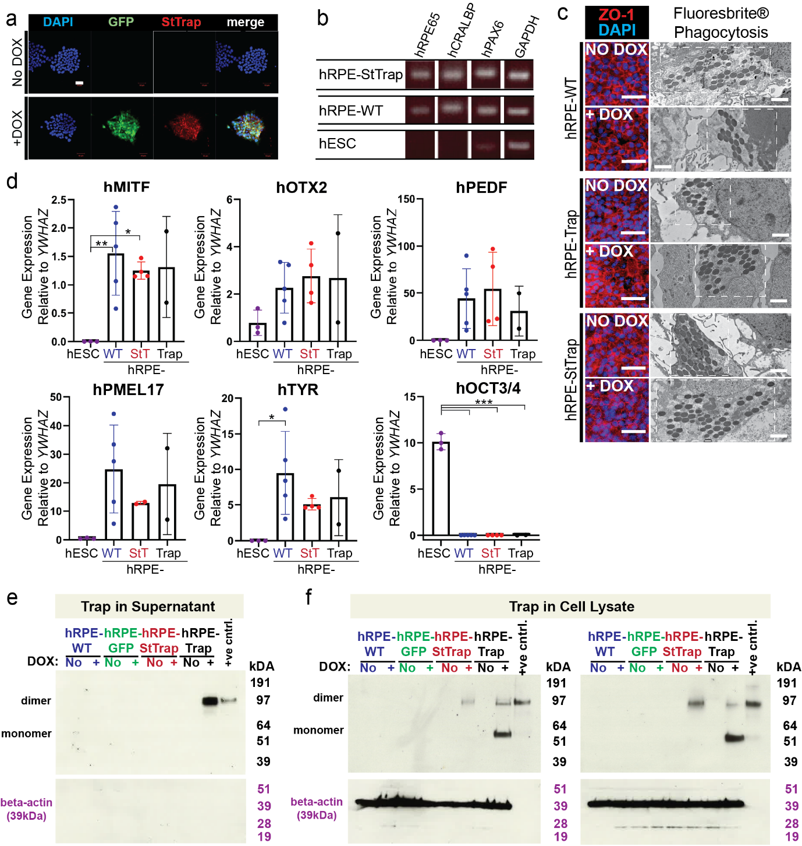
Supplementary Figure 1 | Characterization of engineered hRPE cell lines expressing VEGF Sticky-trap or VEGF-trap. (a) Inducible expression of GFP and VEGF Sticky-trap in transgenic H1 hESCs following doxycycline (DOX) treatment. Scale bar, 50 μm. (b,c) Expression of RPE markers hRPE65, hCRALBP, hPAX6, hMITF, hOTX2, hPEDF, hTYR, and hPMEL17 in differentiated hRPE cell lines. OCT3/4 expression was absent following differentiation. One-way ANOVA; *P < 0.05, **P < 0.01, ***P < 0.001. StT, VEGF Sticky-trap; Trap, VEGF-trap. (d) ZO-1 immunostaining and Fluoresbrite® latex bead uptake demonstrate epithelial integrity and phagocytic activity of hRPE cell lines. Scale bars, 200 μm (ZO-1) and 2 μm (TEM images). (e) Western blot analysis of conditioned media collected from hRPE cultures maintained in the presence or absence of DOX. (f) Western blot analysis of two independent biological replicates demonstrating inducible expression of VEGF Sticky-trap or VEGF-trap in hRPE cell lysates following DOX treatment. Recombinant VEGF-trap protein served as a positive control.

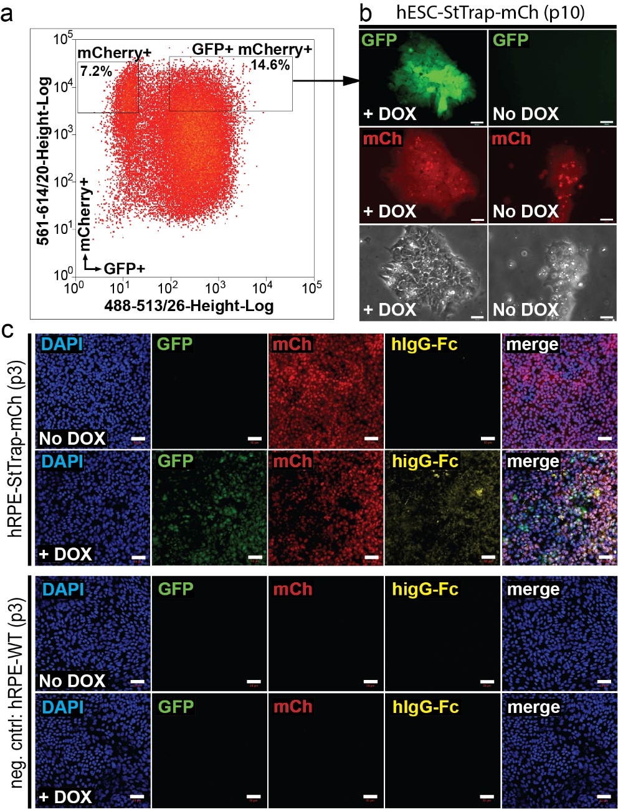
Supplementary Figure 2 | Generation of mCherry expressing hRPE-StTrap cells. (a) Following transfection with the PB-CAG-mCherry expression vector, DOX-induced cells were single-cell sorted based on EGFP and mCherry expression to generate a stable hRPE-StTrap-mCh clonal cell line. (b) The selected clone was evaluated for DOX-inducible EGFP expression and constitutive mCherry expression over multiple passages, including passage 10 (P10). Scale bar, 100 μm. (c) Immunofluorescence analysis of differentiated hRPE-StTrap-mCh cells (P3). hRPE-StTrap-mCh cells constitutively expressed mCherry and exhibited DOX-inducible EGFP-StTrap expression, whereas non-transgenic hRPE-WT cells served as negative controls. Scale bar, 50 μm.

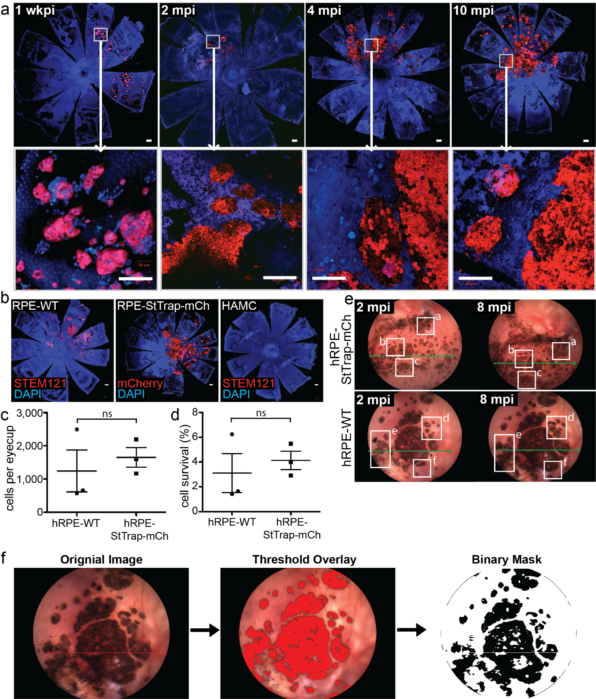
Supplementary Figure 3 | Long-term persistence and integration of subretinally transplanted hRPE cells. (a) Flat-mounted eyecups collected 1 week post-injection (wkpi), 2 months post-injection (mpi), 4 mpi, and 10 mpi following hRPE-StTrap-mCh transplantation. At 1 wkpi, grafted cells were present as multilayered clusters, whereas at later time points cells adopted a flattened morphology consistent with integration into the host RPE monolayer. Scale bars, 500 μm (whole-mount images) and 50 μm (magnified views). (b) Representative flat-mounted eyecups stained with STEM121 or mCherry to identify transplanted hRPE-WT and hRPE-StTrap-mCh cells, respectively. HAMC-injected eyes served as controls. (c) Representative fundus images acquired at 2 and 8 mpi demonstrating stable graft pigmentation over time. Green arrows indicate the OCT scan location. (d) Quantification of pigmented graft area from fundus images using ImageJ color threshold analysis. Data are presented as mean ± SD; ns, not significant.

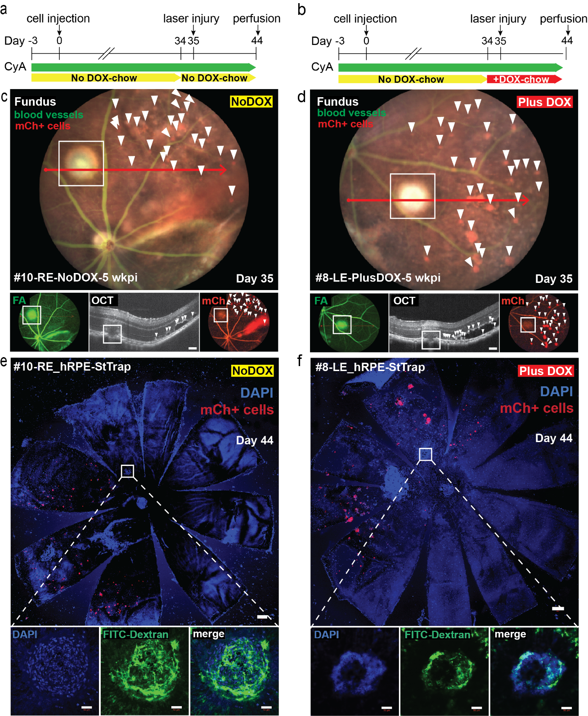
Supplementary Figure 4 | Laser-induced CNV assay. (a,b) hRPE-StTrap-mCh cells were injected into the subretinal space of adult C57BL/6J mice. Five weeks post-injection (wkpi), laser photocoagulation was performed adjacent to grafted mCherry+ cells. Mice received either a regular diet (No DOX) or a DOX-containing diet beginning one day prior to laser photocoagulation. Fundus, fluorescein angiography (FA), optical coherence tomography (OCT), and mCherry fluorescence imaging were used to identify grafted cells and confirm laser placement relative to the graft. White boxes indicate the laser injury site. Scale bar, 100 μm. (c,d) Flat-mounted eyecups collected 9 days after laser photocoagulation (Day 44) show the laser injury site (white boxes) adjacent to transplanted hRPE-StTrap-mCh cells (white arrowheads). Scale bar, 2,000 μm. (e,f) Higher-magnification views of FITC-dextran-stained CNV lesions at the laser injury site. Scale bar, 50 μm. wkpi, weeks post-injection; FA, fluorescein angiography; OCT, optical coherence tomography; mCh, mCherry.

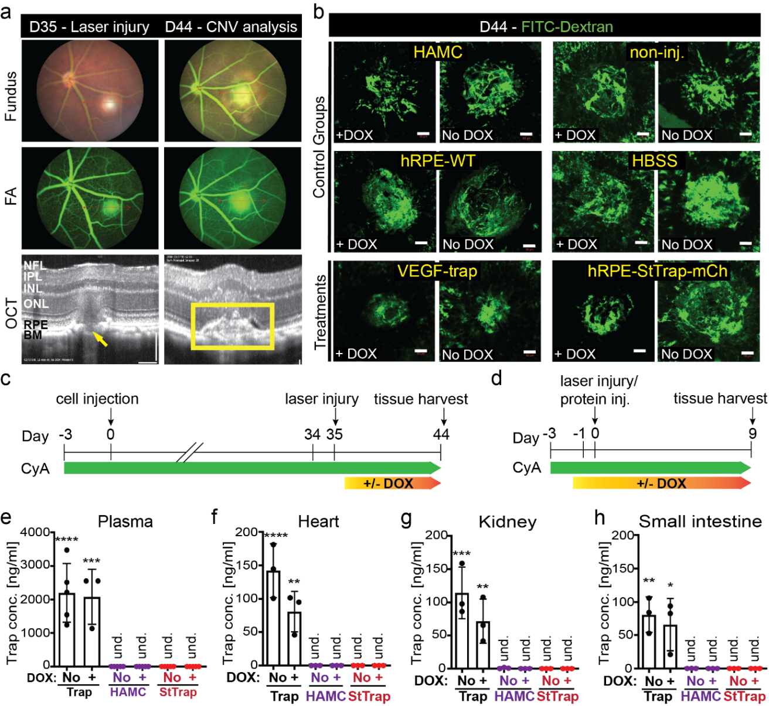
Supplementary Figure 5 | Laser-induced choroidal neovascularization (CNV) model and biodistribution of VEGF-trap proteins. (a) Fundus, fluorescein angiography (FA), and OCT images demonstrating laser-induced rupture of Bruch's membrane (BM) at Day 35 (D35). BM rupture resulted in the formation of a subretinal bubble (arrow). (b) Representative FITC-dextran-perfused CNV lesions collected at Day 44 (D44), 9 days after laser photocoagulation. Only eyes with confirmed BM rupture were included in the study. Scale bars, 100 μm (OCT) and 50 μm (flat-mounts). NFL, nerve fiber layer; IPL, inner plexiform layer; INL, inner nuclear layer; ONL, outer nuclear layer; RPE, retinal pigment epithelium; BM, Bruch's membrane. (c,d) Experimental design for assessment of systemic VEGF-trap exposure following subretinal transplantation of hRPE-StTrap-mCh cells or intravitreal administration of recombinant VEGF-trap protein. (e–h) Human VEGF-trap ELISA measurements in serum, heart, kidney, and small intestine collected 9 days after treatment. Recombinant VEGF-trap protein was detected in serum and peripheral organs following intravitreal administration, whereas VEGF Sticky-trap expressed by transplanted hRPE-StTrap-mCh cells remained undetectable (und.) in all samples analyzed. Data are presented as mean ± SD. *P < 0.05, **P < 0.01, ***P < 0.001, ****P < 0.0001; two-way ANOVA.

