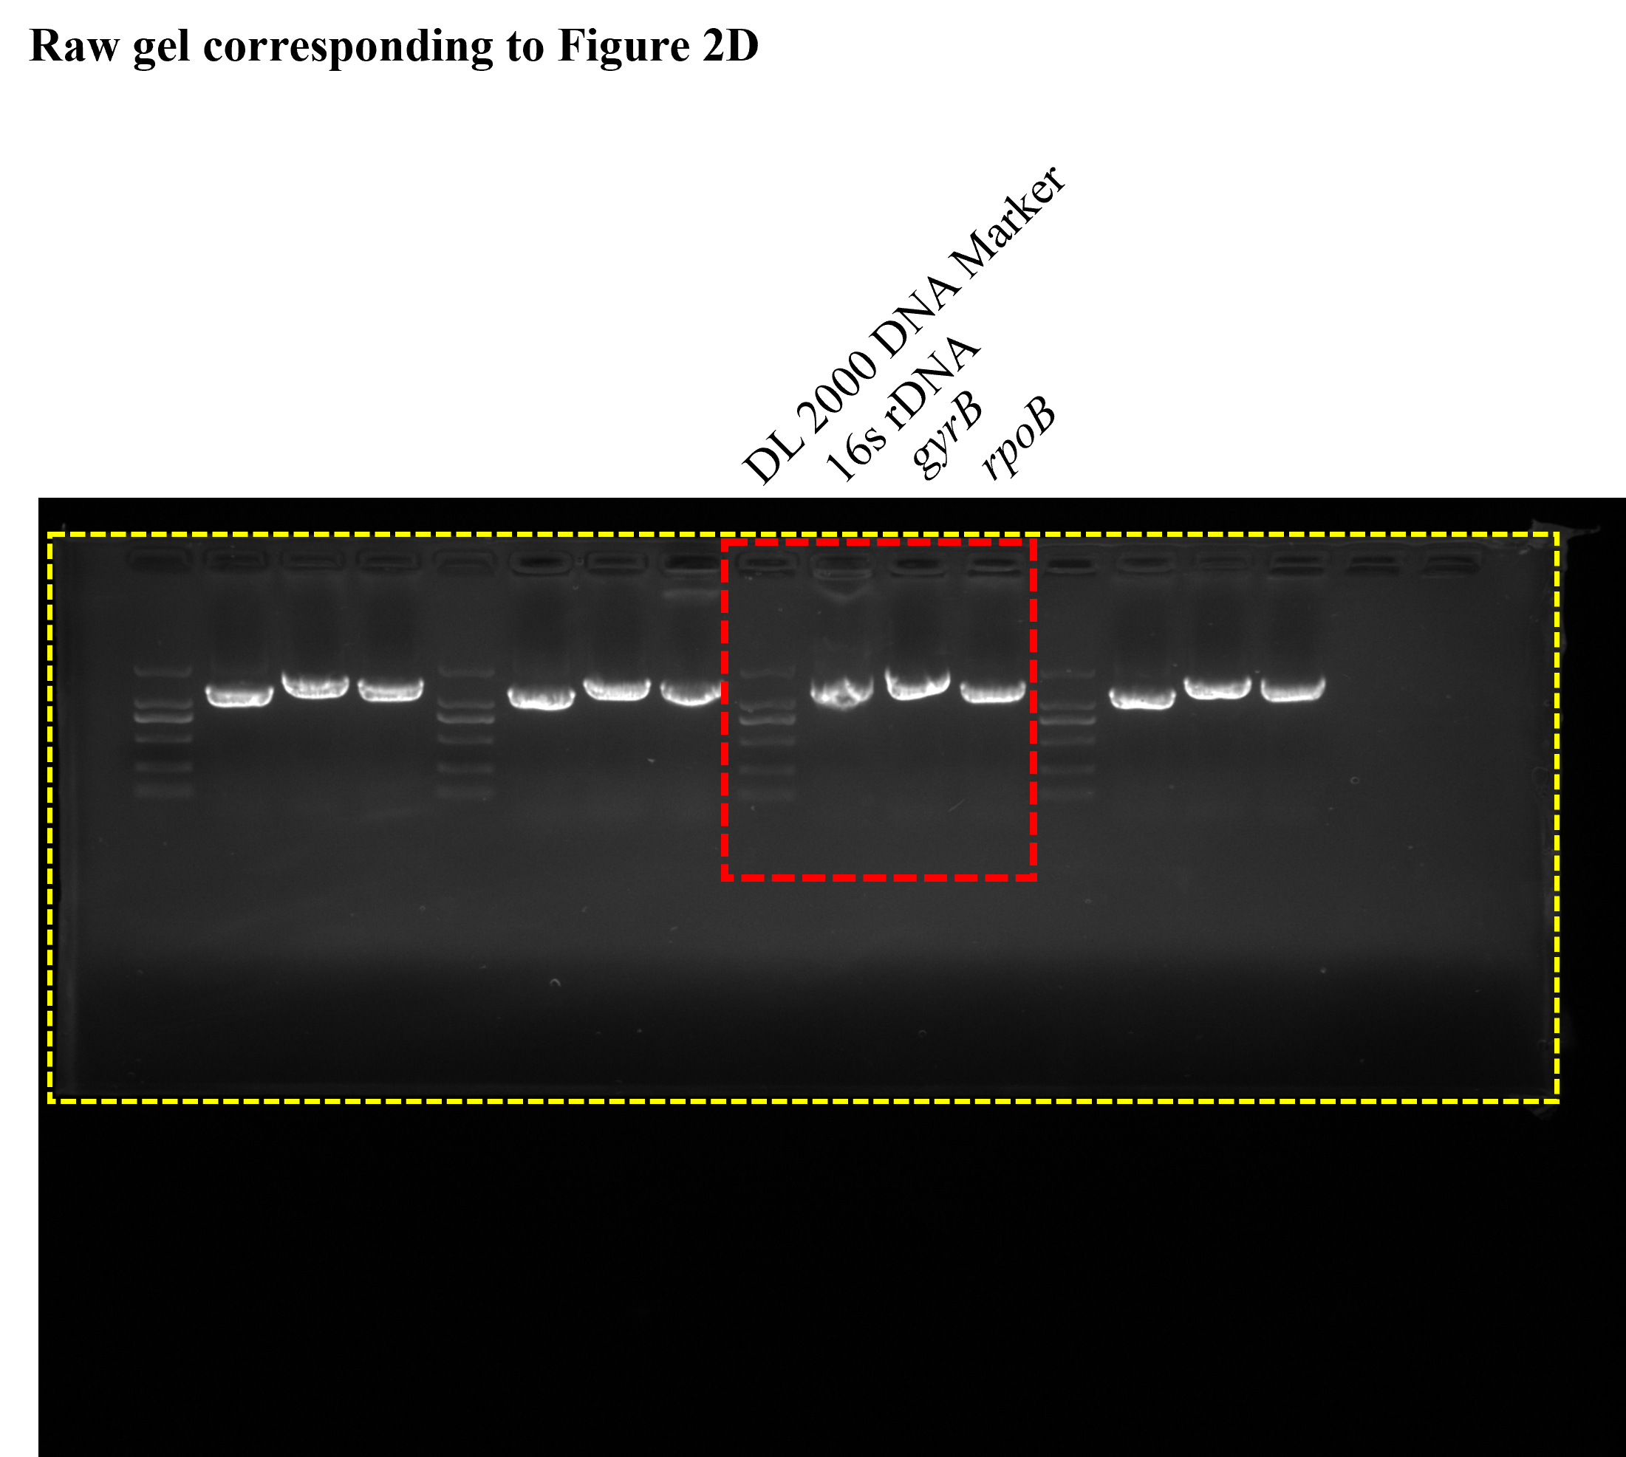
The full-length agarose gel for the PCR amplification of the three reference genes (16S rDNA, gyrB, and rpoB). The yellow dashed outline clearly defines the physical edges of the original, uncropped gel. The red dashed box indicates the specific cropped region that is presented in panel D of Figure 2 in the main text. The lane markers and target gene labels correspond exactly to those detailed in the main figure legend, , while the unlabeled lanes on the left and right represent unrelated samples.
Additional file 2-1. Original, uncropped full-length gel corresponding to Figure 2D.

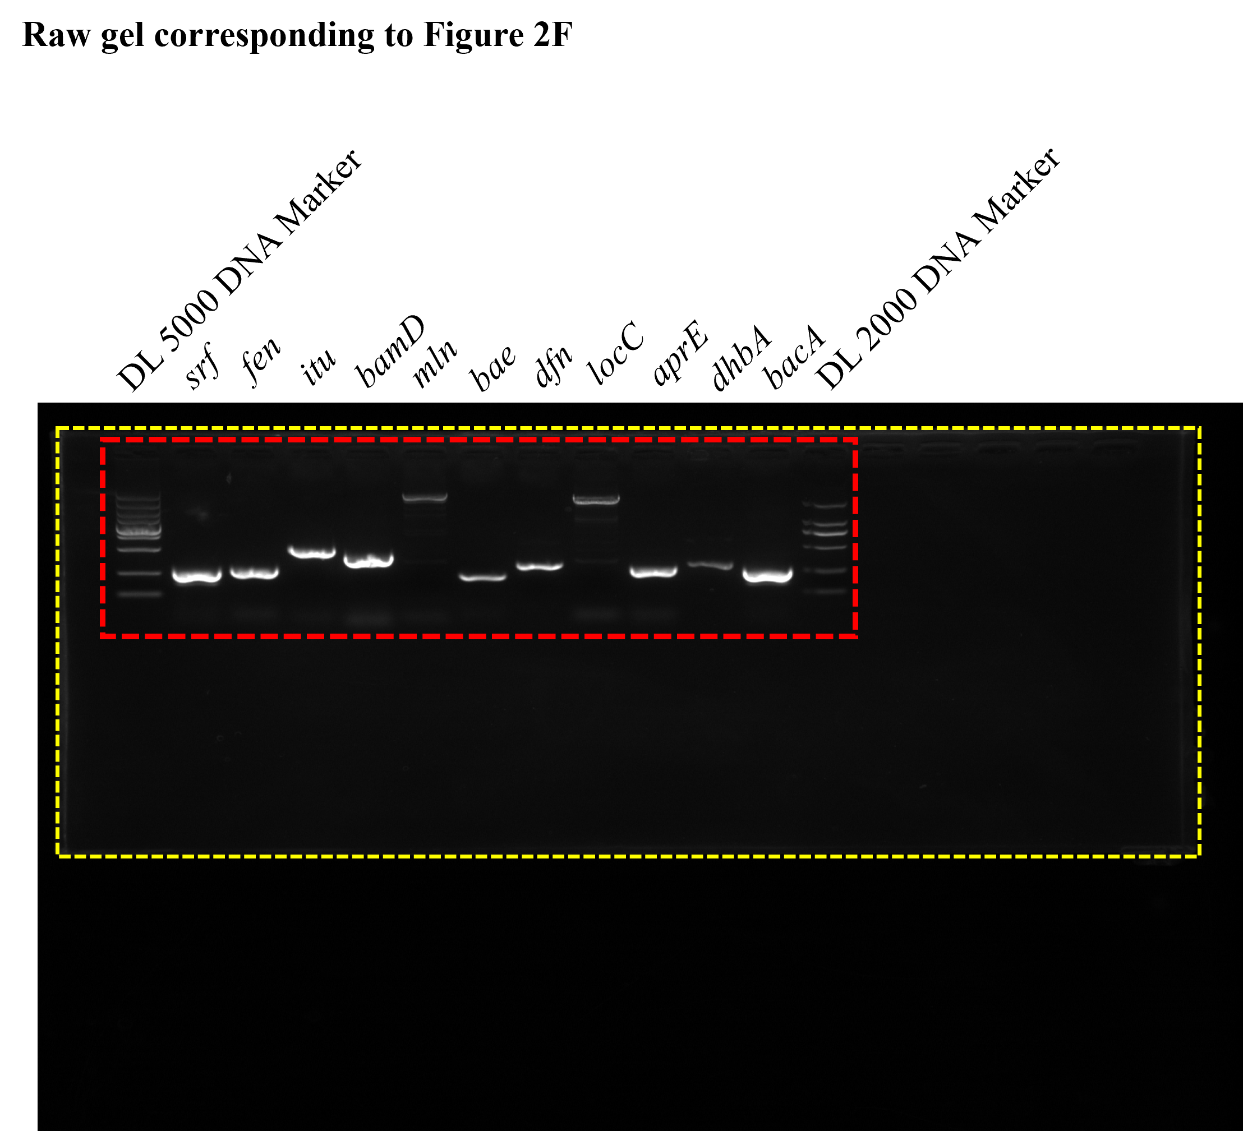
The full-length agarose gel for the PCR screening of secondary metabolite biosynthetic gene clusters (BGCs). The yellow dashed outline clearly defines the physical edges of the original, uncropped gel. The red dashed box indicates the specific cropped region that is presented in panel F of Figure 2 in the main text. The lane markers and target gene labels correspond exactly to those detailed in the main figure legend, while the unlabeled lanes on the right represent empty wells.
Additional file 2-2. Original, uncropped full-length gel corresponding to Figure 2F.

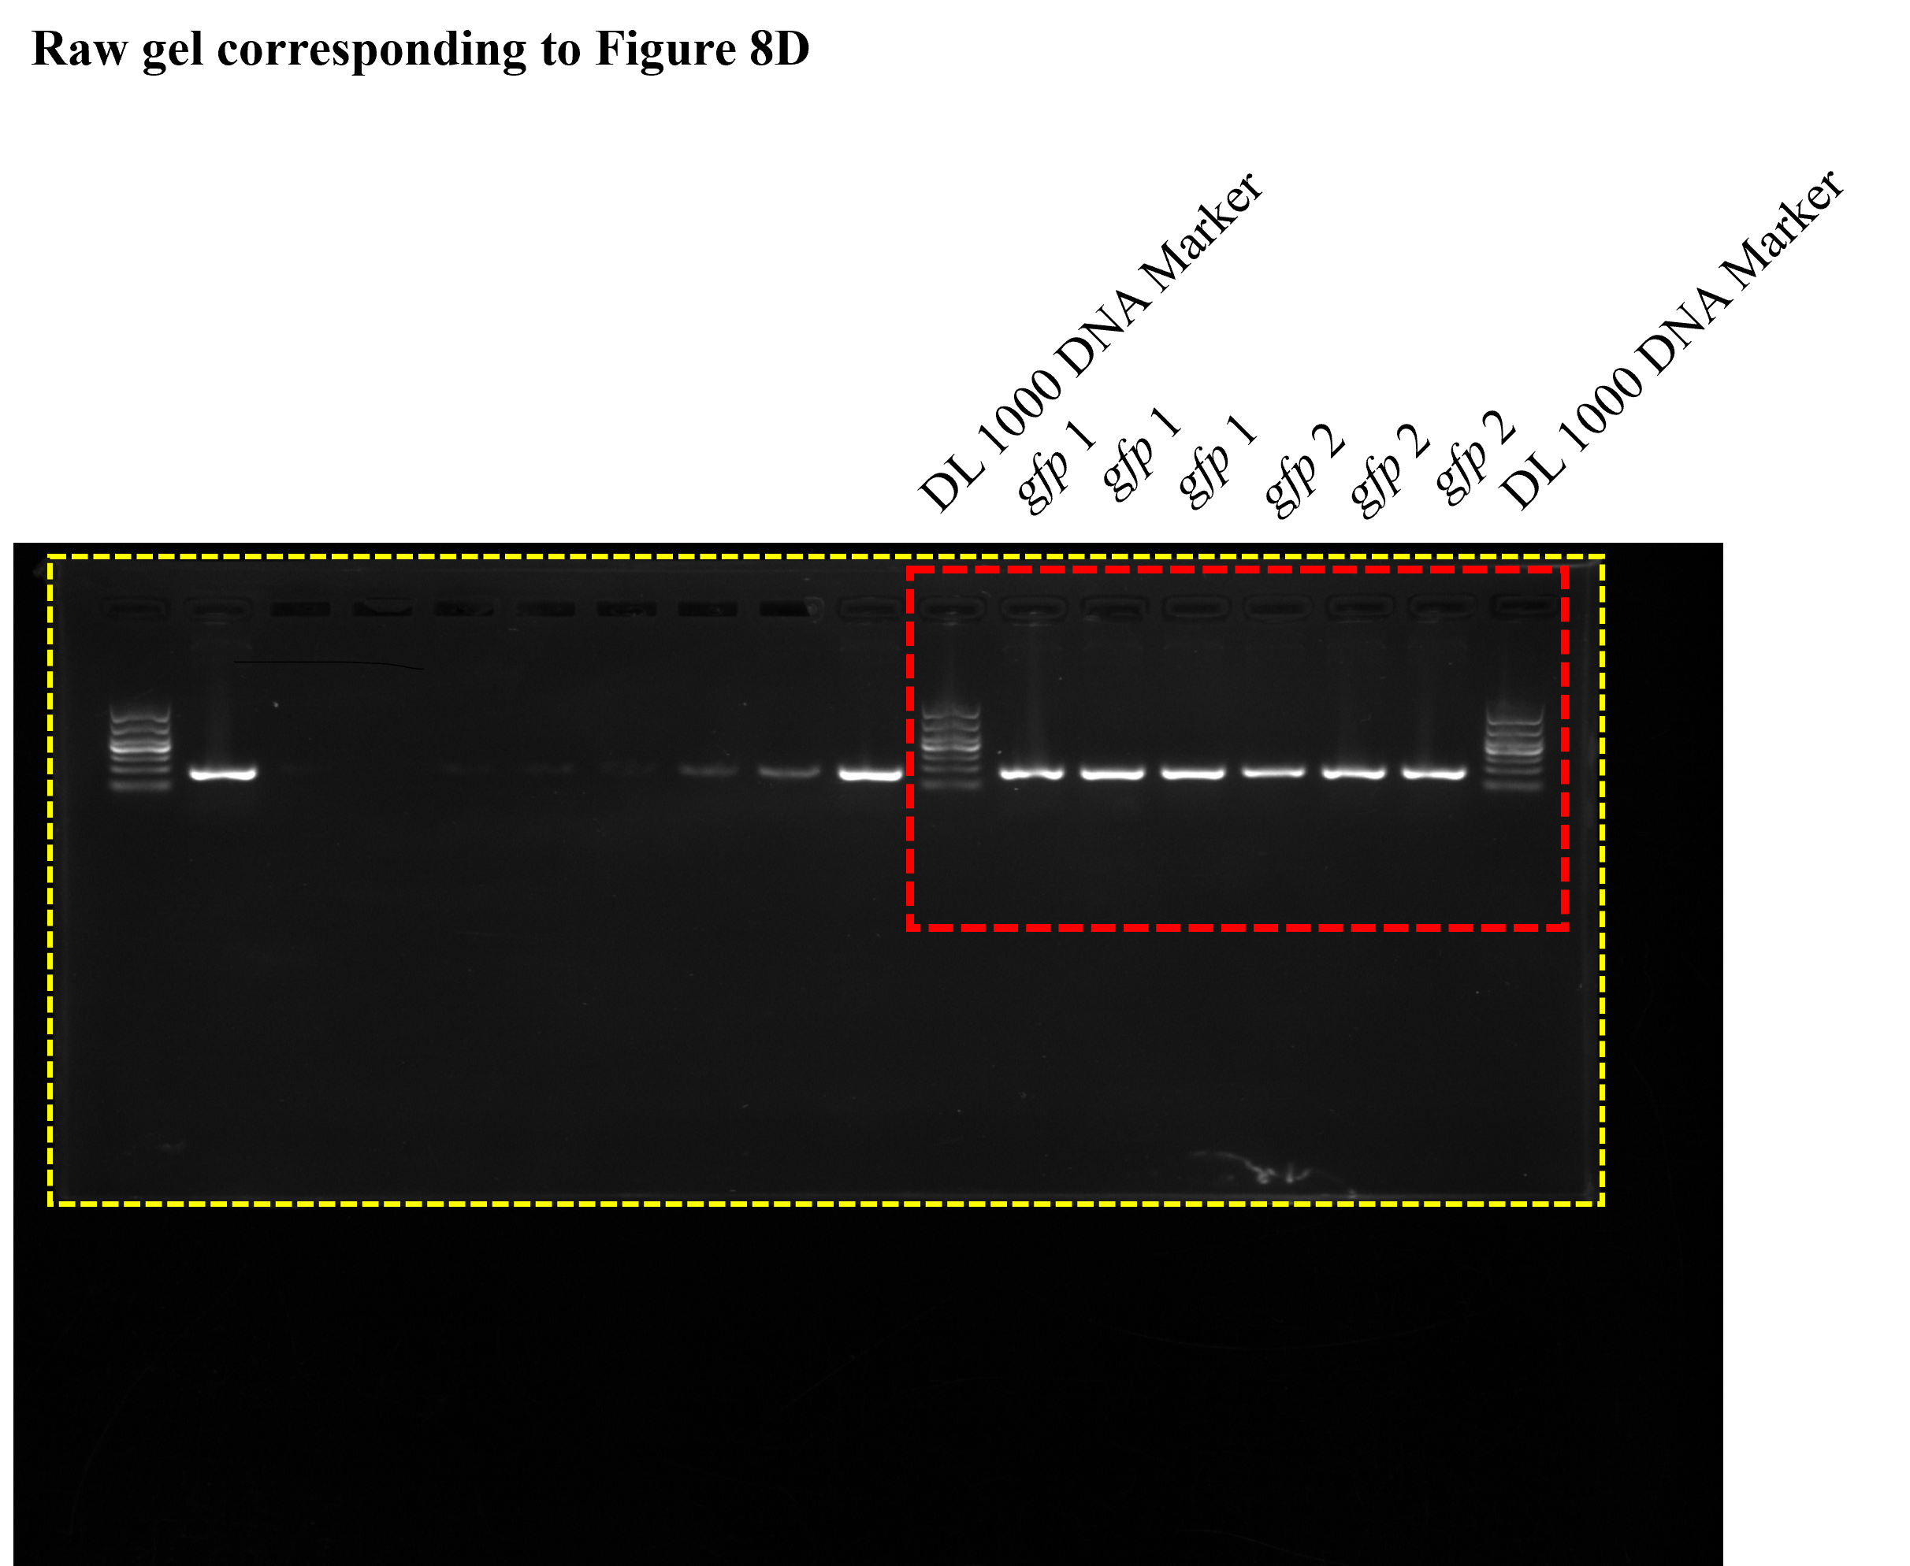
The full-length agarose gel for the molecular validation of the gfp gene via PCR amplification. The yellow dashed outline clearly defines the physical edges of the original, uncropped gel. The red dashed box indicates the specific cropped region that is presented in panel D of Figure 8 in the main text. The lane markers and target gene labels correspond exactly to those detailed in the main figure legend, while the unlabeled lanes on the left represent unrelated samples.
Additional file 2-3. Original, uncropped full-length gel corresponding to Figure 8D.

