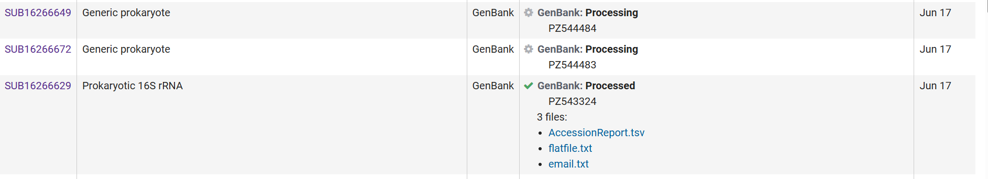
Additional file 3. The submission records and accession details of the 16S rRNA and related sequences in NCBI GenBank.

