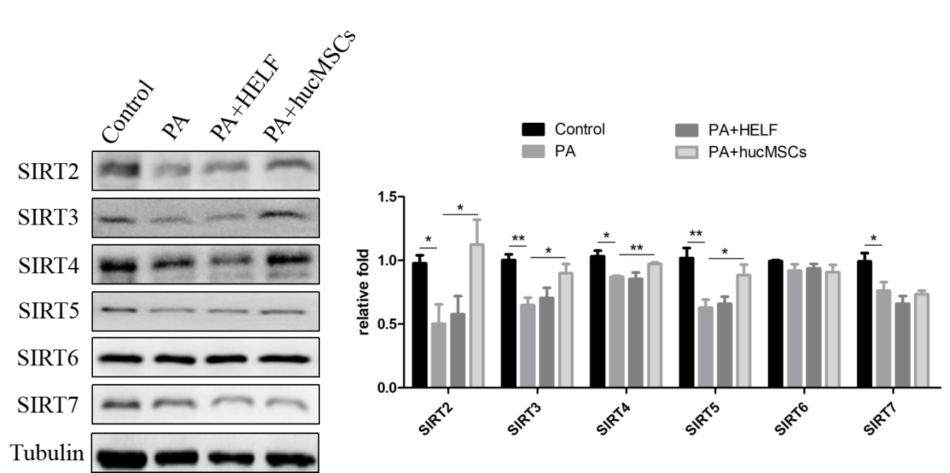
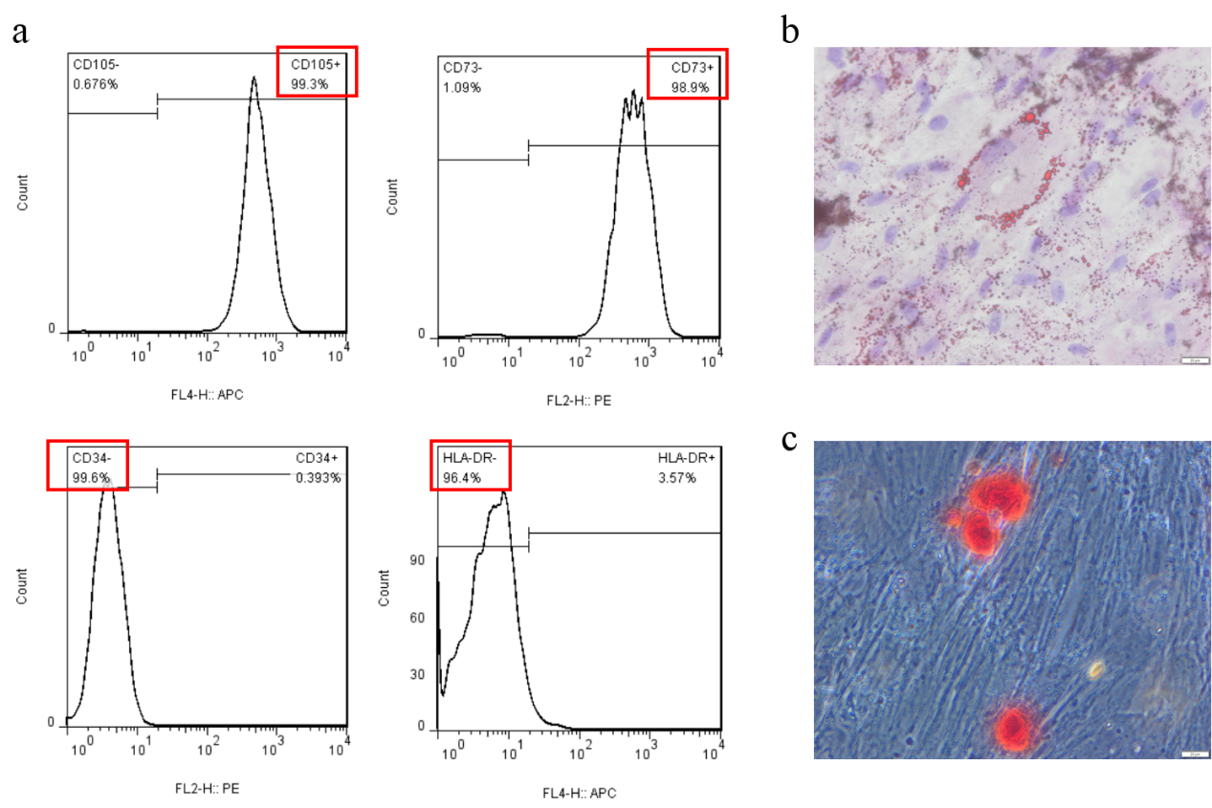
Supplementary Fig.2 The influence of hucMSCs on SIRTs family members expression. Western blotting showed that hucMSCs promoted expression of SIRT2, SIRT3, SIRT4 and SIRT5, whereas didn't influent SIRT6 and SIRT7 levels. Quantification of bands was performed using ImageJ software. All these experiments were repeated for three to four times and the data was presented as the mean ± SEM (*P < 0.05; **P < 0.01).
Supplementary Fig.1 Identification of hucMSCs. a. FACS analysis showed that hucMSCs were positive for stem cell markers CD105 and CD73, and negative for CD34 and HLA-DR. b. Oil Red O staining showed that hucMSCs could differentiate into adipocytes. c. Alizarin Red S staining suggested that hucMSCs could differentiate into osteoblasts.

