Supplement
Personality Heterogeneity Shapes the Neural Organization of Conditioned Threat Learning

Result
Stability and Reproducibility of the GMM-Derived Personality Subtypes
To evaluate the robustness of the identified personality subtypes, we performed complementary analyses examining subsampling stability, random-seed stability, and split-half reproducibility. Subsampling analyses demonstrated that the two-cluster solution remained consistently favored across repeated random subsets of participants, with the Bayesian Information Criterion (BIC) reaching its minimum at k = 2 across 50 independent subsampling iterations. This finding indicates that the selected clustering solution was not driven by sample-specific composition. Random-seed stability analyses further revealed extremely high clustering consistency across 1,000 independent model initializations. Cluster assignments were nearly identical across repeated runs (mean ARI = 0.992 ± 0.018; mean NMI = 0.986 ± 0.031), with median ARI and NMI values both approaching 1.0. These results indicate that the identified subtype structure was highly robust to stochastic variation in model initialization. Finally, split-half reproducibility analyses demonstrated moderate-to-strong agreement between subtype assignments derived from independent participant subsets. Across 1,000 repeated train-test partitions, mean ARI and NMI values were 0.583 ± 0.326 and 0.549 ± 0.302, respectively, with median values of 0.676 and 0.626. These results indicate that the identified personality subtype structure generalized across independent participant samples and was not solely driven by sample-specific clustering patterns. Collectively, these analyses support the robustness, reproducibility, and generalizability of the GMM-derived personality subtypes.

Comparison of NEO-FFI-3 personality dimensions between the GMM-derived subgroups
To further characterize the personality structure of the GMM-derived subgroups, we compared all five NEO-FFI-3 dimensions between clusters (Table 1). Although the clustering procedure incorporated all five personality dimensions, neuroticism emerged as the primary trait distinguishing the two subgroups, exhibiting the largest between-group difference. Additional differences were observed across several other personality dimensions; however, these effects were substantially smaller than those observed for neuroticism.
Supplementary Table1. Comparison of NEO-FFI-3 personality dimensions between the GMM-derived subgroups
Personality Profile | t value | p value
Openness | -3.12 | 2.0e-03
Extraversion | -1.72 | 8.7e-01
Agreeableness | -0.82 | 4.1e-01
Neuroticism | -18.45 | 2.2e-48
Conscientiousness | -0.29 | 7.7e-01

Permutation-Based Validation of Predictive Models
To evaluate whether the observed prediction performance exceeded chance levels, permutation testing was performed by randomly shuffling symptom scores across participants and repeating the complete cross-validation procedure 1,000 times. This procedure generated an empirical null distribution of cross-validated prediction performance under the assumption that no true relationship existed between neural features and symptom measures. For both ASI-3 and ASI-Total models, the observed prediction performance fell well outside the upper tail of the corresponding null distributions (Figure S1). Empirical permutation p-values confirmed that the probability of obtaining prediction accuracies of this magnitude by chance was low, supporting the statistical significance of the reported brain–symptom associations.
Figure S1. Permutation testing of the prediction for the ASI-Total and ASI-3 in high-neuroticism subgroup.

Subjective Fear-Learning Responses
To determine whether personality-defined subgroup differences observed at the neural level were also reflected in overt behavioral responses, subjective fear-learning ratings were compared between the low- and high-neuroticism subgroups. Behavioral responses were quantified as changes in self-reported fear ratings from pre-conditioning to post-conditioning for conditioned threat cues (CSp1 and CSp2) and safety cues (CSm).
Results show that no significant subgroup differences were observed for CSp1 (p = 0.29), CSp2 (p = 0.64), or CSm (p = 0.97) fear ratings (Supplementary Figure 4). That indicate that both personality-defined subgroups exhibited comparable subjective expressions of conditioned fear learning despite pronounced subgroup differences in neural representations of threat learning and anxiety-related symptom profiles.
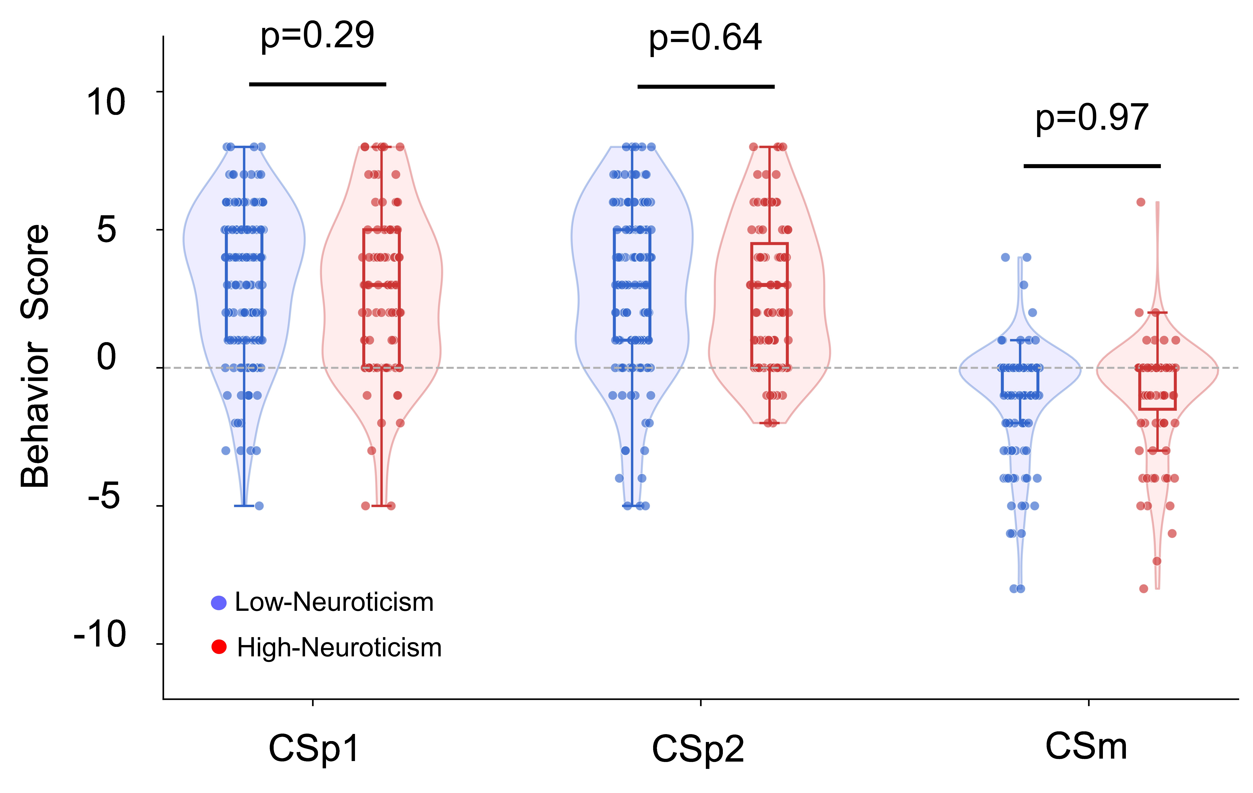
Figure S2. Subjective fear-learning responses across personality-defined subgroups. Violin plots show distributions of fear-rating change scores (post-conditioning minus pre-conditioning).

