Interfacial electrostatic potentials enable low-temperature regeneration by reshaping proton-coupled free-energy landscapes in amine-based CO₂ capture
Yuewei Fan¹, Haoyu Meng¹, Chen Lu¹, Wei Wang^{1,2}, Feng Zhang^{1,2}, Lei Li^{1,2,3*}, Yi Chen^{1,2}, Zhibing Zhang^{1,2,3*}
¹School of Chemistry, Nanjing University, Nanjing, Jiangsu, 210023, China.
²MOE Key Laboratory of Mesoscopic Chemistry, Nanjing University, Nanjing, Jiangsu, 210023, China.
³Nanjing Institute of Micro interface Technology, Jiangbei New Area, Nanjing 210047, China
Table of Contents
1 Background
1.1 Industrial significance of amine-based CO₂ capture
1.2 Interfacial reaction pathways in MIS
1.3 Reaction pathways in amine-based CO₂ capture
2 Methods
2.1 Experimental methods
2.2 Metadynamics simulation methodology
3 Theoretical analysis
3.1 Thermodynamic derivation of the loading–equilibrium relationship
3.2 Electrostatic modulation of reaction kinetics
4 Energy
4.1 Regeneration energy calculation
4.2 Interfacial energy consumption estimation
5 Process engineering and monitoring
5.1 Techno-economic analysis
5.2 Hydrodynamics and bubble coalescence behavior
5.3 Machine-learning-based process monitoring
- Supplementary Figures
1 Background
1.1 Industrial significance of amine-based CO₂ capture
As discussed in the main text, the chemical compatibility between amine-based CO₂ capture and EDL-induced interfacial activation provides an important rationale for selecting this system as a representative example. However, this is not the sole consideration. From an engineering perspective, amine-based CO₂ capture plays a critical role in mitigating carbon emissions from fossil-fuel-based power generation and remains the only capture technology that has been widely deployed at industrial scale. Its industrial relevance therefore provides an additional motivation to explore the engineering feasibility of interfacial strategies.
It should be emphasized that this study focuses on post-combustion CO₂ capture from coal-fired power plant flue gas, where the typical CO₂ concentration ranges from 10 to 15%. Other emission scenarios, such as direct air capture (DAC) or high-concentration CO₂ streams from industries such as cement production (approximately 20–30%), are beyond the scope of the present work. For higher-concentration emission sources, capture or utilization can often be achieved through alternative pathways such as adsorption, mineralization, or direct conversion ^{1,2}. In contrast, under DAC conditions, the extremely low CO₂ concentration, combined with significant thermodynamic and mass-transfer limitations, makes the economic competitiveness of amine-based systems highly debated³. Therefore, the discussion in this study is restricted to post-combustion capture conditions relevant to coal-fired power plants.
This research scope also reflects practical constraints within current energy systems. Although renewable energy sources such as hydropower, nuclear, wind, and solar are widely regarded as ideal pathways for reducing carbon emissions, their large-scale substitution for thermal power generation still faces multiple challenges. For instance, wind and solar power generation are strongly affected by climatic conditions; hydropower development is constrained by hydrological and ecological limitations; and nuclear power involves relatively high construction and safety management costs. In comparison, coal-fired power generation is technologically mature, cost-effective, and operationally stable, with relatively low dependence on natural conditions. Moreover, even in power systems with significantly increased renewable penetration, thermal power units continue to play an essential role in maintaining grid stability and providing load balancing, particularly under extreme weather conditions or during large fluctuations in electricity demand^{4,5}. As a result, coal-fired power generation is expected to remain an important component of energy systems for the foreseeable future, and its associated carbon emissions will continue to pose a structural challenge.
China provides a representative example of this structural issue. As renewable energy has expanded rapidly, the share of coal-fired power generation in China’s electricity mix has declined from 59% in 2019 to 47% in 2024. However, this reduction in share has not translated into a comparable decrease in carbon emissions. During the same period, installed coal-fired capacity increased from 1.19 TW to 1.39 TW, meaning that the absolute scale of coal-related emissions remains substantial. In 2023, CO₂ emissions from China’s coal-fired power generation reached approximately 4.19 billion tons, accounting for roughly 44% of the country’s total emissions⁶⁻⁹. This phenomenon—declining proportional share but persistently large absolute emissions—further highlights the importance of mitigating emissions from coal-fired power plants.
In addressing decarbonization demands in coal-fired power generation, carbon capture technologies are generally categorized into pre-combustion capture, oxy-fuel combustion capture, and post-combustion capture. Among these options, post-combustion capture is considered the most practically deployable pathway at large scale, primarily because it directly treats flue gas streams and is therefore more compatible with existing power plant infrastructure. Several technological routes for post-combustion capture have been explored, including adsorption separation, membrane separation, and chemical absorption. Adsorption-based technologies, such as temperature–vacuum swing adsorption (TVSA/VPSA), combine the principles of TSA and VSA and offer relatively low capital investment and good operational flexibility. However, their application in large coal-fired power plants is still limited by scale and upscaling challenges. Membrane separation has also been proposed as a promising option for post-combustion capture, as it avoids chemical solvents and may provide moderate capital costs. Nevertheless, most membrane systems remain at the research and development stage and have not yet achieved widespread industrial deployment. At present, chemical absorption based on amine solvents remains the most mature and widely applied technology for post-combustion CO₂ capture in coal-fired power plants. Several commercial processes, including the KMALC process, the Fluor Econamine FG Plus process, and the KM-CDR technology, have already been implemented at industrial scale^{10,11}. However, the major bottleneck of this technology lies in the high energy demand required for solvent regeneration, which significantly increases operational costs.
Therefore, regulating the amine absorption–regeneration cycle through the EDL structure generated by micro-interfaces (MIS) not only provides a mechanistic validation of the chemical advantages associated with interfacial free-energy reconstruction but also offers a potentially viable engineering pathway for reducing the energy consumption and cost of CO₂ capture. From an engineering perspective, MIS units can be integrated as external intensification modules into conventional absorption–regeneration process flows, as illustrated in the main text, thereby lowering barriers to technology implementation and deployment.
1.2 Interfacial reaction pathways in MIS
As discussed in the main text, the gas–water interface can rectify transient local electrostatic potentials present in the bulk phase and stabilize them into a functional electric double layer (EDL, Fig. 1a)¹²⁻¹⁶. The high curvature associated with microdroplets, or microbubbles further amplifies this potential distribution^{17,18}. Meanwhile, their hydrodynamic characteristics, namely the large specific interfacial area and rapid surface renewal rates substantially enhance interfacial fluxes, enabling interfacial processes to influence macroscopic reaction behavior^{19,20}. Therefore, we adopt EDL-dominated interfacial polarization as a unified framework to interpret the reaction characteristics observed under MIS conditions.
Based on the functional EDL structure, MIS can provide two distinct forms of interfacial gain. The first is in situ active-species gain, such as reactive species generated at the gas–water interface, including ·OH and H₂O₂ ²¹. The second is interfacial activation gain, in which electric fields, acid–base stratification, and hydrogen-bond network restructuring cooperatively induce directional activation of reactants and reshape the free-energy landscape of reactions²²⁻²⁴. In principle, these two mechanisms may act synergistically. However, because different applications impose distinct requirements on reaction selectivity and stability, current research has largely evolved along these two pathways separately.
In situ reactive species can arise from two main processes. First, the strong local electric field generated by the EDL can directly induce the formation of ·OH radicals from water or dissolved oxygen. Second, during the formation of charged microdroplets, the hydration enthalpy of ions and the effective ionization energy can be reduced, thereby facilitating the generation of ·OH radicals²⁵⁻²⁷. On this basis, several striking conceptual demonstrations have been reported in the literature. For example, under ambient conditions, contact between water microdroplets and N₂ in a PTFE (polytetrafluoroethylene) triboelectric environment has been reported to produce NH₃, accompanied by hydrazine formation^{28,29}. In addition, under microdroplet or microbubble conditions combined with Fenton chemistry, oxidation of N₂ to HNO₃ has also been proposed³⁰. Although interfacial intensification based on reactive species has seen preliminary engineering exploration in gas–oil systems²⁷, its application in gas–water systems remains limited by the poor selectivity, rapid diffusion, and short lifetime of reactive oxygen species (ROS), which constrain yield and reproducibility^{31,32}. Importantly, these limitations do not diminish the engineering potential of the functional EDL generated by microdroplets or microbubbles. If hydrophobic microphases or interfacial pockets can be constructed using materials such as MOFs, organic macromolecules, or carbon nanocages, radicals may diffuse within low-polarity domains and be effectively captured, thereby significantly prolonging ROS lifetime and improving utilization efficiency. Such strategies may substantially enhance reaction loading and selectivity. Nevertheless, based on current evidence and engineering accessibility, this pathway still requires further mechanistic clarification and optimization of the coupled materials–fluid–electric-field system before large-scale implementation becomes feasible.
In contrast, interfacial activation gain arises from the ability of the functional EDL to regulate the enthalpy–entropy balance through the interfacial potential difference. The electric field generated by the EDL can induce directional arrangement and partial desolvation of reactants, for example through acid–base stratification, thereby creating a relatively stable local reaction environment. Such interfacial structuring modifies the solvation configuration of reactants and lowers both the reorganization energy and the transition-state free energy (ΔG‡), effectively activating reaction pathways at the interface. Mechanistically, these effects may enhance a variety of reactions governed by general acid–base interactions and electric-field effects, including esterification, amidation, nucleophilic substitution (SN1/SN2), and nucleophilic addition reactions such as Michael addition ^{33,34}. However, experimental studies directly supporting this interfacial activation framework remain limited. This may partly explain why the interfacial activation mechanism has not yet received attention commensurate with its potential.
On the one hand, the seemingly more dramatic chemistry associated with ROS-driven pathways tends to attract more immediate attention. On the other hand, the application scope and scale-up stability of interfacial activation are still supported by relatively limited experimental evidence. From an engineering perspective, however, structural gains arising from electric-field effects generally offer better reproducibility and tunability, and therefore may be more suitable for stable operation in continuous systems. If EDL-driven interfacial activation can achieve engineering implementation first, it may also provide a baseline framework and synergistic support for the more challenging ROS-based pathways, ultimately promoting the coordinated development of both approaches.
1.3 Reaction pathways in amine-based CO₂ capture
Under this background, representative primary/secondary amines, tertiary amines, and sterically hindered amine systems were selected as model absorbents to evaluate the intensification effect of the MIS unit across different amine chemistries. Different types of amine solutions exhibit distinct dominant reaction pathways during CO₂ absorption. For clarity in the subsequent discussion, the key reactions can be simplified as follows^{10,35,36}.
For primary and secondary amines, as well as some sterically hindered amines, CO₂ first reacts with the amine to form a zwitterionic intermediate:
R₁R₂NH + CO₂ ⇌ R₁R₂NH⁺COO⁻
This intermediate can subsequently be deprotonated by another amine molecule to generate carbamate:
R₁R₂NH⁺COO⁻ + B → R₁R₂NCOO⁻ + BH⁺
For sterically hindered amine systems, the formed carbamate is less stable and can further react with water to produce bicarbonate:
R₁R₂NCOO⁻ + H₂O ⇌ HCO₃⁻ + R₁R₂NH
For tertiary amines, because the nitrogen atom lacks an N–H bond capable of forming a stable carbamate species, CO₂ absorption mainly proceeds through the bicarbonate pathway, which can be approximated as:
R₁R₂R₃N + H₂CO₃ ⇌ R₁R₂R₃NH⁺ + HCO₃⁻
Therefore, in primary and secondary amine systems, CO₂ absorption is typically dominated by the carbamate pathway, whereas in tertiary and sterically hindered amine systems the macroscopic loading is more commonly governed by bicarbonate formation. Based on this distinction, the subsequent derivation of loading–equilibrium relationships primarily focuses on the bicarbonate-dominated regime.
The solvent combinations employed in this work have been widely studied and applied in industrial processes, thereby providing a realistic platform for evaluating the engineering feasibility of the MIS strategy. In addition, the relatively simple chemistry of these systems facilitates clearer interpretation of interfacial effects. It should be noted that the MIS strategy is not restricted to conventional solvent systems. In principle, it can also be integrated with recently developed solvent strategies designed for low-temperature regeneration or high loading, such as biphasic solvent systems or ionic liquids, thereby further amplifying the thermodynamic advantages associated with interfacial regulation.
2 Methods
2.1 Experimental methods
The continuous absorption–regeneration system consisted of an absorption section, an MIS intensification section, and a regeneration section connected in series. A photograph of the experimental setup is shown in Fig. S1. According to the equipment design specifications, both the absorption column and the regeneration column were atmospheric glass columns with dimensions of φ36 × 3 × 1000 mm and a packed height of 800 mm. Temperature and pressure monitoring points were installed at both the top and bottom of the columns. The system was equipped with lean and rich solution storage tanks, a lean–rich heat exchanger, a cooler, an online CO₂ analyzer, and a mass flow control unit, enabling continuous absorption–regeneration operation. The basic operating ranges specified in the operating protocol were as follows: mixed-gas flow rate of 0–30 L min⁻¹, CO₂ volume fraction of approximately 10%, liquid flow rate of 0–100 mL min⁻¹, with the system operated at atmospheric pressure.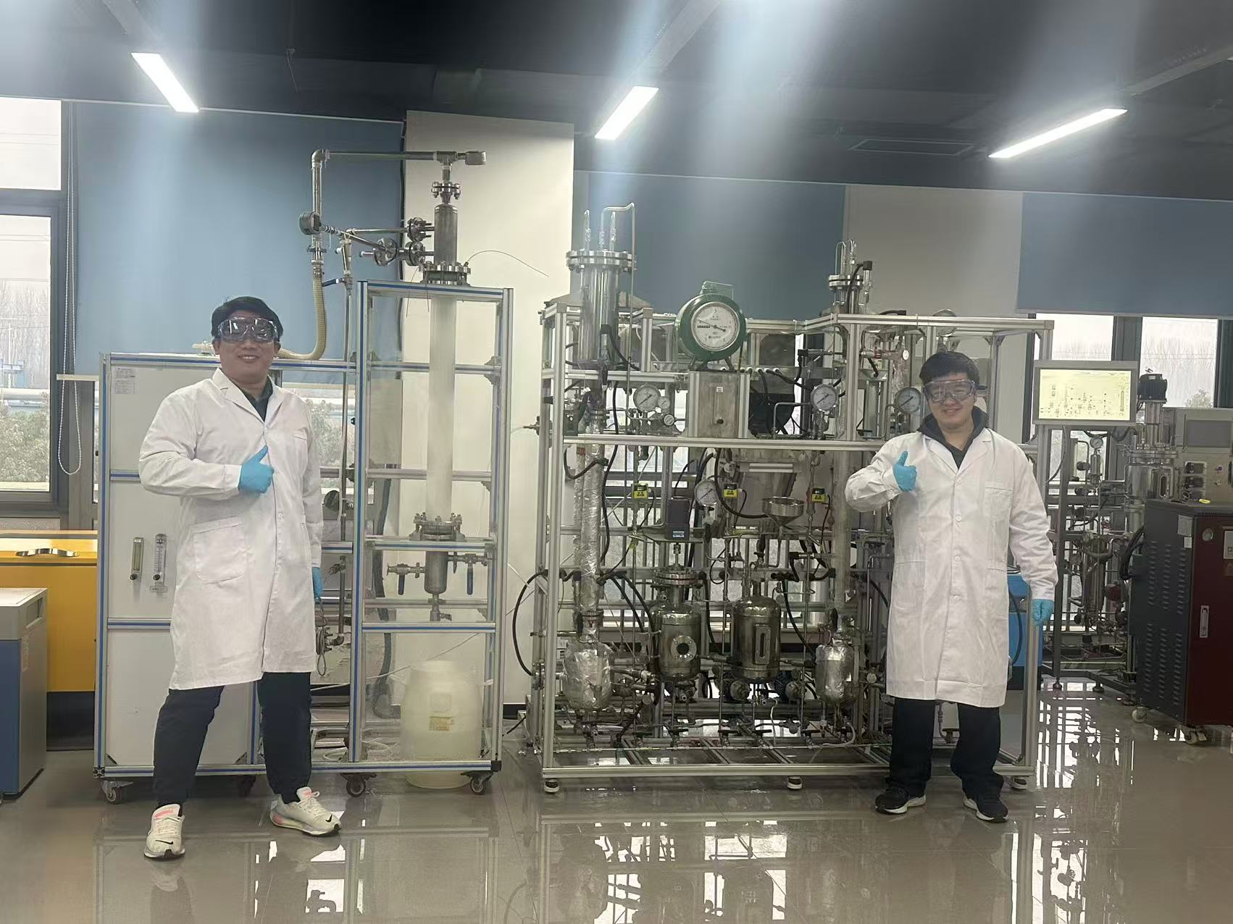
Fig.S1 Photograph of the experimental setup.
The independent MIS intensification section was installed between the absorber outlet and the regenerator inlet. The MIS reactor consisted of a transparent glass column with a total height of 1100 mm, an inner diameter of 100 mm, and a wall thickness of 5 mm. Including the storage tank, the total system volume was approximately 15 L. The MIR micro-interface generator (gas flow capacity 0–30 L min⁻¹) was installed at the top of the reactor to efficiently generate microbubbles under negative pressure conditions.
Unless otherwise specified, the experimental gases were prepared from CO₂/N₂ mixtures without introducing O₂. The operating temperatures of both the absorption column and the MIS section were maintained at 40 °C. The reboiler temperature of the regeneration column was controlled between 75 and 120 °C, while the column body temperature was typically about 20 °C lower than the reboiler temperature. The system operated under atmospheric pressure. Unless otherwise stated, no demister was installed at intermediate locations. A condenser reflux unit was installed at the top of the system and operated using cooling water at ambient temperature.
The total amine concentration used in the experiments was 30 wt%. For the MDEA–PZ system, the molar ratio of MDEA to PZ was 1:3. The total amount of CO₂ absorbed during the experiments was determined using two complementary methods. The first method was based on the difference between inlet and outlet CO₂ concentrations measured by the online gas analyzer, and the total absorption amount was obtained by integrating the instantaneous absorption rate over time. The second method was a volumetric measurement. A fixed volume of reacted solution was sampled and treated with excess sulfuric acid to release the absorbed CO₂ completely. The released gas volume was then measured using a gas burette to calculate the CO₂ absorption amount. The deviation between the two methods was controlled within 5%.
CO₂ loading was defined as the moles of absorbed CO₂ per kilogram of absorbent solution (α = nCO₂ / kg). The solution leaving the regenerator was defined as lean loading, the solution leaving the absorber as rich loading, and the solution leaving the MIS section as MIS loading. The total liquid flow rate was maintained between 10 and 20 mL min⁻¹. The total gas flow rate and its distribution among the sections were determined according to the liquid flow rate and the target capture efficiency. The CO₂ capture efficiency of the absorption column was maintained above 85%, while that of the MIS column was maintained above 75%.
During continuous operation, the system was considered to reach steady state when the key operating parameters of the regeneration column fluctuated by less than 5% over a period of 30 min. For each experimental condition, three parallel samples were collected at intervals of 10 min. The monitored parameters during operation included outlet CO₂ concentration, temperatures at the column top, column body, and reboiler, pressure drop, and lean and rich solution loadings.
Stability tests were conducted using the MDEA–PZ solvent system, with a baseline operation time of 72 h for all stability experiments. The stability evaluation included loading stability under continuous operation, oxidative stability of the solvent, and resistance to sulfur- and nitrogen-containing impurities. Continuous operation stability tests were performed in the same absorption–regeneration setup described above using identical operating parameters. Liquid samples were collected every 2 h for loading analysis, and the solvent level was replenished every 24 h to compensate for evaporation losses. After 72 h of continuous operation, the system was adjusted based on alarm signals from the data-driven online monitoring system, and the cumulative operation time was extended to 100 h.
The oxidative stability and resistance to sulfur and nitrogen contaminants were evaluated in closed-loop tests conducted in the MIS reactor. The total liquid volume was 10 L and the air flow rate was 5 L min⁻¹. To simulate sulfur- and nitrogen-containing impurities, Na₂SO₃ and NaNO₂ were added to the solution at concentrations of 5 mM and 0.1 mM, respectively. These concentrations were selected to create representative sulfur- and nitrogen-containing disturbance conditions in order to evaluate solvent stability under impurity exposure. The effects of microdroplet and microbubble generation devices on system stability were also investigated.
Amine emission rates were measured in the MIS reactor. Six representative amine systems (NH₃, MEA, DEA, MDEA, PZ, and AMP) were selected for testing. Except for ammonia, all amine solutions had a concentration of 30 wt%, while the ammonia solution concentration was 10 wt%. During the experiments, the liquid volume was 10 L and the gas flow rate was set to the maximum capacity of the reactor (30 L min⁻¹), using high-purity nitrogen as the carrier gas.
The outlet gas from the reactor first passed through a drying unit to remove water vapor and was then introduced into an absorption bottle containing 2 M dilute sulfuric acid to capture escaped amines. The tail gas subsequently passed through an aqueous phenolphthalein indicator solution to verify complete absorption of gaseous amines. Each test lasted 6 h. Except for the ammonia system, the escaped amine amount was quantified by measuring the total organic carbon (TOC) content in the sulfuric acid absorption solution. For the ammonia system, the ammonium concentration in the absorption solution was determined by ion chromatography (IC).
To evaluate the effect of mist removal on amine emissions, experiments were conducted both with and without a demister. Under demister conditions, a wire-mesh demister was installed at the reactor outlet to reduce the influence of liquid droplet entrainment on amine emission measurements.
Corrosion behavior was evaluated using Tafel polarization measurements. A standard three-electrode system was employed, in which a 316L stainless steel electrode served as the working electrode, a saturated calomel electrode (SCE) served as the reference electrode, and a platinum wire served as the counter electrode. The electrolyte was the amine solution under investigation, and the experimental temperature was maintained at 40 °C. Polarization tests were performed using an electrochemical workstation (CHI760E, CH Instruments, China). The scanning range was −250 mV to +250 mV relative to the open-circuit potential, with a scan rate of 1 mV s⁻¹. The corrosion current density was obtained by Tafel extrapolation and used to evaluate the corrosion tendency of the system under different operating conditions.
2.2 Metadynamics simulation methodology
The initial configurations of the systems were constructed using the PACKMOL program. Ab initio molecular dynamics simulations were performed with enhanced sampling implemented through well-tempered metadynamics using the PLUMED plugin. The coordination number between the nitrogen atom and surrounding hydrogen atoms CN_NH was chosen as the collective variable to characterize the protonation state of the amine molecule. The coordination number was defined using a smooth switching function with parameters R₀ = 1.2 Å, n = 6, and m = 12. Bias potentials were deposited in the form of Gaussian functions with a deposition interval of 25 fs, a Gaussian height of 0.5 kJ mol⁻¹, and a width of 0.10. The bias factor was set to 10. The free-energy profile was reconstructed from the accumulated bias potential.
3 Theoretical analysis
3.1 Thermodynamic derivation of the loading–equilibrium relationship
To rationalize the linear scaling relationship observed experimentally between ln(Δα) and the ζ potential, an approximate derivation can be formulated based on the electrochemical contribution of the interfacial potential to the reaction equilibrium. For a charged species i, its electrochemical potential under an interfacial potential ψ can be written as
$${\tilde{μ}}_{i}=μ_{i}^{0}+RTln⁡a_{i}+z_{i}Fψ$$
Thus, the interfacial potential alters the relative stability of reactants and products, leading to an apparent equilibrium constant that can be expressed as
$$K_{app}(ψ)=K_{0}exp⁡\left(\frac{z_{eff}Fψ}{RT}\right)$$
where z_{eff} represents the effective charge number coupled to the reaction coordinate, accounting for the combined effects of local electric fields, ion pairing, and solvent reorganization.
For the bicarbonate pathway dominated by tertiary amines, the overall reaction can be approximated as
$$CO_{2}(aq)+H_{2}O+B⇌BH^{+}+HCO_{3}^{-}$$
In the bicarbonate-dominated regime, the CO₂ loading can be approximated as proportional to the bicarbonate concentration
$$α∝m_{HCO_{3}^{-}}$$
Under the electroneutrality approximation, m(BH⁺) ≈ m(HCO₃⁻). From the equilibrium relation it therefore follows that
$$α∝(K_{app})^{1/2}$$
Substituting the interfacial potential dependence of the equilibrium constant gives
$$α(ψ)∝exp⁡\left(\frac{z_{eff}Fψ}{2RT}\right)$$
Therefore, within the regime where MIS produces a significant enhancement relative to macro-interfaces (MAS), the incremental loading can be approximated as
$$Δα∝exp⁡\left(\frac{z_{eff}Fψ}{2RT}\right)$$
Taking the natural logarithm on both sides yields
$$ln⁡(Δα)=\text{const}+\frac{z_{eff}F}{2RT}ψ$$
which indicates a linear relationship between ln(Δα) and the effective interfacial potential.
Experimentally, the directly measurable quantity is the ζ potential rather than the true potential at the reaction site. The effective interfacial potential can therefore be approximated as
$$ψ_{eff}≈λ∣ζ∣$$
where λ represents a mapping coefficient between the slip-plane potential and the actual potential experienced at the reaction site. The resulting scaling relation becomes
$$ln⁡(Δα)∝∣ζ∣$$
This result provides a thermodynamic interpretation for the experimentally observed linear scaling relationship between ln(Δα) and the ζ potential. It should be noted that the present derivation aims to illustrate the scaling relationship rather than establish a rigorous microscopic model. In practical systems, ion pairing, molecular self-association, and solvent structural reorganization may further modify the effective coupling coefficient z_{eff}.
3.2 Kinetic intensification under MIS conditions
The kinetic enhancement induced by MIS originates from the regulation of reactive configuration distributions by the interfacial potential. In essence, this process can be interpreted as a typical enthalpy–entropy compensation phenomenon. Interfacial polarization reduces the activation barrier of the system while simultaneously decreasing the statistical probability of reactive configurations. This effect is therefore directly reflected in the Arrhenius relationship of the reaction rate constant. The kinetic fitting follows the Arrhenius equation:
ln k = ln A − Eₐ / RT
where the slope corresponds to −Eₐ / R and the intercept corresponds to ln A.
For the tertiary amine system represented by MDEA–PZ (Fig.S2a), the fitted kinetic relationships under MAS conditions are:
y = 4.93 − 2816x
whereas under MIS conditions the relationship becomes:
y = −2.85 − 310x.
The corresponding apparent activation energy decreases significantly from 23.4 kJ mol⁻¹ to 2.6 kJ mol⁻¹, nearly an order-of-magnitude reduction. This indicates that the rate-controlling mechanism shifts from conventional chemical reaction control to regulation by the interfacial potential. At the same time, the pre-exponential factor ln A also decreases markedly, suggesting that interfacial polarization lowers the probability of reactive configurations, leading to a characteristic enthalpy–entropy compensation behavior.
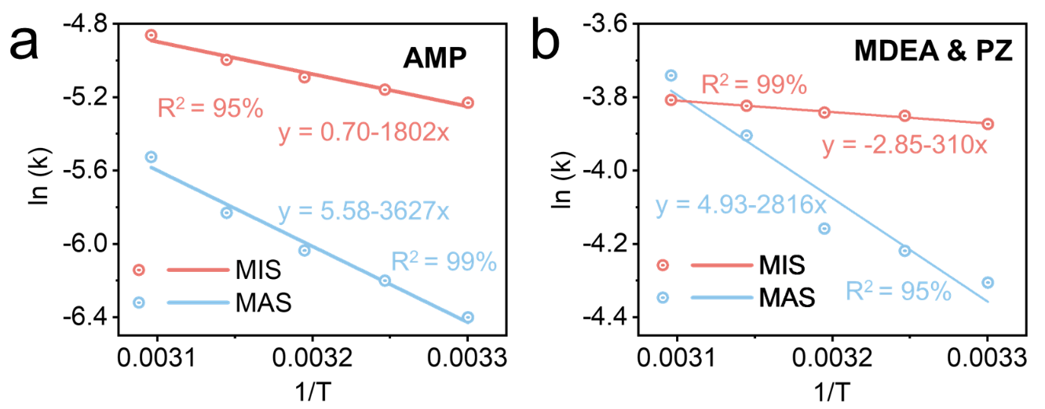
Fig.S2 Arrhenius analysis of absorption kinetics under MIS and MAS conditions. a, AMP. b, MDEA & PZ.
In contrast (Fig.S2b), for the AMP system the fitted kinetic relationships under MAS and MIS conditions are:
y = 5.58 − 3627x
y = 0.70 − 1802x
The corresponding activation energy decreases only from 30 kJ mol⁻¹ to 15 kJ mol⁻¹. Although MIS still lowers the reaction barrier, the magnitude of the reduction is significantly smaller than that observed in the tertiary amine system. This difference indicates that the protonation process of AMP is more strongly governed by molecular configuration constraints rather than interfacial potential regulation.
Therefore, in tertiary amine systems the role of MIS is not to create a new weak chemical bond, but rather to modify the kinetic pathway by lowering the protonation barrier and stabilizing the protonated state.

4 Energy
4.1 Regeneration energy calculation
In conventional amine-based CO₂ capture processes, the regeneration energy consumption is generally composed of three contributions: the reaction heat, sensible heat, and the latent heat of water evaporation. Therefore, the theoretical regeneration heat requirement of the system can be estimated by evaluating these three components separately. In this study, the apparent thermal duty of the regeneration column was further adopted as the reference for the total energy consumption. The difference between the theoretically calculated energy demand and the measured thermal duty was defined as an additional heat term, representing reflux heat, heat loss, and other energy contributions not explicitly accounted for in the theoretical calculation. The overall energy balance can be expressed as
$$Q_{\text{total}}=Q_{\text{reaction}}+Q_{\text{sensible}}+Q_{\text{latent}}+Q_{\text{additional}}$$
The reaction heat corresponds to the enthalpy required for CO₂ desorption from the amine solution. It can be estimated from the difference between rich and lean loadings and the reaction enthalpy of the amine–CO₂ system:
$$Q_{\text{reaction}}=ΔH_{\text{des}}×(α_{\text{rich}}-α_{\text{lean}})$$
where $ΔH_{\text{des}}$represents the desorption enthalpy of CO₂, and $α_{\text{rich}}$and $α_{\text{lean}}$denote the rich and lean loadings, respectively.
In the MIS system, partial CO₂ enrichment induced by the interfacial potential can lead to a quasi-spontaneous proton-transfer process in the interfacial region. Since the thermal effect associated with this process is relatively small, the conventional reaction enthalpy was used as an approximation in the energy decomposition analysis.
The sensible heat arises from heating the solution from the absorption temperature to the regeneration temperature during the regeneration process:
$$Q_{\text{sensible}}=C_{p}×(T_{\text{regen}}-T_{\text{abs}})$$
where $C_{p}$is the average heat capacity of the solution, and $T_{\text{regen}}$and $T_{\text{abs}}$represent the regeneration and absorption temperatures, respectively.
In conventional amine regeneration processes (with a reboiler temperature of approximately 120 °C), the temperature difference between the rich and lean streams after heat exchange is typically about 10 °C. However, under the low-temperature regeneration conditions investigated in this study, this temperature difference becomes significantly smaller. Therefore, the heat-exchange process was re-estimated using Aspen Plus process simulations. The simulation conditions included a solvent flow rate of 72,000 kg h⁻¹ and a heat-exchanger area of 100 m². Under conventional regeneration conditions, the simulation yielded ΔT ≈ 10 ℃, whereas the corresponding ΔT values under low-temperature regeneration conditions are shown in Fig. S3. To ensure consistency in the apparent energy accounting, the preheating of the lean solution prior to entering the regenerator was not included in the total regeneration energy consumption. Under low-temperature regeneration conditions, the preheating temperature difference was approximately 4–7 °C.
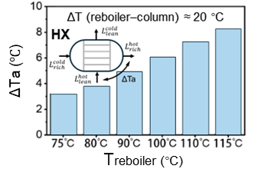
Fig.S3 Lean–rich HX outlet temperature difference, ΔTa (°C).
The latent heat originates from the vaporization of water during regeneration and can be expressed as
$$Q_{\text{latent}}=n_{{\text{H}}_{2}\text{O}}×ΔH_{\text{vap}}$$
where $n_{{\text{H}}_{2}\text{O}}$is the amount of evaporated water and ΔH_{vap} is the latent heat of vaporization of water. The amount of evaporated water was estimated from experimentally measured water loss in the system. Although lowering the regeneration temperature typically reduces water evaporation, within the low-temperature regeneration range investigated in this work (75–90 °C) the water loss per unit gas flow remained relatively constant. This behavior may be associated with the steam-stripping effect accompanying CO₂ desorption.
The additional heat term is defined as the difference between the measured thermal duty of the regeneration column and the theoretically calculated energy consumption:
$$Q_{\text{additional}}=Q_{\text{measured}}-(Q_{\text{reaction}}+Q_{\text{sensible}}+Q_{\text{latent}})$$
This term mainly reflects reflux heat, equipment heat dissipation, and other energy losses not explicitly included in the theoretical estimation. All energy components were calculated under steady-state operating conditions using energy balance analysis and were converted to the specific energy consumption per unit of CO₂ desorbed (GJ·t⁻¹ CO₂).
4.2 Interfacial energy consumption estimation
In MIS systems, the formation of an interfacial potential environment requires additional energy input. Moreover, in practical CCUS processes, a large fraction of inert N₂ must be dispersed into microbubbles or microdroplets to generate gas–liquid interfaces. Therefore, energy consumption associated with interfacial generation should be included in the overall energy evaluation. Table S1 summarizes the interfacial energy density ξ corresponding to different gas–liquid dispersion technologies. This parameter represents the energy required to generate a unit interfacial area and already accounts for pumping losses and electrical conversion efficiency.
For typical coal-fired flue gas (approximately 10% CO₂), capturing 1 t of CO₂ requires processing approximately 5000 Nm³ of flue gas. Under the MIS configuration, about 40% of the flue gas passes through the MIS unit, corresponding to an interfacial generation volume of approximately 2000 Nm³ t⁻¹ CO₂. For MIS formed by microbubble generation, assuming the bubbles are uniformly spherical, the gas–liquid interfacial area density can be estimated from the Sauter mean bubble diameter $d_{32}$:
$$a=\frac{6}{d_{32}}$$
Table S1 Energy comparison of industrial bubble generating systems.
References | Reactor Type | ξ (kJ/m²)
Linek et al.³⁷ | Stirred tank, Rushton turbine | 0.1–0.3
Majumder et al.³⁸ | Downward impinging jet | 0.04
Burns et al.³⁹ | Electro flotation  Dissolved air flotation  Electrostatic spraying | 1.8  1.1  2.7
Hsu et al.⁴⁰ | Gas-inducing dual turbine | 0.002-0.02
Gagnon et al.⁴¹ | Stirred tank, Rushton turbine | 0.02–0.04
Majumder et al.⁴² | Inverse bubbly flow column | ~0.04
Yue et al.⁴³ | Micro-channel | ~1000
Kasundra et al.⁴⁴ | Stirred tank, multiimpeller | 1–33
Terasaka et al.⁴⁵ | Spiral flow microbubbler | ∼0.1
Ansari et al. ⁴⁶ | Downward micro-jet array | 0.015
Ansari et al. ⁴⁷ | Micro-ejector, best case, water | ∼0.015
Our work | Gas-liquid co-current jet reactor | ~0.009
Perfect efficiency | Theoretical, perfect efficiency | 0.00007
The interfacial generation energy can then be expressed as
$$E=ξ⋅a⋅V_{\text{MIS}}$$
where $a$is the interfacial area density (m² m⁻³), $ξ$is the interfacial energy density (kJ m⁻²), and $V_{\text{MIS}}$is the gas volume entering the MIS module (m³). The resulting $E$represents the electrical energy consumption required per ton of CO₂ captured.
Respectively, ξ=0.009 kJm⁻² and ξ=0.0015 kJm⁻² were adopted to represent the value obtained and the literature benchmark. For typical microbubble diameters in the range of 0.15–0.50 mm (corresponding to interfacial area densities of 12,000–40,000 m² m⁻³), the interfacial generation energy is estimated to be approximately 0.216–0.720 GJ t⁻¹ CO₂ (this work) and 0.360–1.200 GJ t⁻¹ CO₂ (literature benchmark). The corresponding interfacial generation cost is approximately 3.33–11.11 USD t⁻¹ CO₂ (this work) and 5.56–18.52 USD t⁻¹ CO₂ (literature benchmark).
Under the baseline condition used in the main text ($d_{32}=0.32\text{ mm}$), the interfacial generation energy is approximately 0.3375 GJ t⁻¹ CO₂, corresponding to a cost of about 5.21 USD t⁻¹ CO₂. Even when this energy consumption is included, the total energy demand remains approximately 2.1 GJ t⁻¹ CO₂, which is still significantly lower than the regeneration energy requirement of conventional amine-based processes (3.5–4 GJ t⁻¹ CO₂). This result indicates that MIS, when implemented as an external intensification module, remains energetically feasible for engineering applications.
5 Process engineering and monitoring
5.1 Techno-economic analysis
To evaluate the engineering feasibility of the MIS-intensified CO₂ capture process, a techno-economic analysis (TEA) was conducted. All equipment dimensions and major process parameters were derived from Aspen Plus process simulations. The plant was assumed to operate for 8000 h per year. Because different solvent systems exhibit different CO₂ loading capacities, the annual CO₂ capture capacity varies slightly, ranging from approximately 0.2–0.3 Mt CO₂ yr⁻¹, which is consistent with the capture performance reported in the main text. According to the process simulation results, the circulating solvent flow rate is approximately 72,000 kg h⁻¹, with a solvent concentration of 30 wt%. For the MDEA–PZ system, the molar ratio of MDEA to PZ is 1:3. All column dimensions, heat-exchange duties, and auxiliary equipment specifications were determined based on these design conditions and were subsequently used for equipment cost estimation.
The total CO₂ capture cost is composed of thermal energy consumption, interfacial generation energy, auxiliary electricity consumption, solvent loss, and equipment depreciation. The overall cost expression can be written as
$$C_{\text{total}}=C_{\text{thermal}}+C_{\text{solvent loss}}+C_{\text{pumping}}+C_{\text{CAPEX }}$$
where $C_{\text{thermal}}$ represents the cost of regeneration heat duty, $C_{\text{solvent}}$ represents the cost associated with solvent loss, $C_{\text{pumping}}$ represents the electricity consumption of circulation pumps and auxiliary equipment, and $C_{\text{CAPEX}}$ denotes the capital depreciation cost of the equipment. The regeneration heat duty and interfacial generation energy have been presented in the main text. The base pumping power consumption was estimated as 5 USD t⁻¹ CO₂, which is consistent with the circulation pump energy consumption of conventional amine-based systems. Since equipment depreciation contributes only a relatively small fraction of the total capture cost, it was not discussed in detail in the main text; the complete calculation procedure is therefore provided in the Supporting Information.
Column costs were estimated using the six-tenths scaling rule:
$$C=C_{0}{\left(\frac{V}{V_{0}}\right)}^{0.6}F_{\text{material}}$$
where $V$is the equipment volume, $V_{0}=20 {\text{m}}^{3}$is the reference volume, and $C_{0}=0.08\text{ MUSD}$represents the reference cost of a carbon-steel column in 2010. All columns were assumed to be constructed from 316L stainless steel, corresponding to a material factor of 1.7. For the MIS reactor column, an additional complexity factor of 1.8 was introduced because it represents a non-standard intensified unit. All costs were updated from the 2010 CEPCI value (550) to the 2026 value (880). Packing costs were estimated based on industrial experience, with water-wash tower packing priced at 2500 USD m⁻³ and absorber/regenerator packing priced at 4000 USD m⁻³. In the MIS-intensified process, the absorber height is significantly reduced due to enhanced mass transfer, although an additional MIS reactor column is introduced.
The lean–rich heat exchanger was assumed to be a shell-and-tube heat exchanger (TEMA type E, fixed-tube-sheet configuration) constructed from 316L stainless steel. According to the process simulation results, the heat-transfer area is approximately 300 m². The heat-exchanger cost was estimated using the Peters–Timmerhaus correlation:
$$C=C_{0}{\left(\frac{A}{A_{0}}\right)}^{n}F_{M}F_{P}$$
where $A_{0}=100 {\text{m}}^{2}$, $n=0.6$, and $C_{0}=120,000$USD represents the base cost of a carbon-steel heat exchanger⁴⁸. The material factor for 316L stainless steel was taken as 2.3, and the pressure factor was taken as 1.0. Under these assumptions, the cost of the lean–rich heat exchanger is approximately 0.53 MUSD. The regeneration section employs a kettle-type reboiler with a design heat flux of 20 kW m⁻², which lies within the typical industrial range of 15–25 kW m⁻². Under low-temperature regeneration conditions (80–90 °C), the system can utilize industrial waste heat or hot-water heat exchange instead of conventional low-pressure steam. Typical heat price ranges are as follows: low-temperature waste heat 0–3 USD GJ⁻¹, process hot water 2–5 USD GJ⁻¹, and low-pressure steam approximately 10 USD GJ⁻¹. Because the MIS-intensified system significantly reduces the regeneration temperature, it becomes more compatible with the utilization of low-grade industrial waste heat, thereby reducing operational costs.
The solvent prices used in the techno-economic analysis were assumed to be 1.5 USD kg⁻¹ for MEA, 2.0 USD kg⁻¹ for MDEA, 6.0 USD kg⁻¹ for AMP, and 3.5 USD kg⁻¹ for PZ. Solvent loss rates were determined based on the amine emission experiments and were incorporated into the operating cost calculation. By accounting for regeneration heat duty, interfacial generation energy, pumping electricity, solvent losses, and equipment depreciation, the overall CO₂ capture cost of the MIS-intensified process can be obtained. Because MIS significantly reduces the regeneration energy requirement, equipment depreciation contributes a relatively small fraction of the total cost; nevertheless, the above calculations provide a consistent economic framework for evaluating the engineering feasibility of the MIS technology.
5.2 Hydrodynamics and bubble coalescence behavior
The stability evolution of microbubbles during their development along the 6 m column, shown in Fig. 2i of the main text, was obtained from CFD simulations. The gas–liquid two-phase flow was described using the Euler–Euler two-fluid model, in which the gas and liquid phases are treated as interpenetrating continua. The conservation equations of mass and momentum, together with the turbulence transport equations, were solved for each phase. Interphase forces include drag, lift, wall lubrication force, virtual mass force, and turbulent dispersion force. The governing equations are summarized in Table S2.
To describe the microbubble size distribution, a Population Balance Model (PBM) was introduced to discretize the bubble size distribution (BSD). In this approach, the continuous size distribution is represented by a finite number of representative bubble diameters and their corresponding probability fractions, allowing the essential bubble dynamics to be retained while maintaining computational efficiency. The resulting bubble size distribution is influenced by several factors, including the gas distributor configuration, gas density, column aspect ratio, and liquid physical properties, which in turn affect the gas holdup and the turbulent energy distribution in the liquid phase.
Table S2. Governing equations of gas–liquid flows.
Model |  |  | Equations
Continuity equation |  |  |  |  |  | $${∂{(αρ)}_{i}}/{∂t}+∇·{(αρu)}_{i}=0, i=gas,liquid$$
Momentum conservation equation |  |  |  | $${∂{\left(αρu\right)}_{i}}/{∂t}+∇·{\left(αρuu\right)}_{i}= -α_{i}·∇P'+∇{(α}_{i}μ_{eff}(∇u+∇u^{T}))+F_{i}+{\left(αρ\right)}_{i}g$$  $$P^{'}=P+\frac{2}{3}·μ_{eff,i}∇·μ_{l}+\frac{2}{3}{ ρ}_{i}k_{l}, μ_{eff,l} =μ_{lam,l}+μ_{t,l}+μ_{b,l}$$  $μ_{b,l}=C_{μb}ρ_{l}α_{g}d_{b}|u_{g}-u_{l}|$, $μ_{eff,g}= \frac{ρ_{g}}{ρ_{l}}(μ_{t,l}+μ_{b,l})$
Turbulence equations |  |  | $$∇·{(ερuu)}_{i}=∇·\left(ε_{l}\left(μ_{lam,l}+{(μ_{t,l}+μ_{t,b})}/{σ_{k}}\right)∇k_{l}\right)+ε_{l}(G_{K,l}-{ρ_{l}ε}_{l})$$
Turbulence equations |  |  | $$∇·{(ερuu)}_{i}=∇·\left(α_{l}\left(μ_{lam,l}+{(μ_{t,l}+μ_{t,b})}/{σ_{k}}\right)∇ε_{l}\right)+α_{l}\frac{ε_{l}}{k_{l}}(C_{ε_{1}}G_{K,l}-C_{ε_{2}}{ρ_{l}ε}_{l})$$  $$G_{k,l}= μ_{eff,l}∇u_{l}·\left(∇u_{l}+{\left(∇u_{l}\right)}^{T}\right)-\frac{2}{3}∇u_{l}·\left(μ_{eff,l}∇{·u}_{l}+{ρ_{l}k}_{l}\right),μ_{t,l}=C_{μ}({ρ_{l}k_{l}^{2}}/{ε_{l}})$$  $μ_{t,g}={μ_{t,l}ρ_{g}}/{ρ_{l}}$,$k_{l,t}=k_{l}+k_{l,g}, k_{l,g}=\frac{1}{2}α_{g}C_{vm}u_{slip}$, $ε_{l,t}=ε_{l}+ε_{l,g}$,${ ε}_{l,g}=α_{g}{gu}_{slip}$
Interphase forces | Drag force |  |  |  |  |  | $$F_{l}^{D}=0.75ρ_{l}α_{g}({C_{D}}/{d_{b}})(u_{g}-u_{l})|u_{g}-u_{l}|$$
Interphase forces | Transverse lift force |  |  |  |  |  | $F_{l}^{L}=C_{L}ρ_{l}α_{g}(u_{g}-u_{l})×∇×u_{l}$, $C_{L}=0.5$
Interphase forces | Wall lubrication force |  |  |  |  |  | $$F_{l}^{WL}={-C}_{wall}ρ_{l}α_{g}{|u_{rel}-{(u}_{rel}·n_{W})n_{W}|}^{2}n_{W}$$
Interphase forces | Virtual mass force |  |  |  |  |  | $$F_{l}^{VM}=C_{VM}ρ_{l}α_{g}({Du_{g}}/{D_{t}}-{Du_{t}}/{D_{t}})$$
Interphase forces | Turbulent dispersion |  |  |  |  |  | $$F_{l}^{TDF}={-C}_{TDF}ρ_{l}{∇α}_{g}$$
Aggregation distribution | ${∂α{ρ_{g}f}_{i}}/{∂t}+∇·αu_{g}f_{i}=S_{bi}$, $\sum_{i=1}^{M}{S_{bi}=0}$
Aggregation distribution | ${∂\left[n\left(V,t\right)\right]}/{∂t}+∇·\left[un\left(V,t\right)\right]+∇_{v}·\left[G_{v}n\left(V,t\right)\right]=0.5\int_{0}^{V}{a\left(V-V^{'},t\right)n\left(V-V^{'}\right)n\left(V^{'},t\right)dV^{'}-\int_{0}^{∞}{a\left(V,V^{'}\right)n\left(V,t\right)n\left(V^{'},t\right)dV'}}$,
Aggregation coefficient | $Γ\left(m_{i},m_{j}\right)=α_{g,max}/(α_{g,max}-α_{g})∙(Γ_{turb}+Γ_{eddy}+Γ_{shear}+Γ_{body}+Γ_{wake}$)
Bubble coalescence behavior was modeled using a modified Liao model. This model considers five mechanisms contributing to bubble coalescence: turbulence-induced collision, eddy capture, velocity gradient, body-force-induced interaction, and wake entrainment. Under MIS conditions, the activity coefficients associated with turbulence-induced and eddy-capture mechanisms were evaluated explicitly, while the remaining coalescence terms were corrected using the maximum interphase velocity, thereby completing the model calibration.
The accuracy of the CFD–PBM framework was validated against experimental data reported in the literature⁴⁹. The relative deviation between simulation results and experimental observations was below 5%, indicating that the model can reliably predict microbubble stability and gas–liquid hydrodynamic behavior. Therefore, the validated model was used to predict the evolution and stability of microbubbles within the column under MIS operating conditions.
5.3 Machine-learning-based process monitoring
To achieve long-term stable operation of the MIS-intensified absorption–regeneration system, a data-driven soft sensor framework was developed to predict the CO₂ loading in the solvent in real time. Conventional determination of CO₂ loading typically relies on offline titration or analytical methods, which are difficult to implement for real-time monitoring in continuous processes. Therefore, machine learning methods were employed to infer solvent loading from variables that can be measured online.
The model input variables include process parameters that can be obtained online, namely the probe potential (E), solution pH, the initial total amine concentration, and the initial amine ratio. These variables reflect the protonation state of the system and the electrochemical environment of the solution, and therefore exhibit strong correlations with the CO₂ loading.
Based on these inputs, a nonlinear regression model was established using the XGBoost algorithm to construct the mapping between measurable variables and solvent CO₂ loading. The training dataset was obtained from experimental data collected during the continuous absorption–regeneration experiments. Model performance was evaluated using cross-validation and the coefficient of determination (R²) (Fig.S4).
The trained model was then embedded into the process monitoring framework as a soft sensor to enable real-time prediction of solvent loading. When the predicted loading deviates significantly from the designed operating window, the system can trigger an alarm signal to guide solvent composition adjustment or operating condition optimization. This data-driven monitoring strategy enables closed-loop regulation of solvent composition and contributes to maintaining the long-term stability of the MIS-intensified CO₂ capture system.
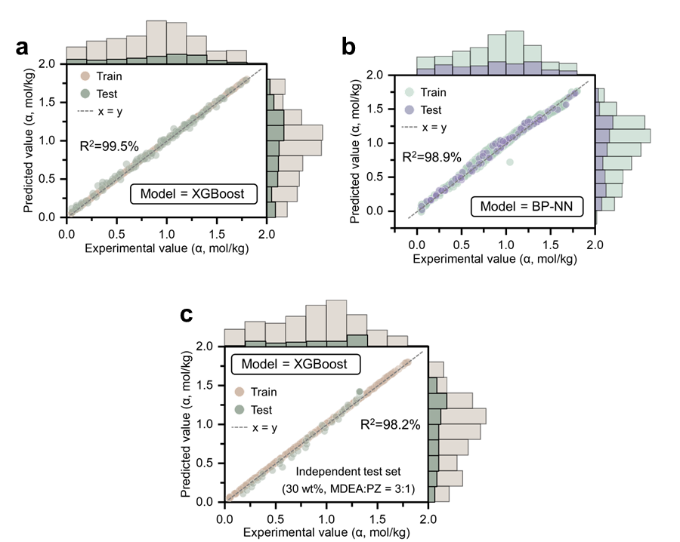
Fig.S4 Model prediction performance and generalization ability. a, Prediction performance of the XGBoost model. b, Prediction performance of the BP neural network model. c, Generalization performance of the XGBoost model.

6 Supplementary Figures
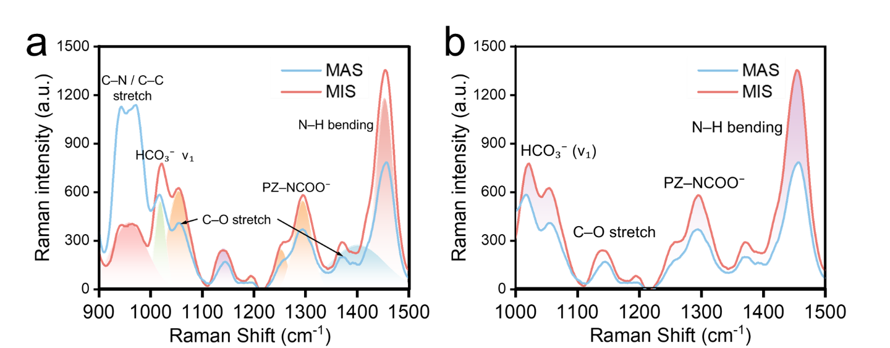
Fig.S5 Raman spectra of product composition and distribution under MIS and MAS conditions. a, AMP system. b, MDEA & PZ system.
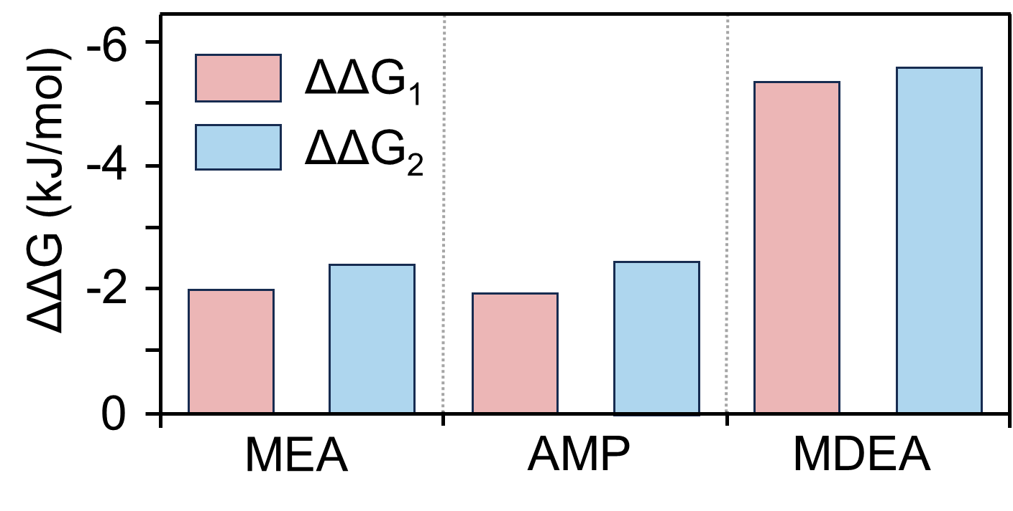
Fig.S6 Comparison of free energy under different dielectric conditions.
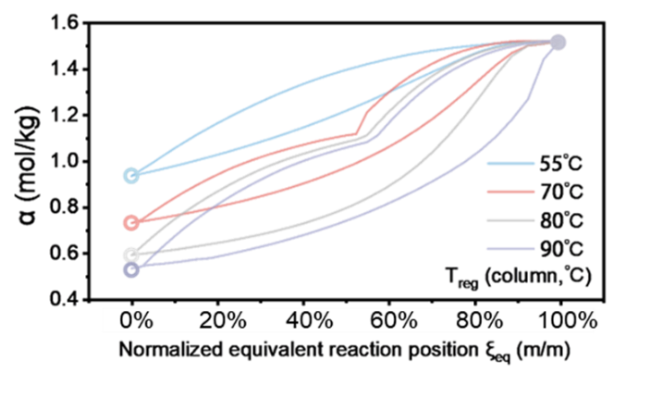
Fig.S7 Reaction progress at equivalent process positions during continuous absorption–regeneration.
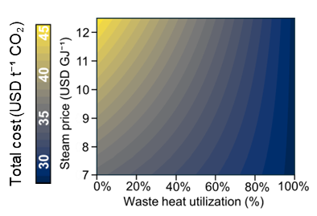
Fig.S8 Sensitivity analysis of TEA to steam price and waste-heat utilization
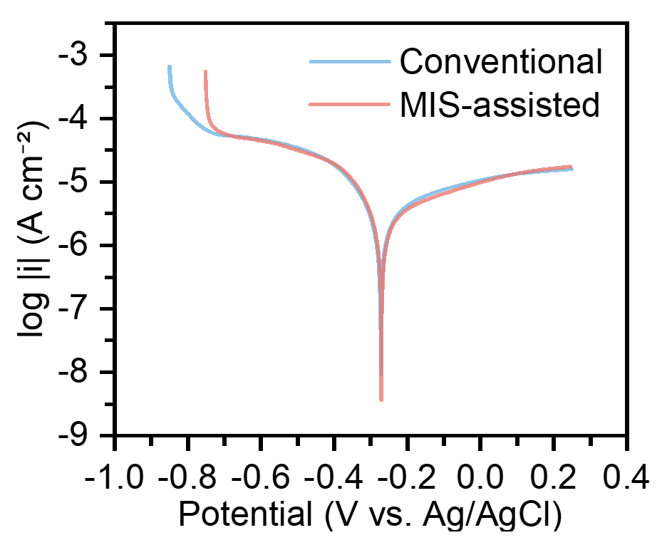
Fig.S9 Corrosion behavior characterized by Tafel polarization
References
1 Boot-Handford, M. E. et al. Carbon capture and storage update. Energy & Environmental Science 7, 130-189 (2014).
2 Rochelle, G. T. Amine scrubbing for CO2 capture. Science 325, 1652-1654 (2009).
3 Wilcox, J. Collaboration can secure carbon capture’s future. Nature Energy 11, 9-10 (2026).
4 Jia, B., Tsau, J.-S. & Barati, R. A review of the current progress of CO2 injection EOR and carbon storage in shale oil reservoirs. Fuel 236, 404-427 (2019).
5 Bachu, S. Review of CO2 storage efficiency in deep saline aquifers. International Journal of Greenhouse Gas Control 40, 188-202 (2015).
6 World Energy Development Report 2024. ( Chinese Academy of Social Sciences, 2024).
7 China Energy Policy Review. (2024).
8 Carbon Capture and Storage (CCS) in Coal-Fired Power Plants. (International Energy Agency (IEA), 2013).
9 he Fourth National Communication on Climate Change of the People’s Republic of China., (Ministry of Ecology and Environment of the People’s Republic of China, 2023).
10 Chao, C., Deng, Y., Dewil, R., Baeyens, J. & Fan, X. Post-combustion carbon capture. Renewable and Sustainable Energy Reviews 138, 110490 (2021).
11 Azar, C., Lindgren, K., Larson, E. & Möllersten, K. Carbon capture and storage from fossil fuels and biomass–costs and potential role in stabilizing the atmosphere. Climatic change 74, 47-79 (2006).
12 Guo, Y. & Hatton, T. A. Enhancing continuous-flow CO2 capture and release from aqueous carbonates via thermal pH regulation. Nature Chemical Engineering, 1-9 (2025).
13 Chamberlayne, C. F. & Zare, R. N. Simple model for the electric field and spatial distribution of ions in a microdroplet. Journal of Chemical Physics 152 (2020). https://doi.org:10.1063/5.0006550
14 Agmon, N. et al. Protons and Hydroxide Ions in Aqueous Systems. Chemical Reviews 116, 7642-7672 (2016). https://doi.org:10.1021/acs.chemrev.5b00736
15 Poli, E., Jong, K. H. & Hassanali, A. Charge transfer as a ubiquitous mechanism in determining the negative charge at hydrophobic interfaces. Nature Communications 11 (2020). https://doi.org:10.1038/s41467-020-14659-5
16 Shi, L. X. et al. Water structure and electric fields at the interface of oil droplets. Nature 640 (2025). https://doi.org:10.1038/s41586-025-08702-y
17 Xia, Y. et al. Droplet- on- demand mass spectrometry reveals curvature- dependent interfacial reactivity in aqueous microdroplets. Proceedings of the National Academy of Sciences of the United States of America 122 (2025). https://doi.org:10.1073/pnas.2519491122
18 Cooks, R. G. & Holden, D. T. Breaking down microdroplet chemistry. Science 384, 958-959 (2024).
19 Yuewei, F. et al. Micro/nanofluid-based carbon-negative process for capturing CO2 from low-carbon flue gas to produce soda ash: effects and enhancement mechanisms. Separation and Purification Technology 354, 128818 (2025).
20 De Luca, S. et al. Effects of Confinement on the Dielectric Response of Water Extends up to Mesoscale Dimensions. Langmuir 32, 4765-4773 (2016). https://doi.org:10.1021/acs.langmuir.6b00791
21 Chen, H. et al. Spontaneous reduction by one electron on water microdroplets facilitates direct carboxylation with CO2. Journal of the American Chemical Society 145, 2647-2652 (2023).
22 Song, X., Basheer, C., Xu, J., Adam, M. M. & Zare, R. N. Methane bubbled through seawater can be converted to methanol with high efficiency. Advanced Science 12, 2412246 (2025).
23 Bose, S., Xia, Y. & Zare, R. N. Understanding the formation of nitrate from nitrogen at the interface of gas–water microbubbles. Chemical Science 15, 19764-19769 (2024).
24 Li, J. et al. Methane C (sp 3)–H bond activation by water microbubbles. Chemical Science 15, 17026-17031 (2024).
25 Lee, K., Mehrgardi, M. A. & Zare, R. N. Interfacial curvature, not simply size, controls spontaneous hydrogen peroxide formation in water microdroplets. Journal of the American Chemical Society 147, 33240-33247 (2025).
26 Lee, J. K., Samanta, D., Nam, H. G. & Zare, R. N. Micrometer-sized water droplets induce spontaneous reduction. Journal of the American Chemical Society 141, 10585-10589 (2019).
27 Wei, Z., Li, Y., Cooks, R. G. & Yan, X. Accelerated reaction kinetics in microdroplets: Overview and recent developments. Annual Review of Physical Chemistry 71, 31-51 (2020).
28 Song, X., Basheer, C. & Zare, R. N. Making ammonia from nitrogen and water microdroplets. Proceedings of the National Academy of Sciences 120, e2301206120 (2023).
29 Li, J., Xia, Y., Song, X., Chen, B. & Zare, R. N. Continuous ammonia synthesis from water and nitrogen via contact electrification. Proceedings of the National Academy of Sciences 121, e2318408121 (2024).
30 Song, X., Basheer, C., Xia, Y. & Zare, R. N. Oxidation of ammonia in water microdroplets produces nitrate and molecular hydrogen. Environmental Science & Technology 58, 16196-16203 (2024).
31 Ding, S.-Y. & Wang, W. Covalent organic frameworks (COFs): from design to applications. Chemical Society Reviews 42, 548-568 (2013).
32 Wen, T., Liu, J., He, W. & Yang, A. in Nanotechnology in regenerative medicine and drug delivery therapy 361-387 (Springer, 2020).
33 Song, Z. et al. Deciphering the microdroplet acceleration factors of Aza-Michael addition reactions. Journal of the American Chemical Society 146, 10963-10972 (2024).
34 Holden, D. T., Morato, N. M. & Cooks, R. G. Aqueous microdroplets enable abiotic synthesis and chain extension of unique peptide isomers from free amino acids. Proceedings of the National Academy of Sciences 119, e2212642119 (2022).
35 Danckwerts, P. The reaction of CO2 with ethanolamines. Chemical engineering science 34, 443-446 (1979).
36 Caplow, M. Kinetics of carbamate formation and breakdown. Journal of the American Chemical Society 90, 6795-6803 (1968).
37 Linek, V., Vacek, V. & Beneš, P. A critical review and experimental verification of the correct use of the dynamic method for the determination of oxygen transfer in aerated agitated vessels to water, electrolyte solutions and viscous liquids. The Chemical Engineering Journal 34, 11-34 (1987).
38 Majumder, S. K., Kundu, G. & Mukherjee, D. Bubble size distribution and gas–liquid interfacial area in a modified downflow bubble column. Chemical Engineering Journal 122, 1-10 (2006).
39 Burns, S., Yiacoumi, S. & Tsouris, C. Microbubble generation for environmental and industrial separations. Separation and purification technology 11, 221-232 (1997).
40 Hsu, Y.-C., Peng, R. Y. & Huang, C.-J. Onset of gas induction, power consumption, gas holdup and mass transfer in a new gas-induced reactor. Chemical engineering science 52, 3883-3891 (1997).
41 Gagnon, H., Lounes, M. & Thibault, J. Power consumption and mass transfer in agitated gas‐liquid columns: A comparative study. The Canadian Journal of Chemical Engineering 76, 379-389 (1998).
42 Majumder, S. K., Kundu, G. & Mukherjee, D. Energy efficiency of two‐phase mixing in a modified bubble column. The Canadian Journal of Chemical Engineering 85, 280-289 (2007).
43 Yue, J., Chen, G., Yuan, Q., Luo, L. & Gonthier, Y. Hydrodynamics and mass transfer characteristics in gas–liquid flow through a rectangular microchannel. Chemical Engineering Science 62, 2096-2108 (2007).
44 Kasundra, R. B., Kulkarni, A. V. & Joshi, J. B. Hydrodynamic and mass transfer characteristics of single and multiple impeller hollow self-inducing reactors. Industrial & engineering chemistry research 47, 2829-2841 (2008).
45 Terasaka, K., Hirabayashi, A., Nishino, T., Fujioka, S. & Kobayashi, D. Development of microbubble aerator for waste water treatment using aerobic activated sludge. Chemical engineering science 66, 3172-3179 (2011).
46 Ansari, M. et al. Chemical hydrodynamics of a downward microbubble flow for intensification of gas‐fed bioreactors. AIChE Journal 64, 1399-1411 (2018).
47 Ansari, M., Bokhari, H. H. & Turney, D. E. Energy efficiency and performance of bubble generating systems. Chemical Engineering and Processing-Process Intensification 125, 44-55 (2018).
48 Towler, G. & Sinnott, R. Chemical engineering design: principles, practice and economics of plant and process design. (Butterworth-Heinemann, 2021).
49 Bando, Y. et al. Flow characteristics in cocurrent upflow bubble column dispersed with micro-bubbles. Journal of chemical engineering of Japan 41, 562-567 (2008).

