Supplementary Information

Phenotypic Change in Mesenchymal Stem Cells to Smooth Muscle Cells Guided by the Cell-Surface Interaction on Patterned-Arrays of Ultrathin Graphene Oxide Films

Rowoon Park^{a,1}, Jung Won Yoon^{b,1}, Jin-Ho Lee^{c}, Suck Won Hong^{a,*}, and Jae Ho Kim^{b,*}
ª Department of Cogno-Mechatronics Engineering, Pusan National University, Busan 46241, Republic of Korea
^{b} Department of Physiology, School of Medicine, Pusan National University, Yangsan, 50612, Republic of Korea
^{c} Department of Biomedical Convergence Engineering, Pusan National University, Yangsan 50612, Republic of Korea
¹ These authors contributed equally to this work.
*Corresponding authors: E-mail: swhong@pusan.ac.kr and jhkimst@pusan.ac.kr
KEYWORDS: stem cells, self-assembly, lithography, tissue engineering, smooth muscle cells

Table S2. List of antibodies used in the present study. WB: western blotting/ICC: immunocytochemistry

Antibody | Catalog | Application | Dilution ratio
α-SMA | ab5694, Abcam | WB | 1:1000
Calponin | C2687, Sigma Aldrich | WB | 1:1000
Calponin | C2687, Sigma Aldrich | ICC | 1:500
SM22α | ab14106, Abcam | WB | 1:1000
SM22α | ab14106, Abcam | ICC | 1:500
Vimentin | 5741, Cell signaling | WB | 1:1000
Desmin | ab15200, Abcam | WB | 1:1000
PDGFRβ | sc432, Santacruz | WB | 1:500
CX43 | ab11370, Abcam | WB | 1:1000
N-cadherin | 610920, BD Biosciences | WB | 1:1000
YAP | 4912, Cell signaling | WB | 1:1000
TAZ | 4883, Cell signaling | WB | 1:1000
GAPDH | sc47724, Santacruz | WB | 1:1000
Alexa flour 568 Phalloidin | A12380, Thermofisher | ICC | 1:500
Alexa flour 488 goat anti-mouse | A11029, Thermofisher | ICC | 1:200
Alexa flour 568 goat anti-rabbit | A11011, Thermofisher | ICC | 1:200
goat anti-mouse IgG-HRP | A17168, Thermofisher | WB | 1:5000
Donkey anti-Rabbit Ig-HRP | ab6802, Abcam | WB | 1:5000

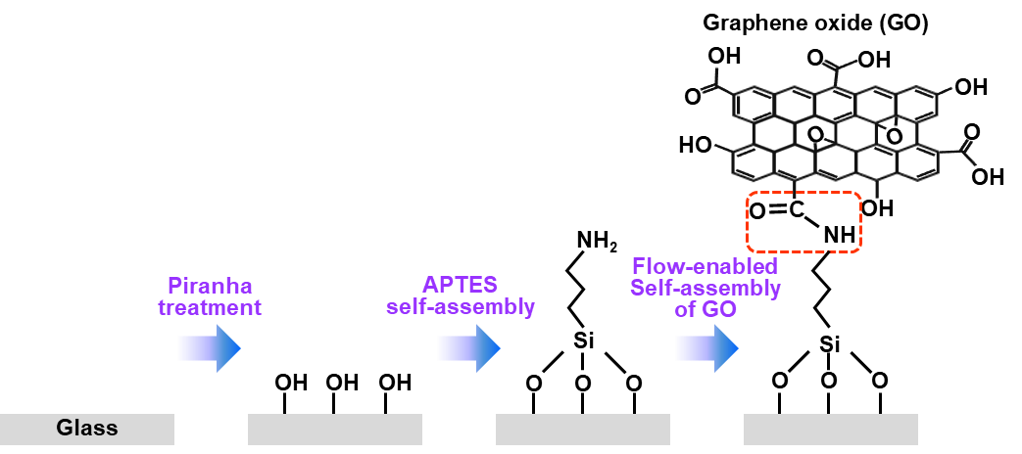

Figure S1. Schematic steps for the surface modification of glass substrate through a hydroxylation process using piranha solution and sequential silanization by 3-aminipropyltriepoxysilane (APTES) treatment.

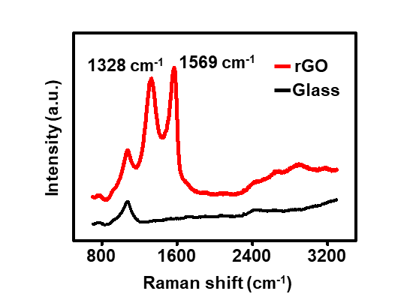

Figure S2. Raman spectra on rGO area (red) and glass area (black).

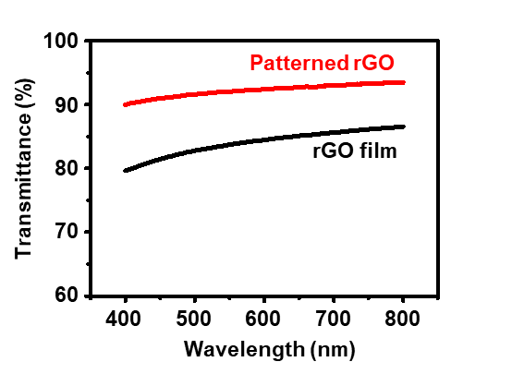

Figure S3. Optical transmittance of gradient rGO stripe pattern and rGO film.

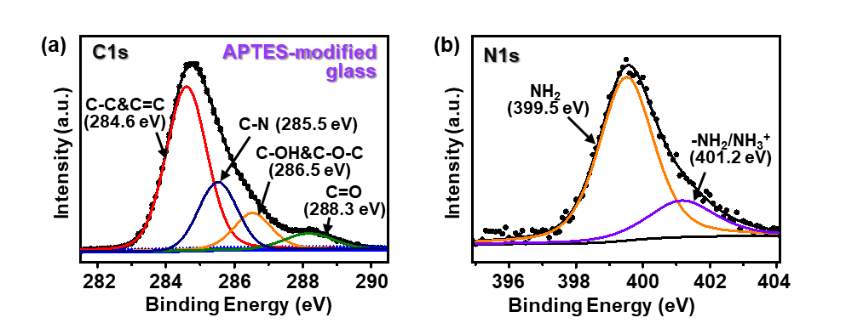
Figure S4. X-ray photoelectron spectroscopy (XPS) spectra of C1s (a) and N1s (b) of the APTES-modified glass substrate.

 | C-OH&C-O-C/C-C | C=O/C-C | C-N/C-C
rGO region | 0.64 | 1.09 | 0.72
Glass region | 1.26 | 0.79 | 0.60
APTES-glass | 0.45 | 0.43 | 0.52

Table S1. Peak area ratios of the oxygen-containing group to the C-C bond obtained by XPS.

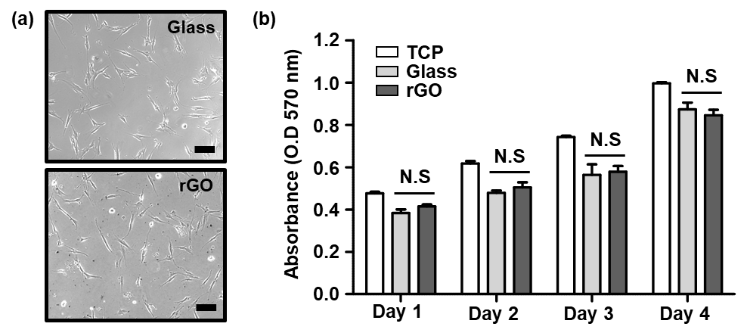

Figure S5. (a) Optical micrographs of MSCs on glass and rGO surface, scale bar: 200 μm. (b) Proliferation of MSCs on the tissue culture plate (TCP), glass, and rGO substrate. The MTT assay was used for the evaluation, which indicated a significant level of proliferation compared to TCP at ≤ 0.05. Data are shown as the mean ± SD (n=3). NS = not significant.

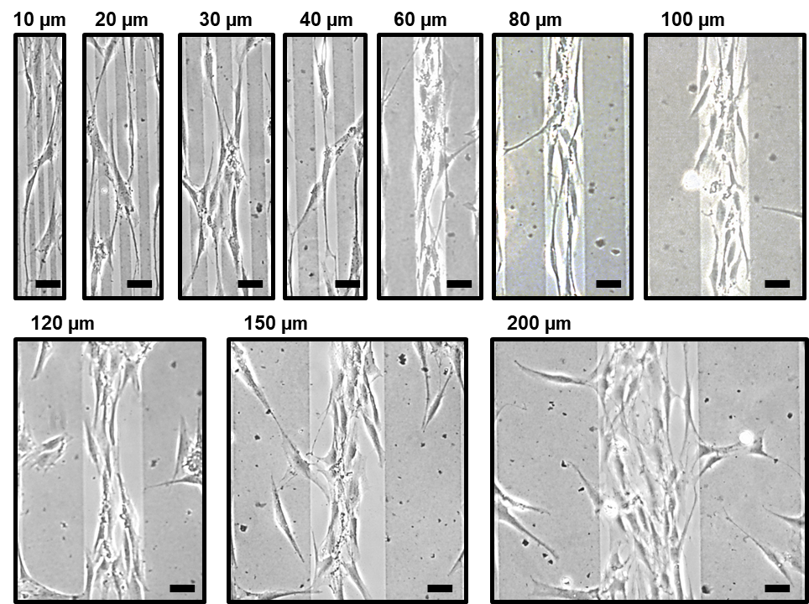

Figure S6. The magnified single-line pattern of MSCs depending on rGO/glass pattern spacing; which clearly revealed the cell-repellant template of rGO, scale bars: 50 µm.

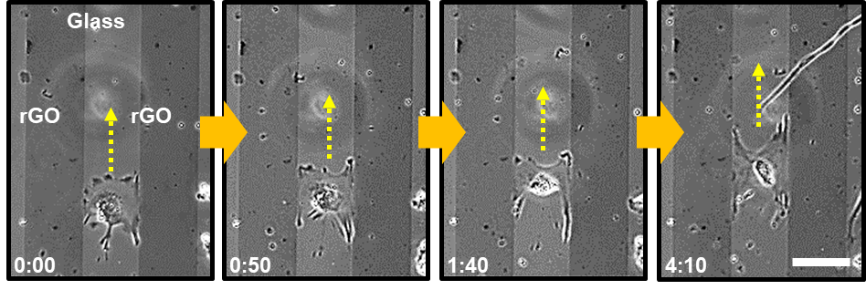

Figure S7. Captured images from the time-lapse movie in recording MSCs movement on the 100 μm pattern spacing of glass/rGO; captured time intervals (min/sec): 0:00/0:50/1:40/4:10, scale bar: 100 µm.

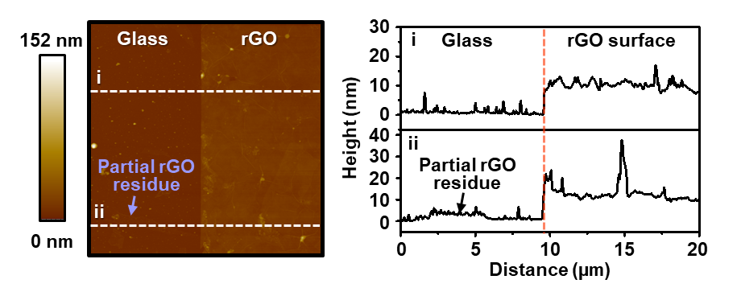

Figure S8. Topographic atomic force microscopy image and height profiles of the micropatterned glass/rGO substrate measured at a size of 20 × 20 µm²; the marked by white dotted lines (i and ii) were measured for the height profiles between the glass and rGO stripe.

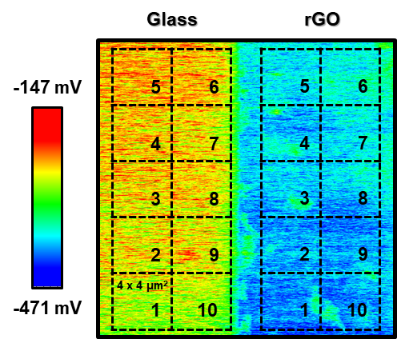

Figure S9. Potential distribution mapping for the surface charge at each glass and rGO region; the mean charge potential was extracted at a size of 4 × 4 µm².

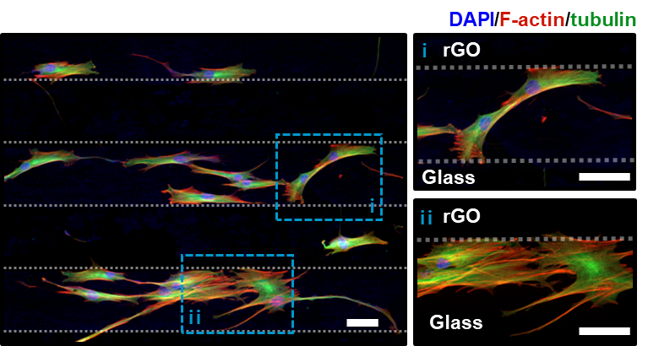

Figure S10. Cell-to-Cell interaction between the aligned MSCs on glass/rGO patterned substrate. Immunocytochemistry fluorescent micrographs represent the expression of F-actin (stress fiber, red), tubulin (microtubule, green), and DAPI (nuclei, blue) in the MSCs cultured on 100 μm pattern-spacing of glass/rGO, scale bar is sequentially 100, 50, and 50 µm.

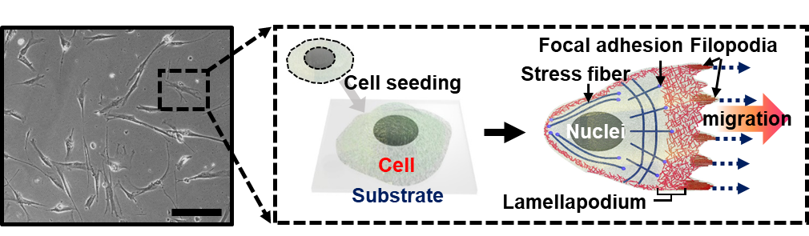

Figure S11. MSCs behavior on the unpatterned glass substrate, and schematic diagrams of MSCs adhesion and migration, scale bar: 200 μm.

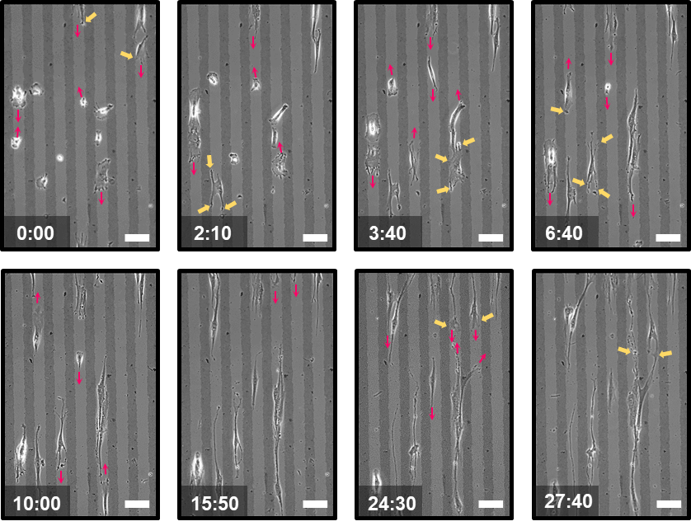

Figure S12. Real-time observations for the migration of MSCs cultured on 40 μm pattern spacing of glass/rGO. The images were captured from a time-lapse recording movie (time intervals (min/sec): 0:00/2:10/3:40/13:10/6:40/10:00/15:50/ 24:30/27:40), scale bars: 100 μm.

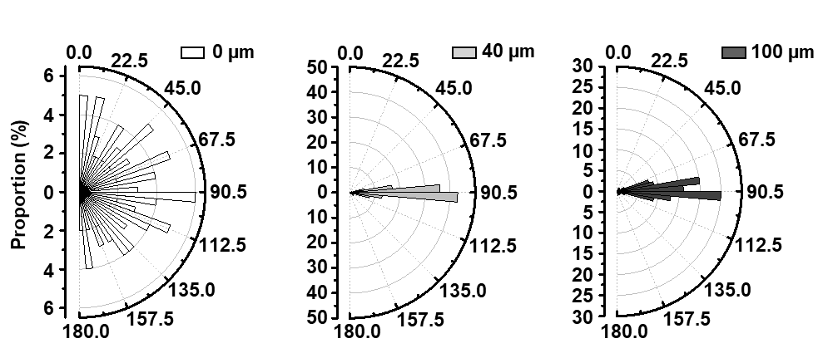

Figure S13. Histogram of the angular orientation of MSCs distributed by the glass/rGO pattern spacing formed on the cell substrate; approximately 90–120 cells were used in this observation.

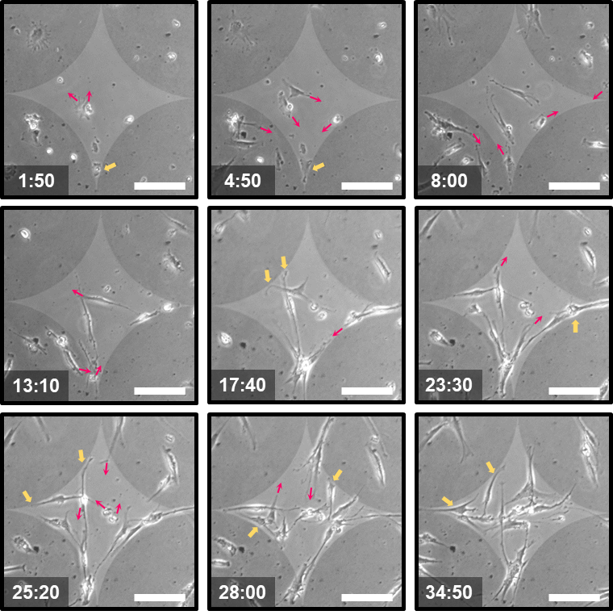

Figure S14. Captured micrographs from time-lapse observations in recording MSCs migration on the cross-patterned glass surrounded by rGO; Time-lapse interval (min:sec), 1:50/4:50/8:00/13:10/17:40/23:30 /25:20/ 28:00/34:50), scale bars: 200 μm.

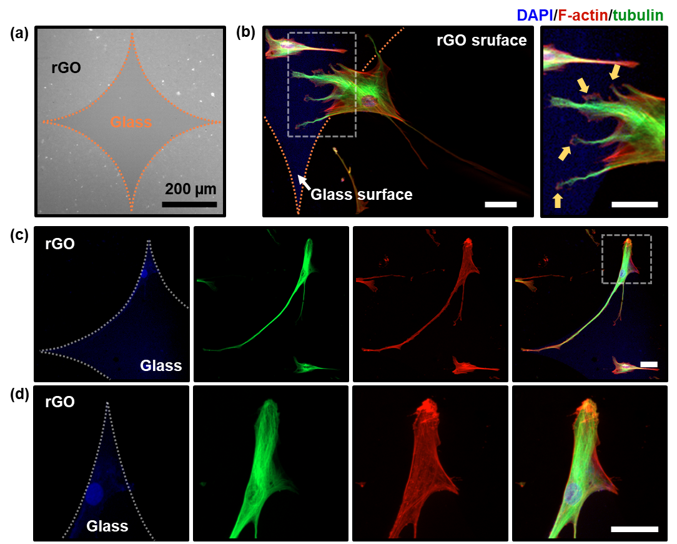

Figure S15. Cytoskeletal arrangement of MSCs cultured on the cross-patterned glass surrounded by rGO. (a) Optical micrograph of cross-patterned glass surrounded by the rGO surface, scale bar: 200 μm. (b-d) Zoom-in fluorescence micrographs for F-actin (stress fiber, red), tubulin (microtubule, green), and DAPI (nuclei, blue) in MSCs, the scale bars from top to bottom are 100, 30, 100, and 50 μm.

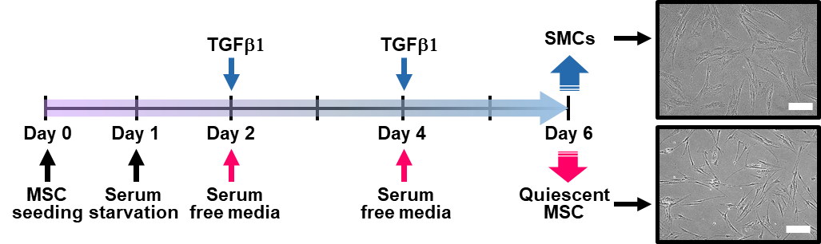

Figure S16. Schematic illustrations of the culture protocol to induce the quiescence of MSCs and TGF-β1-induced differentiation into SMCs, scale bars: 200 μm.

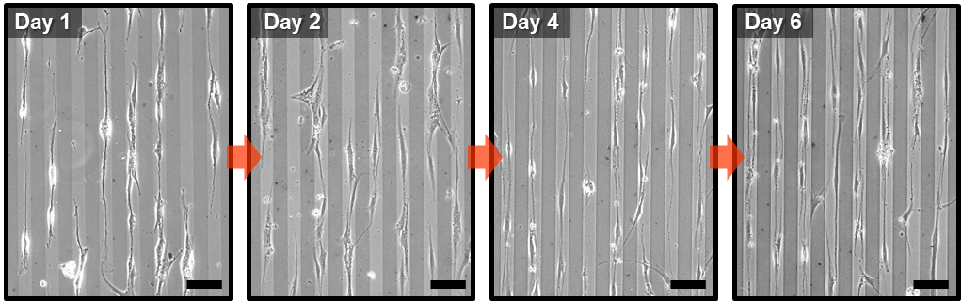

Figure S17. Quiescent MSCs cultured on 40 μm pattern spacing of rGO/glass. Optical micrographs of quiescent MSCs cultured in serum-free media at days 1, 2, 4, and 6 (scale bars: 100 μm).

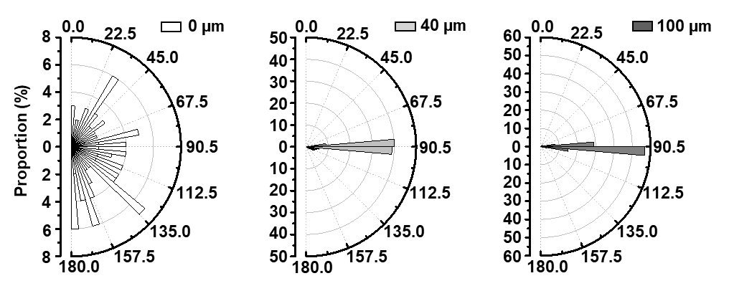

Figure S18. Angular orientation of quiescent MSCs distributed by the glass/rGO pattern spacing; approximately 90–120 cells were used in this observation.

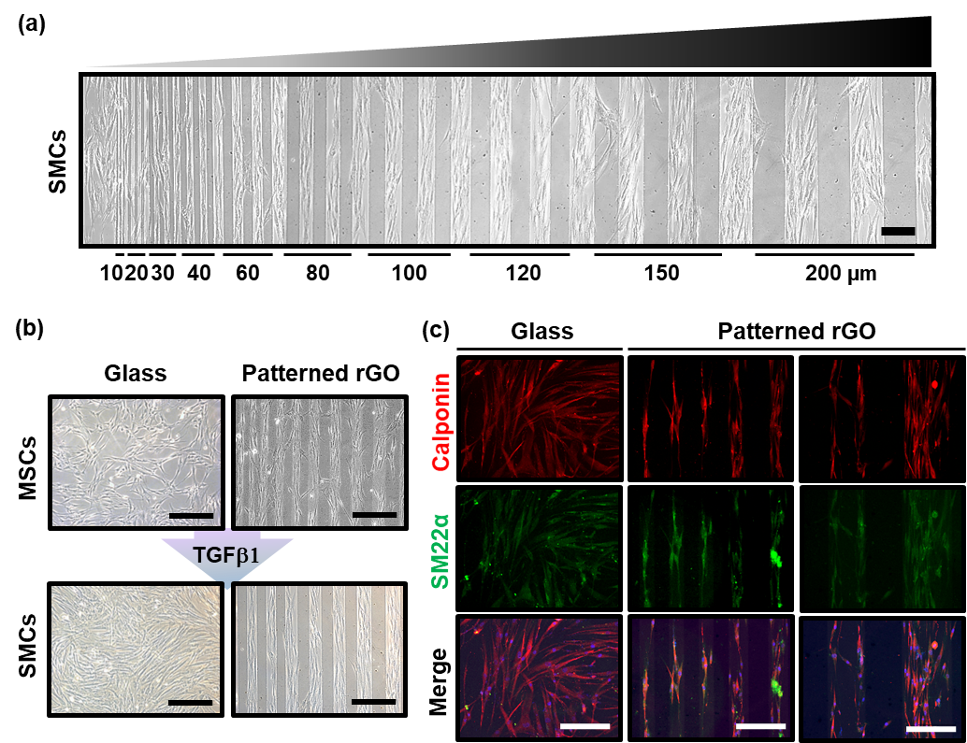

Figure S19. TGF-β1-induced differentiation of MSCs to SMCs on the gradient patterned rGO/glass substrate. (a) Morphological features of the SMCs differentiated from MSCs by a treatment with TGF-β1 on the gradient patterned rGO/glass substrate, scale bar: 200 µm. MSCs were seeded and treated with TGF- β1 (i.e., 10 ng ml-1) for four days. (b) Representative micrographs for the serum-starved MSCs and the SMCs, scale bars: 400 µm. (c) Immunocytochemistry fluorescent micrographs of the expression of calponin (red), SM22α (green), and DAPI (nuclei, blue) in SMCs cultured on a patterned rGO/glass substrate, scale bars: 200 µm.

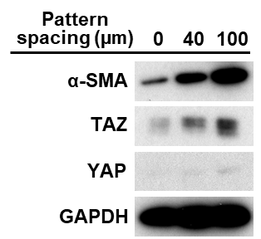

Figure S20. YAP/TAZ expression of quiescent MSCs cultured on an anisotropic rGO/glass patterned substrate. Western blot images of quiescent MSCs, representing the expression of α-SMA (SMC marker) and YAP/TAZ (Hippo pathway marker).

