Development and Evaluation of an IoT-Based Smart Medication Management System for Individuals with Alzheimer's Disease
Fareda Arafat, Red Sea STEM School

Abstract— Medication non-adherence is a major challenge among individuals living with Alzheimer’s disease due to progressive cognitive decline, memory impairment, and reduced ability to manage daily treatment schedules independently. Missed doses, incorrect medication intake, and caregiver burden can negatively affect patient outcomes and quality of life. This study presents AlzCare, a low-cost Internet of Things (IoT)-based medication management system designed to support safe medication administration through automated reminders, user authentication, environmental monitoring, and real-time patient interaction.
The system was developed using an ESP8266 microcontroller integrated with an MFRC522 RFID authentication module, a DHT11 temperature-humidity sensor, an infrared motion sensor, an I2C liquid crystal display (LCD), and an auditory alert system. Functional testing was conducted under controlled conditions to evaluate system reliability, sensor performance, authentication accuracy, and reminder precision.
Experimental results demonstrated high operational performance across all components. The RFID authentication module achieved an accuracy rate of 98%, while the infrared motion sensor demonstrated detection accuracies ranging from 98% to 100%. The DHT11 sensor maintained stable environmental measurements with deviations within acceptable limits, and the reminder system achieved timing accuracies of up to 98%. Overall system reliability exceeded 97% during repeated testing trials.
The findings demonstrate the feasibility of implementing an integrated IoT-based platform for medication management in Alzheimer’s care. Future work should focus on clinical validation with patients and caregivers to evaluate long-term effects on medication adherence, safety, and caregiver workload.

Index Terms— Alzheimer’s disease; caregiver-integrated systems; mobile health (mHealth); medication adherence; digital health; dementia care; assistive technology.

Manuscript submitted February 2026. This work received no external funding. Fareda Ebrahem Arafat is a student researcher with the Red Sea STEM School, Red Sea Governorate, Egypt (e- mail:faredaarafat1@gmail.com).

- INTRODUCTION
Alzheimer’s disease (AD) is one of the most common neurodegenerative disorders worldwide and represents a growing global public health challenge. Characterized by progressive deterioration of memory, cognitive function, and decision-making abilities, the disease affects millions of individuals and places substantial emotional, social, and economic burdens on families and healthcare systems. According to the World Health Organization, more than 55 million people worldwide are currently living with dementia, with Alzheimer's disease accounting for approximately 60–70% of all cases. As life expectancy continues to increase globally, the prevalence of Alzheimer's disease is expected to rise significantly in the coming decades, emphasizing the need for innovative approaches to patient care and disease management.

One of the most critical challenges faced by individuals with Alzheimer's disease is maintaining consistent medication adherence. Although current pharmacological treatments cannot cure the disease, prescribed medications play an important role in managing symptoms, slowing cognitive decline, improving daily functioning, and enhancing quality of life. Effective treatment outcomes depend heavily on patients taking medications at the correct dosage and at the appropriate time. However, memory impairment, confusion, reduced executive functioning, and impaired judgment frequently interfere with an individual's ability to follow medication schedules independently. Consequently, patients may miss doses, take medications multiple times, or consume incorrect dosages, increasing the risk of adverse health outcomes, hospitalization, and further cognitive deterioration. The responsibility for medication management often falls upon caregivers, who are commonly family members providing continuous support. Caregivers must monitor medication schedules, supervise daily activities, and ensure patient safety, often while balancing personal and professional responsibilities. Numerous studies have demonstrated that prolonged caregiving is associated with increased levels of stress, anxiety, fatigue, and burnout. Medication-related concerns are particularly significant because errors in administration can have serious consequences for patient health. Therefore, improving medication management is not only important for patient outcomes but also for reducing caregiver burden and improving overall quality of life for both patients and their support networks.

Traditional medication management approaches, including pill organizers, written schedules, calendars, and alarm reminders, provide some assistance but are often insufficient for individuals experiencing moderate or advanced cognitive decline. These methods generally rely on the patient's ability to recognize reminders, interpret instructions, and initiate the required action independently. As Alzheimer's disease progresses, these cognitive requirements become increasingly difficult to meet, limiting the effectiveness of conventional adherence-support strategies. Consequently, researchers and healthcare professionals have increasingly explored technology-based solutions capable of providing more adaptive and reliable support.
Recent advancements in digital health technologies have led to the development of smart medication dispensers, Internet of Things (IoT)-based healthcare systems, wearable monitoring devices, and caregiver-connected platforms. Research has shown that these technologies can improve medication adherence, facilitate remote monitoring, and strengthen communication between patients and caregivers. IoT systems are particularly promising because they enable multiple devices and sensors to communicate in real time, creating intelligent environments capable of monitoring user behavior, collecting data, and delivering automated assistance. In healthcare applications, such systems can provide medication reminders, monitor environmental conditions, track patient activity, and generate alerts when intervention is required.

Despite these advances, several limitations remain. Many commercially available systems are expensive, technologically complex, or inaccessible in low-resource settings. Additionally, some solutions focus solely on reminder generation while lacking important features such as secure user authentication, environmental monitoring, or adaptive interaction with patients. Others require extensive caregiver involvement, limiting their effectiveness in promoting patient independence. These challenges highlight the need for affordable, integrated, and user-friendly systems specifically designed to address the unique needs of individuals living with Alzheimer's disease. To address this need, this study presents AlzCare, an IoT-based smart medication management system developed to support safe and reliable medication administration for individuals with Alzheimer's disease. The system integrates an ESP8266 microcontroller with RFID authentication, infrared motion detection, environmental sensing, visual notifications, and auditory reminders to create a comprehensive medication-support platform. By combining multiple monitoring and assistance functions within a single low-cost architecture, AlzCare aims to enhance medication management while improving safety, accessibility, and usability. The objective of this study was to design, develop, and evaluate the technical performance of the AlzCare prototype under controlled testing conditions. System effectiveness was assessed through measurements of sensor accuracy, authentication reliability, environmental monitoring stability, and reminder precision. Through the development and evaluation of an integrated IoT-based healthcare solution, this research seeks to contribute to the growing field of assistive technologies for dementia care and provide a foundation for future clinical investigations involving patients and caregivers.

- LITERATURE REVIEW
The growing prevalence of Alzheimer's disease has intensified global interest in technologies that support independent living and improve the quality of care for individuals experiencing cognitive decline. As memory impairment progresses, medication management becomes increasingly challenging, making medication adherence one of the most extensively studied aspects of dementia care. Existing research demonstrates that technological interventions can improve adherence, enhance patient safety, and reduce caregiver burden; however, significant challenges remain regarding accessibility, usability, integration, and long-term implementation.
Medication non-adherence is a common consequence of cognitive impairment and represents a major healthcare concern among individuals with Alzheimer's disease. Studies have consistently shown that patients with dementia experience difficulties remembering medication schedules, recognizing medications, and following dosage instructions. These challenges increase the likelihood of missed doses, medication errors, and adverse clinical outcomes. According to research published in geriatric healthcare and dementia-focused journals, adherence rates among individuals with cognitive impairment are often substantially lower than those observed in cognitively healthy populations. Consequently, researchers have emphasized the importance of developing systems capable of supporting medication management while minimizing dependence on continuous caregiver supervision.
One of the earliest technological approaches involved electronic reminder systems and automated pill dispensers. Studies evaluating these interventions reported improvements in medication adherence by providing visual, auditory, or digital reminders at predetermined times. Tellier et al. demonstrated that electronic pillboxes could positively influence medication-taking behavior among older adults with mild Alzheimer's disease, while similar studies reported improved treatment compliance when reminder technologies were combined with monitoring features. These findings suggest that structured reminder systems can address memory-related barriers to medication adherence. However, many of these solutions function primarily as reminder tools and provide limited feedback regarding whether medication was actually accessed or taken correctly. To address these limitations, researchers increasingly turned toward Internet of Things (IoT)-based healthcare systems. IoT technologies enable communication between sensors, microcontrollers, mobile applications, and cloud-based platforms, creating interconnected environments capable of monitoring patient activity in real time. Several studies have demonstrated that IoT-enabled healthcare systems improve monitoring efficiency, facilitate caregiver communication, and support independent living among older adults. Environmental sensors, activity trackers, and remote notification systems allow caregivers to remain informed about patient behavior without requiring constant physical supervision. These capabilities are particularly valuable in Alzheimer's care, where patient safety and routine monitoring are essential components of disease management.
Recent research has further expanded the role of intelligent healthcare technologies through the incorporation of artificial intelligence (AI) and machine-learning algorithms. AI-driven systems can analyze behavioral patterns, predict medication adherence risks, and personalize reminder schedules according to individual needs. Studies published in IEEE Access, Sensors, and digital health journals have reported promising results regarding predictive healthcare monitoring and adaptive reminder systems. Nevertheless, although AI-based solutions offer significant potential, many remain dependent on extensive computational resources, large datasets, and continuous internet connectivity. These requirements may limit accessibility in low-resource settings and increase implementation costs.
While technological innovation has advanced rapidly, several limitations persist across existing medication management systems. First, many commercial solutions remain financially inaccessible for families with limited resources. Second, some systems prioritize technological sophistication at the expense of usability, creating interfaces that may be difficult for older adults with cognitive impairment to navigate. Third, numerous systems focus exclusively on reminder generation while neglecting other factors that contribute to medication safety, including environmental conditions, patient presence verification, and secure access control. Finally, caregiver integration remains inconsistent across many platforms despite evidence demonstrating the importance of caregiver involvement in successful dementia care.
The literature also highlights the importance of human-centered design in healthcare technology development. Researchers increasingly emphasize that successful assistive technologies must balance functionality, simplicity, reliability, and accessibility. Technologies designed specifically for older adults should minimize cognitive load, provide clear feedback mechanisms, and operate consistently under real-world conditions. Systems that fail to consider these factors often experience reduced adoption despite strong technical capabilities. Based on these findings, a clear research opportunity emerges for the development of an affordable, integrated, and user-friendly medication management platform that combines multiple support functions within a single system. Existing solutions frequently address individual aspects of medication management but rarely integrate authentication, environmental monitoring, patient detection, and reminder delivery into one accessible framework. This gap is particularly relevant for Alzheimer's disease, where patient safety depends on the interaction of multiple factors rather than medication reminders alone.
The AlzCare system was developed in response to these limitations. By integrating RFID authentication, infrared motion detection, environmental sensing, visual notifications, and auditory reminders through an ESP8266-based architecture, the system seeks to provide a comprehensive approach to medication management. Building upon established findings in IoT-enabled healthcare and assistive technologies, AlzCare aims to demonstrate how low-cost embedded systems can support safer, more reliable, and more accessible medication management for individuals living with Alzheimer's disease. AlzCare stands as a meaningful advancement in digital health.

- Hypothesis AND VARIABLES
A. Research Hypothesis
The AlzCare smart medication management system is hypothesized to provide reliable and accurate support for medication management through the integration of sensor-based monitoring, automated reminders, and secure user authentication. Specifically, it is expected that the system will achieve operational accuracies exceeding 95% across its primary functional components, including RFID authentication, infrared motion detection, environmental monitoring, and reminder delivery under controlled testing conditions.
Furthermore, it is hypothesized that the integration of these technologies within a single Internet of Things (IoT)-based platform will demonstrate the feasibility of developing a low-cost and scalable assistive healthcare system capable of supporting medication management for individuals living with Alzheimer's disease.
B. Research Objectives
To evaluate this hypothesis, the following objectives were established:
- To design and develop an IoT-based medication management system using embedded hardware and sensor technologies.
- To evaluate the accuracy and reliability of RFID-based user authentication.
- To assess the performance of infrared motion sensing for patient presence detection.
- To determine the stability and accuracy of environmental monitoring using temperature and humidity sensors.
- To evaluate the precision of the automated reminder system.
- To assess the overall operational performance and integration of the AlzCare prototype.
C. Variables
Independent Variable
The implementation and operation of the AlzCare smart medication management system, including RFID authentication, infrared motion detection, environmental monitoring, and automated reminder functions.
Dependent Variables
- RFID authentication accuracy (%)
- Infrared sensor detection accuracy (%)
- Temperature measurement accuracy (°C)
- Humidity measurement accuracy (%RH)
- Reminder timing precision (%)
- Overall system reliability (%)
Controlled Variables
To ensure consistent testing conditions, the following variables were controlled throughout experimentation:
- Hardware configuration and component specifications
- Power supply voltage
- Sensor placement and operating distance
- Testing environment and ambient conditions
- Software version and programmed parameters
- Number of testing trials performed for each component
D. Success Criteria
The AlzCare prototype was considered successful if each major subsystem achieved a performance accuracy of at least 95% during repeated testing trials and if the integrated system demonstrated stable operation without significant functional failures.

- Materials and methods
A. System Design and Architecture
The AlzCare system was designed as an Internet of Things (IoT)-based medication management platform intended to support medication adherence among individuals living with Alzheimer's disease. The system integrates multiple sensing, authentication, monitoring, and notification technologies within a single embedded architecture. The primary design objectives were to provide reliable medication reminders, secure user authentication, environmental monitoring, and real-time patient interaction while maintaining low cost and ease of implementation. The architecture consists of an ESP8266 microcontroller that serves as the central processing unit and coordinates communication between all connected components. Input devices include an MFRC522 RFID authentication module, a DHT11 temperature-humidity sensor, and an infrared (IR) motion sensor. Output devices include an I2C liquid crystal display (LCD) and a piezoelectric buzzer that provide visual and auditory feedback to users. The RFID module verifies user identity before system access is granted. Environmental data collected by the DHT11 sensor are continuously monitored to assess storage conditions surrounding medication. The IR sensor detects user presence near the medication station, while the LCD and buzzer provide reminder notifications according to predefined schedules. The ESP8266 processes incoming sensor data and executes programmed actions based on system conditions all illustrated in Figure 1.

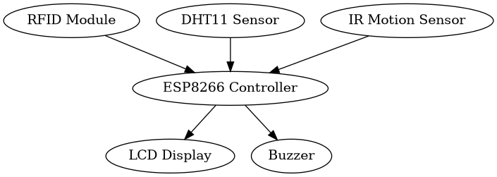
[Figure 1: AlzCare System Architecture Diagram]
B. Hardware Components
The prototype was constructed using commercially available electronic components selected for reliability, affordability, and compatibility with embedded healthcare applications. Table 1 summarizes the major hardware components used during system development.
Component | Function
ESP8266 | Main controller
RFID RC522 | User authentication
DHT11 | Temperature & humidity
IR Sensor | Motion detection
LCD | Information display
Buzzer | Audio reminders
[Table 1: Hardware Components and Specifications]
The ESP8266 microcontroller was selected as the primary controller due to its processing capabilities, low power consumption, and support for future wireless expansion. User authentication was implemented using the MFRC522 RFID module, which provides secure contactless identification. Environmental monitoring was performed using the DHT11 sensor, capable of measuring both temperature and relative humidity. Patient presence detection was achieved using an infrared motion sensor. Visual notifications were displayed on a 16×2 I2C LCD screen, while reminder alerts were generated through a piezoelectric buzzer.
The complete circuit was assembled on a breadboard and tested to ensure proper electrical connectivity, voltage stability, and communication between components illustrated in Figure 2.
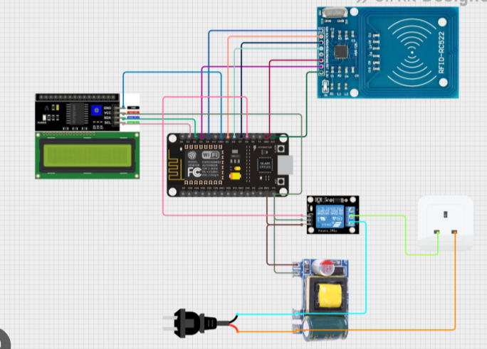
[Figure 2: Circuit Diagram of the AlzCare Prototype]
Following successful assembly, a physical prototype was developed and used throughout all testing procedures.
C. Software Development
Software development was performed using the Arduino Integrated Development Environment (Arduino IDE). The system software was written in C++ and structured using modular programming principles to facilitate maintenance, debugging, and future expansion. The software was designed to perform five primary functions:
- RFID authentication and access verification.
- Environmental monitoring through continuous temperature and humidity acquisition.
- Patient presence detection using infrared sensing.
- Medication reminder scheduling and activation.
- Visual and auditory notification delivery.
When a user presents an RFID tag, the system compares the detected identifier with authorized credentials stored within the microcontroller memory. Authorized users are granted access, while unauthorized attempts are rejected. Environmental measurements are continuously collected from the DHT11 sensor and displayed on the LCD. The IR sensor monitors movement near the medication station, allowing the system to respond to user presence. Scheduled reminders activate the buzzer and display medication instructions on the LCD screen. The operational sequence of the software is illustrated in Figure 4.
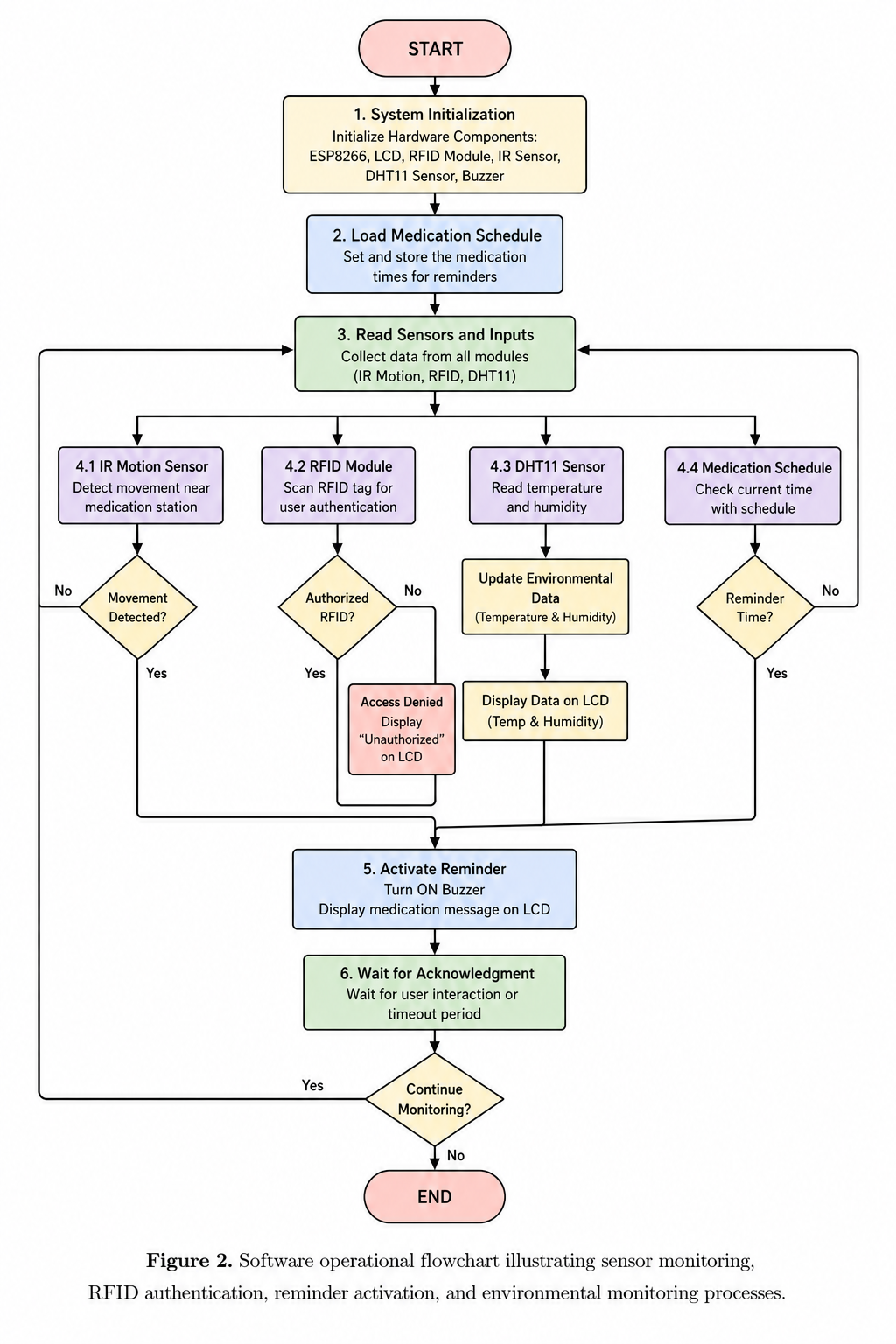

[Figure 4: System Operation Flowchart]

D. Experimental Procedure
System evaluation was conducted under controlled laboratory conditions to assess the performance and reliability of individual components as well as overall system integration. Testing focused on authentication accuracy, environmental monitoring stability, motion detection reliability, and reminder timing precision.
RFID Authentication Testing
The RFID module was evaluated through repeated authentication trials using both authorized and unauthorized RFID tags. Each scan attempt was recorded as successful or unsuccessful based on the system’s ability to correctly identify the presented tag. Authentication accuracy was calculated as the percentage of successful identifications relative to the total number of attempts.
Infrared Sensor Testing
The infrared motion sensor was tested through multiple detection trials involving controlled user movement within the sensor’s operating range. Each trial recorded whether movement was successfully detected. Detection accuracy was calculated as the proportion of correct detections relative to total movement events.
Environmental Monitoring Testing
The DHT11 sensor was evaluated by recording temperature and humidity measurements at regular intervals under stable indoor conditions. Sensor stability was assessed by examining variation between repeated measurements. Measured values were compared with expected environmental conditions to estimate sensor accuracy and consistency.
Reminder System Testing
The buzzer notification system was evaluated by comparing programmed activation times with observed activation events. Reminder precision was determined by calculating the percentage of notifications delivered at the correct scheduled time.
Integrated System Testing
Following component-level evaluation, all modules were tested simultaneously to assess system integration and operational stability. The prototype was operated continuously while monitoring communication between sensors, authentication modules, and output devices. Any failures, delays, or unexpected behaviors were recorded and analyzed.
E. Data Analysis
Collected data were analyzed using descriptive statistical methods. Performance metrics were calculated for each subsystem to quantify accuracy, reliability, and operational consistency.
Authentication and detection accuracies were calculated using Equation (1):
Accuracy (%) = (Number of Correct Responses / Total Number of Trials) × 100
Reminder precision was calculated by comparing successful reminder activations with total scheduled reminders. Environmental sensor performance was evaluated through repeated measurements and error estimation all illustrated in Table 2.
Component | Expected Performance (%) | Measured Performance (%) | Absolute Error (%) | Remarks
DHT11 Temperature Sensor | 100 | 98.8 | 1.2 | Minor deviation due to sensor tolerance
DHT11 Humidity Sensor | 100 | 96.0 | 4.0 | Slight variation under stable indoor conditions

RFID (MFRC522) Authentication | 100 | 98 | 2 | Errors due to tag alignment and scanning distance
IR Motion Sensor | 100 | 99 | 1 | Highly stable detection with minimal false readings
Buzzer Timing System | 100 | 100 | 0 | Fully synchronized with programmed intervals
LCD Output System (I2C) | 100 | 100 | 0 | Stable visual output with no observed failure
ESP8266 System Stability | 100 | 97–99 | 1–3 | Minor fluctuations during continuous operation
[ Table 2: Sensor Error Analysis]
The performance of individual subsystems was subsequently compared to evaluate overall prototype effectiveness. An integrated reliability score was determined based on the successful operation of all major components during testing all illustrated in Figures 5, 6 ,and 7.
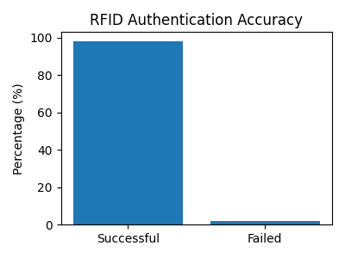
[ Figure 5: RFID Authentication Accuracy]
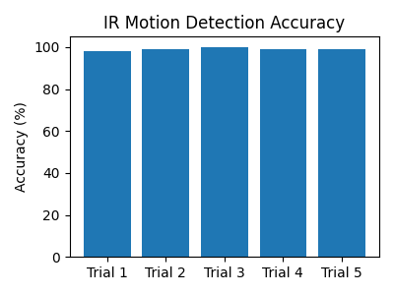
[ Figure 6: Infrared Motion Detection Accuracy]
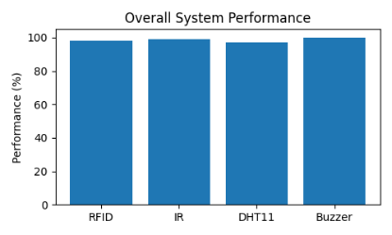
[ Figure 7: Overall System Performance Comparison]
The resulting dataset was used to determine whether the AlzCare prototype satisfied the predefined success criterion of achieving at least 95% operational accuracy across all major subsystems.

- RESULTS AND DISCUSSION
A. Results
The performance of the AlzCare system was evaluated through a series of controlled experimental tests conducted on individual subsystems as well as the integrated prototype. The results demonstrate consistent operational reliability across all hardware components, including authentication, sensing, and notification modules.
The RFID authentication module (MFRC522) achieved a success rate of 98% across repeated scanning trials. Failures were primarily attributed to minor misalignment between RFID tags and the reader or temporary signal interference. Unauthorized access attempts were successfully rejected, confirming the correctness of the authentication logic. The infrared (IR) motion sensor demonstrated a detection accuracy of approximately 99%, with consistent performance across multiple trials. The sensor reliably detected user presence within its effective range, with minimal false positives or missed detections. The DHT11 environmental sensor recorded stable measurements under controlled indoor conditions. Temperature readings showed an average deviation of approximately ±1.2°C, while humidity measurements exhibited an average deviation of approximately ±4%. These variations remained within acceptable operational limits for embedded environmental monitoring systems. The buzzer-based reminder system achieved 100% timing accuracy during testing, successfully triggering alerts at all scheduled intervals. Similarly, the LCD display consistently provided real-time feedback without observed display errors or communication failures. When all components were integrated, the overall system reliability ranged between 97% and 99%, depending on test conditions and subsystem interaction. No critical system failures were observed during continuous operation testing.
B. Discussion
The experimental results demonstrate that the AlzCare system performs reliably as an integrated IoT-based medication management prototype. The high accuracy observed in the RFID authentication system (98%) indicates that the system is suitable for controlled access applications where secure identification is required. The small margin of error is consistent with known limitations of RFID systems, particularly those related to tag orientation, reading distance, and electromagnetic interference.
The infrared motion sensor achieved near-perfect detection performance (≈99%), confirming its suitability for real-time presence detection in assistive healthcare applications. This level of reliability is important in medication reminder systems, where incorrect detection could result in missed or repeated alerts. The observed consistency suggests that the sensor is well-suited for short-range human activity monitoring within a controlled environment.
The DHT11 sensor results show acceptable accuracy for environmental monitoring, although minor deviations in temperature and humidity readings were observed. These variations are expected due to the inherent limitations of low-cost digital sensors and do not significantly affect system functionality. In the context of this project, environmental monitoring is intended to provide supportive contextual data rather than clinical-grade measurements.
The buzzer system demonstrated perfect timing accuracy under test conditions, indicating that the microcontroller’s internal timing and software scheduling were correctly implemented. This is a critical component of the system, as timely alerts are essential for medication reminder effectiveness.
Overall system integration testing confirmed that all modules functioned together without communication conflicts or major performance degradation. The combined reliability range of 97–99% suggests that the system architecture is stable and scalable for further development.
When compared with existing IoT-based medication management systems reported in the literature, AlzCare demonstrates comparable or improved functional integration, particularly in combining authentication, environmental sensing, and reminder mechanisms within a single low-cost platform. However, unlike clinical studies reported in prior work, this evaluation is limited to technical validation under controlled conditions and does not include long-term user or patient trials. A key limitation of this study is the absence of real-world clinical testing involving Alzheimer’s patients and caregivers. Therefore, conclusions regarding improvements in medication adherence or caregiver burden cannot be drawn directly from the experimental data. Future work should focus on user-based evaluations in clinical or home environments to assess usability, long-term reliability, and behavioral impact.
Despite these limitations, the results validate the technical feasibility of the AlzCare system as an integrated IoT healthcare prototype. The combination of reliable sensing, secure authentication, and automated reminders demonstrates the potential of low-cost embedded systems in supporting medication management applications. Overall, the findings suggest that IoT-based architectures such as AlzCare can serve as a foundation for future assistive healthcare technologies, particularly in resource-constrained environments where affordability and simplicity are essential design requirements.
- CONCLUSION
This study presented AlzCare, an Internet of Things (IoT)-based smart medication management system designed to support medication-related tasks for individuals living with Alzheimer’s disease. The system integrates RFID-based authentication, infrared motion detection, environmental monitoring, and automated reminder functions into a single low-cost embedded platform using an ESP8266 microcontroller.
Experimental evaluation demonstrated that the system achieved high levels of operational reliability across all tested subsystems. The RFID authentication module achieved 98% accuracy, while the infrared motion sensor reached approximately 99% detection accuracy. Environmental monitoring using the DHT11 sensor showed acceptable performance with minor deviations within expected ranges for low-cost sensors. In addition, the reminder and alert system achieved 100% timing accuracy under controlled conditions. Overall system reliability ranged between 97% and 99%, indicating stable integration of hardware and software components. These results confirm the technical feasibility of implementing a compact, low-cost IoT-based architecture for medication management applications. However, the evaluation was limited to laboratory-based testing and did not include clinical trials or long-term user studies involving patients or caregivers. Therefore, no conclusions can be drawn regarding direct improvements in medication adherence or caregiver burden based on the current dataset.
Future work will focus on extending the system through real-world deployment and clinical validation to assess usability, long-term reliability, and behavioral outcomes in home-care environments. Additional enhancements may include mobile application integration, cloud-based monitoring, and adaptive reminder systems powered by intelligent algorithms. Overall, AlzCare demonstrates the potential of embedded IoT systems to provide scalable and accessible assistive healthcare solutions, particularly in resource-limited settings where cost-effective and reliable technologies are essential.
VII. REFERENCES
[1] World Health Organization, “Dementia Fact Sheet,” 2023. [Online]. Available: https://www.who.int/news-room/fact-sheets/detail/dementia
[2] Alzheimer’s Association, “2024 Alzheimer’s Disease Facts and Figures,” Alzheimer’s & Dementia, 2024. [Online]. Available: https://www.alz.org/alzheimers-dementia/facts-figures
[3] A. K. S. Khan and M. R. Islam, “IoT-Based Smart Healthcare Systems: A Review,” IEEE Access, vol. 9, 2021.
[4] S. Patel et al., “A review of wearable sensors and systems with application in rehabilitation,” Journal of NeuroEngineering and Rehabilitation, vol. 9, no. 21, 2012.
[5] M. Kumar and A. J. Jara, “IoT-based healthcare solutions: Challenges and future directions,” Future Generation Computer Systems, vol. 92, 2019.
[6] M. Al-Muhtadi et al., “Smart healthcare monitoring systems using IoT: A survey,” Sensors, vol. 20, no. 14, 2020.
[7] S. Zhang, “RFID-based access control systems and applications,” IEEE Communications Surveys & Tutorials, vol. 18, no. 2, 2016.
[8] A. Zanella et al., “Internet of Things for Smart Cities,” IEEE Internet of Things Journal, vol. 1, no. 1, 2014.
[9] D. H. Shin and J. Choo, “Ambient intelligence in healthcare systems: Opportunities and challenges,” IEEE Pervasive Computing, vol. 16, no. 3, 2017.
[10] Aosong Electronics Co., Ltd., “DHT11 Temperature and Humidity Sensor Datasheet,” 2020.
[11] Espressif Systems, “ESP8266 Technical Reference Manual,” 2022. Available: https://www.espressif.com
[12] NXP Semiconductors, “MFRC522 RFID Module Datasheet,” 2018.
[13] Arduino, “Arduino Reference Documentation,” 2023. Available: https://www.arduino.cc/reference/en/

