Supplementary Figure S1. State ranking by high biological burden (% ≥3 abnormal systems).
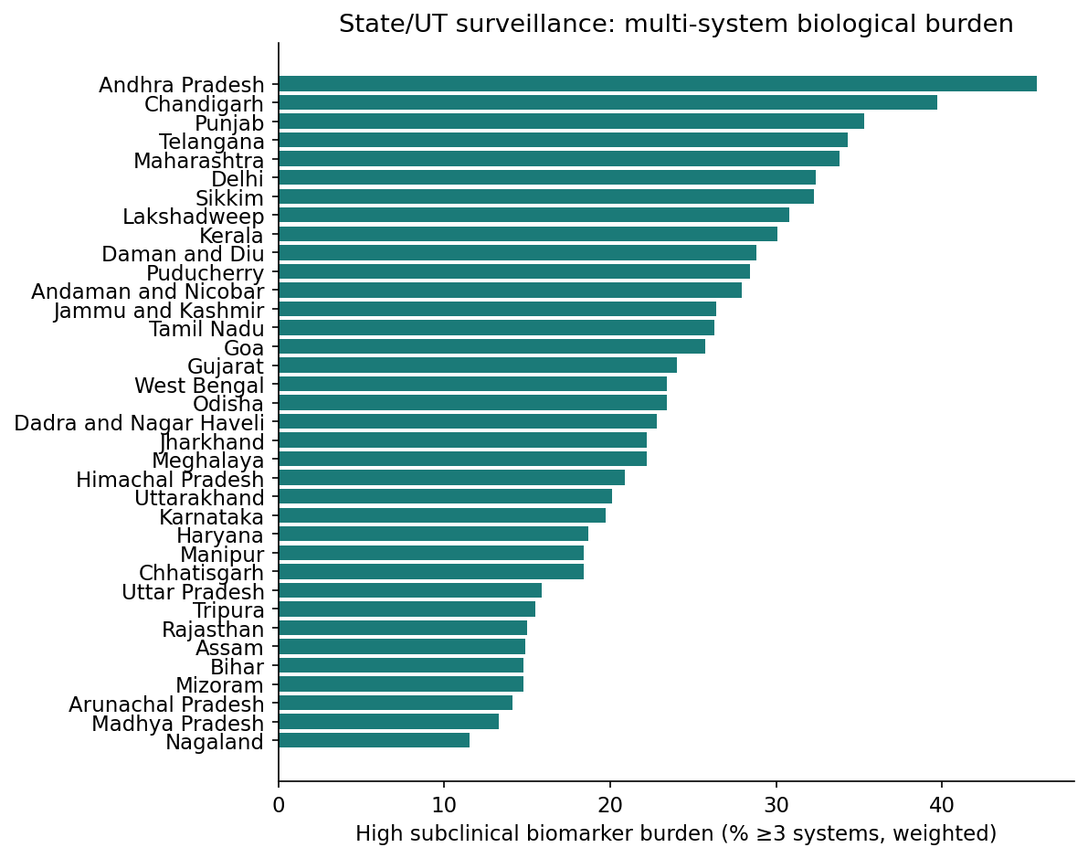
Supplementary Figure S1
Supplementary Figure S2. Adjusted predictors (incidence-rate ratios) of the subclinical biomarker burden count. The count conflates opposing phenotypes; domain-specific associations (Supplementary Table S7) are the primary exposome analysis.
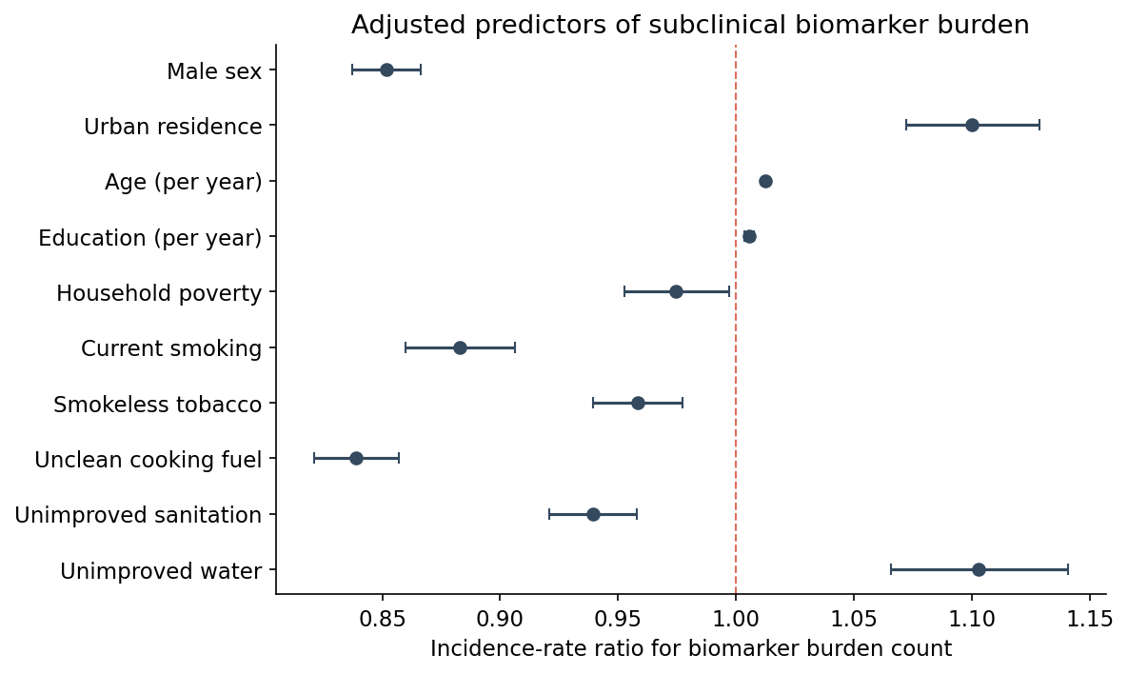
Supplementary Figure S2

