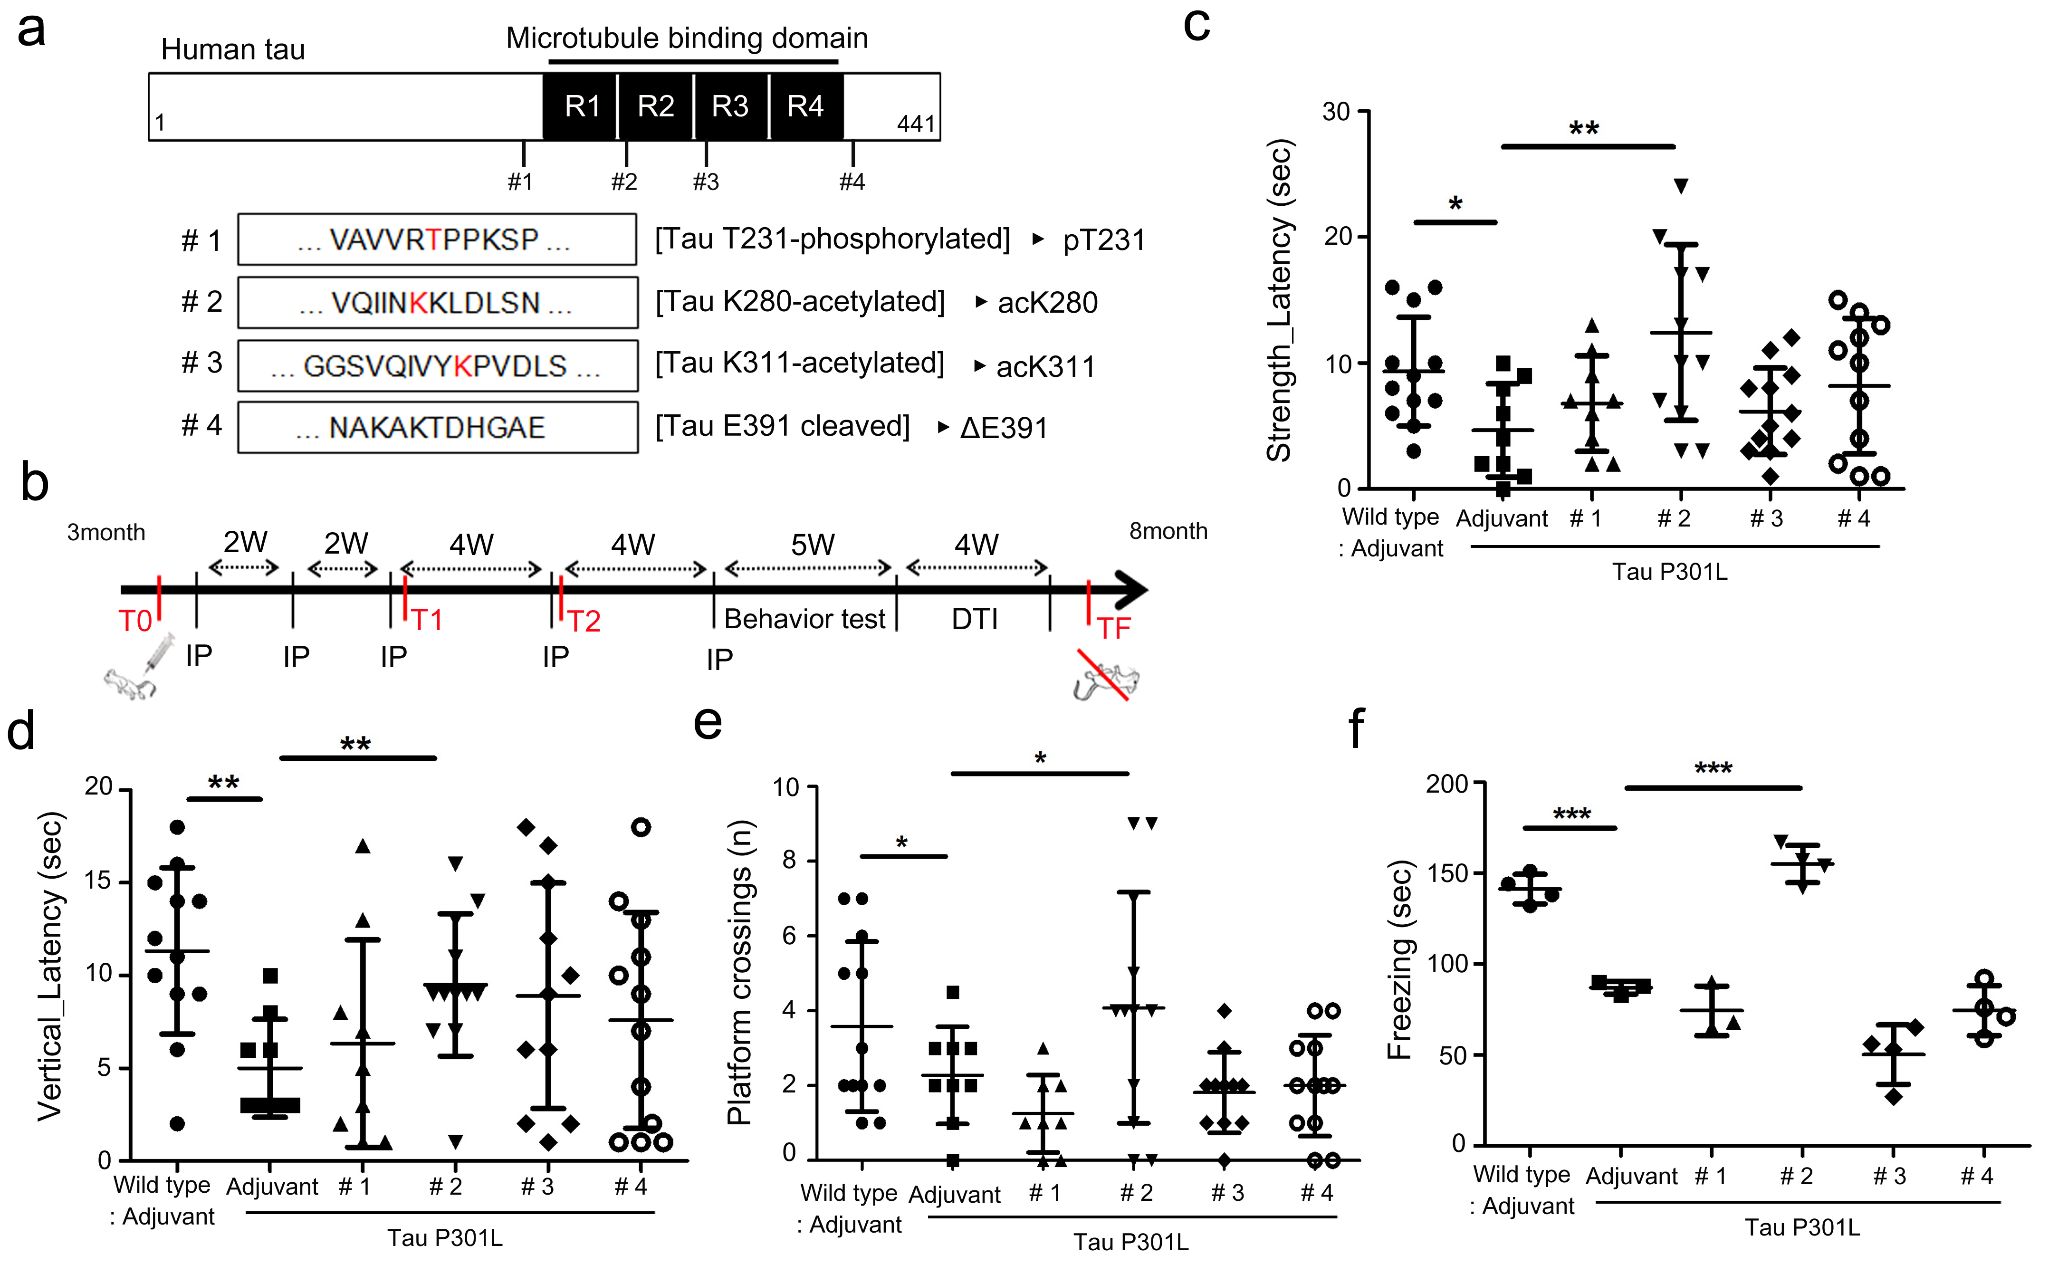

Figure S1. Preliminary experiment for antibody screening. (a) Epitope information used for antibody screening. #1: pT231, #2: acK280, #3: acK311, #4: ΔE391. (b) Schematic diagram of the active immunization experimental schedule. IP: intraperitoneal injection, DTI: diffusion tensor imaging. T: blood sampling time. (c-f) After five consecutive vaccinations for four months in tau-Tg mice with adjuvant or peptides, behavioral tests were performed and treatment effects were compared. Representative analyzed data: peptide vaccination comparison results in (c) strength test (d) vertical test (e) Morris water maze and (f) fear conditioning. Wild type-adjuvant n=4, Tau P301L-adjuvant n=3, Tau P301L-#1: pT231 n=3, Tau P301L-#2: acK280 n=4, Tau P301L-#3: acK311 n=4, Tau P301L-#4: ΔE391 n=4, all mice are male. Strength test, vertical test and platform crossing repeated 3 times. *P < 0.05, **P < 0.01, ***P < 0.001 compared to Tau P301L-adjuvant group.

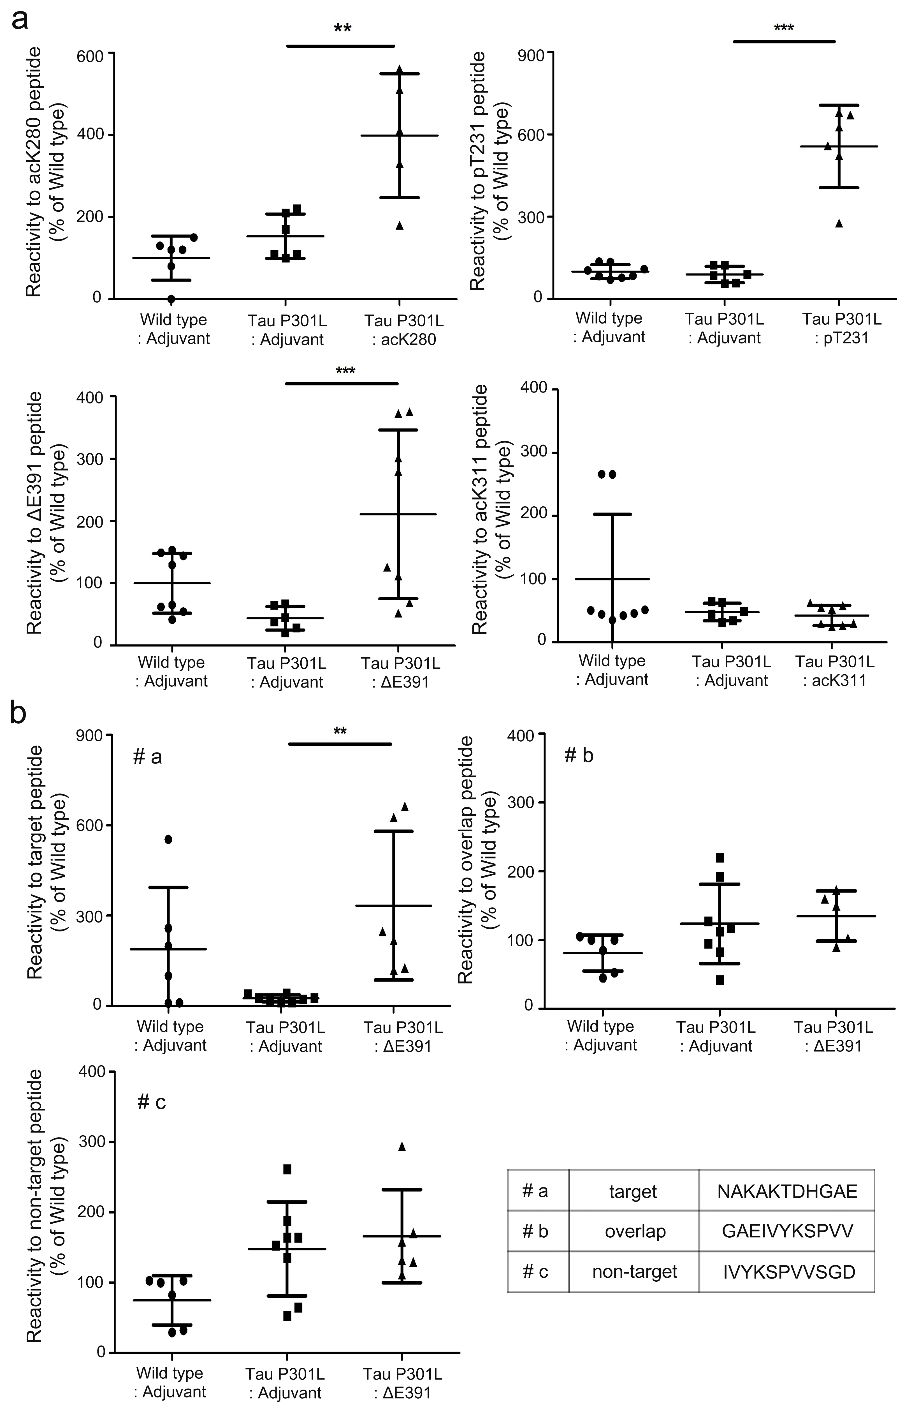

Figure S2. Antibody formation. (a) Quantification of indirect ELISA measurements of plasma IgG responses to each immunized antigen. acK280 peptide: Wild type-adjuvant n=3, Tau P301L-adjuvant n=3, Tau P301L-acK280 n=3. pT231 peptide: Wild type-adjuvant n=4, Tau P301L-adjuvant n=3, Tau P301L-pT231 n=3. ΔE391 peptide: Wild type-adjuvant n=4, Tau P301L-adjuvant n=3, Tau P301L-ΔE391 n=4. acK311 peptide: Wild type-adjuvant n=4, Tau P301L-adjuvant n=3, Tau P301L-acK311 n=4. Experiments were repeated twice and all mice are male. **P < 0.01, ***P < 0.001 compared to Tau P301L-adjuvant group. (b) Quantification of indirect ELISA measurements of plasma IgG responses to tau peptide sequences cleaved at E391: #a, overlapping at E391: #b, distant from E391: #c. Wild type-adjuvant n=3, Tau P301L-adjuvant n=4, Tau P301L-ΔE391 n=3. Experiments were repeated twice and all mice are male. **P < 0.01 compared to Tau P301L-adjuvant group.

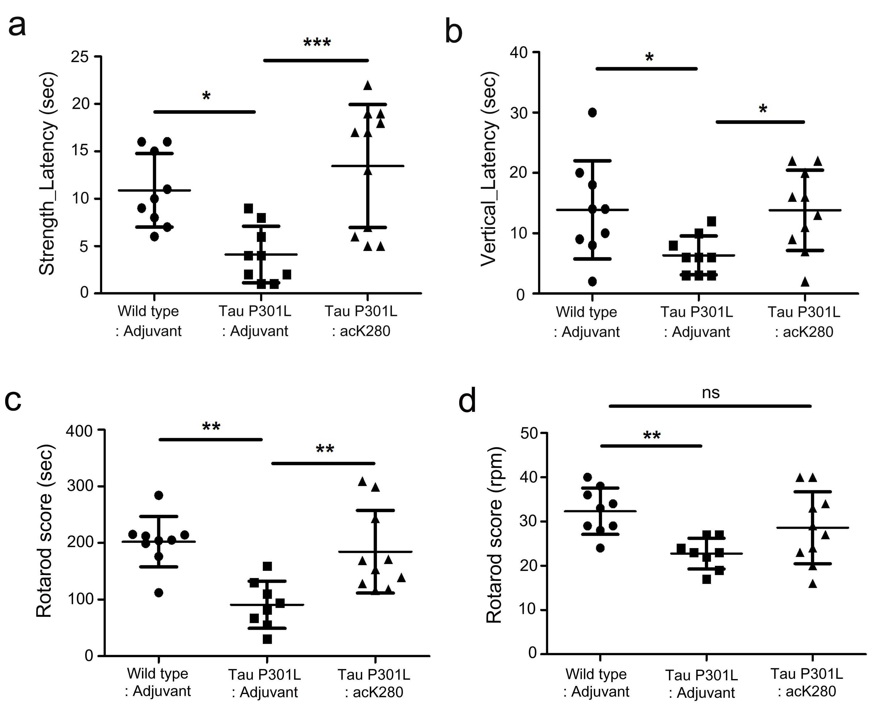

Figure S3. Behavioral improvement by acK280 immunization. After the initial screening, behavioral efficacy with acK280 was confirmed in additional independent experiments. Representative analyzed data; acK280 peptide results (a) strength test (b) vertical test and (c-d) rotarod. Wild type-adjuvant n=9, Tau P301L-adjuvant n=9, Tau P301L-acK280 n=10, all mice are male. *P < 0.05, **P < 0.01, ***P < 0.001 compared to Tau P301L-adjuvant group.

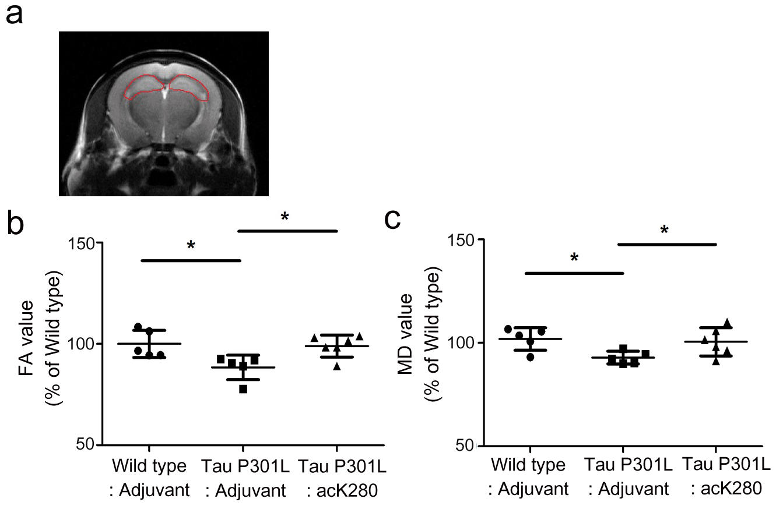

Figure S4. Ameliorated connectivity by acK280 immunization. In vivo diffusion tensor imaging (DTI) progression in the 8-month-old immunized mice. (a) The region of interest (ROI) was the hippocampus. (b) FA value. (c) MD value. Wild type-adjuvant n=5, Tau P301L-adjuvant n=5, Tau P301L-acK280 n=6, all mice are male. *P < 0.05 compared to Tau P301L-adjuvant group.

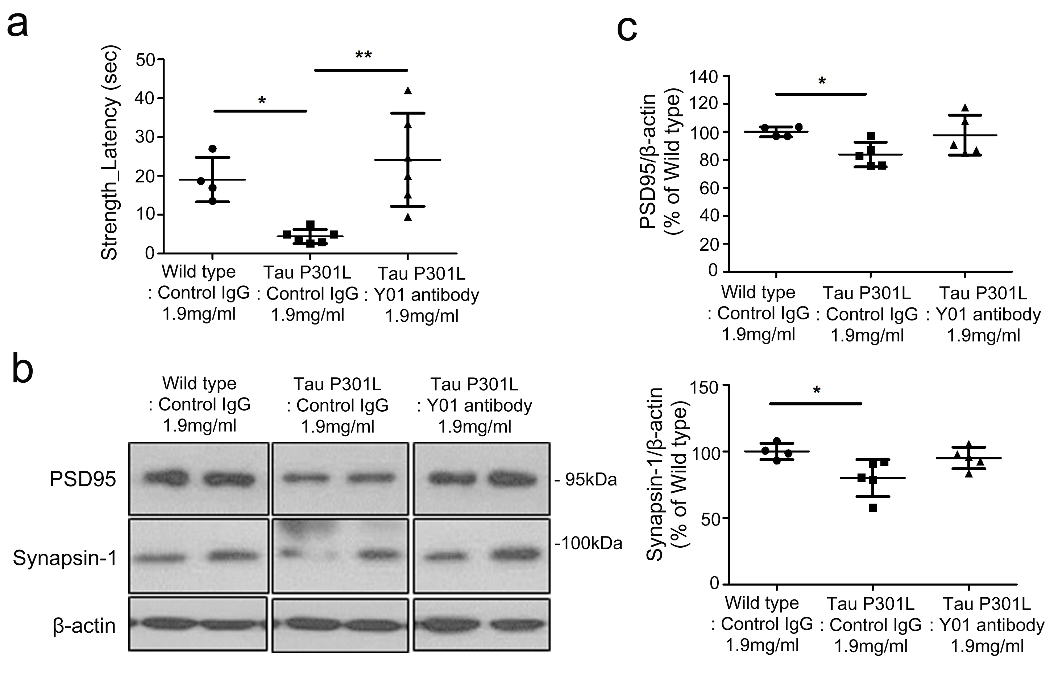

Figure S5. Ameliorated pathology following intracerebroventricular infusion of Y01 antibody. (a) Grip strength test. Wild type-Control IgG n=4, Tau P301L-Control IgG n=6, Tau P301L-Y01 antibody n=6, all mice are male. *P < 0.05, **P < 0.01 compared to Tau P301L-Control IgG group. (b) Representative immunoblots of PSD95, Synapsin-1 and β-actin in the cortex from 9-month-old passive immunized mice (cropped blot images are shown, see Additional file 9: Figure S9 for full immunoblots). (c) Quantification of PSD95 and Synapsin-1 protein levels normalized to β-actin. Wild type-Control IgG n=4, Tau P301L-Control IgG n=5, Tau P301L-Y01 antibody n=5, all mice are male. *P < 0.05 compared to Tau P301L-Control IgG group.

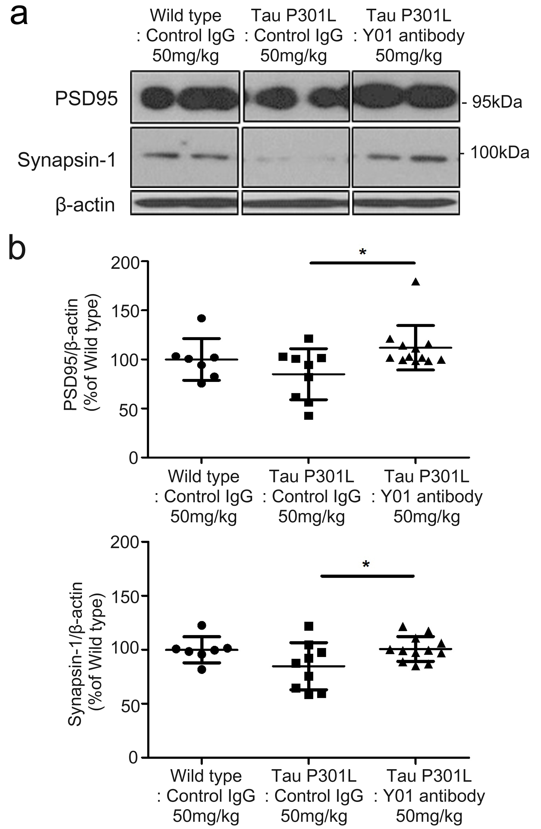

Figure S6. Ameliorated cognition and pathology by intraperitoneal injection of Y01 antibody. (a) Representative immunoblots of PSD95, Synapsin-1 and β-actin in the cortex from passive immunized mice (cropped blot images are shown, see Additional file 9: Figure S9 for full immunoblots). (b) Quantification of PSD95 and Synapsin-1 protein levels normalized to β-actin. Wild type-Control IgG n=7, Tau P301L-Control IgG n=9, Tau P301L-Y01 antibody n=12. *P < 0.05 compared to Tau P301L-Control IgG group.

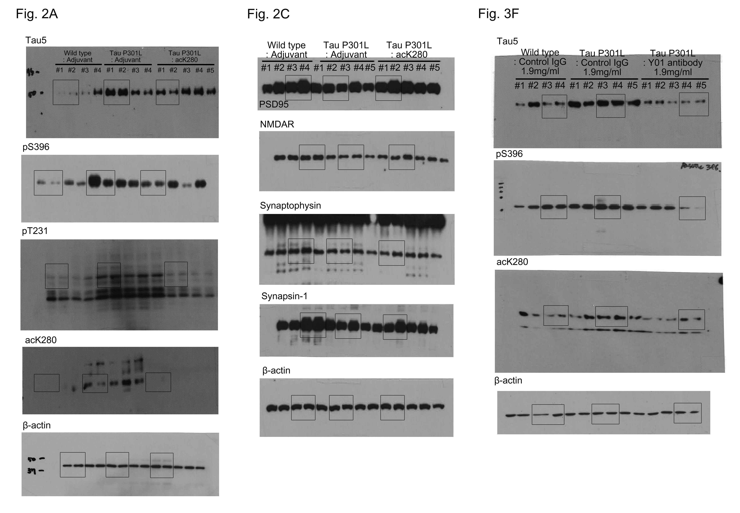

Figure S7. Original full western blot image of main figures.

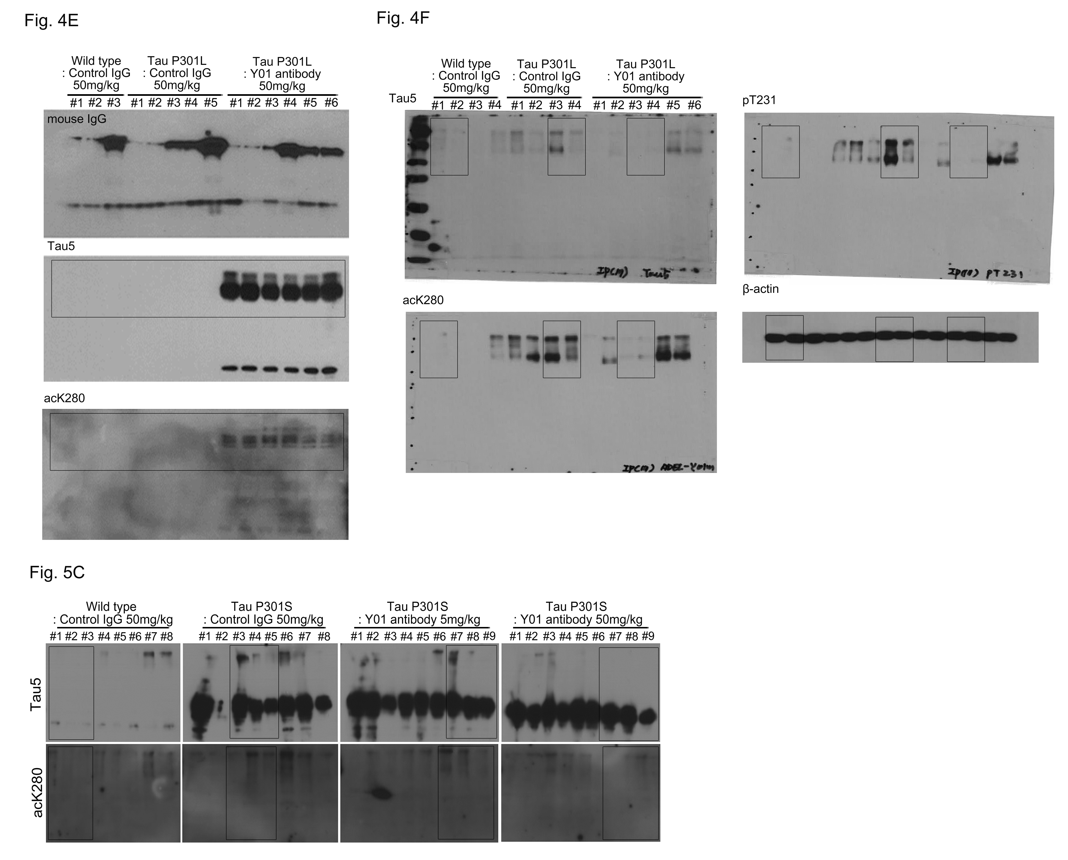

Figure S8. Original full western blot image of main figures.

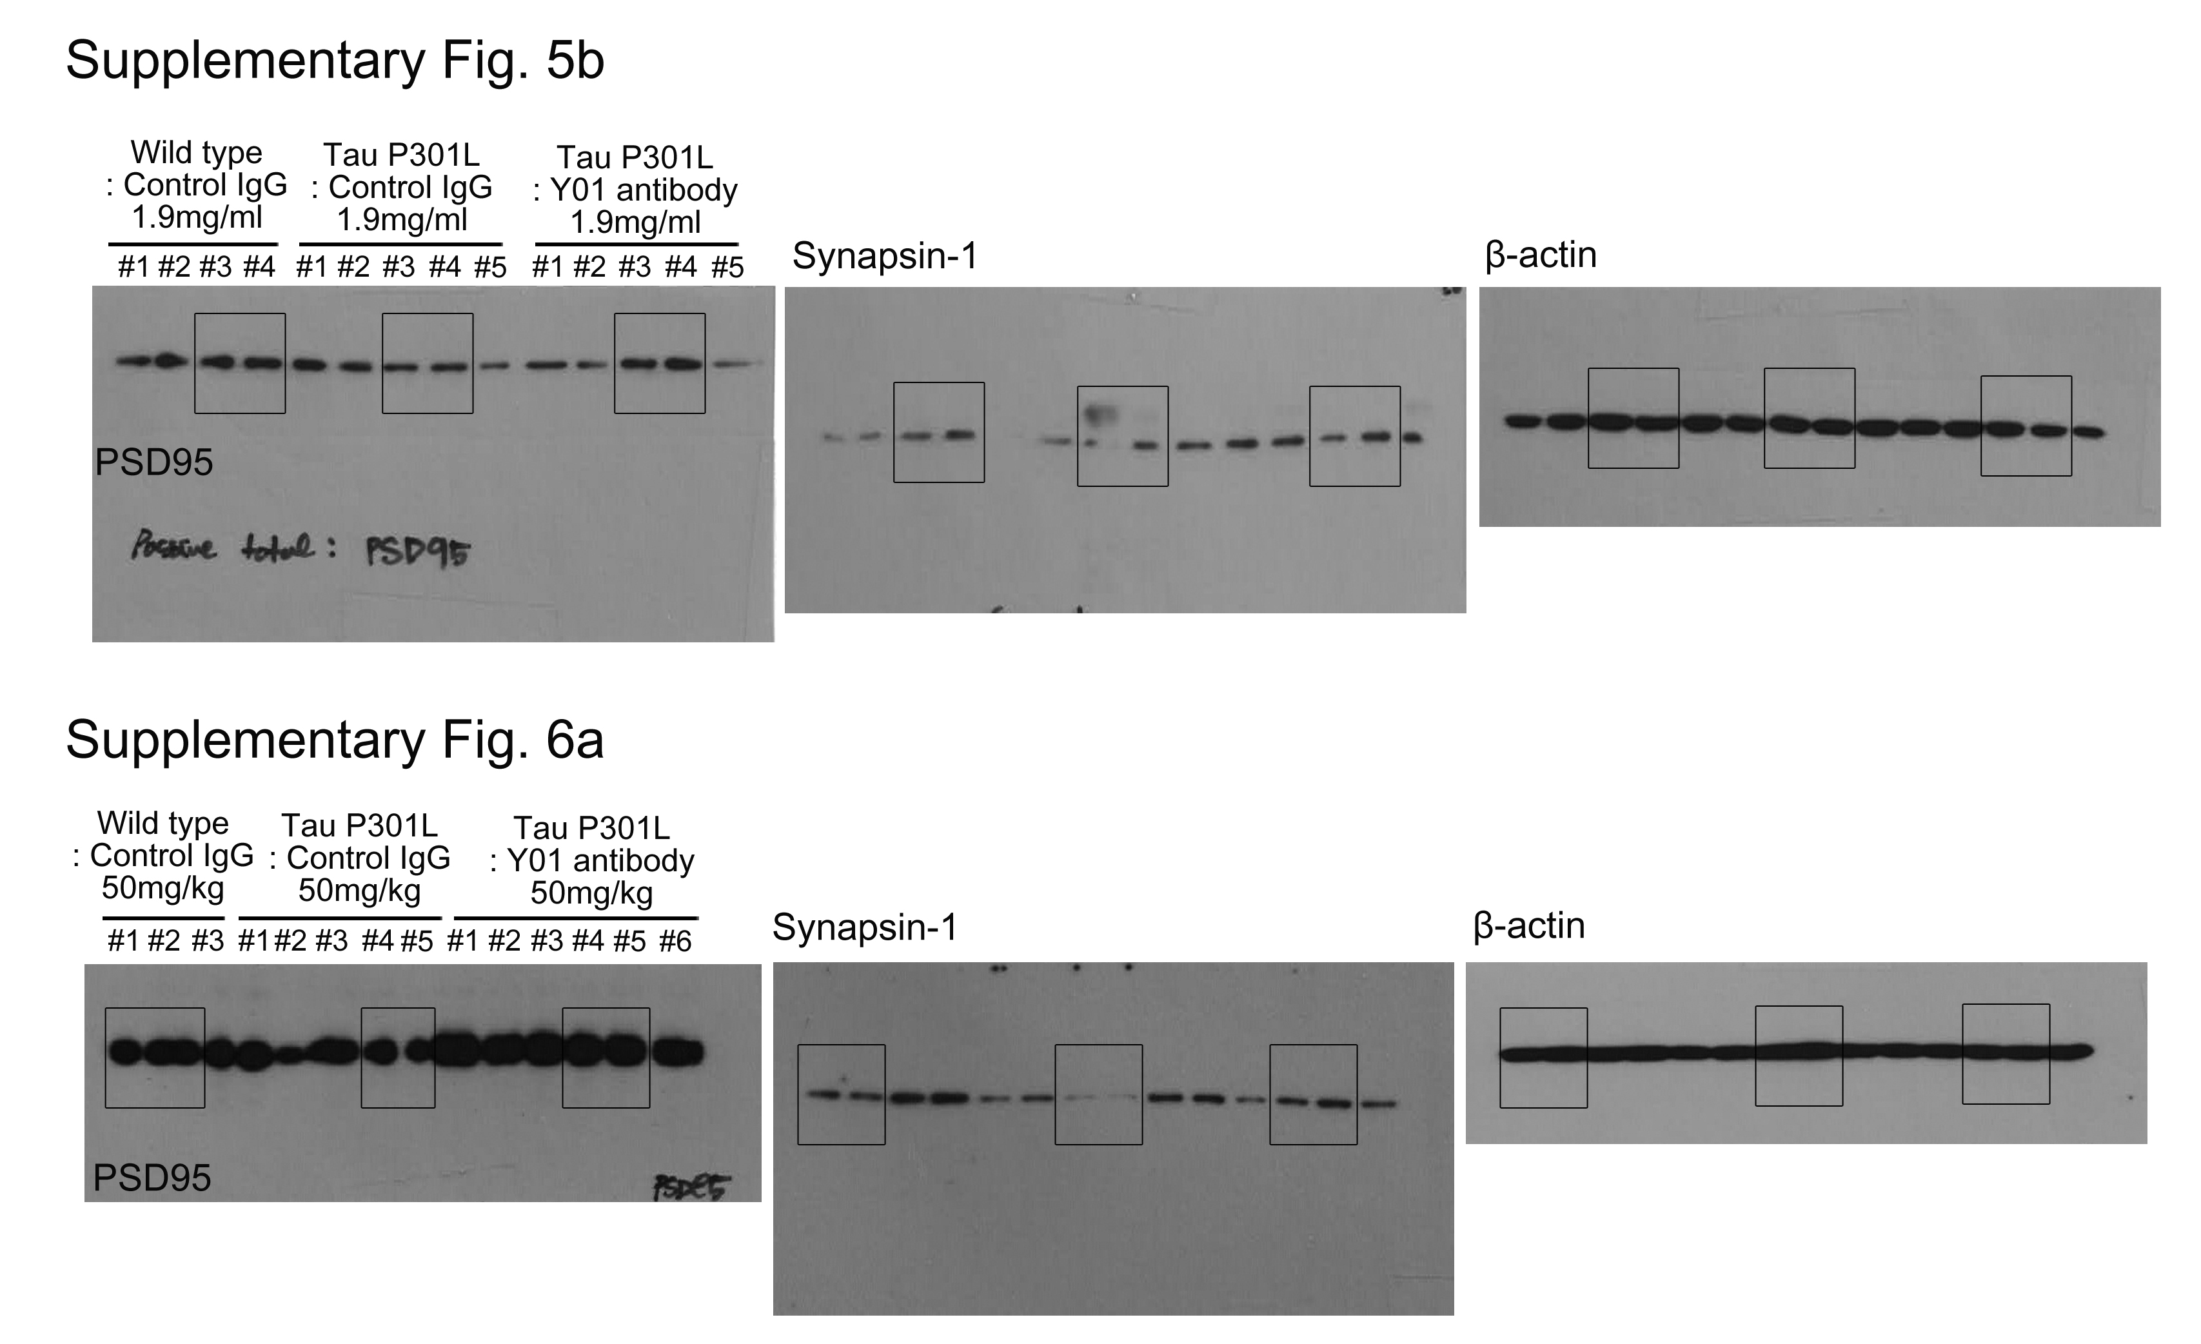

Figure S9. Original full western blot image of supplementary figures.

