Supplemental Information
Supplementary Figures
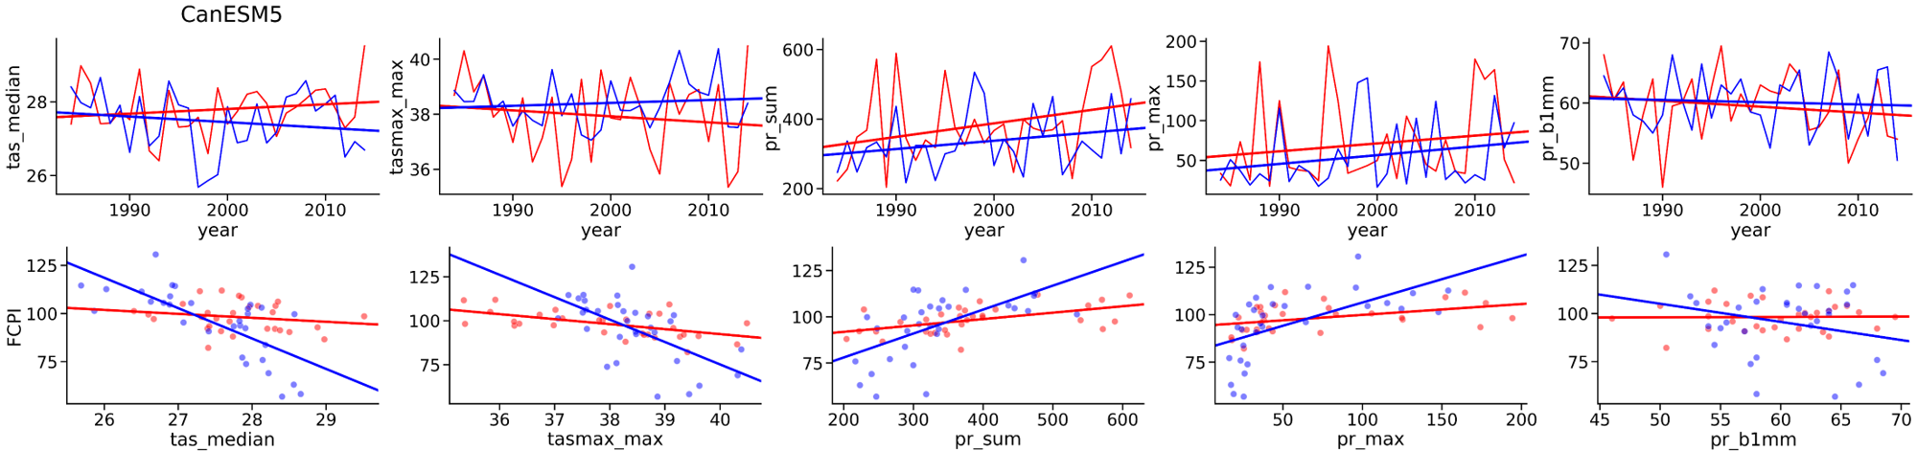
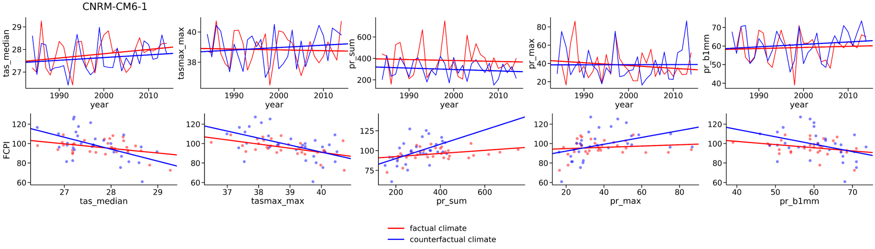
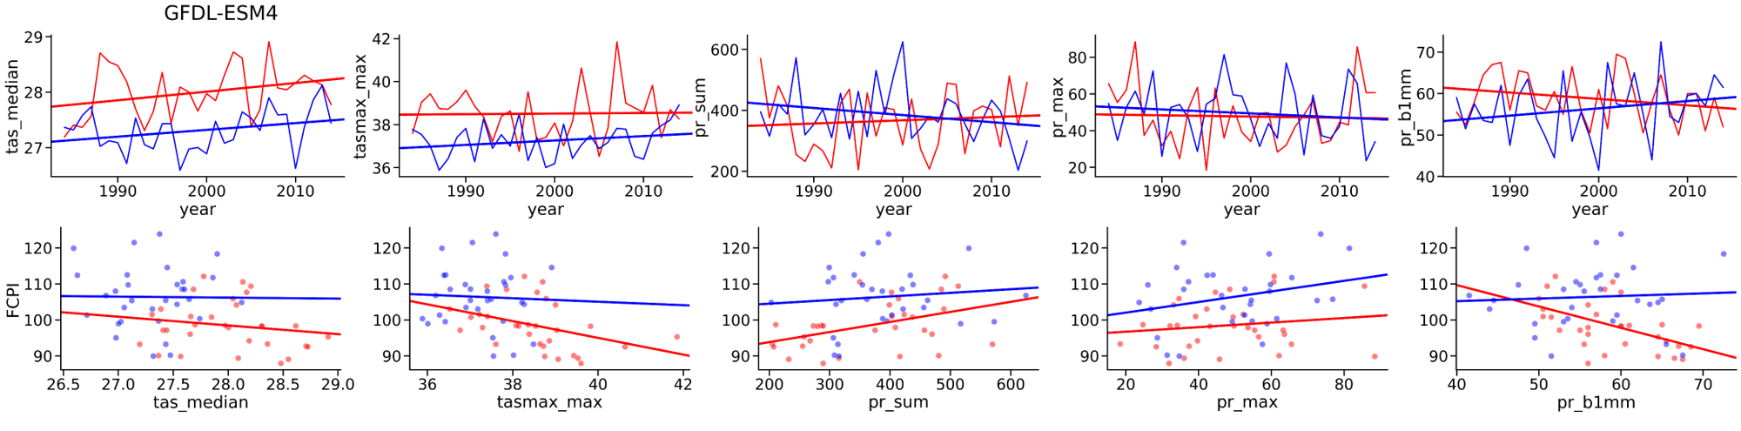

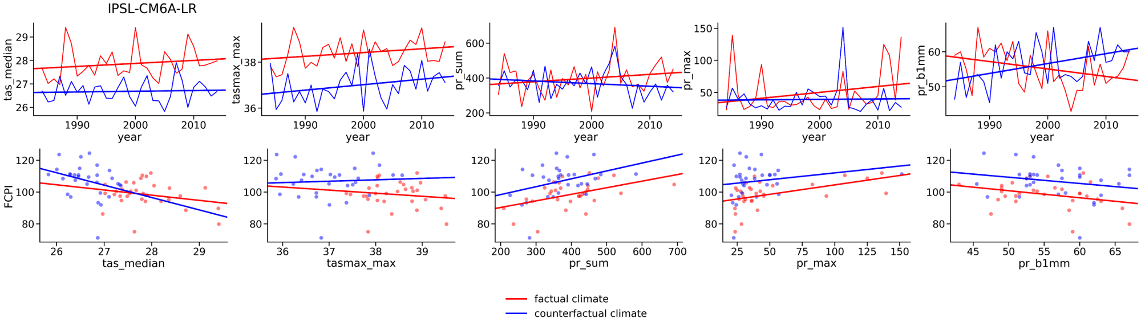

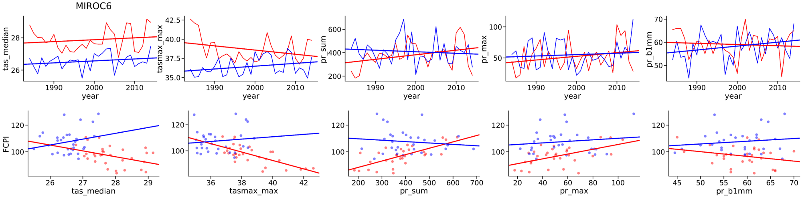
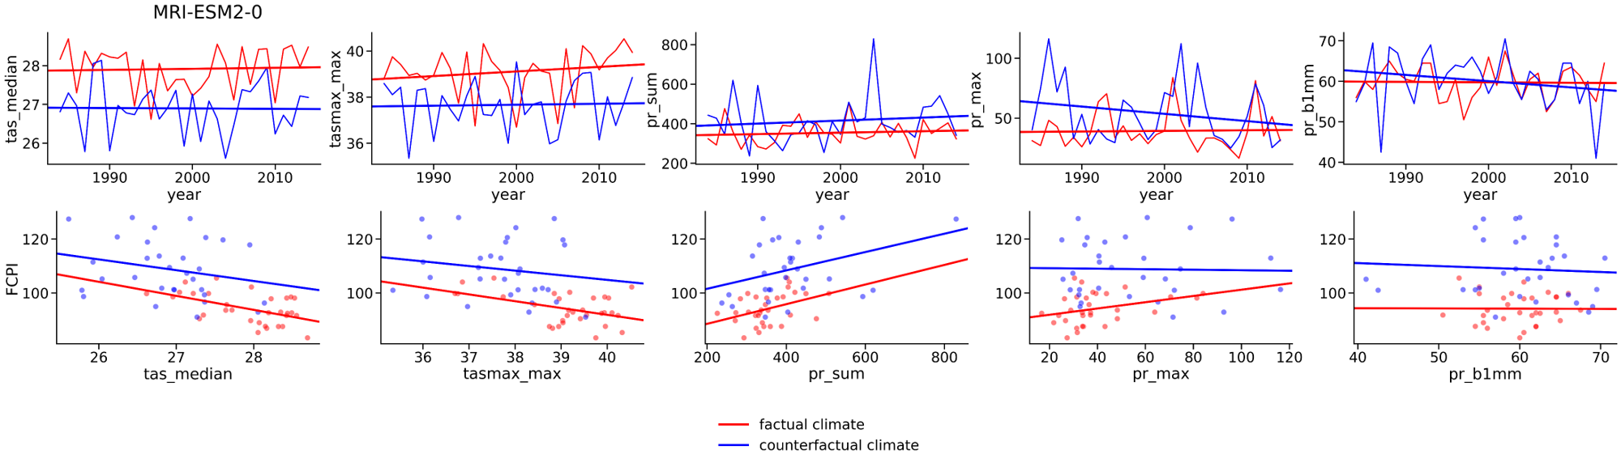
SI Figure 1: Agro-climatic variables for factual and counterfactual simulations from 1984 to 2016 for the growing season of millet - the main food crop in Nouna area (top panels) and their correlation with the Food Crop Productivity Index – FCPI (bottom panels); the plots are presented for each of six considered Global Circulation Model from ISIMIP3b - CanESM5, CNRM-CM6-1, GFDL-ESM4, IPSL-CM6A-LR, MIROC6 and MRI-ESM2-0 - separately.
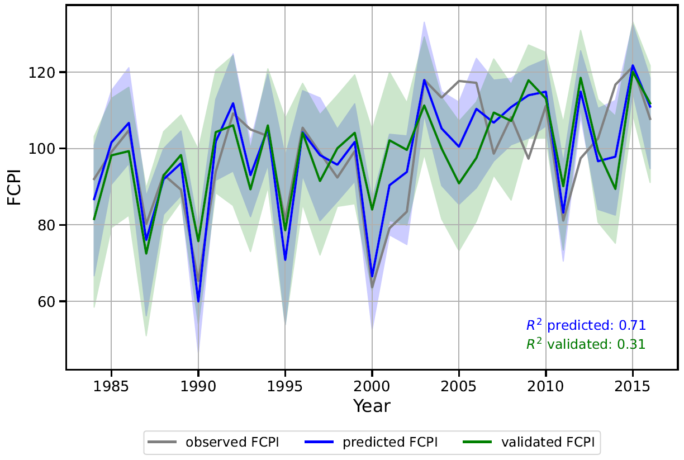
SI Figure 2: Climate-attributable share of the Food Crop Productivity Index (FCPI). The grey line presents the FCPI based on observed crop production data. The blue and green lines show prediction results of a Random Forest Model that is purely driven by agro-climatic variables and thus only represents the climate-driven share of the FCPI. The blue line shows the prediction results of the Random Forest Model when all available data are included in the training process. The green line represents the out-of-sample validation results. In this validation, one year of the time series is excluded from the training process and the prediction is done for this year. The process is repeated for all available years in the time series (leave-one-year-out-cross validation (LOYO-cross validation)). The uncertainty bands show the modelled values between the 5th and 95th percentile over all predicted trees of the random forest model.
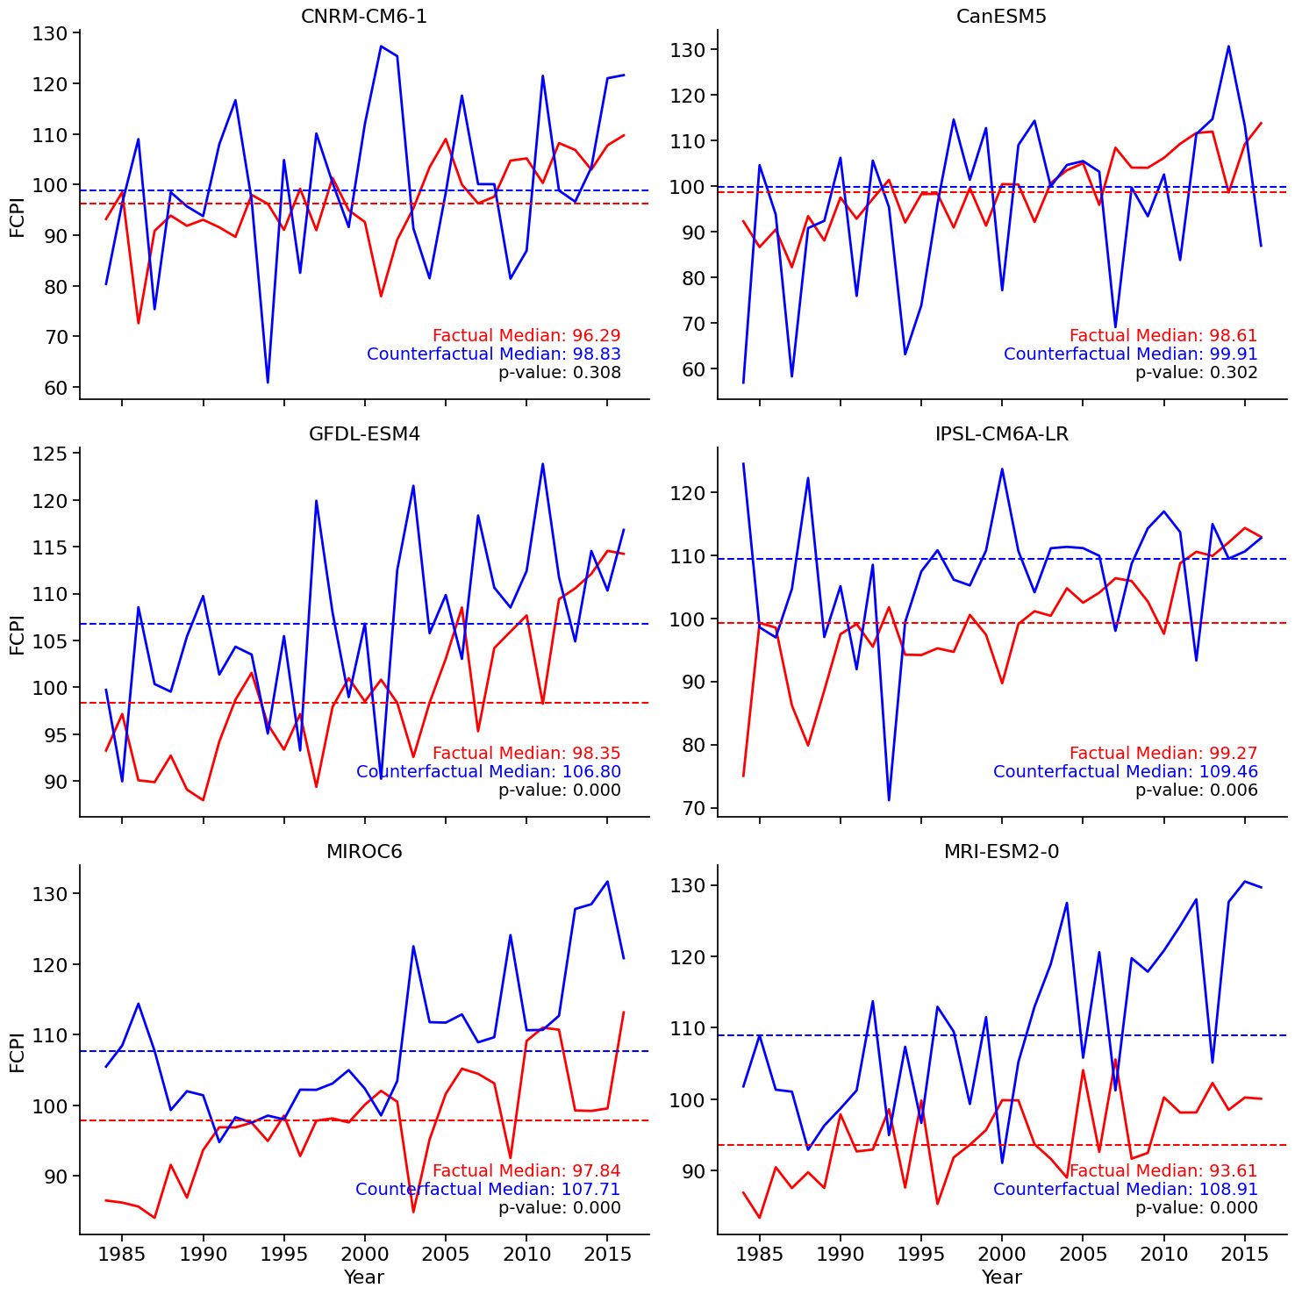
SI Figure 3: Food Crop Productivity Index (FCPI) for factual (red) and counterfactual (blue) climate simulations from 1984 to 2016 for Kossi province, Burkina Faso, for each of the six Global Circulation Model (GCM) from ISIMIP3b - CanESM5, CNRM-CM6-1, GFDL-ESM4, IPSL-CM6A-LR, MIROC6 and MRI-ESM2-0 - separately. The dotted lines represent the median value over the whole period. The p-value provides the result of the paired t-test.

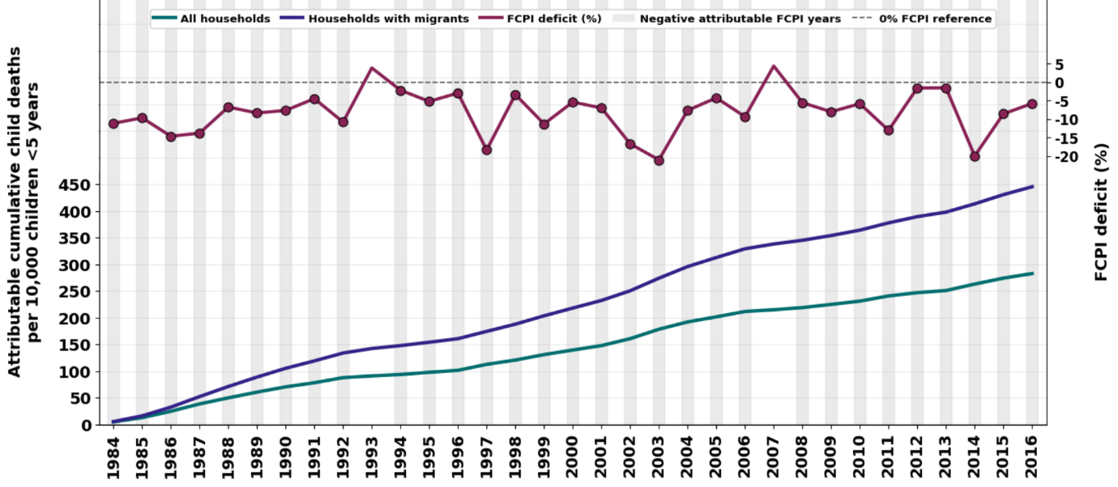
A
B
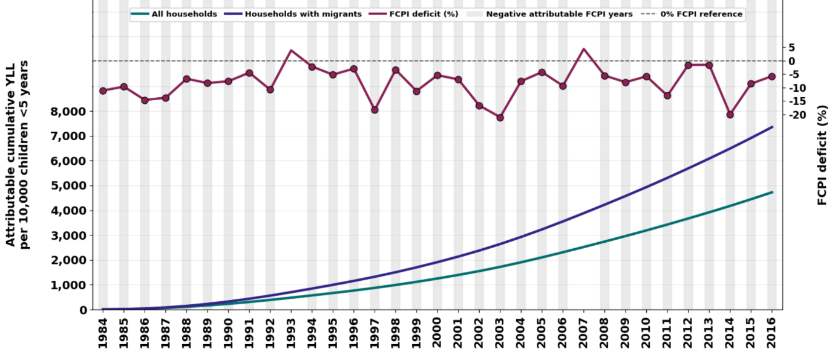
C
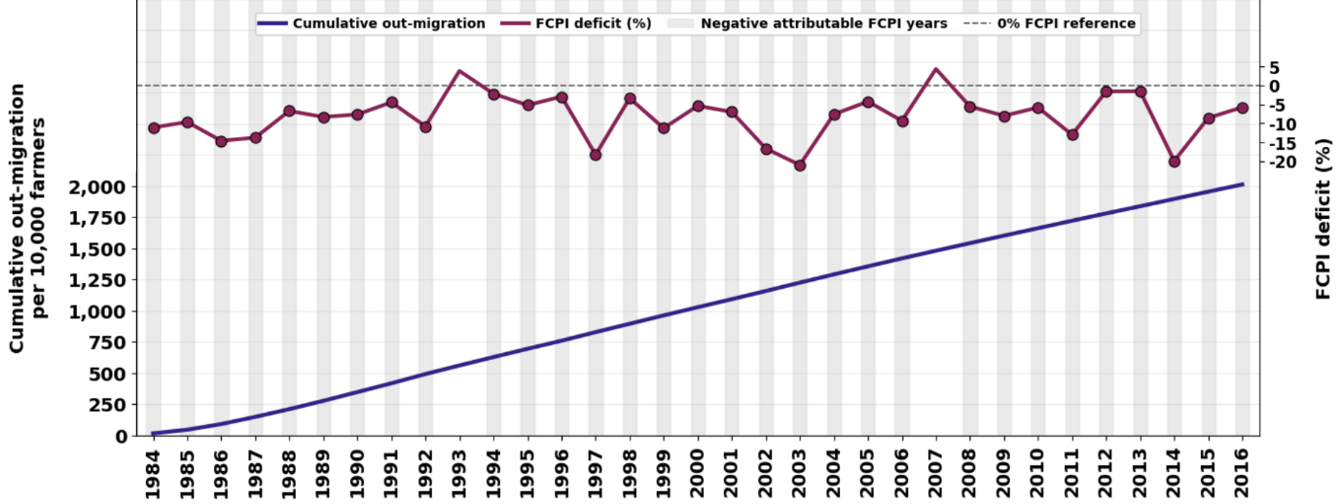

SI Figure 4: The FCPI and corresponding cumulative burdens of child deaths (Panel A) and YLL (Panel B) per 10,000 children<5 years of age and farmer out-migration events (Panel C) per 10,000 farmers attributable to exposure to the anthropogenic climate change through yield reductions in Nouna HDSS population over the period of 1984—2016.

Supplementary Tables
SI Table 1: Descriptive statistics of the five considered agro-climatic variables used as input for the Random Forest Model; the descriptive statistics are calculated over the whole time period considering the growing seasons of all five crops
Climate variable | Abbreviation | mean | min | max
Median daily mean temperature | tas_median | 28.9 | 26.3 | 30.7
Maximum daily maximum temperature | tasmax_max | 41.6 | 35.0 | 43.7
Precipitation sum in mm | pr_sum | 615 | 239 | 922
Maximum daily precipitation sum | pr_max | 38.9 | 19.6 | 67.4
Number of days with precipitation sums equal or below 1mm | pr_b1mm | 103 | 47 | 173

SI Table 2: Descriptive statistics for key crops in Nouna for the period 1984–2016. Production-related statistics are reported in tonnes (t), harvested area in hectares (ha), and yields in tonnes per hectare (t/ha). The share of total production or harvested area represents the contribution of each crop relative to the combined production or area of all five crops. The weather-attributable share is derived from the climate-driven Random Forest Model and quantifies the proportion of variability explained by climate variables alone.
 |  | Millet | Sorghum | Maize | Fonio | Rice
Production | mean | 83209.91 | 55940.84 | 11910.64 | 6560.52 | 621.48
Production | median | 80440 | 51831.07 | 10033 | 7099 | 315
Production | sum | 2745927 | 1846047.56 | 393051 | 216497 | 19266
Production | std | 35202.97 | 21420.38 | 8343.8 | 2939.78 | 642.89
Production | min | 21296 | 25297.84 | 2620 | 301 | 13
Production | max | 154032 | 117000 | 33000 | 12083 | 2385
Production | share of total production | 52.6% | 35.4% | 7.5% | 4.2% | 0.4%
Area | mean | 97742.61 | 61006.56 | 10092.45 | 9798.09 | 645.5
Area | median | 94427 | 51335 | 7800 | 10000 | 400
Area | sum | 3225506 | 2013216.42 | 333051 | 323337 | 20656
Area | std | 33901.71 | 24764.88 | 6265.13 | 3866.43 | 762.11
Area | min | 31180 | 28245.32 | 2843 | 674 | 9
Area | max | 163716 | 121000 | 28600 | 16151 | 3159
Area | share of total area | 54.52% | 34.03% | 5.63% | 5.47% | 0.35%
Yield | mean | 0.83 | 0.92 | 1.12 | 0.66 | 1.09
Yield | median | 0.84 | 0.92 | 1.17 | 0.7 | 1.14
Yield | std | 0.17 | 0.17 | 0.31 | 0.17 | 0.43
Yield | min | 0.52 | 0.5 | 0.54 | 0.1 | 0.29
Yield | max | 1.13 | 1.23 | 1.78 | 0.98 | 2.38

SI Table 3: Survival to age <5 years in relation to individual exposure to reduced food-crop yields from birth to 2 years of age (Cox regression analysis) among children in the Nouna Health and Demographic Surveillance System, Burkina Faso by presence of farmers’ migration in children’s households during the analysis time, 1994–2016
Household category |  | No of children | HR (95% CI) for  90th-10th centile Δ in FCPI
All households |  | 57,288 | 1.12 (1.03, 1.22)
Households with farmers’ migration: | absent | 57,288 | 0.92 (0.85, 1.00)
Households with farmers’ migration: | present | 57,288 | 1.92 (1.74, 2.11)
Households with farmers’ migration: | unknown | 57,288 | 1.16 (1.06, 1.25)

