Supplementary Results — Table of Contents

This supplementary file provides extended methodological details, diagnostic plots, and full statistical outputs supporting the main manuscript results.
- Participant Flow: Recruitment, Exclusions, and Final OCTA Sample
- Baseline Characteristics of OCTA Subsample (Controls vs. AoCo)
- Model Assumptions and Diagnostics
3.1. Residual Distribution and Normality (Histogram, Q–Q Plot)
3.2. Residuals vs. Fitted Values (Homoscedasticity Assessment)
3.3. Model Specification and Multicollinearity (VIF and RESET Tests)
- Multicollinearity and Model Specification
  - Variance Inflation Factors (VIF)
  - Ramsey RESET (Model Specification Test)
  - Heteroscedasticity Note (Robust SE Rationale)
  - Highly Correlated SCP Metrics: Selection of VD as the Representative Parameter
- Full Regression Outputs (Primary Models)
5.1. Model Including SBP (age, sex, SBP, axial length)
5.2. Model Without SBP (age, sex, axial length)
- Timing of Repair and Cardiovascular Burden (Exploratory Subgroup).
Abbreviations:
AoCo, aortic coarctation;
OCTA, optical coherence tomography angiography;
SCP, superficial capillary plexus;
VD, vessel density;
VLD, vessel length density;
FD, fractal dimension;
TVL, total vessel length;
SBP, systolic blood pressure;
DBP, diastolic blood pressure;
IOP, intraocular pressure;
LVH, left ventricular hypertrophy.
All supplementary analyses were performed using Stata/IC 15.1 for Mac (StataCorp, College Station, TX, USA).

Section 1- Participant Flow: Recruitment, Exclusions, and Final OCTA Sample
This section details recruitment, image-quality screening, and the final OCTA sample for AoCo and controls (see Supplementary Figure S1).
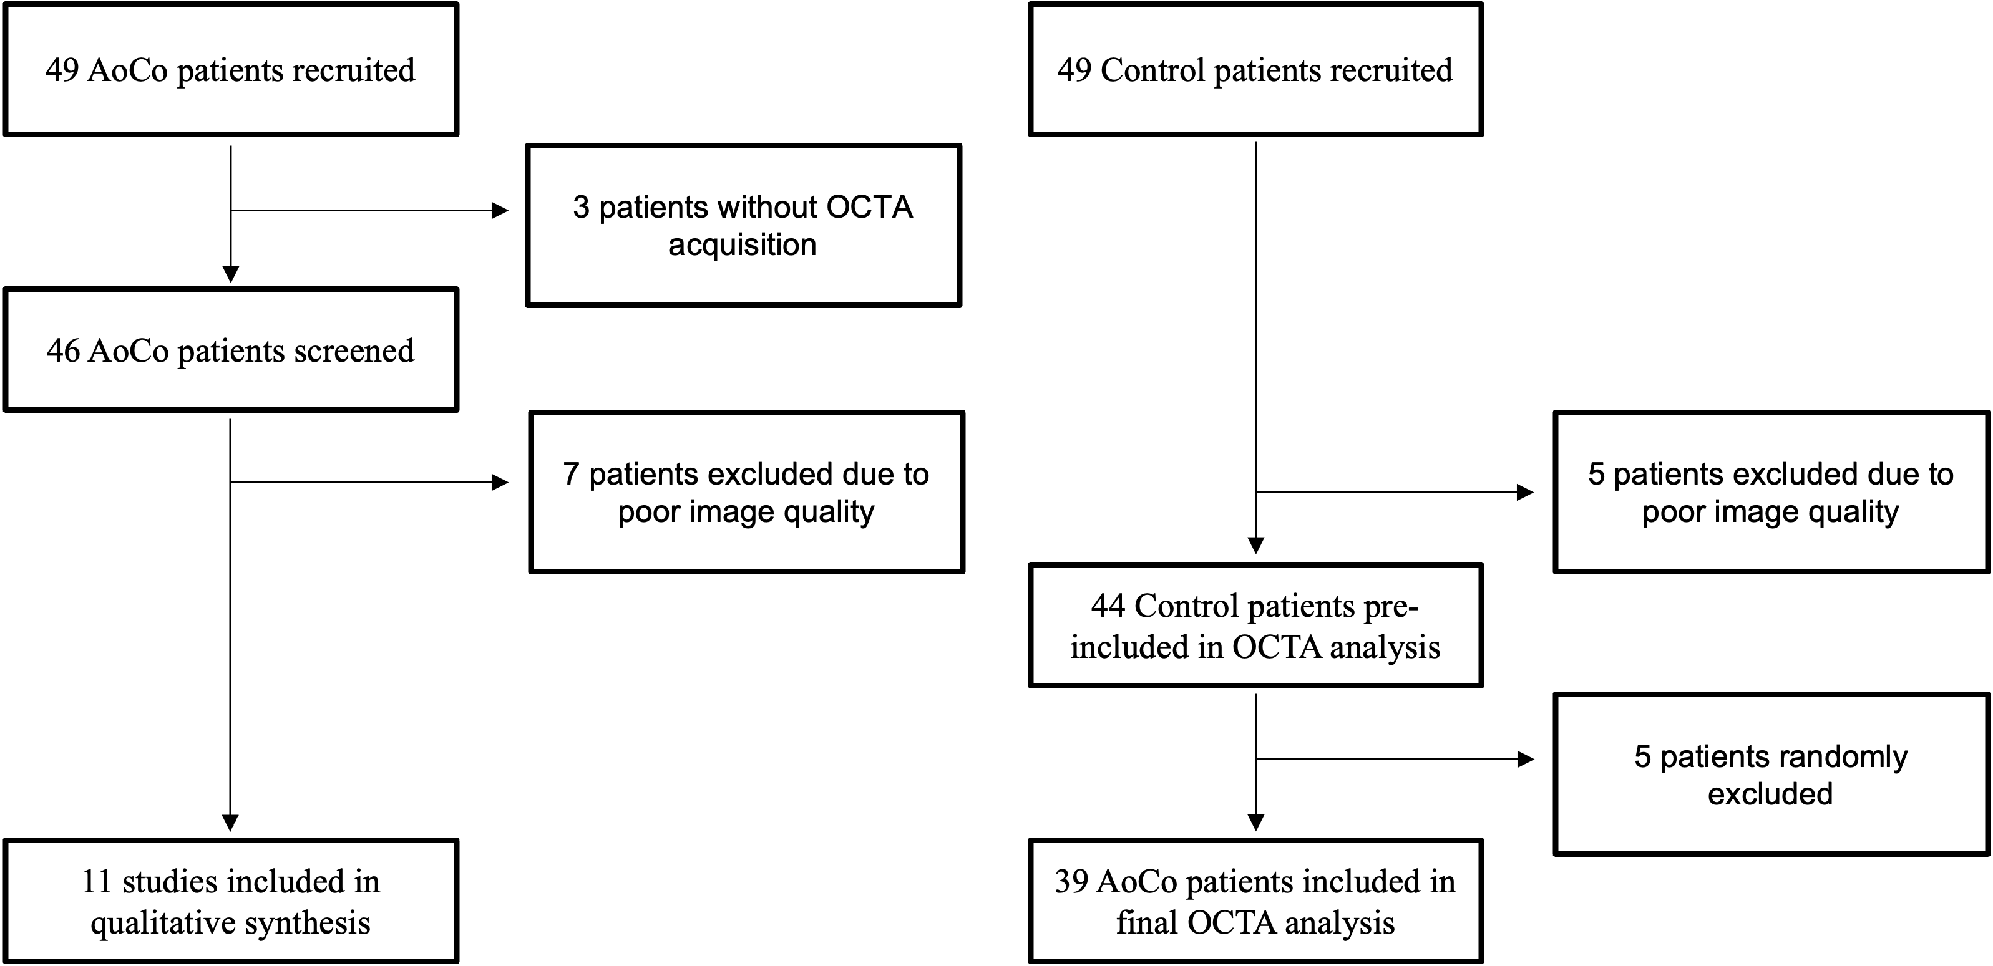

Supplementary Figure S1. Flow diagram showing participant recruitment, exclusion, and inclusion in the OCTA analysis. AoCo, aortic coarctation; OCTA, optical coherence tomography angiography.

Section 2 – Baseline Characteristics of OCTA Subsample (Controls vs. AoCo)
Supplementary Table S1 shows the demographic and clinical characteristics of the patients included in the OCTA analysis. Age did not differ significantly between controls and AoCo patients (20.90 ± 8.82 vs. 22.05 ± 8.79 years, p = 0.518). The proportion of male participants was higher in the AoCo group compared with controls (67.3% vs. 51.3%), but this difference did not reach statistical significance (p = 0.150). Mean systolic BP was significantly higher in the AoCo group (128.33 ± 16.88 mmHg) compared with controls (118.54 ± 12.17 mmHg, p = 0.004), as was diastolic BP (76.64 ± 9.55 vs. 71.03 ± 8.10 mmHg, p = 0.007). No significant between-group differences were found for intraocular pressure (16.19 ± 2.60 vs. 16.14 ± 2.37 mmHg, p = 0.767) or axial length (23.41 ± 1.32 vs. 23.47 ± 0.92 mm, p = 0.841).
Supplementary Table S1. Demographic and clinical characteristics of patients included in the OCTA analysis, stratified by study group (controls vs AoCo patients). Continuous variables are expressed as mean ± standard deviation (SD) or median [interquartile range, IQR], depending on distribution. Categorical variables are presented as counts and percentages. p-values were obtained using Student’s t-test for normally distributed variables, Wilcoxon–Mann–Whitney test for non-normally distributed variables, and χ² test for categorical variables. SBP, Systolic Blood Pressure; DBP, Diastolic Blood Pressure; IOP, Intraocular Pressure.
Variable | Controls | AoCo | p-value
Age, years | 20.90 ± 8.82 (n=39) | 22.05 ± 8.79 (n=39) | 0.518
Sex, male (%) | 51.3% (n=39) | 67.3% (n=39) | 0.150
SBP, mmHg | 118.54 ± 12.17 (n=39) | 128.33 ± 16.88 (n=39) | 0.004
DBP, mmHg | 71.03 ± 8.10 (n=39) | 76.64 ± 9.55 (n=39) | 0.007
IOP, mmHg | 16.14 ± 2.37 (n=38) | 16.19 ± 2.60 (n=38) | 0.767
Axial length, mm | 23.47 ± 0.92 (n=39) | 23.41 ± 1.32 (n=39) | 0.841

Section 3 - Model Assumptions: Residual Diagnostics
3.1 Residual Distribution (Histogram with Normal Curve)
This plot demonstrates the approximate normality of residuals. The distribution closely follows a normal curve, indicating no major deviation from normality.

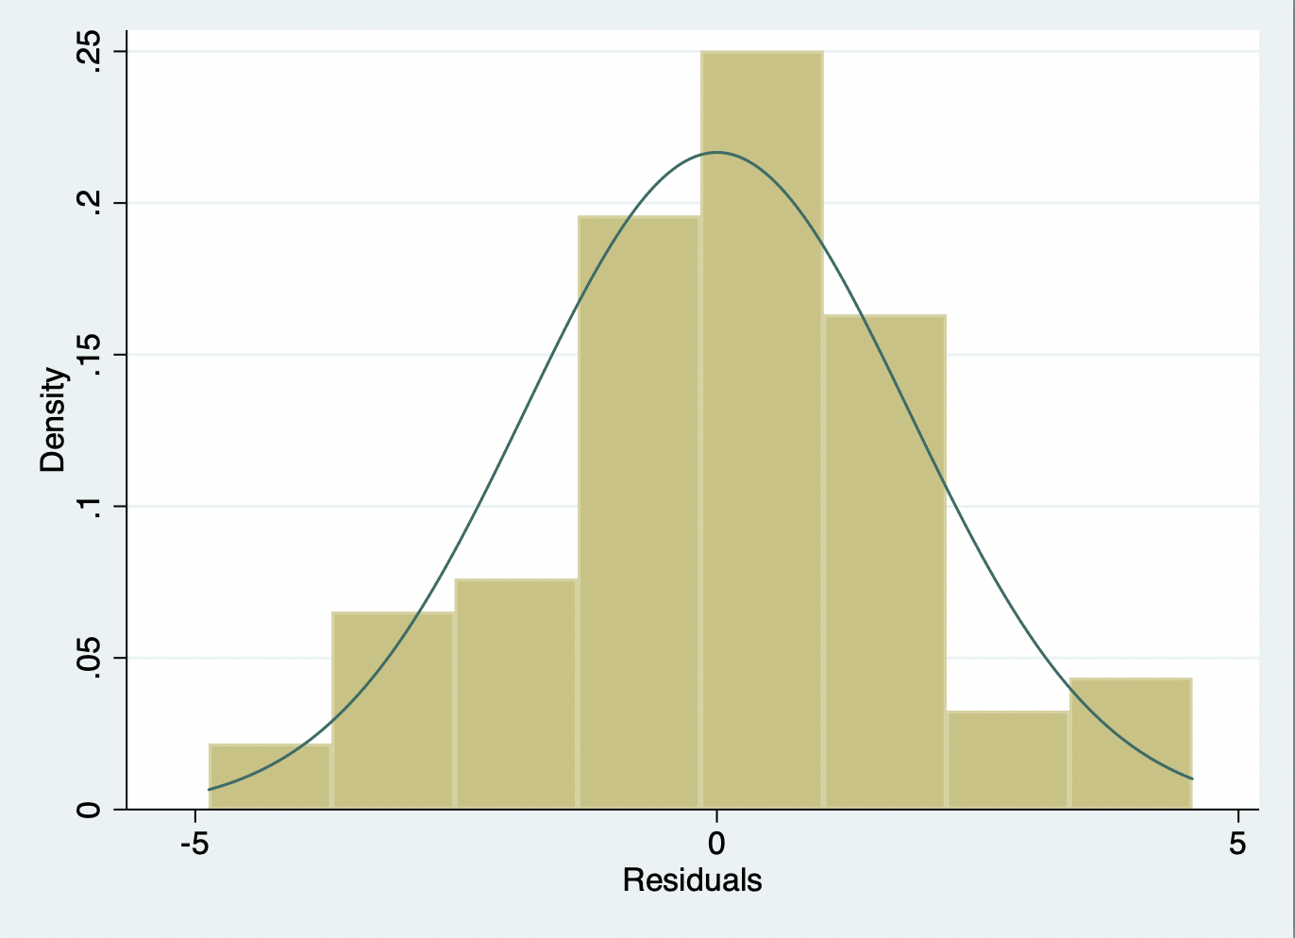
Supplementary Figure S2. Histogram of model residuals.
3.2 Normality Check (Q–Q Plot)
The Q-Q plot shows that the residuals align well with the diagonal line, further supporting the assumption of normality.
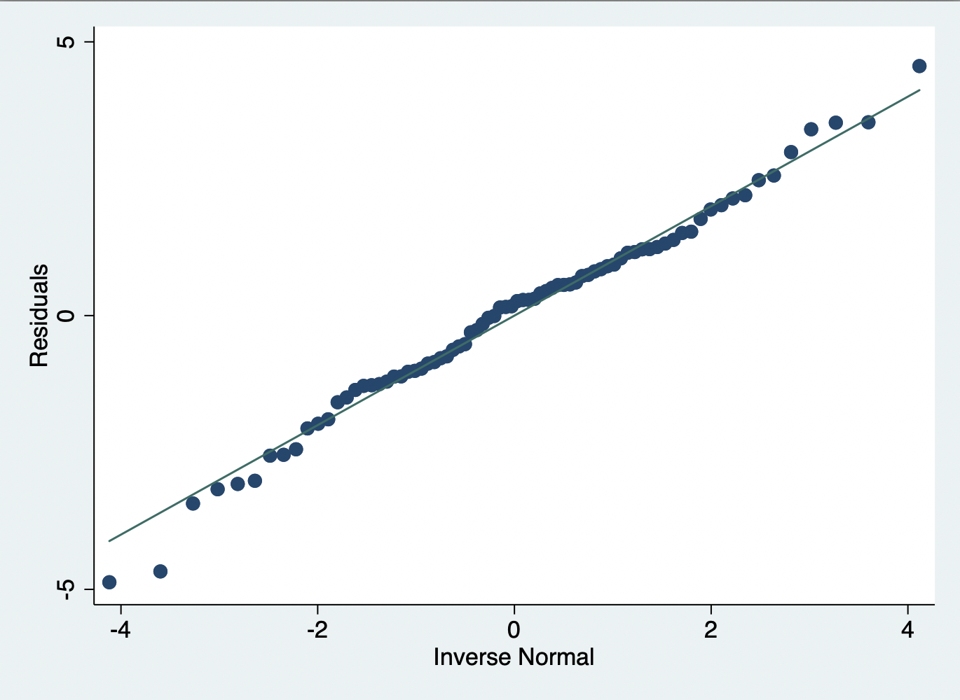
Supplementary Figure S3. Normal Q–Q plot of model residuals

3.3 Residuals vs. Fitted Values (Homoscedasticity Screen)
This scatterplot illustrates the distribution of residuals against predicted values. No clear pattern is observed, suggesting homoscedasticity.

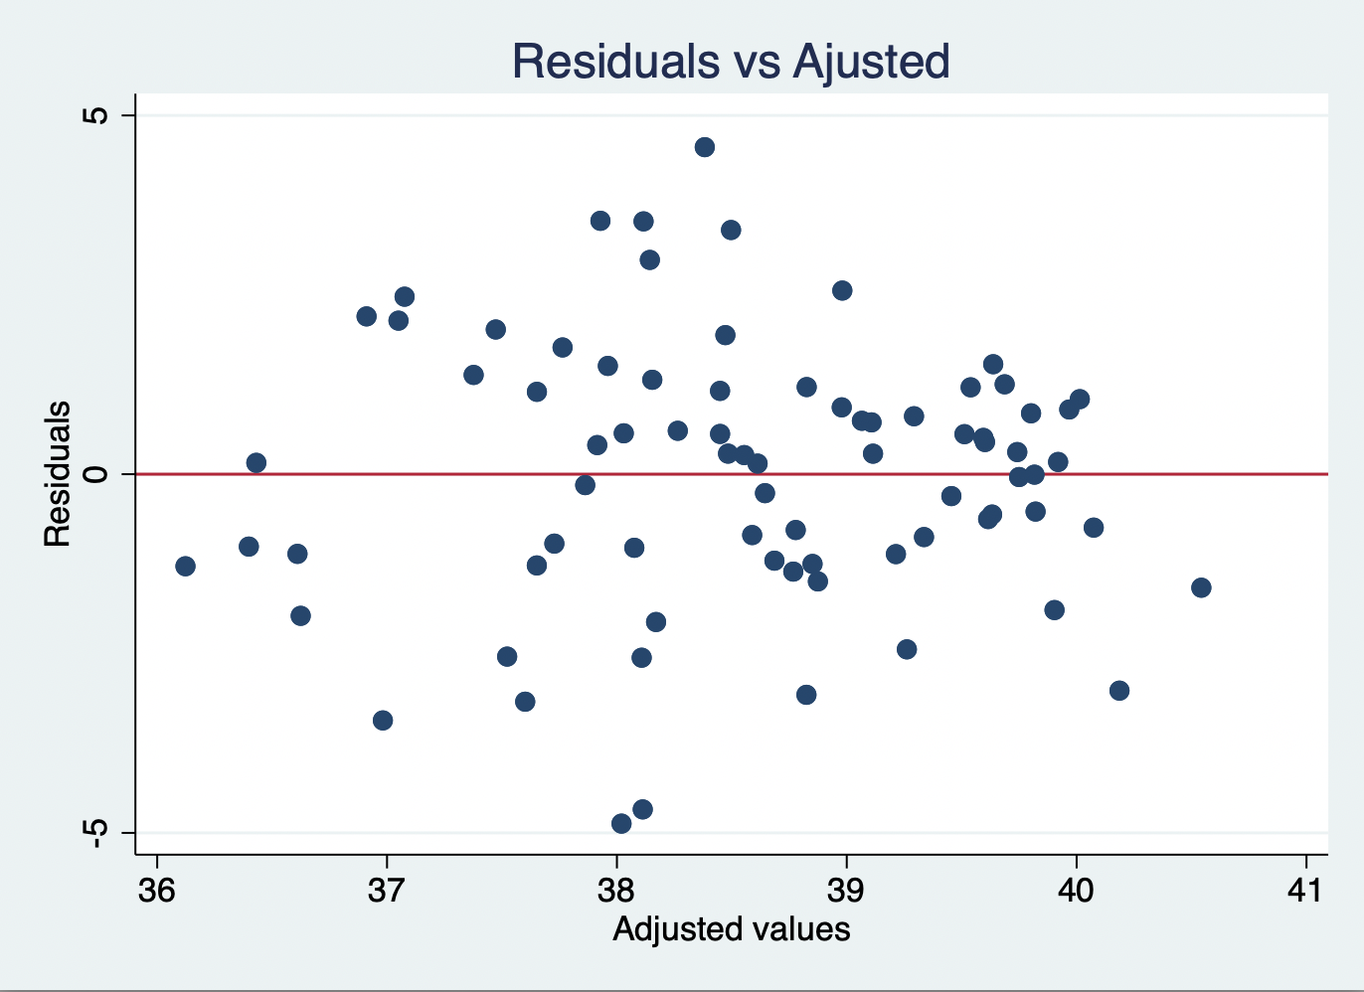
Supplementary Figure S4. Residuals versus fitted values plot.

Section 4 - Multicollinearity and Model Specification
4.1 Variance Inflation Factors (VIF)
Variance Inflation Factor (VIF) values were all below 1.3, with a mean VIF of 1.17, indicating no concern for multicollinearity.
4.2 Ramsey RESET (Model Specification Test)
The Ramsey RESET test yielded a p-value of 0.4643 suggesting no evidence of omitted variable bias in the model.
4.3 Heteroscedasticity Note (Robust SE Rationale)
The Breusch-Pagan test could not be applied after robust standard errors were used (vce(robust)). However, robust SEs are designed to account for potential heteroscedasticity, thereby supporting valid inference.
4.4 Highly Correlated SCP Metrics: Rationale for Using VD as Index Metric
Pairwise Pearson correlations between SCP VD, vessel length density (VLD), fractal dimension (FD), and total vessel length (TVL) were all strong (r = 0.79–0.97, p < 0.001), indicating high collinearity. To avoid multicollinearity in multivariable regression models, only SCP VD was included as the representative metric in the main analysis, given its significance in univariable testing and its intuitive interpretation as a measure of retinal perfusion.
Supplementary Table S2. Pairwise correlations among superficial capillary plexus metrics. Pearson correlation coefficients (r) and corresponding p-values between SCP VD, VLD, FD and TVL
 | VD | VLD | FD | TVL
VD | 1.0000 | 0.9208 | 0.9550 | 0.7850
 | — | 0.0000 | 0.0000 | 0.0000
VLD |  | 1.0000 | 0.9737 | 0.8552
 |  | — | 0.0000 | 0.0000
FD |  |  | 1.0000 | 0.8401
 |  |  | — | 0.0000
TVL |  |  |  | 1.0000
 |  |  |  | —

Section 5 - Full Regression Outputs (Primary Models)
5.1 Model Including systolic blood pressure (age, sex, SBP, axial length)
Supplementary Table S3 shows the multivariable linear regression model with robust standard errors for SCP VD. The model is adjusted for age, sex, SBP, and axial length. The presence of aortic coarctation remained independently associated with lower SCP VD, supporting the hypothesis of intrinsic microvascular dysfunction beyond the effect of blood pressure.
Supplementary Table S3. Multivariable linear regression for SCP V including SBP. Models adjusted for age, sex, axial length, and SBP. Regression coefficients (β) with 95% confidence intervals and robust standard errors are shown.
Predictor | Coef. | Std. Err. | 95% CI | p-value
AoCo | –1.319 | 0.489 | –2.294 to –0.344 | 0.009
Age | –0.075 | 0.026 | –0.127 to –0.023 | 0.005
Sex (male) | –0.229 | 0.439 | –1.103 to 0.646 | 0.604
SBP | –0.0004 | 0.016 | –0.032 to 0.031 | 0.980
Axial length | 0.318 | 0.266 | –0.212 to 0.849 | 0.236
Intercept | 33.749 | 6.127 | 21.536 to 45.963 | <0.001

5.2 Model Without systolic blood pressure (age, sex, axial length)
Supplementary Table S4 shows the multivariable linear regression model with robust standard errors for SCP VD. The model is adjusted for age, sex, and axial length. The presence of aortic coarctation remained independently associated with lower SCP VD, supporting the hypothesis of intrinsic microvascular dysfunction beyond the effect of current blood pressure.
Supplementary Table S4. Multivariable linear regression for SCP vessel density excluding SBP. Models adjusted for age, sex, and axial length only. Regression coefficients (β) with 95% confidence intervals and robust standard errors are shown.
Predictor | Coefficient | Std. Error | 95% CI | p-value
AoCo | –1.322 | 0.453 | –2.226 to –0.419 | 0.005
Age | –0.075 | 0.025 | –0.124 to –0.027 | 0.003
Sex (male) | –0.227 | 0.439 | –1.102 to 0.649 | 0.607
Axial length | 0.318 | 0.259 | –0.199 to 0.834 | 0.224
Intercept | 33.712 | 6.351 | 21.054 to 46.370 | <0.001

Section 6 - Timing of Repair and Cardiovascular Burden (Exploratory Subgroup)
To explore the potential influence of repair timing on cardiovascular phenotype, patients were stratified according to perinatal (≤28 days) versus later repair. Hypertension was significantly more frequent among patients undergoing later repair (43% vs. 7%; Fisher’s exact p = 0.019). In contrast, the prevalence of left ventricular hypertrophy (14% vs. 7%; p = 0.659), non-dipping blood pressure pattern (27% vs. 17%; p = 0.696), hypertensive response to exercise (37% vs. 36%; p = 1.000), and significant residual gradient (22% vs. 14%; p = 0.701) did not differ significantly between groups. The composite cardiovascular burden score tended to be higher in the late repair group, although this difference did not reach statistical significance (Wilcoxon rank-sum p = 0.091).

Supplementary Table S5. Cardiovascular burden markers according to timing of repair (late versus perinatal repair). Categorical variables are presented as n/N (%). P-values were obtained using Fisher’s exact test. The composite cardiovascular burden score was compared using the Wilcoxon rank-sum test.
Clinical variable | AoCo late with marker | AoCo perinatal with marker | Chi² p-value
Hypertension | 15/35 = 43% | 1/14 = 7% | 0.019
LVH | 5/35 = 14% | 1/14 = 7% | 0.659
Non-dipping pattern | 8/30 = 27% | 2/12 = 17% | 0.696
Exercise hypertensive response | 13/35 = 37% | 5/14 = 36% | 1.000
Residual gradient | 7/32 = 22% | 2/14 = 14% | 0.701
Total burden score | Higher in late repair group | — | 0.091

