Supplementary documents

Figure S1. Cardiac output after myocardial infarction and injection of full platelet releasate or isolated components.
Murine platelet releasate was generated using CRP stimulation on washed platelets. Age-matched mice underwent permanent coronary artery ligation to create ischemia, and treatments (25µl) were then injected into the region of ischemia, compared to vehicle buffer (n=8: 4♀ and 4♂). Protein input per 25µl injection was quantified using BCA: 6.2µg full releasate (n=7: 3♀ and 4♂), or isolated releasate components: 5.5µg molecular releasate (n=8: 4♀ and 4♂), 1.6µg large extracellular vesicles (n=9: 4♀ and 5♂), and 1.4µg small extracellular vesicles (n=12: 6♀ and 6♂). Echocardiogram measurements were performed under anesthesia 1, 2, and 3 weeks after permanent coronary artery ligation. A) Cardiac output 7, 14, and 21 days post surgery. Cardiac output is measurement as stroke volume (B) x heart rate (C). Heart rate was manually maintained at ~450 beats per minute (BPM) with anaesthesia adjustment. Analysed using RM two-way ANOVA with Geisser-Greenhouse correction and Dunnett’s multiple comparison test. Presented as mean ± SEM.

Cardiac output was not significantly altered in this murine model of myocardial infarction
Vehicle buffer treated mice had slightly decreased cardiac output (CO) (Fig. S2A), although this was only seen at day 7 and does not statistically differ from baseline animals. Stroke volume (SV) (Fig. S2B) was significantly lower at day 7 in HT controls compared to healthy animals (19.1μl ±3.4 and 29.5μl ±2.5 respectively, SEM, p=0.022 unpaired t test). Although heart rate (Fig. S2C) was kept as consistent as possible during echocardiogram acquisition, control-treated animals had consistently slightly higher heart rate compared to other conditions. This explains the fact that CO did not significantly differ from healthy animals while SV was significantly reduced after the induction of MI, possibly linked to compensatory mechanisms increasing heart rate to ensure cardiac efficiency for animal survival.
While no treatment significantly affected CO (Fig. S2A), this may be partly due to the relatively small variation between healthy and control mice as well as high inter-replicate variation. Nonetheless, FR and S-EV match baseline while vehicle and L-EV treated mice have mildly reduced cardiac efficiency, especially visible at day 7. Interestingly, MR injection slightly improved CO as well. However, these are all statistically insignificant changes which further equalise over time.

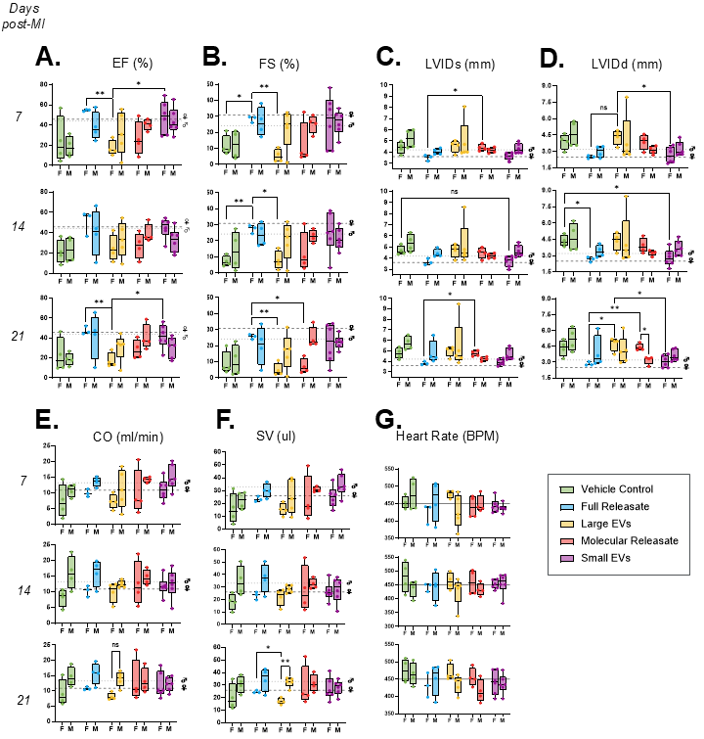
Figure S2. Echocardiogram measurements 7, 14, and 21 days post myocardial infarction, stratified per treatment and per sex
Murine platelet releasate was generated using CRP stimulation on washed platelets. Age-matched mice underwent permanent coronary artery ligation to create ischemia, and treatments (25µl) were then injected into the region of ischemia, compared to vehicle buffer (n=8: 4♀ and 4♂). Protein input per 25µl injection was quantified using BCA: 6.2µg full releasate (n=7: 3♀ and 4♂), or isolated releasate components: 5.5µg molecular releasate (n=8: 4♀ and 4♂), 1.6µg large extracellular vesicles (n=9: 4♀ and 5♂), and 1.4µg small extracellular vesicles (n=12: 6♀ and 6♂). Echocardiogram measurements were performed under anesthesia 1, 2, and 3 weeks after permanent coronary artery ligation: ejection fraction (A), fractional shortening (B), Left Ventricular internal diameter (LVID) at systole (C) and diastole (D), cardiac output (E), stroke volume (F), heart rate (G). Data presented per week between female (F) and male (M) mice with each separate healthy animals’ average presented in dashed lines, per sex. Presented as Min to Max with median. Analysed using multiple unpaired t tests with Welch correction and Holm-Šídák multiple comparisons test. When included, ns represents p<0.06.

Functional Variation Between Sexes
To account for potential sex-dependent effects, both male (♂) and female (♀) animals were used (Fig S3). The included replicates are as follows: Vehicle control n=4♀/4♂; FR n=3♀/4♂; MR n=4♀/4♂; L-EVs n=4♀/5♂; S-EVs n=6♀/6♂.
First, healthy mice (n=5 ♀ and n=5 ♂) were used to measure baseline cardiac parameters, as summarised in horizontal dashed lines. While these did not yield statistically significant difference in any cardiac parameter, some measurements such as LVID showed trends affected by animal size, as healthy males tended to have larger ventricle chambers than females at both diastole (♂4.2mm ± 0.1 vs ♀3.6mm ± 0.2) and systole (♂3.2mm ± 0.3 vs ♀2.5mm ± 0.2). These sex differences remained below statistical significance threshold (p=0.066 and p=0.058 using unpaired t tests.
Despite low replicate numbers, using both female and male animals to study MI was crucial to ensure proper medical representation. Overall, we found that most parameters do not significantly vary between sexes, with mice treated with L-EVs and MR showing the most sex-dependent variation, where females did worse on average especially seen at day 21 post-MI in LVIDd and SV. Similarly, the only differences between treatments were seen in female mice, while on average male mice did not significantly differ from controls. It is important to note that the releasate isolated components were generated from pooled ♀mice. However, there should not be significant differences in platelet secretion content between sexes, nor EV functional differences (based on a human EV meta-study¹). Importantly, all plasma hormone contaminants should have been removed during platelet isolation, and these differential effects are likely dependent on a balance of effectors as sex-specific trends arise when mice are treated with isolated release components while FR treated ♀mice showed consistently healthy cardiac parameters despite low replicate numbers (n=3).
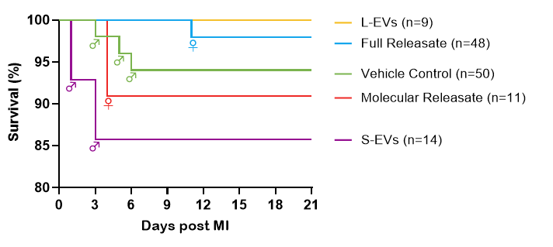
Figure S3. Animal survival in permanent coronary artery ligation mice models.
Kaplan–Meier survival curve of age-matched mice which underwent surgery where the left anterior descending (LAD) branch of the coronary artery is ligated with a suture to create ischemia (day 0); stratified by treatment: platelet releasate components injected into the muscle in the region of ischemia, at the time of ligation. Mice which died during or directly after surgery are not included. Deaths are annotated with the sex of the animal. This encompasses all surgeries performed throughout this study including preliminary data collection and animals which survived to the experimental end point (21 days) but were excluded at the analysis stage for any reason. Exclusion criteria are further explored in the supplementary documents.

Animal survival, Inclusion and exclusion criteria
Animal survival was tracked across 134 mice which have undergone permanent LAD artery ligation including animals used in preliminary data collection, as well as mice which were excluded at the analysis stage for any reason. Out of all animals which recovered from the surgery (day 0), only 5% died before the experimental endpoint (day 21). This allowed for longitudinal study of cardiac function through weekly echocardiograms. Out of the 7 recorded deaths, most were attributed to left ventricle rupture or heart failure, but the cause of death could not always be determined through postmortem investigations. While proportionally more mice died when injected with MR and S-EV, it is likely due to fewer replicates and the nature of the model.
Functional data presented in this study included the following exclusion criteria to reduce inherent morphological and surgical variation: functional and histological data were only included if the animal in question was strain and age-matched, survived to end point, had echocardiograms done at every time point, and presented with intramuscular fibrosis (collagen deposition across the cardiac muscle wall).
Mice which displayed little to no collagen staining in any single region across the apex, middle and base of the heart were considered to have sub-threshold injury, likely due to surgical variation. However, while some replicates displayed enough collagen deposition to be included in functional analysis, they had sub-optimal sectioning which would have significantly affected image analysis results, therefore these particular replicates were excluded from histological analysis.

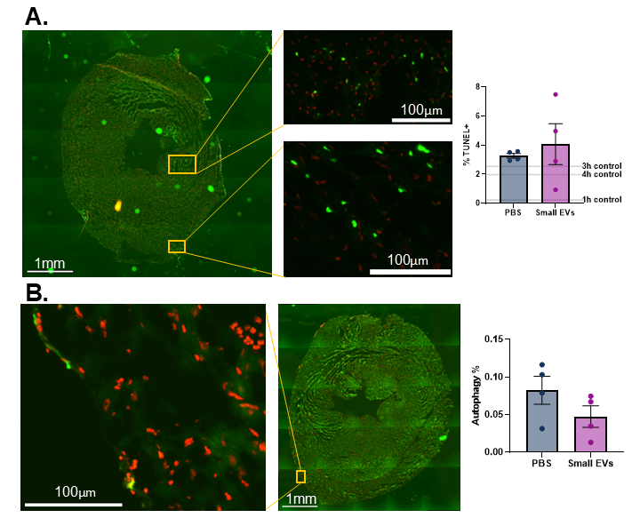
Figure S4. Injecting platelet small extracellular vesicles does not decrease cellular apoptosis or autophagy 3h after myocardial infraction.
Female age-matched mice underwent surgery where the LAD branch of the coronary artery is ligated with a suture to create ischemia, and PBS or platelet small EVs (resuspended in PBS) were then injected into the muscle in the region of ischemia, at the time of ligation. After 3h, hearts were collected and processed for cryostat sectioning and histology to measure cell death using TUNEL assay (A) and autophagy using antibodies against LC3 (B) where stain is green and DAPI is visualised in red. Representative images include over exposed low magnification of the full cardiac sections and example regions of interest. Quantification presented as mean ± SEM (n=4) where the number of green pixels were calculated against all coloured pixels (DAPI+stain).

Platelet small extracellular vesicles do not affect cardiac cell apoptosis or autophagy 3h post myocardial infarction
An acute MI model was performed where animals were sacrificed after 3h post coronary ligation and injection of either PBS or S-EVs. No differences were seen between treatments in apoptosis (Fig S5A) or autophagy (Fig S5B). 3-hour post ischaemia was chosen as the appropriate timepoint to capture the early stage of the injury.

Supplementary Methods:
A TUNEL (Terminal deoxynucleotidyl transferase-mediated dUTP Nick End Labelling) staining kit (Elabscience, #E-CK-A320) was used to assess cardiomyocyte death in histological samples of short term murine MI. OCT frozen heart sections were defrosted at RT (15min) before fixing in 4% PFA and permeabilisation using Proteinase K before following the manufacturers protocol. Briefly, samples were incubated in a labelling solution containing DNA nucleotidylexotransferase (TdT) enzyme and fluorescent dye for 1 h at 37 °C, washed in PBS, and counter-stained with DAPI for 5 min. Coverslips mounted with Fluoroshield and kept in the dark at 4°C for storage. The following controls were included: negative (sample labelled without TdT enzyme) + positive (pre-treated with DNase I before normal labelling). QuPath (v: 0.5.0) was used to analyse the images and calculate the percentage of TUNEL+ nuclei compared to all nuclei on the section. The same object training script for stain classification was used throughout all images, but each image was manually checked and classification modified where required.
For assessment of autophagy, cardiac slides were stained with antibodies against Microtubule-associated protein 1A/1B-light chain 3 (LC3, Proteintech #14600-1-AP) were used. Fluorescent images were processed in FIJI 1.54 to subtract the background with a rolling ball radius of 5 pixels. The background-removed images were then analysed using a custom AFAT² analysis where the number of green pixels are compared to red pixels. The following HSV colour thresholds were used: black pixels (background) [0-255; 0-255; 0-40]; red pixels (tissue or DAPI+) [0-15 + 250-255; 140-255; 25-190]; green pixels (stain+) [60-100; 120-255; 40-240]. Any pixels that did not fall within these HSV parameters were labelled as “other” and ignored during the analysis.

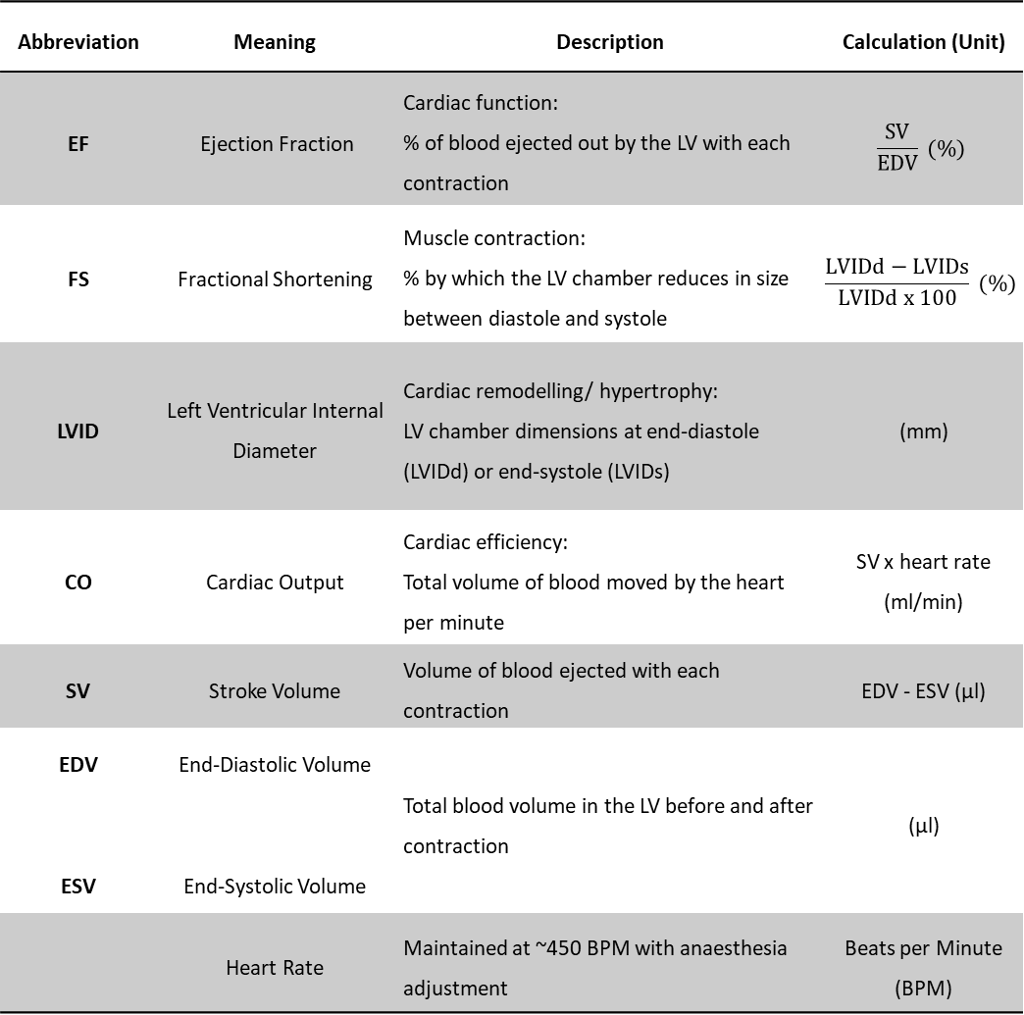
Table S1: Echocardiogram Measurements’ Definitions.

References
1. Noren Hooten, N., Byappanahalli, A. M., Vannoy, M., Omoniyi, V. & Evans, M. K. Influences of age, race, and sex on extracellular vesicle characteristics. Theranostics 12, 4459–4476 (2022).
2. Gratz, D., Winkle, A. J., Dalic, A., Unudurthi, S. D. & Hund, T. J. Computational tools for automated histological image analysis and quantification in cardiac tissue. MethodsX 7, 22–34 (2020).

