Machine-Learning-Guided Defect-Acid Network Engineering in Zn-Modified Y Zeolites for Selective Fischer-Tropsch Wax Hydrocracking
Wenbin Huang¹, Fan Shao¹, Fengzhi Guo, Tianyu Bai, Minghui Zhang, Wenbo Kang, Jinxiao Sun, Zhen Xu, Shixuan Guo, Han Yang, Yasong Zhou, Lu Gong*, Gang Wang *, Qiang Wei*

State Key Laboratory of Heavy Oil Processing, China University of Petroleum-Beijing, Beijing 102249, China

*Corresponding authors. Email: gonglu@cup.edu.cn (Lu Gong); wbhuang611@163.com (Wenbin Huang); qwei@cup.edu.cn (Qiang Wei)

¹Contributed equally to this work.

S1. Experimental Methods
S1.1. Synthesis of Y zeolite and xZnY zeolites.
A seeding gel was prepared by magnetically stirring sodium aluminate (≥99.8%, Aladdin), colloidal silica (≥99%, Aladdin), polydiallydimethyl ammonium chloride (PDDA, 35 wt% in water), NaOH (≥96%, Aladdin), and H₂O for 1 h, followed by aging at 20℃ for 36 h. This seeding gel had a molar composition of 14Na₂O: 1Al₂O₃: 16SiO₂: 0.3PDDA: 260H₂O.
A precursor solution was formulated by mixing sodium silicate (26 wt% SiO₂, 8.2 wt% Na₂O), NaOH, and deionized water. After cooling to 5 ℃, the aged seeding gel was introduced under vigorous stirring for 20 min. Sodium aluminate solution was then added dropwise, followed by vigorous stirring for 20 min. Subsequently, aluminum sulfate (Guangfu Tech.) was incorporated and mixed for 2 h, yielding a synthesis gel with molar composition 6Na₂O: 1Al₂O₃: 12SiO₂: 300H₂O. Hydrothermal crystallization was conducted in Teflon autoclaves using a stepwise temperature program: 24 h at 30 ℃ (pre-crystallization), 24 h at 60 ℃, and 24 h at 95 ℃. The product was filtered, dried, and calcined at 500 ℃ for 4 h to obtain NaY zeolite. Ion exchange was performed by stirring NaY with 0.5 M (NH₄)₂SO₄ solution (99.5 wt%, Aladdin) at 60 ℃ for 2 h per cycle for three times. The solid was then filtered, washed, dried at 100 ℃, and calcined at 500 ℃ to yield H-form Y zeolite (denoted Y).
xZnY zeolites were synthesized via identical procedures using in-situ hydrothermal crystallization. Modification involved adding ZnO (≥99%, Aladdin) to the precursor solution prior to aluminum sulfate addition, where x denotes the theoretical ZnO/Al₂O₃ molar ratio (x = 0.1, 0.2, 0.3, 0.4).
S1.2. Preparation catalysts.
Composite supports were prepared by mechanically blending HY zeolite with amorphous silica-alumina (ASA) at 3:7 weight ratio. The mixture was sieved to 20-40 mesh, followed by impregnation with Pt(NH₃)₄Cl₂ solution to achieve 0.3 wt% Pt loading. After drying at room temperature for 24 h, thermal treatment was conducted at 100 ℃ for 12 h. Final calcination was performed in a muffle furnace at 500 ℃ for 4 h with 2 ℃/min ramp rate, yielding Pt/(HY+ASA) and Pt/(xZnY+ASA) catalysts.
S1.3. Materials characterization.
X-ray diffraction (XRD) patterns were recorded on a DX-2700BH diffractometer (HaoYuan Instrument, China) using Cu Kα radiation (λ = 1.5406 Å) over a 2θ range of 5-50°, with a step size of 0.05° and a scanning rate of 18°/min. The relative crystallinity (RC) of Zn-modified samples was calculated by taking the parent Y zeolite as a reference (RC = 100%) and comparing the integrated peak intensities within 5-40° 2θ. The Y zeolite possesses a FAU-type framework with a cubic symmetry (space group Fd3m). The lattice parameter (a₀) was calculated based on Bragg’s law using the relation , where . Textural properties, including specific surface area, pore volume, and pore-size distribution, were determined using an Autosorb-iQ physisorption analyzer (Quantachrome Instruments). The specific surface area was calculated using the Brunauer-Emmett-Teller (BET) method, while pore size distribution and pore volume were obtained from Barrett-Joyner-Halenda (BJH) analysis. The morphology and particle size of zeolite samples were characterized by scanning electron microscopy (SEM, ZEISS), and the average particle size was obtained from statistical analysis of over 500 crystallites.
Zn coordination states were analyzed by UV-vis diffuse reflectance spectroscopy (UV-vis DRS) using a Shimadzu UV-2600i spectrophotometer equipped with an integrating sphere. Surface chemical composition and electronic states were investigated by X-ray photoelectron spectroscopy (XPS) on a VG ESCALab 250 spectrometer. The X-ray radiation source was Al Kα (1486.6 eV), and the binding energies were calibrated against the C 1s peak at 284.60 eV. Framework structures were examined by Fourier-transform infrared spectroscopy (FT-IR) using a Thermo Scientific Nicolet iS5 spectrometer in the wavenumber of 4000-400 cm⁻¹. Solid-state MAS NMR spectra were recorded on a Bruker Avance-600 spectrometer at 14.1 T with a 4 mm double-resonance probe. The ²⁹Si, ²⁷Al, and ¹H MAS NMR spectra were obtained on a Bruker 400 MHz WB Solid-State NMR spectrometer at a resonance frequency of 59.584, 78.1, and 299.8 MHz, respectively. Prior to analysis, all samples were dehydrated in N₂ at 623 K for 12 h. Hydroxyl infrared spectroscopy (OH-FTIR) was conducted using a Bruker INVENIO-S infrared spectrometer equipped with an MCT detector. Spectra were collected in the range of 400-4000 cm⁻¹ with a resolution of 4 cm⁻¹, averaging 64 scans. After cooling to room temperature, spectra were recorded in transmission mode. The final spectra were obtained after background subtraction (empty cell) and normalized with respect to sample weight. After cooling to room temperature, spectra were recorded in transmission mode. These spectroscopic techniques collectively provide insights into Zn coordination evolution, framework reconstruction, and hydroxyl-related acid site distribution.
Elemental distribution and nanoscale composition were analyzed by high-angle annular dark-field scanning transmission electron microscopy (HAADF-STEM) on a FEI Tecnai G2 F20 microscope equipped with an energy-dispersive X-ray spectrometer (EDS). The bulk SiO₂/Al₂O₃ mole ratios, and the wt% contents of sodium oxide (Na₂O) and zinc oxide (ZnO) were determined by X-ray fluorescence (XRF). The X-ray emission source was a Rh tube operated at a tube voltage of 30 kV, and a dual detector was employed.
Acid properties were characterized by ammonia temperature-programmed desorption (NH₃-TPD) using a DAS-7000 adsorption analyzer. The adsorbed NH₃ was desorbed in the temperature range of 323-873 K at a rate of 5 K/s in He flow (25 mL/min). Brønsted and Lewis acid sites were quantified by pyridine adsorption Fourier-transform infrared spectroscopy (Py-FTIR) using a Bruker Tensor 27 spectrometer. Samples were pretreated under vacuum at 350 ℃ for 4 h prior to pyridine adsorption at room temperature for 30 min. Subsequently, stepwise evacuation at 200 and 350 ℃ for 1 h was performed to differentiate weakly and strongly bound pyridine species. The integrated band intensities were used to quantify Brønsted and Lewis acid site densities. The Brønsted acid site density (C_{B}, mmol/g) was calculated from the integrated peak area IA(B) of the pyridinium-ion band (assigned to BAS), according to:
(1)
The Lewis acid site density (C_{L}, mmol/g) was calculated from the integrated peak area IA(L) of the coordinated pyridine band (assigned to LAS), according to:
(2)
IA(B) and IA(L) correspond to the integrated absorbance of pyridine coordinated to Brønsted and Lewis acid sites, respectively. R is the radius of the self-supported wafer (cm), and M denotes the sample mass (mg). A pellet diameter of 13 mm (R = 0.65 cm) was used in this work. Acid site densities were determined using molar extinction coefficients of 1.88 for Brønsted sites and 1.42 for Lewis sites.
The metal-support interaction (MSI) of Pt/xZnY catalysts was evaluated by H₂ temperature-programmed reduction (H₂-TPR) using a Micromeritics AutoChem II 2920 analyzer. Samples were pretreated at 500 ℃ for 1 h under Ar at 500 °C for 1 h, cooled to 50 ℃, and then exposed to a H₂-Ar mixture (5% H₂, 30 mL/min). Temperature was increased to 800 ℃ at 10 ℃ /min, with H₂ consumption monitored by a thermal conductivity detector (TCD). Pt dispersion was determined by CO pulse chemisorption using a custom-built system equipped with a GC-9790 gas chromatograph (Fuli Co., China). The dispersion was calculated assuming a stoichiometric adsorption ratio of H/Pt = 1, corresponding to one adsorbed hydrogen atom per surface Pt atom. The morphology of the reduced catalysts was examined by high-resolution transmission electron microscopy (HRTEM) on a FEI Tecnai G2 F20 microscope. Samples were ultrasonically dispersed in ethanol and deposited onto carbon-coated copper grids. Pt particle size distributions were obtained by statistical analysis of 200-300 particles from multiple regions of each sample. Average Pt particle sizes (D_{pt}) were calculated using Equation (3):
(3)
where$d_{i}$ was the size of each Pt particle and the $n_{i}$ was the total number of Pt particles.
In situ FT-IR were carried out using an Digilab FTIR spectrometer. In situ FT-IR was employed to investigate the adsorption and activation behavior of linear alkanes over zeolites and catalysts under Ar atmosphere. Considering the limited volatility of long-chain n-docosane under the in situ DRIFTS experimental conditions, n-dodecane was selected as a representative probe molecule to evaluate the initial alkane adsorption and activation behavior. Prior to each measurement, the catalyst sample was pressed into thin wafer (~ 20 mg) and placed in the in situ IR cell. The sample was first reduced under flowing H₂ at 550 ℃ for 4 h to ensure complete activation of the metallic Pt species, followed by purging with Ar to remove residual hydrogen. After cooling to 30 ℃, n-dodecane vapor carried by Ar was introduced into the reaction chamber and allowed to adsorb on the catalyst surface for 30 min to establish adsorption equilibrium. Subsequently, the temperature was increased to 260 ℃ under continuous Ar flow to initiate alkane activation and surface transformation. Time-resolved spectra were continuously collected at 15 s intervals throughout the reaction period for 30 min to monitor the evolution of adsorbed hydrocarbon species and unsaturated intermediates.
Spent catalysts were analyzed by thermogravimetric analysis (TGA) on a TG 209 F1 instrument under an air flow of 20 mL/min from room temperature to 800 ℃ at a heating rate of 10 ℃/min.
S1.4. Catalytic performance test.
Hydrocracking performance was evaluated using n-docosane (n-C₂₂, 96 wt%, Macklin) as model compound and Fischer-Tropsch wax as real feedstock in a fixed-bed reactor (FD-2000). n-C₂₂ hydrocracking was conducted under: 340-420 ℃, 4.0 MPa H₂ pressure, 10 h⁻¹ LHSV, and H₂/feed volume ratio of 400. FT-wax fraction (300-480℃ distillation range, C₁₈-C₃₄) was processed under: 360 ℃, 4.0 MPa H₂, 10 h⁻¹ LHSV, and H₂/feed volume ratio of 400.Catalyst loading was 2 mL with particle size 20-40 mesh. Catalysts were reduced in a tubular furnace at 550 ℃ for 4 h with 2 ℃/min heating rate.
Liquid products were quantified by gas chromatography (GC) equipped with a 50 m × 0.25 mm × 0.1 μm PONA capillary column and flame ionization detector (FID). The oven temperature program was set from 50 ℃ to 280 ℃ at 2 ℃/min ramp rate. Gas flow rates were measured using calibrated flow meters. n-C₂₂ conversion (4), C₉-C₁₇ yield (5), and C₉-C₁₇ selectivity (6) were calculated based on mass balance using the following equations:
$\text{n-}{\text{C}}_{\text{22}}\text{ conversion=}\frac{{\text{N}}_{\text{0}}\text{-N}}{{\text{N}}_{\text{0}}}$ (4)
${\text{C}}_{\text{9}}\text{-}{\text{C}}_{\text{17}}\text{ selectivity=}\frac{{\text{N}}_{\text{i}}}{{\text{N}}_{\text{0}}\text{-N}}$ (5)
${\text{C}}_{\text{9}}\text{-}{\text{C}}_{\text{17}}\text{ yield=n-}{\text{C}}_{\text{22}} conversion\text{×}{\text{C}}_{\text{9}}\text{-}{\text{C}}_{\text{17}}\text{ selectivity}$ (6)
where N₀ represents the initial the mass fraction of n-C₂₂, N is the mass fraction of n-C₂₂ in products, and N_{i} is the mass fraction of C₉-C₁₇ products in all products.
S1.5 DFT Calculation.
The surface charge distribution and metal-support interaction strength of Y zeolite before and after Zn incorporation were investigated using spin-polarized density functional theory (DFT) calculations performed with the VASP package. Adsorption behaviors of long-chain alkanes on Y and Zn-modified Y zeolites were investigated using DFT calculations implemented in the DMol³ module of Materials Studio. Exchange-correlation interactions were described using the generalized gradient approximation (GGA) with the Perdew-Burke-Ernzerhof (PBE) functional, together with Tkatchenko-Scheffler dispersion correction to account for van der Waals interactions. Geometry optimization was performed until the maximum atomic displacement converged below 0.005 Å. The exchange-correlation interactions were treated using the generalized gradient approximation (GGA) with the Perdew-Burke-Ernzerhof (PBE) functional, together with Grimme’s DFT-D3 dispersion correction[1]. A plane-wave cutoff energy of 400 eV was applied for the valence-electron expansion. Electronic self-consistency was achieved with a convergence threshold of 10⁻⁵ eV for total energy[2]. The metal-support interaction between Pt and Y zeolite was quantified using the interaction energy defined as: ΔE_{int}=E_{Y-Pt}-E_{Y}-E_{Pt}. where E_{Y-Pt} is the optimized total energy of the Pt-loaded Y zeolite system, and E_{Pt} and E_{Y} denote the energies of the isolated Pt cluster and the pristine Y zeolite, respectively. A more negative ΔE_{int} indicates stronger metal-support interaction.
Representative Y and ZnY cluster models derived from the FAU framework were constructed to examine hydrocarbon adsorption behavior on different catalytic sites. Linear alkanes (C₆-C₁₂) were selected as probe molecules to establish chain-length-dependent adsorption trends, which can be reasonably extrapolated to longer hydrocarbon feed molecules involved in hydrocracking. Adsorption energies were calculated according to: ΔE_{ads}=E_{sur-mol}-E_{sur}-E_{mol.} where E_{sur-mol} represents the total energy of the adsorbate-zeolite system after adsorption, while E_{sur} and E_{mol} correspond to the energies of the isolated zeolite model and hydrocarbon molecule, respectively. More negative adsorption energies indicate stronger adsorption affinity between hydrocarbon molecules and catalytic active sites.
S1.6 Machine learning analysis.
A data-driven structure-performance analysis was conducted to elucidate the key factors governing hydrocracking selectivity of long-chain alkanes over Y-based zeolite catalysts. A literature-derived database was established by systematically collecting catalytic data reported under different reaction conditions and catalyst compositions. In total, 313 experimental entries comprising 5804 valid numerical data points were extracted from the literature and used for machine-learning analysis. Input descriptors included pore-structure parameters (7 variables, crystallinity, crystal size, V_{total}, V_{meso}, V_{micro,} S_{BET}, S_{ext}), acidity-related properties (9 variables, SAR, total amounts of acid sites, total brønsted acid sites (BAS), medium-strong BAS, total lewis acid sites (LAS), medium-strong LAS, amounts of weak acid sites, amounts of strong acid sites, L/B), metal descriptors (7 variables, metal loading (Pt/Ni/W/Mo), feed carbon number (feed), n_{Pt}/n_{A}, Pt particle size (d_{Pt}), and Pt dispersion (D_{Pt})), and reaction variables (4 variables, temperature, H₂/feed volume ratio, LHSV, H₂ pressure). Catalytic outputs included conversion, cracking selectivity.
Following systematic preprocessing, raw data collected from different literature sources were standardized to ensure dataset consistency and input reliability. Input variables with missing rates above 50% and constant features containing only a single value were removed. To prevent target leakage, all descriptors directly or indirectly derived from conversion were strictly excluded from the conversion-prediction model. For cracking-selectivity prediction, Conversion was introduced as a process-state descriptor of reaction depth to capture variations in cracking behavior at different reaction progression. Beyond the original parameters, derived descriptors were further constructed, including pore-structure ratios, acid-site density and acid-type distribution descriptors, reaction-severity indicators. The specific method can be found in the Supporting Information. High contributions of these derived descriptors in subsequent permutation-importance and SHAP analyses suggest that hydrocracking performance over Y zeolites is not governed by isolated structural or acidic parameters, but by the coupled effects of different parameters.
A total of 17 regression models or model configurations were evaluated, including histogram gradient boosting, extra trees, XGBoost, random forest, gradient boosting, bagging tree, decision tree, linear regression, ridge regression, support vector regression with a radial basis function kernel, k-nearest neighbors, AdaBoost, Gaussian process regression, kernel ridge regression with a radial basis function kernel, linear support vector regression, LASSO regression, and ElasticNet regression. Model training and evaluation were performed using repeated five-fold cross-validation, with predictive performance assessed by coefficient of determination (R²), mean absolute error (MAE), and root-mean-square error (RMSE).
(7)
(8)
(9)
To improve mechanistic interpretability, interpretable machine learning (IML) analysis was further employed to quantify descriptor importance and identify the dominant physicochemical factors governing hydrocracking selectivity. Correlation matrices, feature-importance analysis, and descriptor-performance mapping were combined to elucidate the relationships among pore structure, acidity, metal–acid balance, and catalytic behavior. Particular attention was devoted to identifying the structural descriptors responsible for suppressing secondary cracking and promoting selective formation of middle-distillate hydrocarbons. Model interpretability was further examined using permutation importance, SHAP analysis, partial dependence analysis, and residual analysis to quantify the contributions of key descriptors to model predictions. Therefore, the machine learning analysis primarily served as a mechanistic tool for establishing physically meaningful structure-performance relationships rather than solely developing predictive models. All analyses were performed using Python packages including pandas, scikit-learn, scipy, and matplotlib.
During feature construction, in addition to the original variables describing pore structure, acidity, metal composition, and reaction conditions, a series of catalytically meaningful derived descriptors were introduced to encode relative distributions, normalized properties, and coupling relationships among key variables. Pore-structure descriptors, including V_{meso}/V_{total}, V_{micro}/V_{total}, V_{meso}/V_{micro}, and S_{ext}/S_{BET}, were used to characterize the micro-/mesopore distribution and external surface contribution. Acidity-related descriptors, such as total amounts of acid sites/S_{BET}, total amounts of acid sites/V_{total}, BAS/LAS, BAS/total amounts of acid sites, and LAS/ total amounts of acid sites, were constructed to describe the spatial density of acid sites and the B/L acid distribution. Reaction-severity descriptors, including Temperature/LHSV, H₂/feed volume ratio/LHSV, and H₂ pressure × H₂/feed volume ratio, were used to integrate the effects of temperature, residence time, and hydrogen availability. In addition, n_{Pt}/n_{A} × Temperature and n_{Pt}/n_{A} ×total amounts of acid sites were introduced to describe the coupling between metal-acid balance and reaction conditions. For the cracking-selectivity model, interaction descriptors between conversion and acidity, pore structure, or reaction conditions were further constructed to capture the coupled effects of reaction depth and catalyst properties on cracking pathways.
S2. Y zeolite catalysts screening through machine learning method.

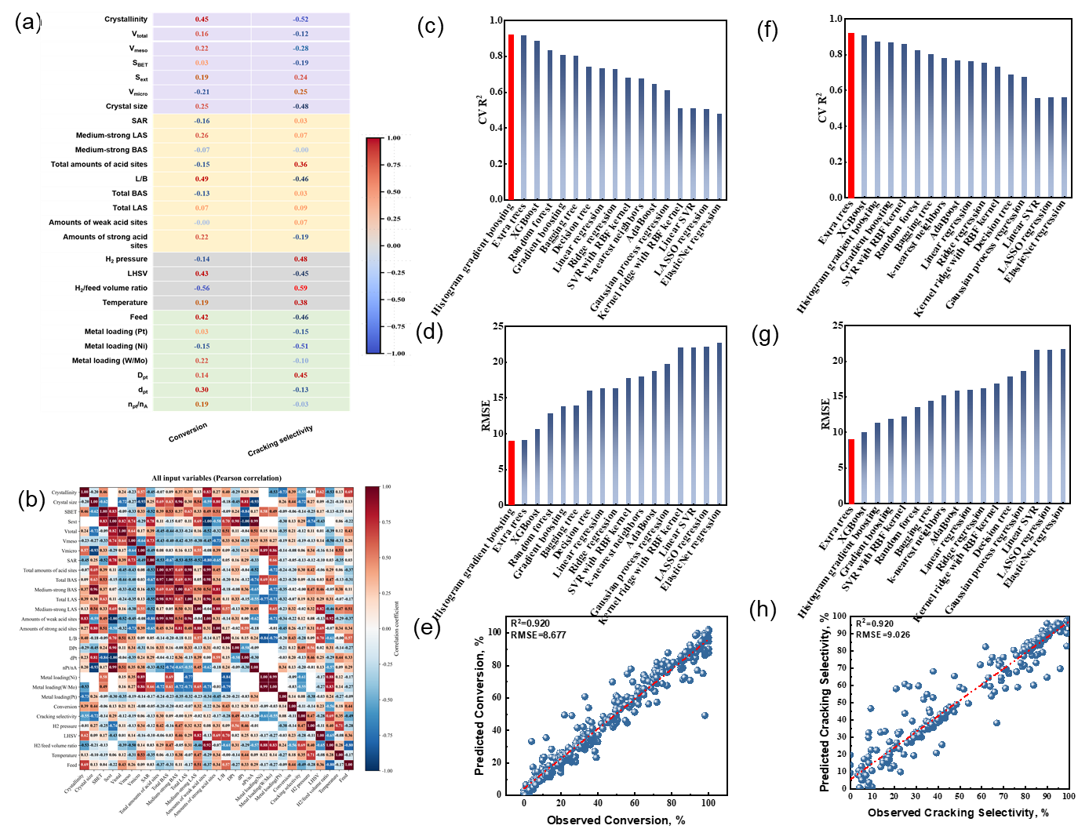
Fig. S1. (a) Spearman correlation heatmap illustrating the dependence of catalytic performance on various descriptors. (purple, yellow, gray, and green denote pore descriptors, acid descriptors, reaction conditions, and metal properties, respectively, (b) Pearson correlation heatmap of all input variables in the Y-zeolite hydrocracking database, CV R² comparison for (c) conversion, (f) cracking selectivity; RMSE comparison for (d) conversion, (g) cracking selectivity; Parity plots of predicted versus observed values for (e) conversion, (h) cracking selectivity.

S3. Catalytic performance evaluation.

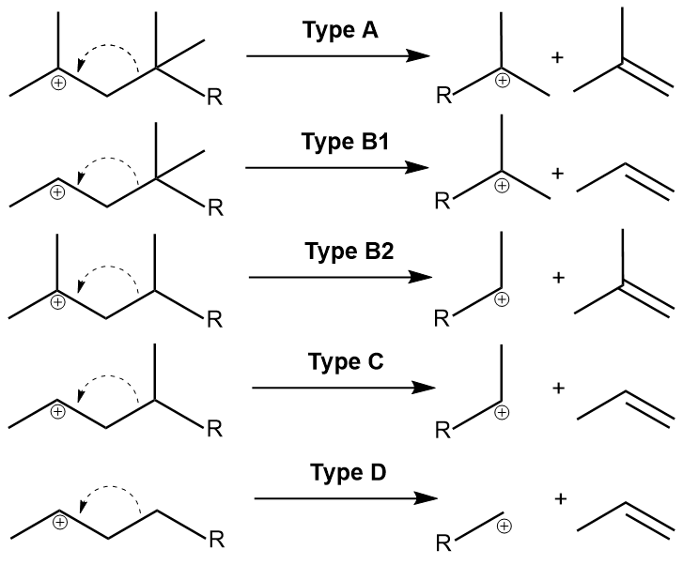
Fig.S2. Classification of β-scission reaction.

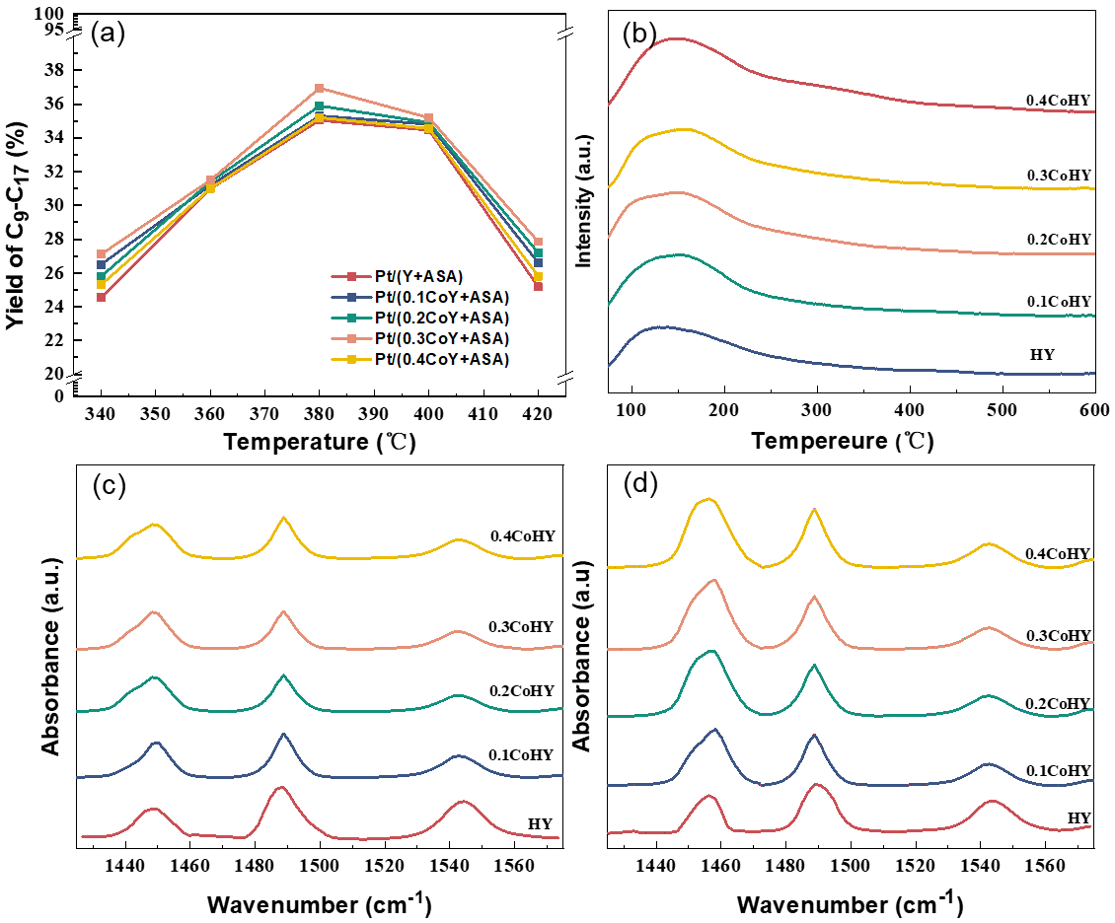
Fig. S3. (a) C₉-C₁₇ yield over various catalysts under varying reaction temperatures, (b) NH₃-TPD spectra of various Y zeolites, (c) Py-IR spectra of various Y zeolites after degassing at 200 ℃, (d) Py-IR spectra of various Y zeolites after degassing at 350 ℃.

Table S1. Acid properties of Y and xCoY zeolites.
Samples | Py-IR amounts of acid sites (μmol/g) |  |  |  |  |  | L/B | NH₃-TPD amounts of acid sites (μmol/g)
Samples | 200 ℃ |  |  | 350 ℃ |  |  | L/B | NH₃-TPD amounts of acid sites (μmol/g)
Samples | B | L | L+B | B | L | L+B | L/B | NH₃-TPD amounts of acid sites (μmol/g)
HY | 115.4 | 412.7 | 528.1 | 110.4 | 225.5 | 335.9 | 3.58 | 589.7
0.1ZnHY | 110.9 | 427.5 | 538.4 | 98.2 | 235.7 | 333.9 | 3.85 | 593.3
0.2ZnHY | 105.5 | 436.4 | 541.9 | 86.9 | 240.5 | 327.4 | 4.14 | 604.7
0.3ZnHY | 109.0 | 452.9 | 561.9 | 79.8 | 245.0 | 324.8 | 4.16 | 608.8
0.4ZnHY | 112.9 | 465.1 | 578.0 | 76.6 | 250.2 | 326.8 | 4.12 | 610.8

Table S2. The catalytic performance of series catalysts reported in the literatures.
Entry | Catalyst | Feedstock | Metal loading (wt%) | Reactor | H₂/Oil ratio | WHSV (h⁻¹) | Reaction  Pressure (Mpa) | Reaction Temperature (℃) | Conversion (%) | Main Results (%) | ref
1 | Pt/0.2ZnY | n-C₂₂H₄₆ | 0.03 | fixed-bed reactor | 400 | 10 | 4 | 380 | 57.8 | Jet fuel selectivity, 60.2 | This work
2 | Pt/0.2CoY |  |  | fixed-bed reactor |  |  |  |  |  |  | This work
3 | Pt/β | FT products (C₁₇₊, 56.7 wt%) | 0.1 | autoclave | - | - | 1.5 | 250 | - | C₉-C₁₅ yield, 31.9 | [3]
4 | Pt/βPt/β | n-C₂₈H₅₈ | 0.1 | autoclave | - | - | 1 | 250 | 84.3 | C₉-C₁₅ selectivity  ,37.8 | [4]
5 | Pt/β | n-C₃₆H₇₄ | 0.1 | autoclave | - | - | 1 | 250 | 99.1 | C₉-C₁₅ selectivity  ,34.3 | [4]
6 | Pt/HY-DA | n-C₁₆H₃₄ | 1 | fixed-bed reactor | 10.5 (molar ratio) | 32 | 2 | 327.5 | 85 | Jet fuel selectivity, 47.6 | [5]
7 | Pt/SAPO-11 | n-C₁₆H₃₄ | 1 | fixed-bed reactor | 800 | 32 | 2 | ~345 | ~95 | Jet fuel yield, 35.9 | [6]
8 | Pt/Y-0.6P | n-C₂₂H₄₆ | 0.3 | fixed-bed reactor | 400 | 10 | 4 | 380 | 74.0 | Jet fuel selectivity, 47.4 | [7]
9 | Pd/MCM-41 | n-C₁₆H₃₄ | 1 | fixed-bed reactor | 20 (molar ratio) | 10 | 6 | 340 | 50 | Jet fuel selectivity, 26.0 | [8]
10 | Pt/HY (100) | n-C₁₅-C₁₈ (biohydrogenated diesel, BHD) | 0.5 | fixed-bed reactor | 30 (molar ratio) | 1 | 3.1 | 310 | 90 | Jet fuel selectivity, 34.4 | [9]

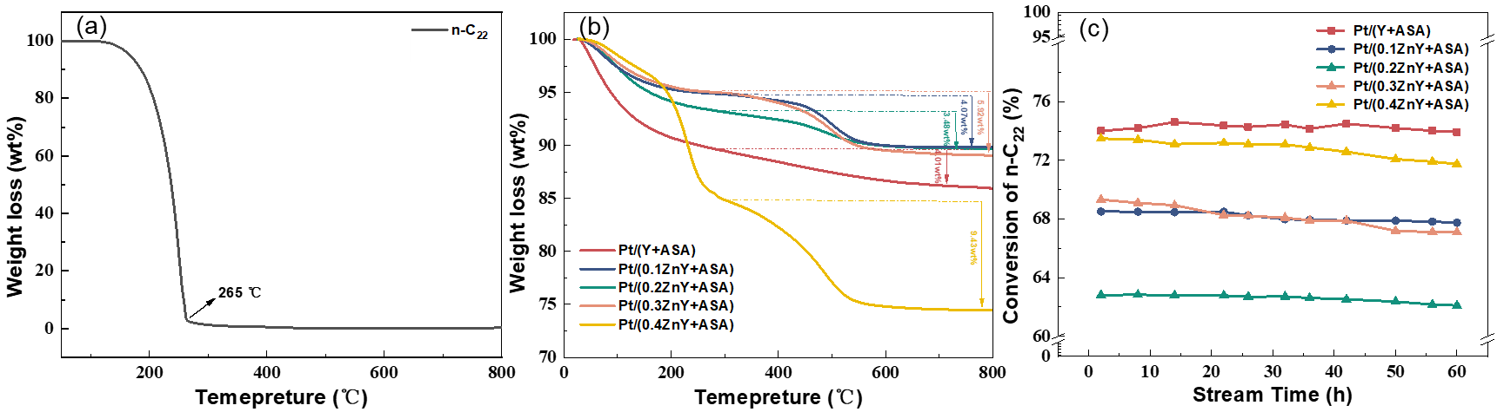
Fig.S4. (a) TGA of n-C_{22,} (b)TGA of the spent catalysts, (c) catalytic stability of fresh catalysts.

Catalyst stability was evaluated through 60 h time-on-stream (TOS) measurements (Fig S4(c)), confirming that the Zn-modified catalyst maintained stable activity over extended time-on-stream. CO pulse chemisorption revealed only minor Pt agglomeration during reaction, with Pt dispersion decreasing slightly after hydrocracking (Table S3). As shown in Fig. S4(a), n-C₂₂ underwent nearly complete mass loss (~100%) at 265 ℃, demonstrating that weight changes observed at higher temperatures could not be attributed to a wax-induced pore-filling effect. There are two stages of weight loss for the spent catalysts. The stage between 50 and 300 ℃ is due to the removal of a small amount of loose fibrous carbon and a wax-induced pore-filling effect, while the one from 300 ℃ to terminal temperature represented the burn-off of soft coke and hard coke. TGA quantified carbonaceous coke deposition (Fig. S4(b)) between 300 ℃ and terminal temperature as follows: Pt/(0.4ZnY+ASA) (9.43 wt%) > Pt/(0.3ZnY+ASA) (5.92 wt%) > Pt/(0.1ZnY+ASA) (4.07 wt%) ≈ Pt/(Y+ASA) (4.01 wt%) > Pt/(0.2ZnY+ASA) (3.48 wt%). In comparison, Pt/(0.2ZnY+ASA) achieved the lowest coke content (3.48 wt%),’ ensuring superior hydrocracking stability. Catalysts with low Zn loadings exhibited enhanced coke resistance owing to reduced BAS density and suppressed secondary cracking. By contrast, excessive Zn incorporation increased carbon deposition due to BAS recovery and intensified deep cracking reactions. Notably, Pt/(0.4ZnY+ASA) exhibited the highest coke deposition, which was attributed not only to increased acidity but also to the formation of polynuclear ZnO_{x} species [10]. Unlike isolated Zn species, these aggregated ZnO_{x} domains favored deep dehydrogenation of long-chain hydrocarbons, accelerating the formation of unsaturated coke precursors.
SEM characterization of fresh/spent catalysts (Fig. S5) provided morphological evidence for coke formation and structural retention. All spent catalysts retained Y-zeolite framework features. Pt/(0.4ZnY+ASA) catalyst exhibited severe sintering and agglomeration (Fig. S5(e-f)), consistent with TGA data and indicative of reaction-induced degradation. Consistent with coke deposition trends, all catalysts except Pt/(0.4ZnY+ASA) catalyst maintained stable n-C₂₂ conversion without significant decline, indicating robust operational stability. Pt/(0.2ZnY+ASA) retained nearly identical composite morphology before and after reaction, confirming excellent stability (Fig. S5(c-d)).

Fig.S5. (a-b) fresh and spent of Pt/(Y+ASA) catalysts, (c-d) fresh and spent of Pt/(0.2ZnY+ASA) catalysts, (e-f) fresh and spent of Pt/(0.4ZnY+ASA) catalyst.

Table S3. Pt dispersion of spent catalysts.
Samples | Pt dispersion (D_{Pt})ª (%)
Pt/(Y+ASA) | 41.06
Pt/(0.1ZnY+ASA) | 39.17
Pt/(0.2ZnY+ASA) | 45.89
Pt/(0.3ZnY+ASA) | 42.03
Pt/(0.4ZnY+ASA) | 36.93
ª Tested by the CO-pulse.

S4. Chemical and structural properties.

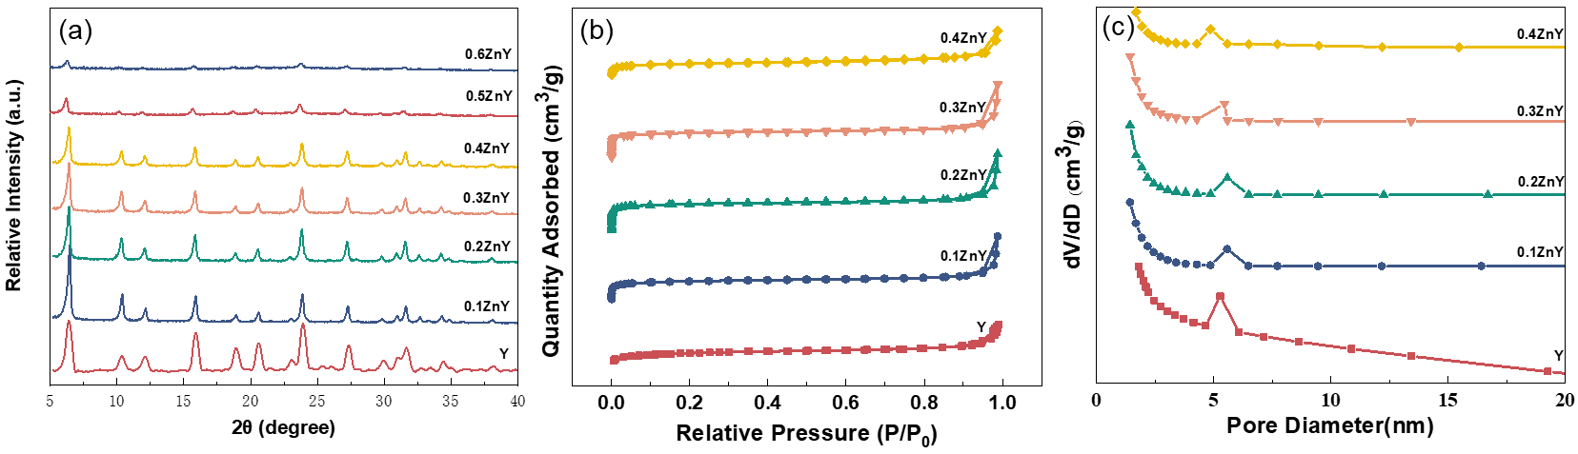
Fig. S6. (a) XRD patterns of Y and xZnY zeolites. (b) N₂ adsorption-desorption of Y and xZnY zeolites, (c) Pore size distribution of Y and xZnY zeolites.

Crystal structures of Zn-doped Y zeolites are characterized by XRD (Fig. S6). All xZnY zeolites exhibited characteristic FAU-topology reflections (ICDD PDF#77-1549), confirming successful framework formation. Absence of ZnO diffraction features (PDF#34-1451; 2θ = 31.6°, 34.2°, 36.1°) indicated that Zn species were highly dispersed and did not form detectable crystalline ZnO domains. Relative crystallinity, calculated from integrated peak area between 5-40° 2θ relative to the reference sample, is summarized in Table S4. Excessive Zn incorporation perturbed local coordination environment and hindered the formation of well-ordered frameworks, thereby lowering crystallinity [11]. As shown in Fig. S6(a), when ZnO/Al₂O₃ exceeded 0.4, characteristic diffraction peaks of Y zeolite were significantly weakened or partially lost, indicating severe framework degradation. Therefore, ZnO/Al₂O₃ ratios were limited to 0.1-0.4 to systematically investigate structural evolution and catalytic performance. Enhanced exposure of the [111] and [220] crystal planes indicated that Zn incorporation altered the crystal growth orientation and surface structure of FAU zeolite. This behavior, although seemingly inconsistent with the decrease in crystallinity, can be rationalized by the evolution of local chemical environments revealed by ¹H MAS NMR, as discussed in the corresponding section. Magnified 5-10° 2θ regions revealed peak shifts toward lower angles for xZnY samples, attributed to unit-cell expansion caused by longer Zn-O bonds (1.9 Å) relative to Al-O (1.7 Å) and Si-O (1.6 Å) [12]. Incorporation of Zn species led to expansion of the unit cell, with lattice parameters increasing progressively with Zn content. SEM images (Fig. S7) further showed uniform Zn distribution, and an increase in crystallite size from 131 nm (parent Y) to 201 nm (xZnY). The appearance of amorphous phases in Fig. S7(h) corroborated the crystallinity loss at high ZnO/Al₂O₃ ratios observed by XRD, yet no severe particle fragmentation or morphological collapse is detected. Zn might be in the framework but also in the channels as various species, both contribute to the lattice parameter.
N₂ adsorption-desorption isotherms (Fig. S6(b)) and pore-size distributions (Fig. S6(c)) showed a gradual decrease in specific surface area with increasing Zn incorporation. All samples exhibited combined Type I/IV adsorption behavior, indicative of hierarchical micro-mesoporous structures, with micropore filling at P/P₀ < 0.1 and H3-type hysteresis loops in the range of 0.5 < P/P₀ < 0.9. At low Zn loadings (ZnO/Al₂O₃ ≤ 0.2), total pore volume, micropore volume, mesopore volume, and average pore size increased simultaneously, which could be attributed to framework expansion induced by Zn incorporation. In contrast, further increasing the ZnO/Al₂O₃ ratio leaded to a decrease in these parameters, likely due to partial pore blockage by [Zn-O-Zn]²⁺ species or ZnO_{x} clusters formed at higher Zn loadings. Elemental mapping by SEM-EDX (Fig. S7(d-f)) and STEM-EDS (Fig. 5) confirmed the uniform spatial distribution of Si, Al, and Zn within the zeolite framework. No large ZnO aggregates (20-100 nm) or ZnO_{x} clusters (>100 nm) were identified. However, presence of small ZnO_{x} species (~2 nm) located on crystal surfaces cannot be completely excluded.

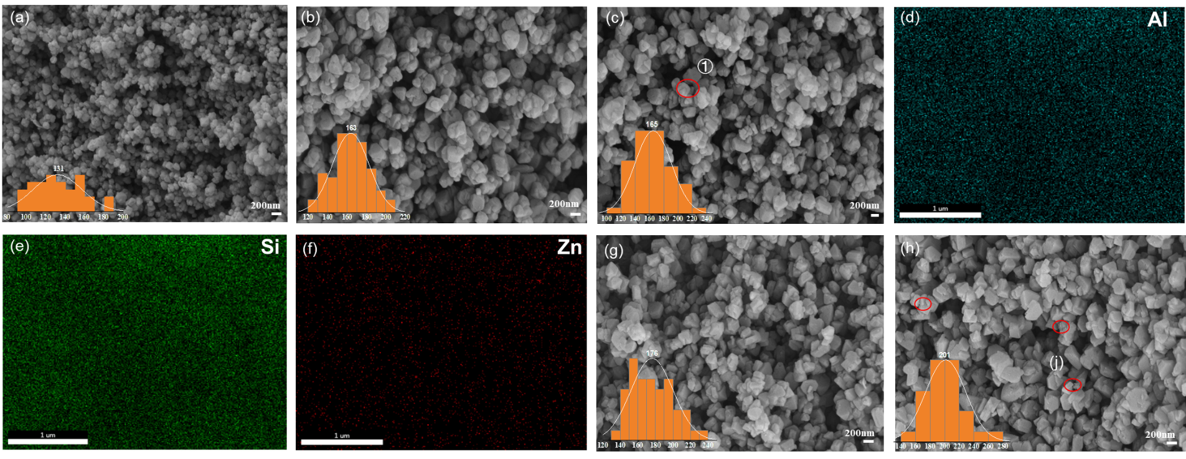
Fig. S7. SEM images of (a) Y zeolite, (b) 0.1ZnY zeolite, (c) 0.2ZnY zeolite, (d-f) EDS mapping of 0.2ZnY zeolite, (g) 0.3ZnY zeolite, (h) 0.4ZnY zeolite.

Table S4. Chemical and structure properties of Y and xZnY zeolites.
Samples | Crystallinityª  (%) | Crystal size^{b} (nm) | Lattice constant (Åª) | S_{BET} (m²/g) | V_{Total} (cm³/g) | V_{Micro} (cm³/g) | V_{Meso} (cm³/g) | Average Pore diameter (nm) | n(SiO₂)/n(Al₂O₃)^{c} | n(ZnO)/n(Al₂O₃)^{c} | SiO₂^{b} (wt%) | Al₂O₃ ^{b} (wt%) | Na₂O ^{b} (wt%) | ZnO ^{b} (wt%)
Y | 100 | 131 | 24.51 | 815 | 0.75 | 0.15 | 0.60 | 4.88 | 5.35 | - | 74.9 | 23.8 | 1.1 | -
0.1ZnY | 91 | 163 | 24.62 | 805 | 0.79 | 0.17 | 0.61 | 5.06 | 5.47 | 0.10 | 74.0 | 23.0 | 1.1 | 1.8
0.2ZnY | 80 | 165 | 24.70 | 784 | 0.84 | 0.21 | 0.63 | 5.05 | 5.67 | 0.19 | 73.5 | 22.1 | 1.0 | 3.4
0.3ZnY | 74 | 176 | 24.72 | 737 | 0.72 | 0.20 | 0.52 | 5.01 | 5.69 | 0.30 | 72.2 | 21.6 | 1.1 | 5.2
0.4ZnY | 69 | 201 | 24.86 | 725 | 0.62 | 0.18 | 0.44 | 4.66 | 5.82 | 0.40 | 71.4 | 20.9 | 1.1 | 6.6
ª Measured by XRD. ^{b} Given by SEM images. ^{c} Calculated by XRF.

S5. Zn-Driven Speciation Evolution and Framework Defect Reconstruction.

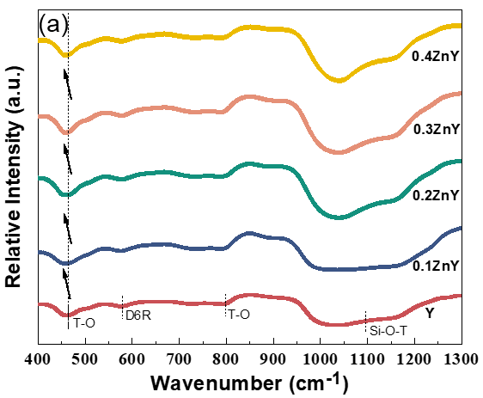
Fig. S8. (a) FT-IR patterns of Y and xZnY zeolites.

FT-IR spectra (Fig. S8) is first employed to examine the structural response of the FAU framework upon Zn incorporation. All samples exhibited typical vibration bands in the range of 450-1300 cm⁻¹, characteristic of FAU-type zeolites. Peaks at 460 and 780 cm⁻¹ corresponded to T-O bending vibrations and symmetric stretching modes (T = Al, Si, Zn), while the band at 570 cm⁻¹ corresponded to double six-membered rings (D6R). A broad band centered at 1070 cm⁻¹ originated from T-O-T symmetric stretching vibration [13]. With increasing Zn loading, systematic redshifts of T-O-T vibration bands were observed at 1070 cm⁻¹, with analogous shifts at 460 and 780 cm⁻¹. Such redshifts indicated a weakening of the average T-O bond strength, which could be attributed to the introduction of Zn-O species possessing lower bond force constants and larger reduced mass compared to Si-O and Al-O bonds. Notably, these spectral variations did not necessarily imply direct substitution of framework Al by Zn in a strict crystallographic sense, but rather reflected perturbation of the local bonding environment, including the formation of Zn-O-Si linkages and distortion of the Si-O-Al framework. Progressive increase in redshift magnitude with Zn loading suggested continuous modification of the framework environment and accumulation of Zn-induced structural perturbations. Meanwhile, preservation of the D6R band indicated that the fundamental framework topology remained largely intact, consistent with XRD observations.

Fig. S9. The nature of Zn in Y and xZnY zeolites.

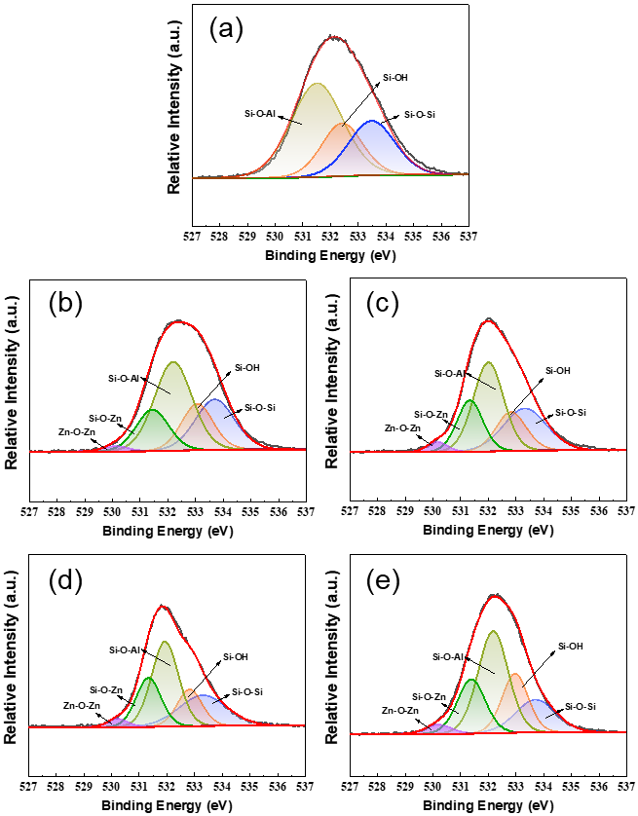
Fig. S10. O 1s XPS spectra of (a) Y zeolite. (b) 0.1ZnY zeolites. (c) 0.2ZnY zeolites. (d) 0.3ZnY zeolites. (e) 0.4ZnY zeolites.

Table S5. The deconvoluted peak areas of the O 1s XPS spectra for Y and xZnY zeolites.
Samples | Si-O-Si /(%) | Si-OH /(%) | Si-O-Al /(%) | Si-O-Zn /(%) | Zn-O-Zn /(%)
Y | 22.7 | 26.5 | 50.8 | - | -
0.1ZnY | 23.7 | 17.7 | 40.5 | 16.5 | 1.6
0.2ZnY | 25.1 | 16.2 | 37.3 | 18.5 | 2.9
0.3ZnY | 24.0 | 17.0 | 38.0 | 19.2 | 3.8
0.4ZnY | 16.9 | 19.9 | 40.2 | 19.9 | 3.1

Quantitative analysis of the deconvoluted O 1s spectra (Fig. S10, Table S5) further identifies a critical Zn-loading threshold at ZnO/Al₂O₃=0.2. O 1s XPS spectra of ZnY zeolites recorded over 0-1350 eV binding energy (BE) are presented in Fig. 3(f). Deconvoluted peaks centered at 533.2 eV ,532.8 eV and 532.1 eV are assigned to Si-O-Si, Si-OH and Al-O-Si groups, respectively [14]. Peaks at 531.6 eV and 531.0 eV are attributed to Zn-O-Si and Zn-O-Zn groups, respectively. At Zn loadings ≤ 0.2, O 1s binding energies decreased, whereas at higher loadings they increased. This dichotomy indicated a critical Zn-speciation-dependent transition [15]. At lower Zn loadings, [ZnOH]⁺ species and framework-associated Zn species predominated, while at higher Zn loadings, [Zn-O-Zn]²⁺ coordination and ZnO_{x} cluster formation became dominant, leading to increased binding energies [10]. The gradual increase of Zn-O-Zn species (Table S5) further confirmed the evolution of extra-framework Zn species and their influence on O 1s binding energy. Notably, at ZnO/Al₂O₃ = 0.4, the relative contribution of Zn-O-Zn species slightly decreased, suggesting further transformation into nanoscale ZnOx clusters [12,16], as supported by UV-vis and BET analyses. XPS analysis further confirmed that Zn incorporation via framework substitution, promoting gradual formation of Si-O-Zn species. Collectively, these results provided a semi-quantitative description of Zn speciation evolution, establishing a clear correlation between Zn coordination environments and framework defect reconstruction.

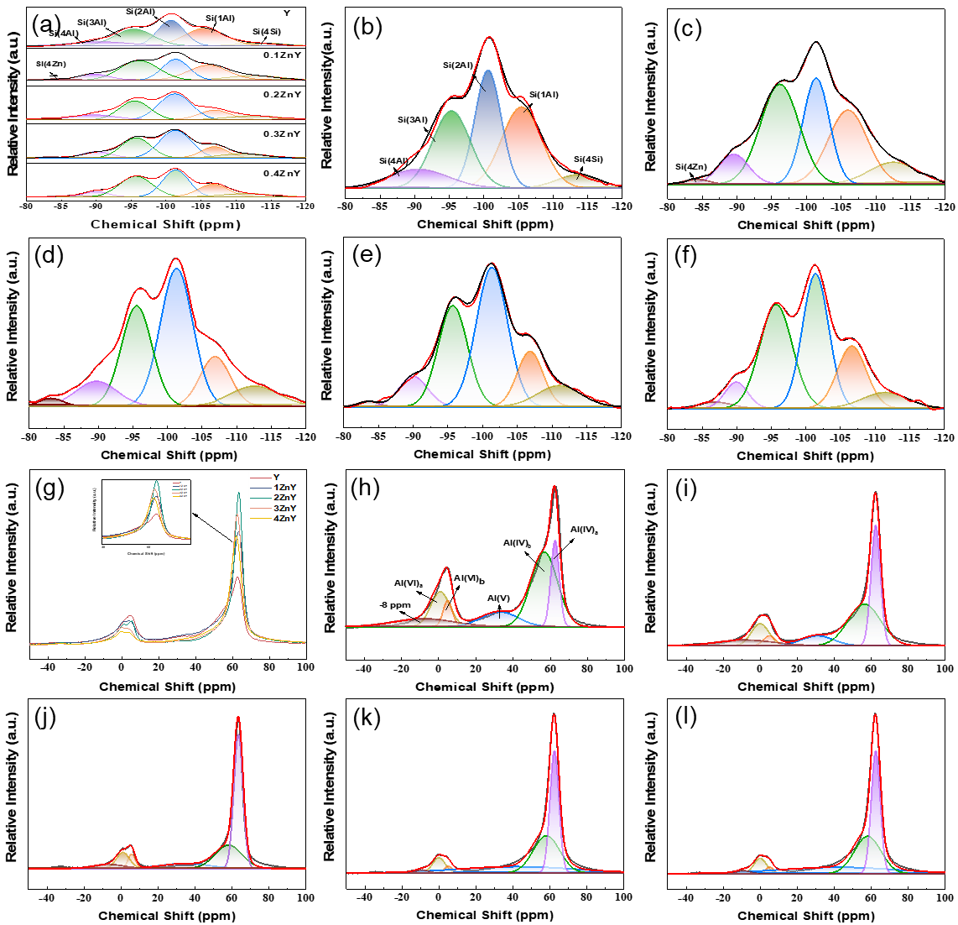
Fig. S11. ²⁹Si MAS NMR spectra of (a) Y and xZnY zeolites. (b) Y zeolite. (c) 0.1ZnY zeolites. (d) 0.2ZnY zeolites. (e) 0.3ZnY zeolites. (f) 0.4ZnY zeolites, ²⁷Al MAS NMR spectra of (g) Y and xZnY zeolites. (h) Y zeolite. (i) 0.1ZnY zeolites. (j) 0.2ZnY zeolites. (k) 0.3ZnY zeolites. (l) 0.4ZnY zeolites.

To further elucidate Zn-induced framework reconstruction, ²⁹Si NMR spectroscopy and ²⁷Al NMR spectroscopy were employed to probe the local coordination environments of Si and Al within the Y zeolite framework (Fig. S11). Quantitative deconvolution of the ²⁹Si NMR spectra revealed a progressive evolution of framework environments with increasing Zn loading (Table S6). The parent Y zeolite exhibited five well-resolved resonances at 113, 106, 101, 96, and 89 ppm, corresponding to Si(4Si), Si(1Al), Si(2Al), Si(3Al), and Si(4Al) species, respectively [17]. Upon Zn modification, all signals shifted upfield, confirming framework-level incorporation. Concurrent peak broadening for Si(xMe) signals (1≤x≤4, Me=Al/Zn) indicated Zn incorporation does not simply substitute Al sites but induces more complex local coordination environments. The evolution of Si species was consistent with the trends observed in O 1s XPS analysis. At low Zn contents (ZnO/Al₂O₃≤0.2), increasing proportions of Si(4Si) and Si(4Zn) environments indicated preferential formation of silicate-Zn oligomers. During nucleation, Zn incorporation promoted healing of defect-rich Q3Si/Q2Si (Si(1Me/ Si(2Me)) environments, accelerated Si-O-Si bond formation, yielding metastable silica-rich domains. Remarkably, at higher Zn loadings (>0.2), the Si(4Si) fraction decreased anomalously from 11.0% to 6.9%, signaling a transition in defect-engineering behavior. Instead of further defect accumulation, Zn incorporation beyond this threshold promoted selective dissolution of silica from Si-rich regions accompanied by Al reinsertion into framework vacancies, as reflected by the increase in Si(xMe) environments. Overall, the opposite trends observed for Si(4Si) and Si(xMe) species demonstrated that Zn incorporation dynamically modulated framework composition through coupled dealumination and desilication processes, ultimately governing the evolution of local environments and acid sites.
²⁷Al MAS NMR spectroscopy is employed to probe the coordination environments of Al species in the zeolite framework (Fig. S11 and Tables S(6-7)). Transient framework-associated Al-OH species (~-8 ppm) [18] and octahedrally coordinated extra-framework Al (EFAl, ~0 and ~5 ppm) [19,20] progressively decreased with Zn incorporation, indicating Zn-induced defect healing and framework reconstruction. At low Zn loading (ZnO/Al₂O₃≤0.2), the decrease in pentacoordinated or distorted tetrahedral EFAl species (~34 ppm) and unstable tetrahedral framework Al ( FAl, ~55 ppm) suggested effective healing of defect-associated Al sites. Concurrently, these species were transformed into stable tetrahedral framework Al (~60 ppm), reflecting reconstruction of the zeolite framework. Consistent with ²⁹Si MAS NMR results, Si(4Al) units associated with Al-rich environments continuously decreased, indicating that Zn preferentially perturbed Al-rich framework domains. Meanwhile, Si(nAl) environments (n=1-3) increased, suggesting redistribution of tetrahedral Al from highly aggregated to more dispersed coordination environments. This process was accompanied by a decrease in Al-OH species. At higher Zn loadings (> 0.2), an opposite trend was observed. The fraction of stable tetrahedral framework Al decreased, accompanied by the reappearance of distorted tetrahedral and pentacoordinated Al species. This behavior indicated partial transformation of framework Al into defect-associated coordination environments, accompanied by regeneration of Al-OH species. Consistent with ²⁹Si MAS NMR results, Intermediate and highly aggregated Si environments (e.g., Si(3Al) and Si(4Al)) transformed into lower-coordination environments (Si(1Al) and Si(2Al)), accompanied by an increase in pentacoordinated Al and regeneration of Al-OH species. XRF and ²⁷Al MAS NMR analyses (Table S2) showed that although the total Al content gradually decreased with Zn incorporation, the amount of tetrahedrally coordinated Al increased initially and reached a maximum at ZnO/Al₂O₃ = 0.2. This indicated that Zn incorporation did not result in simple continuous dealumination but instead induced framework reconstruction associated with defect evolution, thereby directly modulating acid site distribution.
Collectively, Zn incorporation induced a dynamic reconstruction of the defect-acid network in Y zeolites, governed by the evolution of Zn speciation. At low Zn loadings (ZnO/Al₂O₃≤ 0.2), framework substitution and Zn²⁺ exchange with Brønsted acid sites led to consumption of pre-existing hydroxyl groups and effective defect healing, accompanied by condensation of silanol species and redistribution of framework Al into more stable tetrahedral environments. Beyond this threshold, further Zn incorporation triggered a transition to a defect-driven reconstruction regime, in which the evolution of Zn species into [ZnOH]⁺ and [Zn-O-Zn]²⁺ promoted rehydroxylation and regeneration of both Si-OH and Al-OH groups, along with partial desilication and reorganization of local coordination environments. This coupled process of defect healing and re-generation established a dynamically tunable defect-acid network, in which the spatial distribution, density, and nature of Brønsted and Lewis acid sites were continuously modulated. In parallel, distinct Zn species provided additional Lewis acidic and dehydrogenation functionalities, enabling synergistic regulation of metal-acid interactions. As a result, Zn-induced framework reconstruction bridged structural evolution with catalytic functionality, ultimately governing hydrocracking pathways by balancing primary cracking and secondary reactions.

Table S6. The deconvoluted peak areas of the ²⁹Si MAS NMR spectra for Y and xZnY zeolites.
Samples | Si(4Si)/(%) | Si(1Me) /(%) | Si(2Me) /(%) | Si(3Me) /(%) | Si(4Me) /(%)
 |  |  |  |  | Si(4Al)/(%) | Si(4Zn)/(%)
Y | 5.3 | 29.5 | 28.2 | 26.7 | 10.3
0.1ZnY | 8.3 | 25.3 | 24.4 | 33.7 | 7.5 | 0.8
0.2ZnY | 11.0 | 16.7 | 29.0 | 34.8 | 7.4 | 1.1
0.3ZnY | 8.5 | 16.9 | 32.1 | 34.0 | 7.0 | 1.5
0.4ZnY | 6.9 | 17.6 | 34.5 | 33.2 | 5.8 | 2.0

Table S7. The deconvoluted peak areas of the ²⁷Al MAS NMR spectra for Y and xZnY zeolites.
Samples | ~-8 ppm | ~0 ppm | ~5 ppm | ~34 ppm | ~55 ppm | ~60 ppm | Al (VI) | Al (V) | Al (IV)
Y | 10.4 | 14.1 | 5.1 | 11.9 | 42.9 | 15.6 | 19.3 | 11.9 | 58.4
0.1ZnY | 8.9 | 10.1 | 3.7 | 9.0 | 37.5 | 30.8 | 13.8 | 9.0 | 68.3
0.2ZnY | 4.7 | 8.7 | 3.6 | 8.9 | 25.2 | 48.9 | 12.4 | 8.9 | 74.0
0.3ZnY | 3.5 | 6.9 | 3.0 | 13.8 | 31.9 | 40.9 | 10.0 | 13.6 | 72.9
0.4ZnY | 1.2 | 6.1 | 1.6 | 24.0 | 31.9 | 35.2 | 7.7 | 24.1 | 67.0

Table S8. Quantitative distribution of Al species in Y and xZnY zeolites derived from XRF and ²⁷Al MAS NMR.
Samples | n(Al_{total}) | n(Al_{IV}) | n(Al_{V}) | n(Al_{VI})
Y | 0.47 | 0.27 | 0.06 | 0.14
0.1ZnY | 0.45 | 0.31 | 0.04 | 0.10
0.2ZnY | 0.43 | 0.32 | 0.04 | 0.07
0.3ZnY | 0.42 | 0.31 | 0.06 | 0.06
0.4ZnY | 0.41 | 0.27 | 0.09 | 0.03

S6. Influence of acid properties on catalytic activity.

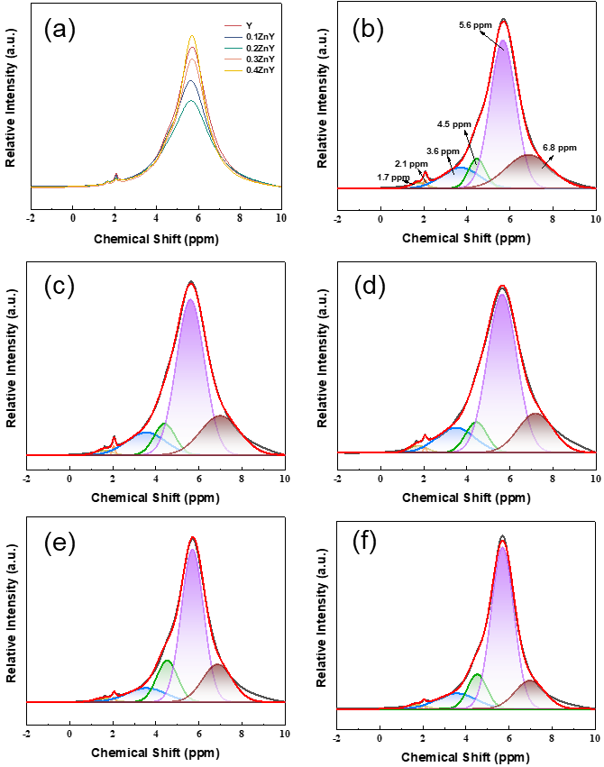
Fig. S12. ¹H MAS NMR spectra of (a) Y and xZnY zeolites. (b) Y zeolite. (c) 0.1ZnY zeolites. (d) 0.2ZnY zeolites. (e) 0.3ZnY zeolites. (f) 0.4ZnY zeolites.

Signals assigned to internal/external Si-OH (1.7 and 2.1 ppm), EFAl-associated hydroxyls (3.8 ppm), and BAS (Si-OH-Al) located in supercages (more accessible) and sodalite cages (less accessible) (4.5-5.6 ppm) (Fig. S12, Table S9) evolved nonmonotonically with Zn loading [21,22].

Table S9. The deconvoluted peak areas of the ¹H MAS NMR spectra for Y and xZnY zeolites.
Samples | 1.7 ppm | 2.1 ppm | 3.8 ppm | 4.4 ppm | 5.6 ppm | 6.8 ppm
Y | 1.4 | 0.5 | 11.7 | 7.6 | 58.5 | 20.3
0.1ZnY | 1.1 | 0.4 | 11.8 | 8.8 | 57.0 | 20.9
0.2ZnY | 1.0 | 0.3 | 11.8 | 9.1 | 56.7 | 21.1
0.3ZnY | 1.1 | 0.3 | 11.7 | 8.0 | 59.3 | 19.6
0.4ZnY | 1.2 | 0.4 | 10.4 | 7.2 | 62.4 | 18.4

Table S10. Acid properties of Y and xZnY zeolites.
Samples | Py-IR amounts of acid sites (μmol/g) |  |  |  |  |  | L/B | NH₃-TPD amounts of acid sites (μmol/g)
Samples | 200 ℃ |  |  | 350 ℃ |  |  | L/B | NH₃-TPD amounts of acid sites (μmol/g)
Samples | B | L | L+B | B | L | L+B | L/B | NH₃-TPD amounts of acid sites (μmol/g)
HY | 115.4 | 412.7 | 528.1 | 110.4 | 225.5 | 335.9 | 3.58 | 589.7
0.1ZnHY | 101.4 | 420.0 | 521.4 | 94.6 | 230.7 | 325.3 | 4.14 | 567.6
0.2ZnHY | 90.8 | 420.6 | 511.4 | 70.4 | 231.0 | 301.4 | 4.63 | 534.4
0.3ZnHY | 95.6 | 429.2 | 524.8 | 67.1 | 235.5 | 302.6 | 4.49 | 580.1
0.4ZnHY | 114.5 | 441.0 | 555.5 | 65.4 | 240.5 | 305.9 | 3.85 | 615.8

To elucidate the influence of Zn doping on the acid properties of Y zeolites, The densities of BAS and LAS are quantified using NH₃-TPD and Py-IR spectroscopy (Table S10) Deconvoluted NH₃-TPD profiles exhibited two distinct features, corresponding to weak acid sites (150 ℃) and medium-strength sites (350 ℃) [23]. A V-shaped evolution of total acid density and acid strength was observed with increasing Zn content, reaching a minimum at the 0.2ZnY zeolite. Py-IR spectra displays characteristic bands at 1540 cm⁻¹ and 1450 cm⁻¹, corresponding to pyridine adsorbed on BAS and LAS, respectively [24]. The total BAS density displayed a V-shaped trend with an initial decrease followed by a recovery, consistent with NH₃-TPD results. At low Zn loadings (ZnO/Al₂O₃≤0.2), the decrease in BAS was mainly attributed to ion exchange between Zn²⁺ species and bridging hydroxyls (Si-OH-Al), as well as selective dealumination accompanied by partial desilication. At higher Zn loadings (>0.2), the evolution of Zn species into [ZnOH]⁺, [Zn-O-Zn]²⁺, and ZnO_{x} promoted defect reorganization and rehydroxylation, leading to regeneration of Si-OH-Al groups and recovery of BAS. From a structural perspective, the increase in weak BAS was closely associated with the rise in Si(2Al) and Si(3Al) environments, which corresponded to more dispersed Al distributions and weaker acid strength. Meanwhile, Zn incorporation led to a continuous increase in LAS density, which was closely related to the evolution of extra-framework Zn species. Isolated Zn²⁺, [ZnOH]⁺, and [Zn-O-Zn]²⁺ all functioned as LAS centers [25]. LAS derived from Zn species promoted carbocation formation and rearrangement, thereby enhancing hydrogen-transfer reactions. This behavior indicated that acid site evolution originated from defect-reconstruction-driven structural changes induced by Zn incorporation.

S7. Influence of alkane activation and hydrogenation-dehydrogenation functionality on catalytic behavior.

Table S11. Pt dispersion and particle size on Y and xZnY zeolites.
Samples | ΔE_{ads}-C₆ (eV) | ΔE_{ads}-C₈ (eV) | ΔE_{ads}-C₁₀ (eV) | ΔE_{ads}-C₁₂ (eV)
Y | -0.11 | -0.22 | -0.52 | -0.69
0.2ZnY | -0.06 | -0.59 | -1.78 | -1.65

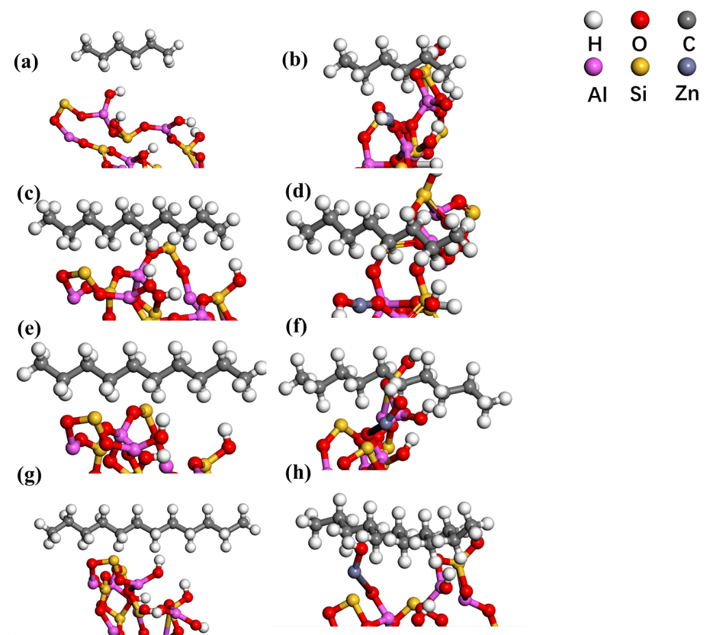
Fig. S13. DFT-optimized adsorption configurations of linear alkanes on Y and ZnY zeolites. (a) C₆ on Y, (b) C₆ on ZnY, (c) C₈ on Y, (d) C₈ on ZnY, (e) C₁₀ on Y, (f) C₁₀ on ZnY, (g) C₁₂ on Y, and (h) C₁₂ on ZnY.

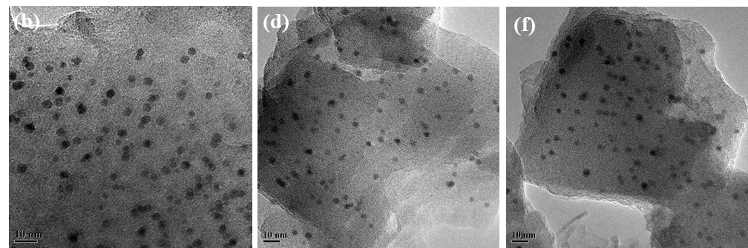
Fig. S14. (a) TEM of Pt/(0.1Y+ASA), (b) TEM of Pt/(0.3ZnY+ASA), (c) TEM of Pt/(0.4ZnY +ASA).

Table S12. Pt dispersion and particle size on Y and xZnY zeolites.
Samples | D_{Pt}ª (%) | Pt content^{b} (wt%) |  | Pt content^{c} (wt%) | d_{Pt}^{c} (nm) | d_{Pt}ª (nm) | n_{Pt}/n_{A}
Pt/(Y+ASA) | 41.5 | 0.30 | 0.29 |  | 2.86 | 4.67 | 0.18
Pt/(0.1ZnY+ASA) | 39.9 | 0.31 | 0.31 |  | 2.89 | 4.69 | 0.17
Pt/(0.2ZnY+ASA) | 46.1 | 0.30 | 0.31 |  | 2.61 | 3.87 | 0.19
Pt/(0.3ZnY+ASA) | 42.2 | 0.29 | 0.30 |  | 2.82 | 4.26 | 0.21
Pt/(0.4ZnY+ASA) | 38.3 | 0.30 | 0.31 |  | 3.08 | 5.06 | 0.24
ª Tested by the CO-pulse. ^{b} Determined by ICP. ^{c} calculated by TEM.

Fig.S15. H₂-TPR profiles of Pt/(Y+ASA) and Pt/(xZnY+ASA) catalysts.

H₂-TPR profiles (Fig. S15) are used to evaluate the reducibility of Pt oxide species in the catalysts. Reducibility reflects the activation energy required for reducing Pt²⁺/Pt⁴⁺ to metallic Pt⁰. The electron-donating effect of Zn weakened newly formed Pt-O-Zn bonds relative to Pt-O-Al linkages, lowering metal-support interaction (MSI) strength and shifting the Pt reduction peaks from 470-510 ℃ to lower temperatures. Isolated Zn²⁺ and mononuclear Zn species exhibited reduction features near 450 ℃, distinct from polynuclear ZnO_{x} clusters reducing at 570 ℃ [26]. Thus, isolated Zn²⁺ and mononuclear species at low loadings facilitated low-temperature reduction. At ZnO/A₂O₃>0.2 (high loading), increased Si-O-Al coordination and the formation of polynuclear ZnO_{x} clusters shifted reduction peaks to higher temperatures. Hydrogen consumption measurements (Table S13) further supported these observations, with Pt/(0.2ZnY+ASA) catalyst displaying the lowest H₂ uptake and the most favorable low-temperature reducibility, maximizing dehydrogenation-hydrogenation functionality. An anomalous low-temperature reduction peak at 281 ℃ in Pt/(Y+ASA) catalyst disappeared upon Zn incorporation. This phenomenon likely originated from isolated Zn²⁺ occupying Pt ion-exchange sites in 0.1ZnY zeolite catalyst, forcing Pt agglomeration (inducing Pt agglomeration and reduced dispersion), while simultaneous Zn-mediated electron donation weakened Pt-O bonds and enhanced reducibility. These counteracting effects eliminated the low-temperature peak and altered the main reduction feature in the TPR profiles [27]. DFT calculations revealed that Zn incorporation reduced surface electron density and weakened the metal-support interaction (MSI). Differential charge density analysis (Fig. S8) showed diminished charge accumulation and enhanced depletion after Zn substitution, indicating weaker electron donation from the framework. This originated from the lower electron-withdrawing capability of Zn compared to Al, resulting in reduced local charge density at substituted sites. Consequently, the Pt-support interaction was weakened, as evidenced by a decrease in binding energy from -18.62 eV (Y) to -19.47 eV (ZnY). Meanwhile, the Pt-O bond length shortened from 2.09 Å (Al-O-Pt) to 2.02 Å (Zn-O-Pt) (Fig. S16), reflecting the altered coordination environment at Zn-modified sites. The weakened MSI reduced the anchoring strength of Pt on strong Al-associated sites, thereby promoting higher dispersion and smaller Pt nanoparticles, consistent with TEM and CO chemisorption results.

Table S13. Hydrogen consumption measurements on various catalysts.
Sample | H₂ quantity (mmol/g)
Pt/(Y+ASA) | 0.56
Pt/(0.1ZnY+ASA) | 0.43
Pt/(0.2ZnY+ASA) | 0.41
Pt/(0.3ZnY+ASA) | 0.49
Pt/(0.4ZnY+ASA) | 0.61

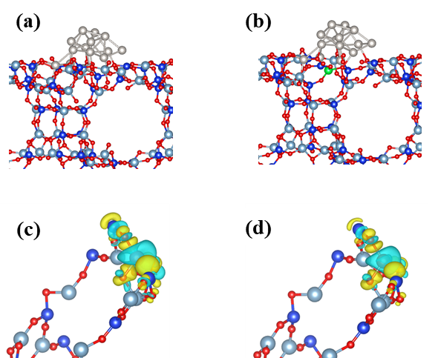
Fig. S16. Interaction energy (a) Pt/Y catalyst, (b) Pt/0.2ZnY catalyst, differential charge density distributions of (c) Y zeolite, (d) 0.2ZnY zeolite. (The yellow regions denote charge accumulation, whereas the cyan regions correspond to charge depletion.)

[1] J.P. Perdew, K. Burke, M. Ernzerhof, Generalized Gradient Approximation Made Simple, Phys. Rev. Lett. 77 (1996) 3865–3868. https://doi.org/10.1103/PhysRevLett.77.3865.
[2] P.E. Blöchl, Projector augmented-wave method, Phys. Rev. B 50 (1994) 17953–17979. https://doi.org/10.1103/PhysRevB.50.17953.
[3] T. Hanaoka, T. Miyazawa, K. Shimura, S. Hirata, Jet fuel synthesis from Fischer–Tropsch product under mild hydrocracking conditions using Pt-loaded catalysts, Chemical Engineering Journal 263 (2015) 178–185. https://doi.org/10.1016/j.cej.2014.11.042.
[4] T. Hanaoka, T. Miyazawa, K. Shimura, S. Hirata, Jet fuel synthesis in hydrocracking of Fischer–Tropsch product over Pt-loaded zeolite catalysts prepared using microemulsions, Fuel Processing Technology 129 (2015) 139–146. https://doi.org/10.1016/j.fuproc.2014.09.011.
[5] Y. Li, C. Mu, G. Chu, Y. Wang, J. Xu, X. Guo, Y. Zhao, S. Wang, X. Ma, Maximizing jet fuel production from n-hexadecane hydrocracking over Pt-supported Y catalysts: Importance of ideal hydrocracking characteristics, Fuel 346 (2023) 128286. https://doi.org/10.1016/j.fuel.2023.128286.
[6] C. Mu, J. Sun, C. Xie, J. Bao, X. Guo, H. Zhang, Y. Zhao, S. Wang, X. Ma, Shape Selectivity of AEL Channels for Anomalously Facilitating Biojet Fuel Production from Long-Chain n -Alkane Hydrocracking, ACS Catal. 14 (2024) 1394–1404. https://doi.org/10.1021/acscatal.3c04465.
[7] F. Shao, F. Guo, T. Bai, Z. Xu, H. Yang, W. Kang, Y. Zhou, W. Huang, G. Wang, Q. Wei, Synthesis of hierarchical nano-Y zeolite supported Pt catalyst for efficient hydrocracking of Fischer–Tropsch wax to jet fuel, Fuel 407 (2026) 137428. https://doi.org/10.1016/j.fuel.2025.137428.
[8] D.E. Romero, M. Rigutto, E.J.M. Hensen, Influence of the size, order and topology of mesopores in bifunctional Pd-containing acidic SBA-15 and M41S catalysts for n-hexadecane hydrocracking, Fuel Processing Technology 232 (2022) 107259. https://doi.org/10.1016/j.fuproc.2022.107259.
[9] T. Hengsawad, C. Srimingkwanchai, S. Butnark, D.E. Resasco, S. Jongpatiwut, Effect of Metal–Acid Balance on Hydroprocessed Renewable Jet Fuel Synthesis from Hydrocracking and Hydroisomerization of Biohydrogenated Diesel over Pt-Supported Catalysts, Ind. Eng. Chem. Res. 57 (2018) 1429–1440. https://doi.org/10.1021/acs.iecr.7b04711.
[10] A. Mehdad, R.F. Lobo, Ethane and ethylene aromatization on zinc-containing zeolites, Catal. Sci. Technol. 7 (2017) 3562–3572. https://doi.org/10.1039/c7cy00890b.
[11] X. Li, Q. Fan, Y. Wu, X. Lin, S. Ma, S. Li, Y. Ye, D. Wang, J. Cheng, Z. Zheng, J. Jiang, Enhancing hydrodeoxygenation-isomerization of FAME over M-SAPO-11 in one-step process: Effect of in-situ isomorphic substitution of transition metals and synergy of PtxSny alloy, Chemical Engineering Journal 452 (2023) 139528. https://doi.org/10.1016/j.cej.2022.139528.
[12] A.J. Mallette, S. Hong, E.E. Freeman, S.A. Saslow, S. Mergelsberg, R.K. Motkuri, J.J. Neeway, G. Mpourmpakis, J.D. Rimer, Heteroatom Manipulation of Zeolite Crystallization: Stabilizing Zn-FAU against Interzeolite Transformation, JACS Au 2 (2022) 2295–2306. https://doi.org/10.1021/jacsau.2c00325.
[13] X. Kong, J. Mei, Z. Liu, Y. Zou, E. Wang, W. Wang, C. Wang, C. Xu, X. Wang, Regulating metal–acid active sites in hierarchical porous Ni/Y for selective hydrocracking of naphthalene, Carbon Resources Conversion (2025) 100326.
[14] D. Gu, H. Wang, Z. Li, Z. Wang, H. Yu, Y. Liu, Q. Wu, S. Yu, X. Jiang, S. Liu, Green synthesis of anthraquinone by one-pot method with Ni-modified Hβ Zeolite, Molecular Catalysis 538 (2023) 112969.
[15] C. Tu, H. Fan, D. Wang, N. Rui, Y. Du, S.D. Senanayake, Z. Xie, X. Nie, J.G. Chen, CO2-assisted ethane aromatization over zinc and phosphorous modified ZSM-5 catalysts, Applied Catalysis B: Environmental 304 (2022) 120956. https://doi.org/10.1016/j.apcatb.2021.120956.
[16] M.R. Anseau, J.P. Leung, N. Sahai, T.W. Swaddle, Interactions of Silicate Ions with Zinc(II) and Aluminum(III) in Alkaline Aqueous Solution, Inorg. Chem. 44 (2005) 8023–8032. https://doi.org/10.1021/ic050594c.
[17] Y. Lyu, Y. Liu, X. He, L. Xu, X. Liu, Z. Yan, The regulation of Si distribution and surface acidity of SAPO-11 molecular sieve, Applied Surface Science 453 (2018) 350–357.
[18] P. Liu, Z. Li, X. Liu, W. Song, B. Peng, X. Zhang, S. Nie, P. Zeng, Z. Zhang, X. Gao, B. Shen, Steaming Drived Chemical Interactions of ZnCl _{x} with Y Zeolite Framework, Its Regulation to Dealumination/Silicon-Healing as well as Enhanced Availability of Brønsted Acidity, ACS Catal. 10 (2020) 9197–9214. https://doi.org/10.1021/acscatal.0c01181.
[19] W. Huang, M. Huang, W. Ma, H. Yang, R. Li, J. Wang, P. Dong, H. Qiu, Q. Wei, Y. Zhou, Rational design of titanium-doped Y zeolite for hydrodenitrogenation of aromatic N-heterocyclic compounds, Chemical Engineering Journal 498 (2024) 155221. https://doi.org/10.1016/j.cej.2024.155221.
[20] S.R. Batool, V.L. Sushkevich, J.A. Van Bokhoven, Correlating Lewis acid activity to extra-framework aluminum species in zeolite Y introduced by Ion-exchange, Journal of Catalysis 408 (2022) 24–35. https://doi.org/10.1016/j.jcat.2022.02.010.
[21] M. Hunger, Multinuclear solid-state NMR studies of acidic and non-acidic hydroxyl protons in zeolites, Solid State Nuclear Magnetic Resonance 6 (1996) 1–29.
[22] M. Hunger, M.W. Anderson, A. Ojo, H. Pfeifer, Study of the geometry and location of the bridging OH groups in aluminosilicate and silicoaluminophosphate type zeolites using 1H MAS NMR sideband analysis and CP/MAS NMR, Microporous Materials 1 (1993) 17–32.
[23] D. Kubička, N. Kumar, P. Mäki-Arvela, M. Tiitta, V. Niemi, T. Salmi, D.Y. Murzin, Ring opening of decalin over zeolitesI. Activity and selectivity of proton-form zeolites, Journal of Catalysis 222 (2004) 65–79. https://doi.org/10.1016/j.jcat.2003.10.027.
[24] X. Dai, T. Liu, L. Mao, Z. Lv, SAPO-11 molecular sieve synthesized via a novel alcohol–water solvent vapor-induced self-assembly conversion method and the hydroisomerization performance of its NiWS-supported catalyst, J. Mater. Chem. A 13 (2025) 30599–30617. https://doi.org/10.1039/D5TA02223A.
[25] A.A. Gabrienko, S.S. Arzumanov, A.V. Toktarev, I.G. Danilova, I.P. Prosvirin, V.V. Kriventsov, V.I. Zaikovskii, D. Freude, A.G. Stepanov, Different Efficiency of Zn²⁺ and ZnO Species for Methane Activation on Zn-Modified Zeolite, ACS Catal. 7 (2017) 1818–1830. https://doi.org/10.1021/acscatal.6b03036.
[26] S.M.T. Almutairi, B. Mezari, P.C.M.M. Magusin, E.A. Pidko, E.J.M. Hensen, Structure and Reactivity of Zn-Modified ZSM-5 Zeolites: The Importance of Clustered Cationic Zn Complexes, ACS Catal. 2 (2012) 71–83. https://doi.org/10.1021/cs200441e.
[27] L. Qi, M. Babucci, Y. Zhang, A. Lund, L. Liu, J. Li, Y. Chen, A.S. Hoffman, S.R. Bare, Y. Han, B.C. Gates, A.T. Bell, Propane Dehydrogenation Catalyzed by Isolated Pt Atoms in ≡SiOZn–OH Nests in Dealuminated Zeolite Beta, J. Am. Chem. Soc. 143 (2021) 21364–21378. https://doi.org/10.1021/jacs.1c10261.

