Supplement:

Supplementary Figure 1: Graphical abstract of the patient journey before and after diagnosis of multiple sclerosis.
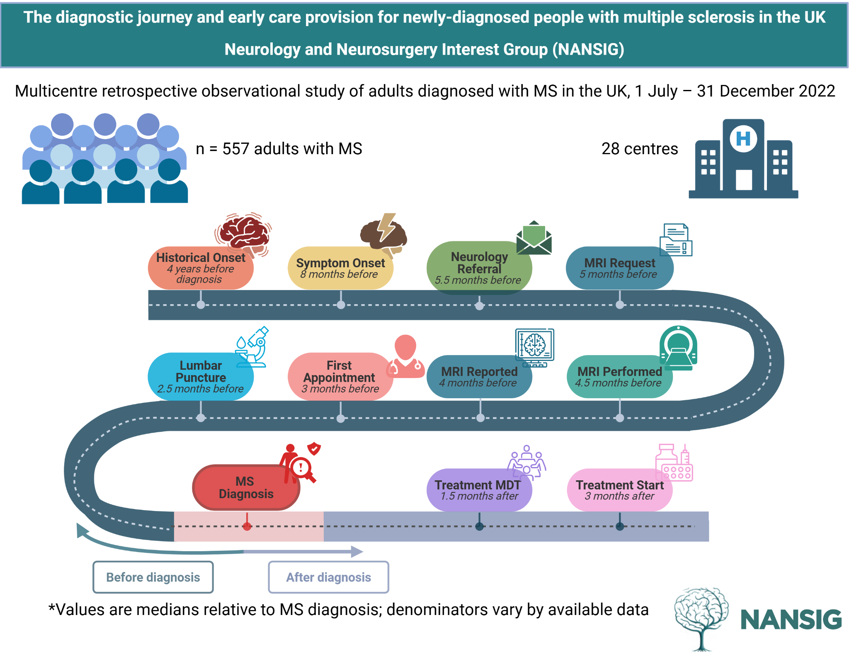

Supplementary Figure 1 Legend:
This figure illustrates the pathway to multiple sclerosis (MS) diagnosis and treatment, based on median timing of key clinical events relative to diagnosis. For simplicity, events are listed to the nearest month (or half month) before or after diagnosis, except for historical onset which is listed in years before diagnosis. The number of individuals included at each time point varies due to data availability; therefore, timings represent stage-specific medians rather than a continuous patient-level trajectory. The timing and sequence of events may vary considerably between individuals and spacing between events is not proportional to time intervals. Due to limited follow-up after diagnosis, with only 67.1% of individuals having initiated treatment, post-diagnosis timepoints are likely to be underestimated and may not fully represent the complete treatment pathway; these findings should therefore be interpreted with caution.

Abbreviations listed: MRI: magnetic resonance imaging of brain or spinal cord; MDT: multi-disciplinary team meeting.

Sample sizes per variable: Historical onset (313), Symptom onset (462), Referral (510), First MRI request (374), First MRI (516), First MRI report (486), First Appointment (535), Lumbar Puncture(298), Diagnosis (557), Treatment MDT (196), Treatment start (323).
Created in BioRender. Henshall, D. (2026) https://BioRender.com/9o3bs0x .

Supplementary Figure 2: Map of participating centres.

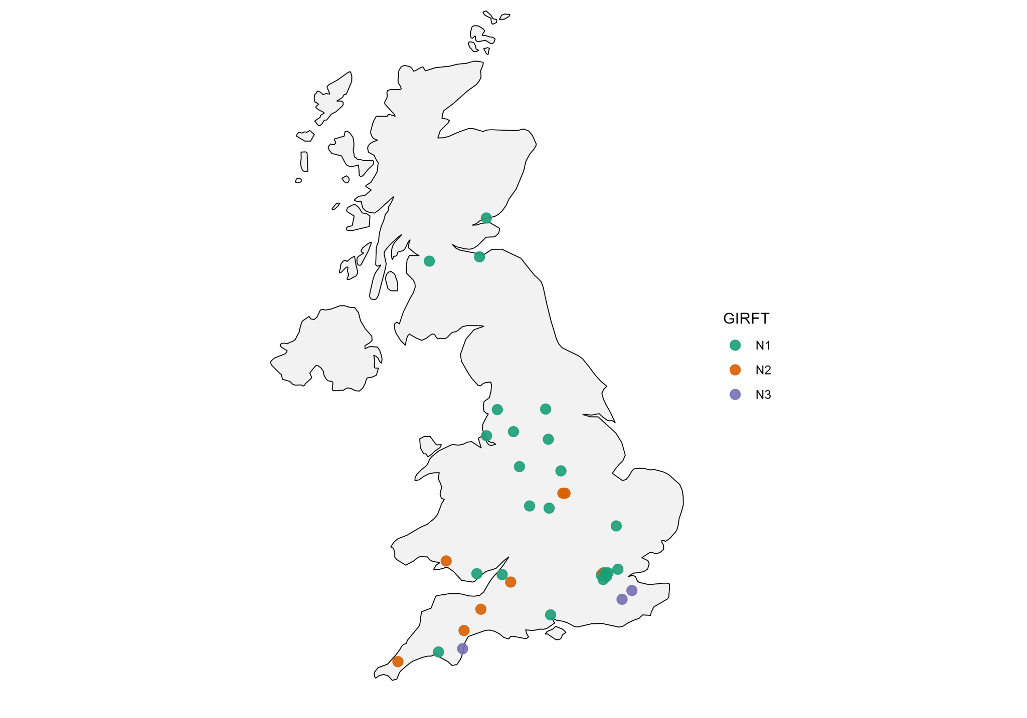

Supplementary Figure 2 Legend:
Getting It Right First Time (GIRFT) hospital categorisation was obtained from the most recent, publicly-accessible GIRFT ‘neurology methodology supporting workbook’ for English centres [A], and approximated for Scottish and Welsh centres centres based on available descriptions. Centre categorisation reflects service provision as follows: N1: inpatient neurology and neurosurgery; N2: inpatient neurology; and N3: on-site neurologists without dedicated neurology inpatient beds. Participating centres are listed by name in our authorship document.
A: Available from: https://gettingitrightfirsttime.co.uk/medical_specialties/neurology/ [Last accessed: 16/4/2026]

Supplementary Figure 3: Time from neurology referral to diagnosis.
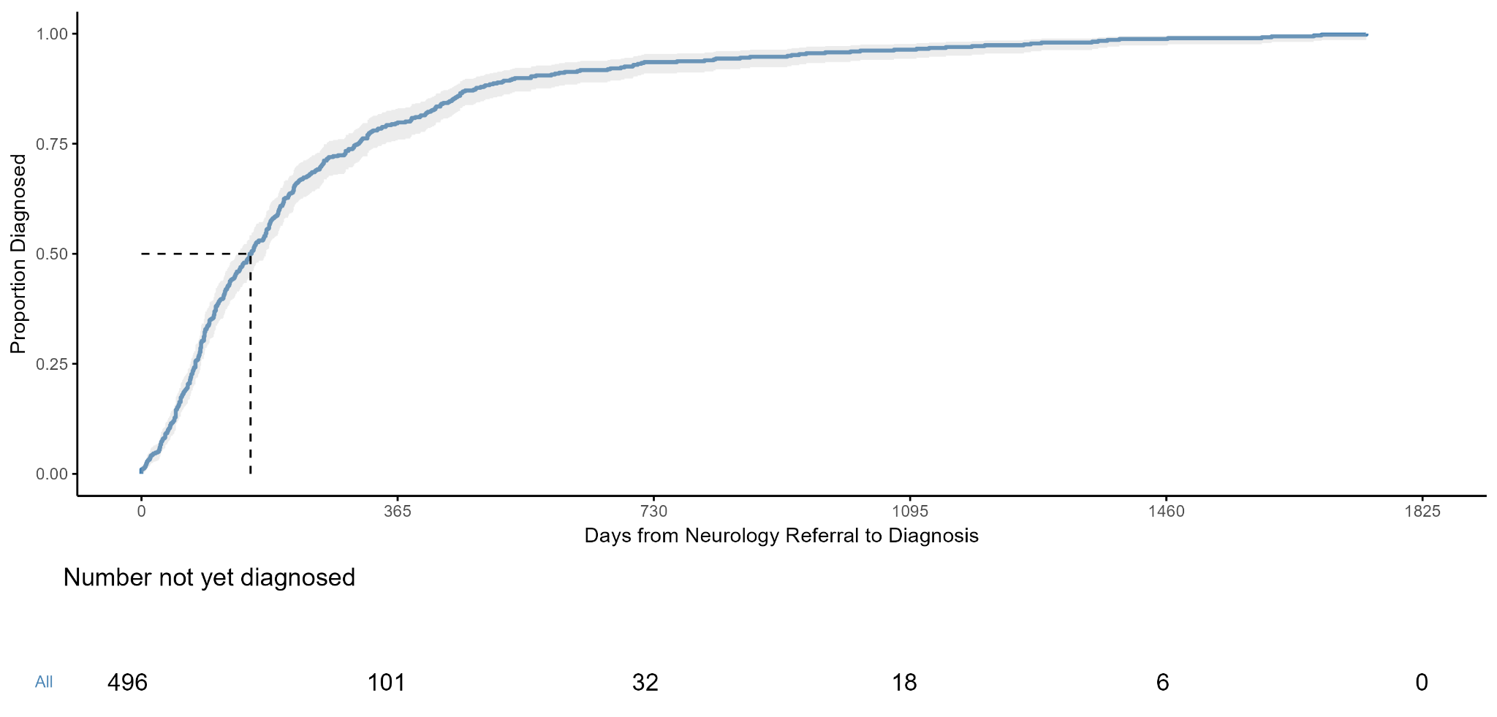

Supplementary Figure 3 Legend:
This is the enlarged version of the inset figure within Figure 3 of the manuscript. This figure details the time-to-diagnosis curve for all individuals, excluding the 7 individuals omitted due to time-to-diagnosis being beyond 5 years (unlikely to reflect the intended data capture for this variable). The grey area indicates continuous 95% confidence intervals of the time-to-event curve.

Supplementary Figure 4: Time from symptom onset to diagnosis.

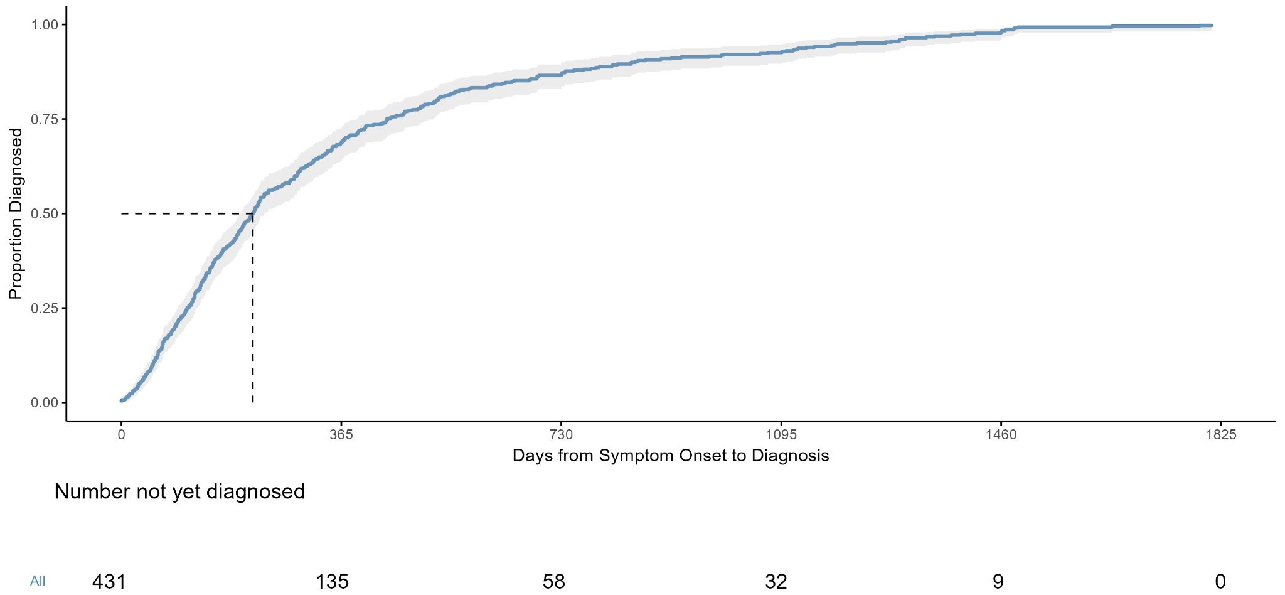

Supplementary Figure 4 Legend:
This is the enlarged version of the inset figure within Figure 4 of the manuscript. This figure details the time-to-diagnosis curve for all individuals, excluding the 25 individuals omitted due to time-to-diagnosis being beyond 5 years (unlikely to reflect the intended data capture for this variable). The grey area indicates continuous 95% confidence intervals of the time-to-event curve.

Supplementary Figure 5: Time from onset of historical symptoms, signs, and/or notable investigations to diagnosis.

Supplementary Figure 5A)
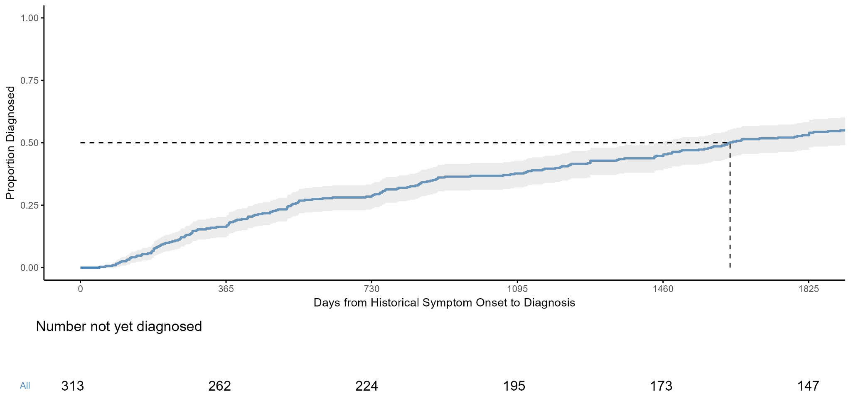

Supplementary Figure 5B)

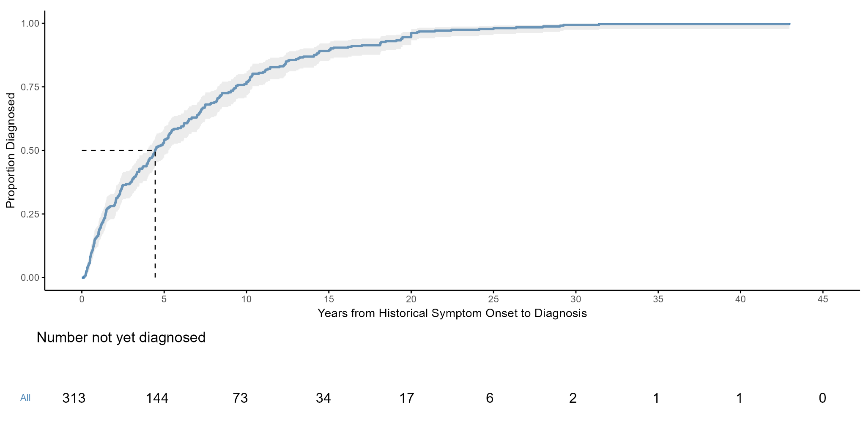

Supplementary Figure 5 Legend:
Time-to-diagnosis curves are shown for individuals with available dates for historical symptoms, signs, and/or notable investigations and diagnosis (n = 313). No upper time limit was applied (i.e. no censoring performed). Panel A) displays the curve with the x-axis truncated at 5 years to improve visual resolution around the median. Panel B) displays the same curve across the full observed time range, with the x-axis shown in years. The grey area indicates continuous 95% confidence intervals of the time-to-event curve. Median time to diagnosis was 1628 days (IQR 529–3419), with a maximum observed time of approximately 43 years. Overall, 147 individuals had time-to-diagnosis values exceeding 5 years, 73 exceeding 10 years, and 34 exceeding 15 years.

Supplementary Figure 6: Diagnostic Pathway Timeline Dot Plot inclusive of historical symptom onset.
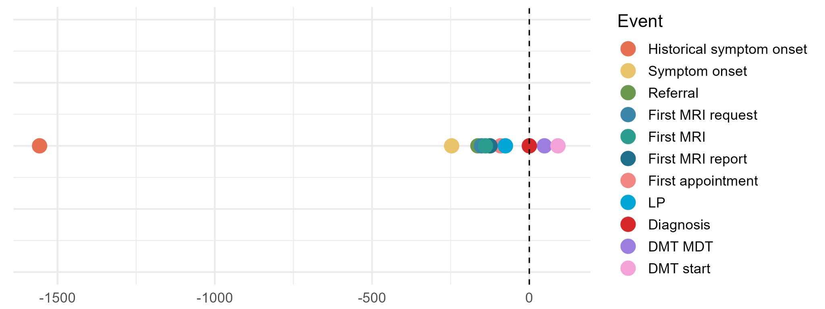
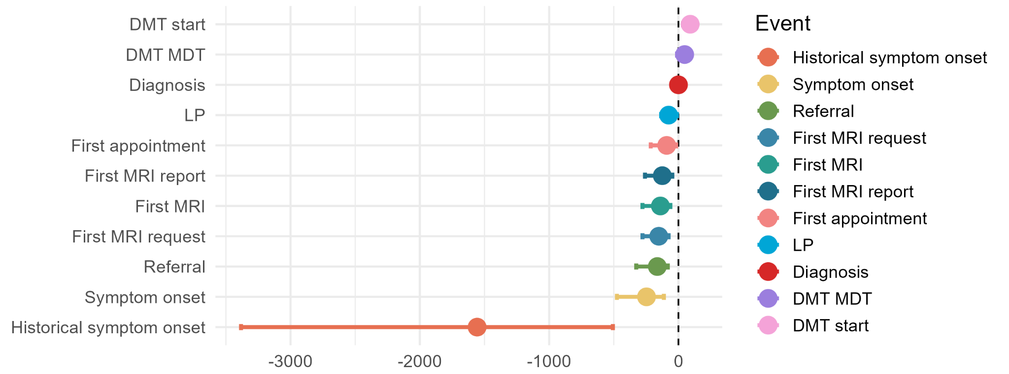

Supplementary Figure 6 Legend:
Dot plot showing the median timing of key diagnostic events relative to diagnosis (day 0), with interquartile ranges (IQRs). Negative values indicate events occurring prior to diagnosis and positive values indicate events after diagnosis. Each timepoint is derived from individuals with available data for that event and does not represent a single patient pathway; sample sizes therefore vary between events. This dot plot differs from Figure 5 in the manuscript by including historical symptom onset.

Abbreviations listed: MRI: magnetic resonance imaging of brain or spinal cord; LP: lumbar puncture; DMT: disease-modifying therapy; MDT: multi-disciplinary team meeting.

Sample sizes per variable: Historical symptom onset (313), Symptom onset (462 individuals), Referral (510), First MRI request (374), First MRI (516), First MRI report (486), First Appointment (535), LP (298), Diagnosis (557 ), DMT MDT (196), DMT start (323).

Supplementary Table 1: Diagnostic Pathway Timeline.
Event | Median days from MS diagnosis | Lower quartile | Upper quartile | Number of individuals with available data
Historical symptom onset | -1557.0 | -3383.0 | -507.0 | 313
Symptom onset | -247.0 | -476.0 | -112.8 | 462
Referral | -163.5 | -326.5 | -82.0 | 510
First MRI request | -152.0 | -278.0 | -76.3 | 374
First MRI | -139.5 | -278.3 | -62.5 | 516
First MRI report | -125.0 | -259.0 | -47.0 | 486
First appointment | -91.0 | -214.5 | -18.0 | 535
LP | -76.0 | -133.8 | -11.5 | 298
Diagnosis | 0.0 | NA | NA | 557
DMT MDT | 48.0 | -11.3 | 78.0 | 196
DMT start | 91.0 | 34.5 | 140.0 | 323

Supplementary Table 1 Legend:
The median number of days from MS diagnosis listed here from symptom onset and referral differ from those presented in the main manuscript due to inclusion of values outside of the 0-5 year limit.

Abbreviations listed: MRI: magnetic resonance imaging of brain or spinal cord; LP: lumbar puncture; DMT: disease-modifying therapy; MDT: multi-disciplinary team meeting.

Supplementary Figure 7: Diagnostic Pathway Timeline Dot Plot for individual centres.

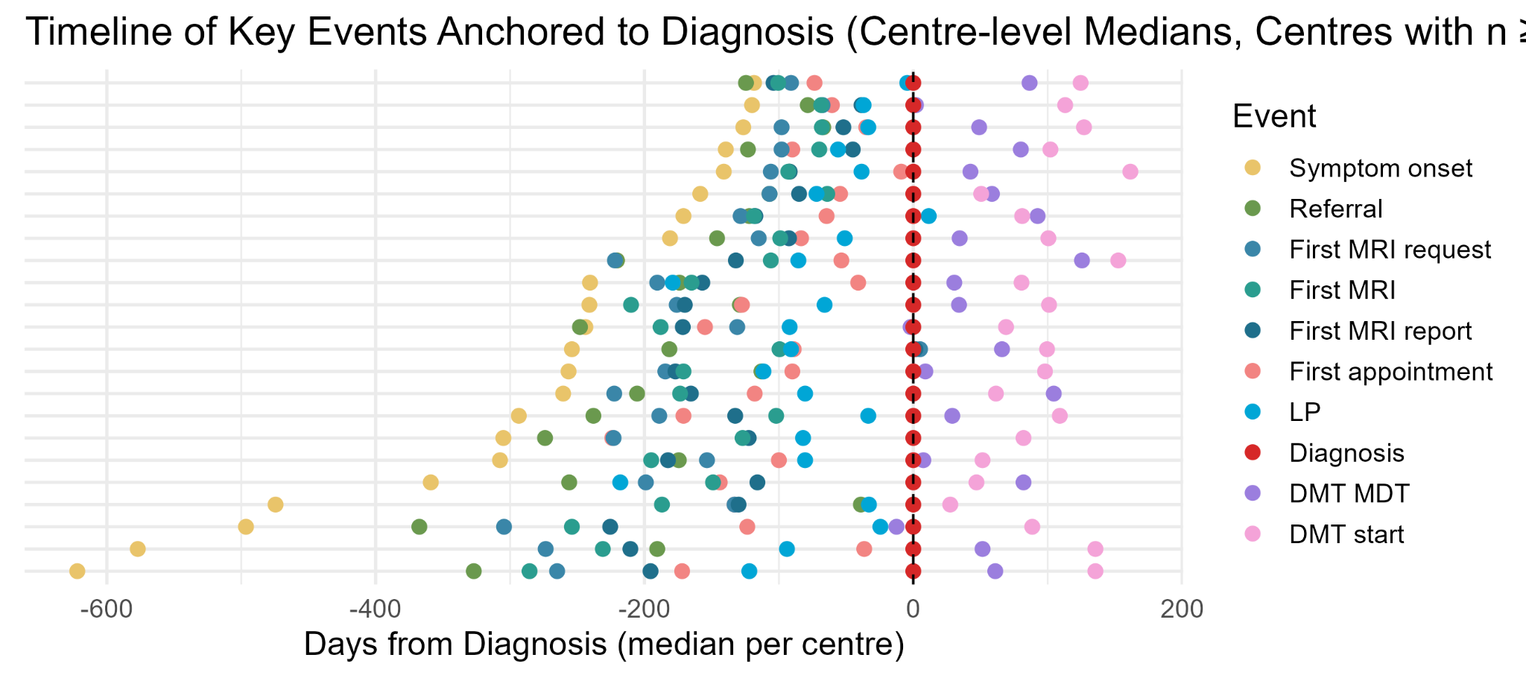

Supplementary Figure 7 Legend:
Each horizontal row represents an individual centre, with each dot showing the median timing of a specific event relative to diagnosis (day 0), calculated using available data at that centre. Centres are ordered by increasing duration from symptom onset to diagnosis (23 centres included).
As medians for each event are calculated from available individuals at that centre, and sample sizes vary between events, timepoints are derived from different patient subsets. As a result, the relative ordering of events within and across centres may not follow a strictly chronological sequence and should not be interpreted as individual patient trajectories.
Only centres with ≥10 individuals with a recorded diagnosis date are included to reduce instability from sparse centre-level estimates.

Supplementary Figure 8: Diagnostic Pathway Sankey.
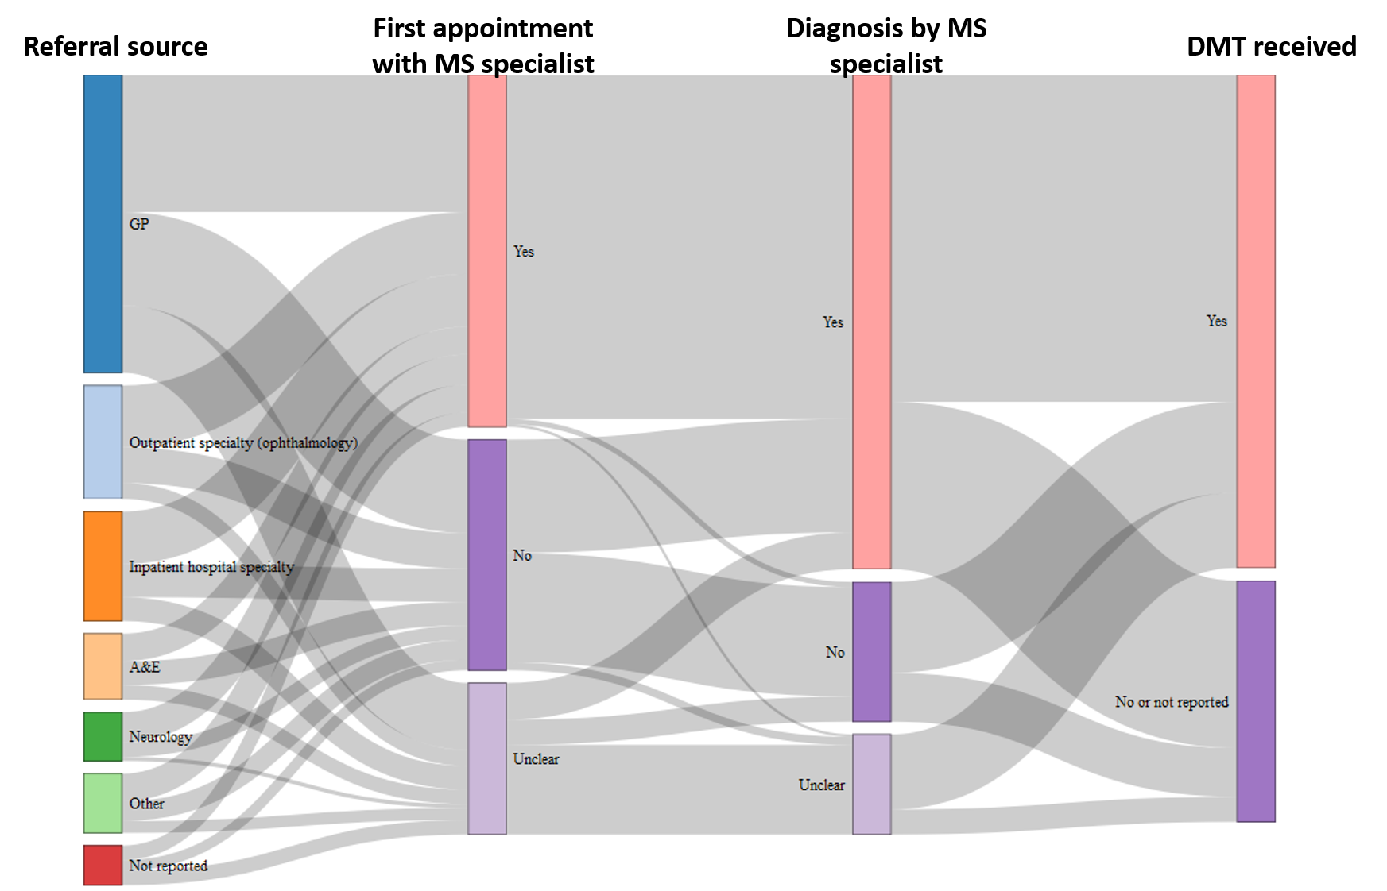

Supplementary Figure 8 Legend:
This figure illustrates the diagnostic pathway through a Sankey diagram, focussing upon flow through diagnosis-specific variables and its relation to commencing treatment. The counts of individuals transitioning between categories are listed in Supplementary Table 2.
Abbreviations listed: GP: General Practice; A&E: accident and emergency department; DMT: disease-modifying therapy.

Supplementary Table 2: Edge list and flow counts used to construct the diagnostic pathway Sankey diagram (Supplementary Figure 7).
Source stage | Source category | Target stage | Target category | Flow count (n)
Referral source | GP | First appointment with MS specialist | Yes | 104
Referral source | GP | First appointment with MS specialist | No | 71
Referral source | GP | First appointment with MS specialist | Unclear | 51
Referral source | Outpatient specialty (ophthalmology) | First appointment with MS specialist | Yes | 47
Referral source | Outpatient specialty (ophthalmology) | First appointment with MS specialist | No | 27
Referral source | Outpatient specialty (ophthalmology) | First appointment with MS specialist | Unclear | 12
Referral source | Inpatient hospital specialty | First appointment with MS specialist | Yes | 40
Referral source | Inpatient hospital specialty | First appointment with MS specialist | No | 25
Referral source | Inpatient hospital specialty | First appointment with MS specialist | Unclear | 18
Referral source | A&E | First appointment with MS specialist | Yes | 21
Referral source | A&E | First appointment with MS specialist | No | 18
Referral source | A&E | First appointment with MS specialist | Unclear | 11
Referral source | Neurology | First appointment with MS specialist | Yes | 23
Referral source | Neurology | First appointment with MS specialist | No | 11
Referral source | Neurology | First appointment with MS specialist | Unclear | 3
Referral source | Other | First appointment with MS specialist | Yes | 21
Referral source | Other | First appointment with MS specialist | No | 15
Referral source | Other | First appointment with MS specialist | Unclear | 9
Referral source | Not reported | First appointment with MS specialist | Yes | 11
Referral source | Not reported | First appointment with MS specialist | No | 8
Referral source | Not reported | First appointment with MS specialist | Unclear | 11
First appointment with MS specialist | Yes | Diagnosis by MS specialist | Yes | 261
First appointment with MS specialist | Yes | Diagnosis by MS specialist | No | 4
First appointment with MS specialist | Yes | Diagnosis by MS specialist | Unclear | 2
First appointment with MS specialist | No | Diagnosis by MS specialist | Yes | 86
First appointment with MS specialist | No | Diagnosis by MS specialist | No | 83
First appointment with MS specialist | No | Diagnosis by MS specialist | Unclear | 6
First appointment with MS specialist | Unclear | Diagnosis by MS specialist | Yes | 28
First appointment with MS specialist | Unclear | Diagnosis by MS specialist | No | 19
First appointment with MS specialist | Unclear | Diagnosis by MS specialist | Unclear | 68
Diagnosis by MS specialist | Yes | DMT received | Yes | 248
Diagnosis by MS specialist | Yes | DMT received | No or not reported | 127
Diagnosis by MS specialist | No | DMT received | Yes | 69
Diagnosis by MS specialist | No | DMT received | No or not reported | 37
Diagnosis by MS specialist | Unclear | DMT received | Yes | 57
Diagnosis by MS specialist | Unclear | DMT received | No or not reported | 19

Supplementary Table 2 Legend:
Counts of individuals transitioning between categories at each stage of the diagnostic pathway. These data correspond to the flows visualised in Supplementary Figure 7. Abbreviations listed: GP: General Practice; A&E: accident and emergency department; DMT: disease-modifying therapy.

Supplementary Figure 9: Time to from diagnosis to starting DMT cumulative incidence plot.
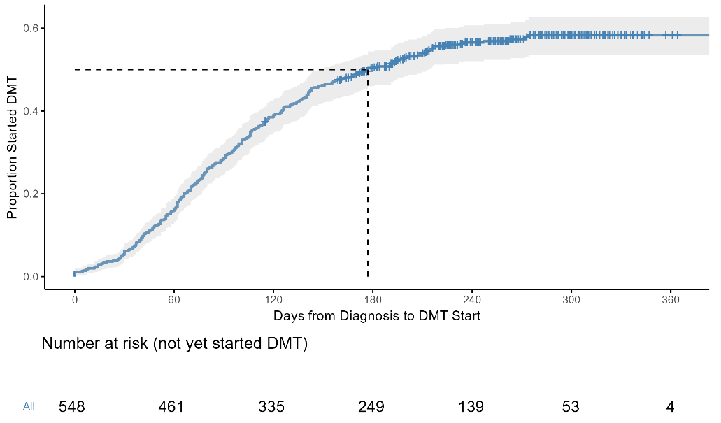

Supplementary Figure 9 Legend:
Follow-up was administratively censored at the date of first data submission for each centre, and this interval (from diagnosis to censoring) was used as a proxy for follow-up duration. As a result, individuals initiating DMT after the censoring date were treated as censored and are not represented as events in the cumulative incidence analysis. 9 individuals who received DMT individuals were right censored.

Median follow-up from diagnosis was 259.0 days (IQR 214.0-308.0; range 115.0-452.0). Follow-up duration was ≥6 months in 91.7% of individuals, but ≥12 months in only 3.1%.
Abbreviations listed: DMT: disease-modifying therapy.

Supplementary Figure 10: First disease modifying therapy received.

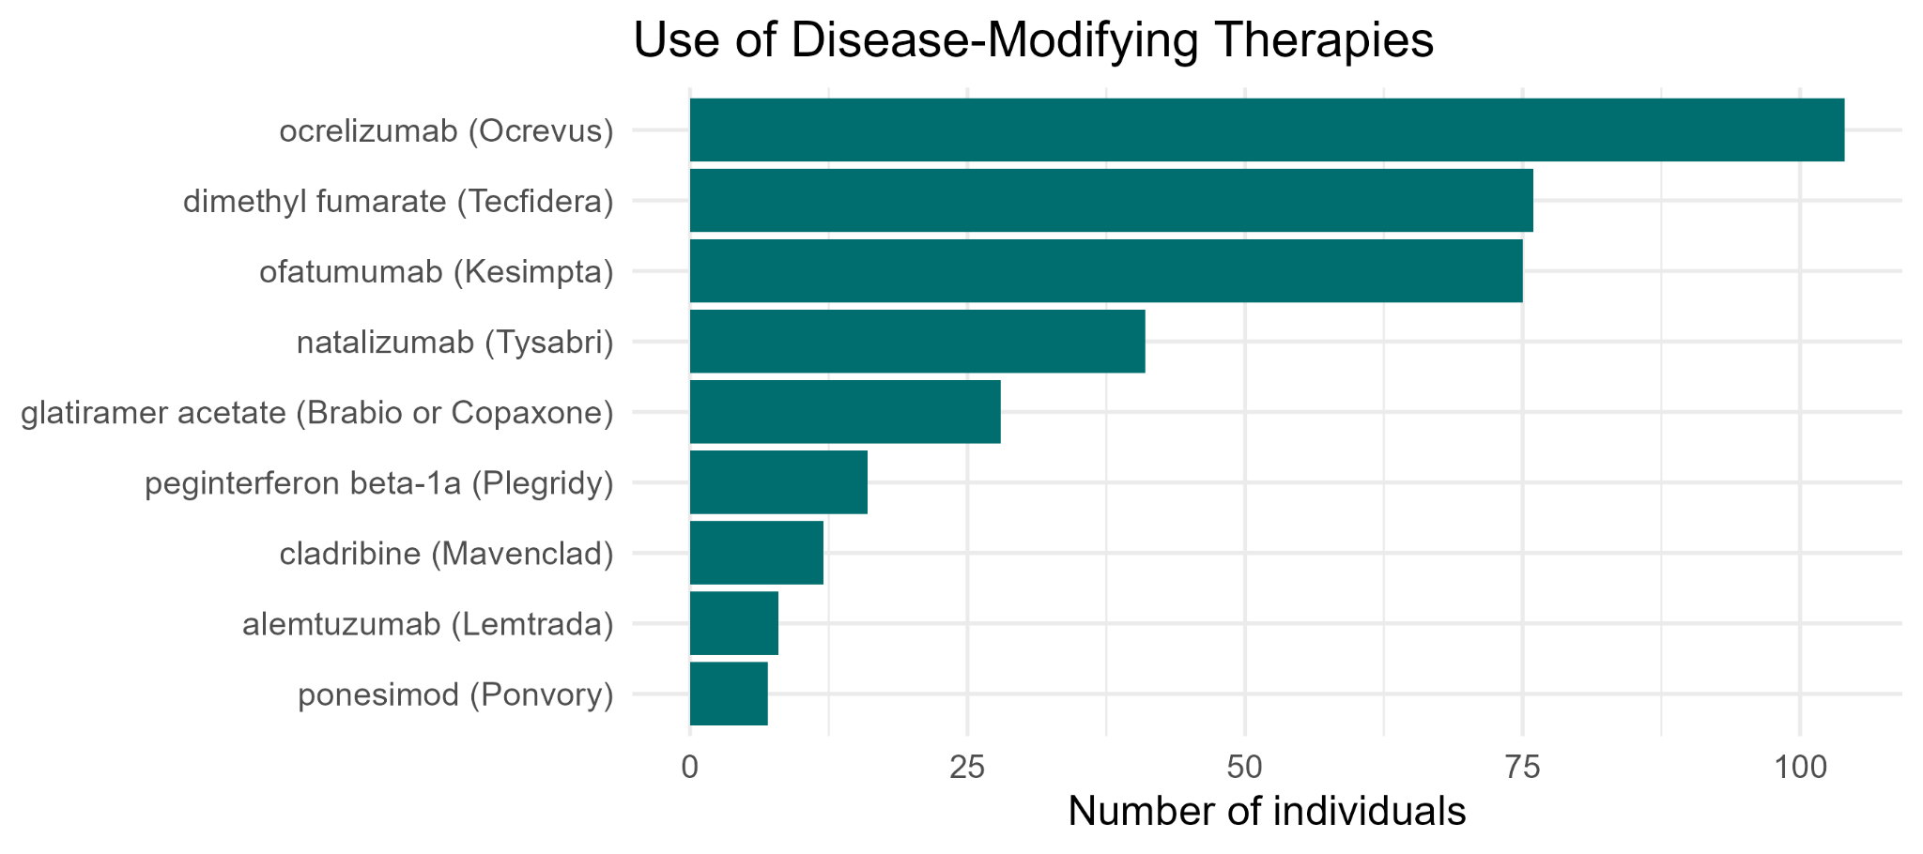

Supplementary Figure 10 Legend:
≤5 individuals (≤1%) received each of the following as their first DMT: teriflunomide (Aubagio), interferon beta-1a (Avonex), ozanimod (Zeposia), siponimod (Mayzent), interferon beta-1b (Extavia), or diroximel fumarate (Vumerity). No individuals received interferon beta-1b (Betaferon), fingolimod (Gilenya), or interferon beta-1a (Rebif) as their first agent.
Abbreviations listed: DMT: disease-modifying therapy.

Supplementary Table 3: A: Symptoms, signs or notable investigations triggering neurology referral. B: Historical symptoms, signs or notable investigations.

Variable | N = 557 ¹
Symptoms/signs/ notable investigations triggering neurology referral.
Motor | 249 (44.7%)
Sensory | 335 (60.3%)
Visual (optic neuritis) | 112 (20.1%)
Visual (other) | 161 (28.9%)
Balance | 147 (26.4%)
Pain | 145 (26.0%)
Cognitive | 23 (4.1%)
Mood | 35 (6.3%)
Bowel | 34 (6.1%)
Urinary | 74 (13.3%)
Swallow | 34 (6.1%)
Migraine | 62 (11.1%)
Abnormal MRI report | 299 (53.7%)
Abnormal LP results | 60 (10.8%)
Historical symptoms, signs, or notable investigations.
Motor | 136 (24.4%)
Sensory | 220 (39.5%)
Visual (optic neuritis) | 64 (11.5%)
Visual (other) | 89 (16.0%)
Balance | 76 (13.6%)
Pain | 89 (16.0%)
Cognitive | 17 (3.1%)
Mood | 29 (5.2%)
Bowel | 30 (5.4%)
Urinary | 52 (9.3%)
Swallow | 14(2.5%)
Migraine | 52 (9.3%)
Abnormal MRI report | 75 (13.5%)
Abnormal LP results | 15 (2.7%)
¹n (%); median [lower quartile, upper quartile]; mean (standard deviation).

Supplementary Table 3 Legend: This table details the raw counts for occurrence of A (top half of table): Symptoms, signs or notable investigations triggering neurology referral; and B (bottom half of table): Historical symptoms, signs or notable investigations. Historical symptoms, signs, and notable investigations include those that may have potentially related to MS, that did not prompt referral to neurology and did not lead to a diagnosis of MS. Individuals could have multiple entries selected per category.
Abbreviations listed: MRI: magnetic resonance imaging of brain or spinal cord; LP: lumbar puncture

Supplementary: Baseline measures and exposures.

The below excerpt is taken from our protocol [A]:

“Demographic variables include: age; sex; ethnicity; index of deprivation (UK centres: index of deprivation decile and rank; ROI centres: Pobal Haase Pratschke (HP) Index 2016 and description); distance from home postcode to MS centre; employment status; and smoking status.

MS variables include: family history of MS (with the degree of relatedness of relative with MS); possible prior misdiagnosis or MS mimic; date of ‘First Relevant’ referral to neurology/MS clinic and source of this referral; symptoms/signs/abnormal investigations prompting this ‘First Relevant’ referral to neurology and date of onset; historical MS-associated symptoms/signs/abnormal investigations that precede ‘First Relevant’ referral to neurology and date of onset.

Neurology appointment and investigation variables include: date of first neurology appointment after referral (if available), and whether this neurologist had a practice focus in MS; documented follow up plan from this appointment; date of subsequent neurology appointment(s); date MRI requested, performed, and reported; MRI findings, region, use of contrast, and modality; date lumbar puncture requested, and performed; and lumbar puncture findings.

MS diagnosis variables include: date of diagnosis and whether the diagnosing neurologist had a practice focus in MS; previous diagnosis of CIS; MS subtype; number of MS relapses at the time of diagnosis; and disability scores at diagnosis (EDSS, Timed 25-Foot Walk Time, Nine-Hole Peg Test Time at Diagnosis (right and left hands), Fatigue Severity Score, and Multiple Sclerosis Functional Composite Score).

MS treatment variables include: DMT(s) received; date of referral for DMT MDT; date of DMT MDT; date of first DMT started; administration method.

Quality measures from QS 108 include: Support at diagnosis (including specifically support to (a) understand the condition, (b) understand MS progression and (c) understand MS management); Follow up after diagnosis; and Physical activity advice.”

[A]: Kuri A, Henshall DE, Chaudhry D, Ooi SZY, Zhang Q, Mathews J, Thomson A, Rog D, Hobart J, Dobson R; Neurology and Neurosurgery Interest Group (NANSIG). Delays in Multiple Sclerosis diagnosis (DIMES): protocol for a multicentre, observational study of multiple sclerosis diagnostic pathways in the United Kingdom and Republic of Ireland. BMC Neurol. 2024 Mar 28;24(1):105. doi: 10.1186/s12883-024-03598-z.

Supplementary Table 4: MRI sequences and use of contrast.

Variable | N ¹
Sequences performed in the first MRI in relation to the index episode, n = 551
T1 | 247 (44.8%)
T2 | 337 (61.7%)
FLAIR | 227 (41.2%)
DWI | 149 (27.0%)
Sequences not reported | 201/551 (36.4%)
Sequences performed in the second MRI in relation to the index episode, n = 334
T1 | 142 (42.5%)
T2 | 193 (57.8%)
FLAIR | 116 (34.7%)
DWI | 71 (21.3%)
Sequences not reported | 114/334 (34.1%)
Sequences performed in the third MRI in relation to the index episode, n = 117
T1 | 48 (41.0%)
T2 | 55 (47.0%)
FLAIR | 38 (32.5%)
DWI | 28 (23.9%)
Sequences not reported | 46/117 (39.3%)
Sequences performed in the fourth MRI in relation to the index episode, n = 32
T1 | 16 (50.0%)
T2 | 16 (50.0%)
FLAIR | 13 (40.6%)
DWI | 10 (31.2%)
Sequences not reported | 19/32 (59.3%)
Sequences performed in the fifth MRI in relation to the index episode, n = 10
T1 | ≤5
T2 | ≤5
FLAIR | ≤5
DWI | ≤5
Sequences not reported | ≤5
Use of contrast agent in the first MRI in relation to index episode, n = 551
Contrast used (type not specified) | 70 (12.7%)
Gadolinium contrast used | 53 (9.6%)
Non-Gadolinium contrast used | 8 (1.4%)
Contrast not used | 181 (32.8%)
Not reported | 245 (44.5%)
Use of contrast agent in the second MRI in relation to index episode, n = 334
Contrast used (type not specified) | 79 (23.7%)
Gadolinium contrast used | 69 (20.7%)
Non-Gadolinium contrast used | ≤5
Contrast not used | 62 (18.6%)
Not reported | 119 (35.6%)
Use of contrast agent in the third MRI in relation to index episode, n = 117
Contrast used (type not specified) | 27 (23.1%)
Gadolinium contrast used | 16 (13.7%)
Non-Gadolinium contrast used | ≤5
Contrast not used | 24 (20.5%)
Not reported | 48 (41.0%)
Use of contrast agent in the fourth MRI in relation to index episode, n = 32
Contrast used (type not specified) | 11 (34.4%)
Gadolinium contrast used | ≤5
Non-Gadolinium contrast used | ≤5
Contrast not used | 6 (18.8%)
Not reported | 9 (28.1%)
Use of contrast agent in the fifth MRI in relation to index episode, n=10
Contrast used (type not specified) | ≤5
Gadolinium contrast used | ≤5
Non-Gadolinium contrast used | ≤5
Contrast not used | 6
Not reported | ≤5
Use of contrast agent in any MRI, n = 551
Any contrast agent | 283 (51.4%)
Gadolinium contrast | 120 (21.7%)
¹n (%)

Supplementary Table 4 Legend:
The interpretation of MRI sequences and use of contrast are limited by substantial non-reporting. The Microsoft Excel CRF was designed to record contrast use and its type for each MRI as a categorical, mutually exclusive variable. However, this structure was not consistently applied across all rows leading to free-text entries requiring manual review. As a result, the distinction between gadolinium and non-gadolinium contrast could not be determined in all cases.

Supplementary Table 5: Centre-level data from Centre Survey.

Variable | Response | Centres (n/N)
Proportion of adults with MS who are given information about MS, its progression and the ways it can be managed by the consultant neurologist at the time of diagnosis.  Please provide an estimate for this proportion, indicated as a percentage (%). | 90.9% (11.9), 90.0% [85. 100] | 13/13
Does your centre have local arrangements in place to ensure that adults with MS have a face‑to‑face follow‑up appointment with a healthcare professional with expertise in MS within 6 weeks of diagnosis? | Yes | 11/13
If 'Yes' selected above, please provide an estimated percentage of patients that are seen within 6 weeks. Please provide an estimate for this proportion, indicated as a percentage (%). | 68.2% (26.4), 80.0% [50, 80] | 11/11
If 'Yes' selected above, what health professionals generally perform this <6 week follow-up appointment? | MS Specialist Nurse 7/11  Neurology Consultant 7/11  Neurology Registrar 1/11 | 11/11
Does your centre provide adults with MS with a single point of contact (with expertise in MS) who coordinates access to their care? | Yes | 12/13
If 'Yes' selected above, what is this health professional’s role? | MS Specialist Nurse 10/12  Neurology Consultant 4/12  Admin team 1/11
Does your centre have a multidisciplinary team (MDT) with expertise in MS to care for adults with MS? | Yes | 13/13
If your centre lacks an MDT with the above specific expertise, does your centre refer to an external MDT (i.e. MDT with expertise in MS at another centre)? | Not applicable | 13/13
If your centre lacks an MDT with the above specific expertise, is there an alternative service to an MDT that your centre provides - for example: a team that is non-multidisciplinary such as several consultants? | Not applicable | 13/13
Does your centre have local arrangements in place to ensure that adults with MS who have problems with mobility or fatigue are supported to remain physically active? | Yes | 12/13
If 'Yes' selected above, please outline these arrangements: | Physiotherapy 11/13*  Exercise or physical activity scheme 4/13*  Exercise education group 1/13*  Fatigue management service 2/13* | 12/12
Does your centre have a local pathway(s) to ensure that adults with MS who have a relapse that would benefit from treatment are offered treatment as soon as possible and within 14 days of the onset of symptoms? | Yes | 10/13
If 'Yes' selected above, please outline below and return via email | Dedicated MS relapse clinic* 6/10
Does your centre routinely arrange review of adults with MS by healthcare professionals with expertise in MS within 12 months of first diagnosis? | Yes | 11/13
If 'Yes' selected above, what is this health professional’s role? | Neurology Consultant 11/11  MS Specialist Nurse 8/11  Neurology Registrar 1/11 | 11/11
Does your centre routinely arrange annual reviews of adults after the above? | Yes | 12/13
If 'Yes' selected above, what is this health professional’s role? | Neurology Consultant 12/12  MS Specialist Nurse 9/12  Neurology Registrar 3/12
If 'Yes' selected above, please estimate the percentage (%) of patients that are seen within 12 months of first diagnosis. | Mean 86.7% (20.3), 92.5% (87.5, 100) | 12/12
Does your centre routinely (ie. within every 1-3 years) audit aspects of MS-related diagnostic pathways or care? | Yes (Yearly or more frequently) 3/13  Yes (every 2 years) 2/13  Yes (every 3 years) 1/13  Yes (unspecified) 5/13  No 2/13 | 13/13
Other than involvement in DIMES, when did your centre last audit aspects of MS-related diagnostic pathways or care? | Ongoing 5/13  2023 4/13  2022 1/13  2018 or before 2/13 | 13/13
"Please provide the average waiting time for neurology outpatient appointments after request/referral. Please indicate a number below, in months. " | 5.5 (3.9), 5 [2, 9.5] | 13/13
If there is an official website providing information to the above question, please provide a URL. | Provided | 2/13
"According to NHS England’s GIRFT categorisation, how would you best describe your neurology centre? For centres in Scotland, Wales, N Ireland, or Republic of Ireland, please choose the option that best describes your centre. " | N1 11/13  N2 1/13  N3 1/13 | 13/13
Do you have MRI scanner(s) at your centre? If yes, please indicate how many MRI scanner(s) on site. | 4.2 (2.0), 4 [2.5, 6] | 13/13
When arranging a lumbar puncture locally, what service(s) are routinely used to perform this? | Ambulatory emergency care (AEC)/ Same day emergency care (SDEC) 5/13  Neurology Registrar/ Senior House Officer (SHO) clinic 3/13  Day case unit 4/13  Physician Associate 1/13 | 13/13
"At your centre how long (on average) in months do you think it takes for a patient to be diagnosed with MS from a) onset of symptoms/signs prompting referral to neurology to MS diagnosis." | 5 (3.3), 4 [3,6] | 11/13
"At your centre how long (on average) in months do you think it takes for a patient to be diagnosed with MS from b) From earliest symptoms /signs related to MS to MS diagnosis." | 12.1 (9.2), 12 [6,14] | 10/13
"At your centre how long (on average) in months do you think it takes for a patient to be diagnosed with MS from c) From referral to neurology to MS diagnosis." | 2.8 (1.3), 2.5 [2, 3.5] | 12/13
"What is the estimated population that your centre provides services for?  Please link URL for reference if available. Example: Maidstone and Tunbridge Wells NHS Trust provides care to … around 760,000 people. Source: https://www.mtw.nhs.uk/about-us/ " | 1,512,000 (1,165,000), 1,000,000 [800,000, 2,500,000]  Total: 19,666,000  Link provided 1/13 | 13/13
Please estimate the number of new patients with MS diagnosed at your centre per year. | 11-20 1/13  31-40 2/13  71-80 1/13  81-90 4/13  91-100 2/13  >100 3/13 | 13/13
Please estimate the number of patients with MS presently under the care of your centre. | 51-60 1/13  >100 12/13 | 13/13
Does your centre provide a Disease Modifying therapy (DMT) (infusions, oral or other) service? | Yes | 13/13
Please estimate the time from referral to DMT treatment to receipt at your centre in weeks. | 8.2 (5.4), 9 [4, 10]  2 centres listed varies by DMT agent | 13/13
Does your centre have a dedicated MS nurse / MS nursing team? If yes, please indicate how many MS nurses are there in the team. | Yes  4.8 (2.0), 5 [3, 6] | 13/13
Does your centre use any local guidelines relating to MS care, treatment, or the use of DMT in MS patients. | Yes 8/13  No 4/13  Not reported 1/13 | 13/13
If 'Yes' selected above, please outline below and return via email | Outlined provided by 5/7 | 5/7

Supplementary Table 5 Legend:
All data are self-reported by the supervising consultant of the participating centres. Survey uptake was 13/30 centres. Data are presented as n/N (%) for categorical variables and mean (standard deviation) and median (interquartile range) for continuous variables, as appropriate. Denominators (N) reflect the number of centres providing responses for each individual question; excluding missing responses and non applicable responses.
Where multiple responses were permitted, counts reflect the number of centres reporting each category and may exceed 100% when considered collectively.
For free-text questions, responses were reviewed and, where appropriate, categorised into clinically meaningful groups.
*Numbers derived from categorisation of free text responses.
Abbreviations listed: DMT: disease-modifying therapy; MDT: multi-disciplinary team meeting.

Supplementary Table 6: STROBE Statement - checklist of items that should be included in reports of observational studies.

 | Item No. | Recommendation | Page  No. | Relevant text from manuscript
Title and abstract | 1 | (a) Indicate the study’s design with a commonly used term in the title or the abstract | 5 | “Methods: DIMES was a multicentre, observational study”
Title and abstract | 1 | (b) Provide in the abstract an informative and balanced summary of what was done and what was found | 5 | “Methods: DIMES was a multicentre, observational study of people with MS consecutively diagnosed between July-December 2022 across 28 UK centres. Trained collaborators extracted clinicodemographic, diagnostic, and early management data from clinical records, with independent validation. Primary outcomes were time to MS diagnosis from: 1) symptoms triggering referral; 2) referral to neurology. Referral pathways, investigation sequences, NICE quality standard adherence, and DMT prescribing were also assessed.  Results: 557 people with newly-diagnosed MS were included (69.8% female; mean age 41.6, standard deviation 13.1). Presenting symptoms, referral pathways, and investigation sequences were variable (40.6% referred by GP, sensory symptoms most common (60.3%)). Median time to MS diagnosis from neurology referral was 155.5 days (IQR 77.0-308.5 days); from symptoms triggering referral, 218.0 days (IQR 110.5-441.0 days). Quality statement adherence ranged 42.2-70.0%. Most individuals commenced DMTs (67.1%).  “
Introduction
Background/rationale | 2 | Explain the scientific background and rationale for the investigation being reported | 6 | “The heterogeneity of early disease has been explored in previous work. Early MS signs and symptoms are often transient, and non-specific. (3) Such signs and symptoms will commonly be evaluated by non-neurologists in primary care, outpatient, or emergency settings, where early diagnostic opportunities (such as referrals to neurology, or imaging) may be missed. (4) This is further borne out in anecdotal reports from people with MS (pwMS), articles from MS charities, and is mirrored in this study’s own patient and public involvement work. (5, 6)  The diagnostic pathway has been less well explored in the UK.”  “Crucially, delays to diagnosis extend beyond a human impact; they are clinically significant. Mounting evidence suggests early highly-effective disease-modifying therapy (DMT) confers better prognosis in MS, which is being studied in clinical trials. (8, 9) Thus, preventable diagnostic delay requires urgent evaluation and policy action.  We therefore designed the DIMES study”
Objectives | 3 | State specific objectives, including any prespecified hypotheses | 6 | “Our findings aim to clarify real-world diagnostic experiences, identify remediable bottlenecks, and inform targeted improvements to ensure timely and more equitable MS diagnosis.”
Methods
Study design | 4 | Present key elements of study design early in the paper | 7 | “DIMES aimed to include all consecutively diagnosed pwMS, irrespective of subtype, between 1st July 2022 and 31st December 2022 at participating centres. “  “DIMES was registered as a service evaluation and/or clinical audit at all included centres”
Setting | 5 | Describe the setting, locations, and relevant dates, including periods of recruitment, exposure, follow-up, and data collection | 7 | “DIMES aimed to include all consecutively diagnosed pwMS, irrespective of subtype, between 1st July 2022 and 31st December 2022 at participating centres. “  “Trained collaborators collected data directly from existing clinical records. Training involved mandatory attendance at a dedicated session led by the steering committee, where the data dictionary and data collection methods were comprehensively discussed, with exemplar scenarios. All collected variables are listed in the study protocol and in the Supplement. (10) Data was entered onto a bespoke, standardised Microsoft Excel spreadsheet, on password-protected NHS computers/servers, supported by a data dictionary (see Supplement).“
Participants | 6 | (a) Cohort study—Give the eligibility criteria, and the sources and methods of selection of participants. Describe methods of follow-up  Case-control study—Give the eligibility criteria, and the sources and methods of case ascertainment and control selection. Give the rationale for the choice of cases and controls  Cross-sectional study—Give the eligibility criteria, and the sources and methods of selection of participants | 7 | (a) “DIMES aimed to include all consecutively diagnosed pwMS, irrespective of subtype, between 1st July 2022 and 31st December 2022 at participating centres. Formal diagnosis by a clinician working in neurology was required to be clearly documented in the clinical notes. pwMS transferred to the centre post-diagnosis (e.g., to facilitate DMT treatment) were excluded, as were individuals with possible/suspected MS who did not receive a confirmed diagnosis within the specified window.”
Participants | 6 | (b) Cohort study—For matched studies, give matching criteria and number of exposed and unexposed  Case-control study—For matched studies, give matching criteria and the number of controls per case | 7 | Not applicable (as not a matched study).
Variables | 7 | Clearly define all outcomes, exposures, predictors, potential confounders, and effect modifiers. Give diagnostic criteria, if applicable | 7 | Outcomes/exposures: “Baseline measures and exposures  Baseline variables included data on sociodemographics, appointments, investigations, diagnosis, and early treatment (see full outline in Supplement).  Symptoms, signs, and/or notable investigations triggering referral to neurology, and historical symptoms, signs, and/or notable investigations, were collected as a standardised categorical list, with free text options.  Outcomes  Primary and secondary outcomes were pre-defined in the protocol. The dual primary outcomes were:  1) Time from onset of symptoms, signs, and/or notable investigations triggering referral to neurology, to MS diagnosis  2) Time from referral to neurology for suspected MS, to MS diagnosis.”  Diagnostic criteria: “ The contemporaneous diagnostic guidelines for this study were the 2017 McDonald criteria. (11)”
Data sources/ measurement | 8* | For each variable of interest, give sources of data and details of methods of assessment (measurement). Describe comparability of assessment methods if there is more than one group | 7 | “All collected variables are listed in the study protocol and in the Supplement. (10)”
Bias | 9 | Describe any efforts to address potential sources of bias | 27 | “Further, the representativeness of our sample is not constrained by the selection biases introduced by opt-in express consent. However, the retrospective design, brief non-standardised follow up post diagnosis, and the inherent limitations of routine clinical documentation remain potential sources of bias.”
Study size | 10 | Explain how the study size was arrived at | 8 | “Based on estimates of annual incidence and the reach of the NANSIG network, we aimed to enroll ≥ 20 centres detailing ~415 pwMS. We deemed a formal sample size calculation inappropriate given there is no minimum effect size pertinent to our primary outcomes, as this is a descriptive study.”
Continued on next page
Quantitative variables | 11 | Explain how quantitative variables were handled in the analyses. If applicable, describe which groupings were chosen and why | 8 | “Mean with standard deviation, or median with interquartile ranges are presented for continuous variables, as appropriate. Categorical data is presented in tables. Time-to-event variables are summarised in cumulative incidence plots. Diagnostic pathways are visualised with Sankey or dot plots.”
Statistical methods | 12 | (a) Describe all statistical methods, including those used to control for confounding | 8 | “Data Analysis  Mean with standard deviation, or median with interquartile ranges are presented for continuous variables, as appropriate. Categorical data is presented in tables. Time-to-event variables are summarised in cumulative incidence plots. Diagnostic pathways are visualised with Sankey or dot plots. Completeness and inter-collaborator agreement were analysed in Microsoft Excel with all other analyses completed in RStudio (Posit Software, v4.5.0 (2025-04-11), PBC, Boston, MA) with all code available through Github (link available on submission).”
Statistical methods | 12 | (b) Describe any methods used to examine subgroups and interactions |  | Not applicable as not performed.
Statistical methods | 12 | (c) Explain how missing data were addressed | 8 | “Completeness and inter-collaborator agreement were analysed in Microsoft Excel”
Statistical methods | 12 | (d) Cohort study—If applicable, explain how loss to follow-up was addressed  Case-control study—If applicable, explain how matching of cases and controls was addressed  Cross-sectional study—If applicable, describe analytical methods taking account of sampling strategy | 16 | Cohort study  “Due to limited follow-up after diagnosis, with only 67.1% of individuals having initiated treatment, post-diagnosis timepoints are likely to be underestimated and may not fully represent the complete treatment pathway; these findings should therefore be interpreted with caution.”  “Follow-up duration from diagnosis was limited (median 259.0 days [IQR 214.0–308.0; range 115–452]), and varied by centre according to data extraction timing. As such, time-to-treatment and proportion receiving DMT agents may be influenced by differential follow-up and limited observation time.”  “Due to limited follow-up after diagnosis, with only 67.1% of individuals having initiated treatment, post-diagnosis timepoints are likely to be underestimated and may not fully represent the complete treatment pathway; these findings should therefore be interpreted with caution.”  “Supplementary Figure 9 Legend:  Follow-up was administratively censored at the date of first data submission for each centre, and this interval (from diagnosis to censoring) was used as a proxy for follow-up duration. As a result, individuals initiating DMT after the censoring date were treated as censored and are not represented as events in the cumulative incidence analysis. 9 individuals who received DMT individuals were right censored.”
Statistical methods | 12 | (e) Describe any sensitivity analyses |  | Not applicable as not performed
Results
Participants | 13* | (a) Report numbers of individuals at each stage of study—eg numbers potentially eligible, examined for eligibility, confirmed eligible, included in the study, completing follow-up, and analysed | 9 | Figure 2: Flowchart of study population
Participants | 13* | (b) Give reasons for non-participation at each stage | 9 | Figure 2: Flowchart of study population
Participants | 13* | (c) Consider use of a flow diagram | 9 | Figure 2: Flowchart of study population
Descriptive data | 14* | (a) Give characteristics of study participants (eg demographic, clinical, social) and information on exposures and potential confounders | 10 | Table 1: Demographic and baseline characteristics
Descriptive data | 14* | (b) Indicate number of participants with missing data for each variable of interest | 10 | Table 1, Table 2, Table 3.  Figure 3, Figure 4, Figure 5, Figure 7.  Supplementary Figure 1, Supplementary Figure 3, Supplementary Figure 4, Supplementary Figure 5, Supplementary Figure 6, Supplementary Figure 7, Supplementary Figure 9.  Supplementary Table 1, Supplementary Table 2.
Descriptive data | 14* | (c) Cohort study—Summarise follow-up time (eg, average and total amount) | 45 | “Follow-up was administratively censored at the date of first data submission for each centre, and this interval (from diagnosis to censoring) was used as a proxy for follow-up duration. As a result, individuals initiating DMT after the censoring date were treated as censored and are not represented as events in the cumulative incidence analysis. 9 individuals who received DMT individuals were right censored.  Median follow-up from diagnosis was 259.0 days (IQR 214.0-308.0; range 115.0-452.0). Follow-up duration was ≥6 months in 91.7% of individuals, but ≥12 months in only 3.1%.”
Outcome data | 15* | Cohort study—Report numbers of outcome events or summary measures over time | 12 | Figure 3, Figure 4, Figure 5, Figure 7.  Table 2, Table 3.  Supplementary Figure 3, Supplementary Figure 4, Supplementary Figure 5, Supplementary Figure 6, Supplementary Figure 7, Supplementary Figure 8, Supplementary Figure 9, Supplementary Figure 10,  Supplementary Table 1, Supplementary Table 2:
Outcome data | 15* | Case-control study—Report numbers in each exposure category, or summary measures of exposure
Outcome data | 15* | Cross-sectional study—Report numbers of outcome events or summary measures
Main results | 16 | (a) Give unadjusted estimates and, if applicable, confounder-adjusted estimates and their precision (eg, 95% confidence interval). Make clear which confounders were adjusted for and why they were included |  | No confounder-adjusted estimates performed.
Main results | 16 | (b) Report category boundaries when continuous variables were categorized |  | The only categorisation of continuous variables relates to time variables, all of which are listed with their start and end time. No other categorisation performed.
Main results | 16 | (c) If relevant, consider translating estimates of relative risk into absolute risk for a meaningful time period |  | Not relevant.
Continued on next page
Other analyses | 17 | Report other analyses done—eg analyses of subgroups and interactions, and sensitivity analyses |  | No subgroup or sensitivity analyses performed.
Discussion
Key results | 18 | Summarise key results with reference to study objectives | 9 | See “Results”.
Limitations | 19 | Discuss limitations of the study, taking into account sources of potential bias or imprecision. Discuss both direction and magnitude of any potential bias | 26 | “This historical timing has caveats of non-exact onsets (e.g., ‘X months/years before appointment’), and potential subjectivity of patient, clinician and collaborator reporting. Despite limitations, it provides additional patient-centric context concordant with the views obtained from patient representatives who suggested their MS symptoms may have started earlier than clinician derived onset”  “However, the retrospective design, brief non-standardised follow up post diagnosis, and the inherent limitations of routine clinical documentation remain potential sources of bias.”
Interpretation | 20 | Give a cautious overall interpretation of results considering objectives, limitations, multiplicity of analyses, results from similar studies, and other relevant evidence | 26 | See “Discussion”.
Generalisability | 21 | Discuss the generalisability (external validity) of the study results | 27 | “Strengths of our study include the large, geographically diverse sample, with data obtained directly from clinical records with stringent quality assurance procedures. The number of centres, across different GIRFT ‘N’ designations, provides reassurance that the data does not merely reflect results from large tertiary/quaternary centres. DIMES may provide improved detail, completeness, and accuracy in its data capture compared to contemporary studies such as registries featuring optional data fields and limited quality assurance. Further, the representativeness of our sample is not constrained by the selection biases introduced by opt-in express consent.”
Other information
Funding | 22 | Give the source of funding and the role of the funders for the present study and, if applicable, for the original study on which the present article is based | 74 | “Funding statement  Nil to declare.”

*Give information separately for cases and controls in case-control studies and, if applicable, for exposed and unexposed groups in cohort and cross-sectional studies.

Supplementary: Authorship details.

Steering Committee:
Ashvin Kuri, David E. Henshall, Daoud Chaudhry, Setthasorn Zhi Yang Ooi, Qiqi Zhang, Joela Mathews, Alison Thomson, David Rog, Jeremy Hobart, Ruth Dobson.

CRediT Statement
This will be provided to journals for each individual manuscript submission.

Central Administrative Support
We are grateful to Mr Rishabh Survarna for his support in collating authorship information.

Notes
[*Data not represented in this first national analysis due to incomplete submission (logistical and/or data validation)]

Centre Listing:
Addenbrooke’s Hospital, Cambridge University Hospitals NHS Foundation Trust: Rahul Shah, Ananyaa Jain, William Brown.
Anne Rowling Regenerative Neurology Clinic, Royal Infirmary of Edinburgh, NHS Lothian: Andrew MacPhie, Orieanna Reeve-Chen, Jack Hao, Michelle ES Teo, Lucas Ho, Aisling LY Chung, Emily Harrison; Kathryn Knight, Dawn Lyle, Peter Foley.
Charing Cross Hospital & St Mary's Hospital, Imperial College Healthcare NHS Trust: Katerina Loupasaki, Bhavana Daryanani, Angela Dolamulla Hewa Kankanange, Shaimaa Ali Awad, Antonio Scalfari.
Derriford Hospital, University Hospitals Plymouth NHS Trust: Natasha Singhal, Rose Olsen, Pranav Malhotra, Siyan Patel, Atrisa Baharloo, Ryan Wilkinson, Michael Paisey, Jenny Ledsam, Jeremy Hobart.
*King's College Hospital, King’s College Hospital NHS Foundation Trust: James Madden, Bea Duric, Hodon Jama, Louisa Paynter, Niranjan Sekher, Sanny Wu, Victoria Williams.
Leeds General Infirmary, Leeds Teaching Hospitals NHS Trust: Rishabh Suvarna, Riya Singjali, Yasindu Y K A Adikarama, Abrar Hassan, Shan Sunny, Divyadarshan Prabhakar, Laura Carrington, Helen Ford.
Leicester General Hospital and Leicester Royal Infirmary, University Hospitals of Leicester NHS Trust: Ololade Tijani, Phoebe Avbulimen, Lilian Zevlaris, Sumedh Sridhar, Franz Nartatez, Ismail Rahman, Sophie Sergiew, Fiona Cray, Mazen Matar.
Maidstone Hospital and Tunbridge Wells Hospital, Maidstone and Tunbridge Wells NHS Trust: Christer Sawaya, Janani Ragavan, Sarah Shakour, Wojciech Slusarczyk, Laura Petzold.
Morriston Hospital, Swansea Bay University Health Board: Owen Headon-Meldrum, Maxim Khosho, Adam Mohamed Capdevila, Junaid Hussain, Gillian Ingram, Marguerite Hill.
Musgrove Park Hospital, Somerset NHS Foundation Trust: Dorota Duklas, Madeline Smith, Matthew Hackney, James Flynn, Jonathan Witherick.
Ninewells Hospital, NHS Tayside: Aminath Izfa Amir, Mia Shanks, Kabir Keswani, Hassan Kamal, Joecelyn Kirani Tan, Jonathan O'Riordan.
Queen Elizabeth Hospital Birmingham, University Hospitals Birmingham NHS Foundation Trust: Anson Wong, Luqmaan Rashid, Anoushka Bucktowar, Devya Kumaresan, Nathanael Leaf, Sanjai Subha, Hsuan-Tung (Tiffany) Kuo, Gordon Mazibrada.
Queen Elizabeth University Hospital, NHS Greater Glasgow and Clyde: Sytske Lub, Ashley Flynn, Brian Ou Yong, Elizabeth Phan, Jonathan Sing Huk Kong, Meghan Minnis, Amy Davidson.
*Queen’s Hospital, Barking, Havering and Redbridge University Hospitals NHS Trust: Nadine I. Schottler, Charalambos Hadjicharalambous, Shreya Suresh, Danai C. Kardassi, Kiran Kuri, Chrysa Pazaiti, Miriam Mattoscio.
Queen’s Medical Centre, Nottingham University Hospitals NHS Trust: Faizan Alware, Saima Ahmed, Harry G Baggott, Jathavi Thirukumaran, Terri Worthington, Christopher Allen.
Royal Cornwall Hospital, Royal Cornwall Hospitals NHS Trusts NHS Trust: Lara Higgins, Ethan Millar, Thomas Smith, James Miller, Luca Di Fabio, Timothy Chau, Oliver Leach.
Royal Devon & Exeter Hospital, Royal Devon University Healthcare NHS Trust: Pavel Loginovic, Madison Taylor, Hateem Rafeeque, Emily Long, Jayne Tolliday-James, Timothy Harrower.
Royal Hallamshire Hospital, Sheffield Teaching Hospitals NHS Foundation Trust: Manwi Singh, Noemi Jester, Avula Aishwarya Rao, Chai Jin Lim, Hannah Bissoon, Arwa Mullamitha, Thomas Fanous, Mina Wahib, Sirpi M Selvaraju, Sarah Platton, Azza Ismail.
Royal Preston Hospital, Lancashire Teaching Hospital NHS Trust: Siddarth Kannan, Navvya Girdhar, Alexandra Hamouda, Amirreza Nanaei, Sophie Rosenke, Maneesha Madavi Weerasooriya, Young Chan, Riffat Tanveer.
Royal Stoke University Hospital, University Hospitals of North Midlands NHS Trust: Yousif Alkhateeb, Abdulatif Alghanim, Roby Abraham.
Royal United Hospital, Royal United Hospitals Bath NHS Foundation Trust: Frederick Renyard, Gemma Traynor, Helena Kilgour, Rebecca Harrison, Beverley Bowers, Gurjit Chohan.
*Salford Royal Hospital, Salford Royal NHS Foundation Trust: Jordan Ford, Kaibin Tan, Vickie Wong, Martin Bell, David Rog.
Southmead Hospital, North Bristol NHS Trust: Sophie Warner, Amy Gimson, Charlie Shepard, Rachel Eacott, Christopher Thornton, Claire Rice.
St George’s Hospital, St. George's University Hospital NHS Foundation Trust: Rohan Bhate, Rhys Owen, Moatisim Qayyum-Bin-Asim, Nawal Siddiqui, Khaled Abdel-Aziz.
The National Hospital for Neurology and Neurosurgery, University College London Hospitals NHS Foundation Trust: Anca-Mihaela Vasilica, Jasneet Kaur Dhaliwal, Ashviniy Thamlimaran, Zenel Qenami, Mia Harada-Laszlo, Fahima Khanam, Piriyankan Ananthavarathan, S Anand Trip.
The Royal London Hospital, Barts Health NHS Trust: Safiya A Zaloum, Emer K Mulholland, Oluwawunmi C Oluokun, Devan Mair, Layyal A Osman, Saloni Yadav, Melisa Cetin, Ruth Dobson.
The Walton Centre, Walton Centre NHS Foundation Trust: Eric Dos Santos De Andrade, Menatalla Elwan, Hussein Saoudy, Marwan Al-Munaer, Knievel Mashida, Ian Pomeroy.
Torbay Hospital, Torbay and South Devon NHS Foundation Trust: Marie Jasim, Agne Straukiene.
University Hospital Coventry & Warwickshire, University Hospitals Coventry & Warwickshire NHS Trust: Lydia Renardson, Stephanie Cynthia Marie Asbridge, Tarunya Arun.
University Hospital of Wales, Cardiff and Vale University Health Board: Christopher Yuta Watanabe, Annabelle Xiao Hui Lim, Alice Stenton, Emma Tallantyre.
University of Southampton / University Hospital Southampton NHS Foundation Trust: Joe Jun Qiao Chen, Saima Sheikh, Sara Ahmadi, Harmeena Kaur, Christopher Hopper, Ian Galea.

Collaborator Listing:

Centre Leads:
Anne Rowling Regenerative Neurology Clinic, Royal Infirmary of Edinburgh, NHS Lothian: Andrew MacPhie, 0000-0002-2514-6095.
Addenbrooke’s Hospital, Cambridge University Hospitals NHS Foundation Trust: Rahul Shah
Charing Cross Hospital & St Mary's Hospital, Imperial College Healthcare NHS Trust: Katerina Loupasaki, 0000-0002-3963-4989.
Derriford Hospital, University Hospitals Plymouth NHS Trust: Natasha Singhal, 0000-0001-5693-7810.
*King's College Hospital, King’s College Hospital NHS Foundation Trust: James Madden, 0000-0002-9723-9469.
Leeds General Infirmary, Leeds Teaching Hospitals NHS Trust: Rishabh Suvarna, 0009-0001-7011-2863.
Leicester General Hospital and Leicester Royal Infirmary, University Hospitals of Leicester NHS Trust: Ololade Tijani , 0009-0006-9391-462X.
Maidstone Hospital and Tunbridge Wells Hospital, Maidstone and Tunbridge Wells NHS Trust: Christer Sawaya, 0000-0002-8376-7527.
Morriston Hospital, Swansea Bay University Health Board: Owen Headon-Meldrum, 0009-0004-9106-9595.
Musgrove Park Hospital, Somerset NHS Foundation Trust: Dorota Duklas, 0000-0001-9431-2408.
Ninewells Hospital, NHS Tayside: Aminath Izfa Amir, 0009-0005-6801-6628.
Queen Elizabeth Hospital Birmingham, University Hospitals Birmingham NHS Foundation Trust: Anson Wong, 0009-0007-7699-6712.
Queen Elizabeth University Hospital, NHS Greater Glasgow and Clyde: Sytske Lub, 0009-0004-5660-9461.
*Queen’s Hospital, Barking, Havering and Redbridge University Hospitals NHS Trust: Nadine I. Schottler, 0000-0002-7649-8883.
Queen’s Medical Centre, Nottingham University Hospitals NHS Trust: Faizan Alware (0009-0002-9982-7341), Saima Ahmed (0000-0003-0455-5452).
Royal Cornwall Hospital, Royal Cornwall Hospitals NHS Trust: Lara Higgins, 0009-0003-1165-8457.
Royal Devon & Exeter Hospital, Royal Devon University Healthcare NHS Trust: Pavel Loginovic, 0000-0002-9701-0234.
Royal Hallamshire Hospital, Sheffield Teaching Hospitals NHS Foundation Trust: Manwi Singh, 0000-0002-3444-8220.
Royal Preston Hospital, Lancashire Teaching Hospital NHS Trust: Siddarth Kannan
Royal Stoke University Hospital, University Hospitals of North Midlands NHS Trust: Yousif Alkhateeb, 0009-0005-6774-0702.
Royal United Hospital, Royal United Hospitals Bath NHS Foundation Trust: Frederick Renyard, 0009-0008-8092-4524.
*Salford Royal Hospital, Salford Royal NHS Foundation Trust: Jordan Ford.
Southmead Hospital, North Bristol NHS Trust: Sophie Warner, 0009-0008-0165-9110.
St George’s Hospital, St. George's University Hospital NHS Foundation Trust: Rohan Bhate, 0000-0002-3024-4327.
The National Hospital for Neurology and Neurosurgery, University College London Hospitals NHS Foundation Trust: Anca-Mihaela Vasilica, 0000-0002-4031-8684.
The Royal London Hospital, Barts Health NHS Trust: Safiya A Zaloum, 0009-0000-4772-5162.
The Walton Centre, Walton Centre NHS Foundation Trust: Eric Dos Santos De Andrade, 0009-0001-4346-6383.
Torbay Hospital, Torbay and South Devon NHS Foundation Trust: Marie Jasim, 0000-0003-2139-3918.
University Hospital Coventry & Warwickshire, University Hospitals Coventry & Warwickshire NHS Trust: Lydia Renardson, 0009-0002-0155-0656.
University Hospital of Wales, Cardiff and Vale University Health Board: Christopher Yuta Watanabe, 0009-0006-5911-5066.
University of Southampton / University Hospital Southampton NHS Foundation Trust: Joe Jun Qiao Chen;, 0009-0006-1182-1236.

Collaborators - Data collectors and/or associated roles:
Addenbrooke’s Hospital, Cambridge University Hospitals NHS Foundation Trust: Rahul Shah; Ananyaa Jain.
Anne Rowling Regenerative Neurology Clinic, Royal Infirmary of Edinburgh, NHS Lothian: Andrew MacPhie; Orieanna Reeve-Chen; Jack Hao; Michelle ES Teo; Lucas Ho; Emily Harrison; Peter Foley; Kathryn Knight; Dawn Lyle.
Charing Cross Hospital & St Mary's Hospital, Imperial College Healthcare NHS Trust: Katerina Loupasaki; Angela Dolamulla Hewa Kankanange; Bhavana Daryanani; Shaimaa Ali Awad.
Derriford Hospital, University Hospitals Plymouth NHS Trust: Natasha Singhal; Rose Olsen; Pranav Malhotra; Siyan Patel; Atrisa Baharloo.
*King's College Hospital, King’s College Hospital NHS Foundation Trust: James Madden; Bea Duric; Hodon Jama; Louisa Paynter; Niranjan Sekher; Sanny Wu.
Leeds General Infirmary, Leeds Teaching Hospitals NHS Trust: Rishabh Suvarna; Riya Singjali; Yasindu Y K A Adikarama; Abrar Hassan; Shan Sunny; Divyadarshan Prabhakar.
Leicester General Hospital and Leicester Royal Infirmary, University Hospitals of Leicester NHS Trust: Phoebe Avbulimen; Lilian Zevlaris; Sumedh Sridhar; Mr Franz Nartatez; Ololade Tijani; Ismail Rahman.
Maidstone Hospital and Tunbridge Wells Hospital, Maidstone and Tunbridge Wells NHS Trust: Christer Sawaya; Janani Ragavan; Sarah Shakour, Wojciech Slusarczyk.
Morriston Hospital, Swansea Bay University Health Board: Owen Headon-Meldrum; Maxim Khosho; Adam Mohamed Capdevila; Junaid Hussain.
Musgrove Park Hospital, Somerset NHS Foundation Trust: Dorota Duklas; Madeline Smith; Matthew Hackney.
Ninewells Hospital, NHS Tayside: Mia Shanks; Kabir Keswani; Hassan Kamal; Aminath Izfa Amir.
Queen Elizabeth Hospital Birmingham, University Hospitals Birmingham NHS Foundation Trust: Anson Wong; Gordon Mazibrada; Luqmaan Rashid; Anoushka Bucktowar; Devya Kumaresan; Nathanael Leaf; Sanjai Subha; Hsuan-Tung (Tiffany) Kuo.
Queen Elizabeth University Hospital, NHS Greater Glasgow and Clyde: Sytske Lub; Ashley Flynn; Brian Ou Yong; Elizabeth Phan; Jonathan Sing Huk Kong; Meghan Minnis.
*Queen’s Hospital, Barking, Havering and Redbridge University Hospitals NHS Trust: Charalambos Hadjicharalambous; Shreya Suresh; Danai C. Kardassi; Chrysa Pazaiti.
Queen’s Medical Centre, Nottingham University Hospitals NHS Trust: Faizan Alware; Saima Ahmed; Harry G Baggott; Jathavi Thirukumaran.
Royal Cornwall Hospital, Royal Cornwall Hospitals NHS Trust: Ethan Millar; Thomas Smith; James Miller; Timothy Chau; Luca Di Fabio; Lara Higgins.
Royal Devon & Exeter Hospital, Royal Devon University Healthcare NHS Trust: Madison Taylor; Hateem Rafeeque; Emily Long; Pavel Loginovic; Jayne Tolliday-James.
Royal Hallamshire Hospital, Sheffield Teaching Hospitals NHS Foundation Trust: Noemi Jester; Avula Aishwarya Rao; Chai Jin Lim; Hannah Bissoon; Arwa Mullamitha; Thomas Fanous; Mina Wahib; Sirpi M Selvaraju.
Royal Preston Hospital, Lancashire Teaching Hospital NHS Trust: Navvya Girdhar; Alexandra Hamouda; Amirreza Nanaei; Maneesha Madavi Weerasooriya; Sophie Rosenke.
Royal Stoke University Hospital, University Hospitals of North Midlands NHS Trust: Abdulatif Alghanim; Yousif Alkhateeb
Royal United Hospital, Royal United Hospitals Bath NHS Foundation Trust: Frederick Renyard; Gemma Traynor; Helena Kilgour.
*Salford Royal Hospital, Salford Royal NHS Foundation Trust: Jordan Ford; Kaibin Tan; Vickie Wong.
Southmead Hospital, North Bristol NHS Trust: Sophie Warner; Amy Gimson; Charlie Shepard; Rachel Eacott; Christopher Thornton.
St George’s Hospital, St. George's University Hospital NHS Foundation Trust: Rhys Owen; Moatisim Qayyum-Bin-Asim; Nawal Siddiqui.
The National Hospital for Neurology and Neurosurgery, University College London Hospitals NHS Foundation Trust: Anca-Mihaela Vasilica; Jasneet Kaur Dhaliwal; Ashviniy Thamlimaran; Zenel Qenami; Mia Harada-Laszlo.
The Royal London Hospital, Barts Health NHS Trust: Safiya A Zaloum; Emer K Mulholland; Oluwawunmi C Oluokun; Devan Mair; Layyal A Osman; Saloni Yadav.
The Walton Centre, Walton Centre NHS Foundation Trust: Eric Dos Santos De Andrade; Menatalla Elwan; Hussein Saoudy; Marwan Al-Munaer; Knievel Mashida.
Torbay Hospital, Torbay and South Devon NHS Foundation Trust: Marie Jasim.
University Hospital Coventry & Warwickshire, University Hospitals Coventry & Warwickshire NHS Trust: Lydia Renardson; Stephanie Cynthia Marie Asbridge.
University Hospital of Wales, Cardiff and Vale University Health Board: Christopher Yuta Watanabe; Annabelle Xiao Hui Lim.
University of Southampton / University Hospital Southampton NHS Foundation Trust: Joe Jun Qiao Chen; Saima Sheikh; Sara Ahmadi; Harmeena Kaur; Christopher Hopper.

Data validators:
Addenbrooke’s Hospital, Cambridge University Hospitals NHS Foundation Trust: Rahul Shah.
Anne Rowling Regenerative Neurology Clinic, Royal Infirmary of Edinburgh, NHS Lothian: Aisling LY Chung.
Charing Cross Hospital & St Mary's Hospital, Imperial College Healthcare NHS Trust: Katerina Loupasaki.
Derriford Hospital, University Hospitals Plymouth NHS Trust: Centre Lead: Natasha Singhal; Atrisa Baharloo.
*King's College Hospital, King’s College Hospital NHS Foundation Trust: James Madden; Bea Duric; Hodon Jama; Louisa Paynter; Niranjan Sekher; Sanny Wu.
Leeds General Infirmary, Leeds Teaching Hospitals NHS Trust: Rishabh Suvarna.
Leicester General Hospital and Leicester Royal Infirmary, University Hospitals of Leicester NHS Trust: Ololade Tijani.
Maidstone Hospital and Tunbridge Wells Hospital, Maidstone and Tunbridge Wells NHS Trust: Christer Sawaya.
Morriston Hospital, Swansea Bay University Health Board: Owen Headon-Meldrum; Gillian Ingram; Marguerite Hill.
Musgrove Park Hospital, Somerset NHS Foundation Trust: James Flynn.
Ninewells Hospital, NHS Tayside: Joecelyn Kirani Tan.
Queen Elizabeth Hospital Birmingham, University Hospitals Birmingham NHS Foundation Trust: Anson Wong; Hsuan-Tung (Tiffany) Kuo.
Queen Elizabeth University Hospital, NHS Greater Glasgow and Clyde: Sytske Lub.
*Queen’s Hospital, Barking, Havering and Redbridge University Hospitals NHS Trust: Charalambos Hadjicharalambous; Shreya Suresh; Kiran Kuri.
Queen’s Medical Centre, Nottingham University Hospitals NHS Trust: Faizan Alware; Saima Ahmed.
Royal Cornwall Hospital, Royal Cornwall Hospitals NHS Trust: Mr Thomas Smith; Lara Higgins.
Royal Devon & Exeter Hospital, Royal Devon University Healthcare NHS Trust: Pavel Loginovic.
Royal Hallamshire Hospital, Sheffield Teaching Hospitals NHS Foundation Trust: Noemi Jester; Manwi Singh.
Royal Preston Hospital, Lancashire Teaching Hospital NHS Trust: Siddarth Kannan; Amirreza Nanaei; Young Chan
Royal Stoke University Hospital, University Hospitals of North Midlands NHS Trust: Yousif Alkhateeb, Abdulatif Alghanim.
Royal United Hospital, Royal United Hospitals Bath NHS Foundation Trust: Frederick Renyard; Gemma Traynor; Helena Kilgour.
*Salford Royal Hospital, Salford Royal NHS Foundation Trust: Nil.
Southmead Hospital, North Bristol NHS Trust: Sophie Warner.
St George’s Hospital, St. George's University Hospital NHS Foundation Trust: Rohan Bhate.
The National Hospital for Neurology and Neurosurgery, University College London Hospitals NHS Foundation Trust: Anca-Mihaela Vasilica; Jasneet Kaur Dhaliwal; Piriyankan Ananthavarathan.
The Royal London Hospital, Barts Health NHS Trust: Melisa Cetin.
The Walton Centre, Walton Centre NHS Foundation Trust: Eric Dos Santos De Andrade.
Torbay Hospital, Torbay and South Devon NHS Foundation Trust: Marie Jasim.
University Hospital Coventry & Warwickshire, University Hospitals Coventry & Warwickshire NHS Trust: Lydia Renardson; Stephanie Cynthia Marie Asbridge.
University Hospital of Wales, Cardiff and Vale University Health Board: Alice Stenton.
University of Southampton / University Hospital Southampton NHS Foundation Trust: Joe Jun Qiao Chen.

Supervising Consultants:
Addenbrooke’s Hospital, Cambridge University Hospitals NHS Foundation Trust: William Brown.
Anne Rowling Regenerative Neurology Clinic, Royal Infirmary of Edinburgh, NHS Lothian: Peter Foley.
Charing Cross Hospital & St Mary's Hospital, Imperial College Healthcare NHS Trust: Antonio Scalfari.
Derriford Hospital, University Hospitals Plymouth NHS Trust: Jeremy Hobart.
*King's College Hospital, King’s College Hospital NHS Foundation Trust: Victoria Williams.
Leeds General Infirmary, Leeds Teaching Hospitals NHS Trust: Helen Ford.
Leicester General Hospital and Leicester Royal Infirmary, University Hospitals of Leicester NHS Trust: Mazen Matar.
Maidstone Hospital and Tunbridge Wells Hospital, Maidstone and Tunbridge Wells NHS Trust: Laura Petzold.
Morriston Hospital, Swansea Bay University Health Board: Gillian Ingram.
Musgrove Park Hospital, Somerset NHS Foundation Trust: Jonathan Witherick.
Ninewells Hospital, NHS Tayside: Jonathan O'Riordan.
Queen Elizabeth Hospital Birmingham, University Hospitals Birmingham NHS Foundation Trust: Gordon Mazibrada.
Queen Elizabeth University Hospital, NHS Greater Glasgow and Clyde: Amy Davidson.
*Queen’s Hospital, Barking, Havering and Redbridge University Hospitals NHS Trust: Miriam Mattoscio.
Queen’s Medical Centre, Nottingham University Hospitals NHS Trust: Christopher Allen.
Royal Cornwall Hospital, Royal Cornwall Hospitals NHS Trust: Oliver Leach.
Royal Devon & Exeter Hospital, Royal Devon University Healthcare NHS Trust: Timothy Harrower.
Royal Hallamshire Hospital, Sheffield Teaching Hospitals NHS Foundation Trust: Azza Ismail.
Royal Preston Hospital, Lancashire Teaching Hospital NHS Trust: Riffat Tanveer.
Royal Stoke University Hospital, University Hospitals of North Midlands NHS Trust: Roby Abraham.
Royal United Hospital, Royal United Hospitals Bath NHS Foundation Trust: Gurjit Chohan.
*Salford Royal Hospital, Salford Royal NHS Foundation Trust: David Rog.
Southmead Hospital, North Bristol NHS Trust: Claire Rice.
St George’s Hospital, St. George's University Hospital NHS Foundation Trust: Khaled Abdel-Aziz.
The National Hospital for Neurology and Neurosurgery, University College London Hospitals NHS Foundation Trust: S Anand Trip.
The Royal London Hospital, Barts Health NHS Trust: Ruth Dobson.
The Walton Centre, Walton Centre NHS Foundation Trust: Ian Pomeroy.
Torbay Hospital, Torbay and South Devon NHS Foundation Trust: Agne Straukiene.
University Hospital Coventry & Warwickshire, University Hospitals Coventry & Warwickshire NHS Trust: Tarunya Arun.
University Hospital of Wales, Cardiff and Vale University Health Board: Emma Tallantyre.
University of Southampton / University Hospital Southampton NHS Foundation Trust: Ian Galea.

Other supervisors:
Anne Rowling Regenerative Neurology Clinic, Royal Infirmary of Edinburgh, NHS Lothian: Kathryn Knight.
Derriford Hospital, University Hospitals Plymouth NHS Trust: Ryan Wilkinson; Michael Paisey; Jenny Ledsam.
Leeds General Infirmary, Leeds Teaching Hospitals NHS Trust: Laura Carrington.
Leicester General Hospital and Leicester Royal Infirmary, University Hospitals of Leicester NHS Trust: Sophie Sergiew; Fiona Cray.
Queen’s Medical Centre, Nottingham University Hospitals NHS Trust: Terri Worthington.
Royal Devon Exeter Hospital, Royal Devon University Healthcare NHS Trust: Timothy Harrower; Jayne Tolliday-James.
Royal Hallamshire Hospital, Sheffield Teaching Hospitals NHS Foundation Trust: Sarah Platton.
Royal United Hospital, Royal United Hospitals Bath NHS Foundation Trust: Rebecca Harrison; Beverley Bowers.
*Salford Royal Hospital, Salford Royal NHS Foundation Trust: Martin Bell.
Southmead Hospital, North Bristol NHS Trust: Amy Gimson.
The National Hospital for Neurology and Neurosurgery, University College London Hospitals NHS Foundation Trust: Fahima Khanam.
The Walton Centre, Walton Centre NHS Foundation Trust: Menatalla Elwan.

Acknowledgements

We would like to thank the members of Patient and Public Involvement and Engagement (Barts MS Advisory Group) for providing invaluable suggestions and appraisal of the DIMES study design.

Statements and Declarations

Ethical considerations

DIMES was registered as a service evaluation and clinical audit at all included centres, adhering to national and local guidelines. As per protocol, at each centre, “The centre lead and accompanying research team at each unit are responsible for registering the study with appropriate approvals, in line with national guidelines.”

Institutional Review Board Statement
The study was conducted in accordance with the Declaration of Helsinki. The lead site for the study was registered by Barts Health NHS Trust clinical effectiveness unit, (Approval ID: 13124, approval date: 27th November 2022).

Consent to participate
Not applicable.

Consent for publication
Not applicable.

Funding statement
Nil to declare.

Data availability statement
Centre conditions preclude sharing individual-level data; aggregate data may be available on request.

Other Disclosures:
A preprint of this article is available at [UPDATE ON SUBMISSION] [Last Accessed: UPDATE ON SUBMISSION].

Declaration of Conflicting Interests:
AK: Nil to declare.
DEH: Nil to declare.
DC: Nil to declare.
SZYO: Nil to declare.
QZ: Nil to declare.
JM, AT, DR, JH & RD’s disclosures are listed here: https://drive.google.com/drive/folders/1JruiG8P_oO8GLXDFdqbhV3wghOy7KQ3A?usp=sharing

Steering Committee ORCIDs
AK: https://orcid.org/0000-0003-0125-4806
DEH: https://orcid.org/0000-0001-7377-3969
DC: https://orcid.org/0000-0003-2935-506X
SZYO: https://orcid.org/0000-0002-7097-0948
QZ: Not listed.
JM: Not listed.
AT: https://orcid.org/0000-0002-9299-0130
DR: https://orcid.org/0000-0002-7262-4248
JH: https://orcid.org/0000-0002-2114-7920
RD: https://orcid.org/0000-0002-2993-585X

CRediT Statements
AK: Conceptualisation, formal analysis, data curation, investigation, methodology, project administration, resources, software, validation (data completeness and inter-collaborator agreement), writing - original draft, writing - review & editing, supervision.
DEH: Conceptualisation, formal analysis (lead), data curation, investigation, methodology, project administration, resources, software (R programming), validation (data cleaning in R), visualisation, writing - original draft, writing - review & editing, supervision.
DC: Conceptualisation, formal analysis, data curation, methodology, software, writing - review & editing.
SZYO: Conceptualisation, project administration.
JM: Conceptualisation, methodology, writing - review & editing, supervision.
QZ: Methodology.
AT: Conceptualisation, methodology, resources.
DR: Conceptualisation, methodology, supervision.
JH: Conceptualisation, writing - review & editing, supervision.
RD: Conceptualisation, methodology, resources, project administration, writing - review & editing, supervision.

