Supplementary File
An Accessible Recirculating Organ-on-a-Chip Model of Pregnancy-Associated Breast Cancer Reveals ER Stress-Driven Tumour-Placental Cross-Talk
Yasmin Abdelkader ^{a,b}, Mahmoud Abdelkarim ^{b,c}, Paulette Peram ^{b}, Matthew Kraljevic ^{d,e} , Aisha S. ALSomiry ^{b}, Rayan Ramadan ^{b}, Laura Edmonds ^{b}, Ying Lao ^{f}, Heather Armstrong ^{d,f,g,h}, Rene P. Zahedi ^{e,f,h,i}, Richard LeDuc ^{d,e}, Hagar I. Labouta ^{a,b,c}
ª Leslie Dan Faculty of Pharmacy, University of Toronto, Toronto, Ontario, M5S 3M2, Canada
^{b} The Keenan Research Centre for Biomedical Science of St. Michael’s Hospital, Unity Health Toronto, University of Toronto, Toronto, Ontario, M5B 1T8, Canada,
^{c} Institute of Biomedical Engineering, University of Toronto, Toronto, Ontario, M5S 3G9, Canada.
^{d} Children’s Hospital Research Institute of Manitoba, 513 – 715 McDermot Av. W, Winnipeg, Manitoba R3E 3P4, Canada
^{e} Department of Biochemistry and Medical Genetics, University of Manitoba, 745 Bannatyne Av., Winnipeg, Manitoba R3E 0J9, Canada
^{f} Manitoba Centre for Proteomics and Systems Biology, 799 JBRC, 715 McDermot Av., Winnipeg, Manitoba R3E 3P4, Canada
^{g} Department of Medicine, Division of Gastroenterology, University of Alberta, 11304 – 83 Ave NW, Edmonton, Alberta T6G 2B7, Canada
^{h} Department of Internal Medicine, 715 McDermot Av., Winnipeg, Manitoba R3E 3P4, Canada
^{i} Cancer Care Manitoba Research Institute, 675 McDermot Av., Manitoba R3E 0V9, Canada

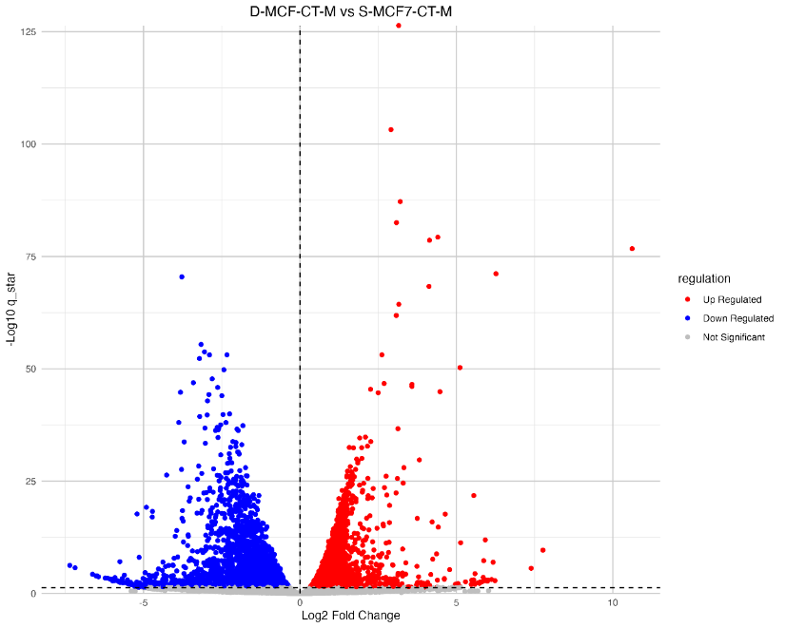
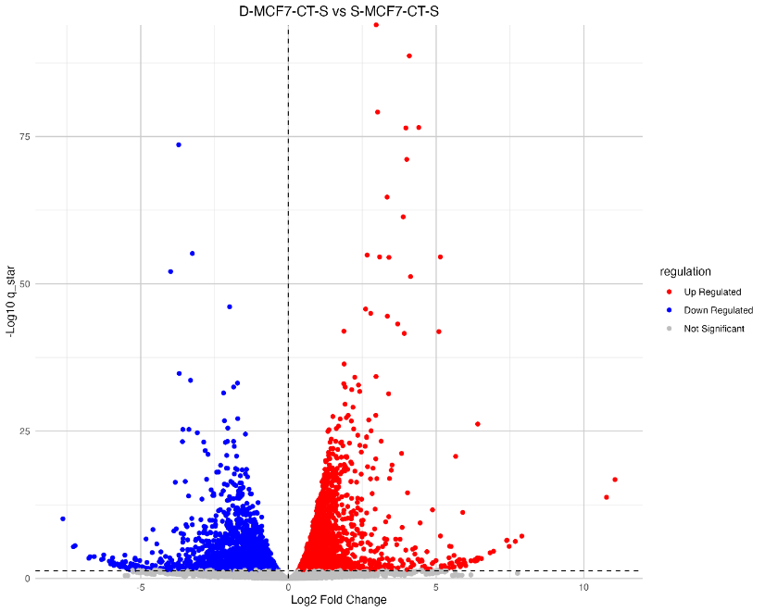
a)
b)

c)
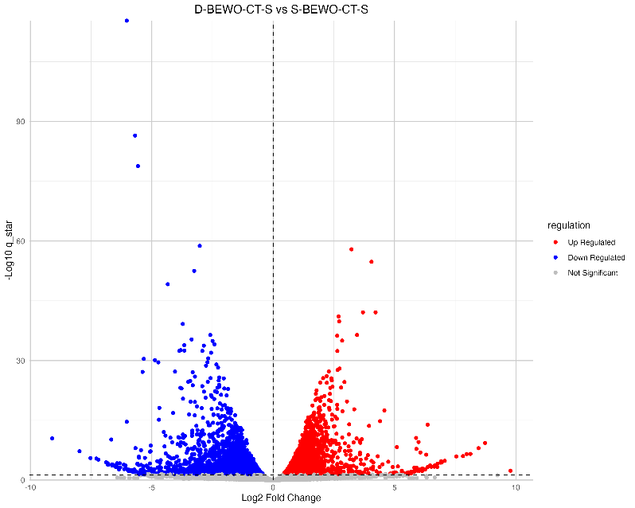
d)
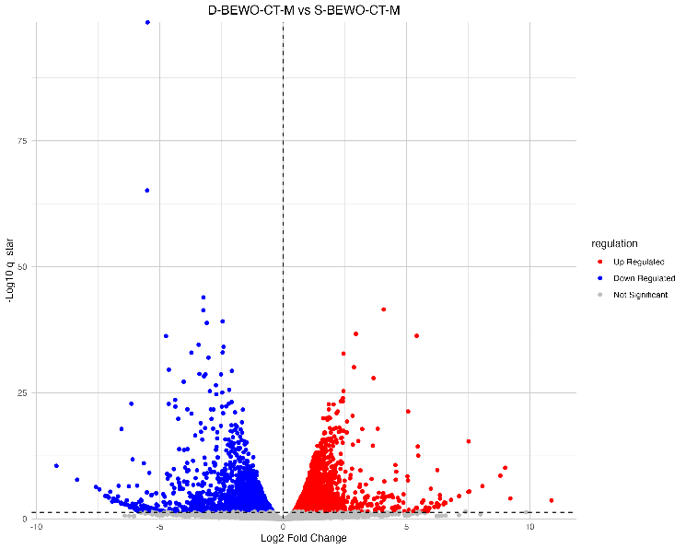

Supplementary Fig. 1: Volcano plots illustrating differential gene expression in the dynamic PABC model compared to the static model. Panels (a) and (b) represent MCF7 cells at S phase and M phase, respectively; panels (c) and (d) show BeWo cells at S phase and M phase, respectively. Significantly upregulated genes are depicted in red (right side), downregulated genes in blue (left side), and non-significant genes in grey.

Supplementary Fig. 2: log2 fold change of HSPA5 in media at 2.05 in media collected from dynamic PABC model versus static conditioned culture.
Supplementary Fig. 3: Increased mean gene expression of (FASN, FAS, CS, ACYL, HMGCR, MVK) but with no statistically significant difference in MCF7 dynamic PABC model versus static MCF7 conditioned culture.
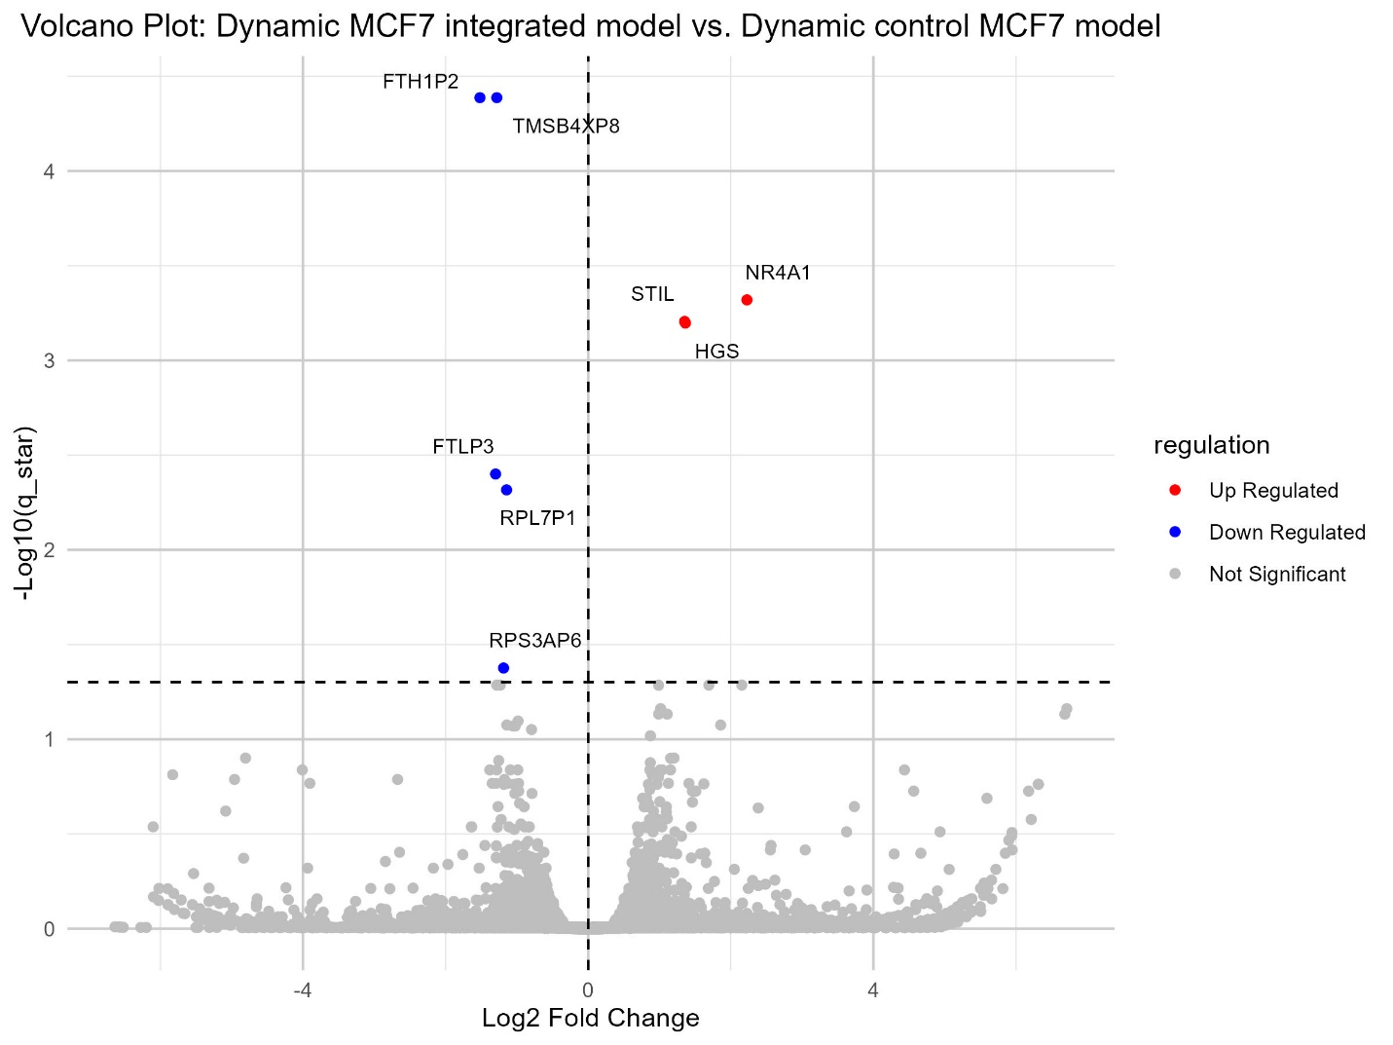
Supplementary Fig. 4: Volcano plots illustrating differential gene expression in MCF7 in the dynamic PABC model compared to the control dynamic MCF7 model. Significantly upregulated genes are depicted in red (right side), downregulated genes in blue (left side), and non-significant genes in grey.

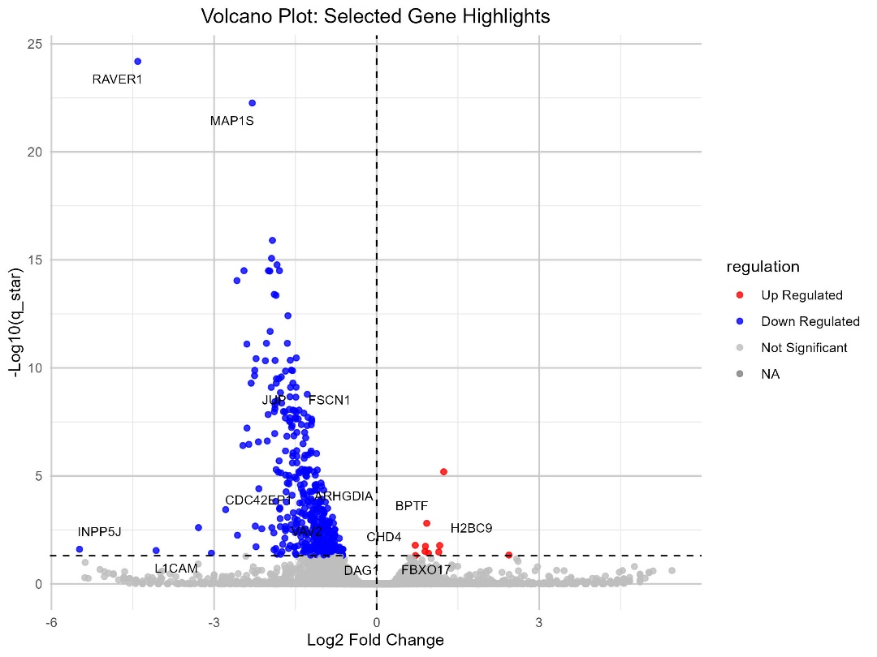
Supplementary Fig. 5: Volcano plots illustrating differential gene expression in BeWo in the dynamic PABC model compared to the BeWo in control dynamic model. Significantly upregulated genes are depicted in red (right side), downregulated genes in blue (left side), and non-significant genes in grey.

Supplementary Fig. 6: a) STC1 affected pathways as detected in [BP] of Go enrichment analysis showed significant enrichment of fructose metabolic process, response to vitamin D, calcium import and cAMP pathways. b) Fold change values of STC1, FBP1, FBP2, MUC5AC and MUC5B. c) KEGG and Reactom analysis showed enrichment of pentose phosphate pathways and fructose and mannose metabolism. d) PPI network shows HSPB1 and EPHA7 proteins shows highest degree of connectivity (k=82) and (k=57) respectively, where DEPs are colored according to their degree, while the surrounding gray nodes represent the 5–10 highest-degree interacting non-DEPs proteins within the network.

