T cell-mediated protection against lethal SARS-CoV-2 challenge by a synthetic long peptide vaccine targeting conserved CD4⁺ and CD8⁺ T cell epitopes

Additional file 1: Fig. S1-S12 and Table S1-S4.

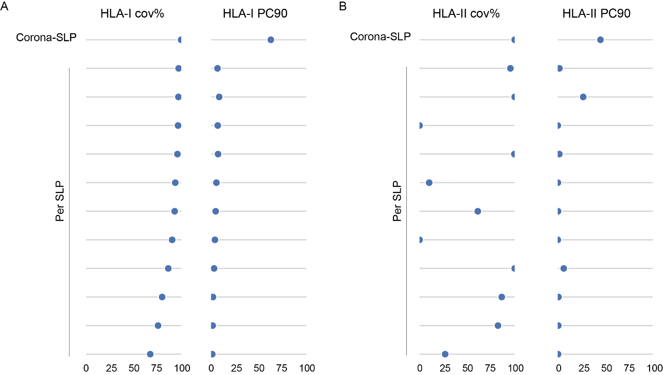
Fig. S1. Population coverage of the Corona-SLP vaccine. (A, B) Predicted population coverage of the final Corona-SLP set and individual SLPs for HLA class I (A) and HLA class II (B) in combined European and North American populations, based on predicted and validated epitopes. Population coverage is indicated as coverage percentage (cov%), and the number of epitopes recognized by 90% of the population is indicated as PC90. Related to Table S1.
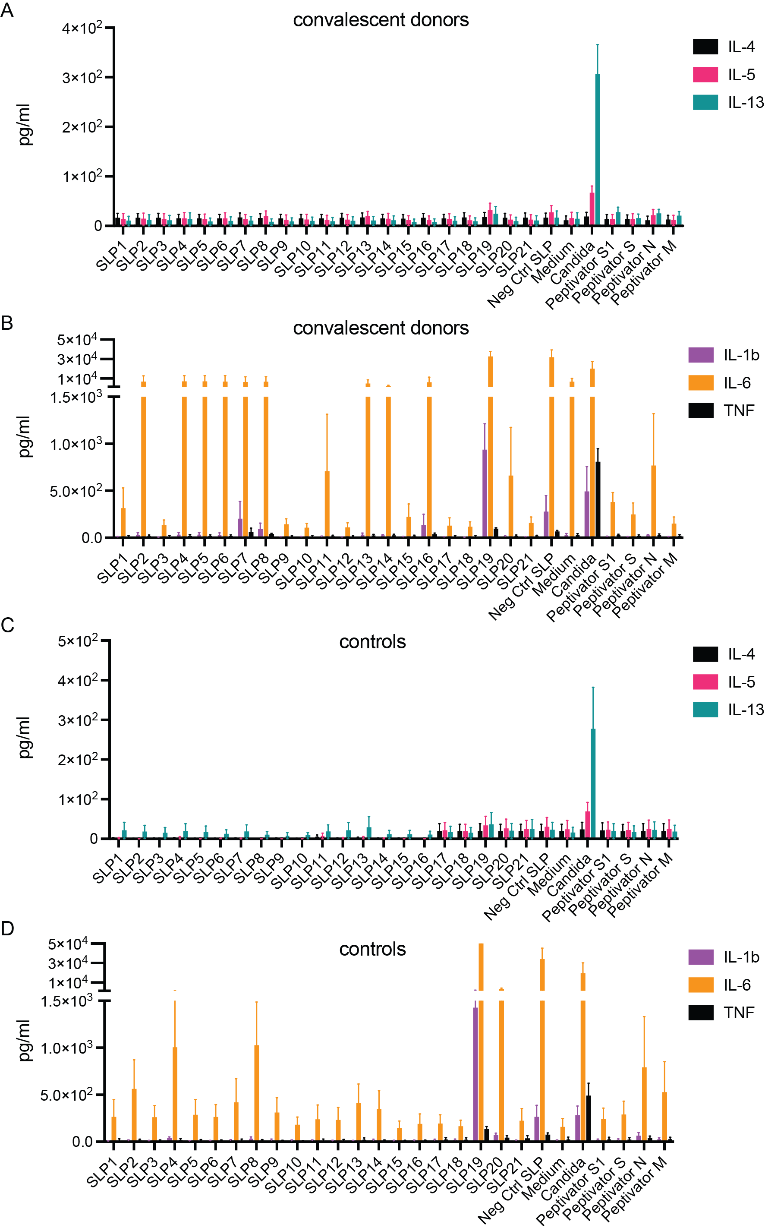
Fig. S2. Cytokine profiles of SLP-stimulated PBMCs from convalescent donors and healthy controls. Supernatants were collected after 3 days of in vitro stimulation with individual SLPs from PBMCs of 9 convalescent donors and 4 healthy controls included in the 4-day ELISpot assay. (A, B) Levels of IL-4, IL-5, and IL-13 (A), and IL-1β, IL-6, and TNF (B), in supernatants from SLP-stimulated PBMCs of convalescent donors. (C, D) Levels of IL-4, IL-5, and IL-13 (C), and IL-1β, IL-6, and TNF (D), in supernatants from SLP-stimulated PBMCs of healthy controls. Data are presented as mean ± SEM. Related to Figure 2.
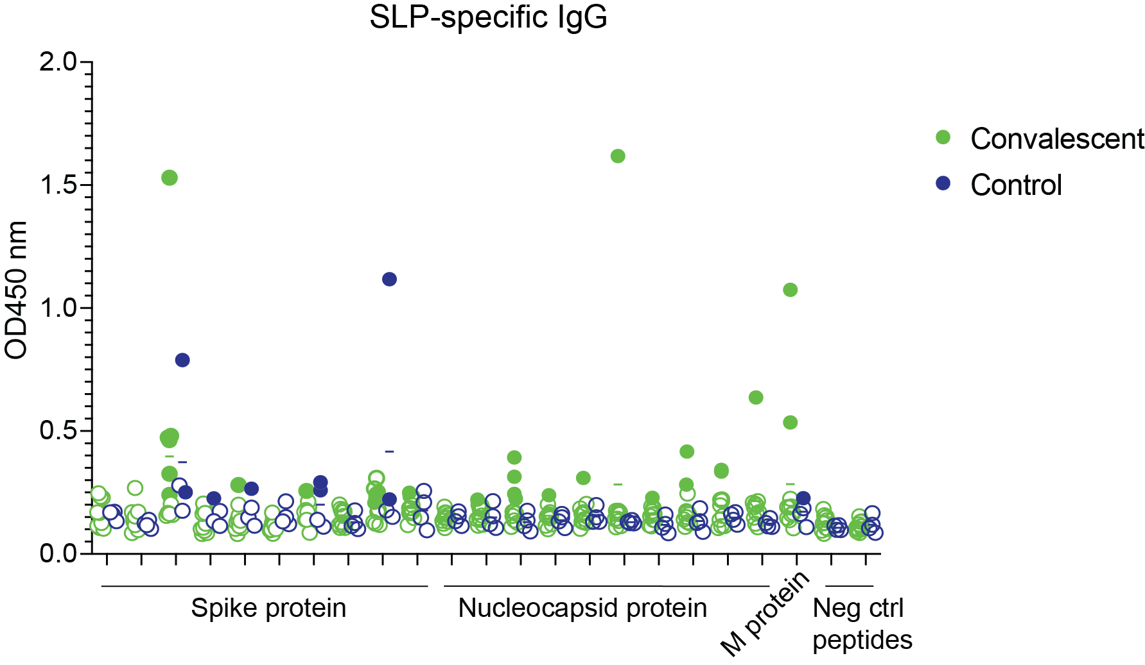
Fig. S3. IgG antibody responses to candidate Corona-SLPs in convalescent donors and healthy controls. OD450 values for 21 candidate SLPs and two negative-control SLPs are shown for convalescent donors (green) and healthy controls (blue). Sera were tested at a 1:50 dilution. Horizontal lines indicate group means. For each donor, the positivity threshold was defined as the mean OD450 of the two negative-control SLPs plus 2 standard deviations and an additional offset of 0.1. Values above the positivity threshold are indicated by filled circles.
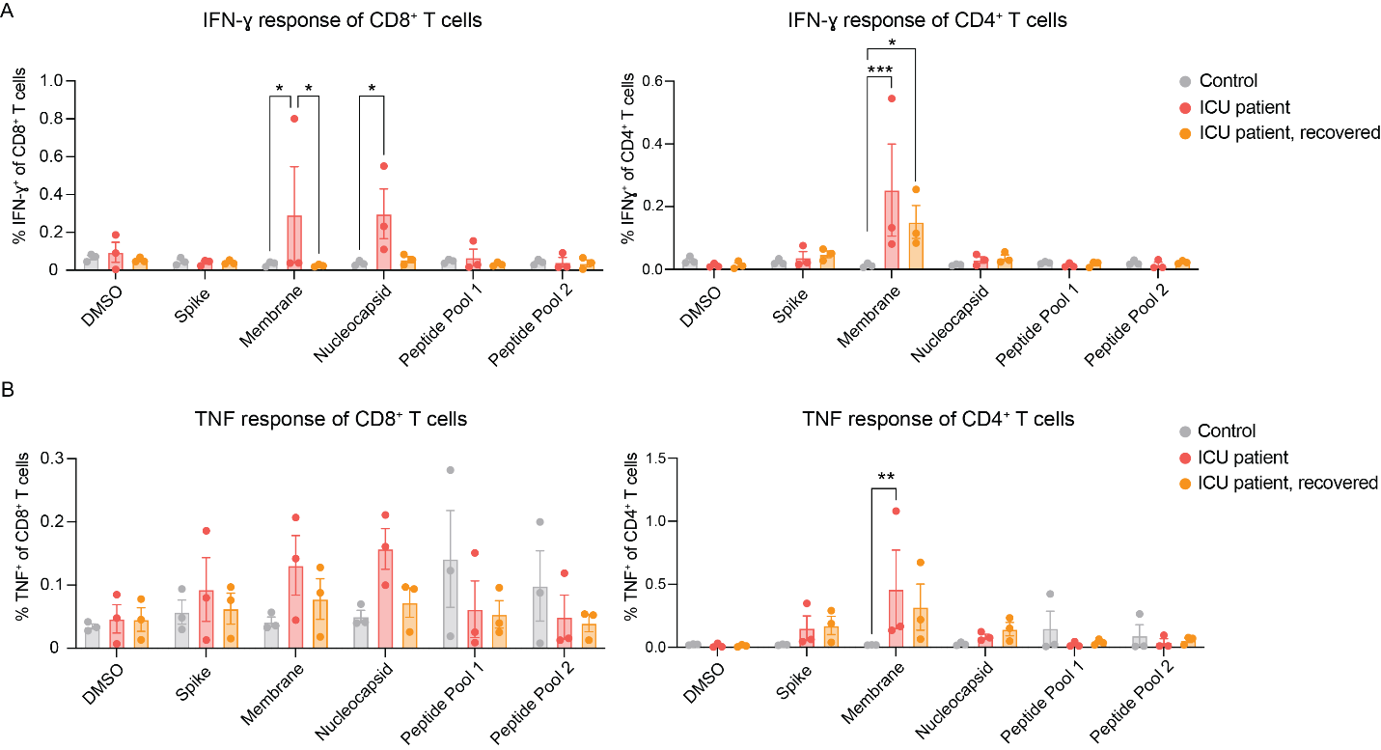
Figure S4. T-cell responses in ICU patients. (A, B) PBMCs from ICU patients and healthy controls were stimulated for 24 h with Peptivator peptide mixes derived from the S, M, and N proteins or with peptide pools containing Corona-SLPs. (A) IFN-γ responses of CD8⁺ T cells (left) and CD4⁺ T cells (right). (B) TNF responses of CD8⁺ T cells (left) and CD4⁺ T cells (right). Data are presented as mean ± SEM. Statistical significance was assessed using one-way ANOVA with Šidák’s multiple-comparison test. *P < 0.05; **P < 0.01.

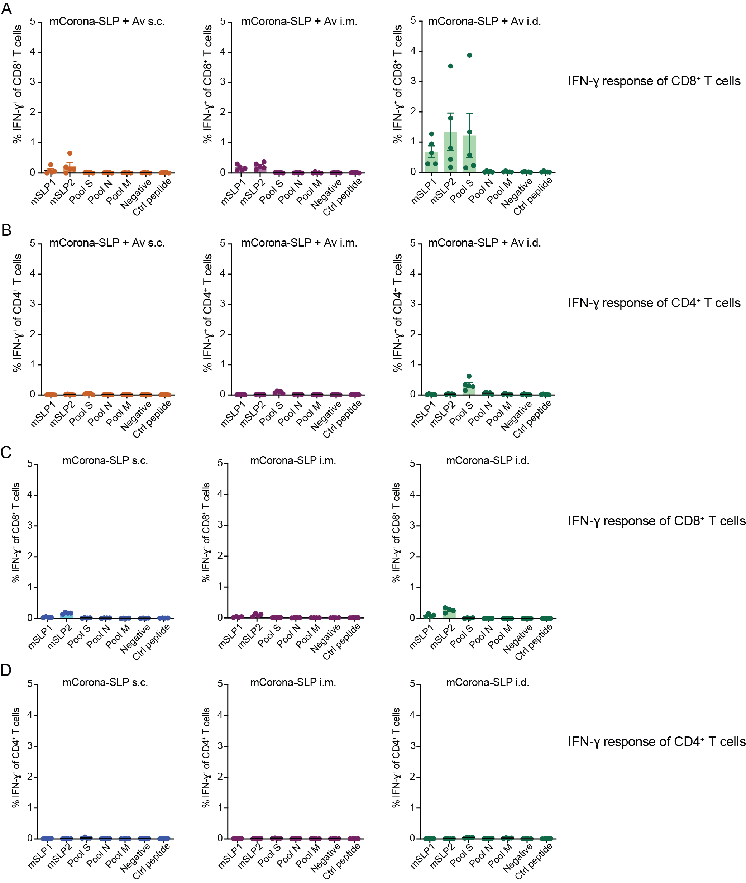
Fig. S5. Effects of route of administration and adjuvant use on mCorona-SLP-induced T-cell responses. (A, B) C57BL/6 mice received three sequential vaccinations in a prime–boost–boost regimen at 2-week intervals with mCorona-SLP (11 SLPs; 50 μg per SLP) combined with Amplivant (50 μg), administered intradermally (i.d.), subcutaneously (s.c.), or intramuscularly (i.m.). Splenocytes were harvested 7 days after the third vaccination and restimulated in vitro with mSLP1, mSLP2, or peptide pools derived from the S, N, and M proteins. IFN-γ responses of CD8⁺ T cells (A) and CD4⁺ T cells (B) are shown. (C, D) C57BL/6 mice received three sequential vaccinations in a prime–boost–boost regimen at 2-week intervals with mCorona-SLP (11 SLPs; 50 μg per SLP) without adjuvant, administered i.d., s.c., or i.m. Splenocytes harvested 7 days after the third vaccination were restimulated in vitro with mSLP1, mSLP2, or peptide pools derived from the remaining S-, N-, and M-derived SLPs. IFN-γ responses of CD8⁺ T cells (C) and CD4⁺ T cells (D) are shown. Dots represent individual mice. Data are presented as mean ± SEM.
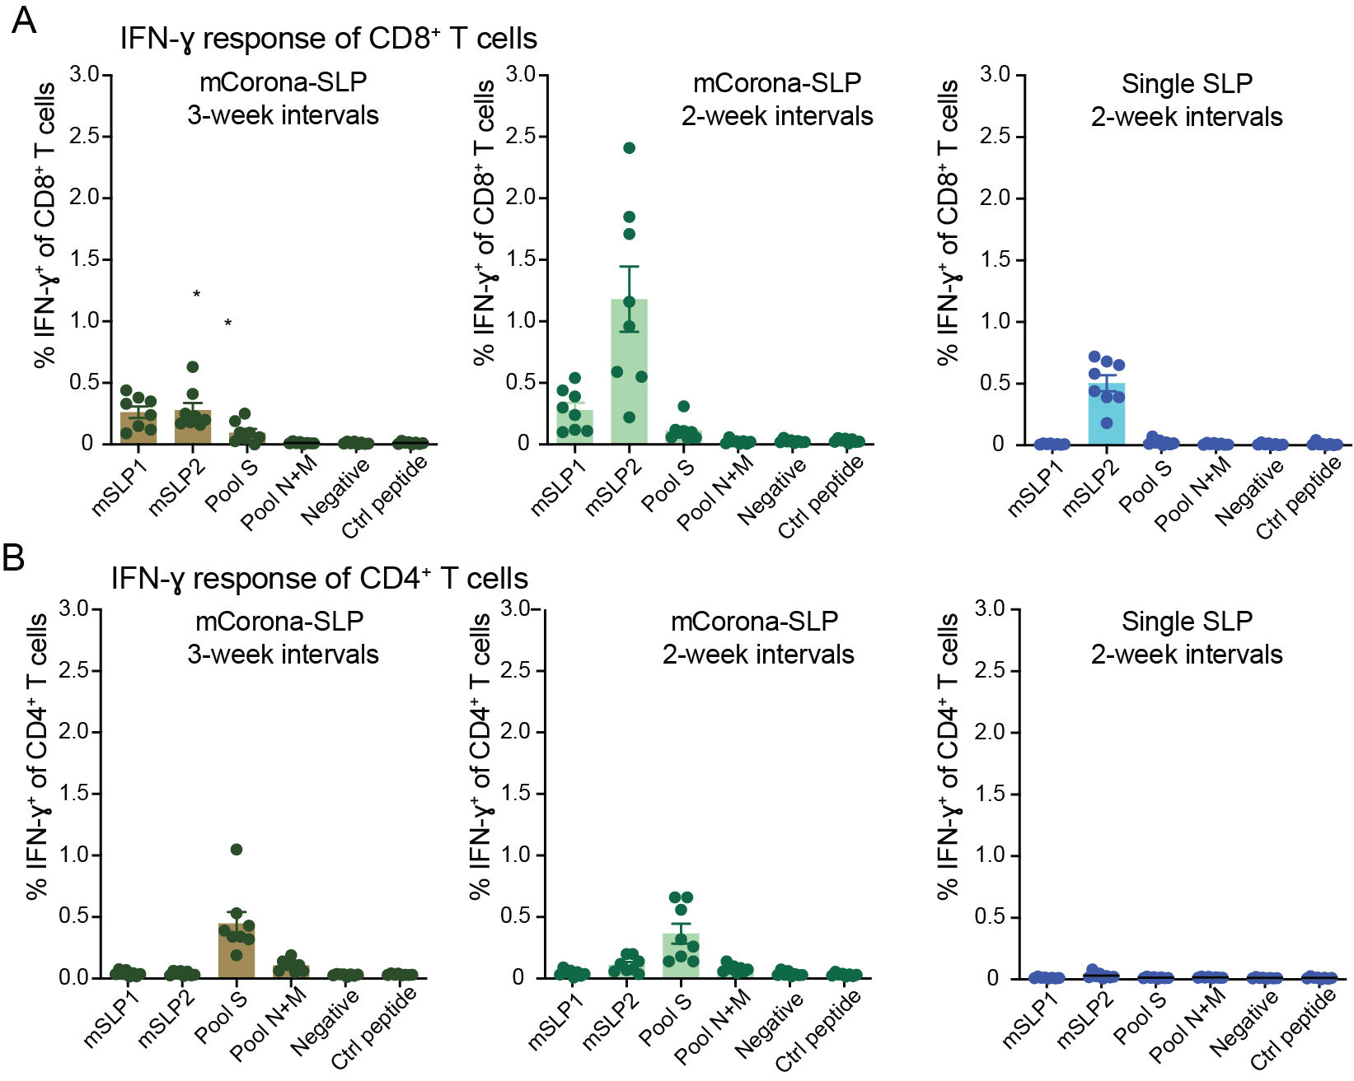
Fig. S6. Optimization of vaccination interval and vaccine composition. (A, B) C57BL/6 mice received three sequential vaccinations in a prime–boost–boost regimen at either 2- or 3-week intervals. Animals were vaccinated with either mCorona-SLP (11 SLPs; 50 μg per SLP) or a single SLP (mSLP2), each combined with Amplivant (50 μg). Splenocytes were harvested 7 days after the third vaccination and restimulated in vitro with mSLP1, mSLP2, or peptide pools derived from the S, N, and M proteins. IFN-γ responses of total CD8⁺ T cells (A) and total CD4⁺ T cells (B) were determined by intracellular cytokine staining. Dots represent individual mice. Data are presented as mean ± SEM.

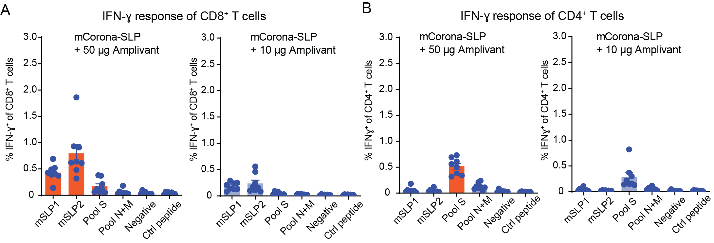
Fig. S7. Optimization of Amplivant dose. (A, B) C57BL/6 mice received three sequential vaccinations in a prime–boost–boost regimen at 2-week intervals with mCorona-SLP (11 SLPs; 50 μg per SLP) combined with either 50 μg or 10 μg Amplivant. Splenocytes harvested 7 days after the third vaccination were restimulated in vitro with mSLP1, mSLP2, or peptide pools derived from the S, N, and M proteins. IFN-γ responses of CD8⁺ T cells (A) and CD4⁺ T cells (B) are shown. Dots represent individual mice. Data are presented as mean ± SEM.

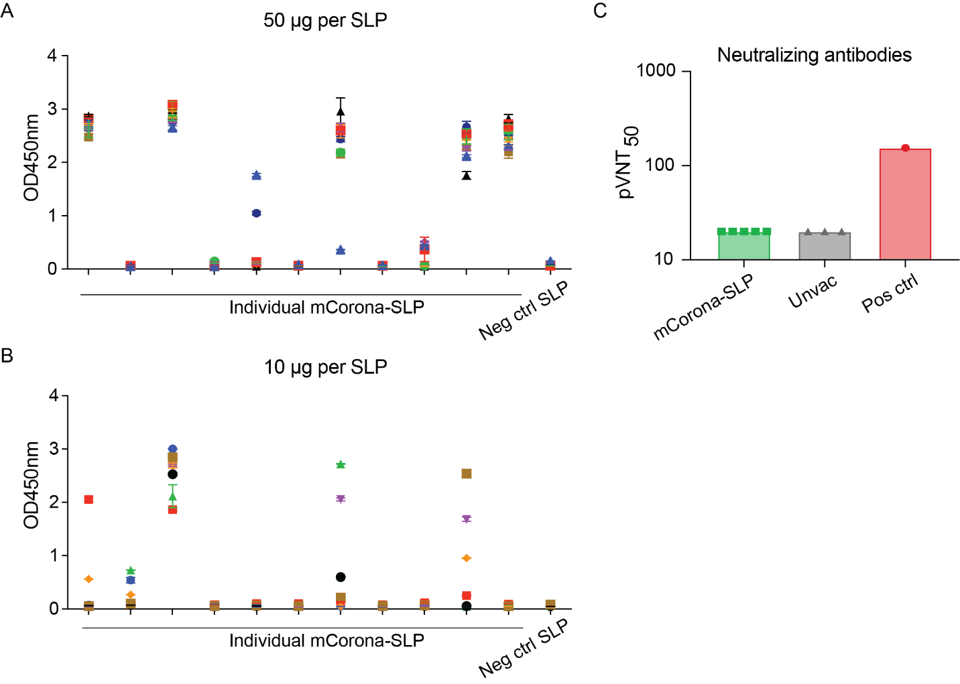
Fig. S8. SLP-specific IgG responses following mCorona-SLP vaccination. (A, B) C57BL/6 mice received three sequential vaccinations in a prime–boost–boost regimen at 2-week intervals with mCorona-SLP (11 SLPs; 50 μg or 10 μg per SLP) combined with Amplivant (50 μg). SLP-specific IgG responses were determined by ELISA. (A) IgG responses following vaccination with 50 μg per SLP. (B) IgG responses following vaccination with 10 μg per SLP. Each symbol represents an individual mouse. (C) Neutralizing antibody responses measured by pseudovirus neutralization assay on day 35 after the first vaccination (7 days after the third vaccination). Dots represent individual mice. Data are presented as mean ± SEM.

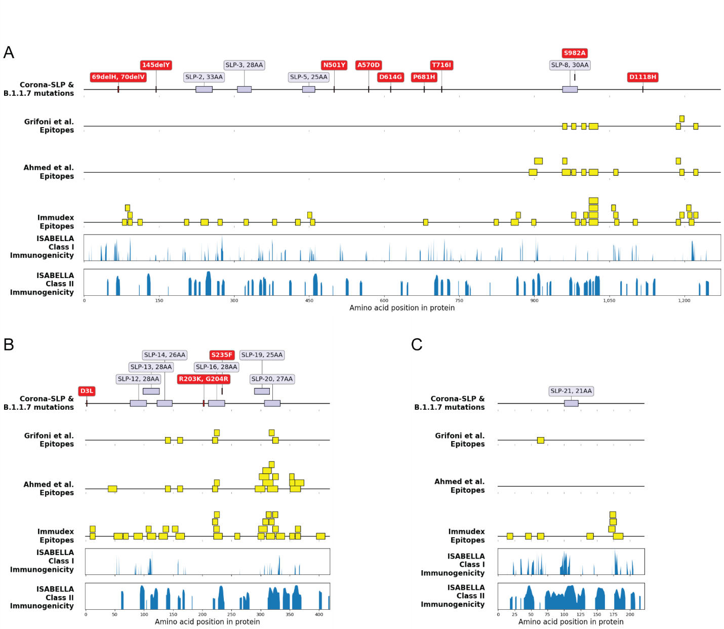

Fig. S9. Alignment of Alpha variant mutations with Corona-SLPs across SARS-CoV-2 proteins. (A–C) Overview of the S (A), N (B), and M (C) proteins showing the positions of Corona-SLPs (blue), B.1.1.7 (Alpha variant of concern) mutations (red), reported epitopes (yellow), and cumulative ISABELLA scores across the wild-type protein sequence (bottom panels). The alignment illustrates the overlap between these features and demonstrates that most Corona-SLPs remain unaffected by Alpha-associated mutations while retaining substantial predicted immunogenicity. Images were generated using the matplotlib and dna_features_viewer Python packages.

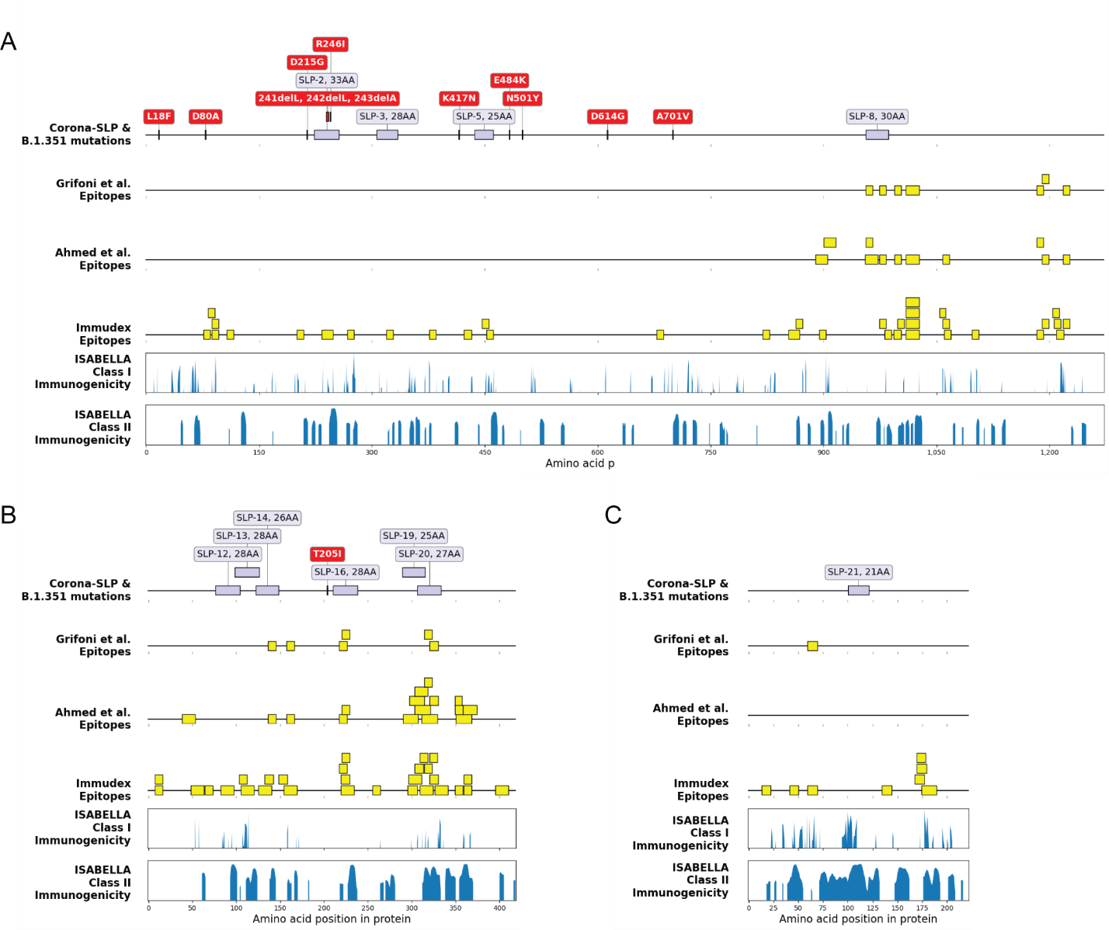
Fig. S10. Alignment of Beta variant mutations with Corona-SLPs across SARS-CoV-2 proteins. (A–C) Overview of the S (A), N (B), and M (C) proteins showing the positions of Corona-SLPs (blue), B.1.351 (Beta variant of concern) mutations (red), reported epitopes (yellow), and cumulative ISABELLA scores across the wild-type protein sequence (bottom panels). The alignment illustrates the overlap between these features and demonstrates that most Corona-SLPs remain unaffected by Beta-associated mutations while retaining substantial predicted immunogenicity. Images were generated using the matplotlib and dna_features_viewer Python packages.
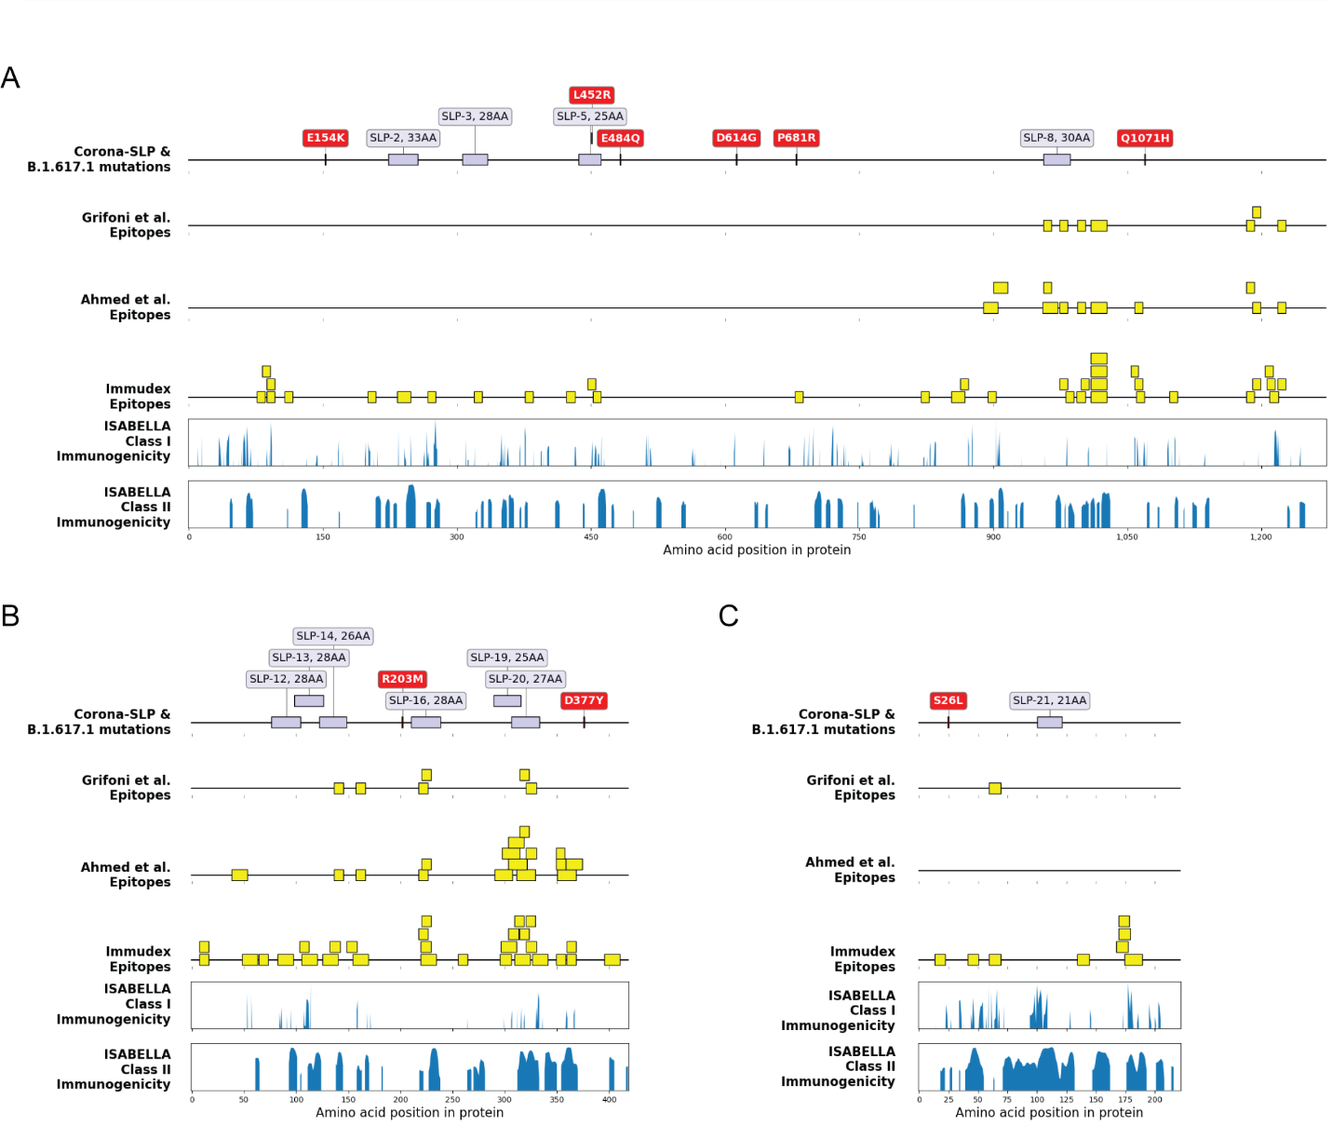
Fig. S11. Alignment of Delta variant mutations with Corona-SLPs across SARS-CoV-2 proteins. (A–C) Overview of the S (A), N (B), and M (C) proteins showing the positions of Corona-SLPs (blue), B.1.617.1 (Delta variant of concern) mutations (red), reported epitopes (yellow), and cumulative ISABELLA scores across the wild-type protein sequence (bottom panels). The alignment illustrates the overlap between these features and demonstrates that most Corona-SLPs remain unaffected by Delta-associated mutations while retaining substantial predicted immunogenicity. Images were generated using the matplotlib and dna_features_viewer Python packages.
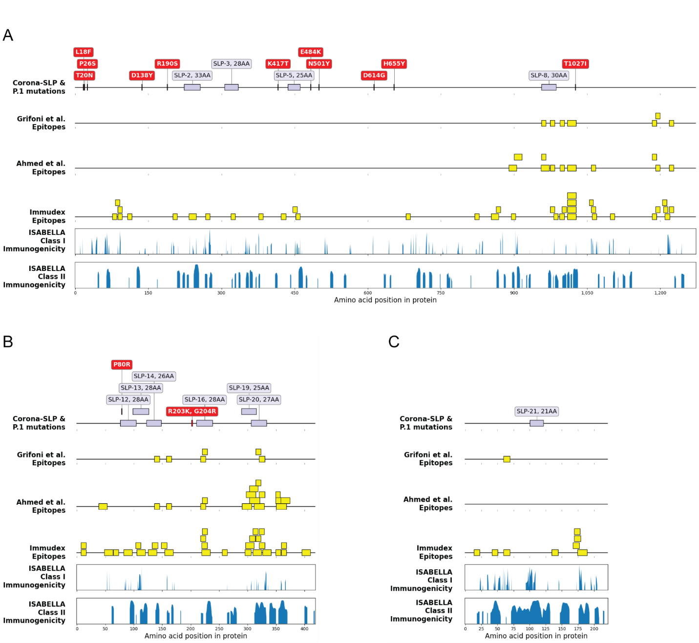
Fig. S12. Alignment of Gamma variant mutations with Corona-SLPs across SARS-CoV-2 proteins. (A–C) Overview of the S (A), N (B), and M (C) proteins showing the positions of Corona-SLPs (blue), P.1 (Gamma variant of concern) mutations (red), reported epitopes (yellow), and cumulative ISABELLA scores across the wild-type protein sequence (bottom panels). The alignment illustrates the overlap between these features and demonstrates that most Corona-SLPs remain unaffected by Gamma-associated mutations while retaining substantial predicted immunogenicity. Images were generated using the matplotlib and dna_features_viewer Python packages.

Table S1. Candidate SLPs designed for human Corona-SLP vaccine. Final selected set of Corona-SLPs for studies in humans is indicated in bold. The selected set of Corona-SLPs for vaccination of mice is shown in italics. The final composition of mCorona-SLP consisted of these SLPs (containing predicted, but not validated mouse MHC class I epitopes), supplemented with 5 SLPs designed around validated C57BL/6 mouse H-2^{b} class I epitopes (see Table S3).
SLP# | SARS-CoV-2 protein | Sequence | Predicted murine MHC class I epitopes | Predicted murine MHC class II epitopes
SLP-1 | S protein | HSTQDLFLPFFSNVTWFHAIHVSGTN | STQDLFLPF, QDLFLPFFSNV, DLFLPFFSNV, LFLPFFSNV, LFLPFFSNVT, FLPFFSNV, FSNVTWFHAI, SNVTWFHAI, SNVTWFHAIHV, VTWFHAIHV, TWFHAIHV, FLPFFSNVTWF, FFSNVTWF, FFSNVTWFHAI, FSNVTWFHA | HSTQDLFLPFFSNVT, STQDLFLPFFSNVTW, TQDLFLPFFSNVTWF, QDLFLPFFSNVTWFH, DLFLPFFSNVTWFHA, LFLPFFSNVTWFHAI, FLPFFSNVTWFHAIH, FSNVTWFHAIHVSGT, SNVTWFHAIHVSGTN, NVTWFHAIHVSGTNG
SLP-2 | S protein | PLVDLPIGINITRFQTLLALHRSYLTPGDSSSG
SLP-3 | S protein | VEKGIYQTSNFRVQPTESIVRFPNITNL | SNFRVQPT, PTESIVRFPNI, TESIVRFPNI, TESIVRFPNIT, ESIVRFPNI, SIVRFPNI | YQTSNFRVQPTESIV, QTSNFRVQPTESIVR, TSNFRVQPTESIVRF, SNFRVQPTESIVRFP
SLP-4 | RBD in S protein | TGCVIAWNSNNLDSKVGGNYNYLYRLFRKSN | VIAWNSNNL, IAWNSNNL, KVGGNYNYL, VGGNYNYL, VGGNYNYLYRL, GGNYNYLYRL, GGNYNYLYRLF, GNYNYLYRL, GNYNYLYRLF, GNYNYLYRLFR, NYNYLYRL, YNYLYRLF, CVIAWNSNNL, SKVGGNYNYL
SLP-5 | RBD in S protein | SNNLDSKVGGNYNYLYRLFRKSNLK
SLP-6 | RBD in S protein | SKVGGNYNYLYRLFRKSNLKPFERDIS
SLP-7 | RBD in S protein | STPCNGVEGFNCYFPLQSYGFQPTNGVGY
SLP-8 | S protein | ALNTLVKQLSSNFGAISSVLNDILSRLDKV
SLP-9 | S protein | VLNDILSRLDKVEAEVQIDRLITGRLQSLQTY
SLP-10 | S protein | KEIDRLNEVAKNLNESLIDLQELGK
SLP-11 | N protein | LPNNTASWFTALTQHGKEDLKFPRGQGVPINTN
SLP-12 | N protein | SSPDDQIGYYRRATRRIRGGDGKMKDLS
SLP-13 | N protein | KMKDLSPRWYFYYLGTGPEAGLPYGANK | DLSPRWYFYYL, LSPRWYFYYL, LSPRWYFYYLG, SPRWYFYYL, RWYFYYLGT | LSPRWYFYYLGTGPE, SPRWYFYYLGTGPEA, PRWYFYYLGTGPEAG, RWYFYYLGTGPEAGL, WYFYYLGTGPEAGLP, YFYYLGTGPEAGLPY, FYYLGTGPEAGLPYG, YYLGTGPEAGLPYGA
SLP-14 | N protein | GANKDGIIWVATEGALNTPKDHIGTR | IWVATEGAL | GIIWVATEGALNTPK, IIWVATEGALNTPKD
SLP-15 | N protein | VLQLPQGTTLPKGFYAEGSRGGSQASSRSSSRS
SLP-16 | N protein | GNGGDAALALLLLDRLNQLESKMSGKGQ
SLP-17 | N protein | YNVTQAFGRRGPEQTQGNFGDQ
SLP-18 | N protein | IRQGTDYKHWPQIAQFAPSASAFF
SLP-19 | N protein | IRQGTDYKHWPQIAQFAPSASAFFG
SLP-20 | N protein | APSASAFFGMSRIGMEVTPSGTWLTYT
SLP-21 | M protein | LFARTRSMWSFNPETNILLNV | SMWSFNPE, SMWSFNPET, SMWSFNPETNI, WSFNPETNI | TRSMWSFNPETNILL, RSMWSFNPETNILLN
Neg control SLP | HBV control | HYFQTRHYLHTLWKAGILYKRETTR
Neg control SLP | Albumine control | ADCCAKQEPERNECFLQHKDDNPNLPRLVRPEVD

Table S2. List of 5 SLPs designed around validated murine C57BL/6 MHC class I epitopes.
SLP# | SARS-CoV-2 protein | Sequence | Validated murine MHC class I epitopes
mSLP1 | S protein | SGWTAGAAAYYVGYLQPRTFL | AAYYVGYL
mSLP2 | S protein | IKNQCVNFNFNGLTGTGVLTESNK | VNFNFNGL
mSLP3 | S protein | STEIYQAGSTPCNGVEGFNCYFPLQ | EIYQAGST
mSLP4 | S protein | PQNQRNAPRITFGGPSDSTGSNQNG | QRNAPRITFGGPSDS
mSLP5 | S protein | PDPSKPSKRSFIEDLLFNKVTLADA | DLLFNKVTL

Table S3. SLP population coverage. Final set of Corona-SLP and individual SLP coverage in Europe and North America combined, of predicated and validated epitopes. Percentage of coverage indicated, number of epitopes recognized by 90% of the population indicated by PC90. Related to Supplementary Figure 1.
HLA class | I |  |  | II
 | average_hit of HLA-I molecules | % coverage | pc90 | average_hit of HLA-II molecules | % coverage | pc90
Corona-SLP | 29.46 | 99.915 | 15.72 | 58.335 | 100 | 44.885
Per SLP | 3.335 | 93.755 | 1.4 | 0.21 | 10.095 | 0.11
Per SLP | 2.27 | 90.47 | 1.02
Per SLP | 2.005 | 79.93 | 0.5 | 1.335 | 86.445 | 0.74
Per SLP | 2.725 | 75.615 | 0.415 | 2.42 | 82.465 | 0.575
Per SLP | 4.095 | 97.285 | 1.69 | 5.46 | 95.52 | 1.735
Per SLP | 4.235 | 96.03 | 1.83 | 2.865 | 99.68 | 1.66
Per SLP | 3.84 | 96.67 | 1.75
Per SLP | 2.31 | 86.39 | 0.795 | 9.785 | 99.995 | 6.26
Per SLP | 1.3 | 67.455 | 0.31 | 0.975 | 26.9 | 0.275
Per SLP | 4.585 | 97.06 | 2.135 | 34.665 | 100 | 26.73
Per SLP | 2.875 | 93.1 | 1.215 | 0.83 | 61.235 | 0.26

Table S4. Effect of SARS-CoV-2 variants on Corona-SLP epitopes. The effect of each variant of concern (VOC) on the final set of human Corona-SLP.
Lineage | VOC Defining S/N/M Protein Mutations | Affected SLPs from Final Set | Remaining Putative Epitopes out of Total Number of Epitopes in affected SLP
B.1.1.7  (Alpha variant) | S:N501Y; S:A570D; S:P681H; S:T716I; S:S982A; S:D1118H; N:D3L; N:S235F | SLP-8 | 6/17
B.1.1.7  (Alpha variant) |  | SLP-16 | 15/16
B.1.1.351  (Beta variant) | S:D80A; S:D215G; S:K417N; S:A701V; S:N501Y; S:E484K | SLP-2 | 17/25
B.1.617.1  (Delta variant) | S:E154K; S:L452R; S:E484Q; S:D614G; S:P681R; S:Q1071H; N:R203M; N:D377Y; M:S26L | SLP-5 | 0/19
B.1.617.1  (Delta variant) |  | SLP-6 | 9/28
P.1  (Gamma variant) | S:L18F; S:T20N; S:P26S; S:D138Y; S:R190S; S:K417T; S:E484K; S:N501Y; S:H655Y; S:T1027I; N:P80R | SLP-12 | 4/8
B.1.1.529  (Omicron variant) | S:A67V; S:T95I; S:G339D; S:S371L; S:S373P; S:K417N; S:N440K; S:G446S; S:S477N; S:T478K; S:E484A; S:Q493R; S:G496S; S:Q498R; S:N501Y; S:T547K; S:D614G; S:H655Y; S:N679K; S:P681H; S:N764K; S:D796Y; S:N856K; S:Q954H; S:N969K; N:RG203KR; M:D3G; M:Q19E; M:A63T | SLP-8 | 4/17

