Supplementary Information

Bioinspired Lotus Fiber-Based Graphene Electronic Textile for Gas Sensing

Da Yeon Cheong^{a,b,†}, Sang Won Lee^{c,†}, Hyo Gi Jung^{c,d}, Seokbeom Roh^{a,b}, Dongtak Lee^{c}, Taeha Lee^{a,b}, Saebomeena Leeª, Wonseok Lee^{e}, Dae Sung Yoon^{c,d,*}, Gyudo Lee^{a,b,*}

ªDepartment of Biotechnology and Bioinformatics, Korea University, Sejong 30019, South Korea
^{b}Interdisciplinary Graduate Program for Artificial Intelligence Smart Convergence Technology, Korea University, Sejong 30019, South Korea
^{c}School of Biomedical Engineering, Korea University, Seoul 02841, South Korea
^{d}Interdisciplinary Program in Precision Public Health, Korea University, Seoul 02841, South Korea
^{e}Department of Electrical Engineering, Korea National University of Transportation, Chungju 27469, South Korea
†These authors contributed equally to this work.
*Corresponding author: G.L. (E-mail: lkd0807@korea.ac.kr); D.S.Y. (dsyoon@korea.ac.kr)
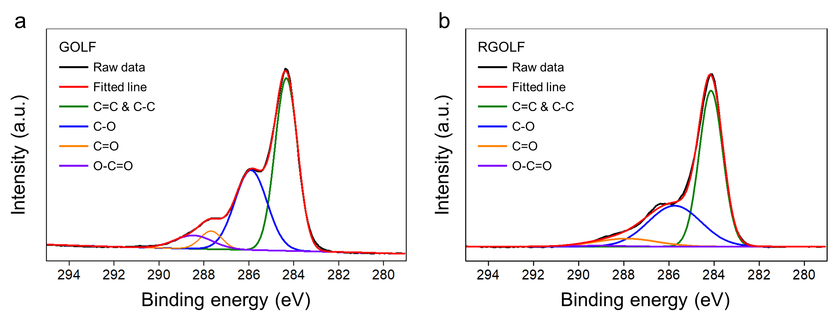
Figure S1. High resolution XPS C 1s spectra of (a) the GOLF, and (b) the RGOLF
Table S1. Analysis of deconvoluted C 1s peaks obtained from the XPS spectra of GOLF and RGOLF
Sample |  | C=C & C-C | C-O | C=O | O-C=O
GO-coated CF  (i.e., the GOLF) | Area | 46827.89 | 30940.57 | 4672.53 | 6060.09
GO-coated CF  (i.e., the GOLF) | Area (%) | 52.92 | 34.96 | 5.28 | 6.85
rGO-coated CF  (i.e., the RGOLF) | Area | 42144.42 | 24732.25 | 54479.97 | 473.26
rGO-coated CF  (i.e., the RGOLF) | Area (%) | 57.87 | 33.95 | 7.52 | 0.65

Table S2. Electrical properties of RGOLFs fabricated with 1 g/L of graphene and various dimeters (150 – 300 μm). (Electrical current measured at 2 V applied voltage)
Diameter | Electric current | Electrical conductance
150 μm | 1.76 ± 0.10 μA | 0.87 ± 0.06 μS
200 μm | 3.05 ± 0.32 μA | 1.49 ± 0.20 μS
250 μm | 4.70 ± 0.24 μA | 2.33 ± 0.11 μS
300 μm | 9.31 ± 0.40 μA | 4.63 ± 0.22 μS

