Fig. S1 Donor/sample sensitivity of the strict-core fibroblast activation-like continuum
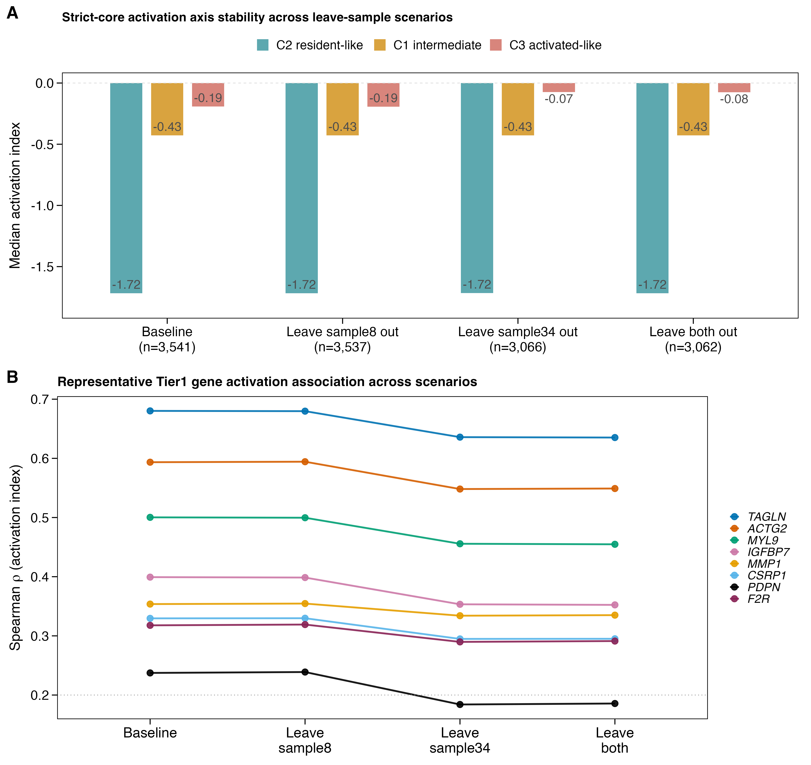

Fig. S1 summarizes the strict-core sample sensitivity analysis in GSE183904. Panel A compares the activation-index cluster order at baseline, after leaving out sample8, after leaving out sample34, and after leaving out both samples, testing whether the order cluster 2 < cluster 1 < cluster 3 is preserved. Panel B summarizes representative Tier1 activation-related genes (TAGLN, ACTG2, MYL9, IGFBP7, MMP1, CSRP1, PDPN, F2R) across the same sensitivity scenarios. The analysis tested whether the strict-core activation axis and Tier1 activation signal were driven solely by the sample8 or sample34 donor imbalance; six of the eight representative genes retained the expected signal in all scenarios; APOD and LSP1 lost signal in the sample34-absent scenarios, and APOD is part of the final seven-gene signature, indicating partial donor sensitivity.

Fig. S2 Frozen-score bootstrap sensitivity analysis of TCGA internal performance
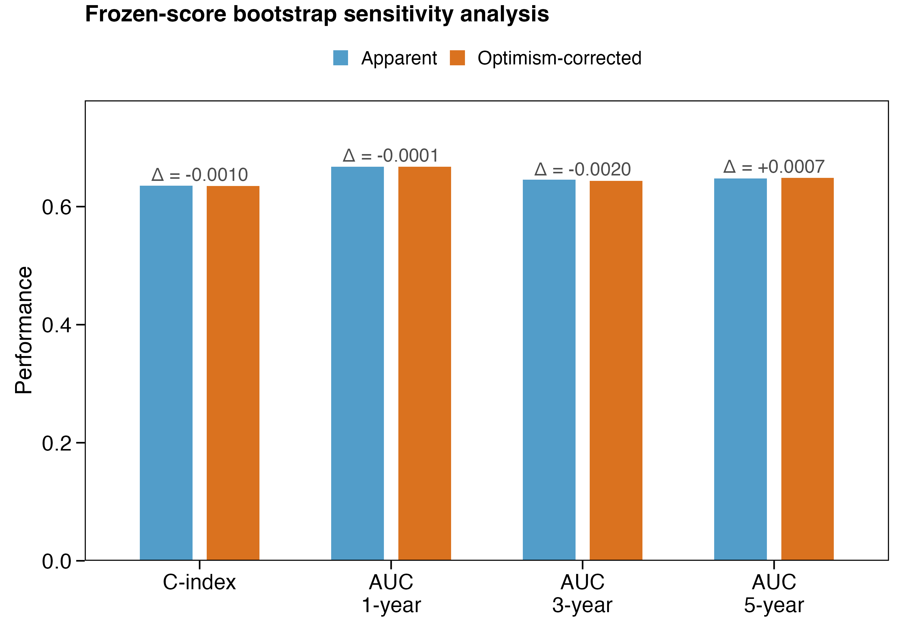

Fig. S2 compares apparent and optimism-corrected C-index and time-dependent AUC using frozen-score bootstrap resampling (1,000 resamples). This analysis uses the fixed final seven-gene risk score without gene reselection, LASSO refitting, coefficient updating, or cutoff updating. Maximum observed optimism was 0.002, indicating negligible fixed-score overfitting beyond the original model-development pipeline.

Fig. S3 Full-pipeline bootstrap optimism correction and gene-selection stability
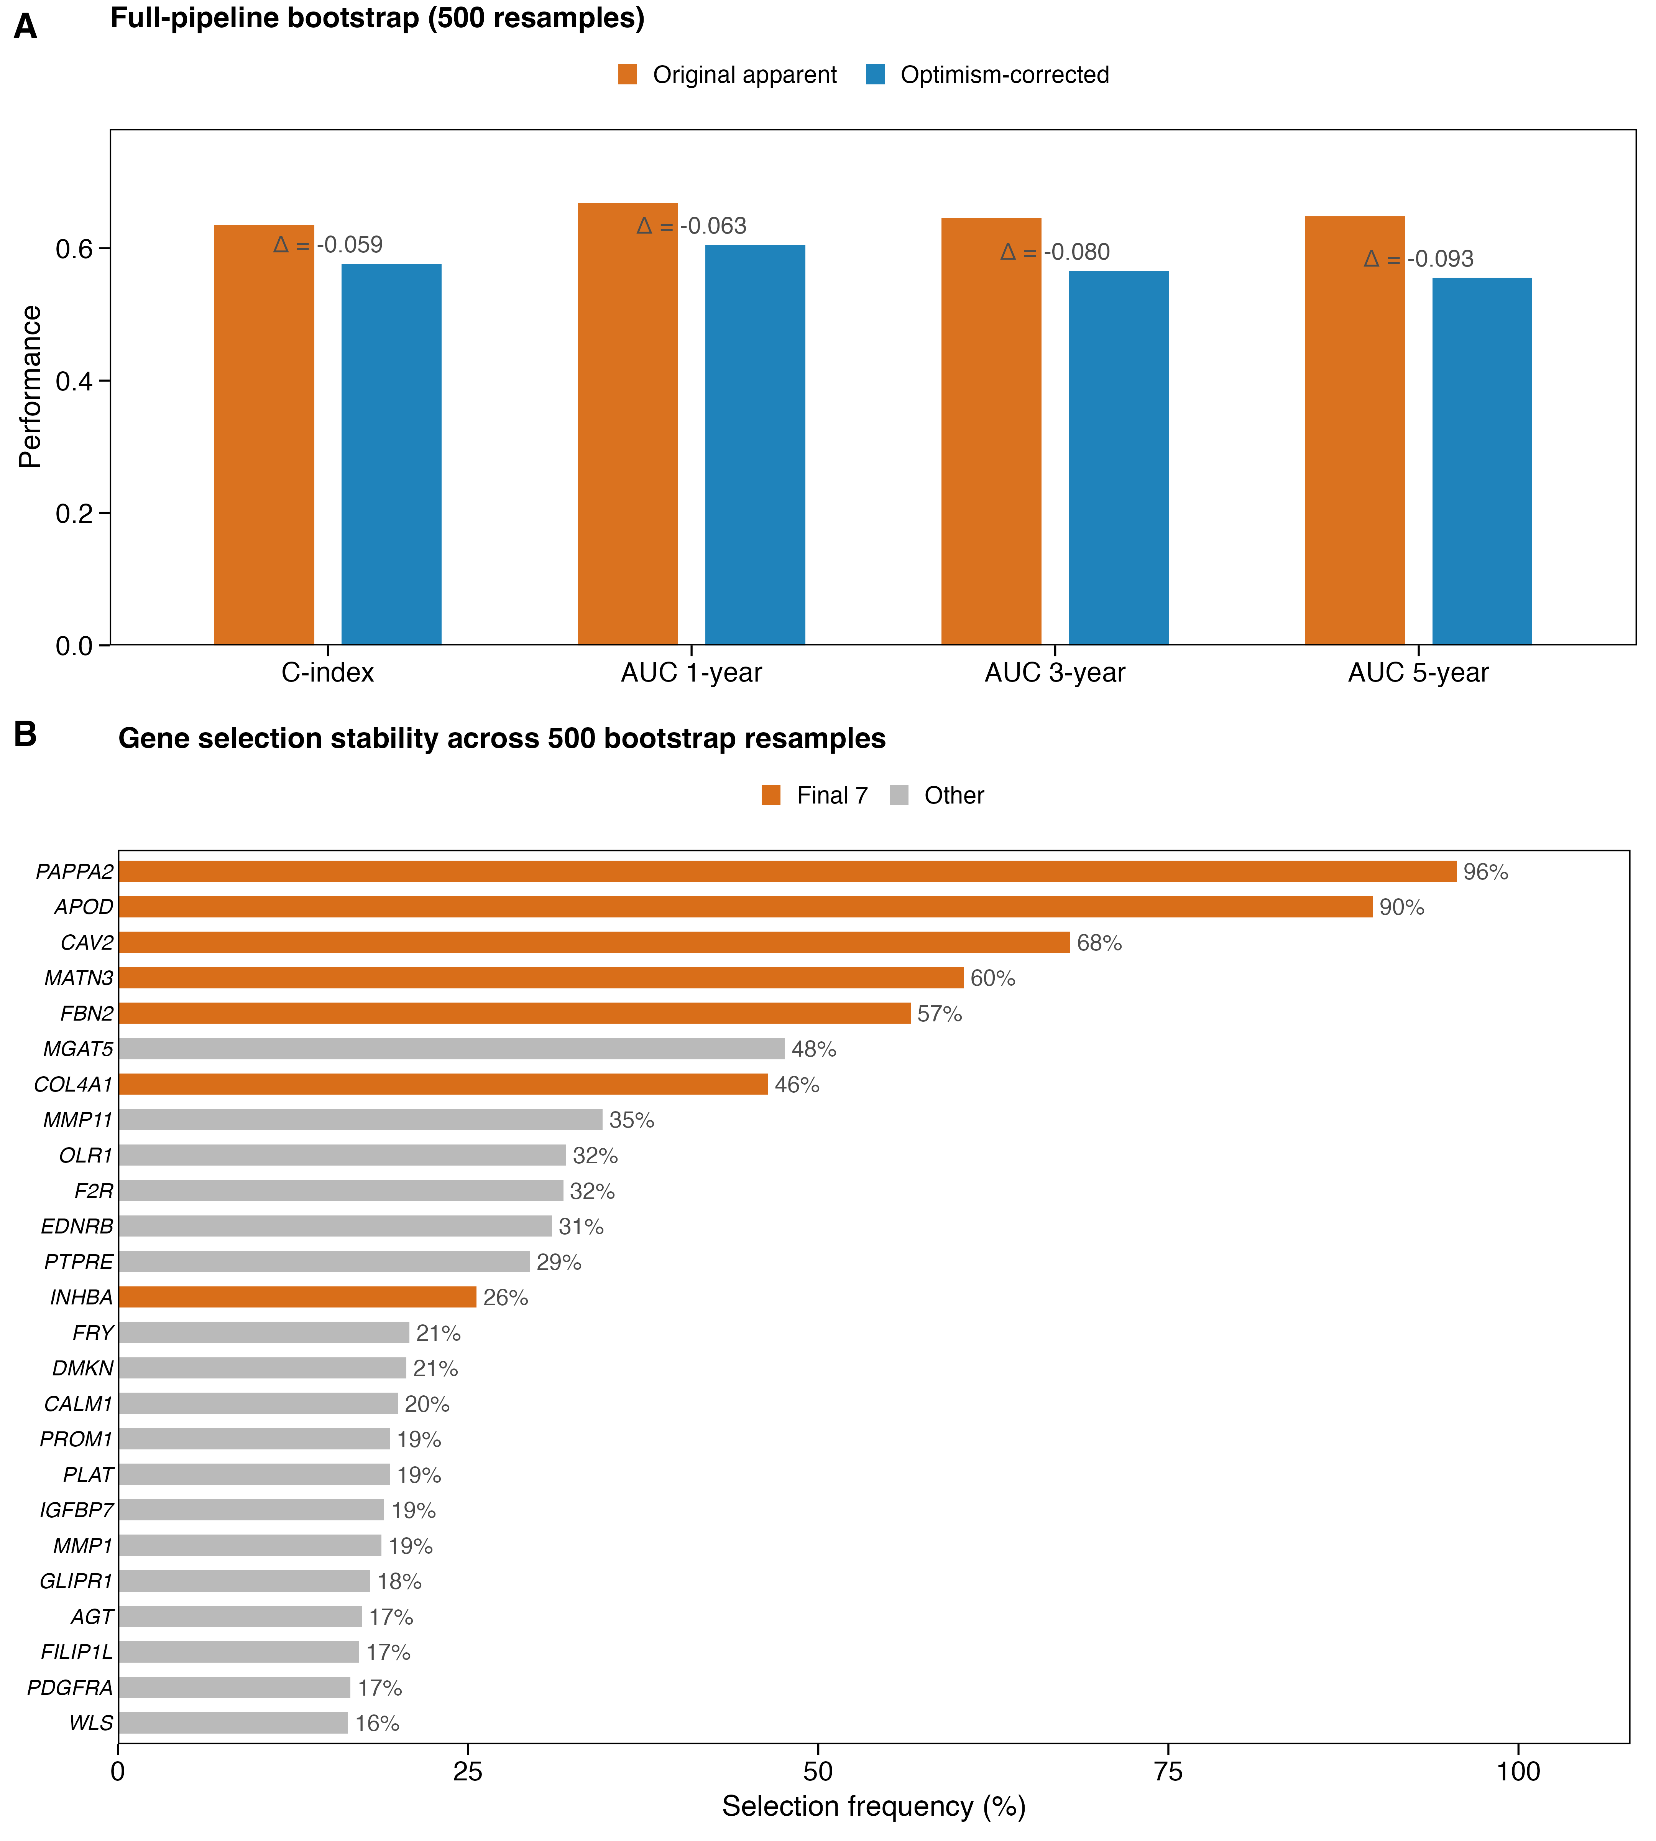

Fig. S3 summarizes the full-pipeline bootstrap analysis (500 resamples) in which univariable Cox screening, LASSO-Cox lambda.min fitting, coefficient estimation, and bootstrap-median cutoff derivation were repeated in each resample. Panel A compares original apparent and optimism-corrected C-index and time-dependent AUC; the corrected C-index was 0.576, with mean optimism of 0.059. Panel B shows gene selection frequency across the 500 resamples for the 25 most frequently selected genes, with the final seven signature genes highlighted. This figure assesses model-development optimism and gene-selection stability from the broader 105-gene mapped Tier1 pool and should not be interpreted as a replacement model for the final fixed seven-gene signature.

Fig. S4 Risk score compared with StromalScore and ESTIMATEScore in TCGA
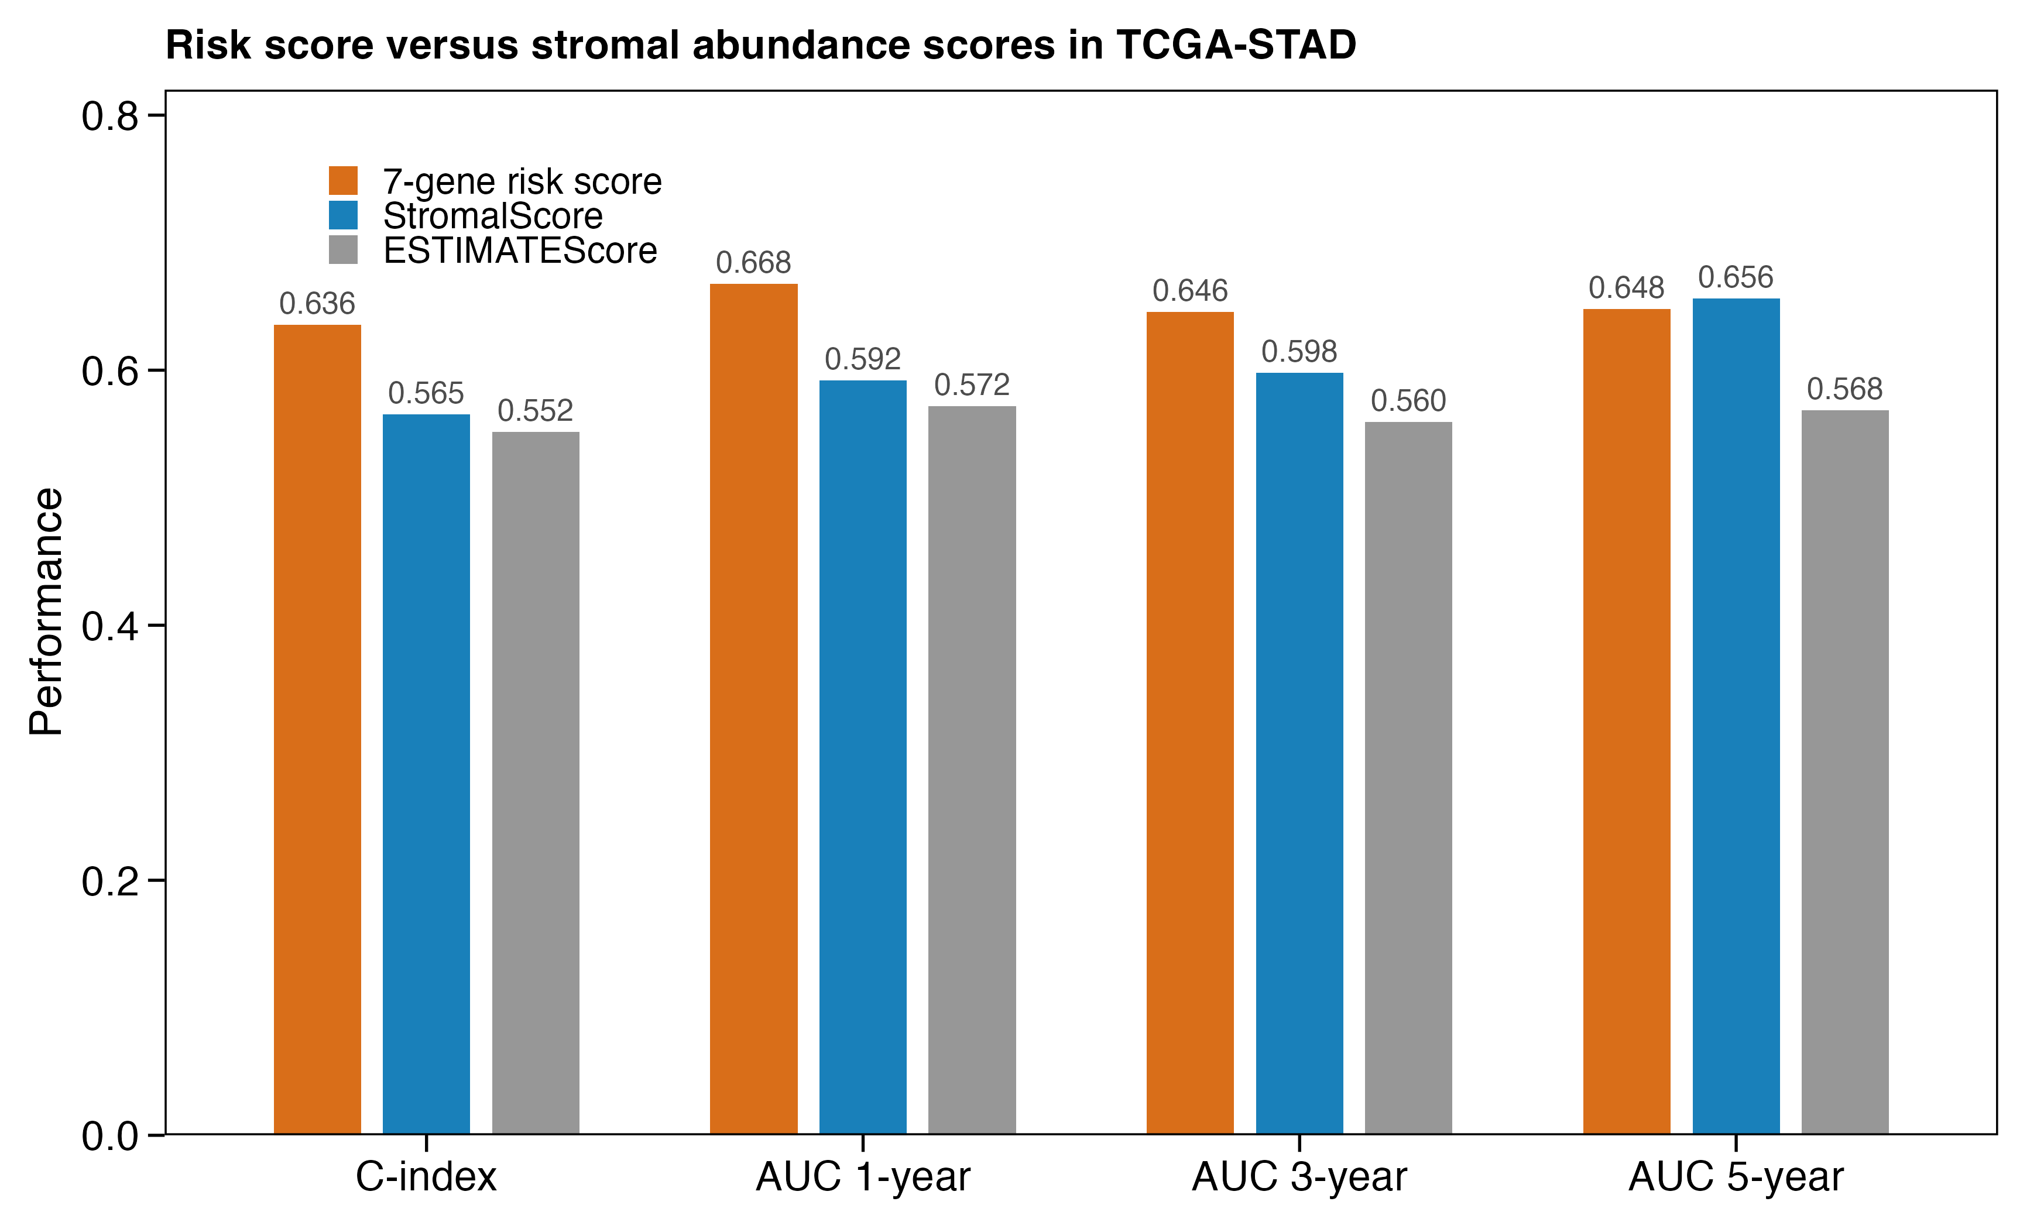

Fig. S4 compares the prognostic association of risk score, StromalScore, and ESTIMATEScore in the fixed 388-sample TCGA evaluation set. The risk score C-index (0.636) exceeded StromalScore (0.565) and ESTIMATEScore (0.552), as did 1- and 3-year AUCs; at 5 years, StromalScore AUC (0.656) was similar to and slightly higher than risk score AUC (0.648). The figure supports the focused Cox analyses testing whether the seven-gene score remains associated with overall survival beyond generic stromal or ESTIMATE abundance.

Fig. S5 Donor-aware activation consistency and incremental prognostic information
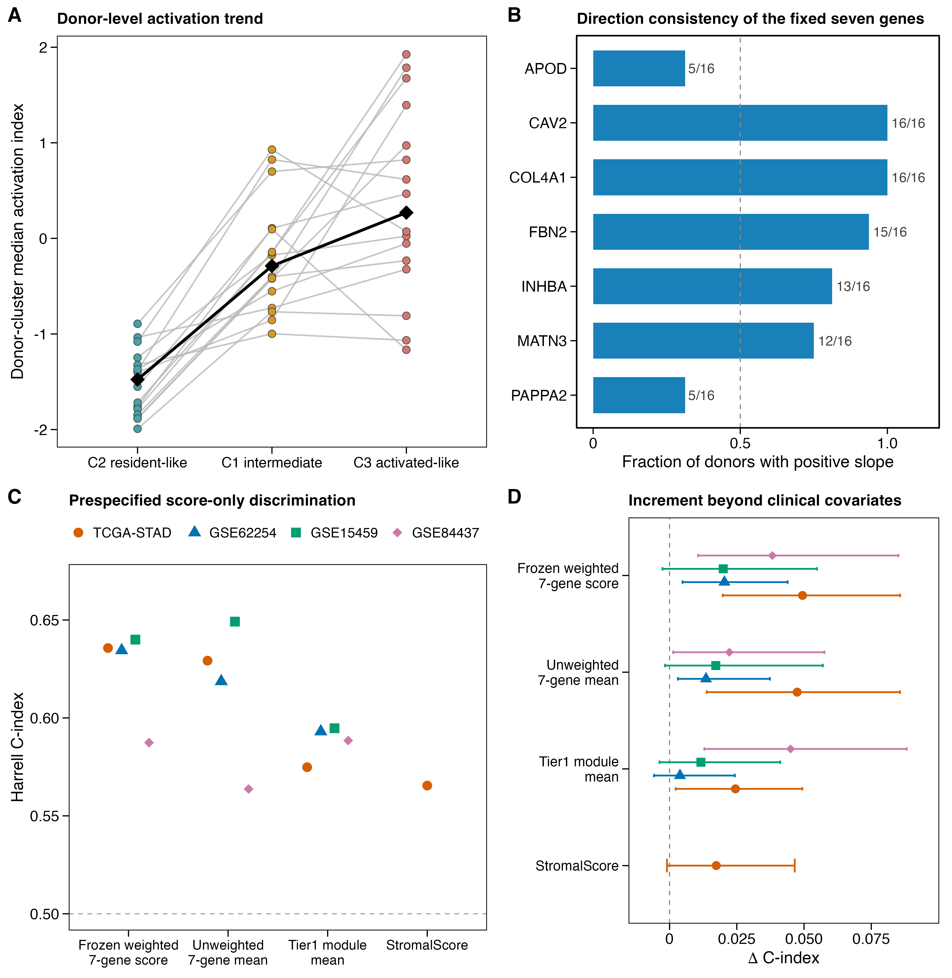
Fig. S5 summarizes donor-aware single-cell consistency and prespecified score comparisons. Panel A shows donor-level median activation index across the C2 resident-like, C1 intermediate, and C3 activated-like clusters for the 16 donors with at least five cells in each cluster; black diamonds indicate medians. Panel B shows the fraction of these donors with a positive expression slope for each fixed signature gene. Panel C compares score-only Harrell C-indices for the frozen weighted score, unweighted seven-gene mean, Tier1 module mean, and TCGA StromalScore. Panel D shows the apparent change in C-index after adding each score to cohort-specific clinical models, with 300-resample bootstrap intervals after excluding replicates with Cox warnings or errors. Clinical coefficients were fitted within each cohort; the increment analysis does not define a transportable combined clinical model.

